Student Name: Nelson da Boa Esperanca Capela  Student Number: 1905999 | Module: Managing Hotel Administration  Lecturer: Robyn Griffiths

Hotel department: Front Office and Sales and conference | Date of submission: 10th March 2023
According to Booking.com (2023), ibis Birmingham New Street Hotel is based at 21 Ladywell Walk, B5 4ST in the hearty of Chinese village and the Arcadian Centre, close to Birmingham New Street Station, Bullring shopping centre and the Birmingham Hippodrome.

In terms of Organisational structure, the hotel is managed by the general manager and manager assistant which are in control of the administrative and operational sector. The administrative sector is formed by front office, FO (e. g. reception) and back office, BO (e. g. Sales and events team, SET).
The operational sector is formed by Housekeeping, Food and Beverage and the Maintenance team). According to Buchanan and Huczynski (2016), Mullins and McLean (2019) this structure is essential because it facilitate the control, coordination of job role and stablish lines of communication.
The other departments such as Human resources and financial department are based at Accor head office, which are evidence that this hotel is not decentralised. All the strategics and operational decisions are made at Accor central office (Buchanan and Huczynski. 2016).

During my contact with FO and SET I learned that they both deal with hotel reservation and card payment. The SET in contrast with FO, they do not deal with single hotel reservation. They are accountable to deal with group booking over 8 guests and the reservation of Events (e. g, conference, meeting and banqueting). I also observed that communication, professionalism, team working, and collaboration are essential for the operationality of the hotel. When SET for example receive call or email for the room reservation if they are for less than 8 people, the SET transfer the reservation to the FO and in the same way the FO transfers to the SET if are more than group of 8.
The SET has the responsibility to negotiate with costumers the catering options for the events and the meeting room price. They stablish the prices according to the event room capacity and daily rate. Indeed, they also can offer especial rate for the room if the costumer are loyal members.
The hotel department leaders, meeting every day on briefing to share relevant information about hotel performance, concern guest requirements etc. They also created the WhatsApp group for communication and interaction between them and with guest.

These interaction and communication between them are possible because the use of technology and internet. Vallen and Vallen (2013) stated that technology provide accurate information, enable good operational controls, good performance and improve guest satisfaction.
Close observation in to SET and FO, allowed me to understand that all department use Property Management System, PMS. The FO use Front Office light System, FOLS wile SET use DIGI system. The PMS empower the hotel staff and management with skills to perform their job efficiently and to enhance guest experiences and expectation. The team can, manage booking reservations, guest check-in/checkout, room rates, guest requirements, emails, card payments, access to travel agency websites to transfer guest reservation and booking confirmations, loyal program of the brand, to offer the loyal members personalized service, products and benefits such as preferred room, free drinks, free breakfast, chocolates and especial rate. Likewise, it gather data for market segmentation, create financial, marketing and occupancy reports. It also enables staff to overbook rooms, see which room need maintenance and cleaning etc (Oracle, 2023).

The attention to details, higher concentration, flexibility, computer skills, written verbal and non-verbal communication are essential skills for the staff who works in FO. The collaboration and team working are also evident on the SET and F&B. F&B collaborate on room setup and the catering required for the delegates presented by SET. The SET and FO provide guest food requires such as allergy and dietary to the F&B. The Housekeeping provide room cleaning and maintenance fix and repair the faults. The interaction on FO enabled to see the importance of verbal and non-verbal communications skills such as writing, speaking, facial expression, smile, the dress we wear, our body language because FO are in close contact and interaction with costumer and guest interaction (Rahimi and Kozak, 2017).
In contrast with others department, the FO team face the challenge and pressure of guest complaint, guest requirement, answering phones and make reservation. They are the first point of contact with guest. They also have a responsibility to attend on bar, provide guest local directions. This multitasks functions can result stress and mental tiredness. Its fundamental as staff to have a self-control of emotions and feeling to behave in professional and polite manners when interacting face to face or by phone to not upset or make guest feel uncomfortable (Siebert and Walsh, 2013; Losekoot et al., 2018).

According to Accor (2019) the hotel is a budget and economic 3 stars hotels.
They use the multitask skill strategy to manage the human resources effectively, to reduce the financial cost, increase revenue and return the investment (Peng, Zhao and Mattila, 2015).
CIPD (2022) also states that 3 stars hotel uses zero hours and temporary contract to as a strategy to reduce cost. Blanco, Oehmichen and (2011) point out that cost reduction, limited service, space reduction (e.g., reception and, restaurant and bar at same area) are strategies of the economic hotels. In contrast, I believe that these cost reductions strategies are positive for brand profitability, reduction but they can promote demotivation and staff turnover. This view is advocated by Akinyomi (2016) study that suggest work environment (Pict 1), small and uncomfortable desk in reception for 1 FO staff can demotivate staff and promote staff turnover. Likewise, Brady and Briody, 2016 support the view that temporary and zero hours contract also can promote staff turnover.

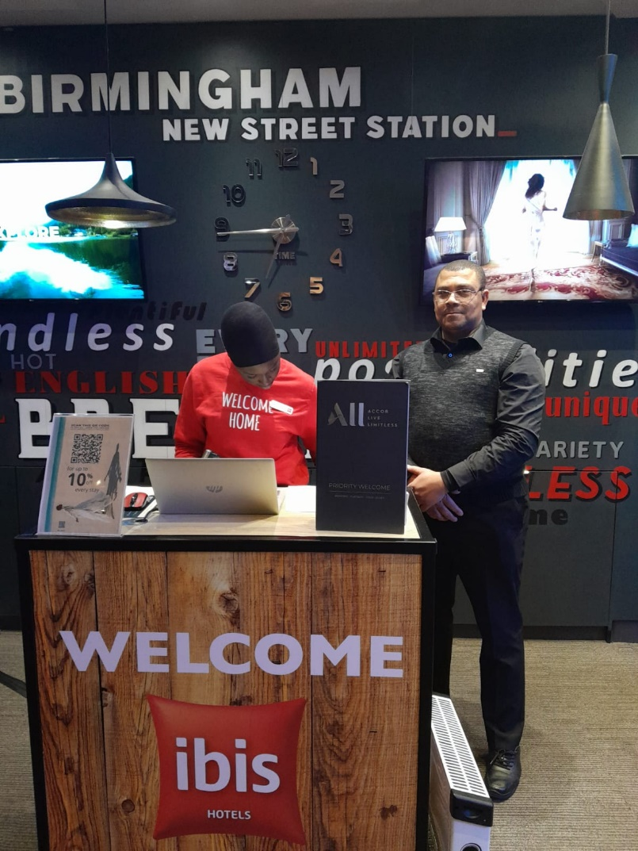
Pict 1 (ibis FO)

The “Issue”
Datta (2022) advocate that this issue is a worldwide problem for the Hospitality industry because they have difficulty to attract, recruit and retains the manpower. Work life balance, low renumeration, career development and job promotion also drive the staff turnover. Indeed, employees just stay on these hotels to empower themselves with experiences than to move to luxury and upscale hotels for better pay and career development (Chittiprolu et al., 2021; People Management, 2023).
I noticed that in FO there is higher turnover rate. Reduced staff in FO, the mini reception desk (Pict 1) also impacted on my learning development. I did not have any access to a computer training, manage reservation and check guest in. Indeed, multitask FO are requested to do including tasks they are not fully qualified to do (e.g., kitchen chief), can impact negatively in the team performance, motivation, job stress and job resignation (Savelsbergh et al., 2012).

The turnover has the following impact:
- Job disruption and extra cost such as cost with recruitment and training (Armstrong and Taylor ,2020).
- Loss of experienced staff (Chittiprolu et al.,2021).
- Profit reduction, low performance and competitivity (HEE et al., 2018).
- Customers lose relationships that kept them coming back, (People Management, 2023)
- Lack of career development and poor salary (World Economic Forum ,2023)

The solution for turnover:
- Employees retention through flexible policies and competitive salaries (People Management, 2023; Akinyomi, 2016).
- Improve staff motivation.
- Improve workplace conditions, engagement and environment (Dwesini, 2019).

Placements on this sector gave me the opportunity to get workplace experience and to learning the challenges hotel environment present. It also enabled me to implement the academic skill into the workplace and enabled me to enhance my CV with employability experience and skills. Furthermore, it taught me how to behave professionally and how to interact with team and with the guest for their satisfaction.

Recommendations

- Implement and promote career development and job progression.

- Improve motivation and staff engagement to decrease staff turnover.

- Offer staff competitive salary.

- Improve staff job contract from zero and temporary to full time and parttime permanent.
- Improve workplace conditions.

Reference
Accor (2019) ibis Birmingham New Street Station [online]. Available at: https://all.accor.com/hotel/1459/index.en.shtml (Accessed 08/02/2023).

Akinyomi, O.J., (2016) ‘Labour turnover: Causes, consequences and prevention’. Fountain University Journal of Management and Social Sciences, 5(1), pp.105-112.

Armstrong, M. and Taylor, S., (2020). Armstrong's handbook of human resource management practice. Kogan Page Publishers.

Blanco, A.C., Oehmichen, A. and Frood, S., (2011) ‘European hotel development–Focus on budget hotels’. Journal of Retail & Leisure Property, 9(5), pp.373-379.

Brady, M. and Briody, A., (2016) ‘Strategic use of temporary employment contracts as real options’. Journal of General Management, 42(2), pp.31-56. Doi/epdf/10.1177/030630701704200204

Booking.com (2023) Stay in the heart of Birmingham [online]. Available at: https://www.booking.com/hotel/gb/ibis-birmingham-centre.en-gb.html (Accessed 08/02/2023).

Chittiprolu, V., Singh, S., Bellamkonda, R.S. and Vanka, S.,( 2021) A text mining analysis of online reviews of Indian hotel employees. Anatolia, 32(2), pp.232-245.

CIPD (2022) Zero-hours contracts
https://www.cipd.co.uk/knowledge/fundamentals/emp-law/terms-conditions/zero-hours-factsheet

Datta, A., (2022). Turnover intentions and workplace climate in budget hotels of India. Anatolia, 33(4), pp.588-602. Doi.org/10.1080/13032917.2021.1984961

Dwesini, N.F.,(2019) ‘Causes and prevention of high employee turnover within the hospitality industry: A literature review.’ African Journal of Hospitality, Tourism and Leisure, 8(3), pp.1-15.

HEE JUNG (ANNETTE) KANG, BUSSER, J. and HYUNG-MIN, C., (2018) Service climate: how does it affect turnover intention? International Journal of Contemporary Hospitality Management, 30(1), pp. 76-94.

Losekoot, E., Lasten, E., Lawson, A. and Chen, B.,(2018) ‘The development of soft skills during internships: The hospitality student’s voice’. Research in Hospitality Management, 8(2), pp.155-159. Doi-org.ezproxy.uwtsd.ac.uk/10.1080/22243534.2018.1553386

Peng, J., Zhao, X. and Mattila, A.S.,( 2015) ‘Improving service management in budget hotels’. International journal of hospitality management, 49, pp.139-148. Doi.org/10.1016/j.ijhm.2015.06.005

People Management(2023) 5 ways managers can stop employee turnover[online]. Available at:
https://www.peoplemanagement.co.uk/article/1811821/5-ways-managers-stop-employee-turnover
(Accessed 05/03/23).
Tse, T.S. M., (2010)’ What do hospitality students find important about internships?’. Journal of Teaching in Travel & Tourism, 10(3), pp.251-264.Doi.org/10.1080/15313221003792027

Tripadvisor (2023) Hotel ibis Birmingham Centre New Street[online]. Available at: https://www.tripadvisor.co.uk/Hotel_Review-g186402-d191991-Reviews-Hotel_ibis_Birmingham_Centre_New_Street-Birmingham_West_Midlands_England.html (Accessed 08/02/2023).

Rahimi, R. and Kozak, M., (2017) Impact of customer relationship management on customer satisfaction: The case of a budget hotel chain’. Journal of travel & tourism marketing, 34(1), pp.40-51.Doi.org/10.1080/10548408.2015.1130108

Savelsbergh, C., Gevers, J.M., van der Heijden, B.I. and Poell, R.F. (2012) ‘Team role stress: Relationships with team learning and performance in project teams’. Group & organization management, 37(1), pp.67-100. Doi:10.1177/1059601111431977

Siebert, S. and Walsh, A.,( 2013) ‘Reflection in work-based learning: self-regulation or self-liberation?’ Teaching in Higher Education, 18(2), pp.167-178.

Vallen, G, & Vallen, J (2013) Check-In Check-Out: Managing Hotel Operations : Pearson New International 9th Edition, Pearson Education, Limited, Harlow. Available at: https://ebookcentral.proquest.com/lib/trinity/reader.action?docID=5173949 (Accessed 08/03/23)

World Economic Forum (2023) 5 things that make workers stay at their jobs (hint: it’s not salary)
https://www.weforum.org/agenda/2022/12/5-things-that-make-workers-stay-at-their-jobs-not-salary/

