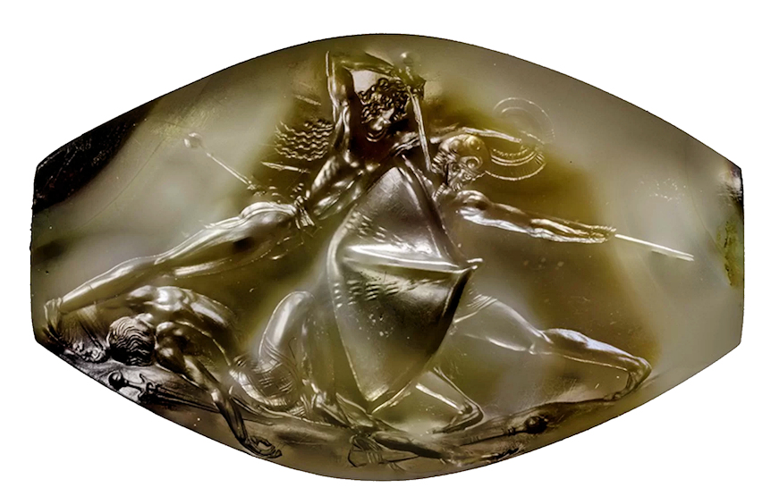
Pylos, agate sealstone from Griffin Warrior Tomb, Pylos. 16th century BCE

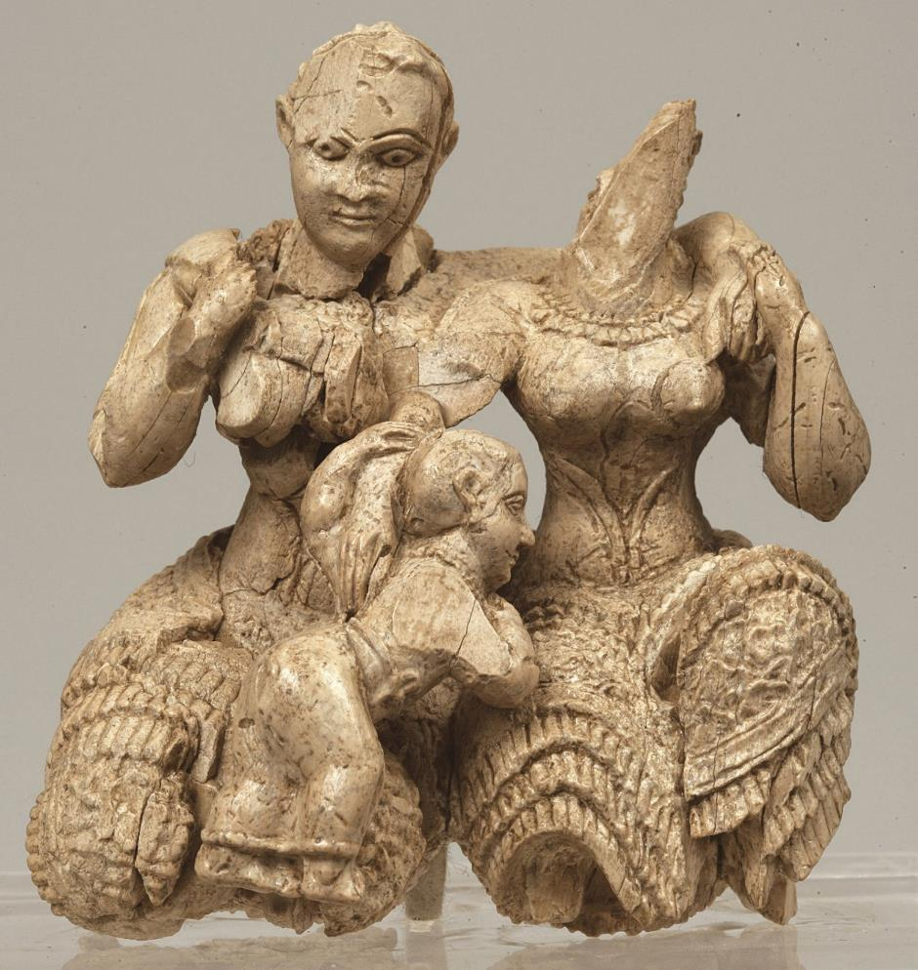
Ivory triad sculpture, cropolis of Mycenae, palace area, 15th-14th c. BCE.
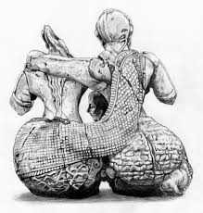 (detail of back)
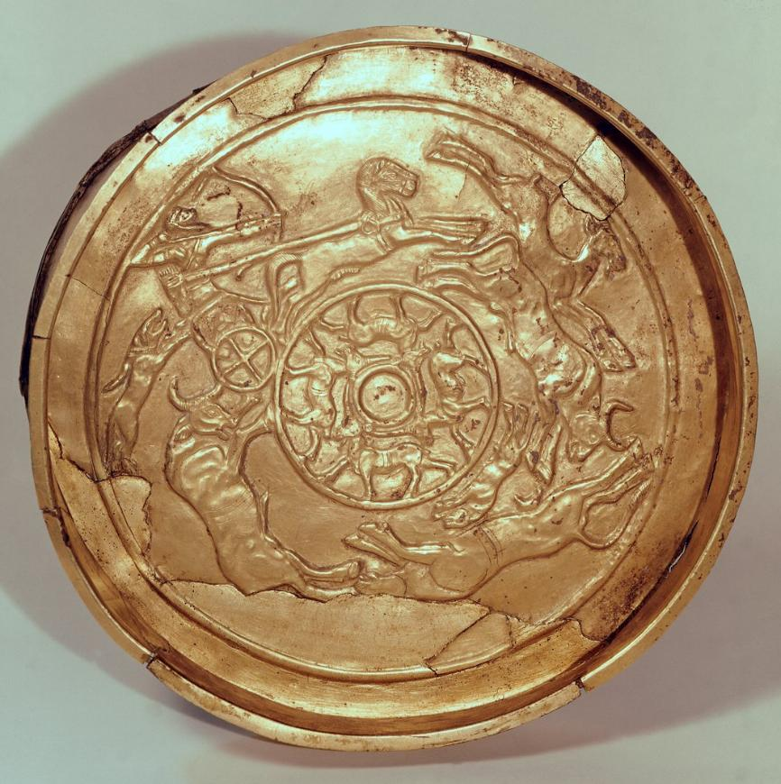
Gold bowl, Ugarit. 14-13th century BCE

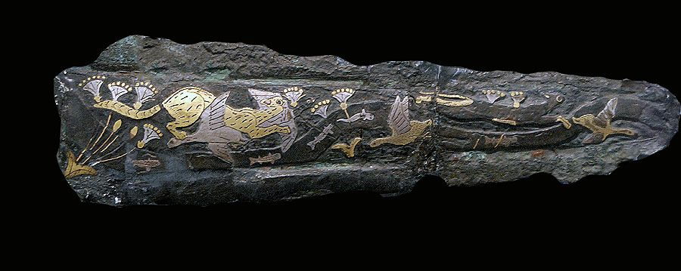
Inlaid dagger, Mycenae Grave Circle A. Early 15th Century BCE.

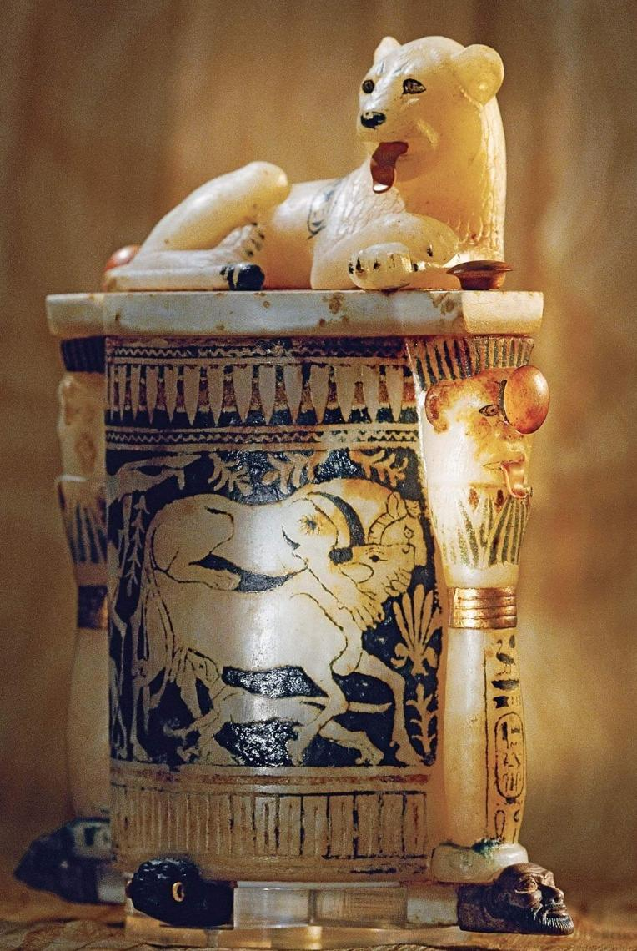
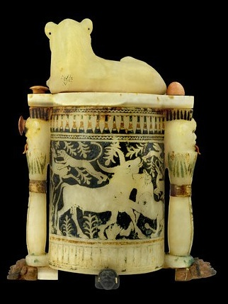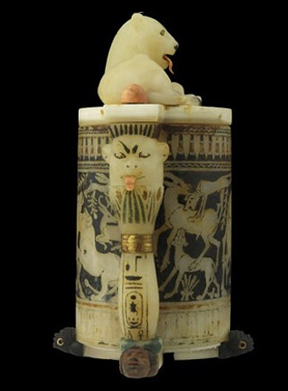
Alabaster cosmetic vase, tomb of Tutankhamun

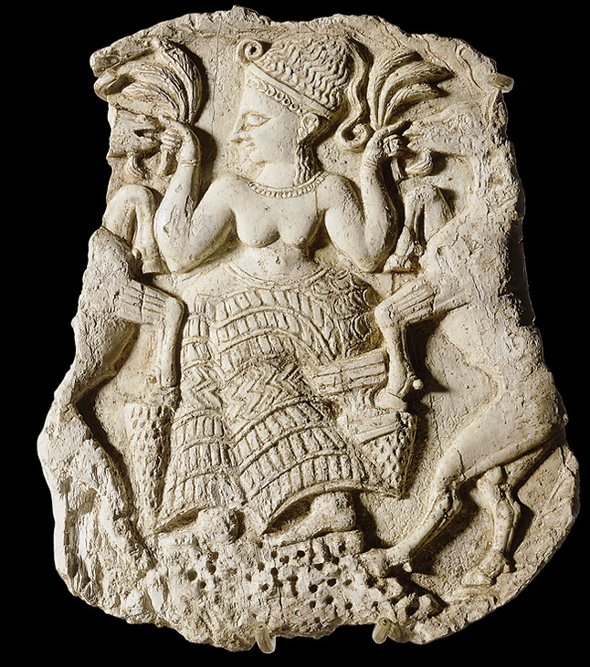
Lid of ivory pyxis (cylindrical box), Minet el Beidha (harbour of Ugarit), 13th century BCE.

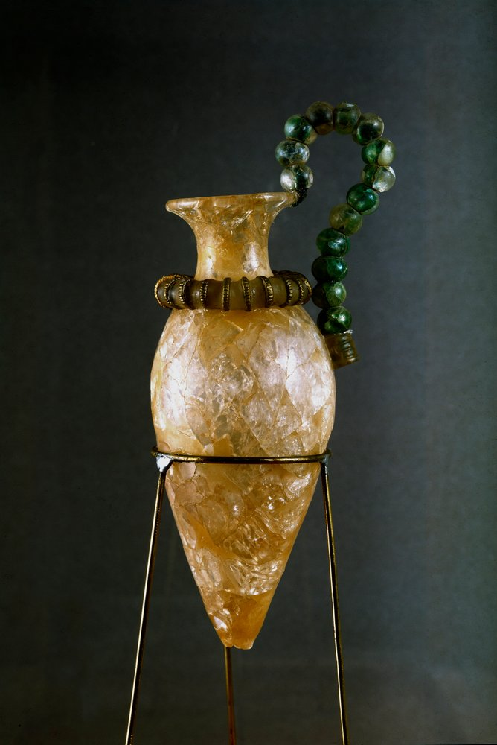

Rock crystal and copper rhyton (libation vase) from the palace of Zakros, Crete. 15th century BCE.

