Will Naish
CIPD Number: 88139784
Total Word Count: 2470

Professional behaviours and people

- With reference to typical activities and behaviours, appraise what it means to be a ‘people professional’. (AC 1.1)
People professionals (PP) enhance workplaces by understanding, communicating, and unlocking organisational value. They drive change, handle complexity, and navigate uncertainty. The Profession Map aids people professionals in improving their work lives. CIPD (2023)
The HR function historically focused on administrative tasks like issuing contracts, maintaining records, running payroll, and maintaining policy statements. In unionised organisations, it also maintained strong relationships with employee representatives. However, the role has evolved, with more focus on maximising individual and collective contributions. The HR function contributes to organisational success by encouraging staff to maximise their personal contributions and ensuring effective leadership across the organisation. Taylor and Woodhams (2016a)
People professionals play a crucial role in workforce planning, balancing available skills with required numbers, analysing current and future workforces, and addressing gaps for long-term success by hiring the right people. CIPD (2023b)
Recruitment and hiring are crucial for professionals to select suitable candidates, involving setting up roles, attracting applicants, managing applications, screening, and scheduling meetings. (CIPD, 2022)
People professionals use direct and indirect communication channels to encourage employee opinions, record feedback, and educate managers on company goals. They maintain a positive attitude, fostering trust and collaboration among employees. (CIPD, 2023c)
L&D professionals create learning programs for businesses to grow and adapt, focusing on motivation and attitude. They identify current and future skills needs, and create flexible online and off-site programs to meet the needs of all employees. CIPD (2024)
The profession map is a global standard for professionals, aiding decision-making, confidence, and career advancement. It outlines goals, values, and knowledge, adapting to new roles, specialties, and opportunities. CIPD (2023b)
Human resources professionals are essential for organisational effectiveness and employee development, assisting individuals and contributing to various sectors. They develop strategies, collaborate with trade unions, evaluate skills, implement culture-change initiatives, train managers, and nurture talent. CIPD (2023c)

- Discuss how ethical values underpin the work of a people professional, including two examples of how ethical values might be applied in a people practice context. (AC 1.2)
The CIPD's Profession Map emphasises ethical practice, fostering trust through consistent application of principles and values in decision-making, highlighting the importance of ethical values in organisational culture.CIPD (2024a)
Ethics, derived from philosophical theories like God-based ethics, intuitionism, consequentialism, virtue ethics, situation ethics, and ideology, are based on moral rules, objective properties, consequences, virtuous character, individual interests, and uniqueness. Ethics can also be used for political ideology. BBC (2014)
Deontological ethical systems prioritise moral obligations, utilitarian theories maximise benefits, rights-based theories safeguard societal rights, and virtue ethics evaluate individuals based on character, reputation, and motivation, promoting justice and beneficence. Chonko (2012)
Harassment and poor treatment in the workplace underscore the significance of ethics in an organisation, with people professionals playing a crucial role in influencing strategy and management. (CIPD, 2023f)
PP employs evidence-based decision-making, prioritising high-quality research findings over intuition or instinct, ensuring informed policy-making and effective project execution. (GOV.UK, 2021) Utilising evidence-based decision-making helps reduce biassed perspectives and relies on solid proof rather than individual opinions.
HR policies guide employees and organisations in employment matters, promoting trust, fairness, and inclusivity. They influence motivation, reputation, and talent retention. Legal compliance is essential, and implementation requires collaboration among leaders, managers, and employees. (CIPD, 2023f)
People managers are key in promoting ethical practices within organisations, ensuring fair policies, legal compliance, and safe working conditions. They act as ambassadors, holding employees accountable, and role-modelling ethical practices, promoting alignment of personal and organisational values. (CIPD, 2024b)
Ethical frameworks often provide a narrow perspective, limiting the consideration of alternative values and perspectives. Integrating multiple ethical frameworks can provide a more comprehensive and nuanced approach to ethical decision-making, accounting for cultural differences and complexity.
- Consider the importance of people professionals being able to influence others and ensure that the ‘people practice voice’ is heard in an organisation, through informed, clear and confident communication. (AC 1.3)

People professionals play a crucial role in promoting employee engagement, trust, and organisational reputation. Effective communication is essential for retaining employees, fostering a positive work environment, and reducing turnover. However, challenges arise in providing adequate information, particularly during uncertain times and rapid change. CIPD (2023e)
HR professionals must possess knowledge and expertise to influence others, as line managers can undermine their position without it. They should be friendly, assertive, and able to strike a bargain in difficult situations. This allows them to communicate their thoughts and listen to stakeholders' concerns, fostering trust and understanding. Taylor and Woodhams (2016b)
People function is crucial for organisational performance and career advancement, ensuring right people are in right jobs, providing necessary skills, training, and development, and protecting their rights. CIPD (2023e)
In the people profession, contradictory insights and claims persist, leading to mental shortcuts and biases. Large consulting firms promote new models to empower employees and boost performance. Common biases include authority, conformity, and confirmation bias, potentially overvaluing these factors. CIPD (2023a)
According to CIPD (2023f) professional courage is crucial for HR, OD, and Learning professionals in a world where truth, justice, and 'being right' have been distorted. It's vital to uphold ethics, morality, and fairness, and to be positively influential and creative in the future design of the world of work, especially in the face of advancing digital technologies and new economic models.

Misinformed people professionals can lead to poor decision-making in employee relations, talent management, and organisational development, negatively impacting performance and employee satisfaction. According to Vince (2019) Poor HR practices can lead to low morale, lost business, and legal issues. Employee conflict, inadequate training, and team building issues can result. Legal issues like wrongful termination and discrimination can arise. Knowledgeable professionals are more respected and influential.

HR professionals must understand an organisation’s vision, strategic objectives, products, services, and operational processes to build credibility. They should be commercial, pragmatic, and communicate effectively. HR effectiveness is reflected in business performance, including sustainability, profitability, productivity, innovation, and growth. (INSIDEHR, 2023)
People professionals' ability to influence others and ensure the 'people practice voice' is heard in an organisation is largely dependent on their communication skills, which enable them to advocate for employee needs and drive positive change.
- For each of the situations below (a & b), provide an example of an issue that would cause you to raise the matter to a manager (or other authority) - and describe how you would do this.
a) where you consider something to be unethical (whether or not it is illegal),
b) where you believe something contravenes legislation. (AC 1.4)

- A Manager using their senior level to promote family members within the company
Conflict of interest arises when an employee's personal affiliation with another firm or commercial entity clashes with their professional obligation. The consideration of the influence on team members and working methods, particularly when reporting to each other, is of utmost importance when two employees in a team with a personal relationship. gregguilford (2020a)
The organisation should require employees to report any personal ties and convene if two employees have a relationship to discuss the consequences on their colleagues and take appropriate actions. gregguilford (2020b)
To report a conflict of interest in the workplace i would understand the company's policies, gather relevant information, report to the Manager, provide a clear and detailed report of appropriate information, maintain confidentiality and cooperate with investigations. This helps maintain ethical standards and protect the integrity of the workplace.

- I have witnessed theft in the workplace where an employee is stealing from the workplace
Gross misconduct refers to serious actions or effects by an employee, such as fraud, physical violence, negligence, or insubordination. It is typically relevant in dismissals related to work behaviour, but employers must follow fair procedures if accused. ACAS (2022)
Theft is defined as dishonestly appropriating property with the intention of permanently depriving another. Sections 2-6 of TA 1968 provide further interpretation. "Dishonestly" is not dishonest if the person believes they have a legal right to take the property, would agree to it if they knew, or could not find the owner. However, TA 1968 does not provide a complete definition of "dishonesty." Crown Prosecution Service (2019)
If I had noticed theft in the workplace I would Document the theft incident details, including the date, time, and nature, to aid in an investigation. Report the incident to management, following company procedures. Maintain confidentiality and avoid discussing the situation with colleagues or others not directly involved. I would also Cooperate with investigations, providing additional information or evidence as needed. Adhere to company policies and legal requirements related to reporting theft in the workplace, including cooperating with law enforcement if necessary.
- Discuss two theories or models relating to the human and business benefits of people at work feeling included, valued, and fairly treated, concluding your discussion with a summary of your own view of these benefits. (AC 2.1)
Social Identity Theory, developed by Henri Tajfel and John Turner in the 1970s, suggests that individuals' self-concept is influenced by their affiliation with social organisations. It explains how these organisations, such as socioeconomic class, family, or sports teams, shape an individual's sense of pride and self-esteem. Social identity groups provide a sense of belonging, shared goals, and a sense of pride, helping individuals understand their identity within a larger community. They also offer a structure for understanding their self within the broader context of a larger community, fostering shared qualities, ideals, or ambitions that contribute to shaping one's identity. (McLeod, 2023)
In my view Social Identity Theory can foster a sense of unity and purpose among employees, leading to improved team performance, increased output, and increased employee happiness. A company culture that values fairness, inclusion, and respect fosters a sense of belonging and value, resulting in increased engagement, commitment, and loyalty. Effective leaders can use Social Identity Theory to motivate and motivate employees by creating a shared identity, trust, and alignment with the company's goals.
A psychological contract is a mutually agreed upon arrangement between an employer and a worker that is formed on the basis of shared expectations and responsibilities. Emerging in the 1960s, it highlights the significance of the human element in professional relationships. Legal contracts are formal written agreements, but psychological contracts pertain to the dynamics of the working relationship between employees and employers, as well as the reciprocal expectations employees have of their employers. While it is not possible to legally mandate a psychological bond, judges may take into consideration the connection between the employer and employee. Employees frequently attribute responsibility for their behaviour to their superiors, resulting in a desire for flexible work arrangements. CIPD (2022a)
I believe a positive psychological contract boosts employee engagement by valuing their contributions, leading to increased commitment and productivity. This human approach is appreciated by employees, resulting in increased job satisfaction. A satisfied workforce is more productive, creative, and innovative. This contract benefits both employees and the organisation by fostering engagement, retention, trust, and a positive employer brand.

In my view the benefits of people at work feeling included, valued, and fairly treated are far-reaching. They include improved job satisfaction, employee well-being, motivation, collaboration, reduced turnover, diversity, innovation, and a positive organisational culture. Ultimately, creating an environment where employees feel included, valued, and fairly treated is essential for promoting individual and organisational success. The Hilton is a corporate entity that has actively embraced employee engagement and has achieved recognition as a leading employer.
Hilton's Senior Leadership Business Immersion program connects senior leaders to hotel operations, allowing them to understand workers' day-to-day experiences. The three-day program involves working in departments like Housekeeping, Food & Beverage, Banqueting, and Engineering, providing authentic insight into staff challenges and potential improvements. (Brownlee, 2019)
- Discuss two ways in which a people professional can build inclusivity into a people practice initiative at the design stage, and two ways of checking inclusivity after a people practice initiative is implemented. (AC 2.2)

A welcoming work environment fosters a sense of belonging, promoting health, creativity, and business growth. However, some employees may feel left out due to superficial treatment, which can lead to a lack of loyalty. Job seekers are increasingly seeking companies that value diversity, particularly among Millennials, who are more likely to feel excluded. To foster inclusivity, companies should ask employees what they need to feel like part of the team, and consider using confidential polls or one-on-one meetings.
Onboarding is a crucial part of a new employee's experience, as it sets the tone for their connection to the company. Ensuring inclusion is a significant part of the onboarding process ensures that new employees feel recognised and included, fostering a sense of belonging and support. By doing so, companies can create a more inclusive and productive work environment. Boatman (2021)
The establishment of inclusive communication is of utmost importance in fostering an environment that promotes a sense of belonging, respect, and recognition for all individuals. The concept encompasses the comprehension, appreciation, and appreciation of diverse viewpoints, as well as the acknowledgment of the extensive array of identities within the contemporary global community. The cultivation of empathy is of utmost importance, and it is imperative for businesses to actively pursue greater accessibility by incorporating content that caters to those with disabilities and diverse cultural backgrounds. The implementation of inclusive communication practices is a cost-effective endeavour, since organisations have the cost-free option to embrace such practices through inclusive recruiting policies, training initiatives, and customer service initiatives. It is crucial to have a comprehensive and enduring plan for inclusive communication, and the HR department should be cognisant of the impact of interactions on different groups and make efforts to establish an environment that is inclusive. HR should initiate inclusive policies, establish diversity committees, and provide training to ensure that all individuals have enhanced opportunities for inclusive communication. Scott (2023)

An employee engagement poll is a tool used to assess the engagement of an organisation’s workforce. It provides valuable insights into employees' feelings, thoughts, and actions across roles, departments, and branches. However, it's important to use anonymous surveys to avoid potential biases. Polls with too many questions can make results less accurate and make it difficult to compare facts, potentially leading to negative organisational decisions. Jay (2021)
People analytics is a method of analysing data about individuals to solve business problems, utilising insights from HR, IT, and external sources like salary surveys. It involves key terms like correlation, causation, predictive, and prescriptive, and outlines a strategy and process. CIPD (2024d)
People analytics projects should align with business and HR strategies, aiming to connect people data with business data for informed decision-making, enable HR leaders to use analytics for appropriate HR activities, and measure HR effectiveness. CIPD (2024e)
People professionals can ensure inclusive and responsive initiatives by incorporating these approaches during the design stage and checking inclusivity post-implementation.

Bibliography

ACAS (2022). Types of dismissal: Dismissals. [online] Acas. Available at: https://www.acas.org.uk/dismissals/types-of-dismissal [Accessed 15 Mar. 2024].
BBC (2014). Ethics: a General Introduction. [online] www.bbc.co.uk. Available at: https://www.bbc.co.uk/ethics/introduction/intro_1.shtml [Accessed 1 Mar. 2024].
Boatman, A. (2021). 7 Ways HR Can Help Create an Inclusive Environment at Work. [online] AIHR. Available at: https://www.aihr.com/blog/inclusive-environment-at-work/ [Accessed 7 Mar. 2024].
Brownlee, D. (2019). How the ‘Best Companies to Work For’ Engage Employees and Retain Top Talent. [online] Forbes. Available at: https://www.forbes.com/sites/danabrownlee/2019/09/04/how-the-best-companies-to-work-for-engage-employees-and-retain-top-talent/?sh=6f5bba211eca [Accessed 7 Mar. 2024].
Chonko, L. (2012). Ethical Theories. [online] DSEF. Available at: https://dsef.org/wp-content/uploads/2012/07/EthicalTheories.pdf [Accessed 1 Mar. 2024].
CIPD (2022a). CIPD | Psychological Contract. [online] CIPD. Available at: https://www.cipd.org/uk/knowledge/factsheets/psychological-factsheet/#what-is-the-psychological-contract [Accessed 7 Mar. 2024].
CIPD (2022b). CIPD | Recruitment Process Overview | Factsheets. [online] CIPD. Available at: https://www.cipd.org/uk/knowledge/factsheets/recruitment-factsheet/#recruitment [Accessed 26 Feb. 2024].
CIPD (2023a). Building an evidence-based People Profession. [online] CIPD. Available at: https://www.cipd.org/uk/views-and-insights/thought-leadership/insight/evidence-based-profession/ [Accessed 5 Mar. 2024].
CIPD (2023b). CIPD | The Profession Map. [online] CIPD. Available at: https://www.cipd.org/uk/the-people-profession/the-profession-map/ [Accessed 29 Feb. 2024].
CIPD (2023c). CIPD | the Profession Map. [online] CIPD. Available at: https://www.cipd.org/uk/the-people-profession/the-profession-map/ [Accessed 26 Feb. 2024].
CIPD (2023d). CIPD | the Profession Map. [online] CIPD. Available at: https://www.cipd.org/uk/the-people-profession/the-profession-map/ [Accessed 29 Feb. 2024].
CIPD (2023e). CIPD | Workforce Planning | Factsheets. [online] CIPD. Available at: https://www.cipd.org/uk/knowledge/factsheets/workforce-planning-factsheet/ [Accessed 26 Feb. 2024].
CIPD (2023f). Professional Courage and Influence. [online] CIPD. Available at: https://www.cipd.org/uk/the-people-profession/the-profession-map/explore-the-profession-map/core-behaviours/professional-courage-influence/ [Accessed 5 Mar. 2024].
CIPD (2023g). Why Work in the People profession? [online] CIPD. Available at: https://www.cipd.org/uk/the-people-profession/careers/why-work/ [Accessed 5 Mar. 2024].
CIPD. (2022c). CIPD | Race Discrimination at Work. [online] Available at: https://www.cipd.org/uk/knowledge/factsheets/race-employment-discrimination-factsheet/#what-is-race-discrimination [Accessed 7 Mar. 2024].
CIPD. (2023h). CIPD | Employee Communication. [online] Available at: https://www.cipd.org/uk/knowledge/factsheets/employee-communication/#roles-and-responsibilities-in-communication [Accessed 5 Mar. 2024].
CIPD. (2023i). CIPD | Employee Relations | Factsheets. [online] Available at: https://www.cipd.org/uk/knowledge/factsheets/relations-employees-factsheet/#Employeerelations [Accessed 26 Feb. 2024].
CIPD. (2023j). CIPD | HR Policies | Factsheets. [online] Available at: https://www.cipd.org/uk/knowledge/factsheets/hr-policies-factsheet/#four [Accessed 1 Mar. 2024].
CIPD. (2023k). CIPD | on This Page. [online] Available at: https://www.cipd.org/uk/knowledge/factsheets/ethics-role-hr-factsheet/#:~:text=They%20can%20support%20the%20embedding [Accessed 1 Mar. 2024].
CIPD. (2024a). CIPD | Ethics at work: an Employer’s Guide. [online] Available at: https://www.cipd.org/uk/knowledge/guides/ethics-work-guide/#conclusion [Accessed 1 Mar. 2024].
CIPD. (2024b). CIPD | Ethics at work: an Employer’s Guide. [online] Available at: https://www.cipd.org/uk/knowledge/guides/ethics-work-guide/#fairness-and-organisational-politics [Accessed 1 Mar. 2024].
CIPD. (2024c). CIPD | Learning and Development Roles. [online] Available at: https://www.cipd.org/uk/the-people-profession/careers/roles/learning-development/#:~:text=Here%20are%20some%20of%20the [Accessed 29 Feb. 2024].
CIPD. (2024d). CIPD | People Analytics | Factsheets. [online] Available at: https://www.cipd.org/uk/knowledge/factsheets/analytics-factsheet/#two [Accessed 10 Mar. 2024].
CIPD. (2024e). CIPD | People Analytics | Factsheets. [online] Available at: https://www.cipd.org/uk/knowledge/factsheets/analytics-factsheet/#five [Accessed 10 Mar. 2024].
Crown Prosecution Service (2019). Theft Act Offences | The Crown Prosecution Service. [online] Cps.gov.uk. Available at: https://www.cps.gov.uk/legal-guidance/theft-act-offences [Accessed 15 Mar. 2024].
GOV.UK (2021). Evidence-based Decision Making Framework Used by the Regulatory Horizons Council. [online] GOV.UK. Available at: https://www.gov.uk/government/publications/evidence-based-decision-making-framework-used-by-the-regulatory-horizons-council/evidence-based-decision-making-framework-used-by-the-regulatory-horizons-council [Accessed 1 Mar. 2024].
gregguilford (2020a). Relationships at Work | Workplace Relationship Policy. [online] HR Solutions. Available at: https://www.hrsolutions-uk.com/news/personal-relationships-at-work-policy/ [Accessed 15 Mar. 2024].
gregguilford (2020b). Relationships at Work | Workplace Relationship Policy. [online] HR Solutions. Available at: https://www.hrsolutions-uk.com/news/personal-relationships-at-work-policy/ [Accessed 15 Mar. 2024].
INSIDEHR. (2023). How HR Can Build Credibility and Strong Partnerships with Business Leaders – Connecting Hr with Australia. [online] Available at: https://www.insidehr.com.au/position-of-influence-how-to-strengthen-hrs-ability-to-impact-business-performance/#:~:text=While%20of%20course%20it%20matters [Accessed 7 Mar. 2024].
Jay, S. (2021). A Complete Guide to Employee Engagement Survey Analysis. [online] AIHR. Available at: https://www.aihr.com/blog/employee-engagement-survey-analysis/ [Accessed 7 Mar. 2024].
McLeod, S. (2023). Social identity theory in psychology. [online] Simply Psychology. Available at: https://www.simplypsychology.org/social-identity-theory.html [Accessed 7 Mar. 2024].
Scott, C. (2023). Inclusive Communication: What Is It and Why It Matters. [online] AIHR. Available at: https://www.aihr.com/blog/inclusive-communication/ [Accessed 7 Mar. 2024].
Taylor, S. and Woodhams, C. (2016a). Studying Human Resource Management. 2nd ed. London: CIPD.
Taylor, S. and Woodhams, C. (2016b). Studying Human Resource Management. 2nd ed. London: CIPD.
Vince, K. (2019). Consequences of Poor Human Resource Management. [online] The Christopher Group. Available at: https://www.tcgco.com/consequences-of-poor-human-resource-management/#:~:text=Poor%20HR%20practices%20will%20likely [Accessed 7 Mar. 2024].

Will Naish
CIPD Number: 88139784
Total Word Count: 1022

1.Reflect on your own approach to working inclusively and building positive working relationships with others. (AC 2.3)
Employers should not discriminate against gender-based employees, but outdated ideas about work appropriateness and reward systems can lead to sexual harassment and unfair disadvantages for both genders. Unison (2016)
I collaborates with diverse employees from various races, age groups, abilities, and genders in the organisation, avoiding discrimination based on protected characteristics. I believe in allowing everyone to participate in tasks, regardless of gender, and promoting inclusivity.
Age significantly impacts organisational dynamics. Despite initial opposition, a young female coworker excelled and became a manager, demonstrating the importance of promoting progression regardless of age.
Research indicates diverse workforces enhance decision making, innovation, and problem-solving. However, a diverse workforce requires empowerment, belonging, and a safe environment for employees to reach their full potential. (CIPD, 2022)
I strongly advocate for an open, inclusive environment, valuing every individual's voice. They encourage round table discussions, equal development opportunities, and coaching, fostering strong relationships.the importance of trust, listening, and reciprocation within the team, ensuring no thought or perspective is overlooked.
Trust, respect, self-awareness, inclusion, and open communication are crucial for fostering good work relationships, promoting honesty, responsibility, diversity, and connection. (Mind Tools, 2022)
The significance of diverse perspectives and empathy in professional settings, having personally experienced leadership and inspiration from dictatorial employers.
Of all the elements I have described, I would like to improve my confidence in leading colleagues by gaining more knowledge and experience. The CIPD course is enabling me to challenge myself and acquire more skills and knowledge.

2. Explore how the role of a people professional (specialist or generalist) is evolving and the implications this has for your CPD. (AC 3.1)
The role of professionals in society is rapidly evolving, either through the use of technology or the implementation of hybrid working models.
Technology can boost productivity and job quality, but improper implementation can reduce returns, undermine worker wellbeing, and lead to skill loss. PP must stay updated for organisational success. (CIPD, 2022b)

AI and automation impact work is contentious, with some predicting job losses and others predicting improvements. Despite risks, only half of affected workers receive training. (CIPD, 2021)
Flexible working practices encompass various work arrangements, including part-time, term-time, job-sharing, compressed hours, remote work, hybrid working, career breaks, and commissioned outcomes. (CIPD, 2023)
The CIPD advocates for flexible working conditions to become the norm, as 46% of employees lack them, despite their potential to enhance engagement, job satisfaction, and wellbeing. (CIPD, 2023a)
To enhance my professional trajectory in human resources, I believe technology plays a crucial role. Acquiring expertise in emerging technologies, hybrid work arrangements, and obtaining certificates like CIPD will enhance my job skills.
3. With reference to your responses for Q1 & Q2, and feedback on your behaviours or performance obtained from (at least) one other person, assess your current strengths, weaknesses, and development needs. Your response should include an explanation of the feedback received and how it has informed your self- assessment. (AC 3.2)

My key strength lies in my ability to motivate others, leading to successful objectives and increased employment engagement in retail management, exemplified by consistent compliments and alignment with company values.
According to (CIPD, 2023c) Influencing others in daily work involves courage, challenging resistance, speaking up, and taking a stand, involving making change cases, contributing ideas, gaining stakeholder buy-in, and working with line managers.

My strength lies in my ability to effectively communicate information, fostering confidence and trust among my team, and creating an excellent work environment.

According to (Peters, 2023) Strategic communication is vital for employee sense-making and crisis management, reducing ambiguity and promoting positive outcomes by covering timing, content, style, and channels with clear, honest messaging.

My weakness is consistently recognising positive qualities in individuals and trusting information. However, prior workshops and assignments have highlighted the importance of evidence-based practice, which will aid in thoroughly analysing various perspectives and situations.

According to CIPD (2023a) Professionals in the field of people management frequently address intricate organisational challenges, necessitating a profound comprehension of efficacious strategies to impact crucial results, while avoiding passing trends, obsolete knowledge, or superficial remedies.

Based on job applications a need for further training in human resources technologies, including ATS and data mining, due to the revolutionising nature of HR and the need for personal and professional growth.

The CIPD Profession Map highlights HR professionals' knowledge in 'technology and people', requiring them to evaluate the impact of current and future technologies on workforce practices. Mohdzaini (12AD)

- In follow-up to your self-assessment, identify a range of formal or informal development activities you will undertake to support your ongoing professional development. Your response should include a brief description of your chosen activities and your reasons for selecting them. (AC 3.3)

Following self-assessment, I have identified formal and informal development activities to support professional growth, addressing gaps and enhancing skills in specific areas
Enrolling in strategic HR management and technology courses on the CIPD website and attending seminars will enhance understanding of HR efforts in corporate strategy and organisational change management.

Stacey Harris' 'Introduction to HR Technologies' course explores HR technology environments, key factors, and application. It includes real-world case studies and helps identify skills for achieving goals and builds confidence in decision-making through risk awareness. CIPD (n.d.)
I'll regularly review industry journals, research papers, and books to stay updated on HR trends, laws, and best practices, utilising self-directed learning and the CIPD's diverse studies to enhance my knowledge.
The CIPD conducts research on various work-related topics, including skills, workforce planning, people analytics, and corporate transparency, providing updates on these findings. CIPD (n.d.)
The activities will focus on self-assessment improvement, industry updates, skill enhancement, and professional network expansion, ensuring ongoing professional development.

- Reflect on the impact of three previous learning activities (i.e., not the activities planned at Q4 above) on your behaviour and performance. The selected activities may be any formal/planned or informal/unplanned activities undertaken in the last 12 months, which you consider to have impacted your behaviour and performance. (AC 3.4)

Photo 1 – my personal development plan
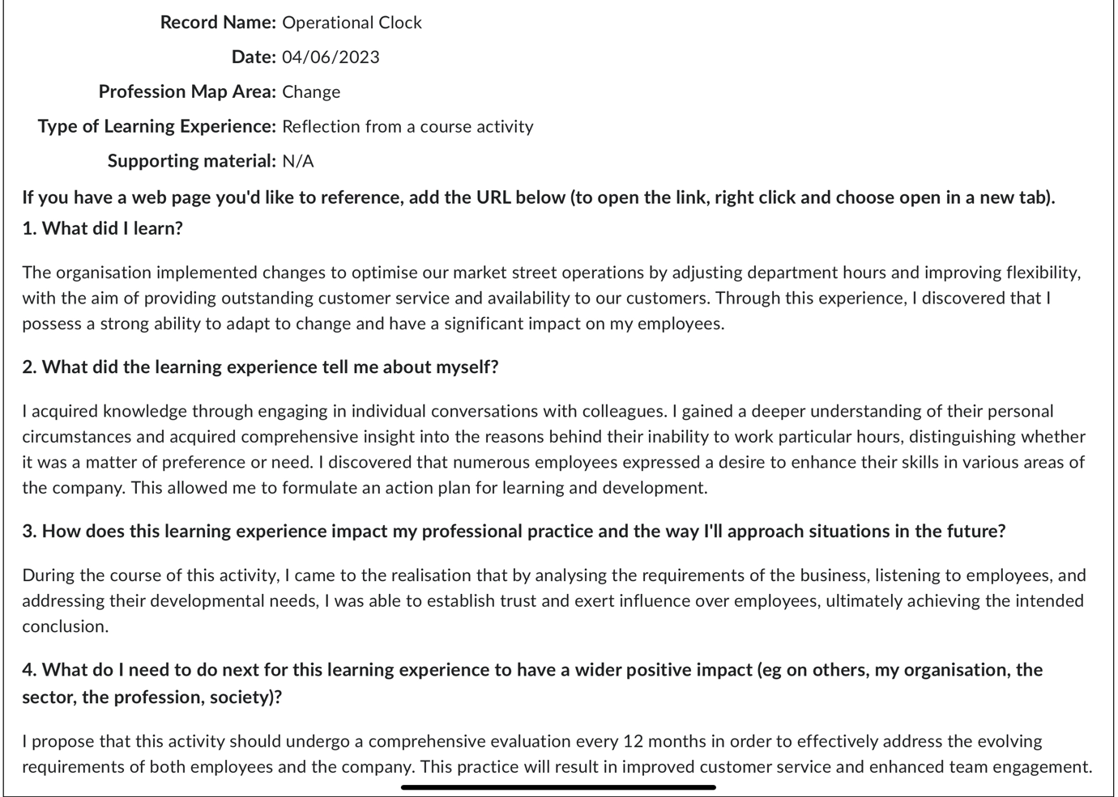

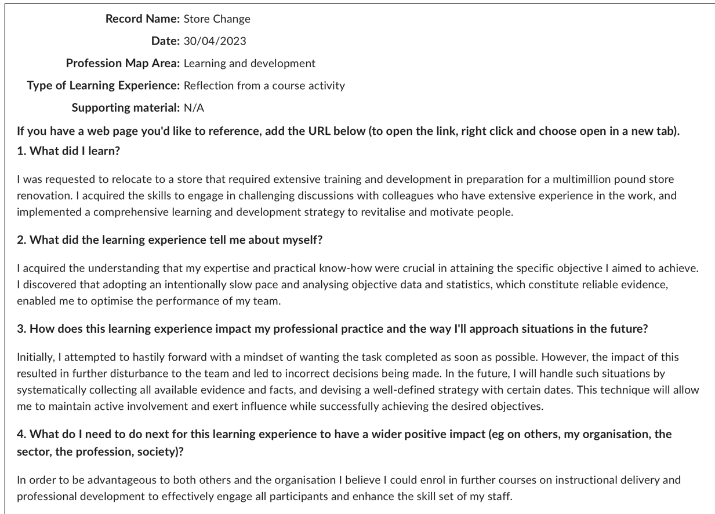
Photo 2 – my personal development plan

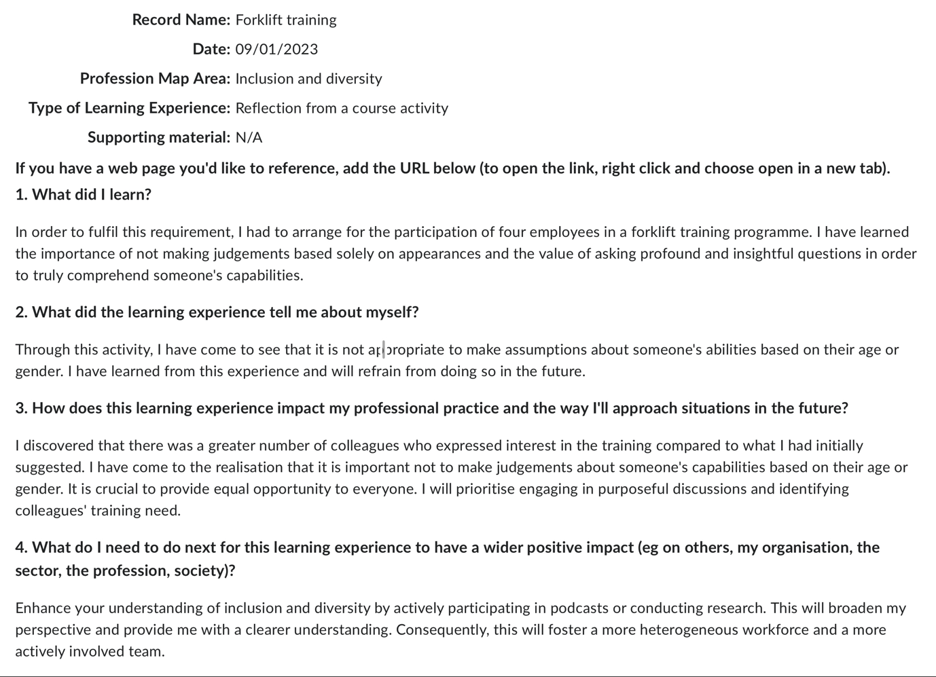
Photo 3 – M personal development plan

Bibliography
CIPD (2022a). CIPD | Equality, Diversity and Inclusion in the Workplace | Factsheets. [online] CIPD. Available at: https://www.cipd.org/uk/knowledge/factsheets/diversity-factsheet/ [Accessed 10 Mar. 2024].
CIPD (2023a). CIPD | Evidence-based HR: Make better decisions and step up your influence. [online] CIPD. Available at: https://www.cipd.org/uk/knowledge/guides/evidence-based-profession/ [Accessed 10 Mar. 2024].
CIPD (2023b). CIPD | Flexible and Hybrid Working Resources. [online] CIPD. Available at: https://www.cipd.org/uk/topics/flexible-hybrid-working/ [Accessed 10 Mar. 2024].
CIPD (2023c). CIPD | Flexible Working Practices | Factsheets. [online] CIPD. Available at: https://www.cipd.org/uk/knowledge/factsheets/flexible-working-factsheet/#title2 [Accessed 10 Mar. 2024].
CIPD (n.d.). CIPD | Reports. [online] CIPD. Available at: https://www.cipd.org/uk/knowledge/reports/ [Accessed 11 Mar. 2024].
CIPD (n.d.). Learn about Technology and People Practices with the CIPD. [online] shop.cipd.org. Available at: https://shop.cipd.org/product?catalog=Technology-and-People-Practice-Essential-Insights [Accessed 11 Mar. 2024].
CIPD (2023d). Professional Courage and Influence. [online] CIPD. Available at: https://www.cipd.org/uk/the-people-profession/the-profession-map/explore-the-profession-map/core-behaviours/professional-courage-influence/ [Accessed 10 Mar. 2024].
CIPD. (2021). CIPD | Technology and the Future of Work | Factsheets. [online] Available at: https://www.cipd.org/uk/knowledge/factsheets/emerging-future-work-factsheet/#how-do-these-technologies-impact-the-people-profession [Accessed 10 Mar. 2024].
CIPD. (2022b). CIPD | Using Technology Responsibly to Manage People. [online] Available at: https://www.cipd.org/uk/knowledge/guides/responsible-technology-use/ [Accessed 10 Mar. 2024].
Mind Tools (2022). Building Good Work Relationships. [online] www.mindtools.com. Available at: https://www.mindtools.com/aorqe4z/building-good-work-relationships [Accessed 10 Mar. 2024].
Mohdzaini, H. (12AD). CIPD | ‘Tech Savvy’ HR Practice. [online] CIPD. Available at: https://www.cipd.org/uk/views-and-insights/thought-leadership/insight/tech-savvy-hr/ [Accessed 10 Mar. 2024].
Peters, R. (2023). CIPD | Employee communication. [online] CIPD. Available at: https://www.cipd.org/uk/knowledge/factsheets/employee-communication/#principles-of-an-effective-employee-communications-strategy [Accessed 10 Mar. 2024].
Unison (2016). UNISON. [online] UNISON National. Available at: https://www.unison.org.uk/get-help/knowledge/discrimination/gender-discrimination/ [Accessed 10 Mar. 2024].

