Advanced Software Development
[ACCA5011]

Name: - Sai Harsha Jangili
Student ID: - 1908692

Table of Contents
The Difference between a Class and an Object 3
Class: - 3
Object: - 3
Difference between Class and an Object: - 3
Data Encapsulation 4
Interfaces 4
Impact of interface in developing a code 4
References 5

The Difference between a Class and an Object

Class: -
A class is a prototype or template of an object which contain variables which stores the required data and function to perform operations, classes are helpful in forming and handling new object. Class is a group that contains similar objects (Anon., n.d.).

Object: -
Object is and user defined and created by the keyword class, the nature of the object is defined by the class, the creation of new objects and managing them are done by the class. Group of similar objects are all contained in same class in the program (Rouse, 2005) (Anon., 2015).

Difference between Class and an Object: -

Class | Object
It is prototype of an object that contains variables in a program. | Object is an occurrence of a class.
Class is a logical existence. | Object is physical existence.
No memory allocation is done during the runtime. | Required memory allocation is done at the time of declaration.
Class declaration is only once in a program | Object can be created as per the requirement.
Class can exist without any objects in it. | Objects can’t exist without a class.
Class doesn’t have any value. | Every object in the class has a value.
Class cannot be deployed | Object can be deployed.
(Anon., n.d.)

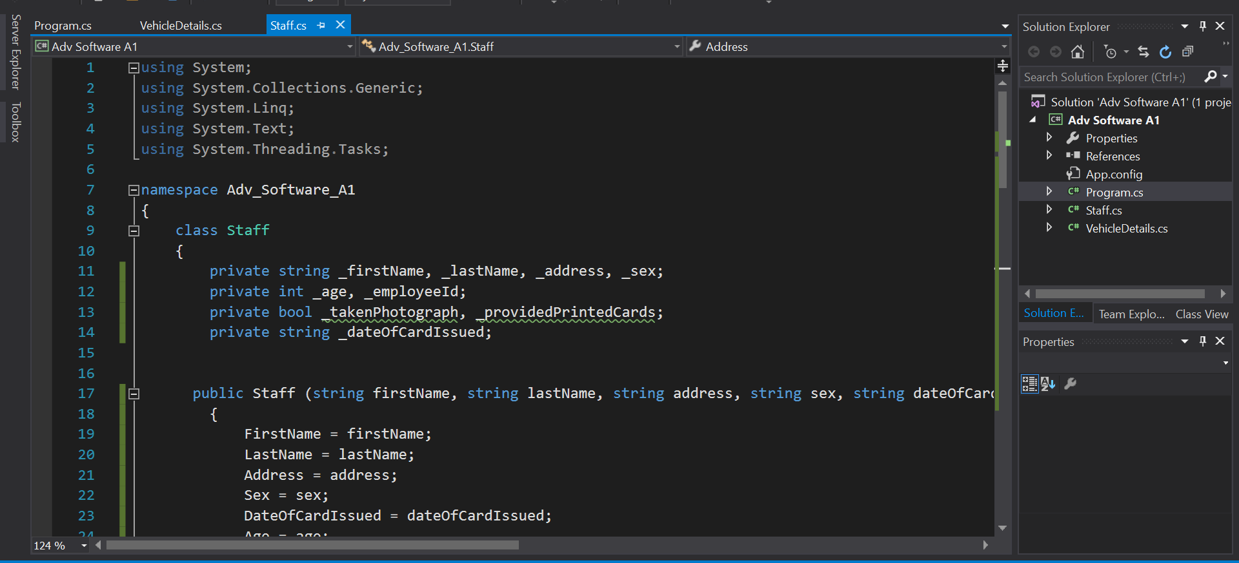
Here in the above image it shows the class in the program. The class is names as staff.

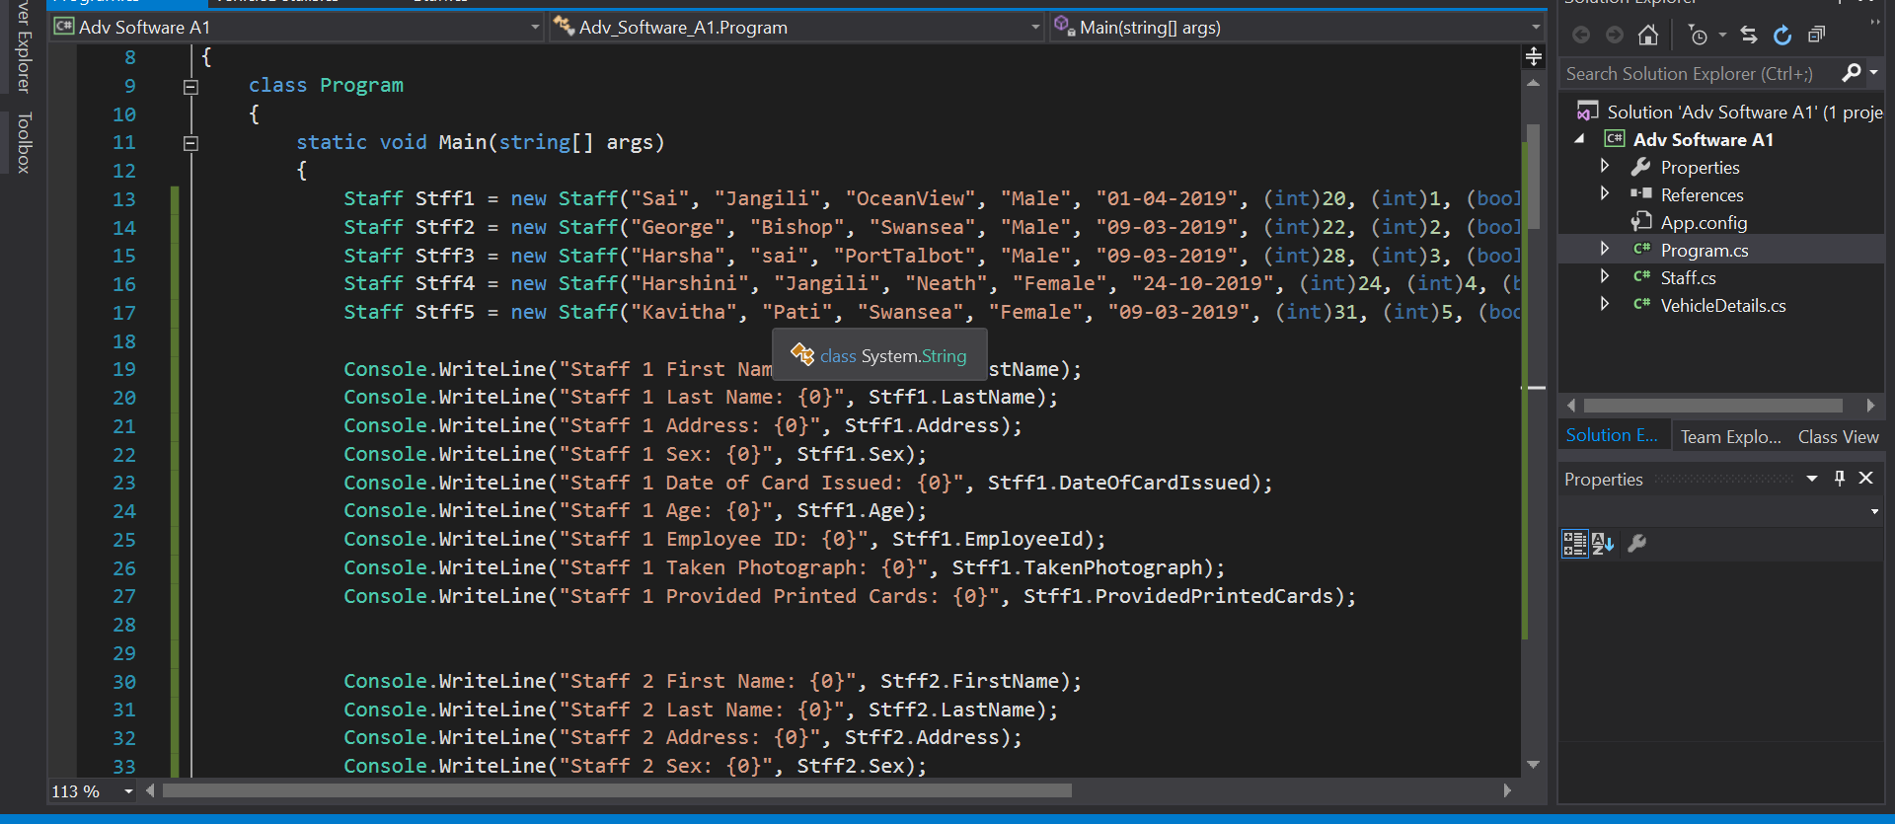
Here for the class Staff the objects are Stff1, Stff2, Stff3, Stff4, Stff5.

Data Encapsulation
The term data encapsulation is a method which is used to keep the details of the class hidden from the user. It restricts the direct access to few objects in the class components form user. It is also known as data hiding. An attribute which is not visible from and object will be bundled with the different types of methods and read and write access will be given to the attribute so that the specific information is hidden so that it can’t be seen by the user. When the information is required by the user it can’t get the access directly to get the data it will need to contact specific attribute to get the data stored in it. The importance of implementing data encapsulation occurs when the class implementation changes but the interface is same, in this case the user should use different methods to get the data from the attribute (craig, 1996) (JANSSEN, 2017) (Agarwal, n.d.).

Interfaces
An interface is like the class in a program but the difference between interface and class is interface clearly explains the behavior and the understanding between the user and an object. Interface is an agreement that a class should fulfill. Interface explains what a class must to and what not to do, it sends the instructions to the class in a program. Multiple inheritance can be occurred with interface but not with class. Interface explains the properties and procedures that should be available in class (Anon., 2017) (Anon., n.d.) (Microsoft, 2018).

Impact of interface in developing a code
Interface provides a true component-based programs, loose link which helps implementation getting easily separated from the interface. Using interface is easy to maintain and allows code to be reused and much more available because execution gets separated easily from the user interface. Using the interface in the code helps the code developers to describe the link between the different elements and interfaces clearly explains the responsibilities and the limitations between various elements (Cochran, 2019) (Berry, 2011)

References
Agarwal, H., n.d. GeeksforGeeks. [Online]
Available at: https://www.geeksforgeeks.org/encapsulation-in-c/
[Accessed 16 FEB 2020].
Anon., 2015. Microsoft. [Online]
Available at: https://docs.microsoft.com/en-us/dotnet/csharp/programming-guide/classes-and-structs/objects
[Accessed 17 FEB 2020].
Anon., 2017. Wiki Books. [Online]
Available at: https://en.wikibooks.org/wiki/C_Sharp_Programming/Interfaces
[Accessed 16 FEB 2020].
Anon., n.d. Java T point. [Online]
Available at: https://www.javatpoint.com/difference-between-object-and-class
[Accessed 16 FEB 2020].
Anon., n.d. TutorialsTeacher. [Online]
Available at: https://www.tutorialsteacher.com/csharp/csharp-interface
[Accessed 16 FEB 2020].
Anon., n.d. What is the Difference between a Classes and an Object?. [Online]
Available at: https://www.w3schools.in/java-questions-answers/difference-between-classes-objects/
[Accessed 16 Feb 2020].
Berry, D., 2011. redgate hub. [Online]
Available at: https://www.red-gate.com/simple-talk/dotnet/net-framework/designing-c-software-with-interfaces/
[Accessed 16 FEB 2020].
Cochran, M., 2019. C# Interface based development. [Online]
Available at: https://www.c-sharpcorner.com/article/C-Sharp-interface-based-development/
[Accessed 16 FEB 2020].
craig, D., 1996. Data Encapsulation. [Online]
Available at: http://www.cs.mun.ca/~donald/bsc/node13.html
[Accessed 17 FEB 2020].
JANSSEN, T., 2017. Stackify. [Online]
Available at: https://stackify.com/oop-concept-for-beginners-what-is-encapsulation/
[Accessed 16 FEB 2020].
Microsoft, 2018. Microsoft. [Online]
Available at: https://docs.microsoft.com/en-us/dotnet/csharp/programming-guide/interfaces/
[Accessed 16 FEB 2020].
Rouse, M., 2005. TechTarget. [Online]
Available at: https://searchapparchitecture.techtarget.com/definition/object
[Accessed 16 FEB 2020].

Appendices



