LCBB4005 The Global Business Environment Assessment 1

Student Name: Sali Refat
Student ID: 2122704

Table of Contents
Introduction 4
SWOT Analysis of General Motors 4
PESTEL Analysis of General Motors: 6
Porter’s Five Forces Analysis of General Motor Corporation: 8
Value Chain Analysis of General Motor Corporation: 11
Sustainable Competitive Advantage: 13
Technological Advancement: 13
Brand Reputation: 13
Positioning: 13
Conclusion: 14
References 15

List of figures:
Figure 1: General Motors Logo 3
Figure 2: PESTEL analysis 5
Figure 3: Porter's five forces analysis 7
List of Tables:
Table 1: Porter's five forces analysis of General Motors 9

Introduction
General Motors was a company formed in 1908. This company has manufacturing and a distribution center in Canada, The United States of America, and several other countries. It also includes designing cars and selling cars, trucks, and automobile parts. General Motors has eclipsed Ford Motor Company as the leading American passenger-car producer by 1929 (Jen, 2022). The following figure represents it:

Figure 1: General Motors Logo
Source: (Gm.com, 2022)
This company always claims that its accountability, transparency, and integrity helped the company establish and develop its image and reputation as a corporate responsibility leader. Using tools such as SWOT and PASTEL analysis, Porter’s five forces, and the value chain model, this report will extensively assess and evaluate both the company’s internal and external factors.

SWOT Analysis of General Motors

Strength:
The strengths of General Motors are given below: -
- Dominance in the marketplace: They have a significant advantage because they are the earth's largest and most prominent automaker.
- Optimal Technique for Selling: More sales equals more revenues and profit margins.
- Cars with the lowest risk of accidents: These strengths help customers set their minds to buy a car.
- Exceptionally creative: General Motors’ innovation is credited to its considerable investments in R&D, which worked to design the automobile added with a combination of the diesel motor. (Martha, 2022).

Weakness:
- Negative Publicity: Some years back, General Motors faced some challenges. It faced negative publicity for cheating on its trucks' level of emissions. That is the reason why they lose public confidence. (Martha, 2022).
- The absence of diversification: This Corporation invested in the same sector.
- Problems with the quality of the product: Inappreciable issues or defects can create big trouble for the customers.

Opportunity:
External elements that may provide a competitive edge to a company are opportunities. The opportunities that General Motors has are below:
- Eco-friendly alternatives should be prioritized: GM needs to start thinking about its carbon footprint and how it can minimize waste and the harm it does to the environment (Loth, 2022).
- Portfolio Diversification: Diversification is possible in many industries, from flexible transportation options like car-sharing to the growing demand for electric bikes (Martha, 2022).

Threat:
The threat of an organization refers to it has the potential to destroy its reputation, venture, image, or product. General Motors have some threats. Those are given below:
- Concerns about trade: Trade issues between more than one country can negatively impact General Motors. Such as complications allying with China and The United States of America.
- Costs of fuel and materials: General Motors Corporation is based basically on vehicles, that are why the price of fuel and cost of materials create affect the most.
- Labor-related issues: GM lost over $2 billion as a result of a massive strike in 2019 that affected 48,000 workers across 34 plants. Strikes will hurt business and long-term sustainability if they become more frequent (Martha, 2022).

PESTEL Analysis of General Motors:
PESTEL analysis is a strategy that evaluates the outward surroundings by using Political, Economic, Social, Technological, Environmental, and Legal elements. The PESTEL analysis of General Motors Company aids in the identification of business concerns and the direction of such attempts for organizational growth. The following figure represents the PESTEL analysis:
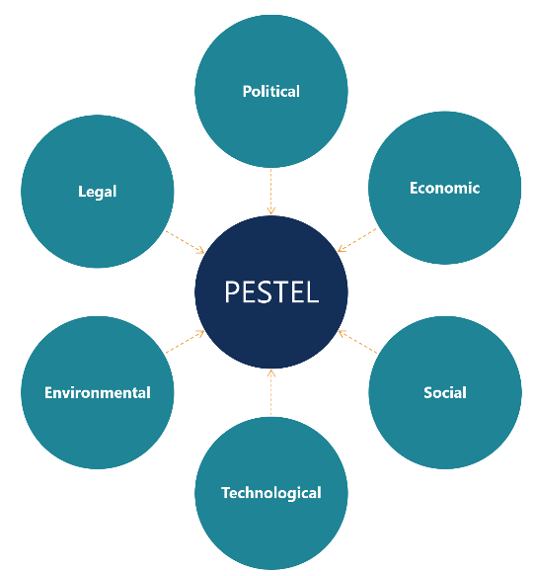
Figure 2: PESTEL analysis
Source: (Corporate Finance Institute, 2022)

Political factors:
The effects of political factors and conditions on General Motors' business performance are listed and included in this PESTEL analysis factor. All political factors are dependent on the Government or antigovernment parties' hand. It also creates a substantial impact on society (Dov, 2022). For political reasons, people are being encouraged to use public transport. People are using buses and trains, which reduces the number of customers of General Motors.

Economic factors:
Depending on the economic condition of the automobile markets, this sector operates. The below economic factors are the external economic factors that play a vital role in this industry-
- The increasing rate of growth of the developing market
- The stability of the center market
- The growing competition in the market (Jalal, 2022)

Social factors:
The automobile industry is influenced by the behavior of the employees and consumers, which is further determined by sociocultural conditions. The bellowed factors have significantly affected the automobile industry-
- The growing call for motorcar with time
- The call for persevering vehicles has also increased
- The growing demand for shared vehicles has increased, which is a threat (Jalal, 2022).

Technological factors:
To develop the competitive structures, they enrolled different technologies in the market as the analysis of PESTEL has explained the effects of technological terms and conditions in the market.

Environmental factors:
General Motors wants to work for contrivance disposal area operations to protect its brand image by indicating environmental responsiveness. That is how GM will reduce greenhouse gas emissions.

Legal factors:
General Motors has not been able to dodge legal issues and legal troubles. According to a 2017 ruling by the US Supreme Court, General Motors cannot dodge lawsuits brought by victims of the Faulty Switches disaster in Detroit, Michigan (Jalal, 2022).

Porter’s Five Forces Analysis of General Motor Corporation:
Because of the aggressiveness of enterprises in the vehicle sector, General Motors faces a high level of competition. Such external factors contribute to a highly competitive competition with GM (Mathur, 2022). Porter's five forces model is a useful analytical tool for determining how such factors, either present in every industry, affect a company's competitive position and overall profitability (Pratap, 2022). The following figure represents the porter’s five forces analysis:
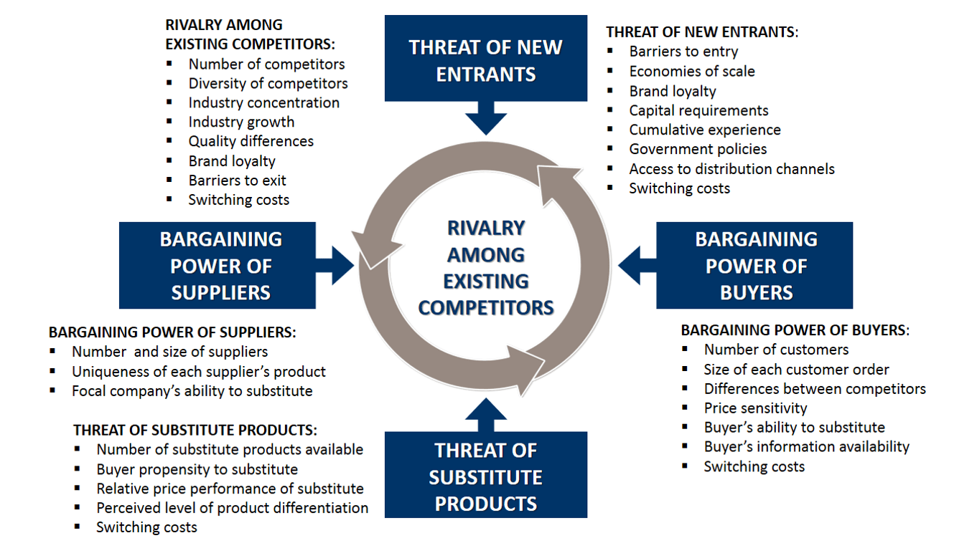
Figure 3: Porter's five forces analysis
Source: (B2U - Business-to-you.com, 2022)
Those are discussed below:
Name of the forces | Forces | Assessment
Industry Rivalry | - Firms with a high level of aggression  - Exit obstructions of a high order  - General Motors must compete with domestic and international automakers to maintain and grow its market share. | Low
The Threat of New Entrants | - An external factor, moderate switching barriers, exerts a moderate force on the GM.  - There is a moderate amount of alternative availability.  - Customers buy only one automobile one time | Moderate
Threat of Substitute | - The threat of substitutes is moderate  - Moderately high switching costs  - Public transportation, bicycles, and other modes of transportation are all viable alternatives to the automobile industry. | Low
Bargaining power of the suppliers | - The vast majority of manufactured goods are sold to end-users.  - General Motors has access to a somewhat large number of suppliers, such as steelmakers.  - The high overall supply is obtainable to General Motors (Pratap, 2022). | Low
Bargaining Power of the  Buyers | - The expanding influence of consumers and shifting demographic patterns are the key contributors to this relatively high level.  - Although switching costs are high in the automobile sector, corporations cannot afford to lose clients (Pratap, 2022). | High
Table 1: Porter's five forces analysis of General Motors
Source: (Self-Made)

Value Chain Analysis of General Motor Corporation:
General Motors relies heavily on Porter's Value Chain Analysis. All activities should not be given equal weight because that would violate the spirit of the organization's stand-alone structure. General Motors must acknowledge that not all activities or functions merit the same level of scrutiny in order to conduct an effective Value Chain Analysis. Adapting Porter's Value Chain framework, the first step is to define activities' importance based on their market value and delivery system (Cruze, 2022).

Primary activities:
General Motors strives to be the most inclusive organization globally because we appreciate the importance of ensuring diversity is accepted, valued and reflected in how we recruit, hire, develop, and promote (Cicillia, 2022). Production, ways to solve problems, and product platforms are the essential tasks that add value to this organization. They mainly design, produce, manufacture, and sell vehicles (Su, 2022).

Inbound Logistics:
Distribute the product. GM should establish a good relationship with the supplier.GM may face various kinds of interruptions for not analyzing the inbound logistic. It will help them follow the stages from raw materials to the final products (Monica, 2022).

Operation:
Operational analysis becomes more important when raw materials arrive and General Motors Company is ready to transform the raw material into a finished product and launch it on the market.

Outbound Logistics:
Delivery to the client via all intermediaries is known as outbound logistics. To uncover new sources of competitive advantage and achieve its long-term growth targets, General Motors might examine and optimize its outbound logistics (Monica, 2022).

Marketing and Sales:
GM will offer those products which are better than their competitors. This will not create value for producing high-quality products without marketing and sales.

Services:
There is a relation between pre-sale and post-sale while upgrading customer loyalty. Today’s modern customer will observe the post-purchase behavior of the seller. So service should be more powerful.

Support Activities:
These support activities help GM utilize its primary activities to enhance its production capability more smoothly, effectively, and efficiently. Overall, support activities are depicted in a vertical column of the primary tasks. All the activities of GM are presented, maintaining the equality in the generic value chain model.

Infrastructure:
Infrastructure refers to how effectively and efficiently GM nourishes its culture, value, tradition, objectives, and goals. GM commends individuals who have worked relentlessly to progress the Build Back Better Plan, particularly the Bipartisan Infrastructure Framework, and urges Congress and the Administration to move through with legislation that would enhance the country significantly (Clington, 2022).

Human Resource Management:
GM is constantly conscious of their employee's growth, personal skills, development, Etc. They always arrange different kinds of training sessions to develop their employee’s skills.

Technology Development:
Research and invention have propelled humanity forward in astonishing ways throughout history, and day by day, it is solving human curiosity and problems.GM keeps developing its technology to cope with the generations and serve the customers and fulfill their demands (Monica, 2022).

Procurement:
The efficacy of GM's procurement strategies is a critical factor in the company's performance. In order to maintain the intended business activities, the corporation has a procurement department that focuses on best practices and initiatives.

Sustainable Competitive Advantage:
GM has been making high-quality autos for more than a century. The vice president of General Motors argues that the corporation can presently break even in a market of less than 10 million people, according to Mark Reuss. General Motors faces multiple problems and must avoid becoming overly reliant on large trucks and SUVs sales. Also, these are popular because of their low-interest rates and lower gas rate. The company establishes a superior and long-term position over its competitors, resulting in a sustainable competitive advantage.

Technological Advancement:
GM has always been committed to providing the most excellent products to their customers by paying close attention to detail and incorporating cutting-edge technology into their vehicles. GM is making some bold efforts in the area of innovation.

Brand Reputation:
General Motors does not have a good reputation. However, management has been focused on resolving some of their issues in order to reclaim a better reputation in their markets.

Positioning:
General Motors' marketing strategy aids the competitive company's positioning in the market and achieving its business goals and objectives.GM analyses 4p of the marketing mix to position their product.

Conclusion:
This report has thoroughly examined the internal and environmental elements that significantly influence General Motors Corporation. By analyzing their total performance utilizing SWOT, PESTEL, Porter's five forces, and the value chain model on a global scale, they may identify their competitive advantages over their primary competitors in the industry. General Motors is one of the major companies in the automobile industry. This report has critically evaluated the challenges of their internal and external business environments. It has maintained its reputation and trustable relation with customers and will be able to attain its objectives and goals.

References
- B2U - Business-to-you.com, 2022. Porter's Five Forces EXPLAINED with EXAMPLES | B2U. [online] B2U - Business-to-you.com. Available at: <https://www.business-to-you.com/porters-five-forces/> [Accessed 17 April 2022].
- Cecilia, T., 2022. Manufacturing as a Competitive Advantage in GM’s Electrification Strategy. [online] Linkedin.com. Available at: <https://www.linkedin.com/pulse/manufacturing-competitive-advantage-gms-strategy-gerald-johnson> [Accessed 16 April 2022].
- Clinton, H., 2022. General Motors Supports Environmental Priorities of Bipartisan Infrastructure Framework and The Build Back Better Plan. [online] media.gm.com. Available at: <https://media.gm.com/media/us/en/gm/news.detail.html/content/Pages/news/us/en/2021/sep/0928-bbb.html> [Accessed 17 April 2022].
- Corporate Finance Institute, 2022. PESTEL Analysis. [online] Corporate Finance Institute. Available at: <https://corporatefinanceinstitute.com/resources/knowledge/strategy/pestel-analysis/> [Accessed 17 April 2022].
- Cruze, C., 2022. Value Chain Analysis of General Motors Company. [online] Essay48. Available at: <https://www.essay48.com/value-chain-analysis/2886-General-Motors-Company-Value-Chain-Analysis> [Accessed 17 April 2022].
- Dov, L., 2022. General Motors PESTEL/PESTLE Analysis & Recommendations - Panmure Institute. [online] Panmore Institute. Available at: <http://panmore.com/general-motors-pestel-pestle-analysis-recommendations> [Accessed 16 April 2022].
- Gm.com, 2022. General Motors: Pushing the Limits of Transportation & Technology. [online] Gm.com. Available at: <https://www.gm.com/> [Accessed 17 April 2022].
- Jalal, S., 2022. General Motors PESTEL/PESTLE Analysis & Recommendations - Panmore Institute. [online] Panmore Institute. Available at: <http://panmore.com/general-motors-pestel-pestle-analysis-recommendations> [Accessed 17 April 2022].
- Jen, W., 2022. Learn More About GM's Vision | General Motors. [online] Gm.com. Available at: <https://www.gm.com/company/about-us> [Accessed 16 April 2022].
- Loth, M., 2022. Eco-Friendly Products - 69 Green Products for a Sustainable Earth. [online] Eco-Friendly Habits. Available at: <https://www.ecofriendlyhabits.com/eco-friendly-products/> [Accessed 16 April 2022].
- Martha, S., 2022. General Motors SWOT Analysis. [online] Business Strategy Hub. Available at: <https://bstrategyhub.com/general-motors-swot-analysis/> [Accessed 16 April 2022].
- Mathur, D., 2022. General Motors Five Forces Analysis (Porter’s) & Recommendations - Panmore Institute. [online] Panmore Institute. Available at: <http://panmore.com/general-motors-five-forces-analysis-porters-recommendations> [Accessed 17 April 2022].
- Monica, K., 2022. Value Chain Analysis Of General Motors Company. [online] Essay48. Available at: <https://www.essay48.com/value-chain-analysis/2886-General-Motors-Company-Value-Chain-Analysis> [Accessed 17 April 2022].
- Pratap, A., 2022. General Motors Five Forces Analysis - notesmatic. [online] notesmatic. Available at: <https://notesmatic.com/general-motors-five-forces-analysis/> [Accessed 17 April 2022].
- Su, W., 2022. Key Activities. [online] General Motors. Available at: <https://lswiams.weebly.com/key-activities.html> [Accessed 16 April 2022].

