
University of Wales Trinity St Davids
Application of Computer Aided Engineering Processes- Piston Study

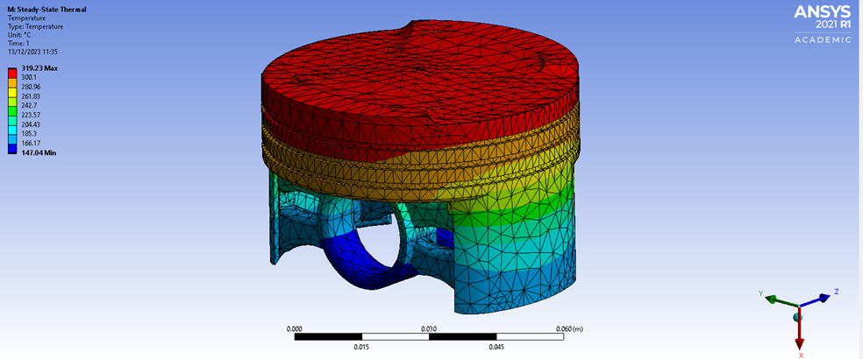

Author: Dylan Huw Davies
Supervisor: Andrew Noble

Student Number: 2100937
Course title: Motorsport Engineering
Date: 16/12/23

Contents
1.0 Introduction 5
2.0 Literature review 6
specifying joints 6
Meshing Process 6
3.0 Validation study 7
3.1 Selecting a Suitable validation Case. 7
Bimetallic strip 7
Elastic bending under continuous load 7
3.2 Identification of Fundamental Principles 7
Kinematic Study 7
Thermal Study 7
Structural Study 7
3.3 Analytical Solution 8
Bimetallic strip Solution 8
Elastic Bending-Continuous Load Solution 8
3.4 Replication in ANSYS 9
Bimetallic Beam ANSYS 9
Elastic Cantilever beam ANSYS 10
3.6 Mesh Independence Study 10
Piston mesh independence study 11
4.0 CAD Modelling & Assembly 14
14
5.0 Kinematic Simulation 15
5.1 Material Properties for Realism 15
Limitations of Boundary conditions 15
5.2 Kinematic Results 15
Significance and realism of motion load data 15
6.0 Thermal study 16
6.1 Thermal study Results 16
7.0 Static structural study 18
7.2 Fully linked system results 18
8.0 Structural Analysis and Optimization 20
8.1 Iterative Design Approach 20
8.2 material choice 21
8.3 Conditions 21
8.3 Piston results 22
Flat crown piston 22
Crown redesign with double arm piston 23
Thin support Piston 24
Dome single arm piston 25
9.0 Conclusion 26
Appendix 27
Kinematic study joints 27
Flat top design 28
Dome piston 28
Mesh Independent study for piston results 30
32
Thin support design with improved crown 32
References 35

Figures

Figure 1 Ansys Results for Bimetallic beam. 9
Figure 2 Ansys Results for Elastic Bending 10
Figure 3 Piston Mesh Independent study final mesh 10
Figure 4 Min deformation vs mesh size for piston 11
Figure 5 Max deformation vs mesh size for piston 11
Figure 7 Piston Skirt mesh study Min Deformation 11
Figure 6 Piston skirt mesh study Max deformation 11
Figure 8 Piston Crown mesh study (Min deformation) 12
Figure 9 Piston crown mesh study Max deformation 12
Figure 10 Original piston geometry 13
Figure 11 Assembly Geometry 13
Figure 12 Motion Forces results from original piston design. 15
Figure 13 Steady State thermal tree 16
Figure 14 Thermal study results from original piston design 16
Figure 15 ANSYS workbench linking system. 17
Figure 16 Fully linked system results 18
Figure 17 fully linked stress results 18
Figure 18 Flat crown piston 19
Figure 19 Double arm and crown redesign 20
Figure 20 Improved crown with thin single arm 20
Figure 21 Dome piston with single arm 21
Figure 22 Flay crown deformation. 22
Figure 23 Flat crown piston stress 22
Figure 24 Crown redesign with double arm piston 23
Figure 25 Crown redesign with double arm piston stress 23
Figure 26 Thin support piston deformation 23
Figure 27 Thin support piston stress 24
Figure 28 Dome single arm piston deformation 24
Figure 29 Dome single arm piston stress 24

Tables
Table 1 Bimetallic strip properties 8
Table 2 Elastic Bending UDL continuous Load 9
Table 3 Thermal Conditions for piston 16
Table 4 Piston weight reduction improvements 22

Equations
$F=ma$ Equation 1 Newtons second Law 7
$q= -K∇T$ Equation 2 Fourier’s Law For conduction 8
$σ=Eε$ Equation 3 Hooke’s Law Stress and strain 8
$ELy d2uzdx2=M$ Equation 6 Elementary equation for beam deflection using Euler-Bernoulli theory. 9
$Iy=wt312$ Equation 7 quadratic moment of a cross-section respect to y axis 9
$uzX= qx2(6L2-4Lx+ x2)24EIy$ Equation 8 Integrate equation 3 and apply boundary conditions for beam. 9
$Uzmax= qL48EIy=3pL42Ew2t=157.143$ Equation 9 Maximum displacement occurs at point x = L 9

1.0 Introduction
Computer-Aided Engineering (CAE) is a pivotal tool in engineering, significantly impacting component design and testing. This assessment focuses on CAE's practical implementation, covering assembly modelling, kinematics analysis, and static structural assessment. The goal is to showcase how CAE enhances structural performance, considering loadings and optimizes component mass. Thermal conditions are incorporated to address challenges in material property degradation realistically. The report emphasizes the importance of validation testing to ensure CAE output accuracy, discussing limitations and mesh sizing's impact on results.

2.0 Validation study
Comparing CAE analyses with fundamental solutions establishes a strong foundation.

2.1 Selecting a Suitable validation Case.

Bimetallic strip
Bimetallic strips are crucial in engineering, exemplifying the distinct interaction of copper and Invar with thermal expansion coefficients. This results in significant deflection due to temperature changes, serving as prototypes for validating thermal analyses and providing insights into material behaviour and thermal expansion principles.

Elastic bending under continuous load
Elastic bending in engineering refers to the deformation of a structural element, such as a beam, within its elastic limit under load. This is crucial to ensure structures withstand loads without permanent deformation. It involves applying Euler-Bernoulli beam theory equations, governing the relationship between loads, bending moments, and deflections.

2.2 Identification of Fundamental Principles

Kinematic Study
The kinematic study delves into component motion within an assembly, relying on classical mechanics principles, particularly Newton's second law.
Equation: The basic equation governing motion is
$F=ma$ Equation 1 Newtons second Law
In ANSYS, these principles translate into the software's dynamics solver, solving for displacements, velocities, and accelerations under various loading conditions.

Thermal Study
Thermal studies are rooted in heat transfer principles, governed by equations like Fourier's Law for conduction.
Fourier's Law for conduction is represented by,
$q= -K∇T$ Equation 2 Fourier’s Law For conduction
ANSYS uses these equations in its thermal solver to predict temperature distributions and heat transfer within components.

Structural Study
Structural studies involve principles of structural mechanics, incorporating equations for stress and strain, deformation, and material properties. Hooke's Law-
$σ=Eε$ Equation 3 Hooke’s Law Stress and strain
expresses the linear relationship between stress ( $σ$ ), Young's modulus ( E ), and strain ( $ε$ ). ANSYS leverages these equations in its structural solver to predict deformations, stresses, and strains in response to applied loads.
ANSYS employs numerical methods for each study, enabling engineers to comprehensively simulate and analyse real-world scenarios. The integration of these principles within ANSYS creates a robust and accurate simulation environment for kinematics, thermal, and structural analyses.

2.3 Analytical Solution

Bimetallic strip Solution
The properties of Invar and copper can be seen in table 1.
Material | Invar | Modulus of  elasticity | Ei | 137000 | Mpa
 |  | Poisson’s Ratio | Vi | 0.28 | -
 |  | Coefficient of  thermal Expansion | αi | 1.20E-06 | 𝐶^(−1)
 | Copper | Modulus of  elasticity | Ec | 130000 | Mpa
 |  | Poisson’s Ratio | Vc | 0.354 | -
 |  | Coefficient of  thermal Expansion | αc | 2.00E-05 | 𝐶^(−1)
Geometry |  | Cross-section | w | 5 | mm
 |  | Layer thickness | ti=tc=t | 1 | mm
 |  | Length | L | 100 | mm
Load |  | Thermal loading | Tc | 1000 | c
Table 1 Bimetallic strip properties
$K_{1}=4+6\frac{t_{c}}{t_{i}}+4{(\frac{t_{c}}{t_{i}})}^{2}+\frac{E_{c}}{E_{i}}{(\frac{t_{c}}{t_{i}})}^{3}\frac{E_{i{ t}_{i}}}{E_{c} t_{c}}$ Equation 4 dimensionless coefficient k1
Equation 4 defines the dimensionless coefficient ( K1) for a bimetallic strip. considering parameters like copper layer thickness (tc), Invar layer thickness (ti), modulus of elasticity for copper (Ec), and modulus of elasticity for Invar (Ei). It comprehensively captures their influence on the strip's behaviour.

$U_{z,max}= \frac{6(α_{i}-α_{c})(t_{i}+t_{c})T_{c}}{t_{s}^{2}K_{1}} \frac{L^{2}}{2}$ Equation 5 Maximum deflection of bimetallic strip
Equation 5 determines the maximum deflection (Uzmax) of a bimetallic strip, considering coefficients of thermal expansion for Invar (α_i) and copper (α_c), thickness of Invar and copper (t_i and t_c), temperature difference (ΔT), strip length (L), and the dimensionless coefficient (K1) from Equation 4. This equation characterizes the strip's deformation under temperature variations.

Elastic Bending-Continuous Load Solution
Properties of the Elastic Bening study can be found in table 2.

Material | Elastic-Plastic | Modulus of  elasticity | Ei | 210000 | Mpa
 |  | Poisson’s Ratio | Vi | 0 | -
 |  | Shear Modulus | G | 1.05E+05 | Mpa
Geometry | Plate | Width | w | 0.05 | m
 |  | Thickness | t | 0.005 | m
 |  | Length | L | 1 | m
Load | Plate | Pressure | P | 2750 | pa
Table 2 Elastic Bending UDL continuous Load
${EL}_{y} \frac{d^{2}u_{z}}{{dx}^{2}}=M$ Equation 6 Elementary equation for beam deflection using Euler-Bernoulli theory.
Equation 6 defines the elementary beam deflection using Euler-Bernoulli theory, where (EL_y) is Young's modulus, (uz) is the deflection divided by the position along the beam (x), and (M) is the applied moment, describing the curvature-beam moment relationship.
$I_{y}=\frac{{wt}^{3}}{12}$ Equation 7 quadratic moment of a cross-section respect to y axis
Equation 7 provides the quadratic moment of a cross-section concerning the y-axis, where (I_y) is the moment of inertia, (w) is the width, (t) is the thickness, and it quantifies material distribution around the y-axis.
$u_{z}\left(X\right)= \frac{{qx}^{2}(6L^{2}-4Lx+ x^{2})}{24EI_{y}}$ Equation 8 Integrate equation 3 and apply boundary conditions for beam.
Equation 8 expresses beam deflection (uz) as a function of position (x), obtained by integrating Equation 6 and applying boundary conditions. It involves parameters like distributed load (q), beam length (L), modulus of elasticity (E), and moment of inertia (I_y).
$U_{zmax}= \frac{qL^{4}}{8EI_{y}}=\frac{3pL^{4}}{2Ew^{2}t}=157.143$ Equation 9 Maximum displacement occurs at point x = L
Equation 9 calculates the maximum displacement (U_zmax) of the beam at (x = L), considering parameters such as applied load (q or p), beam length (L), modulus of elasticity (E), width (w), and thickness (t).

2.4 Replication in ANSYS

Bimetallic Beam ANSYS
In Ansys, a static structural analysis is established with an initial mesh size of 2.5e-4. Fixed supports are applied to both beams, and a thermal condition of 122°C is assigned to both bodies. This temperature is chosen to account for the initial environment temperature starting at 22°C.
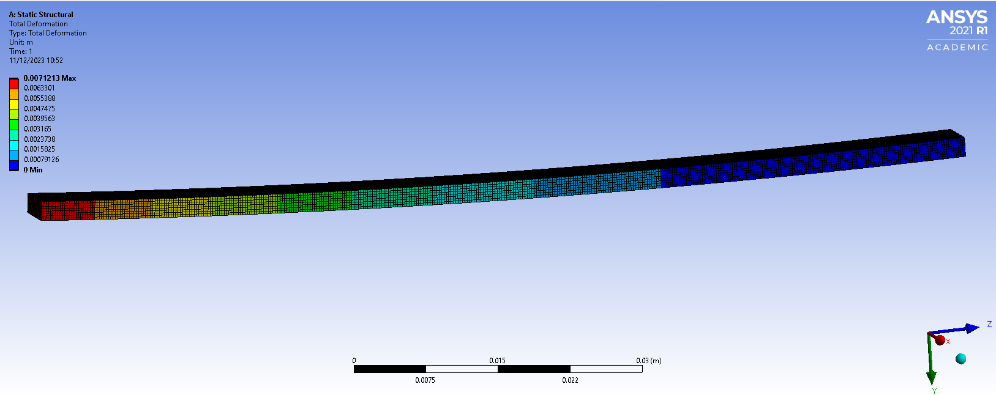
Figure 1 Ansys Results for Bimetallic beam.

The Bimetallic beam experiences a max deflection of 0.0071213 m, which achieves a 1.028% of error compared to the analytical answer.

Elastic Cantilever beam ANSYS
Similar procedures are applied with mesh sizes matching those of the bimetallic beam. A fixed support is incorporated, and a continuous pressure of 2750 Pa is applied to the top surfaces. The solution reveals the total deformation, providing critical insights.
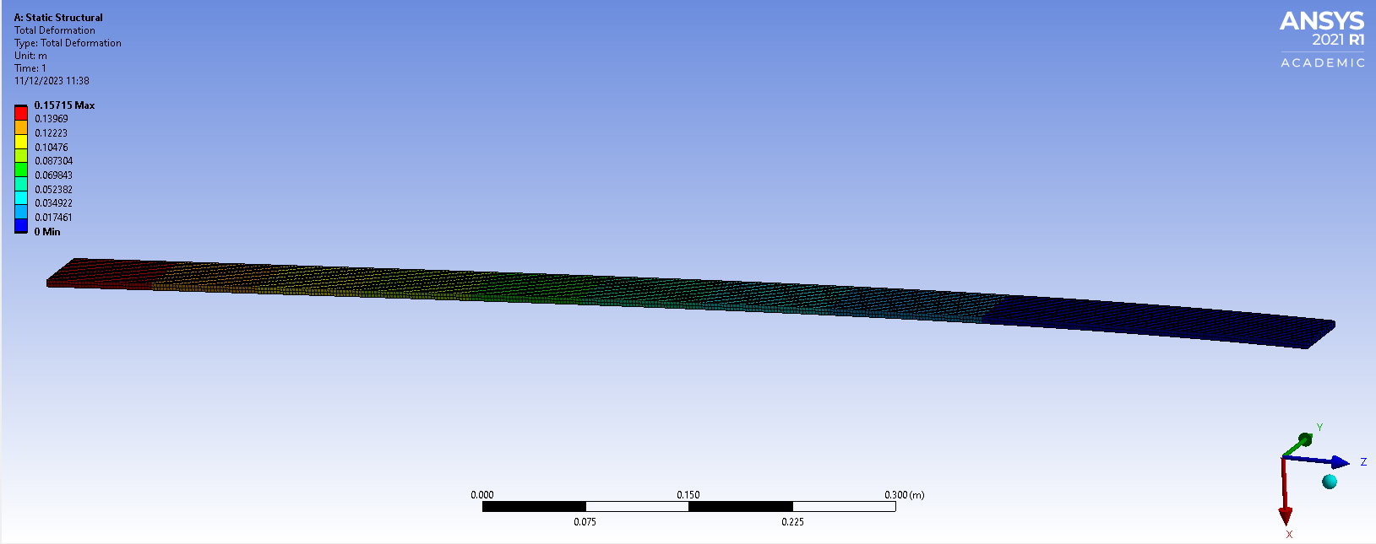
Figure 2 Ansys Results for Elastic Bending
The Elastic bending case experiences a max deformation of 0.15715 which is a 0.004455% of error compared to the analytical answer.

2.6 Mesh Independence Study
Systematically adjusting mesh density and observing convergence helps find the optimal balance between precision. This study enhances confidence in numerical analysis reliability.
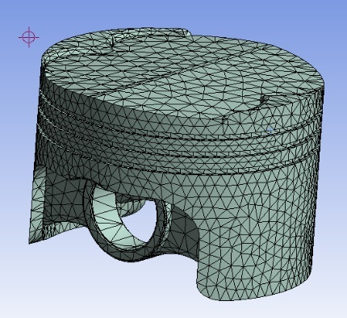
A mesh independence study is conducted on the piston due to its complex geometry, compared to the bimetallic strip and beam. This focused study on the piston yields valuable data applicable for subsequent analyses.
Figure 3 Piston Mesh Independent study final mesh
Meshing divides geometry into elements and nodes, representing stiffness and mass distribution. Default element sizes consider model factors, adjusting mesh fineness for success (Arora, Bhushan, Arora, Aggarwal, 2011).
The piston mesh was divided into three sections—skirt, piston crown, and the remaining piston—using ANSYS mesh sizing tools. This segmentation enhances accuracy in results and analysis. Initially, a mesh independence study was performed on the standard mesh.

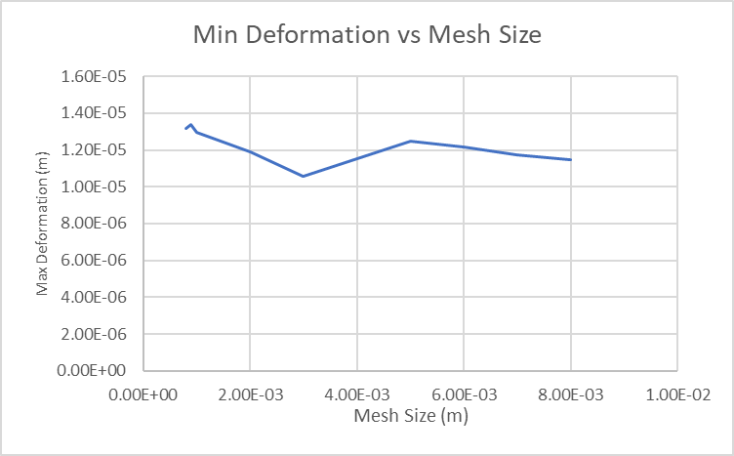
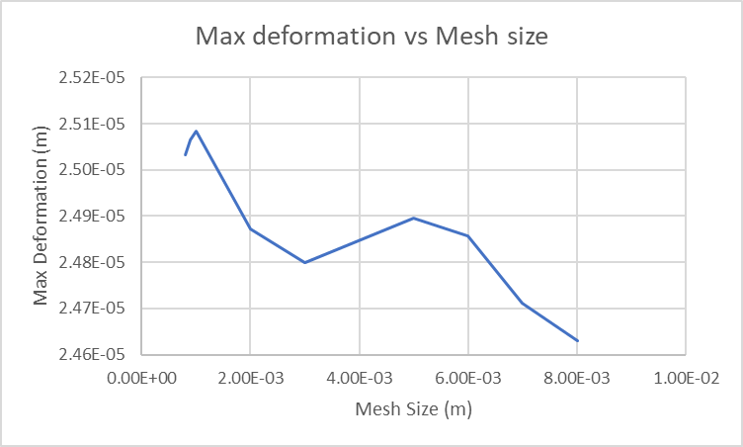
A mesh size can be found at 3e-3 to 4e-3m where the results are very similar from figure 4. It is more easily seen from the Min deformation graph Figure 5
Figure 4 Min deformation vs mesh size for piston
Figure 5 Max deformation vs mesh size for piston
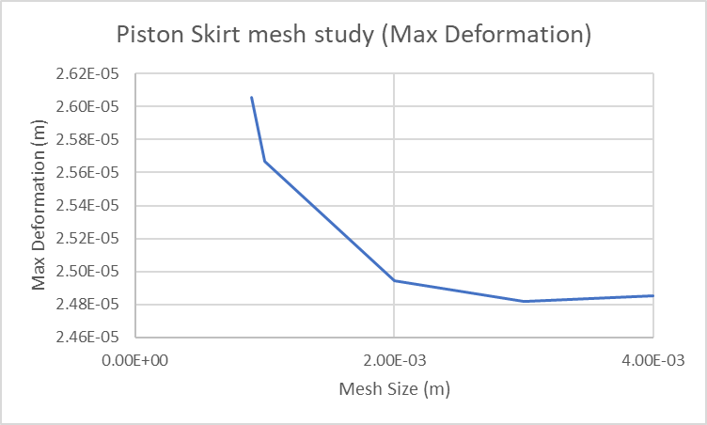
Now doing a mesh independent study on the skirts.
Figure 6 Piston skirt mesh study Max deformation
A mesh size that doesn’t significantly affect the results can be seen to be 3e-3 from figure 6 and 7, which is then applied to the skirts for the next study.

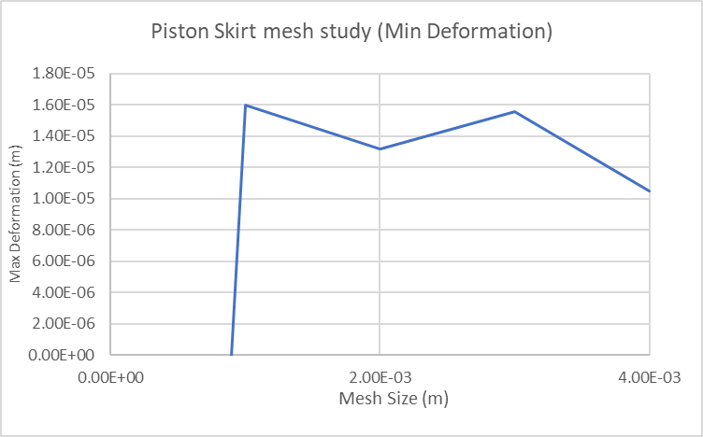
Figure 7 Piston Skirt mesh study Min Deformation

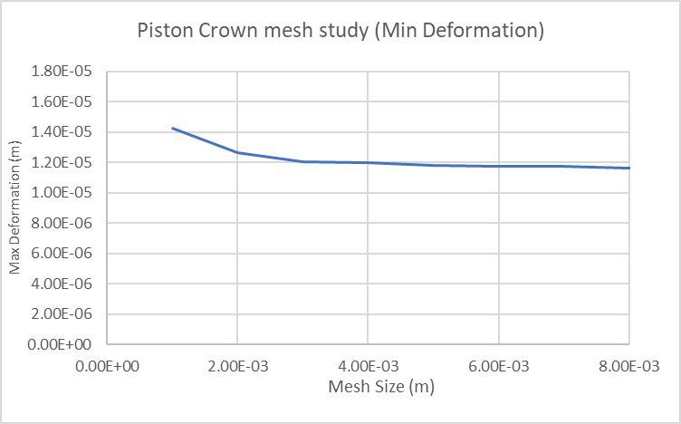
A mesh independent study is then done on the piston crown.
Figure 8 Piston Crown mesh study (Min deformation)

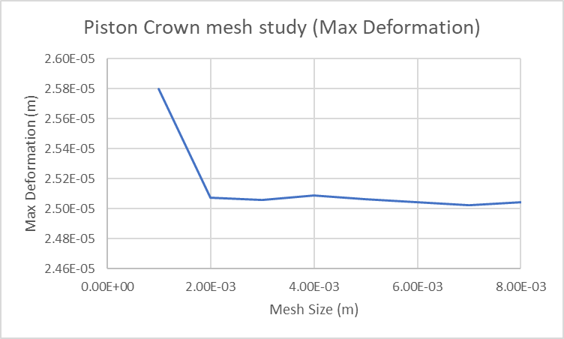
A mesh size that is independent from deformation change can be seen to be 4e-3 t0 5e-3m from figure 8 and 9.
Figure 9 Piston crown mesh study Max deformation

3.0 CAD Modelling & Assembly
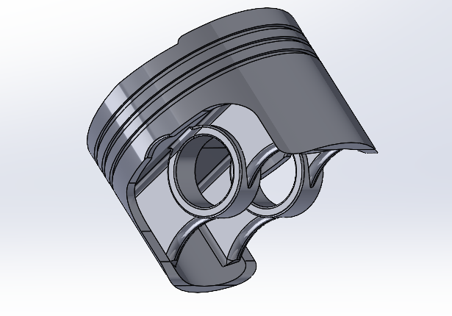
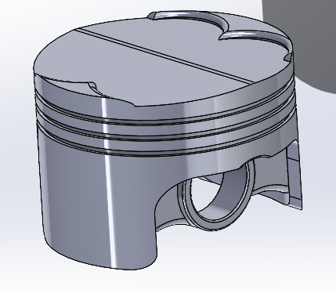
The starting point for the piston geometry can be seen in figure 3, which will later be improved to reduce weight.
Figure 10 Original piston geometry
The whole assembly can be seen in figure 4.
Figure 11 Assembly Geometry
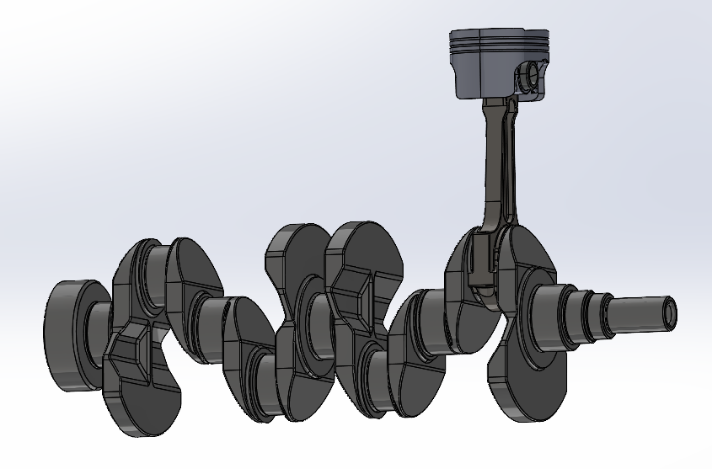

4.0 Kinematic Simulation
Prior to structural analysis, a kinematic simulation is crucial for understanding the dynamic behaviour of the piston system, providing essential force data for subsequent analyses. A rotational velocity of 4000rpm is applied to the crankshaft body-to-ground joint.
Joints categorize body movement based on rotational and translational degrees of freedom, determining fixed or free motion (Arora, Bhushan, Arora, Aggarwal, 2011).
A revolute joint is employed to connect the pin to the piston, mirroring the connection between the pin and the connecting rod, as well as the connecting rod to the crank. Subsequently, a body-to-ground joint is applied to the crankshaft, permitting free rotation in the z-axis. Similarly, a body-to-ground joint is implemented for the piston, securing it in each axis except the vertical (z), enabling vertical movement.
Boundary conditions, involving forces, pressure, velocity, supports, and constraints, are crucial for a thorough analysis, fundamental in understanding and studying the system (Kumar, Aggarwal, 2015).

4.1 Material Properties for Realism
The piston will be made from 6061 alloy which is taken from granta and the rest of the assembly is made from structural steel.

Limitations of Boundary conditions
Assuming perfect rotation for the piston pin oversimplifies real-world factors like wear, thermal expansion, and clearance. These unconsidered elements can impact the piston's overall performance and lead to discrepancies between simulation and real-world behaviour. In kinematic simulations, simplifications, such as applying a body-to-ground rotational joint to the crankshaft, neglect deformations and flexibility under heavy loads. Similar oversimplifications in body-to-body rotational joints for the connecting rod, gudgeon pin, and piston-pin connections may lead to inaccuracies, particularly in dynamic conditions, affecting predictive simulation accuracy.

4.2 Kinematic Results
Figure 5 shows that the piston experiences 2280.3N of overall forces (purple line).
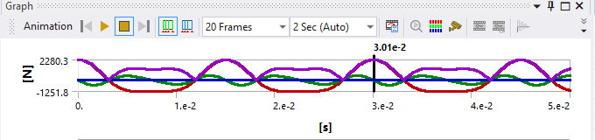
This motion load data is then exported at its peak to be used in the linked system .
Figure 12 Motion Forces results from original piston design.

Significance and realism of motion load data
Kinematic analyses often oversimplify by neglecting dynamic effects such as inertia, external forces, and important sources of resistance like friction. Key factors like heat generation, fluid dynamics interactions, manufacturing tolerances, and non-linear material responses are commonly excluded. To attain more accurate results, dynamic analyses, such as simulations or finite element analyses, are necessary to capture the complexities of real-world piston behaviour.

5.0 Thermal study
Thermal condition must be applied accurately to make sure conditions are realistic. The thermal conditions for the piston as seen in table 3 and are applied by a convection condition. Before this can happen, a mesh size must be determined and use. A mesh of 0.04 was used that was determined form the independent mesh study.
Column1 | Average heat  transfer coefficient | Temperature (Celsius)
Crown | 497.5 | 928.5
Crown side | 447.5 | 425
Top groove | 437.5 | 190
Middle Groove | 437.7 | 190
Oil Groove | 338.75 | 163.75
Underside | 676 | 91.25
Skirt | 462.5 | 107.5

Table 3 Thermal Conditions for piston
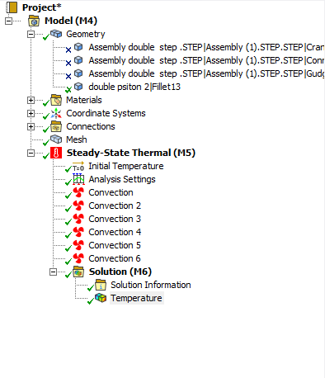
The convection conditions are added and can be seen in figure13 underneath steady state thermal. This condition must be applied accurately as a small chance can dramatically affect results.
Figure 13 Steady State thermal tree

5.1 Thermal study Results
Applying precise thermal conditions to a piston is crucial for engineering and design, This study lacks precise thermal stress analysis, essential to prevent thermal-induced failures like fatigue and cracking.
Incorporating proper cooling channels helps manage excessive heat.
However, the current thermal modelling lacks 100% accuracy by not considering different thermal conditions under varying scenarios. This limitation hinders a comprehensive understanding of potential failure points. To enhance reliability, thermal conditions should simulate various real-world scenarios, enabling informed decisions based on realistic performance expectations.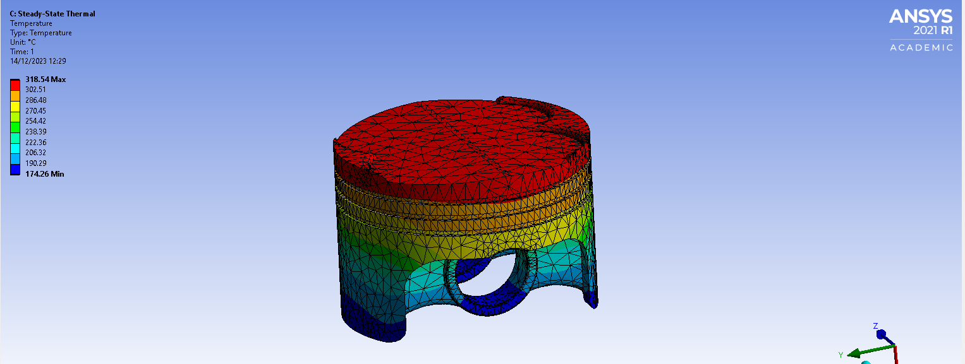
Figure 14 Thermal study results from original piston design
The piston crown experiences high temperatures from direct exposure to combustion gases. The top ring and ring grooves, vital for sealing the combustion chamber, also encounter elevated temperatures. The piston skirt, while less directly exposed, experiences heat through conduction from the crown and other heated components. Additionally, the pin undergoes increased temperatures due to conduction.

6.0 Static structural study
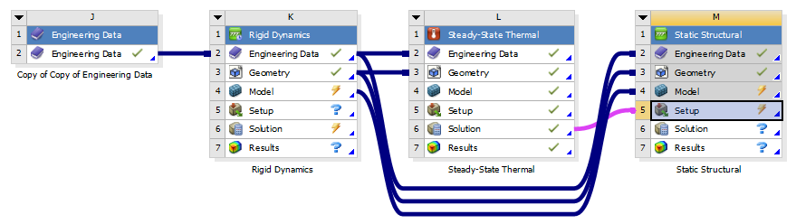
Next a fully linked system is completed by bring in a static structural, steady state thermal and kinematic study. The process to do this in ANSYS can be seen in figure 15 and how each system links into each other.
Figure 15 ANSYS workbench linking system.
A static structural focuses on loads that don't cause substantial inertia and damping effects. The analysis assumes steady loading and response conditions, meaning that both the applied loads and the structure's response are considered to change slowly over time. (Arora, Bhushan, Arora, Aggarwal, 2011).
A pressure of 1.5e7 is applied to the piston crown (Performance under pressure, 2021) utilizing the mesh size determined in section 3.6 for accurate results. A fixed connection is applied to the pin holes to prevent the piston from moving away.

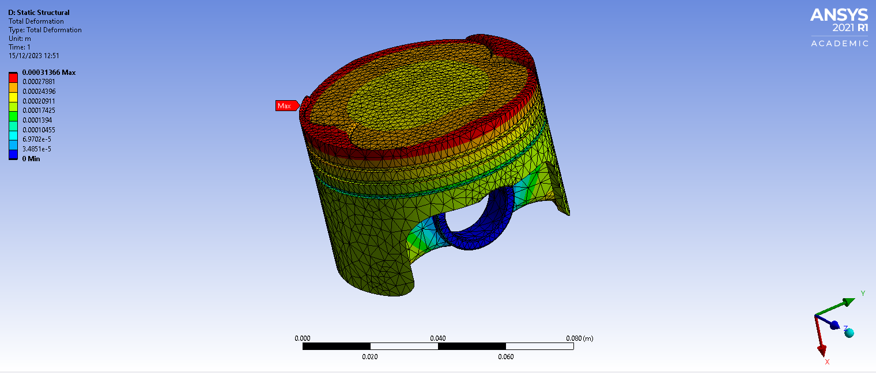
6.1 Fully linked system results

Figure 16 Fully linked system results
The piston experiences a max deformation on the edges of the piston crown of 0.00031366m, with the skirts only experiencing the minimum about of deformation. The arches underneath also experience small amounts of deformation which can lead to weight reduction in them areas. The crown of the piston can be redesigned to reduced deformation as well.
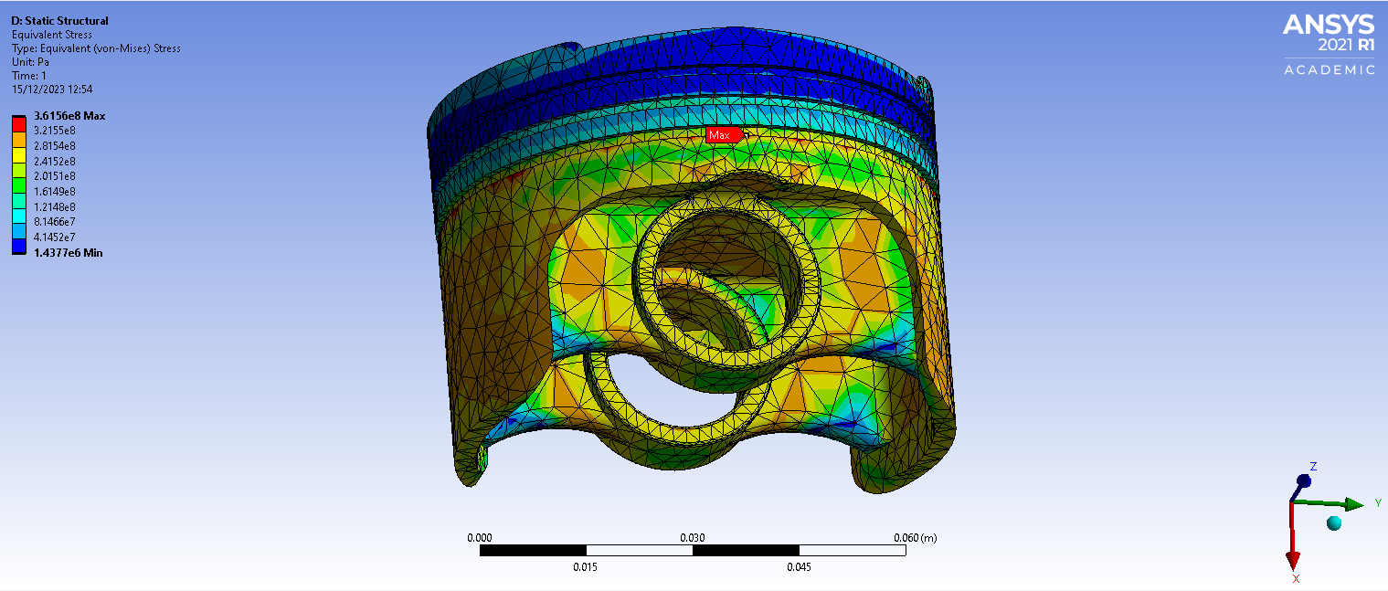
Figure 17 fully linked stress results
The piston experiences max stress at the oil grove and lowest stress at the piston crown and in the arches underneath the piston. The oil grove is a fixed geometry requirement so can’t be change.

7.0 Structural Analysis and Optimization
Results from section 6 enable an improved piston design with weight reduction, strategically enhancing engine performance. A lighter piston offers benefits like improved responsiveness, smoother operation, increased comfort, and enhanced fuel efficiency. Lower stress on critical components increases reliability and longevity, while higher RPM capability is advantageous for high-performance engines

7.1 Iterative Design Approach
The following figures shows the iterative design approach from analysis results from section 6.

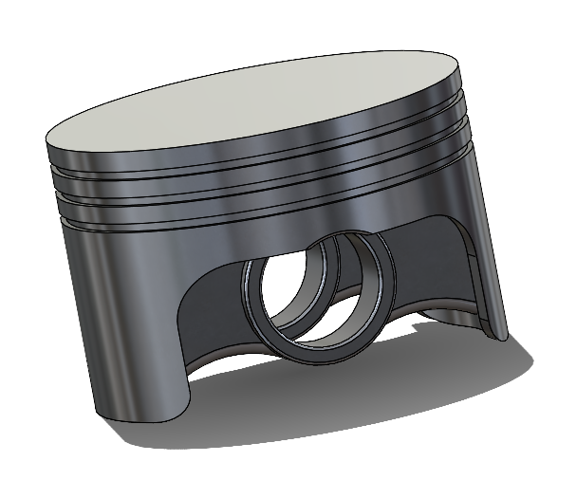

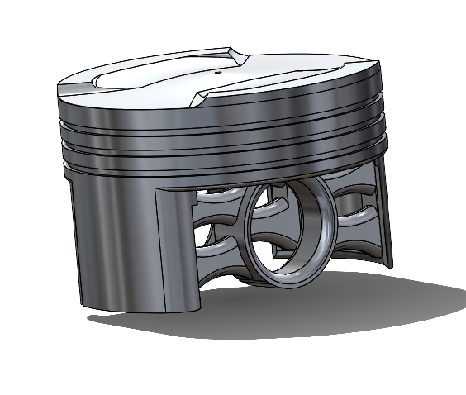
Figure 18 Flat crown piston
Figure 19 Double arm and crown redesign

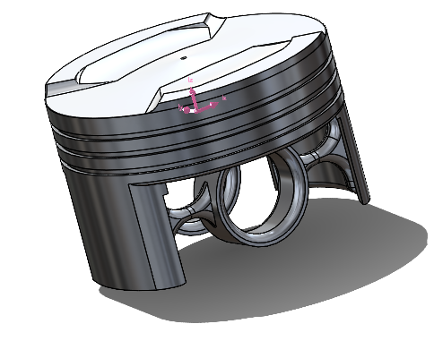
Figure 20 Improved crown with thin single arm
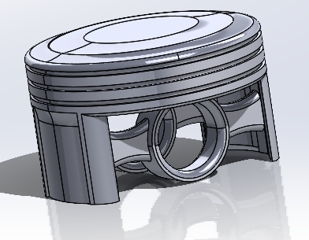
Figure 21 Dome piston with single arm

7.2 material choice
Setting up a study involves crucial material selection. ANSYS offers materials with set values, but for greater accuracy, Granta is recommended, allowing properties like Young's modulus to be graphically plotted for precise choices. However, material choice impacts setup; ANSYS materials allow a weak spring setup, while Granta materials require a fixed support, introducing some unrealistic scenarios.

7.3 Conditions
When working with Aluminium 6061 in Granta, adding a fixed support to the piston is essential to prevent movement and ensure simulation completion. However, this creates an unrealistic scenario as the fixed position at the pin hole does not undergo deformation under a load.
Incorporating a body-to-ground general joint in the transient section for the piston allows the pin hole to experience deformation. Nevertheless, the extent of deformation at this specific pin is minimal, and its impact on the overall system is negligible. This is why, in both cases, a fixed support is preferred despite its limitations in accurately representing the pin hole's deformation under load.

7.3 Piston results
Table 4 summarizes the mass reduction in each piston design, showcasing its impact on deformation and stress.
Table 4 Piston weight reduction improvements
Looking at each case will give a better understanding of each improvement and why it was done and how the outcome was designed.

Flat crown piston
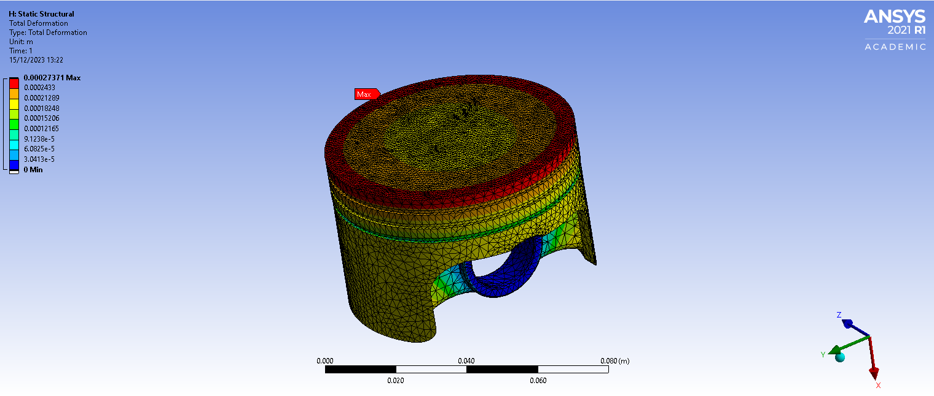
A simple design was to flatten the piston crown to see the affects it caused.
Figure 22 Flay crown deformation.
The deformation pattern on top of the piston is nearly identical to the original design however, the flat crown allows for an evenly distributed load and simplifies the stress pattern which can be seen in figure 22.

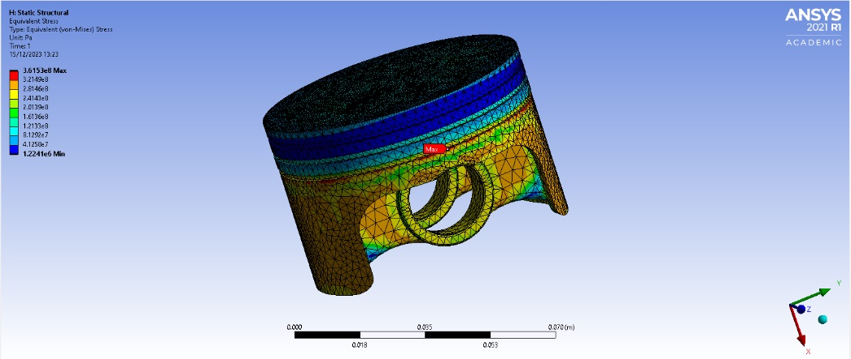
Figure 23 Flat crown piston stress
The uniform distribution is in averting concentrated stress areas that may result in deformation. This study underscores the potential for further refinement in the crown design to mitigate corner deformation. Additionally, material reduction around the pin hole appears feasible, given the observed minimal deformation.

Crown redesign with double arm piston
This design achieves weight reduction through a dual-arm structure around the pin hole and a shorter skirt length. The piston crown incorporates a modest dome in the centre for uniform force distribution, enhancing structural integrity and stiffness.
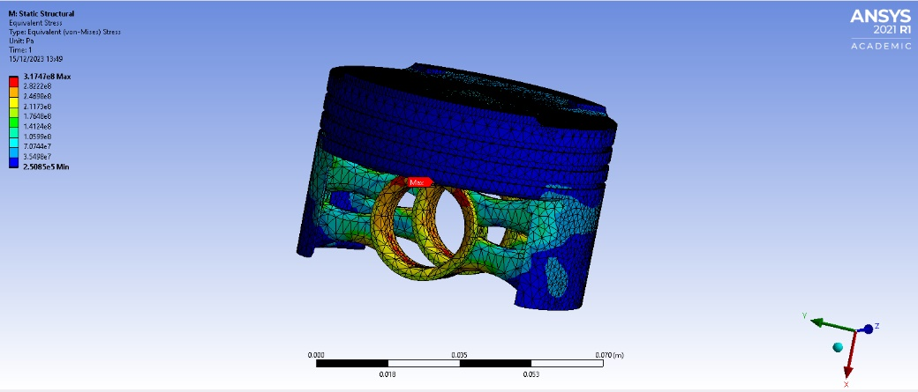
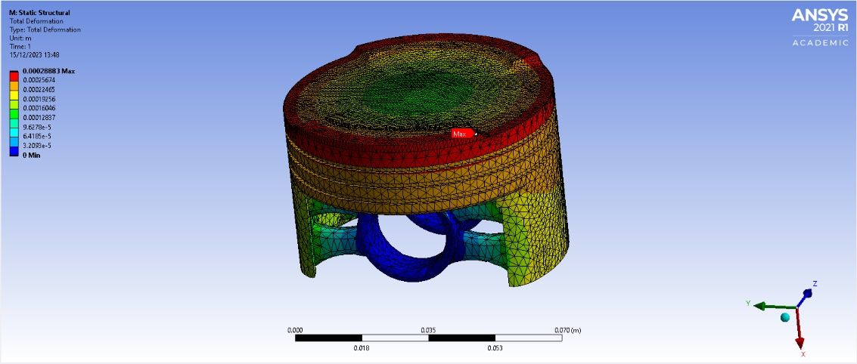
The small dome also contributes to temperature distribution, as evidenced in Table 4 results. Despite the double-arm design demonstrating minimal stress and deformation, enabling further weight reduction, the pin hole now encounters maximum stress. It is imperative to redesign the arm for even stress distribution, striking a balance between weight reduction and structural integrity. Nevertheless, the crown's corners exhibit increased deformation compared to the flat crown design.
Figure 25 Crown redesign with double arm piston stress
Figure 24 Crown redesign with double arm piston

Thin support Piston
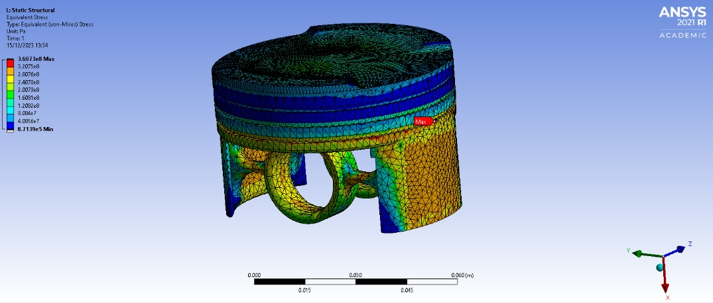
More weight reduction was done around the pin hole with a more curved underneath design to stop localized stress points.
Figure 26 Thin support piston deformation
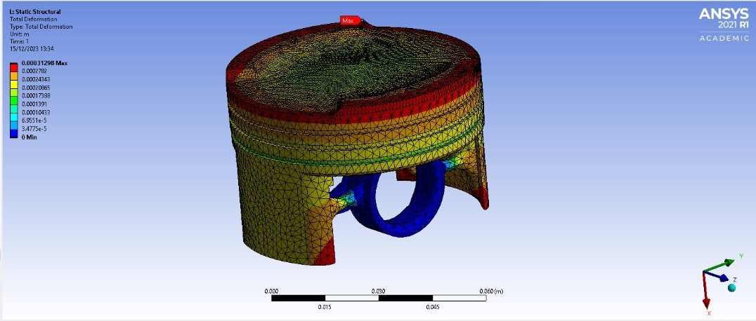
This design currently faces excessive deformation at the skirt corners, with the weight reduction in the central position leading to heightened deformation on the crown's rim compared to other configurations. Figure 27 illustrates a notable reduction in stress at the pin hole; however, this improvement has had adverse repercussions on other aspects of the design.

Figure 27 Thin support piston stress

Dome single arm piston
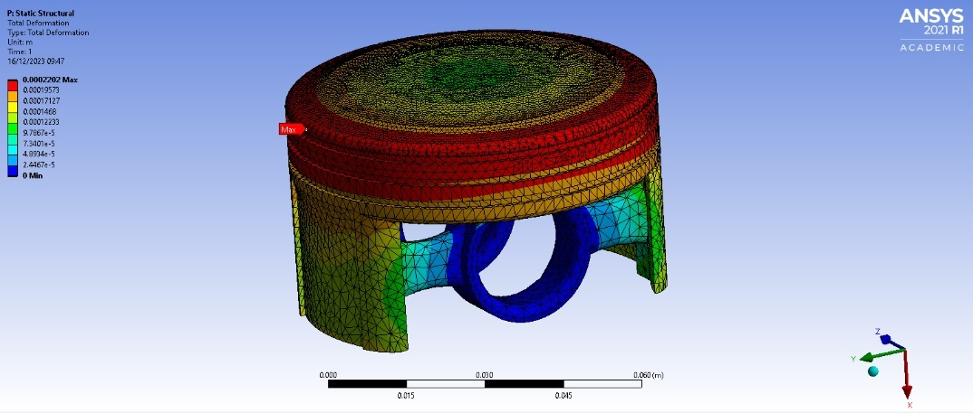
A final design is made by unitizing all the best parts of each piston design so far and by reducing more weight in areas that experiences low stress and deformation.
Figure 28 Dome single arm piston deformation
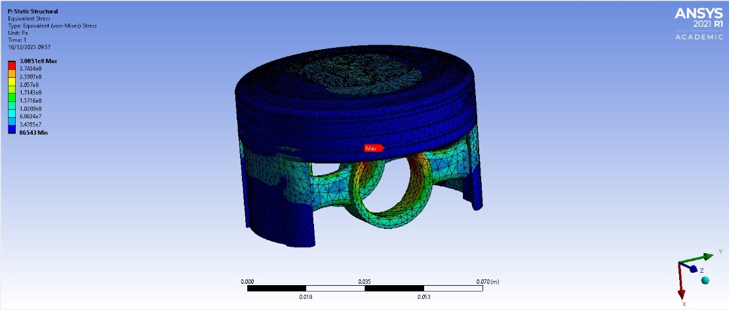
A dome crown on a piston minimizes deformation and stress by distributing forces more evenly, enhancing structural integrity, and promoting efficient heat dissipation during combustion.
Figure 29 Dome single arm piston stress

Reducing skirt weight and reinforcing the piston arm create a dual impact. Skirt weight reduction optimizes overall mass, boosting performance and efficiency. Simultaneously, the thicker arm enhances structural integrity, resisting stress and preventing deformation under varying loads.

8.0 Conclusion
CAE is vital for modern engineering design, enhancing efficiency and precision in optimizing structural performance. Despite its benefits, acknowledging limitations like assumptions is crucial for real-world validation. The presented case study demonstrates CAE's practical application in addressing structural considerations and material property degradation challenges.
As engineering design advances, it's crucial to refine CAE methodologies to align better with real-world scenarios. The importance of accurate boundary conditions and joints cannot be overstated, as they significantly impact results and may not fully represent certain real-world situations. Validation testing remains essential for ensuring the reliability of CAE outputs in addressing structural considerations and material property challenges.

Appendix

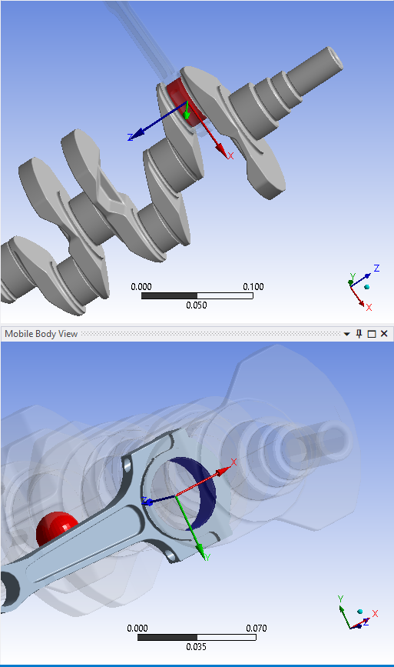
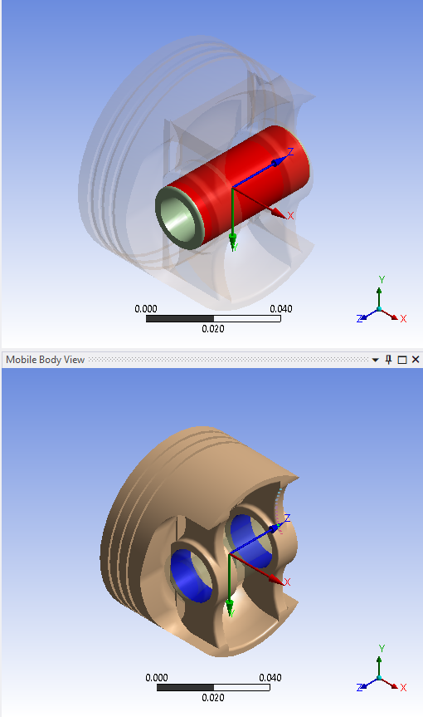
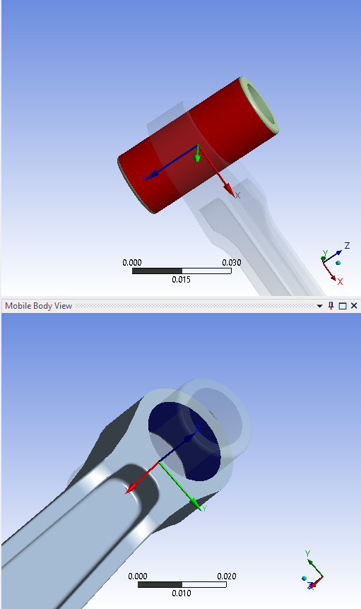
Kinematic study joints

Flat top design

Dome piston

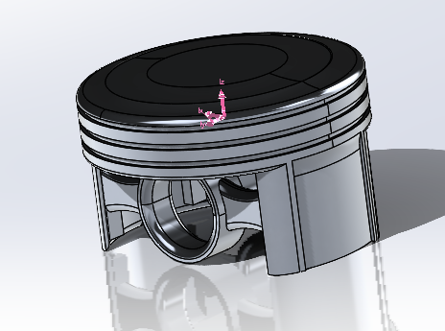

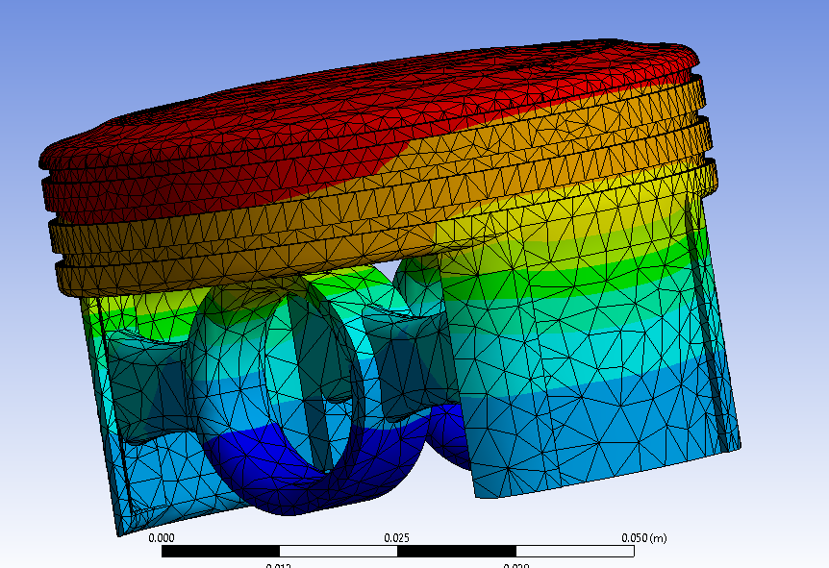
temperature

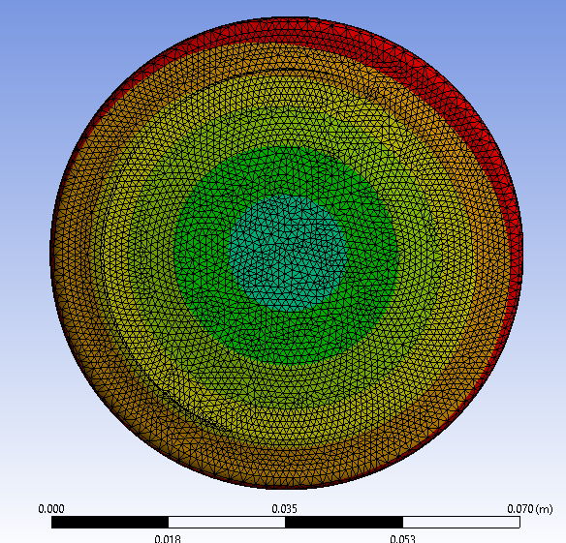

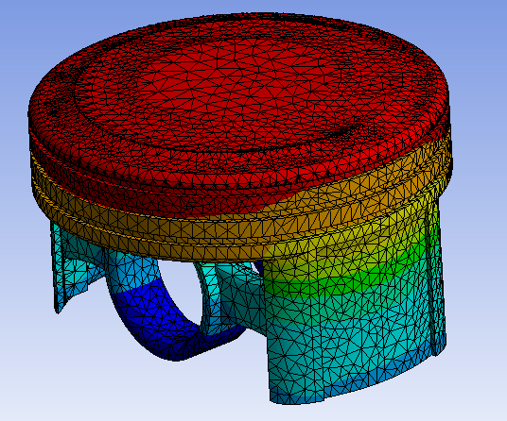

Mesh Independent study for piston results
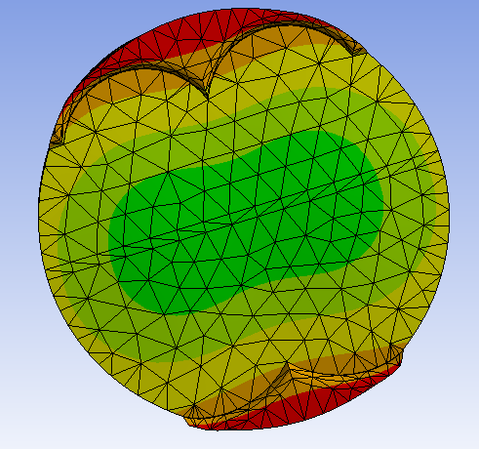

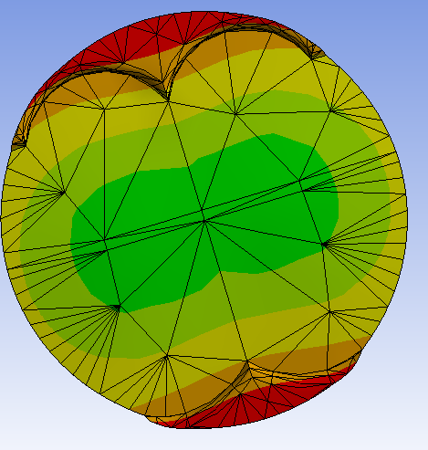

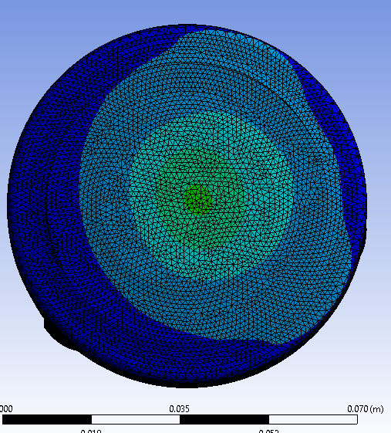

Thin support design with improved crown
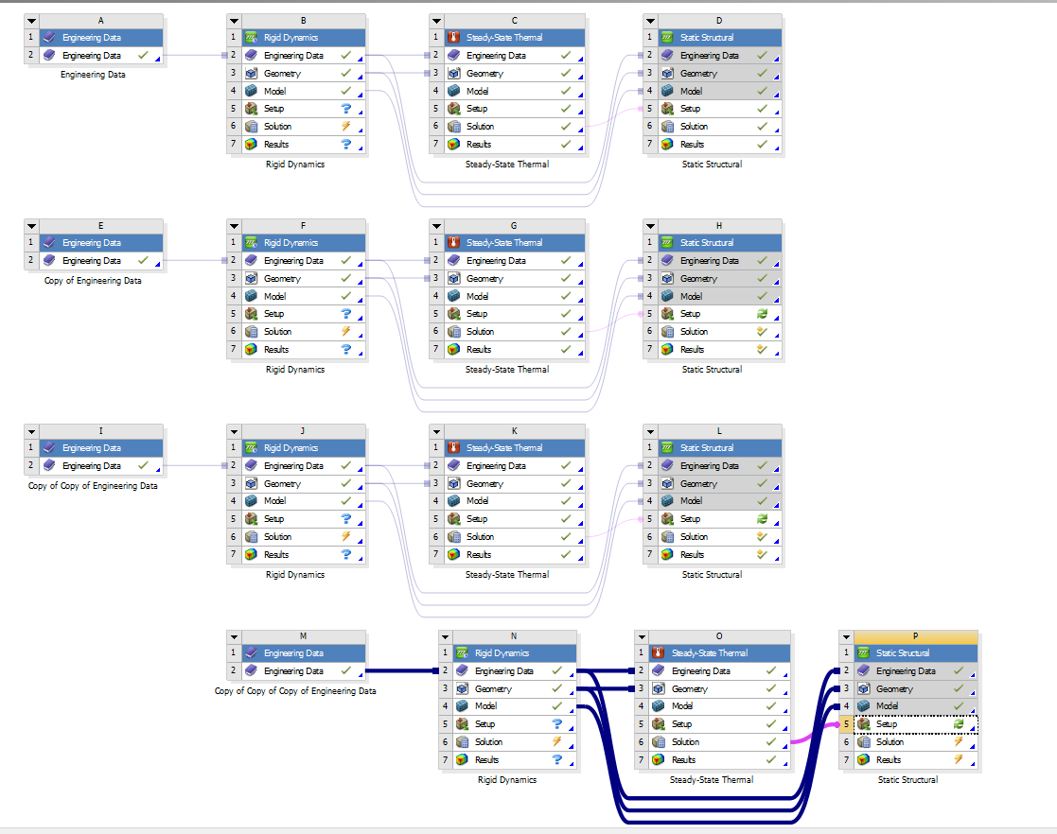

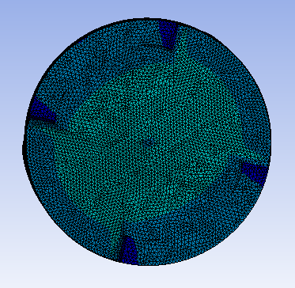
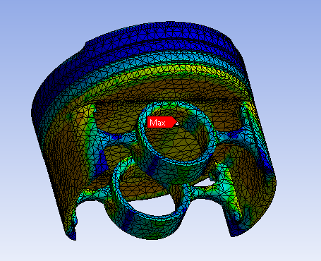

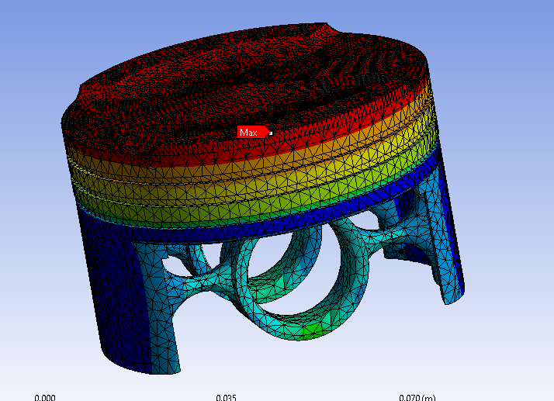

References
Arora, V. K., Bhushan, G., Arora, V., & Aggarwal, M. L. (2011). A Comparative Study of CAE and Experimental Results of Leaf Springs in Automotive Vehicles. In Article in International Journal of Engineering Science and Technology. https://www.researchgate.net/publication/265262521

https://www.perkins.com/en_GB/campaigns/powernews/global-focus/genuine-parts.html. (2021). Performance under pressure. [online] Available at: https://www.perkins.com/en_GB/campaigns/powernews/global-focus/genuine-parts.html#:~:text=Starting%20in%20the%20combustion%20chamber [Accessed 17 Dec. 2023].
Kumar, K., & Aggarwal, M. L. (2015). Finite element analysis and optimization of a mono parabolic leaf spring using cae software. Engineering Solid Mechanics, 3(2), 85–92. https://doi.org/10.5267/j.esm.2015.2.003

Kurchatkin, I. v., Gorshkalev, A. A., & Blagin, E. v. (2017). Methods of the working processes modelling of an internal combustion engine by an ANSYS IC Engine module. Journal of Physics: Conference Series, 803(1). https://doi.org/10.1088/1742-6596/803/1/012085

