Rodd, J. (2013) Leadership in early childhood: A pathway to professionalism. Maidenhead. OU Press.
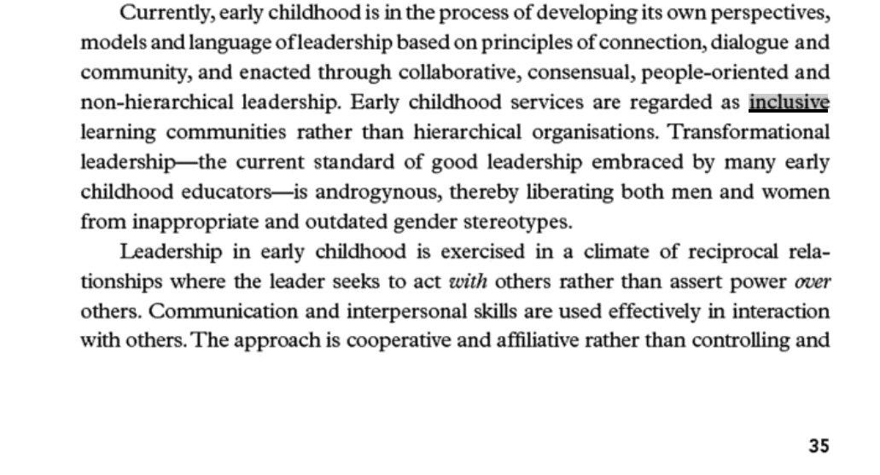
pp 35-36

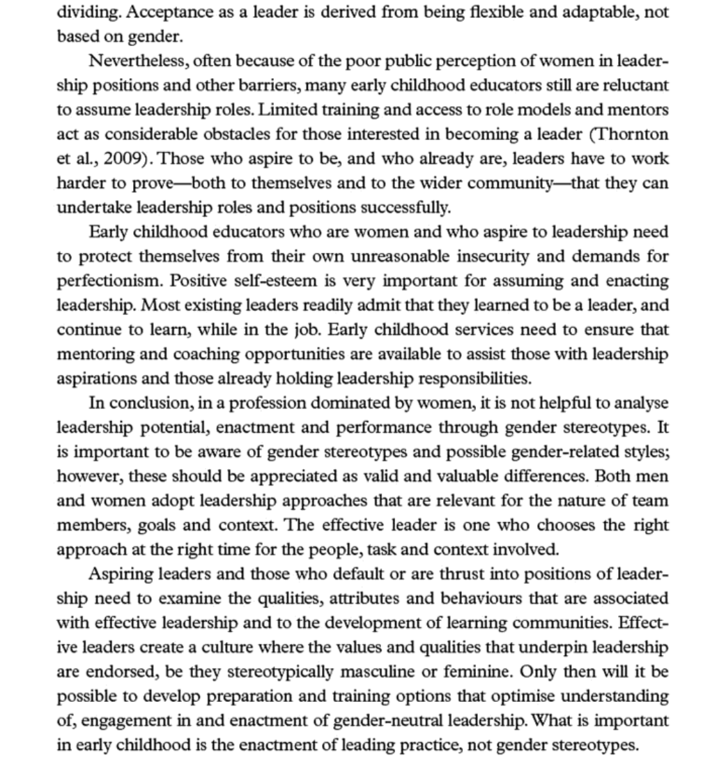

P.204



