

Research and Case Scenario in Data Security and Compliance
  - Data and security compliance
  - ACCA5034
Olivia Collins | UWTSD 2403891 | 06/01/2026
Table of Contents
Research Paper 1
Case Scenario 5
Introduction 5
Organization Structure 5
Policies & Procedures 7
Compliance 8
Governance & Strategy 9
Risk Management 10
Contingency Planning 11
Protection Mechanisms 13
Conclusion 13
References 13

Research Paper

Abstract-
Artificial intelligence (AI) and machine learning (ML) systems have become increasing popular as their technologies improve and become more efficient. These systems are used for their services for enabling advanced automation and data-driven decision making. However, using these systems introduces significant ethical, operational and regulatory risks. Organisations must focus on how to eliminate as many of these risks while also following the law. Over the past couple of years, these technologies have caused some problems within ethics due to the sheer amount of power that it takes to run a prompt on an AI model and how ML can replace human jobs.
General Data Protection Regulation (GDPR) and Digital Operational Resilience Act (DORA) are regulations in which companies and individuals must abide themselves to. GDPR is a law that govern data privacy, giving individuals greater control over their own personal data (like names, emails and IP addresses) This law also sets strict rules on how organisations collect, process and store data. DORA is a regulation that ensures that financial entities can withstand cyber-attacks. This ensures that entities (like banks, insurers and investors) have proper risk management and data resilience. Network and Information Security Directive 2 (NIS2) is a law that is structured around cybersecurity, this has recently replaced the last NIS directive by setting stricter rules and expanding more into sectors (like transport, health, public admin and digital services.) This is to help boost cyber resilience across the EU. These regulations and laws hold security into account and create a safe environment on the internet for everyone. Although, these regulations are mainly held in the EU, most other countries are taking inspiration by abiding and creating similar regulations.
This study examines the governance frameworks of AI and ML systems within a fragmented regulatory environment and navigating GDPR alongside new regulations.
- Introduction
AI and ML are both rapidly increasing in popularity with the normalisation of people using for everyday tasks. Whether that be using them to help the people make decisions or if they need a formal email written, one of the many AI models can now do that. Although, the advancement in these technologies has also turned plenty of heads due to the sheer number of risks and problems these technologies can bring. From an ethical standpoint, AI is humanity’s worst enemy, from the sheer power it takes to run an AI model to the replacement of human jobs. AI is starting to become more of a problem rather than the solution that people thought it would be.
Regulations are what protect the public from facing devastation on the internet, with many rules aiding with the management of data breaches and attacks. GDPR is one of the most well-known regulations and laws within the EU, with its sheer power and strict rules it has saved many people from their information getting leaked or used by blackmailers. GDPR is a law that protects data privacy, helping people gain control over their personal data online. This law not only helped people, but it also helped the EU base and design newer regulations around it, including DORA and NIS2.

This study focuses on the governance of AI and ML systems and how we must stay vigilant while manging the risks for AI data and models. While also diving into the laws and regulations within a fragmented world.

- AI and ML
Artificial intelligence (AI) and machine learning (ML) have become vital to the world of modern digital technology with sectors like finance, healthcare, transportation and many more. These technologies are increasingly relied upon for data analysis, automation and prediction. AI is a term that is used for when a computer can do certain tasks that are typically associated with human beings. That could be from creating digital images, writing text or even creating videos. AI’s advancement over the past 5 year as has shocked the world, from originally creating simple results to simple prompts, to creating intricate results every time. Even though many people trust AI, it can still make mistakes, whether that be misunderstanding of the prompt given or a total miscalculation. ML is a branch of AI that focuses on the development of using algorithms that can learn from a set of data, which allows systems to learn, make predictions and improve with time. ML typically is used for voice assistants and fraud detection. These both come with their own risks and problems. [1]

- Risks with AI and ML
Many people see AI as a lifesaving tool, while being used in hospitals to spot early stages of diseases or being used to help with accessibility for disabled people. But the reality is that it is far from that. Some of these risks include privacy violations, job displacement, misinformation and cybersecurity threats[2]. Privacy violation can happen when a person who is using a generative AI model, tells it their personal information which gets stored and then gets misused without proper consent. Job displacement is a huge threat that is looming over everyone, from general practitioners with people using AI to self-diagnose to cashiers being replaced by AI run self-checkouts. Every job sector is being affected by the growing fear of being replaced by AI. [3] Misinformation that spans from AI, is a huge problem including deepfakes. Deepfakes are realistic, AI-generated digital pieces of media that portray people saying or doing things that never happened. These deepfakes have become a huge problem, originally designed for entertainment has recently turned dark with people using it for revenge, this could include making a well-known figure say or do something that could get them into controversies and trouble. In 2025 there has been an estimated 8 million deepfakes online, which is huge increase since 2023 which was approximately at 500,000. [4]AI cybersecurity risks can happen through attackers using AI for advanced phishing, malware and deepfakes. These scams and attacks can be easily fell for due to how realistic some of these can be. Through AI, these attacks have advanced compared to the last few years, which means more people have fallen for these.
- Governance of AI and ML
AI governance encompasses the policies, process and organisational structures that ensure AI systems are developed and operated with effective governance in mind. Data governance in AI is a foundational framework consisting of rules, processes and standards that ensure that the AI model produces accurate, secure and compliant data. While also managing ethical, bias and privacy risks, building upon past data governance by addressing unique ML challenges for trust and business values. Data governance mainly uses regulations and laws like GDPR, to build trustworthy and unbiased AI systems. AI systems rely on large datasets that may include personal, sensitive or biased information. So, rules must be set in order data quality and lawful processing. Documentation of data and how it used within the AI model is essential with following GDPR, since sensitive information may be misused by the model without consent from the user.

- European Regulatory Landscape
The regulatory environment in the EU is increasingly complex and fragmented, with organisations required to comply with multiple overlapping legal frameworks. Rather than being governed by a single, unified framework, organisations must comply with multiple overlapping regulation that differ in scope, focus and enforcement. This fragmentation comes from slow rise of new regulations, which are made to combat emerging risks without replacing existing regulations.
The General Data Protection Regulation (GDPR) continues to serve as the foundational framework for personal data protection. While its years of protection and security has helped millions of people, newer regulations have been made such as the Digital Operational Resilience Act (DORA) and the Network and Information Security Directive (NIS2) that introduces additional obligation related to digital resilience and cybersecurity. All these regulations, cover different sectors, resulting in situations where a single organisation may be subject to multiple regulatory requirements simultaneously. For example, an AI model company supporting critical infrastructure may have to comply with GDPR’s data protection principles, DORA’s resilience and testing requirements and NIS2’s cybersecurity and incident reporting obligations.
Regulatory fragmentations increase the complexity of compliance by requiring organisations to interpret and reconcile overlapping requirements that may use different terminology or emphasise different risks. This can lead to duplicated controls, increase costs and uncertainty regarding any regulatory expectations.

- GDPR, DORA and NIS2
GDPR is a law in the EU that was adopted in 2016 to combat the rising use of computers and devices. This regulation focuses on protecting sensitive and private data, giving individuals greater control over their person data while also setting strict rules for how organisations can collect, process and store the data. This applies to any organisation that processes personal data of individuals in the EU, regardless of the organization’s location. If an organisation is not compliant with this law, then there could be a heavy fine that can go up to 20 million euros. Recently there have been some new laws and regulations that have been put into to place to extend the law further and across different platforms and formats.
DORA is an EU regulation that ensures that financial entities can withstand and recover from technological disruptions, like cyberattacks. This regulation as adopted in 2025 to create digital resilience across the entire financial sector against digital threats.
NIS2 is the EU’S updated, broad cybersecurity law that has recently replace its original counterpart, NIS. NIS2 has stricter rules and expands to more sectors compared to NIS. These rules include, that any medium/large entity must implement strong risk management, report on incidents swiftly and face tougher penalties if there’s no compliance with these rules. This law is to help enhance overall cybersecurity vigilance, particularly for critical infrastructure and essential services, almost acting as a GDPR for cybersecurity.

- The Impact of regulations on AI and ML
Regulations have a significant role in shaping how AI and ML systems are designed and implemented. Rather than regulating AI alone, existing European Union regulations influence AI indirectly by imposing requirements related to data protection and cybersecurity. As a result, regulatory compliance affects not only how AI systems are governed but also how they function.
GDPR has a direct impact on AI systems that process personal data. Principles such as data protection, purpose limitation and transparency constrains the types of data that can be used for model training. Article 22 of GDPR covers automated individual decision making, which directly affect AI by restricting decisions based solely on automated processing.
NIS2 influences AI systems by strengthening cybersecurity and resilience measures for organisations that are using AI to operate essential and important services. AI models and data pipeline must be protected against cyber threats. NIS2 therefore affects how AI systems are monitored and integrated into organisational security frameworks requiring continuous monitoring and incident response capabilities.
Together, GDPR and NIS2 shape AI systems beyond compliance documentation, influencing design choices, governance structures and operational practices. By following the regulations and rules, organisations can ensure that AI systems remain secure, transparent and trustworthy in regulated environments.
- Evolving Regulation and AI Governance
Governing AI systems in the European Union is expected to become more comprehensive in the next coming years. As AI’s development continuously advances, the regulations and laws mist change with it too. While the current regulations such a s GDPR and NIS2 regulate AI indirectly, future regulations are likely to address AI systems directly. this evolution reflects on the growing recognition and usage of AI alongside the security and societal risks of AI deployment.
As of 2025, the European Union are working on creating the first AI Act. First proposed in 2021, the EU plan on adopting this AI Act to establish a risk-based AI classification system. This now means that depending on the risk factor of the AI system, it could get banned. An example of this is AI that can manipulate behaviour of vulnerable people. Like a voice-activated toy for kids, that could trigger unwanted response if prompted.
In 2024, the EU took on the first rules on AI, which will come into full force in 2026. Although some rules have already come into place including, banning AI systems that pose big risks, rules on general-purpose AI systems meaning full transparency are required when being used.
One significant development is the increasing of emphasis on lifecycle-based governance. Regulations are moving on from static compliance models towards continuous monitoring, due to the sheer range of what AI systems can achieve. Continuous model monitoring and documentation are likely to become standard regulatory expectations.
Advances in AI technology, including more autonomous and adaptive systems will further challenge existing governance approaches.
- Conclusion
The increasing integration of AI and ML systems into critical services and infrastructures has made effective governance and regulation necessary. While AI technologies offer a wide range of significant benefits in terms of efficiency and automation, they also introduce complex risks related to data protection, ethics and cybersecurity. Addressing these risks are quite a difficult task within the fragmented regulatory landscape of the European Union.
This study covered how AI and ML systems are governed under the key regulations of the EU: the General Data Protection Regulation (GDPR), the Digital Operation Resilience Act (DORA) and The Network and Information Security Directive (NIS2). Although, these regulations differ in purpose and focus, they all share common principles of risk management and accountability. GDPR shapes how AI systems process personal data and make automated decisions, while DORA and NIS2 influence the resilience and security of digital infrastructures that support AI deployment.
Fragmented regulations show that they significantly increase compliance complexity, particularly for organisation operating critical services. As a result, organisations must constantly change their compliance approaches due to them becoming insufficient. Instead, organisations must adopt an integrated lifecycle-based framework that aligns with the sections of the organisation.
Looking ahead, evolving regulatory expectations will continue to raise the standards for AI governance and regulations.
- References
- References
[1] "Artificial Intelligence (AI) vs. Machine Learning" CU-CAI.
[2] "AI Risks that Could Lead to Catastrophe | CAIS." [Online].
[3] "The MIT AI Risk Repository." Online].
[4] "What are deepfakes and how can we detect them?" [Online].
[5] "General Data Protection Regulation (GDPR) – Legal Text." [Online].
[6] "A Comprehensive Checklist for Mastering DORA Compliance." Accessed: 6 2026. [Online].
[7] "NIS2 Directive: securing network and information systems | Shaping Europe’s digital future." [Online].
[8] "Art. 22 GDPR – Automated individual decision-making, including profiling" General Data Protection Regulation (GDPR).
[9] "EU AI Act: first regulation on artificial intelligence." [Online].

Case Scenario

Introduction
ResilientIntellect Ltd is a threat intelligence and consultancy company that develops an AI-powered threat analysis software and uses a hybrid workforce. It assists businesses to combat real time threats from cyber-attacks. This company is expanding into the EU and must comply with DORA and NIS2 regulations[1,2,3]. These regulations impose strict requirements for resilience, incident reporting and cybersecurity, relevant to organizations like ResilientIntellect Ltd that uses AI systems and cloud-based services.
AI systems, while offering automation and advanced threat detection, introduce new vulnerabilities, including data integrity risks and model poisoning. Simultaneously, a hybrid workplace also introduces more additional attack surfaces and openings known as exposure points. These can lead to data breaches and leaks, which can ruin an organization’s reputation.
To address these challenges and secure the AI systems, cloud infrastructure and hybrid workforce, this report proposes that ResilientIntellect Ltd adopts a Zero-Trust aligned security approach. Zero Trust principles are ideal for handling modern cyber threats, including supply chain attacks, ransomware and cloud misconfigurations.
By aligning security strategy with business objectives and regulatory requirements, ResilientIntellect can safeguard its AI and cloud-based systems, its hybrid workforce while maintaining operational resilience and regulatory compliance. All these factors can lead to higher client trust.

Organization Structure
A well-defined organizational structure is critical for the effective deployment of Zero Trust principles, as well as compliance with DORA and NIS2. The new EU security unit should combine a clear structed hierarchy with different skill sets, strategic oversight and expertise.
Here’s an example of this
Roles | Responsibilities
CISO (Chief Information Security Officer) | Oversee the organization’s overall cybersecurity strategy. Zero trust adoption. Reports to the CEO.
DevSecOps Lead | Integrates security and ensures that AI models are validated and dependencies are verified.
Cloud Security Architect | Designs secure cloud environment, implements CSPM and access policies. Validates configurations against DORA/NIS2 requirements.
Compliance Manager | Ensures adherence to DORA and NIS2, manages reporting and regulatory updates.
Security Analysts | Continuous monitoring, threat detection and incident response.

The hierarchy of roles is as follows:

CEO
CISO

Cloud
DSO

CM
SA

Justification:
- Cloud Security Architect: Cloud-first design is critical because misconfigurations pose as one of the largest risk factors in EU operations.
- DevSecOps Lead: AI pipelines introduce software supply chain risks; this role ensures that security is enforced into the development of the AI system.

Policies & Procedures
Policies are the backbone of a Zero Trust strategy; they provide enforceable guidelines for secure operations. Having policies and procedures set in place is so important since they define expectations and standardise processes across AI pipelines, cloud environments and hybrid workforce. For ResilientIntellect’s EU operations, policies must address AI usage, Saas configuration and BYOD, ensuring that proper regulatory compliance with Dora and NIS2.

AI Usage Policy
- Purpose
The purpose of this AI usage policy is to ensure the ethical and secure use of AI systems while preventing data misuse, model poisoning and reputational risks.

This will apply to all internal and client facing AI systems, including the threat intelligence models.

- Key points
- Data Minimisation
Only processes necessary personal data, implements anonymity, and maintains data lineage logs.
- Bias & Fairness Monitoring
Pre-deployment testing for model bias, continuous monitoring after deployment and periodic re-training to ensure only fair outcomes are reached.
- Model validation & Integrity
All AI models are verified for accuracy, reliability and absence of malicious modifications (Model Poisoning).
- Human-in-the-Loop (HITL)
High-impact decisions are required to be supervised by a human before final execution.
AI usage is a large part of ResilienceIntellect’s identity, especially for their threat intelligence system. Which directly influences client’s cybersecurity decisions. Non-compliant or biased AI models could lead to legal breaches and reputational damages.

Secure SaaS Configuration Policy
- Purpose
The purpose for a Software as a Service (SaaS) configuration policy is to protect cloud-hosted services and SaaS applications used internally and for clients.

This will apply to all SaaS applications, cloud storage and collaboration platforms.

- Key Points
- Role-Based Controls
Employees and AI systems are granted minimal and necessary permissions to perform tasks.
- CSPM (Cloud Security Posture Management)
Continuous and automated auditing of SaaS configurations to detect misconfigurations, security gaps and compliance drift. Ensuring that workers and clients are secure and safe when using the services.
- Automated Update Management
All SaaS and connected cloud based services must automatically apply security patches and updates to remain up to date on any new security features.
- Multi-Factor Authentication (MFA)
All accounts require MFA, to secure any sensitive data from any phishing schemes.
If Cloud and SaaS configurations are not completed thoroughly, it may lead to data breaches and even unauthorized users getting into the systems.

Bring Your Own Device (BYOD) Policy
- Purpose
The purpose of a BYOD policy is to secure hybrid workforce devise that acceses the EU infrastructure and AI systems.
This will be applied to all employee-owned laptops, tablets and mobile devices that are used for work purposes.

- Key points
- Device registration
Devices must be registered in the company’s management system before accessing any resources.
- Endpoint Encryption
All BYOD devices must use full-disk encryption and endpoint detection and response (EDR) agents to detect anomalies.
- Conditional Access and Compliance Checks
Any access to the AI pipelines, SaaS apps and cloud storage will require devices to pass additional compliance checks. Including, antivirus status, security configuration and multi-factor authentication.
Hybrid workforce models increase attack surfaces. BYOD policies combined with Zero Trust, enforce continuous verification and reduce insider threats or unintentional misconfigurations.

Compliance
Compliance is critical for ResilientIntellect’s Eu operations, as failure to meet DORA and NIS2 requirements can result in regulatory penalties, reputational damage or operational disruption.
DORA Compliance
The Digital Operational Resilience Act (DORA) requires financial and critical service organizations to ensure that their ICT systems, including AI pipelines must remain resilient under stress or attack. Some key compliance measures include:
- Risk Management: All AI and cloud systems must undergo continuous risk assessments and scenario-based resilience tests.
- Third-Party Risk Management: AI pipelines that use third party services or models must verify that the security and integrity of the external dependencies can be trusted and used safely.
- Audit and Documentation: DORA requires detailed records of the AI models development, deployment, updates, incidents and mitigations actions.
- Business Continuity Testing: Regular simulations ensure that AI and cloud-based services can sustain operational continuity even when disruptions occur.
All these measures will ensure that ResilienceIntellect is prepared for any situation and is compliant with DORA’s rules. [2]

NIS2 Compliance
The Network and Information Security Directive 2 (NIS2) require organisations to implement strong risk management and quick reports of incidents. If they are not compliant with NIS2, organisations may face large fines and penalties. Compliance requirements include:
- Incident Detection and Reporting: Significant cybersecurity incidents, such as ransomware attacks or AI pipeline compromises must be reported to EU authorities within 24 hours.
- Management accountability: Senior management must take full responsibility for security measures and ensure policies, procedures and technical controls are all enforced.
- Security Measures: Every network, endpoint and AI pipeline within the organisation must be checked for security through continuous monitoring and tests.
Complying with NIS2 will help ResilientIntellect grow their operations within the European Union without any penalties or faults. [3]

Governance & Strategy
Governance and strategy provide the framework for aligning security compliance and business objectives, ensuring that AI, cloud and hybrid workforce operations are resilient, secure and accountable. For ResilientIntellect’s European Union operations, governance must integrate with the Zero trust principles, regulation obligations (DORA & NIS2) and AI ethics, while also allowing strategic decision making and risk informed operations.
Governance Framework NIST CSF 2.0
The NIST cybersecurity framework (CSF) 2.0 is applied ass the backbone of the governance model. It tuns of five core functions – Identify, Protect, Detect, Respond and Recover – to help organisations manage and reduce cyber risk. [4] [5]
- Identify: assists in the development of organizational understanding of managing cybersecurity risks. This could be for people, data or systems.
- Protect: outlines the appropriate steps needed to be taken to secure the critical systems.
- Detect: defines the correct activities to identify the occurrence of a cyber attack or event.
- Respond: shows how to act regarding a detected cybersecurity incident.
- Recover: identifies how to maintain plans for resilience and restore any lost data. Pick up the pieces and rebuild.

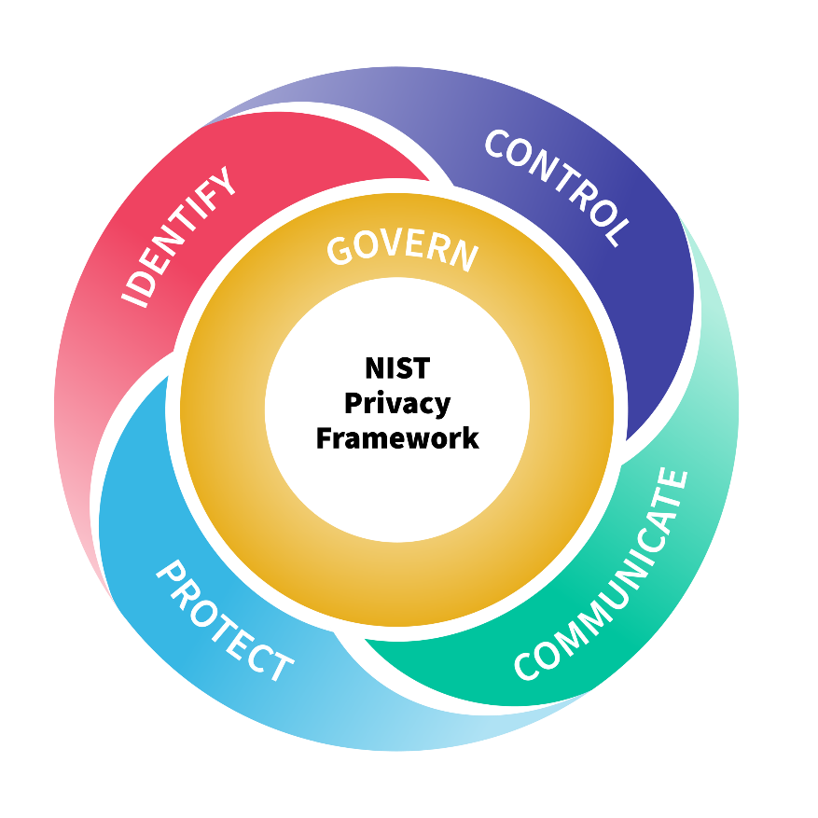
These key functions help organisations with a structured governance cycle, ensuring that all aspects of a cyber incident are managed proactively without overreaction.

Risk Management
AI systems, hybrid workforce operations and cloud-based dependent services all introduce multiple risks.
Risk | Likelihood | Impact | Mitigation
Poisoned AI models | Medium | High | Third-party verification, model explainability and HITL reviews.
Cloud Misconfiguration | Medium | High | CSPM, automated monitoring and configuring baselines
Ransomware targeting AI/data | Low | Very High | Storing backups, DR plan and SIEM alerting
Insider Threat | Medium | Medium | Conditional access, activity logging and policy enforcement
Vulnerable software dependencies | High | High | DevSecOps dependency scanning, automated patching and supply chain risk audits.
This risk assessment focuses on the highest impact threats while also complying with DORA’s operational resilience requirements and NIS2’s cybersecurity reporting obligations.

Contingency Planning
Contingency planning is an essential requirement for an organization operating within AI driven systems. Under DORA, ResillientIntellect must demonstrate the ability to maintain operational continuity and recover rapidly from severe ICT disruptions. Especially for a company that specializes in AI-powered threat intelligence software, the loss or possible compromise of the AI trained models that help with the software would be devastating and could lead to severe operational and reputational risk.
In order to combat this, a high-impact contingency plan must be set in place with different scenarios that could possibly happen.
Scenario 1 – Ransomware Attack
A ransomware attack represents one of the most severe threat scenarios for ResilientIntellect’s EU operations, particularly given its reliance on AI-driven threat intelligence and cloud infrastructure. [6]
In this scenario, a person gains access to the systems through a compromised credential, phishing scheme or possibly software supply chain. Once inside, the attacker accesses sensitive data, and finds the correct spot to release the ransomware.
This attacker has targeted two critical assets:
AI Training Datasets:
Encryption or deletion of training data could destroy the integrity and availability of AI models. Which results in the threat of intelligence software being down.
Source Code:
Having compromised source code allows attackers to halt development, disrupt updates or inject malicious code. This not only impacts the service continuity but also exposes clients to downstream supply chain attacks.
This overall operational impact of this attack would be exponential, not only affecting the organization but the clients too. This attack would require the organization to report the incident to the authorities due to NIS2, and to recover quickly under DORA. The company would also need a disaster recovery plan. [7]
Disaster Recovery Plan
The disaster recovery plan (DRP) is a well-known plan that all businesses must comply with. Without this plan proper recovery after a disaster will not be successful. A good disaster recovery plan must be structured around containment, recovery and response. [8]
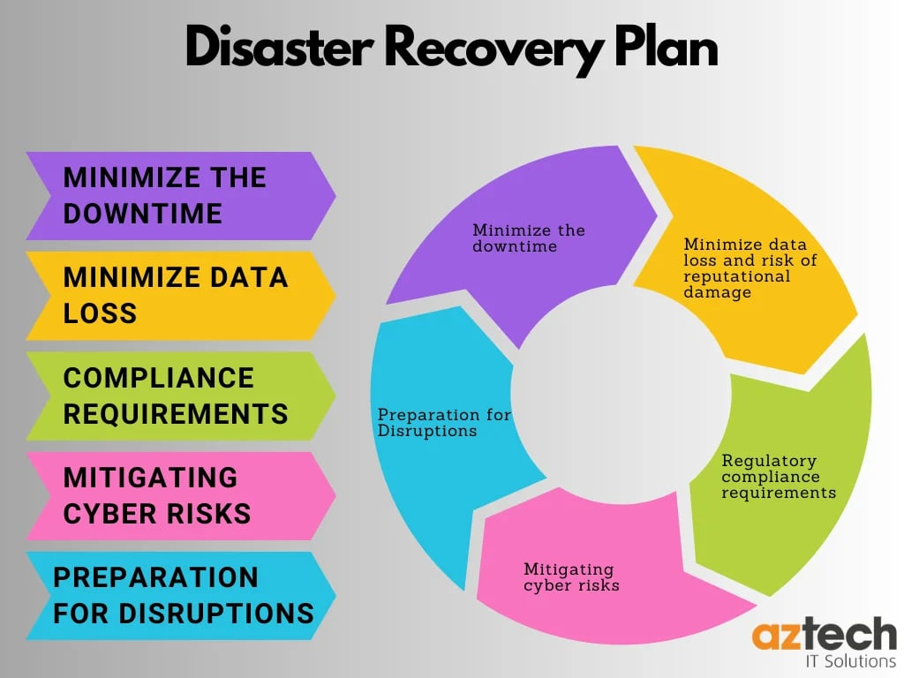

Protection Mechanisms
Protection mechanisms translate governance and policy into technical enforcement terms, forming the operational core of a Zero trust aligned security program. These are some mechanisms that ResilientIntellect could benefit from:
Identity and Access management (IAM) controls access based systems and reduces the number of credential-based attacks. This includes Phishing resistant MFA enforced on every user and device and continuous authentication to validate identity and location.
Endpoint detection and response (EDR) is to be deployed across all corporate BYOD devices; this ensures automated isolation of all compromised endpoints. Which ensures compliance with NIS2, meeting its requirements for endpoint security. [9]
Security Information and Event Management (SIEM) enable real-time visibility, auditability and regulatory reporting required by both DORA and NIS2.
Cloud Security Posture Management (CSPM) includes continuous scanning of cloud configurations and detections of misconfigured cloud storage, excessive permissions or exposed endpoints. Since cloud-based incidents are a leading cause of breaches, CSPM ensures that those incidents do not happen. [10]

Conclusion
This report discusses how ResilientIntellect’s expansion into the European Union can be successful with these requirements. These requirements highlight a security program capable of addressing a large range of combined challenges of having AI driven systems, hybrid work environments and regulatory obligations. This report has also proposed a comprehensive Zero-Trust aligned program designed to meet the requirements of DORA and NIS2, while supporting innovation and business growth.
By integrating organization structure, policies, procedures, compliance, governance, risk management, contingency planning and protection mechanisms, th9is proposal covers everything that ResilientIntellect would need to grow in the EU,
By adopting an integrated security plan like the one shown in this report, ResilientIntellect can focus on building their AI threat intelligence software, due to the new plan covering and protecting their critical AI assets, while also maintaining their client’s trust.

References
[1] European Union, Regulation (EU) 2016/679 of the European Parliament and of the Council (General Data Protection Regulation), Official Journal of the European Union, 2016.
[2] European Union, Regulation (EU) 2022/2554 on Digital Operational Resilience for the Financial Sector (DORA), Official Journal of the European Union, 2022.
[3] European Union, Directive (EU) 2022/2555 on Measures for a High Common Level of Cybersecurity across the Union (NIS2 Directive), Official Journal of the European Union, 2022.
[4] National Institute of Standards and Technology (NIST), Cybersecurity Framework (CSF) 2.0, NIST, Gaithersburg, MD, USA, 2024.
[5] National Institute of Standards and Technology (NIST), Zero Trust Architecture, NIST Special Publication 800-207, 2020.
[6] European Union Agency for Cybersecurity (ENISA), Threat Landscape for Ransomware Attacks, ENISA, 2023.
[7] European Union Agency for Cybersecurity (ENISA), Artificial Intelligence Cybersecurity Challenges, ENISA, 2021.
[8] ISO/IEC, ISO/IEC 27001:2022 – Information Security Management Systems, International Organization for Standardization, Geneva, Switzerland, 2022.
[9] ISO/IEC, ISO/IEC 27002:2022 – Information Security Controls, International Organization for Standardization, Geneva, Switzerland, 2022.
[10] Cloud Security Alliance, Security Guidance for Critical Areas of Focus in Cloud Computing, CSA, 2023.
[11] Gartner, Market Guide for Cloud Security Posture Management, Gartner Research, 2023.
[12] MITRE, ATT&CK® Framework, MITRE Corporation, 2024.
[13] OWASP, OWASP Top 10 – CI/CD Security Risks, OWASP Foundation, 2023.
[14] OWASP, Machine Learning Security Top 10, OWASP Foundation, 2023.
[15] IBM Security, Cost of a Data Breach Report, IBM Corporation, 2023.

