Olivia Roadnight (2501022)

Programme: Computing Portfolio
Module:Computer Architecture and Operating Systems
Module code: ACCA4022
OS Assignment
Student name: Olivia Roadnight

Table of Contents
0
1.Introduction 2
2.Key functions of popular general-purpose Operating Systems 2
2.1 Core functions of General Purpose Oss: 5
3.Use of Windows OS CLI commands 11
3.1 Documentation of 10-12 different Batch &/or PowerShell commands with the use of options/switches 11
3.1Process management 12
3.2 File & directory management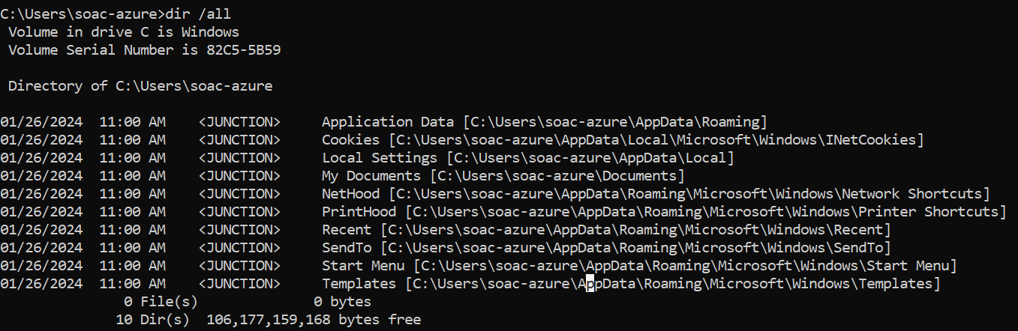 13
3.3 Network testing/monitoring 15
3.4 User management 16
3.5 Task scheduling 17
4.Use of Linux OS CLI commands [15] 18
4.1Documentation of 10-12 different Bash commands with the use of options/switches on Ubuntu 18
4.1 Process management 19
4.2 File & directory management 21
4.3 Network testing/monitoring 22
4.4 User management/ Task scheduling 22
5. Use of Windows OS scripts 23
5.1 Documentation of the use of batch scripts by demonstrating key features of a Win. OS scripting language 23
6. Use of Linux OS scripts 30
6.1 Documentation of the use of Bash scripts by demonstrating key features of a Linux OS scripting language 30
7. Conclusion and Key Findings 37
8. Appendices 38
Appendix 1: Engagement with Lecture Activity Answers 38
Appendix 2: Additional Script Screenshots 40
9 References 50

1.Introduction
This report will cover an overview of an OS, critical functions of general ones, documenting the use of Batch commands in a Windows CLI, and bash in Ubuntu Linux commands. And a documentation of the Windows OS batch scripts and of Linux OS scripts with screenshots of the processes, then concluding with key findings of the report.

2.Key functions of popular general-purpose Operating Systems
An Operating System acts as an intermediary interface between hardware and software, allowing applications to communicate with the hardware through components such as device drivers. [1]General purpose-OSs including Windows, Linux and MacOS have the same foundational roles and functions but designed for different purposes, they manage hardware resources, applications and perform a large range of tasks a user can run.
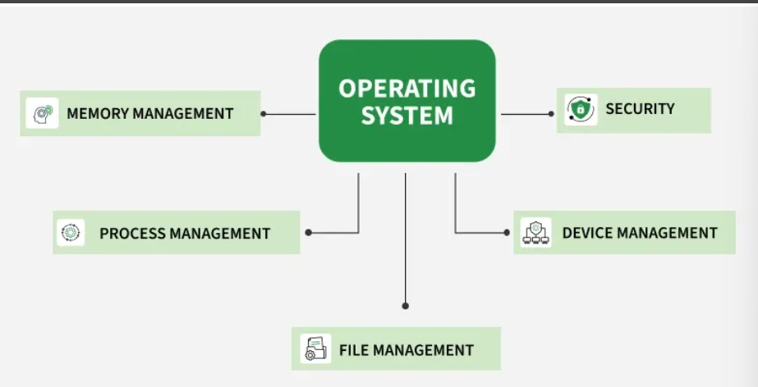
Figure 1 Core Functions of an Operating System
General purpose OSs perform core functions including process, memory protection, file system, and device management, alongside providing a user interface and handling security and access controls, networking integration, error handling, and resource allocation for a system. These functions aim to make the computer system user-friendly, efficient, and to abstract complex hardware details. [2] [3]
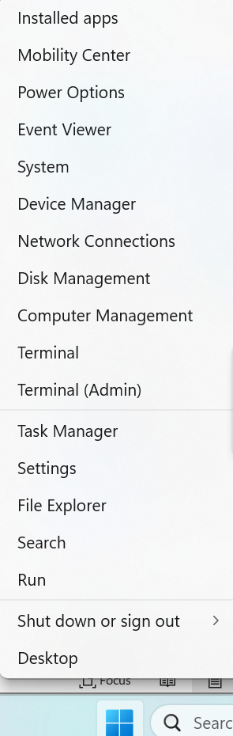
Figure 2 Windows Home Button with Drop Down Box Displaying Features user can access

2.1 Core functions of General Purpose Oss:

The Kernel
Another key component of the OS is the Kernel is the core of the OS that is loaded into memory at boot and remains there to manage hardware communicating. Acting as an interface between the hardware and software, it is responsible for managing system resources and interacting directly with the hardware, which performs critical tasks such as process scheduling, memory allocation and I/O control. It also handles system calls, enabling software applications to request services from the OS. [4] [5]
Process Management: It manages and schedules processes running on the computer system, allocating resources such as CPU time and memory to ensure efficient execution.
Additionally, in process Scheduling, CPU runs programs according to the Kernel’s process scheduler, determining which programs to execute, enabling multitasking due to context switching to quickly switch between processes, so that each process receives CPU time to enable multitasking and fairness. This improves system responsiveness and efficient processing power usage.
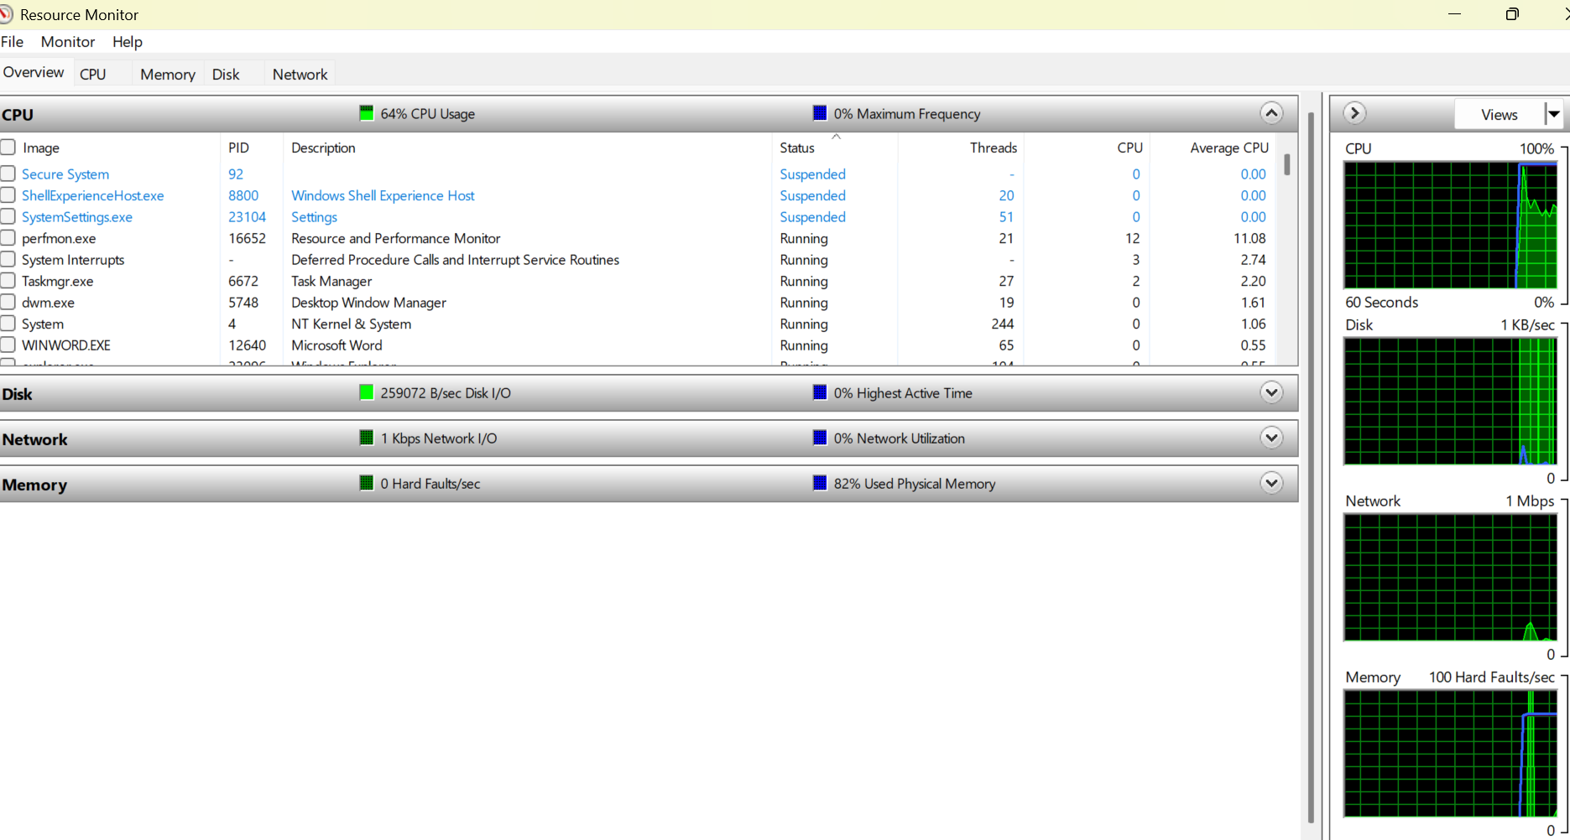
Figure 3 Resource Monitor
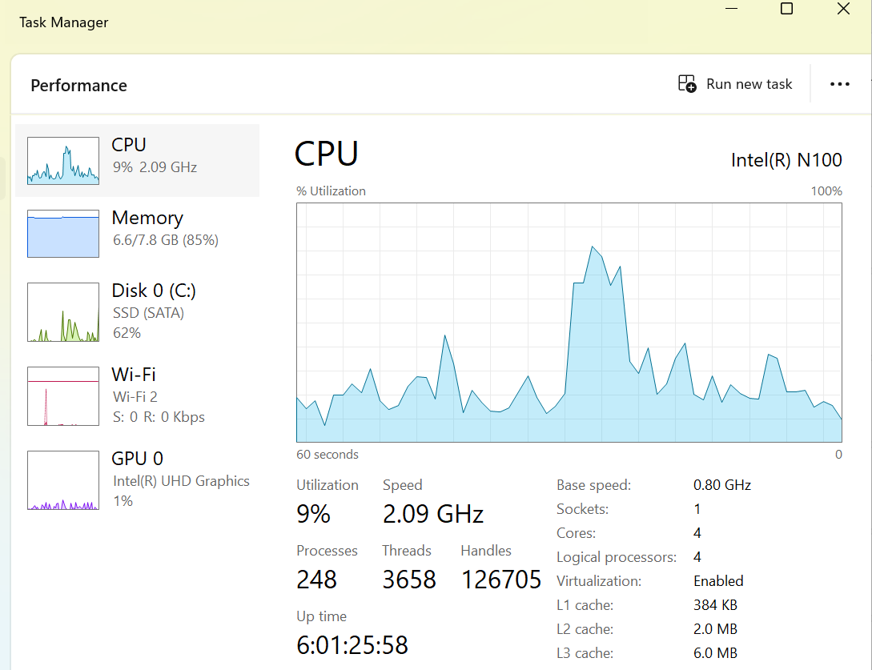
Figure 4 Task Manager
Memory Management: Responsible for allocating and organising system memory to different processes and managing virtual memory when the physical memory is limited. Allowing for multiple applications to run simultaneously without conflict.
The Kernel plays a big part in managing both physical and virtual memory, it allocates the memory to processes that start and finish, tracks free memory, controls the paging and switching between RAM and disk, which means the OS pretends to have more RAM than what is physically installed, by moving inactive data to a storage devices to free up space. And protects memory by ensuring that all processes cannot obstruct each other. [6] [7]
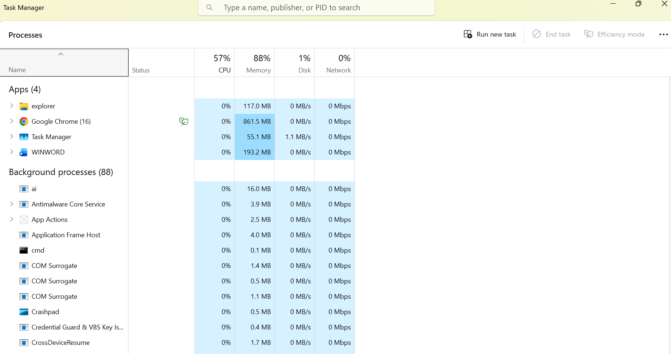
Figure 5 Task Manager
File System Management: Provides a structured way of organizing and storing files on storage devices, allowing users and programs to create, access, and manage files and directories.
The Kernel manages file systems by regulating how data is stored, organised and accessed on storage devices by providing a consistent interface for applications to read or write files.
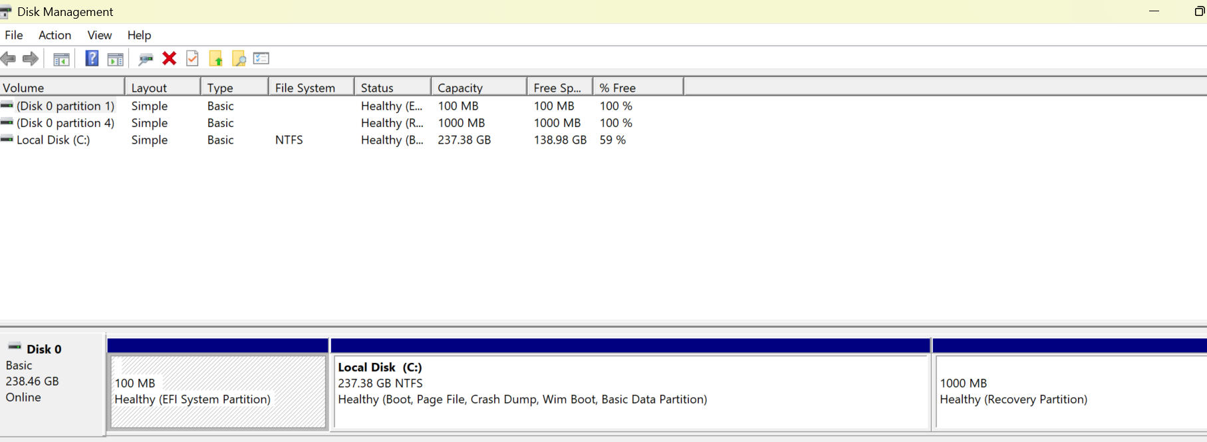
Figure 6 Disk Management
Device Management: Controls input and output devices, such as keyboards, printers, and network interfaces, ensuring communication between these devices and software applications.
The Kernel also handles I/O devices via device drives. Providing standardised API for software to interact with hardware without any specific records of details on hardware and resolves any applications’ requests for the use of the same hardware as others so there’s no conflict. Furthermore, when one uses an input hardware device, the OS waits to receive an “interrupt” signal from the hardware to the CPU to stop its current task and handle that input request immediately then resumes its activities without wasting CPU polling for input constantly. [8]
Interrupt handling is key for the OS to function, it is the process of temporarily pausing CPU to handle various tasks by “interrupting” the current process to address priority requests such as hardware signals and software exceptions to ensure the efficiency of system responsiveness and multitasking. [9]
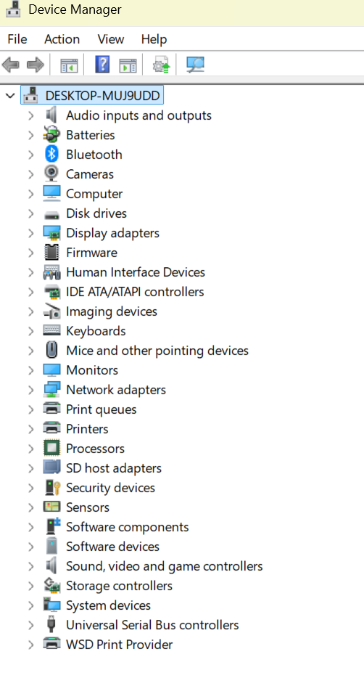
Figure 7 Device Manager
User Interface: This provides a means for users to interact with the computer system, presenting information and enabling input through interfaces such as command-line interfaces (CLI) or graphical user interfaces (GUI).
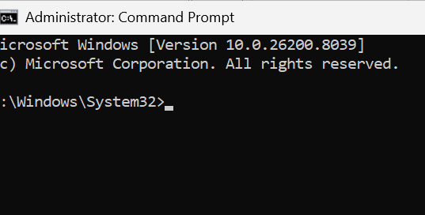
Figure 8 CLI in Adminstrator Permissions
Security and Protection: This is software which enforces security measures to protect the system and user data, including user authentication, access control, and networking capabilities, which runs in the background. The windows defender is a built in security system programs, it includes various types of protection provided to defend the system against malicious software, such as antivirus, adware, phishing, spyware, and the program also provides a warning of about any untrusted sources before a user visits a website or downloads a program.
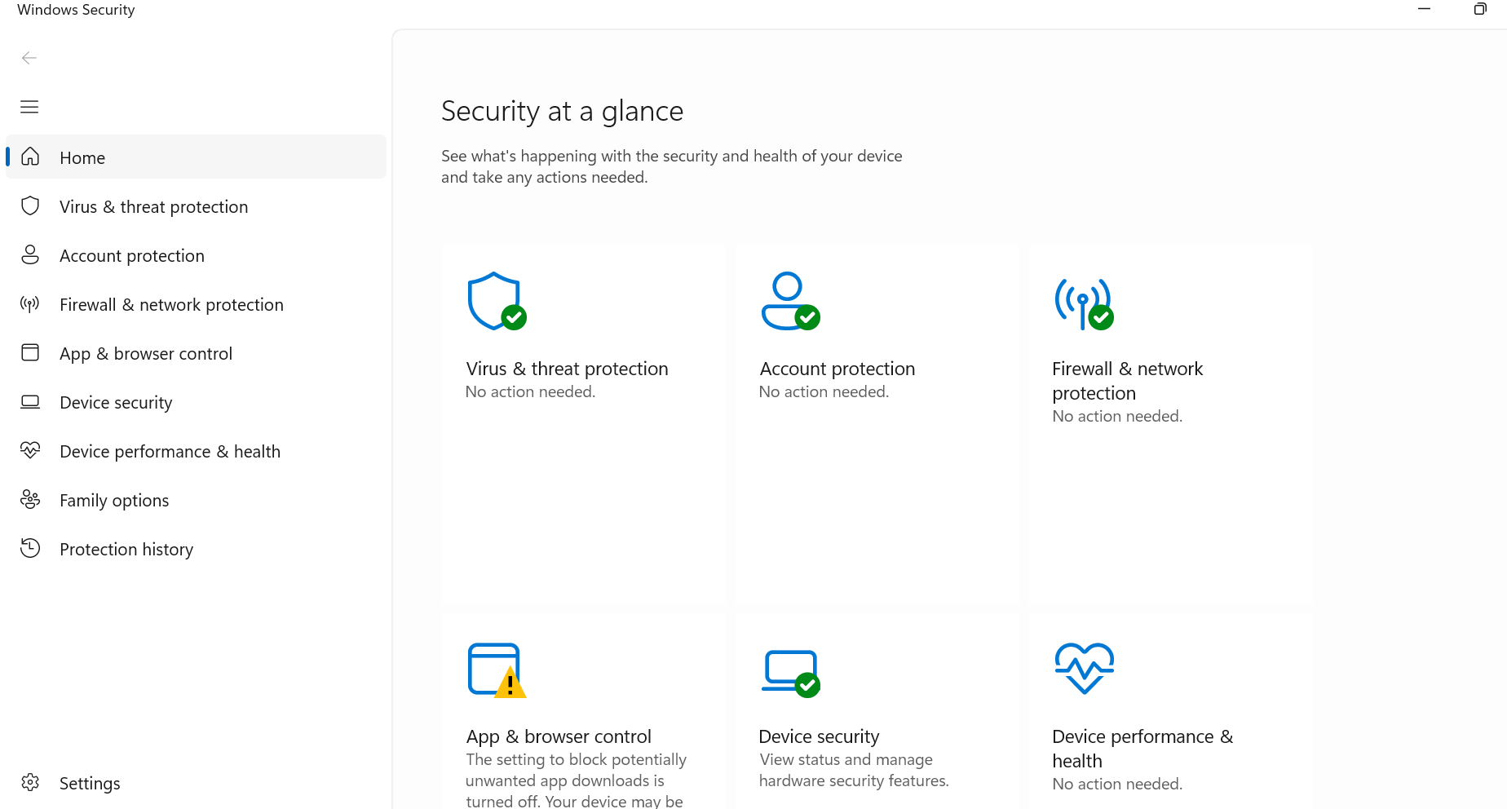
Figure 9 Windows Security on Settings
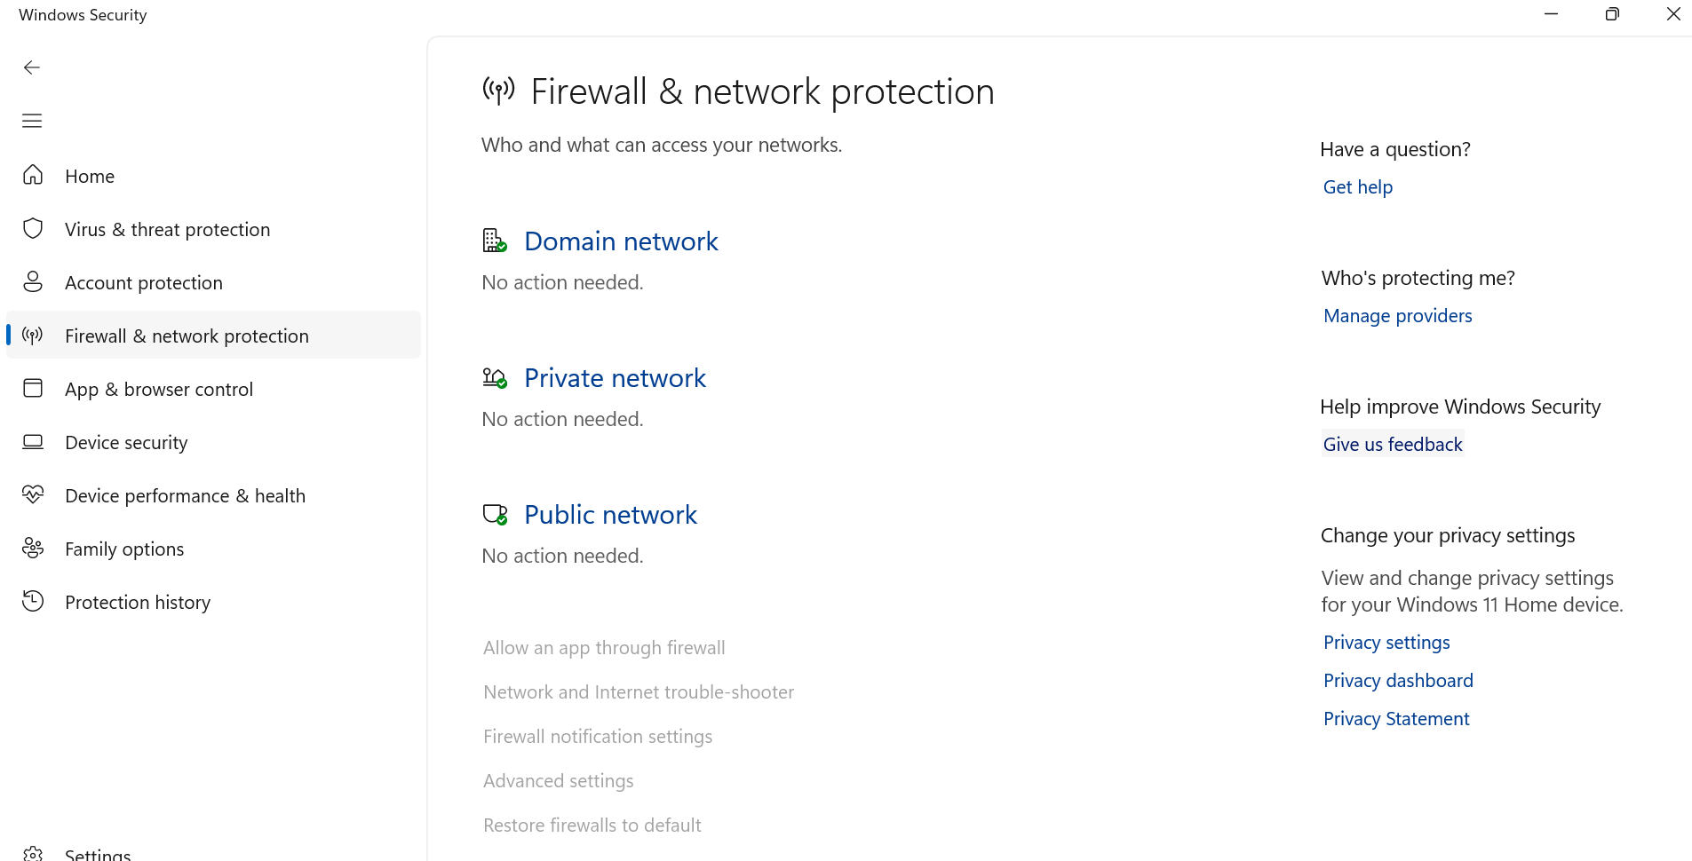
Figure 10 Windows Security in Settings

Overall, the OS acts as a resource allocator that manages the communication between a user and the hardware, it plays a key role with the use of the Kernel is managing CPU, processes, memory, file systems, I/O device management, scheduling algorithms, virtual memory and interrupt handling to efficiently, reliably and securely ensure operations of the computer system. [10]

3.Use of Windows OS CLI commands

3.1 Documentation of 10-12 different Batch &/or PowerShell commands with the use of options/switches
This section will demonstrate key Windows CLI commands used for process management, file management, network analysis, and task scheduling. These commands will provide administrators with direct access over OS resources,

3.1Process management
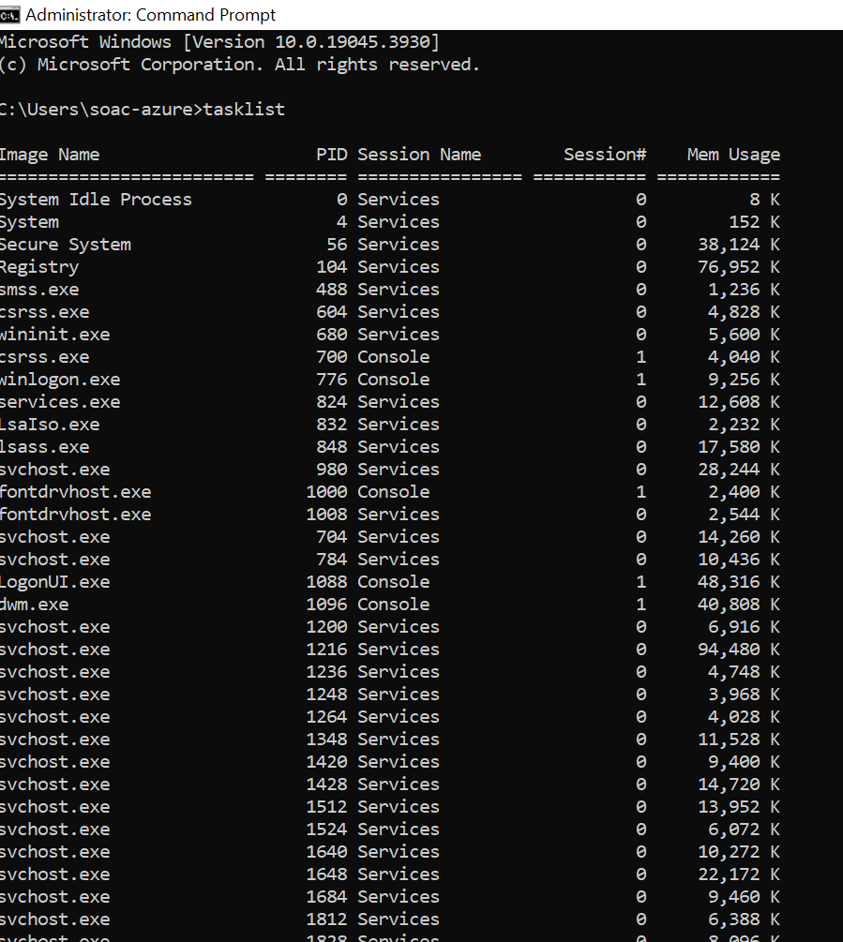
Displays the current running tasks, provides key information for troubleshooting or monitoring system performance such as process name, PID and memory usage on the device. [11]

3.2 File & directory management
The dir /all command shows all files and subdirectories to the user, this includes hidden, system and read-only files, which is normally hidden from the normal dir list. It supports in troubleshooting and system administration to identify all and any hidden malware or misconfigured system files.
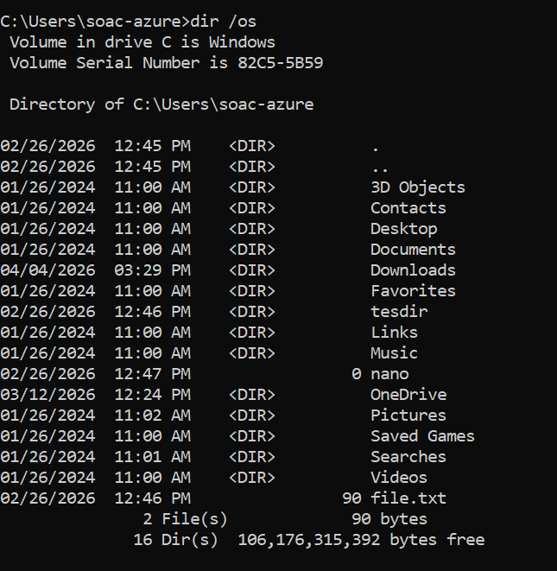
Lists files in a directory sorted by chronological size, this assists with disk space management and troubleshooting to identify large files and managing disk space.
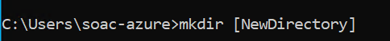
This command creates a new folder quickly and efficiently, allowing the user to organise their files by creating multiple directories at once, supporting with options to set permissions and create nested folders easily. [12]

3.3 Network testing/monitoring
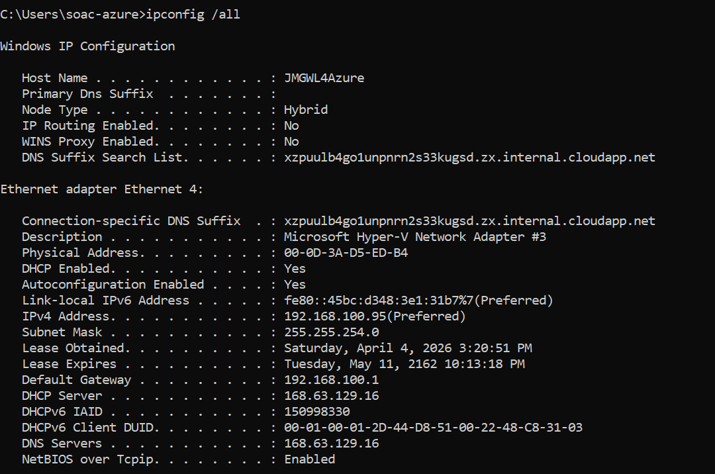
This provides detailed current network configuration, including IP/MAC Addresses, subnet mask, default gateway, DHCP status and server IP, DNS servers and lease times. Useful for diagnosing network connectivity issues and verifying network settings.
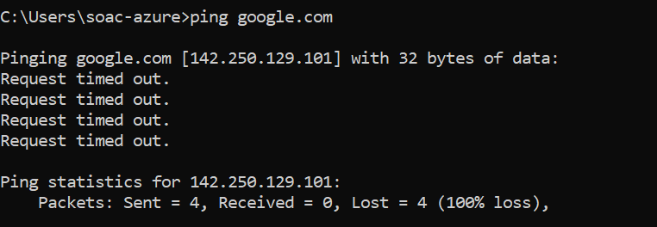
Useful for checking internet connection and measuring latency, it sends packets to test connectivity between devices.
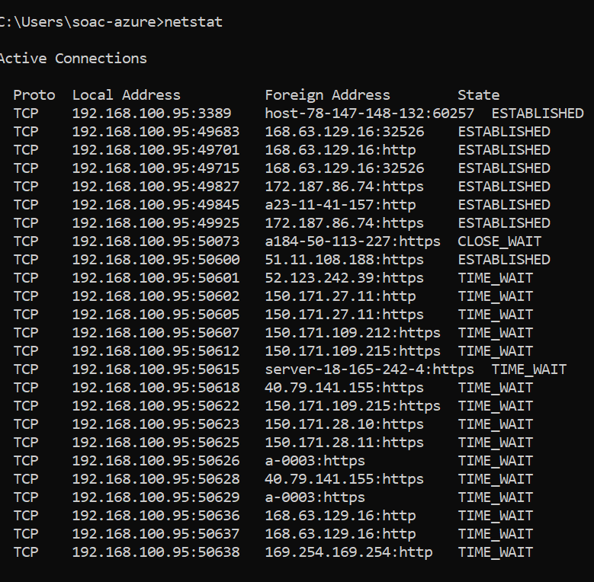
This displays all current TCP and UDP connections, listening ports, and network statistics amd helping monitor network activity, troubleshoot connection issues and bottlenecks, and detect possible security connection threats.

3.4 User management
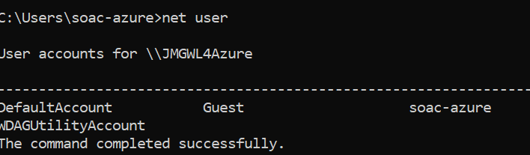
This is faster than navigation through the GUI, it allows one to create, modify, delete and view user accounts on the device, helping administrators manage user accounts, having the ability to reset passwords, enable or delete accounts and manage group memberships through scripts.
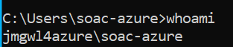
Shows the effective user’s username of the current user and privileges helping verify identities, permissions, security assessments, and show one has the permissions for tasks they are required to access. [13]

3.5 Task scheduling
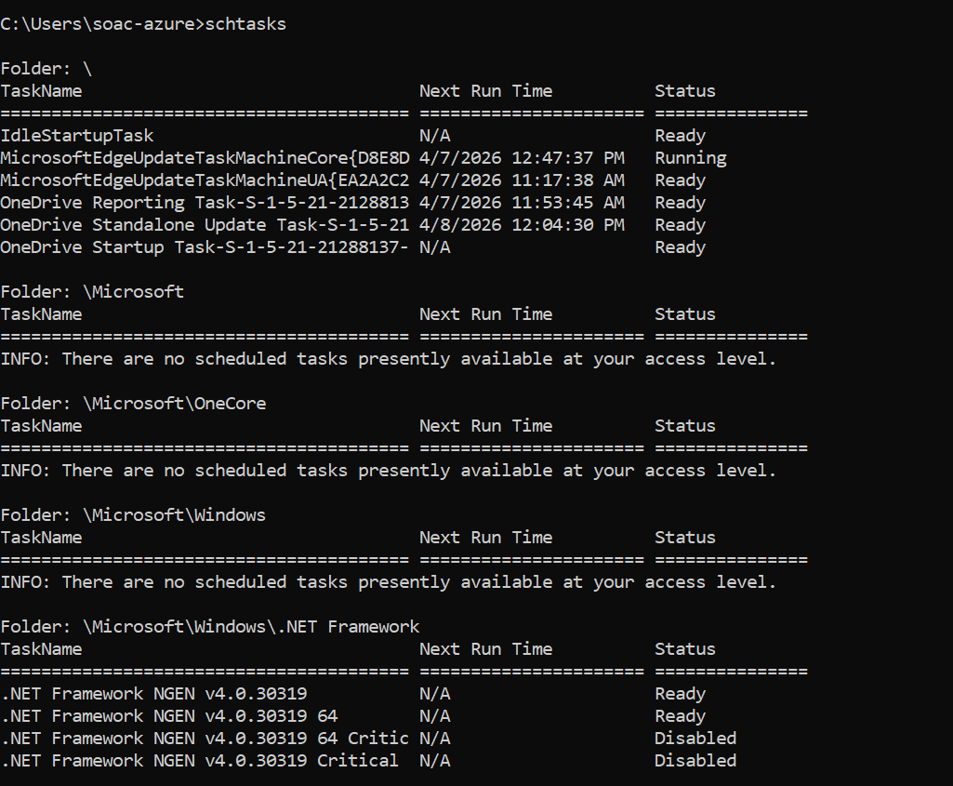
Allows the user to create, delete, query, change, run and terminate scheduled tasks on the system. Which is useful for automating tasks without using the GUI, including on remote systems.
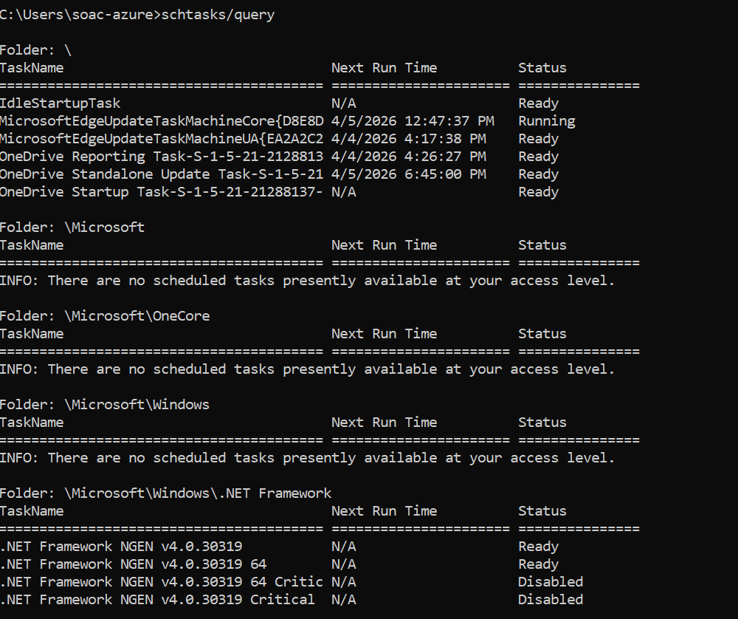
This displays a list of all currently scheduled tasks that are running or will run on the local system, including their status and schedules. Useful for troubleshooting issues, monitoring tasks and identifying any running unauthorised or failed tasks. [14]

4.Use of Linux OS CLI commands [15]

4.1Documentation of 10-12 different Bash commands with the use of options/switches on Ubuntu
This section documents commonly used Linux Bash commands for monitoring system performance, managing files and analysing network activity.

4.1 Process management
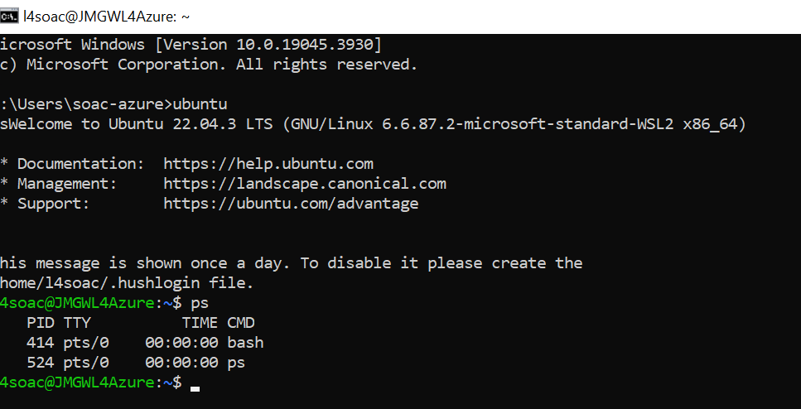
This displays a snapshot of current running processes, including CPU/memory usage, the moment the command is executed. Assisting with diagnosing issues monitoring system activity and their consumption and managing processes.
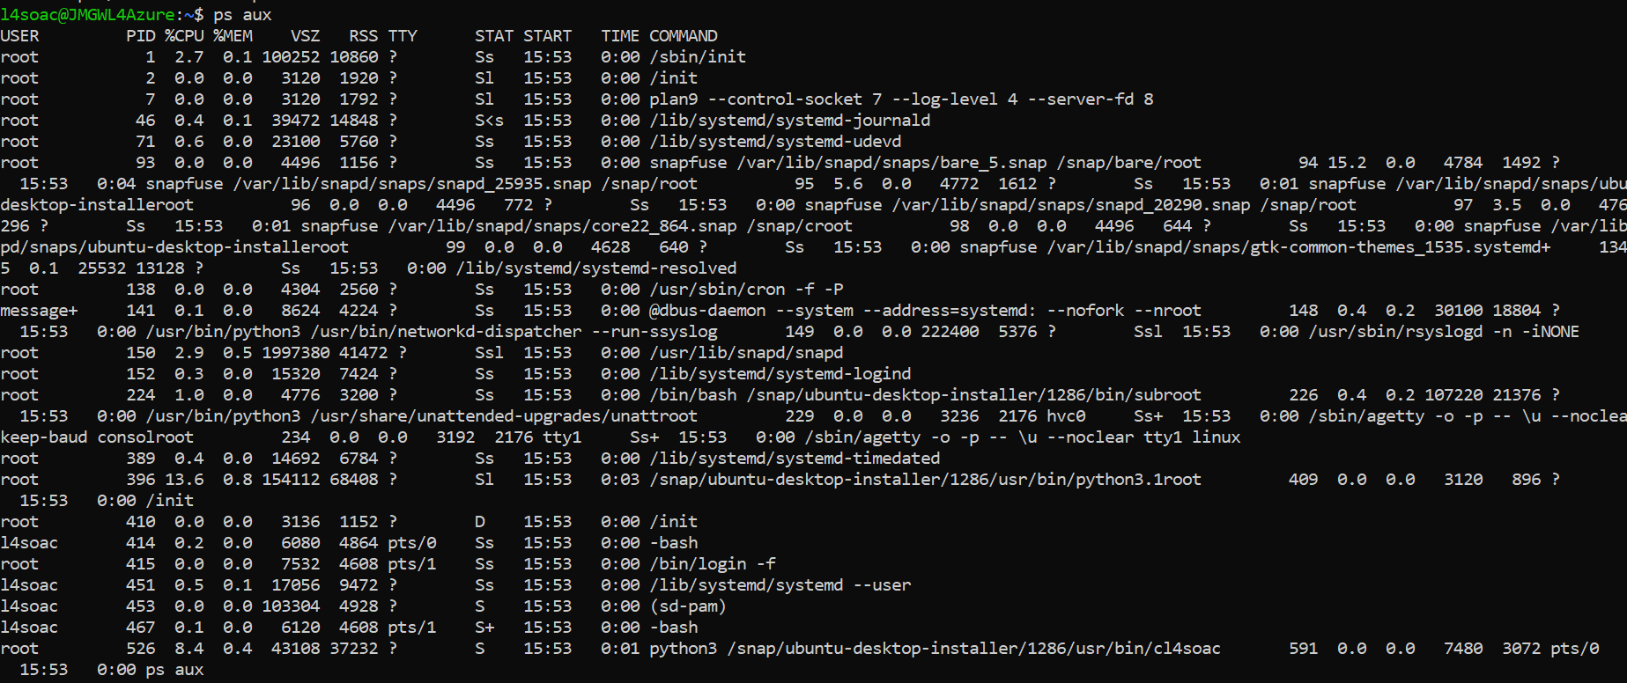
Shows all current running processes owned by all users on the system like the above but also lists processes owned by all users, including detailed information such as resource usage and system services. Used for monitoring performance, diagnose issues and manage and monitor applications and processes.
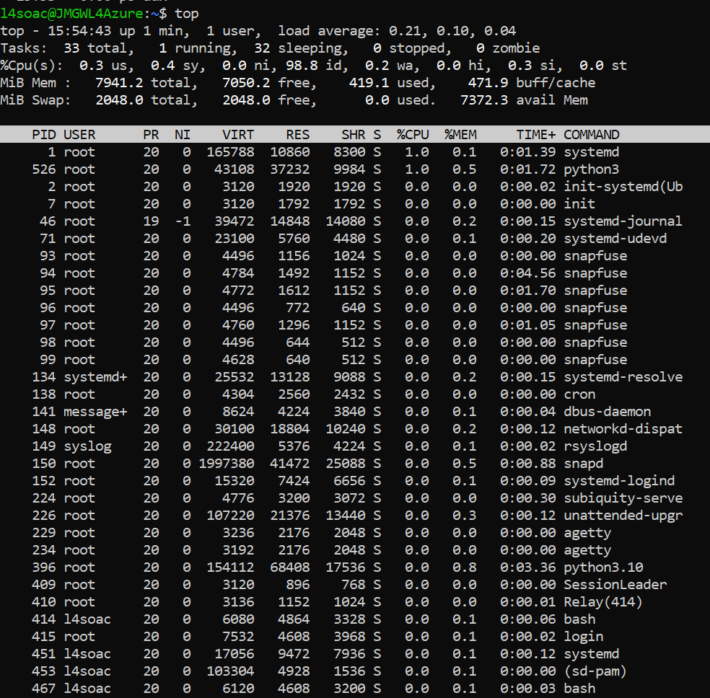
Displays a real-time view of system processes and resource usage managed by the kernel. Key for monitoring performance, process consumption, manage memories and processes.
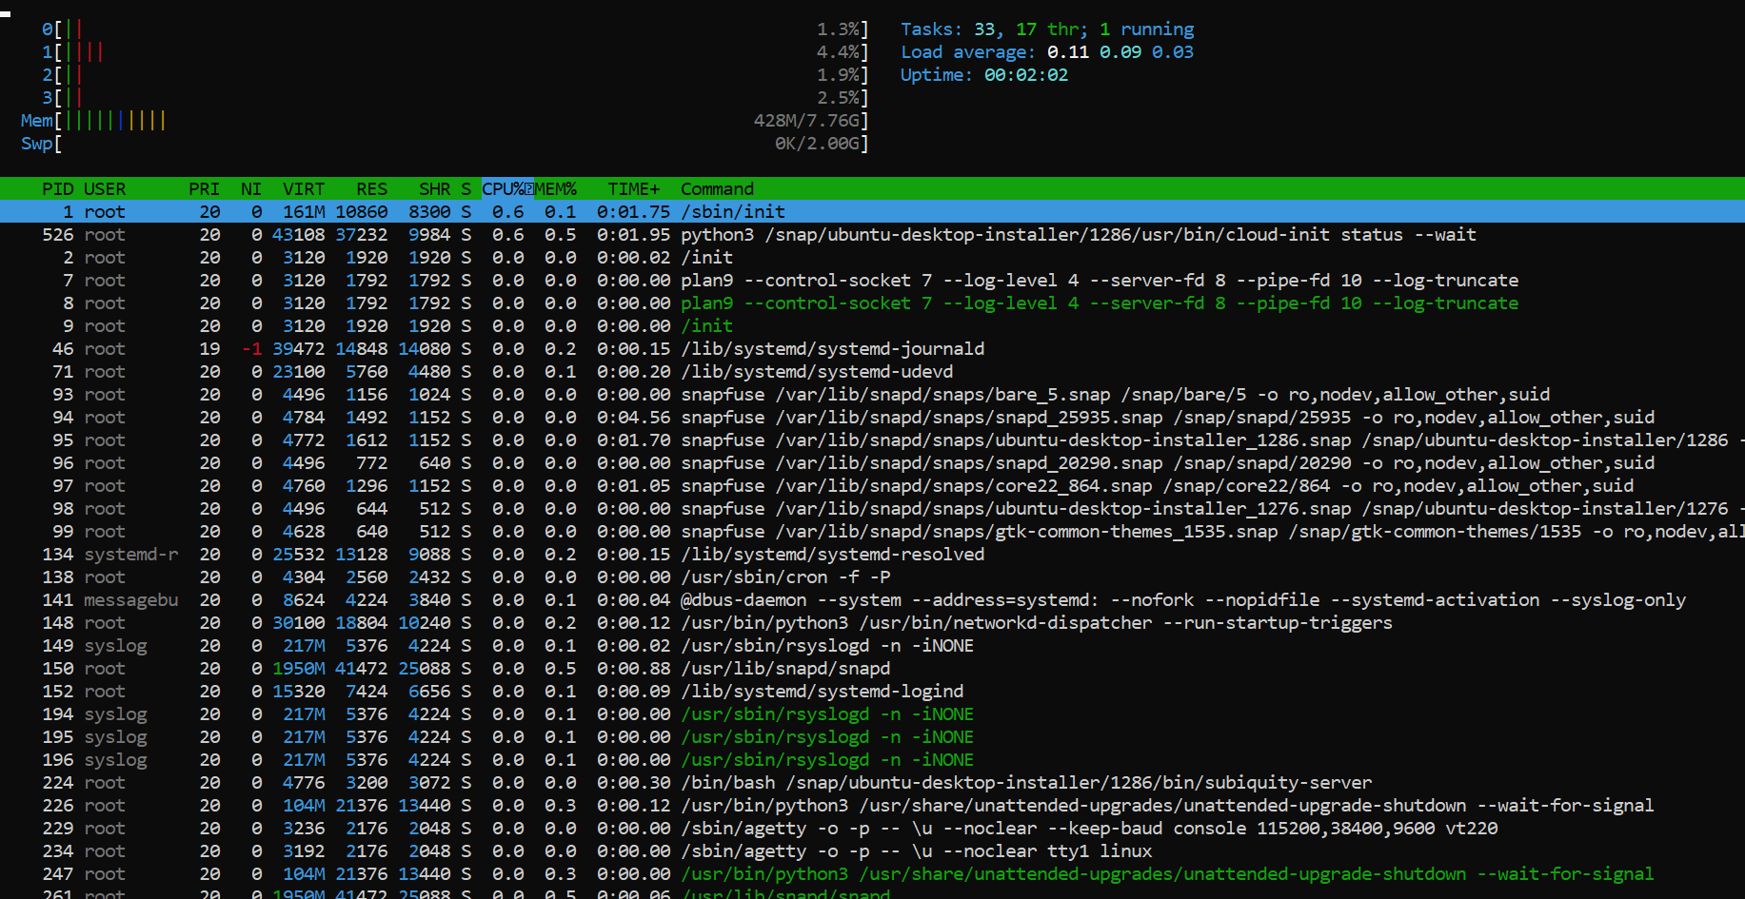
Tool to interact with system processes and manage resources in real time, and an upgraded more user-friendly version the top command. Useful for managing and monitoring processes in real-time.

4.2 File & directory management
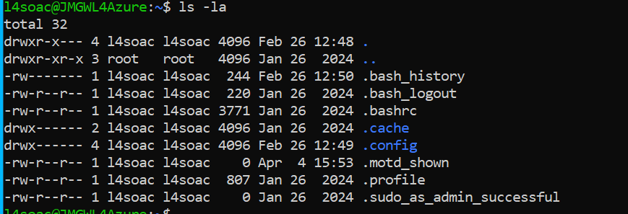
Lists all files in current directory, showing hidden files, and detailed information such as file permissions and size. Useful to manage files and diagnose any file details.
Creates an empty file and updates timestamps of an existing files for file creation and scripting tasks, which is useful for triggering time-sensitive processes and quickly creating empty placeholders without the need to change the actual file content.
Changes file permission to allow read, write and execute for all users. This supports in resolving permission denied errors by identifying who is granted access to read, edit and execute files on the system.

4.3 Network testing/monitoring
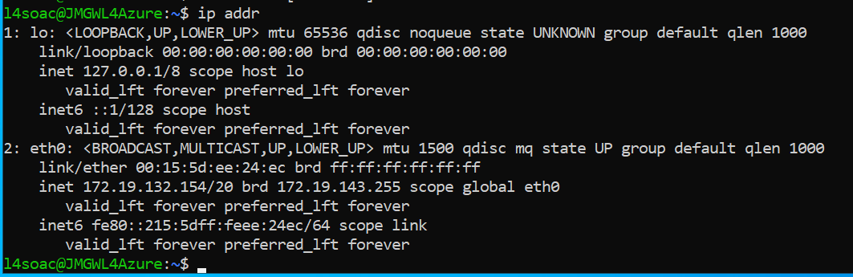
Displays IP addresses, network interface information for network configuration management and useful for diagnosing real-time connectivity issues to identify any faulty equipment or issues with device configuration.
Sends packet requests to Edge’s DNS server to test reachability, access and measure the connection speed with the server. It diagnoses network connectivity and measures latency and response time.
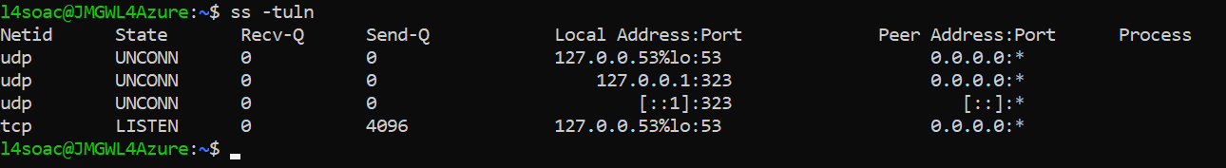
Shows active network connections and listening services to monitor network activity, which is an upgraded version of netstat as it shows real-time connections, useful for checking open services.

4.4 User management/ Task scheduling
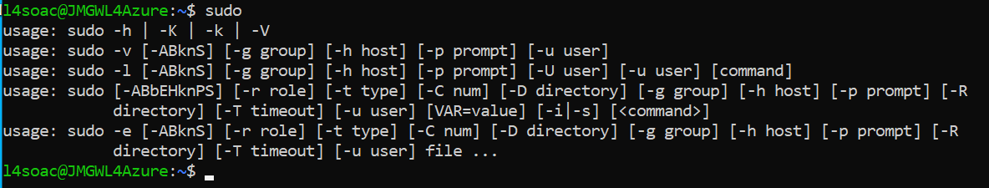
Allows a user permitted to execute commands with elevated privileges, providing a secure and logged method, protecting the system from accidental damage or malicious changes completed by the user performing administrative tasks.
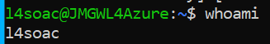
Shows the effective username of the current user using the current shell session, useful for quick verification of the identification in the session, determining the user executing the current tasks.
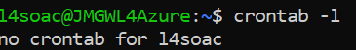
Lists all scheduled tasks on the system and for viewing current user’s crontab file contents to check automated tasks and troubleshoot for scheduling issues, detecting any possible running hidden or unauthorized tasks that a malicious scripts.

5. Use of Windows OS scripts

5.1 Documentation of the use of batch scripts by demonstrating key features of a Win. OS scripting language

Variables
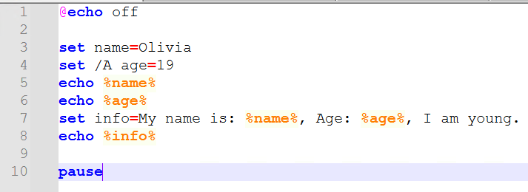
To define variables, one uses the “set” command, in the script, the %name% variable which is enclosed in percent signs to allow access to the set value, which allows the script to store and reuse data flexibly.

User Input
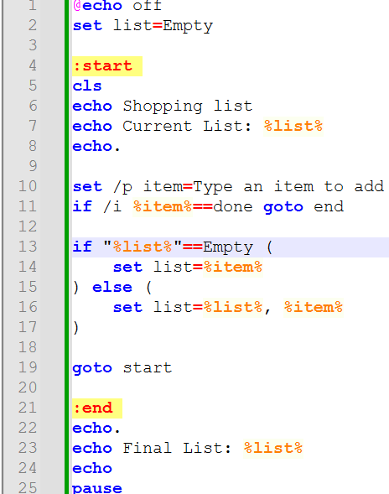
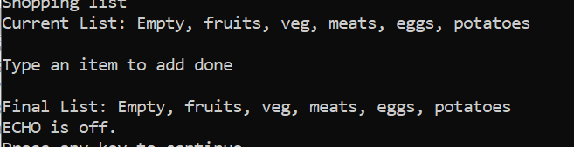
The set/p command is to receive information from the user, of which, this pauses the script and shows a custom prompt to guide the user on what to input. When the user inputs text, it is then stored into a variable, allowing the script to use it to make decisions.

If Statements
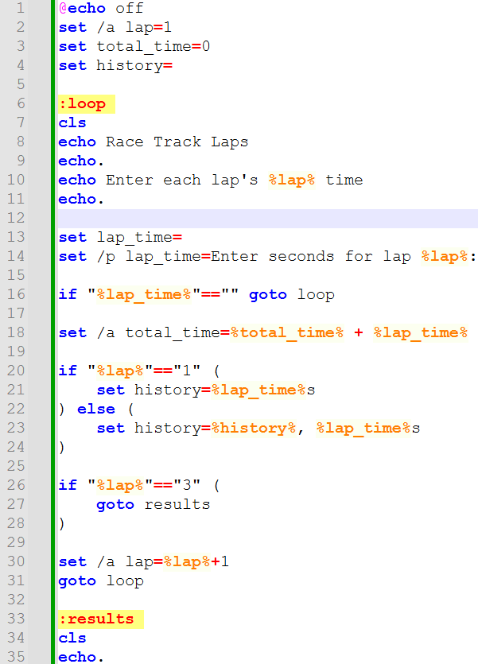
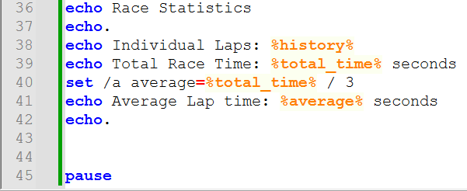
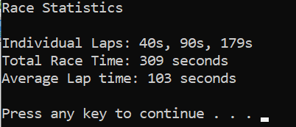
If statements are used for conditional logic. Where the script compares a variable’s value against a specific string using a comparison operator such as “==”. If the condition is true and matches the logic created, then Wbased on the user’s input, it is skipped or moved to the “else” statement.

Loops
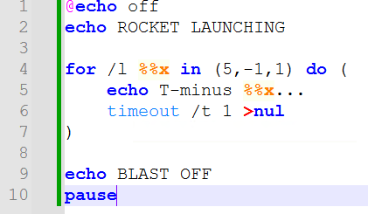
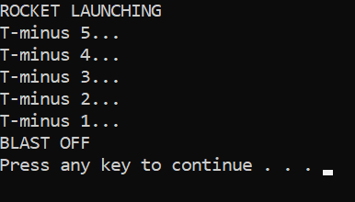
There is “label” and “goto” command to create a repeating loop, which then is used at the end of the script, the OS is then instructed to jump back to that point, making the script run continuously until manually closed.

Functions
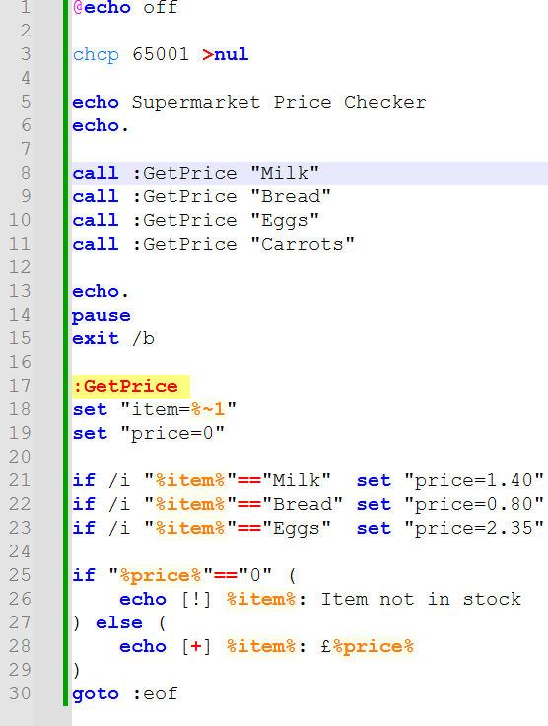
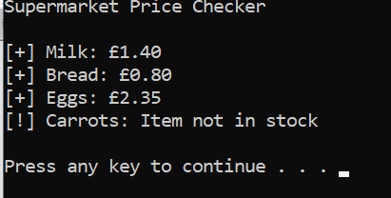
The script uses call command and labels for creating functions, such as the “call :GetPrice”, which the script uses to jump to that point of the code, executes it, then returns to the original line to continue.

Arrays
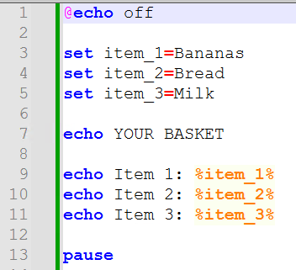

Batch does not use arrays, so a similar one was created by using name variables with suffixes such as “item_1” then a loop, treating the numbered variables as a list of data.

6. Use of Linux OS scripts

6.1 Documentation of the use of Bash scripts by demonstrating key features of a Linux OS scripting language
Every Bash script uses a shebang; “#!/bin/bash” command at the start to give instructions to the Linux Kernel to define it as a bash shell when executing commands in the file for the kernel’s interpreter. Additionally, to use the scripts in the Linux ubuntu, one must use the “chmod +x (script name)”, which gives permission in Linux to execute and run the script as it is not executable by default.

Variables
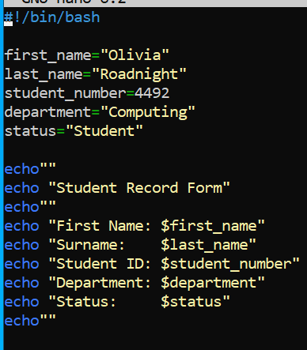
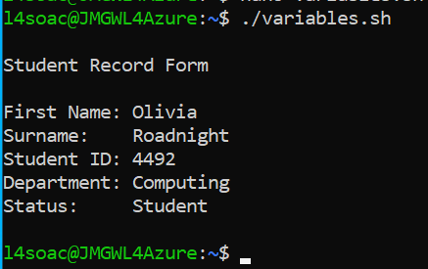
To define variables in bash, it assigns them without spaces around the equals signs. In this script, it uses that variable and a dollar sign prefix to reference it later in the code, which distinguishes the variables name from the data it contains.

User Input
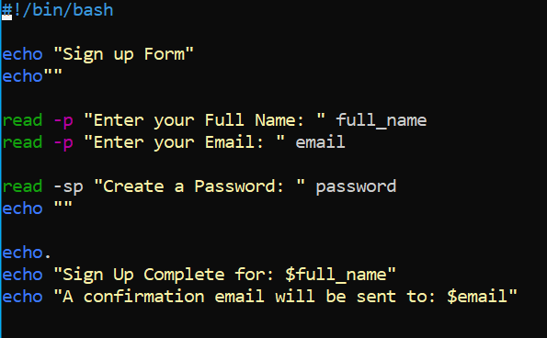
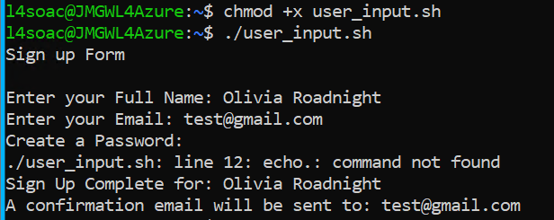
This script uses the “read” command to be interactive with the user, the command pauses execution and waits for user input a response to a prompt on the code, which is then stored into the specific variable it is addressing, and allows the script to process continually changing data received in real time.

If Statement
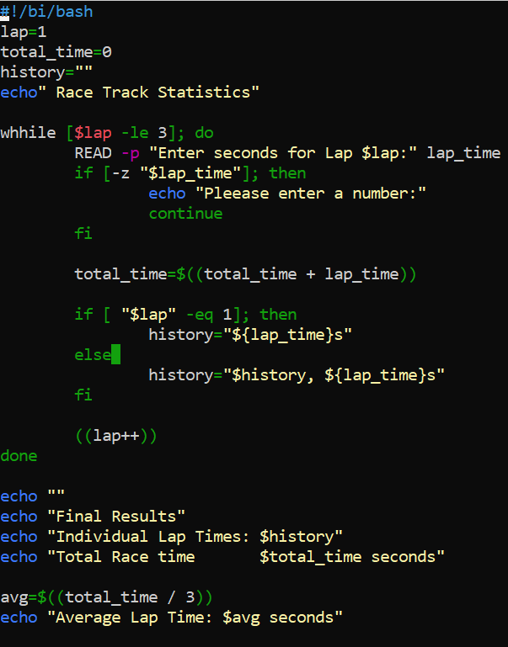
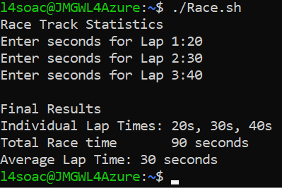
If, then and fi blocks of code is used to handle conditional logic in the script. This one evaluates condition inside square brackets, and if it is met, the code after “then” is executed. Which is helpful for handling errors and making logical decisions based on user data.

Loops
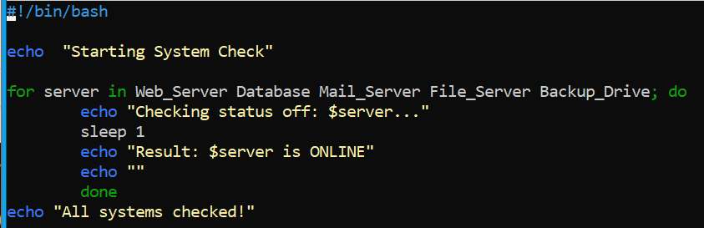
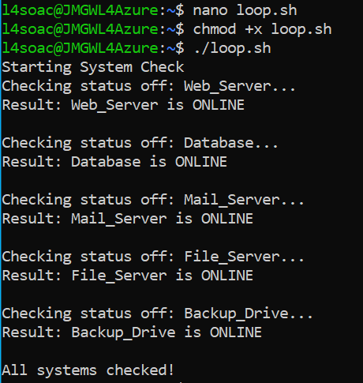
The “for” loop allows the script to repeat specific instructions in the code. In bash, loops use “do” and “done” commands to structure the code, allowing the script to perform repetitive tasks, including processing multiple files or counting numbers without the need for developer intervention.

Functions
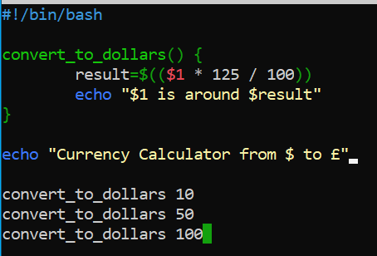
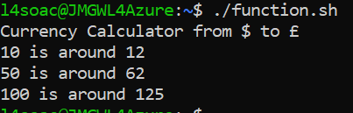

Bash uses functions to flexibly use code, such as by grouping a unique name, allowing for multiple calls of the same piece of code from different points in the script, which avoids code duplication and make it easier to maintain.

Arrays
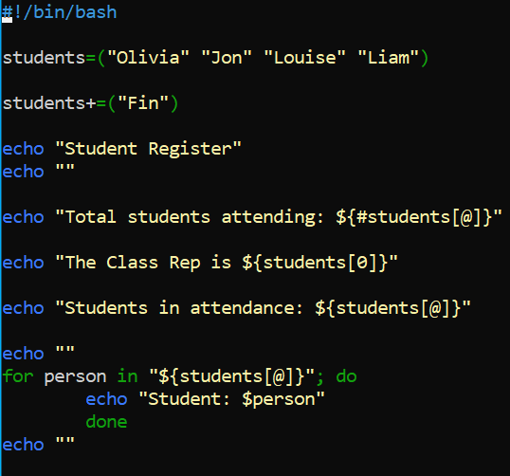
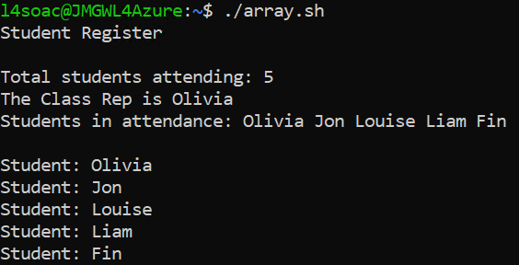
An array in bash is defined using parentheses, this script uses a single variable to store multiple related items. This helps with managing the list of data and repeatedly go over them, making it useful for managing a list of system users or filenames.

7. Conclusion and Key Findings
Overall, Batch and Bash syntax differs significantly, both provide thee logical code for scripting such as variables, loops and conditional logic, key for system administration and management.
Key findings:
Using loops and functions in Batch and Bash can replace repetitive manual tasks with reusable and efficient scripts, reducing human error and ensure consistency of operations across the OS.
Additionally, both languages provide reliable methods for interactive communication with systems. The set /p and read command allows scripts to adapt to real-time user input, making it a useful tool for real-time guided system configurations.
Furthermore, to make complex decisions both use if statements, improving error handling, by checking conditions such as file existence or user permissions before execution and whether they meet conditional logic validation or not.
Batch files are easier to run as they can be executed directly whereas Bash scripts require permissions using the “chmod +x” command to run, which demonstrates that Linux is considered more secure according to users and that the systems enforce stricter access control and follow “least privilege” principles.
Finally, administrators can more quickly monitor CPU usage, handle file systems and check network health using CLI commands as the scripts provide direct access to the systems resource management features, which is quicker compared to accessing a GUI for more experienced users. However, it is easier to use the GUI for beginners as it is visual and intuitive to navigate, and is often easier for completing quick infrequent tasks, and quick for investigating the source of the problem when troubleshooting as it is easier to read rather than a complex CLI output.
In summary, the OS acts as an intermediary between hardware and software. These features are essential for system administration, as they improve system performance, maintainability and security. Which was investigated through research and documenting critical functions of general ones, and testing Batch commands in a Windows CLI, and Bash commands in Ubuntu Linux. Creating Windows OS batch scripts and of Linux OS scripts, which were all tested and evidenced the results on this report with screenshots of the processes, then concluding with key findings and a final conclusion.

8. Appendices

Appendix 1: Engagement with Lecture Activity Answers
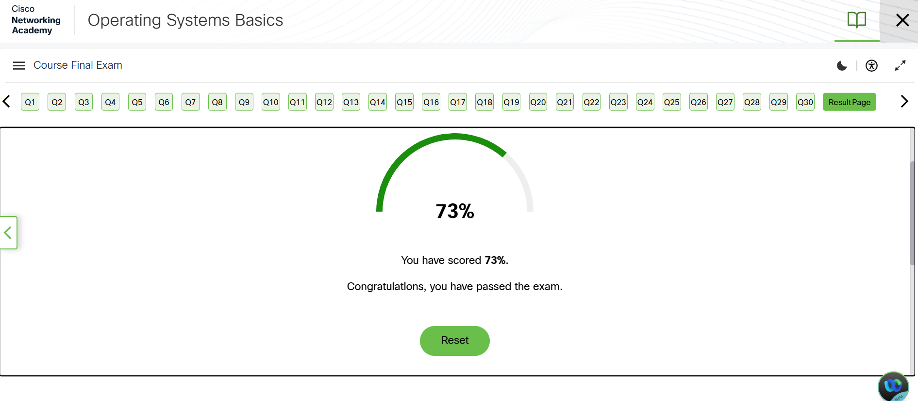
Figure 11 Cisco Operating System Basics Course on Cisco Learning
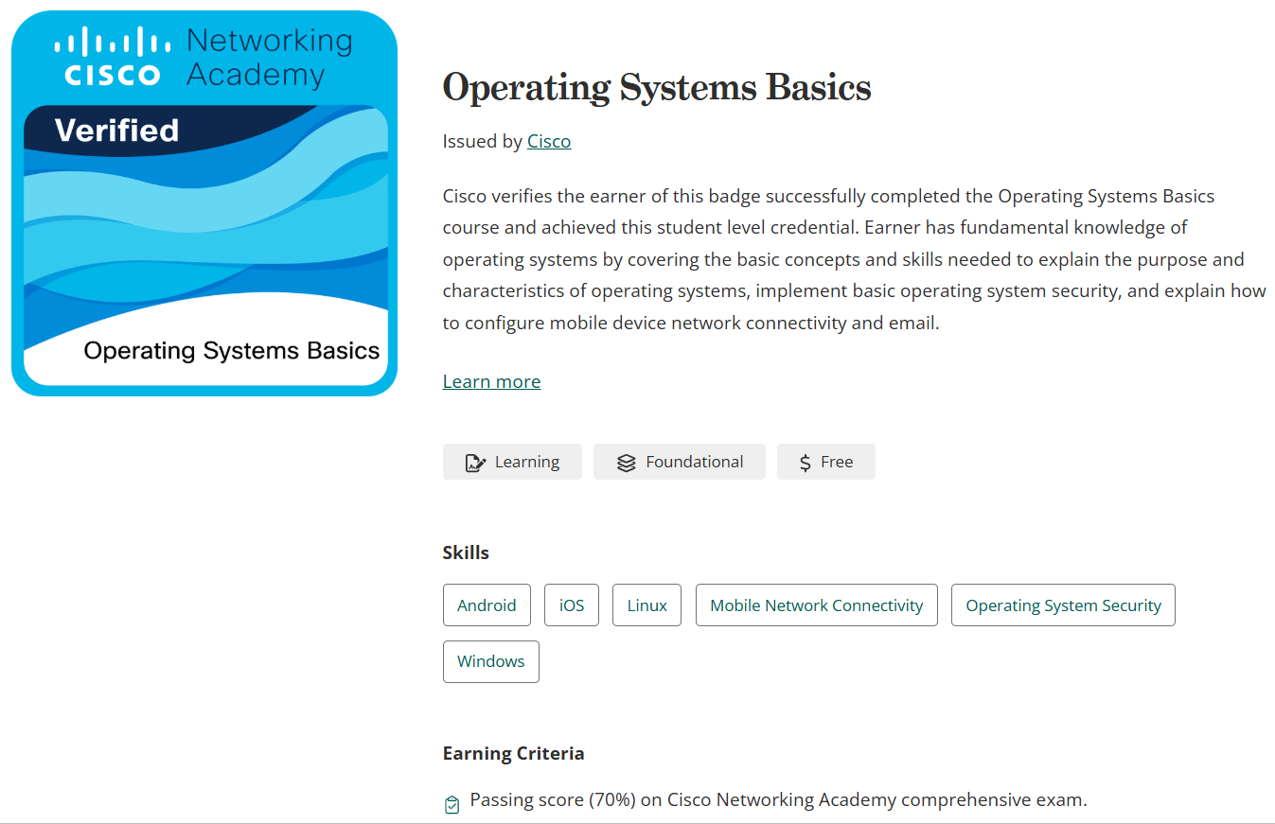
Figure 12 Cisco Learning course: https://www.netacad.com/courses/operating-systems-basics?courseLang=en-US
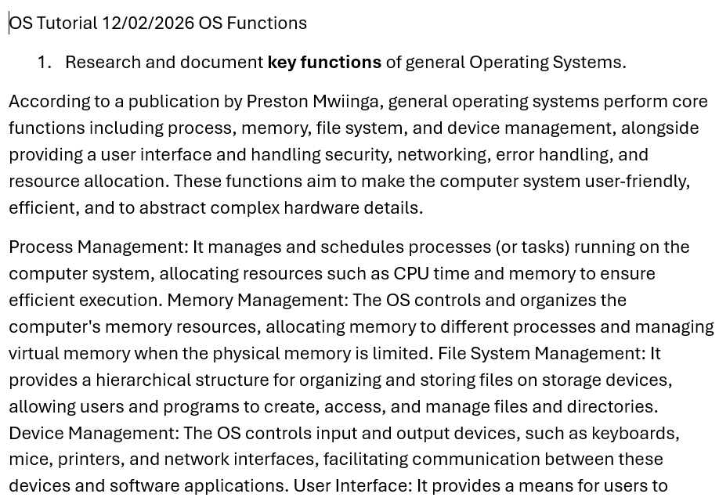
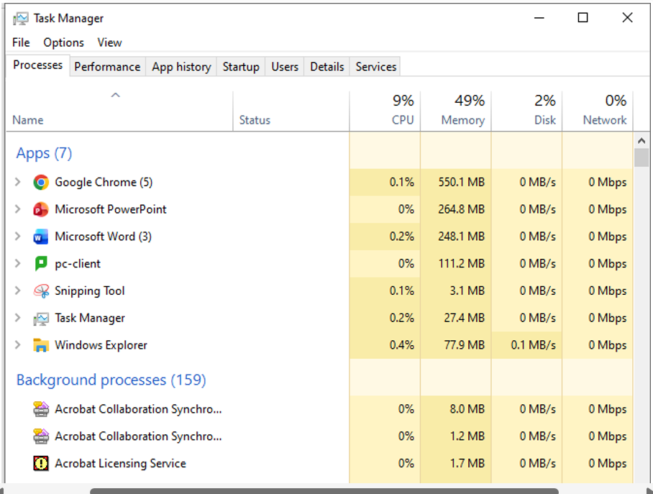
Figure 13 Lecture Activity with Windows OS features
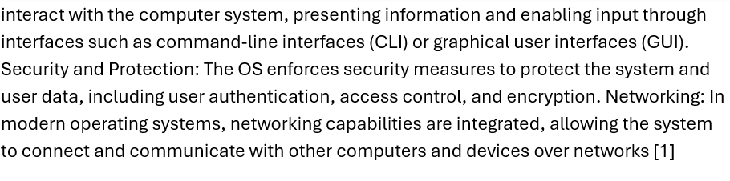

Appendix 2: Additional Script Screenshots

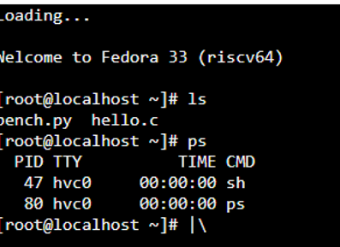
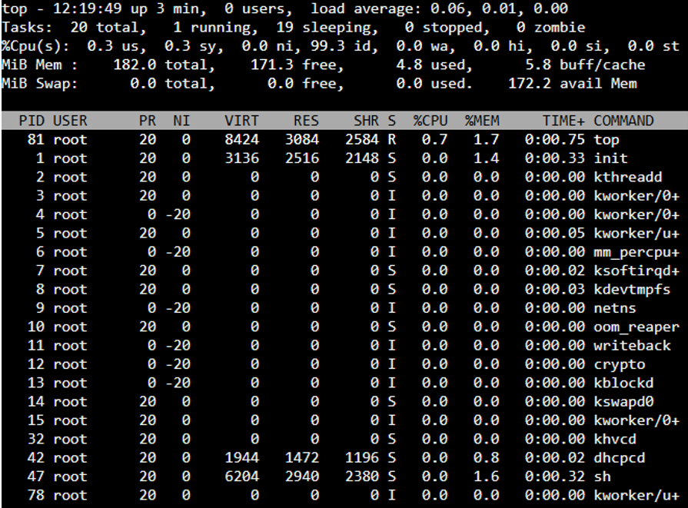
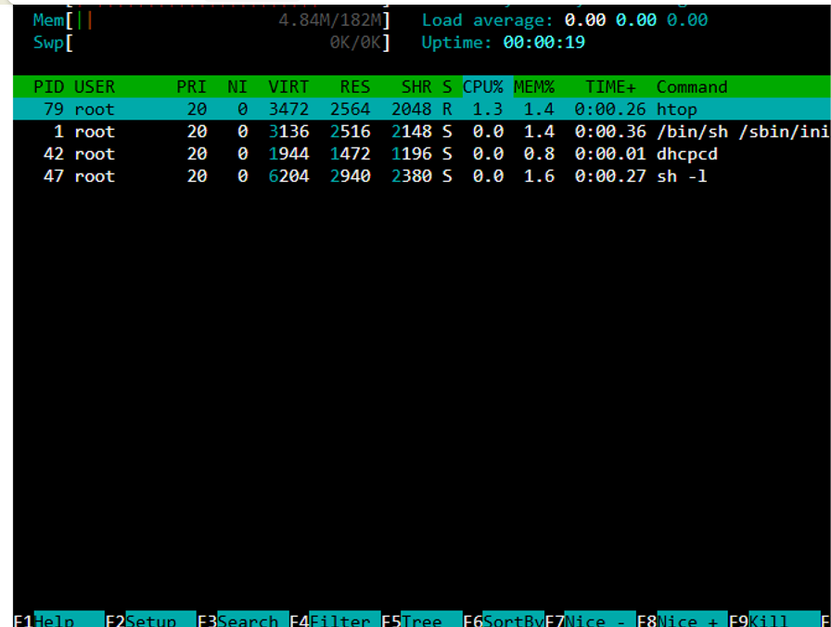
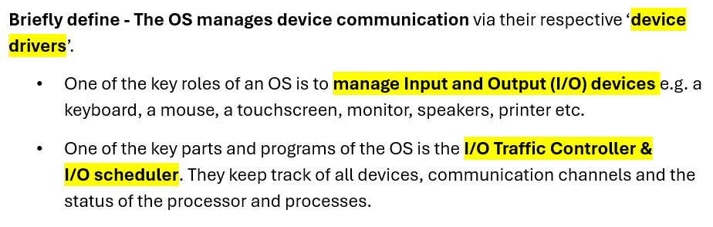
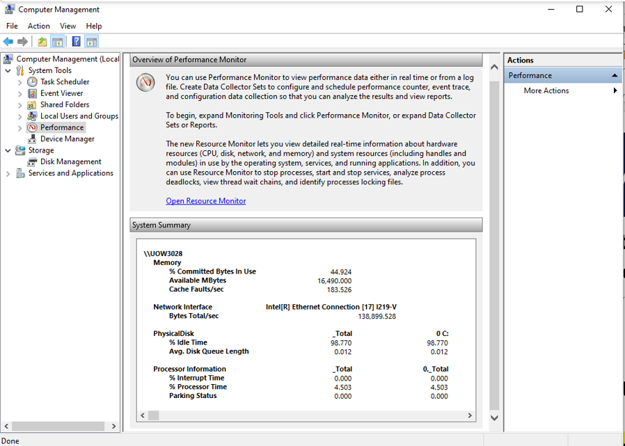
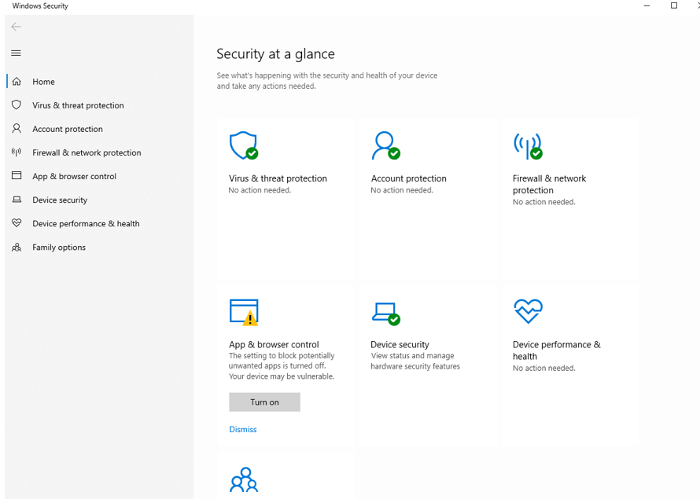
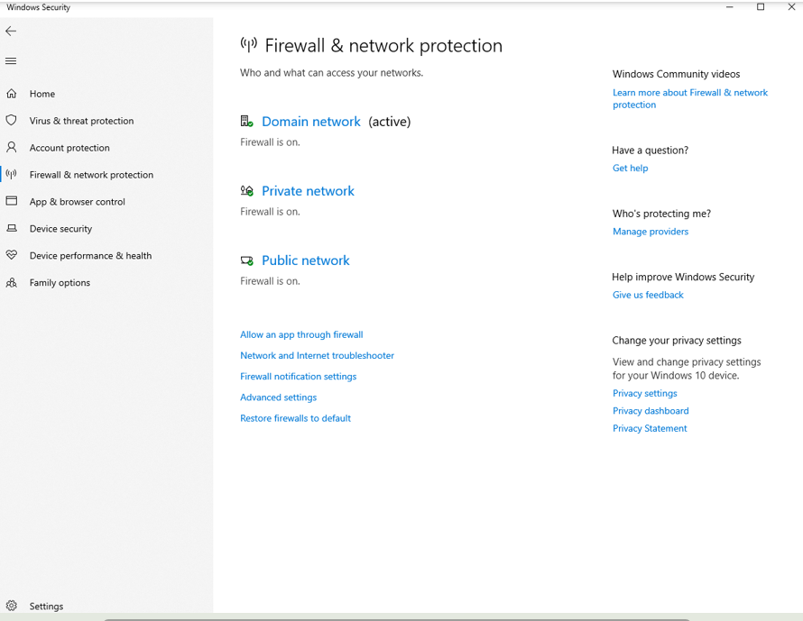
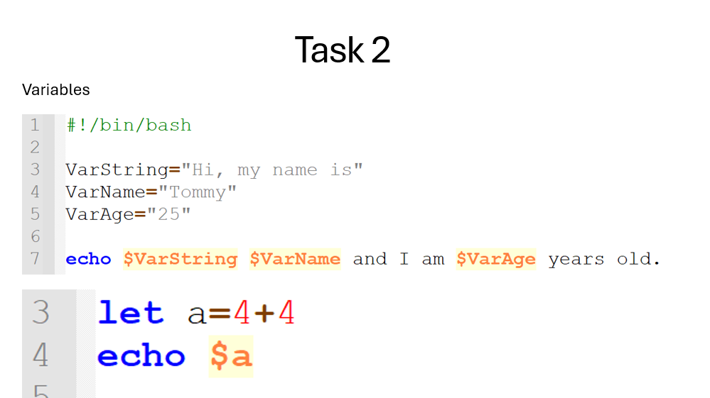
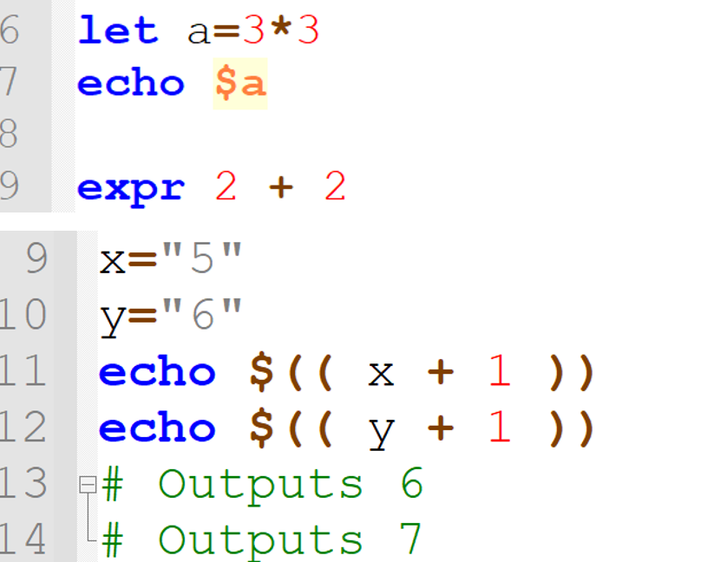
Figure 14 Lecture Activity with Bash
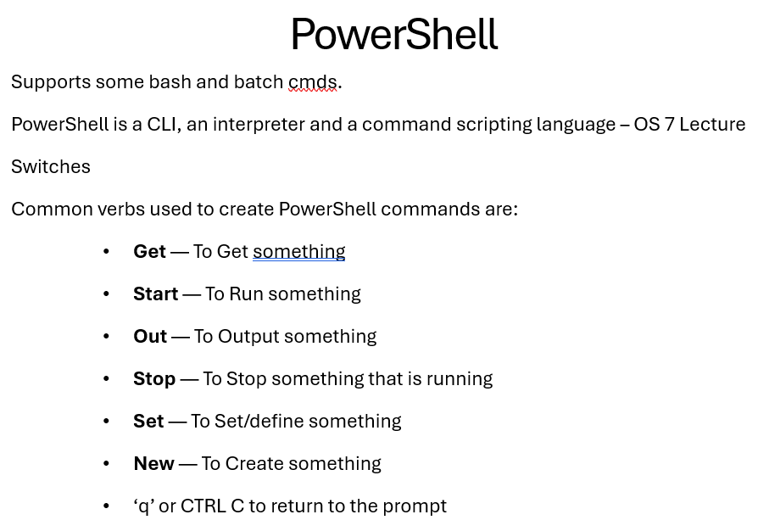
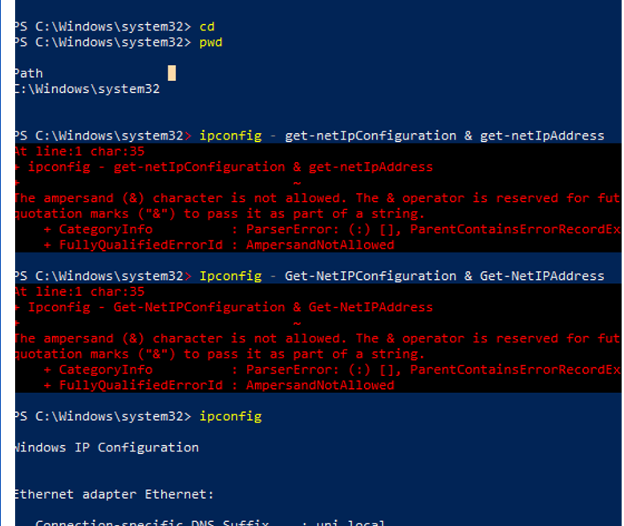
Figure 15 Lecture Activity Batch
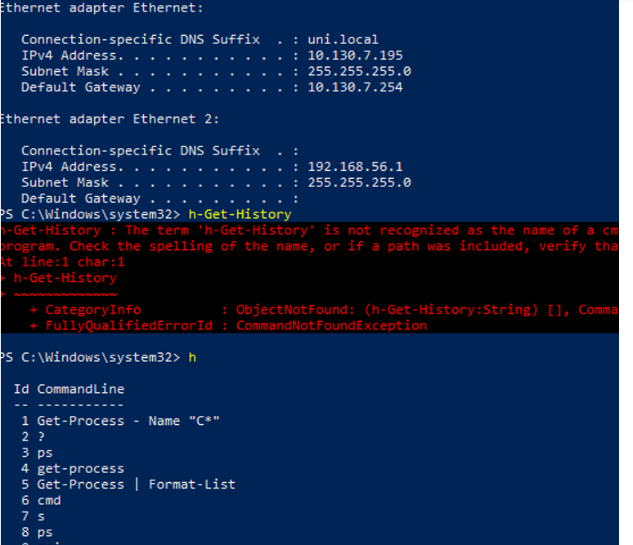
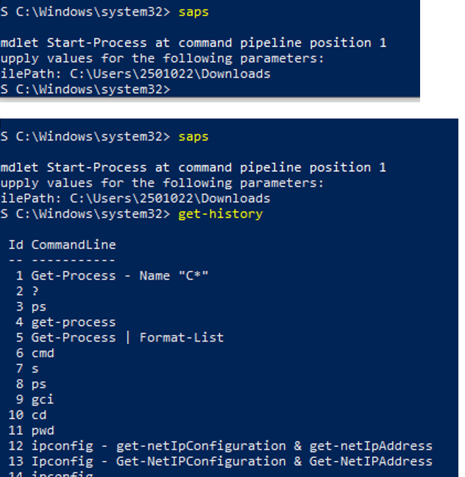
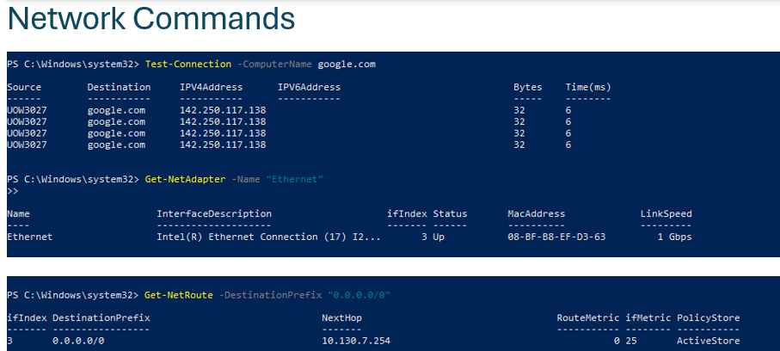
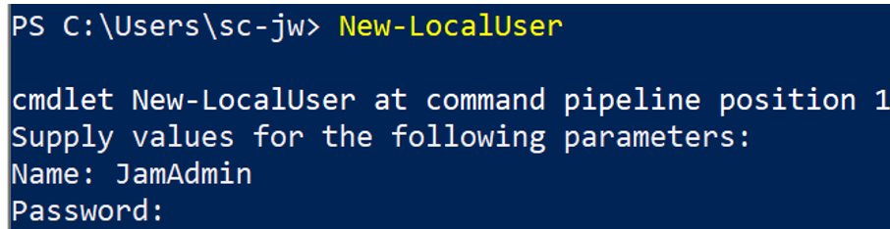

9. References

[1] | M. Y. Shakor, “Chapter One Introduction to Operating System Concepts,” [Online]. Available: https://www.researchgate.net/publication/364185356_Chapter_One_Introduction_to_Operating_System_Concepts.
[2] | GeeksForGeeks, “Introduction to Operating System,” [Online]. Available: https://www.geeksforgeeks.org/operating-systems/introduction-of-operating-system-set-1/.
[3] | webmaster01122, “Module 1 - Platform Technologies (1).pdf,” [Online]. Available: https://www.slideshare.net/slideshow/module-1-platform-technologies-1-pdf/270878534.
[4] | jumpcloud, “What Is an OS Kernel?,” [Online]. Available: https://jumpcloud.com/it-index/what-is-an-os-kernel#:~:text=Central%20Control,resources%20and%20managing%20context%20switching..
[5] | GeeksForGeeks, “Kernel in Operating System,” [Online]. Available: https://www.geeksforgeeks.org/operating-systems/kernel-in-operating-system/.
[6] | C. S. E. Team, “What Is Memory Management? How It Works, Techniques, and Uses,” [Online]. Available: https://www.coursera.org/articles/memory-management.
[7] | R. Geissler, “What is the purpose of virtual memory on a Windows operating system? Is it necessary to have virtual memory?,” [Online]. Available: https://www.quora.com/What-is-the-purpose-of-virtual-memory-on-a-Windows-operating-system-Is-it-necessary-to-have-virtual-memory.
[8] | R. Naraian, “What happens when you press a key on keyboard,” [Online]. Available: https://www.hackerearth.com/practice/notes/write-a-step-by-step-execution-of-things-that-happen-after-a-user-presses-a-key-on-the-keyboard-use-as-much-detail-as-possible/#:~:text=Below%20step%20by%20step%20execution,the%20IRQ%20number%20for%20this).
[9] | GeeksForGeeks, “Interrupt in Operating System,” [Online]. Available: https://www.geeksforgeeks.org/operating-systems/interrupts/.
[10] | intechfy, “Functions of Operating System in Detail: Process, Memory, and Device Management,” [Online]. Available: https://intechfy.com/functions-of-operating-system/.
[11] | Microsoft, “Microsoft Build 2026,” [Online]. Available: https://learn.microsoft.com/en-us/windows-server/administration/windows-commands/tasklist.
[12] | C. Team, “Complete List: Command Line Prompt (CMD),” [Online]. Available: https://www.codecademy.com/article/command-line-commands.
[13] | M. Learn, “Microsoft Build 2026,” [Online]. Available: https://learn.microsoft.com/en-us/windows-server/administration/windows-commands/whoami#:~:text=The%20whoami%20command%20shows%20information,current%20domain%20and%20user%20name..
[14] | M. Learn, “Microsoft Build 2026,” [Online]. Available: https://learn.microsoft.com/en-us/windows-server/administration/windows-commands/schtasks-query.
[15] | A. S. Walia, “50+ Essential Linux Commands: A Comprehensive Guide,” [Online]. Available: https://www.digitalocean.com/community/tutorials/linux-commands.
[16] | Preston-Mwiinga, “https://www.researchgate.net/profile/Preston-Mwiinga/publication/372132620_OPERATING_SYSTEM/links/64a5a0ddc41fb852dd53fc24/OPERATING-SYSTEM.pdf,” OPERATING SYSTEM.
[17] | C. Team, “Complete List: Command Line Prompt (CMD),” [Online]. Available: https://www.codecademy.com/article/command-line-commands.
[18] | A. S. Walia, “50+ Essential Linux Commands: A Comprehensive Guide,” [Online]. Available: https://www.digitalocean.com/community/tutorials/linux-commands.

