Dissertation for Masters of Business Administration (MBA) 2021

Jamie Wilson
1803758
The relationship of operational efficiency activities with employee engagement
Submitted: 16th July 2021





Declarations
This work has not previously been accepted in substance for any degree and is not being concurrently submitted in candidature for any degree.

Signed – Jamie Wilson (candidate)

Date 16/07/2021

STATEMENT 1

This work is the result of my own investigations, except where otherwise stated.

Other sources are acknowledged by footnotes giving explicit references. A bibliography is appended.

Signed – Jamie Wilson (candidate)
Date 16/07/2021

STATEMENT 2

I hereby give consent for my work, if accepted, to be available for photocopying and for inter-library loan, and for the title and summary to be made available to outside organisations.

Signed – Jamie Wilson (candidate)
Date 16/07/2021

Acknowledgements
I would like to express my sincere thanks to my family for their continued support, encouragement, and guidance throughout this MBA. The sacrifices they’ve made throughout this programme have made this possible.
I would also like to thank the survey respondents who took the time to participate in this study, without this help, research for this project would not have been possible. Finally, I’d like to thank Glenn Behenna for his support and guidance as a supervisor throughout this process.

Abstract
The competitive environment in which modern businesses operate require them to be operationally efficient whilst targeting high levels of employee engagement (Felix & Maggi, 2019). These business aims are related and in pursuit of one may degrade the other. Business leaders lack sufficient guidance as to what efficiency strategies can be implemented without having a significantly detrimental effect on employee engagement.

The aim of this research is to determine the interaction between typical business operational efficiency activities and employee engagement to inform strategic organisational decision making.

Secondary research and extant literature have been reviewed to identify contemporary business efficiency activities and antecedents to employee engagement. Relationships between the activities and engagement factors have been theorised.

A quasi-experimental research method has been used to answer the specific research question What relationship do efficiency activities have with employee engagement? A quantitative survey was used to gather data from a non-probability voluntary response sample.

Analysis of the survey responses demonstrated several relationships between operational efficiency activities and employee engagement level. It can be shown that Job Enrichment is the category of engagement factor which has the largest interaction with efficiency activities. Individual efficiency activities have been ranked to provide guidance to business leaders.

Table of Contents
Declarations 2
Acknowledgements 3
Abstract 4
Table of Contents 5
Chapter 1 - Introduction 7
1.1 Background 7
1.2 Research Rationale 8
1.3 Aims and Objectives 10
1.4 Research Design 10
Chapter 2 - Literature Review 12
2.1 Introduction 12
2.2 Operational Efficiency 12
2.3 Employee Engagement 25
Chapter 3 - Theoretical Framework 29
Chapter 4 - Methodology 33
4.1 Introduction 33
4.2 Research Design 33
4.3 Data Collection 34
4.4 Methods of Analysis 35
4.5 Ethical Consideration 37
Chapter 5 - Analysis of Results 38
5.1 Introduction 38
5.2 Descriptive Statistics 38
5.3 Correlations 43
5.4 Limitations 48
Chapter 6 - Conclusions and Recommendations 49
Bibliography 54
Appendix A – Survey Questions 60
Appendix B – Correlations Table 64

Introduction

Background
A business is defined as an organisation which produces and sells goods or which provides a service (Collins Dictionary, 2021). In order for a business to be successful it must make a profit. That is not to say however that the sole purpose of every business is to make a profit. The purposes of many businesses are based on the passion or vision of their founder, which if successfully developed, results in profit (Freeman, 2014).

While profit is an intrinsically important measure, it is clear that focusing too heavily on profit can lead to profit maximisation strategies that may degrade or contradict the businesses main purpose or values (Ahlstrom, 2010). To understand a business’s performance, we must measure how well it uses its resources to generate that profit, i.e. its efficiency.

Efficiency began to be widely discussed in management in the late 19th and early 20th century as the theory of scientific management was being developed by Frederick Taylor (Muldoon, 2020). Many followers of the efficiency movement extended Taylors theory throughout the 20th century, and efficiency remains a core measurement in most management theories today – despite being applied quite differently. Classical efficiency measures were focused predominantly on optimising individual tasks (Taylor, 1911).

Whilst efficiency optimisation still plays an important role in ensuring a business is profitable, an obsessive focus can have negative effects. For example, asking a design team to undertake more product designs but with no resource increase is essentially asking them to be more efficient. This can work up to a point, until the design team become over-worked, miss deadlines, suffer from stress related ill-health, and become disengaged from the company, potentially seeking employment elsewhere.

The style of efficiency measure in the aforementioned example, although sometimes necessary, is clearly non-sustainable and will consequently impact the longer-term success of the organisation (Ramsay, 2019). To sustain business success an organisation must be able to adapt to changing circumstances. This ability to anticipate, prepare for, respond and adapt to incremental change and sudden disruptions in order to survive and prosper is defined as the organisations resilience (Denyer, 2017).

Martin (2019) suggests that building organisational resilience can generate a greater competitive advantage and advises businesses to sacrifice some short-term efficiency gains in favour of longer-term productivity by investing and trusting in employees.

Organisational resilience is becoming increasingly important. Recent years have seen high levels of uncertainty due to political and economic tensions (Lelieve, et al., 2019). The pace of technological development and the disruption of advances such as autonomous driving, alternative powertrains and new mobility solutions within the automotive industry alone have been substantial.

In addition to these developing external factors, the year 2020 saw one of the most substantial global disruptions in modern times. The coronavirus pandemic has exposed points of weakness in many organisations and highlighted the need for greater resilience (Barriball, et al., 2020).

Globalisation has continued to grow, despite significant turbulence in recent years (Ghemawat & Altman, 2019). Globalisation can be a source of opportunity but can also introduce additional risk. The tumultuous geopolitical environment that multinational businesses operate in requires resilience to deal with the external factors that have the potential to impact any area of the organisation (European Commission Joint Research Centre, 2015).

To build organisational resilience, employee’s need to be able to adapt to change, have clear alignment with business goals and often be willing to go the extra mile – all of which are traits more commonly found in engaged employees (Craig, 2018). Employee engagement is a term that has become widely used in management and human resource fields. Shuck & Wollard (2010) define employee engagement as “an individual employee’s cognitive, emotional, and behavioural state directed toward desired organisational outcomes”. Studies show that an engaged employee demonstrates, on average, a 20% individual performance improvement and are 87% less likely to leave the organisation (Buchanan, 2004).

Globalisation also leads to increased competition (Bang & Markeset, 2011). Customers have a greater choice of goods and services and how they acquire them. The expectations of customers require businesses to maintain a competitive advantage, partly, through increased quality and lower prices (Bang & Markeset, 2011). In a highly competitive market businesses must operate efficiently to meet profit aspirations.

In summary, high levels of competition and uncertainty in a globalised market require businesses to be efficient and resilient. The antecedent to these characteristics is hypothesised to be engaged employees. This research aims to study the link between engaged employees and business efficiency strategies.

Research Rationale
The business issue that this research aims to address is based on businesses experiencing increasing competitiveness (which requires high efficiency), increasing external uncertainty (which requires organisational resilience), and changing social norms / attitudes to work (which requires organisations to consciously create a work environment that attracts, retains and develops people). These interrelated issues have varying degrees of existing literature and require careful consideration to obtain a successful balance.

Research on business efficiency is extensive and a multitude of contemporary articles and papers are available (Coelli, et al., 2005). The strategies employed to measure and improve efficiency are well documented and validated through substantial studies (Baik, et al., 2013). Recent literature reviews show a lack of research on how business efficiency strategies impact employee engagement (Motyka, 2018).

Resilience is required for businesses to respond to disruptions as well as positively adapt in the face of challenging conditions, leveraging opportunities and delivering sustainable performance improvement (Denyer, 2017). Research and literature on organisational resilience has increased in recent years; a review of Google Scholar articles shows a nearly three-fold increase between 2000 – 2010 (18,400 articles) and 2011 – 2020 (55,000 articles). Despite this increase, there remains some inconsistency in the understanding of the construct (Duchek, 2019). To address this uncertainty, the British Standards Institution released the first standard on organisational resilience (British Standards Institution, 2014).

In addition to the Standard, several studies aim to identify the behaviours and competencies required to develop a resilient organisation (Duchek, 2019). Many of the required employee behaviours are represented by good employee engagement (Craig, 2018). Wang et. al (2016) completed quantitative research which establishes a positive relationship between resilience and work engagement.

The relationship between employee engagement and organisational profitability is well researched and documented (Walker, 2018). High levels of engagement promote retention of talent, foster customer loyalty and improve organisational performance and stakeholder value (Lockwood, 2007). Strategies to improve engagement are widely published. For example, Saks (2006) conducted a quantitative study which determined a number of antecedent variables can predict job and organisation engagement (Figure 1).

Figure 1 - Model of Antecedents and Consequences of Employee Engagement (Saks, 2006)

Evidently, it is understandable why the target of a highly engaged workforce has become ubiquitous in business. The strategies regularly employed to improve financial performance, however, may negatively impact this target. Business leaders need to make decisions on how to minimise costs, whilst improving engagement. Clearly a balance exists, which will vary dependent on each organisation’s context. Leaders need guidance on the point where efficiency increases have a detrimental impact to engagement, and subsequently a negative impact to business performance (potentially outweighing the initial improvement).

The interaction between business efficiency strategies and employee engagement are not well documented in academic literature. The intent of this research is to determine the relationship between contemporary business efficiency strategies and employee engagement levels to inform business leaders and decision makers. Academic literature has been used to form hypothesised linkages and is compared against primary research to develop a substantiated model.

Aims and Objectives
The competitive environment in which modern businesses operate require them to be operationally efficient whilst targeting high levels of employee engagement (Felix & Maggi, 2019). These business aims are related and in pursuit of one may degrade the other. Business leaders lack sufficient guidance as to what efficiency strategies can be implemented without having a significantly detrimental effect on employee engagement.

The aim of this research is to determine the relationship between typical business operational efficiency activities and employee engagement to inform strategic organisational decision making.

The specific objectives addressed by this research are:

- Review of contemporary business operational efficiency measures.
- Hypothesise theoretical link between operational efficiency measures and employee engagement factors.
- Gather and analyse data to confirm or reject the hypothesis.
- Generate ranked interaction between operational efficiency measures and employee engagement factors.

Research Design
Chapter One: This chapter introduces the reader to the research topic, including background information, and how the chosen topic relates to contemporary business issues.

Chapter Two: The literature review provides an overview of previous research on business efficiency, organisational resilience, and employee engagement. Where already identified, relationships between these phenomena will be discussed. This chapter forms the basis for the research and further analysis.

Chapter Three: Chapter three develops the theoretical relationship between operational efficiency and employee engagement, based on secondary research identified within the literature review.

Chapter Four: This chapter presents the research methods used and justification for such methods. Limitations of the chosen research methods are described as applicable.

Chapter Five: The results from the primary research conducted are presented in this chapter.

Chapter Six: The implications of the primary research, synthesised with existing research, are discussed and implications of the work are presented. Recommendations for future research and how this contribution can be applied to the business community.

Literature Review

Introduction
Optimising operational efficiency is a key element of business success. But an obsessive focus can impact employee engagement, which can consequently reduce organisational performance and resilience. Understanding how operational efficiency measures can be implemented whilst maintaining employee engagement is key to building an efficient yet resilient business.

The aim of this literature review is to present and critically evaluate the existing academic research which will form the theoretical basis for this dissertations research topic. Using secondary research, potential operational efficiency activities will be identified and the relationship between operational efficiency and employee engagement will be hypothesised.

Operational Efficiency

Background
The term efficiency started to be applied to economics in the late 19th century as the efficiency movement began to gather momentum (Cappelli, 2020). At this time, efficiency improvements were predominantly driven from analysing individual tasks or processes and identifying the elimination of waste (Taylor, 1911). A general definition of efficiency is “the quality of being able to do a task successfully, without wasting time or energy” (Collins Dictionary, 2020).

Efficiency has remained an important factor in business, although it is now often applied to many distinct areas. For the purpose of this research, we are interested in operational efficiency. In the field of microeconomics there are many variations on the definition of operational efficiency (Coelli, et al., 2005). Operational efficiency is defined here-in as how well a business uses its resources, without waste, to generate revenue from its operations.

The terms efficiency and productivity are often used interchangeably. Despite being closely related, they are not precisely the same phenomena (Coelli, et al., 2005). Productivity is the measure of outputs to inputs (Equation 1). For example, if a manufacturing firm increases the number of units it produces by 500 whilst the inputs remain static, it has increased its productivity. However, if 20% of the units are of inadequate quality, the process is not efficient. Typically, productivity is concerned with maximising outputs whilst efficiency is concerned with minimising inputs (Mankins, 2017). Regardless of how many units an inefficient business produces, they could always produce more by reducing waste.

$$Productivity=\frac{Outputs \left(y\right)}{Inputs (x)}$$
Equation 1 - Productivity
Leading on from the earlier definition of operational efficiency, to improve efficiency a business must utilise its resources well and without waste. The type of resources a business uses to generate revenue will certainly vary. An organisations resources may include tangible items such as machinery or property (real estate), and intangible resources such as knowledge or data. This research will focus on the resource that is common in most organisations, human resources.

To be efficient we therefore need to minimise waste in how employees operate within an organisation. This waste can sometimes be obvious, such as with a process where there are unnecessary steps. However, if we strive for 100% efficiency of human resources, we need to clearly define what is waste and what is value adding. Humans cannot work indefinitely with no breaks. This has been identified since the beginning of scientific management where employees were given additional rest breaks and productivity increased as a result (Taylor, 1911) – breaks are therefore not wasted time.

Another example of this is present in the how Costco manage staffing levels in their stores. The management understand the maximally efficient level of staffing and allow for some additional slack. This allows customers to feel like they’re being taken care of which adds customer loyalty. As a result, Costco has higher sales per square foot and profitability than their competitors (Martin, 2020).

The link between operational efficiency and profitability has been demonstrated many times (Pollack & Adler, 2016). When designing and implementing improvement strategies, consideration must be given to the impact on all areas of the business to minimise unintended consequences. This research will focus on determining how operational efficiency strategies can impact employee engagement within an organisation.

Operational Efficiency Measurement

Businesses must be able to measure operational efficiency if they are to determine the scale to improve. To graphically demonstrate this, Figure 2 shows a possible production frontier (line 0F’) which indicates the maximum output (y) achievable from each input (x) (Coelli, et al., 2005). Businesses operating on Point ‘A’ are not efficient as there is potential to increase output from the same input. Whereas points ‘B’ and ‘C’ represent efficient businesses. By adding a straight line from the origin through the operating points, we can determine the productivity at each point as the gradient of this line is outputs (y) over inputs (x) (Equation 1). The point of maximum possible productivity can be found at the tangent of the frontier (0F’), as this is the point where the business can generate the most outputs for a given input.

F’
x
y
0
A
B
C
Figure 2 – Production Frontier (Coelli, et al., 2005)
Figure 2 shows that scaling operations by adding more inputs isn’t always the most efficient way to operate. This will depend on the production frontier which will be unique for each organisation (Coelli, et al., 2005). Using production frontiers, a company’s economic efficiency can be measured using various functions that become increasingly complex as multiple inputs and outputs are considered (Baik, et al., 2013).

Productivity measurements are intrinsically linked to efficiency measurements. Whilst they both relate outputs to inputs, efficiency is a state where the maximum possible outputs are derived from a set of inputs, i.e. not wasting any input resources (Jayamaha & Mula, 2011). Therefore, by determining maximum possible productivity, you can also determine efficiency (Khezrimotlagh, 2017).

Most businesses will have several inputs and several outputs to consider when determining productivity which make simple ratio analysis inappropriate (Baik, et al., 2013). Many different approaches have been developed to measure productivity and efficiency, often producing different numerical results – making selection of appropriate measurement methods critical (Jayamaha & Mula, 2011).

Productivity and efficiency measurement approaches can be broadly categorised into Partial Factor or Total Factor Productivity (PFP or TFP respectively) (Jayamaha & Mula, 2011). Partial factor productivity considers measurement of one factor and does not include the impact of changes to other factors (Coelli, et al., 2005). Some argue that PFP measures are useful when there are unknown constraints or objectives (Fried, et al., 2008). However, most literature claims partial measures provide a misleading indication, as many inputs are disregarded (Jayamaha & Mula, 2011).

The most popular approach in empirical studies of productivity and efficiency is the Production Frontier Approach (PFA) (Jayamaha & Mula, 2011). As depicted by Figure 2, the PFA approach uses observed data to construct a production frontier for estimating productivity and efficiency (Coelli, et al., 2005). Baik, et al (2013), used a large sample of observations from between 1976 and 2008 to provide robust evidence that efficiency change measures based on frontier analysis are positively associated with current and future profitability changes.

There are several techniques available to generate production frontiers. One of the most widely used in management is Data Envelope Analysis (DEA). DEA can be used to empirically measure productivity and is commonly used to determine relative efficiency between different areas of a business or between similar organisations to identify potential improvements (Baik, et al., 2013).

Measurement of productivity and efficiency is key to understanding where potential improvements exist within an organisation. Understanding how efficiency is measured helps build an awareness of what can be done to improve it. The context is important to this research but conducting measurements for organisations is beyond the scope of this work. Existing research will be used to identify and validify effects of potential efficiency improvements.

Operational Efficiency ACTIVITIES
An efficient business is one which operates at its maximum level of productivity. Therefore, by maximising outputs from inputs a business can become more efficient. The Productivity Commission of Australia identify three fundamental approaches to improving operational efficiency (Productivity Commission of Australia, 2015):
- Improving technical efficiency – increasing output based on the same level of input from more efficient use of existing technology.
- Technological progress and organisational change – adopting new technologies or organisational structures to increase output beyond any additional input requirements.
- Increasing returns to scale – scaling production to leverage reduced costs.
Within each of these categories, any activity or initiative aimed at improving operational efficiency risks unintended side-effects. A commonly cited example is one of introducing a measuring system to track transactions per employee that was then used to calculate bonuses. The result was increased productivity for the teams involved except data processing which came under incredible pressure and increased staffing as well as spending on hardware and software. The expansion in overhead was not initially measured as the organisations measurement system focused only on the productivity of direct labour. Any efficiency activity must consider the interaction with the rest of the business and potential trade-offs (Chew, 1988). This research aims to determine the interaction of operational efficiency activities with employee engagement.

Technical Efficiency

For the purpose of this research, operational efficiency is defined as how well a business uses its resources, without waste, to generate revenue from its operations. Similarly, technical efficiency is generally regarded as output maximisation from a set of inputs (Economics Online, 2020). To improve technical efficiency, businesses must therefore identify and minimise waste during operational activities.

Management theories have been developed over many decades to address the issue of identifying and eliminating waste. Lean manufacturing was extensively studied by the Toyota Motor Corporation which developed it’s Toyota Production System based on lean principles (Jayaram, et al., 2010). One of these principles is to reduce processes that don’t bring value to the end product, i.e. waste. The success they experienced sparked the transfer and application of the philosophy to other areas of business such as management and more recently software engineering.

In Lean, waste is defined as any activity that consumes resources but brings no value to the end customer (Womack & Jones, 1996). There are several methods used in lean to identify waste, one of the key steps is to map the value stream and determine which processes do not add value. Within Lean there are typically 7 types of waste that can be applied to processes – Inventory, Waiting, Defects, Overproduction, Motion, Transportation, and Over-processing. Identifying and reducing these wastes where possible, with a focus on customer value, increases efficiency of business processes (Delias, 2017).

Clearly defining what value is with respect to the customer provides a strong business focus and improves clarity of tasks for employees, thereby improving efficiency by eliminating non-value adding tasks where possible (Abdallah, et al., 2019). Lean management improves technical efficiency through elimination of waste in processes and incremental, continuous improvement (Womack & Jones, 1996).

Technological progress and organisational change

Mankins and Garton (2017) write about the factors they believe to determine an organisations productive power – time, talent, and energy. They argue that these are the inputs to a knowledge driven organisation, viewed as a collection of individuals with unique skills and talents who devote time to the company. The amount of energy the individuals bring to the workplace impacts the quality of output they produce. Managing these inputs is an organisational responsibility and not that of the individuals.

The research that Mankins and Garton (2017) conducted revealed several insights into how to improve an organisations productivity. The model they developed indicated that organisational drag (practices, procedures, and structures that waste time and limit output) contributes to more than a 20 percent drop in productive power. For example, attending meetings that shouldn’t have been scheduled or don’t have the right attendees, and responding to emails that shouldn’t have been sent or sent to unnecessary recipients (Mankins & Garton, 2017).

The productivity that is lost due to organisational drag can be compensated through good talent management and employee engagement. The study found that the best-performing companies focused their best talent in a few critical roles. They also strive to ensure teams can collaborate efficiently and effectively to get things done. They recognise that teaming is more important than simply bringing in great talent.

The effect of employee engagement on productivity is well publicised and concurs with Mankins and Garton’s findings where a satisfied employee is 40 percent more productive than an unsatisfied one, but an engaged employee is 44 percent more productive than a satisfied one. Initiatives to engage employees aiming to get them to use their discretional energy directed towards the organisation can improve productivity, but often will only partially make up the negative effect of organisational drag. Drag can demotivate employees, if they consistently have poor experiences with processes and communications, they will be not be able to be as effective as they desire, and their engagement may suffer as a result (Sharma, et al., 2019). Employee engagement initiatives need to address drag as part of any improvement programs or the engagement improvements may degrade over time.

This existing research demonstrates the importance of reducing organisational drag as well as improving engagement and talent management. Part of organisational drag is technical inefficiencies which have already been discussed, the remainder can be contributed to organisational design.

All organisations need to balance governance with agility of decision making (Sharma, et al., 2019). Overly complicated bureaucratic processes that may have been established through short-term needs or organisational growth will consume otherwise productive time if not re-structured to reflect a business’s changing demands. If an employee needs approval from 12 stakeholders each time they need to make a minor change to a prototype because of the way the organisation is structured, significant time could be saved by identifying only the key approvers and structuring appropriately.

The intent of this work is not to review which organisation design is most efficient, that is a vast subject, but to recognise that an organisations design must be appropriate for the company’s industry, ethos, employee culture, size, amongst other factors.

Technological advancements were also identified by the Australian Productivity Commission as being an area of potential productivity improvement (Productivity Commission of Australia, 2015). Leveraging technological advancements to improve efficiency can focus on several areas:
- Advancements to operational tools: Technological advances in tools that businesses use to generate their products, such as manufacturing equipment, simulation software, and communication tools, can improve efficiency of individual tasks and processes.
- Advancements to management tools: Digitalisation has allowed for extensive analysis of organisational data such as task durations, scheduling effectiveness, and employee engagement factors. These analyses allow for greater insights on business performance to determine where waste can be eliminated, and efficiency improved.
Information is increasingly becoming the core part of business processes, where the application of information determines the outcome of the process (Dority, 2006). Often, the business does not consider the information as an organisational resource and it is therefore not managed as such. The lack of management of information can have immense effects on employee productivity, efficiency, effectiveness, and profitability (Avanade, Inc., 2017).

Technological advancements in digital technologies have created many opportunities to improve information management and collaboration. In 2015, Wakefield Research surveyed 500 global C-level executives and IT decision-makers across seven countries regarding the advantages of a truly digital workplace. The results were clear and compelling: reduced costs, improved productivity, increased innovation, revenue growth, and employee engagement (Avanade, 2017).

These technological advancements, however, are challenging businesses to adopt the latest available tools to seek efficiency improvements. In a study of digital workspaces, over 30 percent of respondents cited IT related issues as the largest time-waste and the technology they had available in their home was more cutting-edge than what was available at their place of work (Berland, 2016).

Digitalisation of business processes is enabling easier identification of waste through data analytics. Sustaining efficiency improvements often requires incentivisation, which the same data analytics can also direct (pwc, 2021). Leveraging organisational data to identify, measure, sustain and predict efficiency improvements is becoming more mainstream by using process optimisation and simulation tools (pwc, 2021).

Smart Factories, Industrial IoT, and Industry 4.0 are all terms that are used to describe the latest application of technological advancements to manufacturing. Increasing levels of automation has been a productivity target for decades, industry 4.0 takes automation further by using big data to predict and adapt to allow for the most efficient process. Technological advancements such as digital twins of manufacturing equipment can reduce downtime and optimise maintenance schedules, therefore reducing waste and increasing efficiency (Flaig, 2018).

Introducing new technologies into a business can be complex and have significant impact to employees, introductions therefore need to be carefully managed. Investments will typically increase costs in the short term and decrease efficiency while employees adapt to new methods and cultures (Green, 2016).

Increasing Returns to Scale

When the scale of operations is increased in a production environment, the increased revenue generated from additional product sales is typically greater than the effect of initial capital expenditure and additional overhead (Ray, 2015). However, as can be seen from the production frontier in Figure 2, some organisations can experience diseconomies of scale beyond a certain threshold due to increased complexity. Each production organisation should identify and target their most productive scale size through scale efficiency analysis (Ray, 2015).

Decisions on production scale optimisation need also include other factors such as supply chain management, employee resourcing, distribution models, and adherence to organisational mission. For example, the lowest cost per production unit may be determined to require a large ‘mega-factory’ but having production in one location increases risk from socio-economic instability. If distribution is global, it may also increase shipping costs, times, and environmental impact. Smaller, localised production facilities can often provide a more flexible resource and increase organisational efficiency, despite not operating at optimal productive scale (Kumar, et al., 2020).

Businesses which rely heavily on knowledge-based processes to generate value cannot measure optimum scale as easily. Organisational structure is fundamental to optimising scale from knowledge-based business. Smith (1976) proposed that when the extent of a market is small, labour should be undivided (i.e. a single employee performs a wide variety of tasks). As the extent of the market expands, labour should be subdivided to specialise on each particular task. By subdividing labour, employees become more specialised and may perceive opportunities to improve their tasks (Langlois, 1999).

Langlois (1999) also suggests that overheads are lessened through the re-use of knowledge, i.e. different employees don’t need to learn the same tasks. In large organisations, similar could be said if knowledge sharing and collaboration are prevalent. For example, one employee may try to solve a problem, using their organisational network they connect with other specialists in their field who have solved similar problems in the past and subsequently they reduce the learning curve overhead (Langlois, 1999).

Summary of Operational Efficiency Activities

From a review of literature, the activities listed in Table 1 have been identified as potential activities to improve operational efficiency. Lean Management is one of the most prevalent tools used to improve efficiency. Although not explicitly listed in Table 1, the principals and derived activities are included. The activities from literature have been combined where appropriate to simply the listing.

What businesses can do: | How: | Why:
Set clear business priorities. | Require solid business case for every initiative and assign an executive to oversee each initiatives progress and adherence to budget. Clearly define what the customer sees as value. | Prevents initiatives being started that consume time and budget that aren't closely aligned to priorities.
Set up clear delegations of authority for time investments. | Restrict who can call meetings of certain size/type. Train employees on how to select attendees and how long meetings should last. | Minimise wasted time spent in non-essential meetings.
Create a protocol for e-communications. | Set rules for email exchanges and other e-comms such as limiting number of messages and discourage replies to messages that are meant for informational purposes only. Deter people from copying unessential recipients. | Reduce time spent on unnecessary e-communication.
Leverage data and AI where appropriate to monitor, measure and act on employee's productivity. | Provide real-time data on organisational load for managers to review and scrutinise. Use data analysis tools to collect and analyse employee activity and provide insights into habits and performance. Going beyond simply the number of messages sent, but detailed analytics using AI to identify gaps in performance and where waste can be eliminated. | Determine where time is being spent and identify waste. Set targets to reduce. Identify where productivity could be improved at an individual and also organisational level.
Optimise decision making processes within the organisation. | Map decision making processes within the organisation. Determine the number of nodes that are necessary for efficient operation. Study the structure, accountabilities, governance, and organizational working styles and identify components that can be simplified or eliminated to enhance efficiency. Reconsider organisational pyramids to reduce the number of people who do not add value in making or executing decisions. | Making the decision making process simpler and faster will reduce process waste and make it more intuitive to reduce required training and potential for errors.
Identify the businesses top talent and ensure they are situated to make the biggest difference. | Apply quantitative and qualitative techniques to measure potential during hiring, promotion, and development processes. Identify the talent and capabilities that are needed to build a competitive advantage, and then look for alignments and disconnects within the organization. Understand where differentiated capabilities are required and identify business-critical roles to determine how best to deploy high performing talent. | Find and nurture top talent for the business. Make best use of the business’s talent.
Ensure all-star teams reach their full potential. | Leaders of talented teams need to be capable of encouraging peak performances. Leverage engaged employees to motivate others around them. Provide great support to the teams so they can focus on what they do best. Define big missions to inspire talented big-ego's to put them first. Avoid overshadowing of others by recognising outstanding performance in non-mission critical activities and establish shared rewards. | Talented teams need to be managed to reach their full potential.
Track and reward team performance - not just individual performance. | Set appropriate team goal and incentivise and reward the team, not just individuals. | Will encourage collaboration instead of competition.
Actively look to cut financial costs of business inputs. | Review finances to identify cost reductions: Headcount reductions, forced/pushed overtime (paid or unpaid), discretionary spend cuts, equipment cuts, supply chain cost reductions. | Fundamental in the efficiency calculation, reduce the input whilst maintaining the output and efficiency is increased.
Review and optimise business processes. | Conduct 'Lean' style review of processes to identify waste. Consider the entire organisation. Empower task specialists to improve efficiency. | Removing any non-value add steps will allow employees to spend more time on productive tasks.
Ensure knowledge is treated as a resource and managed appropriately. | Develop culture of knowledge sharing and collaboration. | Minimise repeated work and leverage the businesses existing knowledge and expertise to create value.
Invest in technological advancements to enable employees to work more efficiently. | Review existing equipment and latest innovations and invest where business cases exist. | Latest technologies can minimise waste associated with equipment and subsequently improve throughput of employees.
Ensure the organisational structure facilitates technically efficient processes. | Review organisational structure as business grows and priorities change. | If the organisations structure is overly complex and processes are unnecessarily complicated, efficiency will be limited no matter how much effort the employee applies.
Ensure the scale of operations aligns with the organisation’s priorities. | Determine optimal productivity scale and define targets based on trade-off between return on scale and risk/business priorities. | Efficiency can be increased through scaling of operations but must consider balance of other factors.
Table 1 - Operational Efficiency Activities

Employee Engagement

Background
There are many aspects of human resource management that could potentially impact business performance (Bakator, et al., 2019). This research will focus on leveraging the strong academic background of employee engagement theory. William Kahn is widely accredited with distilling the modern concept of employee engagement (Sharma, et al., 2019). In his 1990 study, Kahn identified three psychological conditions that enable engagement – meaningfulness, safety and availability (Kahn, 1990).

Several other studies have investigated employee engagement and reported on factors that impact engagement and the linkage to organisational performance. Maslach et al (2001) argued that engagement is the antithesis to burnout. They identified three dimensions of burnout: exhaustion, cynicism, and ineffectiveness. Consequently, an alternative definition of engagement was generated by identifying the direct opposite of these three dimensions, namely, engagement is characterised by energy, involvement, and efficacy (Gonzalez-Roma, et al., 2006).

Analysing data from thousands of qualitative focus groups conducted by the Gallup Organisation, Harter et al aimed to study the characteristics of successful employees and managers and productive work groups (Harter, et al., 2002). The results of this study presented a positive relationship between employee engagement to important business outcomes such as profitability.

Much of the early literature on employee engagement was authored by practitioners and consulting firms (Saks, 2006). This lack of academic studies resulted in Saks’ 2006 article, entitled Antecedents and Consequences of Employee Engagement, in which he argued employee engagement can be explained through Social Exchange Theory (SET). SET claims that relationships evolve over time into trusting, loyal, and mutual commitments if parties abide by certain rules of exchange such as reciprocity (Cropanzano & Mitchell, 2005).

A recent systematic literature review of employee engagement highlighted a growing trend in article generation over recent years. Despite this growth, the review did not identify any studies directly relating operational efficiency activities to engagement (Motyka, 2018).

Employee Engagement Measurement
Several techniques and scales have been developed to assess employee engagement in recent years. Motyka (2018) analysed 71 studies of employee engagement. Of these, 43 relied on self-reported questionnaires to collect data. Podsakoff et al. (2003) highlight the risk of subjective analyses like these due to the tendency of respondents to maintain consistency between the declared attitudes and actions. However, the approaches used were well established in the field and widely accepted (Motyka, 2018).

The majority (82%) of the studies Motyka examined used a form of the Utrecht Work Engagement Scale (UWES) developed by Schaufeli and Bakker of Utrecht University (Schaufeli & Bakker, 2004). The most prevalent version of the scale used in 47 out of 71 studies was UWES-9 (Motyka, 2018).

The Utrecht Work Engagement Scale (UWES) provides a valid and reliable indicator of work engagement (Schaufeli & Bakker, 2004). It assesses engagement through questions designed to test the employee’s work-related state of mind that is characterised by vigour, dedication, and absorption. Schaufeli et al, (2002) provide the following definition of these factors:

“Vigour is characterised by high levels of energy and mental resilience while working, the willingness to invest effort in one’s work, and persistence even in the face of difficulties. Dedication refers to being strongly involved in one’s work and experiencing a sense of significance, enthusiasm, inspiration, pride, and challenge. Absorption is characterised by being fully concentrated and happily engrossed in one’s work, whereby time passes quickly, and one has difficulties with detaching oneself from work”.

The aim of this research is to determine the relationship between efficiency activities and the three characteristics of engagement (vigour, dedication, and absorption). To provide greater context of the relationship between the efficiency activities identified in Table 1 to these characteristics, their antecedents must be defined.

Gupta, et al. (2019) present a systematic literature review of employee engagement in which the antecedents to engagement have been assimilated from multiple papers (Table 2). These factors have been extracted from extant literature encompassing several theories, concepts, and approaches.

Antecedents of Employee Engagement
1 | Organisational Justice and Trust
2 | Job Demand and Resources
3 | Job Characteristics
4 | Communication and Employee Voice
5 | Employee perception of HRM Practices
6 | Work - Life Balance
7 | Performance Management
8 | Leadership
9 | Perceived Organisational Support / Value
10 | Job Satisfaction
11 | Organisational Culture
12 | Safety Climate
13 | Organisational Climate
14 | Rewards & Recognitions
15 | Talent Management Initiatives
16 | Workplace Relationships (peers, supervisors, mentors)
17 | Job / Work Stress
18 | Organisational Commitment
19 | Employee Demographics (age, gender, experience, designation)
Table 2 - Antecedents to Employee Engagement (Gupta, et al., 2019)

These employee engagement factors have been summarised further into six factors in Table 3 (Barik & Kochar, 2017).

Summarised Employee Engagement Factors
1 | Reward System
2 | Job enrichment
3 | Effective leadership
4 | Scope of advancement & self-development
5 | Employment security
6 | Self-managed team & decision-making authority
Table 3 - Summarised Employee Engagement Factors (Barik & Kochar, 2017)

Employee Engagement and Business Success

The links between employee engagement and business outcomes have been extensively researched, studied and analysed over the past few decades (Wollard & Shuck, 2011). Motyka (2018) analysed 71 studies and determined 48 to have a statistically significant relationship between engagement and task performance. Furthermore, seven of the studies found a statistically significant link between employee engagement and financial performance.

Extant literature provides validity of a positive association between engaged employees and operational efficiency (Bakker & Demerouti, 2008). The inverse, however, is not as well explored. This research aims to determine the relationship between efficiency activities that a business may adopt and the impact they may have on employee engagement.

The interaction between efficiency activities and engagement can be impacted by many transverse factors. Mankins and Garton (2017) discuss the importance of making the most of top talent. They argue that if highly talented employees are put in roles or teams that prevent them from reaching their impact potential, they may become disconnected from their work and disengage as a result. Talent management is therefore important not just to ensure the business allows employees to contribute where their skills can have the greatest impact, but also to maintain employee engagement.

Similarly, training and development have been shown to lead to increased profitability (Tahir, et al., 2014). It has also been shown to improve efficiency as it leads to increased occupational knowledge (Suleiman, et al., 2018). Thirdly, training and development is shown to be an influencing factor to employee engagement by ensuring employees have the knowledge and skills they need to perform their jobs (Patro, 2013). The relationship between training and development, employee engagement, and organisational profitability is clearly complex, but has been demonstrated to exist. Efficiency activities which ensure talented employees and teams are developed and allowed to reach their potential are examined further in this research.

Employee ownership can be an effective method to motivate employees through profit sharing (Harrison & Frawley, 2018). The theory assumes that employees exercise extraordinary work effort to make sure their company is financially successful because their reward is based on business performance. However, Harrison and Frawley (2018) also found that in times of high organisational financial performance employees can become complacent, were not as motivated, and their desire to improve diminishes. This is an example of the importance of business context when selecting appropriate efficiency measures.

The extant literature on employee engagement and operational efficiency serves as the foundation of this research. The existing studies and interactions will be developed to provide an indication of relationship between operational efficiency activities and employee engagement levels.

Theoretical Framework
The aim of this research is to determine the interaction between typical business operational efficiency activities and employee engagement to inform strategic organisational decision making. In pursuit of this aim, the objective of this section is to present a hypothesised model of the linkages between efficiency activities and employee engagement based on secondary research and existing literature.

Literature, including reference books and case studies, have been examined to extract typical operational efficiency activities (Table 1). Similarly, work by Gupta, et al. (2019) and Barik & Kochar (2017) to identify and summarise antecedents to employee engagement has been leveraged to develop a list of employee engagement factors. The employee engagement factors detailed in Table 4 will be used to hypothesise relationships and inform the discussion of this study’s primary research.

It is important to recognise that all potential activities that could aim to improve operational efficiency are not included in the list. And likewise, all possible antecedents to employee engagement have not been exhausted. The lists represent factors that are commonly found in contemporary literature and business case studies.

Employee Engagement Factors
1 | Reward System | Incentive programmes that include intangible rewards, recognising and rewarding good performance.
2 | Job enrichment | Meaningful and challenging work, avoiding repetitive tasks, job characteristics, shared sense of meaning, work conditions.
3 | Effective leadership | Active promotive of key behaviours, leadership style tailored to team, perceived organisational support, level of supervision, clear vision from senior management, inspiring leadership.
4 | Career and Personal Development | Opportunities that bring new challenges, increase responsibilities, greater prestige, showcasing talent.
5 | Job security | Confidence in company performance and long-term success. Low perceived risk of losing job.
6 | Employee Empowerment | Participation in decision making process, freedom to improve area of concern.
Table 4 - Employee Engagement Factors (Adapted from Barik & Kochar (2017))

Linkages between the efficiency activities and employee engagement factors have been hypothesised and are tabulated in Table 5 and graphically represented in Figure 3. This research aims to determine how the efficiency activities relate to an employee’s level of engagement. This model, based on secondary research, will be used to inform discussion on the results of additional primary research. The purpose of which is to provide guidance to decision makers to prioritise efficiency activities that maintain or build strong employee engagement.

Table 5 - Efficiency Activity Interaction with Employee Engagement Factors
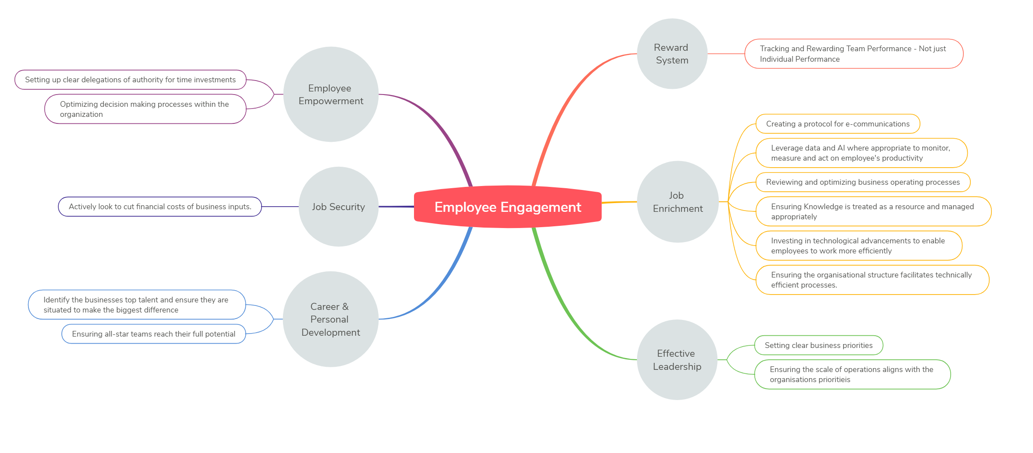
Figure 3 - Efficiency Activity Interaction with Employee Engagement Factors

Methodology

Introduction
The aim of this research is to advance the understanding of the interaction between operational efficiency activities and employee engagement. A survey will be developed and used to collect data on participants’ level of employee engagement and the efficiency activities they are aware of within their organisations. The survey will be based on reviewed literature and well-established techniques. This research will attempt to provide guidance to business leaders and decision makers on how particular efficiency activities can impact employee engagement.

The specific question this research aims to answer is What relationship do efficiency activities have with employee engagement?

Research Design
Existing literature on employee engagement is extensive and the requirements for employee engagement have been analysed across a multitude of studies. To further the understanding of the impact that operational efficiency activities may have on employee engagement, a survey has been designed to gather quantitative data from a sample of employees. A quantitative survey is appropriate as it allows the researcher to establish statistically significant conclusions about the study’s sample, which may be generalised to other organisations and employees (Lowhorn, 2007).

The limitations of adopting a quantitative research methodology include the potential to miss contextual detail and the risk of receiving responses aligned to the closest survey options, rather than the true behaviour, attitude and motivation of the respondent (Babbie, 2010). The method will, however, allow for more generalisation of the conclusions through a greater number of participants. The limitations of this research prevent a full probability sample, therefore non-probability sampling will be used due to accessibility and convenience.

The scope of this research does not allow for a full experimental analysis, consequently a quasi-experimental (or causal-comparative) research method will be used. This approach aims to establish a relationship between the variables. The independent variable (in this case the efficiency activity) is identified but not manipulated, and the effect on the dependent variable (the employee’s engagement level) is measured (Rutgers, 2021).

The theories identified in the literature review have been used to develop hypothesised relationships between the variables of this research. A deductive approach will be used to test these hypotheses through the aforementioned survey. This will be conducted with a positivist research philosophy, which supports the assumption that survey responses represent ‘observations’ which can validly be measured and analysed using statistical procedures (Buckingham & Saunders, 2004).

Phenomenologists critique the positivist approach of attempting to quantify the findings of social research by suggesting the quantification violates the meaning which people invest in their actions. Additionally, Marxists have argued that the reduction of qualitative differences to a quantitative scale is anti-humanist and oppressive (Buckingham & Saunders, 2004). Recognising these possibilities, Buckingham & Saunders (2004) propose that the use of numbers and statistics in social research need not result in mindless tabulation of data, or in destructive disregard for individual distinctiveness.

Data Collection
A survey will be used to collect data as it complements the positivist approach and allows collection of numerical responses to inform quantitative research. The survey will be online based due to availability of and access to participants – compounded by the current Covid-19 pandemic. Online surveys are widely accepted by researchers, with their use increasing significantly in recent years (Evans & Mathur, 2018).

Non-survey digital data collection and analysis can gather more accurate and deeper information regarding the level of impact of efficiency activities on engagement (Evans & Mathur, 2018), however, this would require intimate access to organisations’ and employee’s data. This level of data collection is not within the scope of this research but should be considered for future studies.

The survey will be structured in two main segments. Firstly, the participant will be asked questions regarding efficiency activities that their organisation may have implemented. The participant will have the flexibility to respond on a Likert scale linked to the level of execution of the efficiency activity within the organisation, ranging from ‘Does not do’ to ‘Core Business Activity’. Using a scale response will allow for deeper data analysis and clarification of responses.

The second part of the survey will use a recognised short survey to measure the level of employee engagement of the respondent. Based on the work of Motyka (2018), the Utrecht Work Engagement Scale (UWES) developed by Schaufeli and Bakker of Utrecht University (Schaufeli & Bakker, 2004) will be used to measure employee engagement. Motyka’s literature review identified that 82% of the studies examined used a form of UWES, the most prevalent being the UWES-9 which was used in 47 out of 71 studies.

The UWES-9 scale is a shortened, validated version of the original UWES, which is the recommended version to minimise time commitment and therefore response rate (Schaufeli & Bakker, 2004). Significant UWES-9 studies have been completed and a database compiled of the responses – these figures will be used as a baseline in this research’s data analysis.

The survey will be accessible online, and participants will not be restricted, however a covering statement will convey some pre-requisites of contributors. These pre-requisites have been established to reduce complexity of the analysis.
- The survey will be in English only.
- Only those in current employment will be included in the analysis.

The survey will use non-probability voluntary response sampling due to convenience and speed of access to participants. The total population is assumed to be very large (greater than 20,000). For a target maximum margin of error of 10% at a confidence level of 95%, the minimum number of respondents (sample size) will be 100 (Raosoft, 2004). The survey will be available for the set period and a greater number of respondents will be welcomed.

Demographic data will be requested as part of the survey to generate additional descriptive statistics of the population sample. The proposed demographic questions are included in Appendix A – Survey Questions. Where possible, the same groupings have been used as earlier studies to allow for cross-examination of results.

A pilot survey will be run with a very small sample. The data will not be used in the analysis but will test the functionality and practicalities of the survey delivery method.

Methods of Analysis
Data collected via the online survey will be analysed to answer the research question: What relationship do efficiency activities have with employee engagement? To answer this question, the data must be analysed to determine if there is a correlation between the respondent’s engagement level and the activities that their employing organisation conducts.

The independent variable in this research is the level of execution of the efficiency activities. This will be scored using a Likert scale. Each efficiency activity will be analysed individually as its own group. The interaction between efficiency activities is not part of the scope of this research.

Likert scales are typically ordinal in natural, in that response categories have rank order, but the intervals between them cannot be presumed equal (Blaikie, 2003). The data collection survey has been designed to support the assumption that the Likert data constitutes interval-level measurement. This has been achieved through a standard interval scale rather than assigning each category of response to a specific statement. There is continual debate over the treatment and analysis of Likert scales, however analysis of Likert scales (as opposed to individual Likert items) has shown that the Likert response format produces empirically interval data and can approximate ratio data (Carifio & Perla, 2008).

The dependent variable in this research is the level of employee engagement of the participant. Employee engagement will be measured using the Utrecht Work Engagement Scale (UWES) developed by Schaufeli and Bakker of Utrecht University (Schaufeli & Bakker, 2004). Respondents assign a score of between 0 and 6 to UWES statements. A total score is calculated by determining the mean of the responses. The UWES manual contains a database of norm scores from the UWES-9 survey (Table 6) which will be used to provide insight into the sample population. Demographical data will also be collected to support the validity of the sample population.

 |  | Total Score
Engagement Categories | Very Low | ≤1.77
Engagement Categories | Low | 1.78 – 2.88
Engagement Categories | Average | 2.89 – 4.66
Engagement Categories | High | 4.67 – 5.50
Engagement Categories | Very High | ≥ 5.51
Mean |  | 3.74
Standard Deviation |  | 1.17
Standard Error |  | 0.01
Range |  | 0.00 – 6.00
Table 6 Norm Scores for UWES-9 (N = 9,679) (Schaufeli & Bakker, 2004)
The initial analysis will focus on descriptive statistics of the sample population. Demographical data will be analysed to determine if the respondent sample is representative of the workforce population. For continual scales, such as age, standard distributions will be compared. Categorical data types, such as gender, will be analysed for equality compared to industry norms. The UWES-9 employee engagement responses will be compared to the UWES database (Table 6) using a simple t-test. T-tests are one of the most commonly used statistical tests and widely accepted in research for comparing two independent samples (Kranzler, 2018). The descriptive analysis will provide confidence in the sample population and determine if any questions should be excluded from inferential analysis.

The independent variable (the efficiency activity execution level) will be analysed to determine if there is a relationship to the dependent variable (level of employee engagement). Each efficiency activity will be analysed as an individual factor. A Pearson correlation analysis will assess the variables for linear relationships. Scatter plots of the values will be analysed to identify if any relationship is curvilinear and requires an alternative technique such as a Spearman correlational analysis. Pearson correlation analyses are well established in research methodologies and widely used in engagement studies (Bakator, et al., 2019).

The level of execution of each efficiency activity will be analysed independently against the level of employee engagement, resulting in 14 correlation analyses. For each analysis, the Pearson Correlation Coefficient (r_{xy}) will be calculated. The coefficient of determination (r²_{xy}) will also be calculated to describe the effect size of the correlation. The coefficient of determination is the percent of variance in one variable that is attributed to the other variable (Kranzler, 2018). If the analyses show two variables are correlated, it does not mean that one causes the other. However, it is important to note that if they are not correlated, one cannot be the cause of the other (Kranzler, 2018). Additional experimental analysis would be required to determine if the relationship is cause-effect.

The analysis sets the null hypothesis as, H₀= There is no correlation between efficiency activity execution level and employee engagement, i.e. r_{xy}=0. The alternative hypothesis is, H₁=There is a correlation between efficiency activity execution level and employee engagement, i.e. r_{xy} ≠ 0.

The results of the correlational analyses will be interpreted to identify a rank order of execution for businesses with the assumption that the target is a highly engaged workforce with a high level of efficiency activity execution. The efficiency activities will be prioritised as follows:
- Activities with a positive correlation to engagement, ordered by strongest correlation.
- Activities with no correlation to engagement.
- Activities with a negative correlation to engagement.
The analysis aims to provide an indication of which efficiency activities impact engagement, if they positively or negatively impact engagement, and which ones are linked to the highest level of engagement to allow managers to make more informed decisions by understanding the impact of efficiency activities they may employ.

Ethical Consideration
The research will be conducted in accordance with the University of Wales Trinity Saint David Research Ethics & Integrity Code of Practice (University of Wales Trinity Saint David, 2020).
All data collection will be in accordance with European GDPR legislation (University of Oxford, 2020). All data will be secured using cloud-based Microsoft resources and disposed of when no longer required for analysis. Respondents will be voluntary and anonymous. A covering statement will accompany the survey providing background, purpose and potential future uses of the work.

Analysis of Results

Introduction
A survey has been conducted to analyse the relationship between business efficiency activities and employee engagement. The data has been digitally collected and analysed using IBM’s Statistical Package for the Social Sciences (SPSS).

Descriptive Statistics
This section will present descriptive statistics on demographics of survey respondents. A total of 81 responses were received between 23rd April 2021 and 7th June 2021. Respondents who do not meet the criteria for this research have been excluded (Table 7).

Criteria | Requirement | Number of Respondents Excluded
Employment Status | Full or Part Time | 1
Table 7 - Excluded Respondents
A total of 80 responses have been included in the analysis. This sample size is less than the originally targeted 100 respondents (Chapter 14.3 . A sample size of 80 produces a calculated error of 10.83% with a confidence level of 95% (Raosoft, 2004).

Occupation
The occupation of the respondents is well distributed with the highest population being Management Occupations (25%).
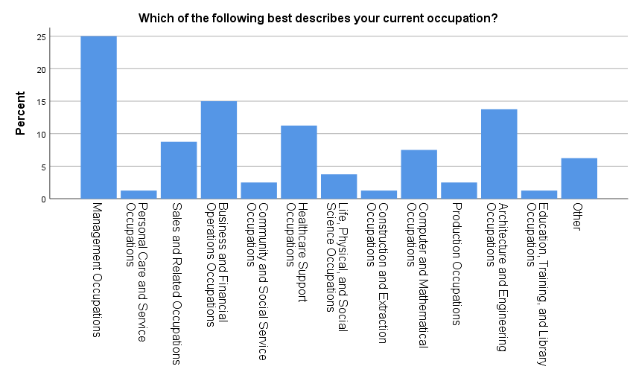
Figure 4 – Occupation Frequencies

Age
The age range of respondents is from 18 to 60 or older. The largest group is 30 to 39 year olds with approximately 39% of the sample population.
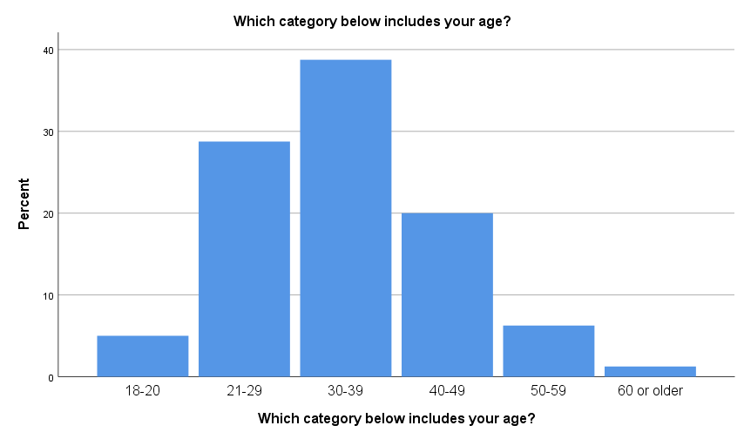
Figure 5 - Age Frequencies

Gender
The split of gender of respondents is exactly 50%, representing an impartial sample population.

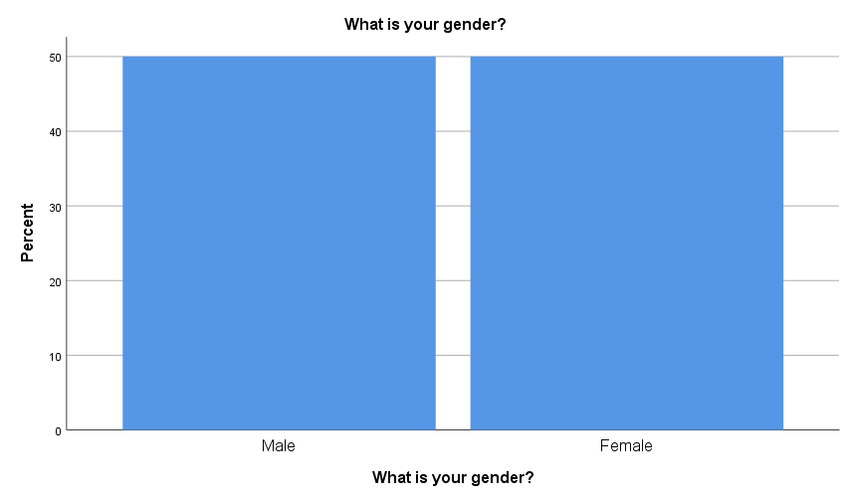
Figure 6 - Gender Frequencies

Tenure
The length of time the respondents have been employed by their current organisation is well distributed. Approximately 76% of respondents have been with their current organisation for more than a year.
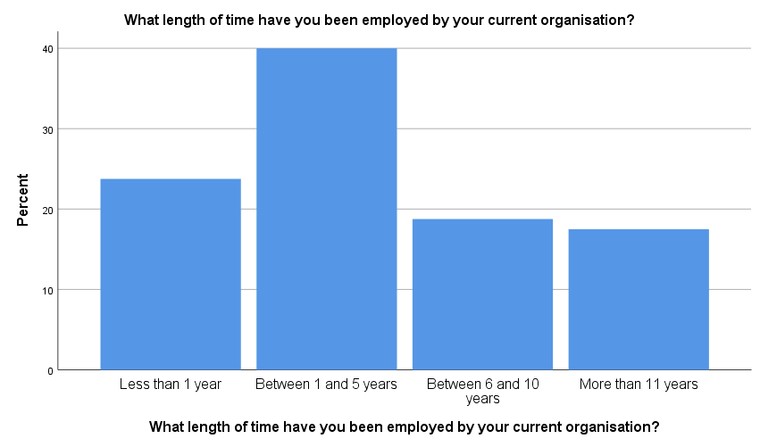
Figure 7 - Tenure Frequencies

Position
There is a good distribution of positions of respondents, with a mix of individual contributors and people leaders. Senior managers and directors represent a lesser population of around 14% as is to be expected.

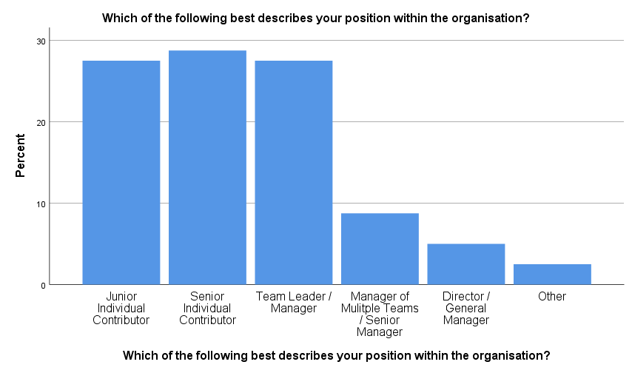
Figure 8 - Position Frequencies

Company Size
The size of the organisations of respondents is well distributed, with 65% being large organisations having more than 250 employees.
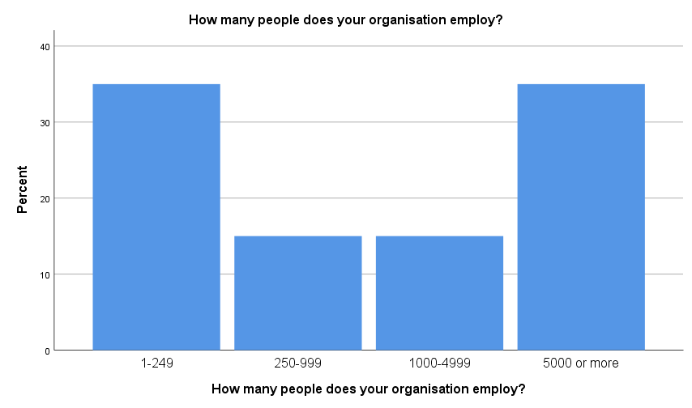
Figure 9 - Company Size Frequencies

Engagement

The survey design used the shortened UWES-9 version of the Utrecht Work Engagement Scale. Significant UWES-9 studies have been completed and a database compiled of the responses (Schaufeli & Bakker, 2004). The measured engagement values from these large sample studies (Figure 6) have been compared to the measured engagement values in this research.

A one-sample t-test has been completed on the survey results against a baseline engagement score mean (from Figure 6) of 3.74. The results are shown in Table 8 which indicate that the engagement scores from this research’s respondents do not significantly vary from that of the UWES general population.

One-Sample Test
 | Test Value = 3.74
 | t | df | Sig. (2-tailed) | Mean Difference | 95% Confidence Interval of the Difference
 |  |  |  |  | Lower | Upper
CALCULATED VARIABLE - ENGAGEMENT | 1.327 | 80 | .188 | .13691 | -.0684 | .3422
Table 8 - Engagement One-Sample T-Test

The engagement scores gathered in the survey have been categorised to allow direct comparison with the UWES statistical norms. The categories are defined as follows:

Qualification | Lower Limit |  |  |  | Upper Limit
Very high | 95 percentile | ≤ | Score
High | 75 percentile | ≤ | Score | < | 95 percentile
Average | 25 percentile | ≤ | Score | < | 75 percentile
Low | 5 percentile | ≤ | Score | < | 25 percentile
Very low |  |  | Score | < | 5 percentile
Table 9 - Engagement Score Categories
The categorised norm scores for the survey respondents are shown below in Table 10.

Engagement Category
 |  | Frequency | Percent | Valid Percent | Cumulative Percent
Valid | Very low | 4 | 5.0 | 5.0 | 5.0
Valid | Low | 17 | 21.3 | 21.3 | 26.3
Valid | Average | 39 | 48.8 | 48.8 | 75.0
Valid | High | 18 | 22.5 | 22.5 | 97.5
Valid | Very high | 2 | 2.5 | 2.5 | 100.0
Valid | Total | 80 | 100.0 | 100.0
Table 10 - Categorised Engagement Scores

Correlations
The aim of this research is to determine the relationship between typical business operational efficiency activities and employee engagement to inform strategic organisational decision making. The research has been designed to test the hypotheses as follows:

H₀= There is no correlation between efficiency activity execution level and employee engagement, i.e. r_{xy}=0.

H₁=There is a correlation between efficiency activity execution level and employee engagement, i.e. r_{xy} ≠ 0.

The validity of these hypotheses against theoretically derived relationships has been tested using the Pearson correlation method. The survey data gathered satisfies all requirements for a Pearson correlation as described in Section 4.4 . The full Pearson study results are presented in Appendix B – Correlations Table. A summary of the relationships is shown in Table 11 with discussion on the respective relationships in the following paragraphs.

 | ‘Efficiency Activity’ vs Engagement | r | r²
R1 | Sets clear business priorities | .120 | 0.014
R2 | Sets up clear delegations of authority for time investments | .240* | 0.058
R3 | Has a protocol for e-communications | .268* | 0.072
R4 | Leverages data and AI where appropriate to monitor, measure and act on employee's productivity | .070 | 0.005
R5 | Optimises decision making processes within the organisation | .116 | 0.013
R6 | Identifies the businesses top talent and ensures they are situated to make the biggest difference | .348** | 0.121
R7 | Ensures all-star teams reach their full potential | .375** | 0.141
R8 | Tracks and rewards team performance - not just individual performance | .242* | 0.059
R9 | Actively looks to cut financial costs of business inputs. | .008 | 0.000
R10 | Reviews and optimises business processes | .314** | 0.099
R11 | Ensures knowledge is treated as a resource and managed appropriately | .367** | 0.135
R12 | Invests in technological advancements to enable employees to work more efficiently | .166 | 0.028
R13 | Ensures the organisational structure facilitates technically efficiency processes | .396** | 0.157
R14 | Ensures the scale of operations aligns with the organisations priorities | .383** | 0.147
Table 11 - Correlation Summary

R1 – The relationship between engagement and ‘setting clear business priorities’: The results show there is no significant correlation as there is no linear association between the engagement score and the level of execution of setting clear business priorities. Although there is no direct correlation to engagement score, there is indicated positive correlation to other efficiency measures (most prominently ‘setting up clear delegations of authority for time investments’) suggesting setting clear business priorities is part of a wider business approach which promotes engagement.

R2 – The relationship between engagement and ‘setting clear delegations of authority for time investments’: A weak correlation has been identified, suggesting setting clear delegations of authority for time investments, such as meetings/events/workshops, can improve employee engagement.

R3 – The relationship between engagement and ‘having a protocol for e-communications’: A weak correlation has been identified, suggesting businesses with a defined protocol for e-communications can promote employee engagement by reducing time spent on unnecessary e-communications.

R4 – The relationship between engagement and ‘leveraging data and AI where appropriate to monitor, measure and act on employee's productivity’: The results show that there is no significant correlation between leveraging data to manage an employee’s productivity and employee engagement. The leveraging of data and AI, whilst improving efficiency (pwc, 2021), does not directly impact employee engagement.

R5 – The relationship between engagement and ‘optimising decision-making processes within the organisation’: The results show that there is no significant correlation between optimising organisational decision making processes and employee engagement. However, optimising decision making processes may still improve efficiency through reducing process waste.

R6 – The relationship between engagement and ‘identifying the businesses top talent and ensuring they are situated to make the biggest difference’: A moderate correlation has been identified between identifying and situating the businesses top talent effectively and employee engagement. This suggests that companies that find and nurture top talent for the business and likely to have higher employee engagement.

R7 – The relationship between engagement and ‘ensuring all-star teams reach their full potential’: A moderate correlation has been identified between managing talented teams to help them reach their full potential and employee engagement.

R8 – The relationship between engagement and ‘tracking and rewarding team performance - not just individual performance’: A weak correlation has been identified between managing performance as a team, not just individuals, and employee engagement. Setting team goals instead of individual goals can encourage collaboration instead of competition and often improve organisational efficiency (Craig, 2018). This research also suggests it can improve employee engagement.

R9 – The relationship between engagement and ‘actively looking to cut financial costs of business inputs’: The results show that there is no significant correlation between actively looking to cut financial costs and employee engagement, i.e. actively looking to cut financial costs does not impact employee engagement.

R10 – The relationship between engagement and ‘reviewing and optimising business processes’: A moderate positive correlation has been identified between reviewing and optimising business process and employee engagement. This suggests that removing process waste not only allows employees to work on more productive tasks, but also can improve their engagement.

R11 – The relationship between engagement and ‘ensuring knowledge is treated as a resource and managed appropriately’: A moderate positive correlation was identified between treating knowledge as a managed resource and employee engagement. This suggests that employee engagement can be improved whilst developing a culture of knowledge sharing and collaboration to improve efficiency by minimising repeat work and leveraging the businesses existing knowledge and expertise to create value.

R12 – The relationship between engagement and ‘investing in technological advancements to enable employees to work more efficiently’: The results show there is no significant correlation between investing in technological innovations for efficiency improvements and employee engagement.

R13 – The relationship between engagement and ‘ensuring the organisational structure facilitates technically efficient processes’: A moderate positive correlation has been identified between ensuring an organisations structure facilitates technically efficient processes and employee engagement. If an organisations structure is overly complex and processes are unnecessarily complication, efficiency will be limited no matter how much effort the employee applies, thereby stifling engagement.

R14 – The relationship between engagement and ‘ensuring the scale of operations aligns with the organisations priorities’: A moderate positive correlation has been identified between ensuring operational scale algins with organisational priorities and employee engagement. This suggests that determining operational scale should consider factors other than purely return on scale.

The data analysis has identified several relationships between efficiency activities and employee engagement. A secondary aim of this research is to provide guidance to business decision makers on which efficiency activities they should prioritise based on the assumed target of a highly engaged workforce. All the efficiency activities identified have potential to improve operational efficiency, prioritising the activities with positive correlation to engagement can also therefore improve the organisations employee engagement.

The correlational analyses have been ranked using the coefficient of determination (r²), i.e. the amount of change in engagement that can be attributed to by the efficiency activity. Table 12 shows the recommended order of prioritisation of efficiency measures based on the target of a highly engaged workforce. Every efficiency measure will clearly have several other factors which much also be considered and tailored to the specific situation of the organisation in question.

 | ‘Efficiency Activity’ vs Engagement | r² | Recommended Priority
R13 | Ensures the organisational structure facilitates technically efficiency processes | 0.157 | 1
R14 | Ensures the scale of operations aligns with the organisations priorities | 0.147 | 2
R7 | Ensures all-star teams reach their full potential | 0.141 | 3
R11 | Ensures knowledge is treated as a resource and managed appropriately | 0.135 | 4
R6 | Identifies the businesses top talent and ensures they are situated to make the biggest difference | 0.121 | 5
R10 | Reviews and optimises business processes | 0.099 | 6
R3 | Has a protocol for e-communications | 0.072 | 7
R8 | Tracks and rewards team performance - not just individual performance | 0.059 | 8
R2 | Sets up clear delegations of authority for time investments | 0.058 | 9
R12 | Invests in technological advancements to enable employees to work more efficiently | 0.028 | 10
R1 | Sets clear business priorities | 0.014 | 11
R5 | Optimises decision making processes within the organisation | 0.013 | 12
R4 | Leverages data and AI where appropriate to monitor, measure and act on employee's productivity | 0.005 | 13
R9 | Actively looks to cut financial costs of business inputs. | 0 | 14
Table 12 - Ranked Efficiency Activities

Limitations
There are several limitations relating to the research approach and analysis. A survey has been used to gather primary research data using non-probability voluntary sampling. Although due diligence has been used to describe the sample using statistical techniques, the results cannot be generalised to same extent as a probability sample (Evans & Mathur, 2018). Results can therefore not be treated as representative of the full global workforce and can only be used as an indication.

Within the last 12 months the global workforce has experienced significant change and, in many circumstances, intense pressure due to the Covid-19 pandemic. The global economy has suffered tremendously and in many industries levels of redundancies are high, furlough schemes are being used, and social lockdowns have impacted personal wellbeing and approaches to work (HM Government, 2020). Consideration should be given to the level of engagement and types of responses in light of these factors.

Conclusions and Recommendations
The aim of this research is to determine the relationship between typical business operational efficiency activities and employee engagement to inform strategic organisational decision making.

A review of literature has demonstrated the continued need to ensure businesses operate efficiently. However, contemporary literature asserts the most effective methods to drive efficiency are significantly different to those employed in early scientific management and the subsequent reward-based motivation management that is still prevalent in many organisations today.

The competitive environment in which modern businesses operate require them to be operationally efficient whilst targeting high levels of employee engagement (Felix & Maggi, 2019). These business aims are related and in pursuit of one may degrade the other. Business leaders lack sufficient guidance as to what efficiency strategies can be implemented without having a significantly detrimental effect on employee engagement.

The data analysis herein demonstrates several relationships between specific business efficiency activities and employee engagement. The potential efficiency gain of each activity is not considered in this analysis. Each activity is also likely to have interactions with other business factors. The efficiency activities summarised in Table 13, are ranked solely on the impact to employee engagement. A full cost-benefit analysis of each efficiency activity should be conducted to understand the complete impact to the organisation.

 | ‘Efficiency Activity’ vs Engagement | r² | Recommended Priority
R13 | Ensures the organisational structure facilitates technically efficiency processes | 0.157 | 1
R14 | Ensures the scale of operations aligns with the organisations priorities | 0.147 | 2
R7 | Ensures all-star teams reach their full potential | 0.141 | 3
R11 | Ensures knowledge is treated as a resource and managed appropriately | 0.135 | 4
R6 | Identifies the businesses top talent and ensures they are situated to make the biggest difference | 0.121 | 5
Table 13 - Top 5 Efficiency Activities for High Engagement
An important conclusion is that in all cases where a correlation has been identified, with the exception of R9 - Actively looks to cut financial costs of business inputs, the relationship has been positive. That is, companies that implement measures to improve efficiency, have higher employee engagement. This relationship is not directional, i.e. it may be the case that organisations with highly engaged employees are more likely to implement business efficiency activities.

The activity with the strongest link to engagement is “Ensure the organisational structure facilitates technically efficient processes”. As organisations grow and macro-economic factors shift, the priorities within organisations also change. This often results in an alteration to or completely new organisational structures. If the organisations structure is overly complex and processes are unnecessarily complicated, efficiency will be limited no matter how much effort the employee applies (Mankins & Garton, 2017). This has a knock-on effect to engagement – if an employee cannot be as effective as they want to be due to factors out with their control their engagement may suffer (Sharma, et al., 2019).

Economies of scale are well understood, and the optimal scale of efficiency can be calculated with relative ease (Ray, 2015). However, this research shows that organisations which do not consider other factors such as supply chain management, employee resourcing, distribution models, and adherence to organisational mission, may be negatively impacting employee engagement.

Teams consisting of high-performing individuals need to be managed to reach their full potential and provide the greatest impact to the organisation (Mankins & Garton, 2017). Leaders of talented teams need to be capable of encouraging peak performances and provide support so the team can focus on what they do best. The data analysis has shown that this approach also has a positive relationship with employee engagement.

Information is frequently a core part of business processes, where the application of information determines the outcome of the process (Dority, 2006). Information and organisational knowledge, when treated as a resource and managed appropriately, can have immense effects on employee productivity, efficiency, effectiveness, and profitability (Avanade, Inc., 2017). This study demonstrates that developing a culture of knowledge sharing and collaboration, which minimises repeated work and leverages the businesses existing knowledge and expertise to create value, has a positive relationship with employee engagement. The research does not provide conclusive evidence of the direction of the relationship - treating knowledge as a resource may increase engagement, or high engagement may increase opportunity for knowledge to be managed appropriately.

A study by Mankins & Garton (2017) found that the top-performing companies focused their best talent in a few critical roles. By applying quantitative and qualitative techniques to measure potential during hiring, promotion, and development processes, they could align talent and capabilities to business-critical roles. Following this approach has been shown in this research to have a positive relationship with employee engagement.

The preceding 5 relationships all have positive impacts to both efficiency and engagement. These are the recommended activities to prioritise, contingent on an assessment of the impact of these efficiency activities to other elements within the business.

In Chapter 3, a theoretical framework was developed to demonstrate the linkages between efficiency activities and employee engagement based on secondary research and existing literature. Applying this framework to the survey analysis results, it can be shown that Job Enrichment is the category which has the largest interaction with efficiency activities (Table 14).

A cause-effect relationship has not been demonstrated between efficiency activities and engagement; simply that organisations which have implemented efficiency activities have shown to also have improved job enrichment – and visa-versa. Job enrichment is provided through meaningful and challenging work, avoiding repetitive tasks, a shared sense of meaning, and work conditions (Barik & Kochar, 2017).

Table 14 - Efficiency Activity Interaction with Employee Engagement Factors (Survey Data)

Most companies are already implementing several or all the identified efficiency activities to some extent – the collected data showed no participants responded that their organisations did not do any of the listed activities. The level of maturity of each activity and the effectiveness of what has been implemented needs to be considered when looking for additional improvements. It is well understood that unintended consequences may be impacting certain areas of the business and negating gains elsewhere.

Future research could take a deeper look at specific organisations as case studies to assist in determining the true impact of many of these efficiency activities and how they quantifiably relate to business performance. Access to sensitive business and employee data would be required, which could be easily gathered through readily available tools and anonymised. This detailed data gathering could provide better insights into how employees are engaged and where efficiency activities are impacting.

The drive for operational efficiency is clear - extant literature and primary data within this research have both shown that most organisations are already implementing several activities to increase efficiency. Employee engagement is also widely acknowledged; however, it is a complex concept. Differences in definitions and continuing research highlight that the many interrelated factors require a flexible approach which is tailored for each individual organisation (Lockwood, 2007).

This study provides an indication of how these two subjects interact with each other. Companies can use this research when developing strategies to improve efficiency. It is not intended to be a complete guide, but to provide additional information for business leaders to consider when selecting appropriate efficiency activities.

Bibliography
Abdallah, A. B., Dahiyat, S. E. & Matsui, Y., 2019. Lean management and innovation performance. Management Research Review, 42(2), pp. 239-262.
Ahlstrom, D., 2010. Innovation Growth: How business contributes to society. Academy of Management Perspectives, Volume 24, pp. 10-23.
Avanade, Inc., 2017. Global Survey: Companies are unprepared for the arrival of a true digital workplace. [Online]
Available at: https://www.avanade.com/~/media/asset/research/digital-workplace-global-study.pdf.
[Accessed 16 02 2021].
Babbie, E. R., 2010. The practice of social research. 12th ed. Belmont: Wadsworth.
Baik, B., Chae, J., Choi, S. & Farber, D. B., 2013. Changes in Operational Efficiency and Firm Performance. Contemporary Accounting Research, 30(3), pp. 996-1026.
Bakator, M., Petrovic, N., Boric, S. & Dalic, N., 2019. Impact of Human Resource Management on Business Performance: A Review of Literature. Journal of Engineering Management and Competitiveness, 9(1), pp. 3-13.
Bakker, A. & Demerouti, E., 2008. Towards a model of work engagement. Career Development International , 13(3), pp. 209-223.
Bang, K. E. & Markeset, T., 2011. Impact of Globalization on Model of Competition and Companies’ Competitive Situation. In: Heidelberg, ed. Advances in Production Management Systems. Value Networks: Innovation, Technologies, and Management. Berlin: Springer, pp. 276-286.
Barik, S. & Kochar, A., 2017. Antecedents and Consequences of Employee Engagement: A Literature Review. International Journal of Latest Technology in Engineering, Management and Applied Sciences., 6(4), pp. 33-38.
Barriball, E., George, K., Marcos, I. & Radtke, P., 2020. Jump-starting resilient and reimagined operations, s.l.: McKinsey & Company.
Berland, P. S., 2016. Dell & Intel Future Works Global Report, s.l.: s.n.
Blaikie, N., 2003. Analyzing Quantitative Data. s.l.:Sage.
British Standards Institution, 2014. BS 65000:2014 - Guidance on organizational resilience , s.l.: s.n.
Buchanan, L., 2004. The Things They Do for Love. Harvard Business Review, Decemeber.
Buckingham, A. & Saunders, P., 2004. The Survey Methods Workbook: From Design to Analysis. 1st ed. s.l.:Polity Press.
Cappelli, P., 2020. Stop Overengineering People Management. Harvard Business Review, 98(5), pp. 56-63.
Carifio, J. & Perla, R., 2008. Resolving the 50-year debate around using andmisusing Likert scales. Medical education, 42(12), pp. 1150-1152.
Chew, B. W., 1988. No-Nonsense Guide to Measuring Productivity. Harvard Business Review, 1 January.
Coelli, T. J., Rao, D. P., O'Donnell, C. J. & Battese, G. E., 2005. An Introduction to Efficiency and Productivity Analysis. 2nd ed. New York: Springer.
Collins Dictionary, 2020. Definition of 'efficiency'. [Online]
Available at: https://www.collinsdictionary.com/dictionary/english/efficiency
[Accessed 26 01 2021].
Collins Dictionary, 2021. Definition of 'business'. [Online]
Available at: https://www.collinsdictionary.com/dictionary/english/business
[Accessed 18 01 2021].
Craig, W., 2018. How to Build Engaged and Resilient Teams. [Online]
Available at: https://www.forbes.com/sites/williamcraig/2018/01/23/how-to-build-engaged-and-resilient-teams/#57a0ba5e7315
[Accessed 27 10 2020].
Cropanzano, R. & Mitchell, M. S., 2005. Social Exchange Theory: An Interdisciplinary Review. Journal of Management, 31(6), pp. 874-900.
Delias, P., 2017. A positive deviance approach to eliminate wastes in business processes. Industrial Management and Data Systems, 117(7), pp. 1323-1339.
Denyer, D., 2017. Organisational Resilience, s.l.: BSI and Cranfield School of Management.
Dority, K. G., 2006. Rethinking Information Work. s.l.:Libraries Unlimited.
Dowdall, J., 2019. Measuring Operational Efficiency. [Online]
Available at: https://www.catalystconsulting.co.uk/measuring-operational-efficiency/
[Accessed 11 11 2020].
Duchek, S., 2019. Organizational resilience: a capability-based conceptualization. Business Research, Volume 13, pp. 215-246.
Economics Online, 2020. Efficiency. [Online]
Available at: https://www.economicsonline.co.uk/Business_economics/Efficiency.html
[Accessed 16 02 2021].
European Commission Joint Research Centre, 2015. The challenge of resilience in a globalised world, Brussels: European Commission.
eurostat, 2016. Glossary:Enterprise size. [Online]
Available at: https://ec.europa.eu/eurostat/statistics-explained/index.php/Glossary:Enterprise_size
[Accessed 25 11 2020].
Evans, J. R. & Mathur, A., 2018. The value of online surveys:a look back and a look ahead. Internet Research, 28(4), pp. 854-887.
Felix, S. & Maggi, C., 2019. What is the Impact of Increased Business Competition?, s.l.: International Monetary Fund.
Flaig, J., 2018. Industry 4.NO – measuring up the fourth Industrial Revolution. [Online]
Available at: https://www.imeche.org/news/news-article/feature-industry-4.no-measuring-up-the-fourth-industrial-revolution
[Accessed 17 02 2021].
Freeman, E. R., 2014. Is Profit the Purpose of Business?. [Online]
Available at: https://ideas.darden.virginia.edu/is-profit-the-purpose-of-business
[Accessed 18 01 2021].
Fried, H. O., Lovell, C. A. & Schmidt, S. S., 2008. The Measurement of Productive Efficiency and Productivity Change. s.l.:s.n.
Ghemawat, P. & Altman, S. A., 2019. The State of Globalization in 2019, and What It Means for Strategists, s.l.: Harvard Business Review.
Gonzalez-Roma, V., Schaufeli, W. B., Bakker, A. B. & Lloret, S., 2006. Burnout and work engagement: independent factors or opposite poles?. Journal of Vocational Behaviour, Volume 68, pp. 165-174.
Green, P., 2016. The perceived influence on organizational productivity: A perspective of a public entity. Problems and Perspectives in Management, 14(2), pp. 339-347.
Groenewald, T., 2004. A Phenomenological Research Design Illustrated. International Journal of Qualitative Methods, 3(1).
Guba, E. G. & Lincoln, Y. S., 1994. Competing paradigms in qualitative research. Handbook of qualitative research, Volume 2, pp. 163-194.
Gupta, A., Tandon, A. & Barman, D., 2019. Employee Engagement: Evolution, Approaches, and Perspectives. In: Management Techniques for Employee Engagement in Contemporary Organizations. s.l.:IGI Global, pp. 1-19.
Harrison, J. A. & Frawley, S., 2018. What does employee ownership effectiveness look like? The case of a Canadian-based firm. Canadian Jounral of Administrative Services, Volume 35, pp. 5-19.
Harter, J. K., Schmidt, F. L. & Hayes, T. L., 2002. Business-Unit-Level Relationship Between Employee Satisfaction, Employee Engagement, and Business Outcomes: A Meta-Analysis. Journal of Applied Psychology, 87(2), pp. 268-279.
HM Government, 2020. Analysis of the health, economic and social effects of COVID-19 and the approach to tiering, s.l.: GOV.UK.
Jayamaha, A. & Mula, J. M., 2011. Productivity and Efficiency Measurement Techniques: Identifying the Efficacy of Techniques for Financial Institutions in Developing Countries. Journal of Emerging Trends in Economics and Management, Volume 2, pp. 454 - 460.
Jayaram, J., Das, A. & Nicolae, M., 2010. Looking beyond the obvious: Unraveling the Toyota production system. International Journal of Production Economics, Volume 128, pp. 280-291.
Kahn, W. A., 1990. Psychological conditions of personal engagement and disengagement at work. Academy of Management Journal, 33(4), pp. 692-724.
Khezrimotlagh, D., 2017. Decision Making and Productivity Measurement, s.l.: Cornell University.
Kranzler, J. H., 2018. Statistics for the terrified. 6th ed. Lanham, Maryland: Rowman & Littlefield.
Kumar, M., Tsolakis, N., Agarwal, A. & Srai, J. S., 2020. Developing distributed manufacturing strategies from the perspective of aproduct-process matrix. International Jounral of Production Economics, 219(1), pp. 1-17.
Langlois, R., 1999. Scale, Scope, and the Reuse of Knowledge, s.l.: s.n.
Lelieve, D., Radtke, P., Rohr, M. & Westinner, R., 2019. Building Resilient Operations, s.l.: McKinsey & Company.
Lockwood, N. R., 2007. Leveraging Employee Engagement for Competitive Advantage, Alexandria: Society for Human Resource Management.
Lowhorn, G. L., 2007. Qualitative and Quantitative Research: How to Choose the Best Design. Nashville, Tennessee, Academic Business World International Conference.
Mankins, M., 2017. Great Companies Obsess Over Productivity, Not Efficiency. [Online]
Available at: https://hbr.org/2017/03/great-companies-obsess-over-productivity-not-efficiency
[Accessed 01 02 2021].
Mankins, M. & Garton, E., 2017. Managing and Investing in Time, Talent, and Energy. Leader to Leader, 2017(85), pp. 59-61.
Martin, R., 2020. When Efficiency Goes Too Far, s.l.: Harvard Business Review.
Martin, R. L., 2019. The High Price of Efficiency, s.l.: Harvard Business Review.
Maslach, C., Schaufeli, W. B. & Leiter, M. P., 2001. Job Burnout. Annual Review of Psychology, 52(1), pp. 397-422.
Motyka, B., 2018. Employee engagement and performance: a systematic literature review. International Journal of Management and Economics, 54(3), pp. 227-244.
Muldoon, J., 2020. Taylor Made Management. In: The Palgrave Handbook of Management History. s.l.:Palgrave Macmillan, pp. 499-520.
Parmar, B. L., 2019. People and Profits: The Impact of Corporate Objectives on Employees' Need Satisfaction at Work. Journal of Business Ethics, 154(1), pp. 13-34.
Patro, C. S., 2013. The Impact of Employee Engagement on Organization's Productivity. s.l., Shri Dharmasthala Manjunatheshwara Institute for Management Development.
Podsakoff, P. M., MacKenzie, S. B., Lee, J.-Y. & Podsakoff, N. P., 2003. Common method biases in behavioral research: a critical review of the literature and recommended remedies. Journal of Applied Psychology, 88(5), pp. 879-903.
Pollack, J. & Adler, D., 2016. Skills that improve profitability: The relationship between project management, IT skills and small to medium enterprise profiability. International Journal of Project Management, 34(5), pp. 831-838.
Productivity Commission of Australia, 2015. What is productivity and how is it measured?, s.l.: s.n.
pwc, 2021. Increase Operational Efficiency. [Online]
Available at: https://www.pwc.co.uk/issues/data-analytics/issues/analytics-to-run-operations-more-efficiently.html
[Accessed 17 02 2021].
Ramsay, M., 2019. Has the Push for Productivity Gone Too Far?. HR Magazine, 4 September.
Raosoft, 2004. Sample Size Calculator. [Online]
Available at: http://www.raosoft.com/samplesize.html
[Accessed 16 03 2021].
Ray, S. C., 2015. Nonparametric measures of scale economies and capacity utilization: Anapplication to U.S. manufacturing. European Journal of Operation Research, 245(2), pp. 602-611.
Rehman, A. A. & Alharthi, K., 2016. An Introduction to Research Paradigms. International Journal of Educationakl Investigations, 3(8), pp. 51-59.
Rutgers, 2021. Systematic Reviews in the Health Sciences: Types of Research within Qualitative and Quantitative. [Online]
Available at: https://libguides.rutgers.edu/Systematic_Reviews
[Accessed 08 03 2021].
Saks, A. M., 2006. Antecedents and Consequences of Employee Engagement. Journal of Managerial Psychology, 21(07), pp. 600-619.
Schaufeli, W. & Bakker, A., 2004. Utrecht Work Engagement Scale Preliminary Manual, s.l.: Occupational Health Psychology Unit Utrecht University.
Schaufeli, W. B., Salanova, M., Gonzalez-oma, V. & Bakker, A. B., 2002. The Measurement of Engagement and Burnout: A Two Sample Confirmatory Factor Analytic Approach. Journal of Happiness Studies, 3(1), pp. 71-92.
Sharma, N., Chaudhary, N. & Singh, V. K., 2019. Employee Engagement: Evolution, Approaches, and Perspectives. In: Management Techniques for Employee Engagement in Comtemporary Organisations. Hershey: IGI Global, pp. 1-19.
Shuck, B. & Wollard, K., 2010. Employee Engagement and HRD: A Seminal Review of the Foundations. Human Resource Development Review, 9(1), pp. 89-110.
Smith, A., 1976. An Inquiry into the Nature and Causes of the Wealth of Nations. Glasgow Edition ed. Oxford: Clarendon Press.
Spear, S. & Bowen, K. H., 1999. Decoding the DNA of the Toyota Productyion System. Harvard Business Review, September-October, pp. 96-106.
Suleiman, Y. et al., 2018. Impact of Employees’ Training on Organization Profitability: Implication for Business and Educational Managers. Amity Journal of Training and Development, 3(2), pp. 1-16.
Sy, W., 2016. Capitalism and Economic Growth Across the World. SSRN Electronic Journal.
Tahir, N., Yousafzai, I., Jan, D. & Hashim, M., 2014. The Impact of Training and Development on Employees Performance and Productivity A case study of United Bank Limited Peshawar City, KPK, Pakistan. International Journal of Academic Research in Business and Social Sciences, 4(4), pp. 86-98.
Taylor, F. W., 1911. The Principles of Scientific Management. 1st ed. New York: Harper & Brothers.
University of Oxford, 2020. Responsibilities under GDPR. [Online]
Available at: https://researchsupport.admin.ox.ac.uk/policy/data/responsibilities
[Accessed 26 11 2020].
University of Wales Trinity Saint David, 2020. Research Ethics & Integrity Code of Practice. [Online]
Available at: https://www.uwtsd.ac.uk/media/uwtsd-website/content-assets/documents/research/research-ethics-integrity-code-practice.pdf
[Accessed 26 11 2020].
Walker, J. C., 2018. How Operational Efficiency Leads to Organizational Profitability Through Implementation of Management Theory, s.l.: California Southern University.
Wallerstein, I., 1979. The Capitalist World-Economy. Connecticut: Yale Universirty.
Wang, Z., Li, C. & Li, X., 2016. Resilience, Leadership and Work Engagement: The Mediating Role of Positive Affect. Social Indicators Research, Volume 132, pp. 699-708.
Wollard, K. K. & Shuck, B., 2011. Antecedents to Employee Engagement: A Structured Review of the Literature. Advances in Developing Human Resources, 13(4), pp. 429-446.
Womack, J. P. & Jones, D. T., 1996. Lean Thinking : Banish Waste and Create Wealth in Your Corporation. New York: Simon & Schuster.

Appendix A – Survey Questions
- Which of the following categories best describes your employment status? Please note that it is requested only participants in full-time employment will be included in this research.
  - Full Time Employment (more than 35 hours per week)
  - Part Time Employment
  - Unemployed

- Which of the following best describes your current occupation?
  - Management Occupations
  - Personal Care and Service Occupations
  - Sales and Related Occupations
  - Business and Financial Operations Occupations
  - Community and Social Service Occupations
  - Legal Occupations
  - Healthcare Support Occupations
  - Life, Physical, and Social Science Occupations
  - Construction and Extraction Occupations
  - Computer and Mathematical Occupations
  - Protective Service Occupations
  - Installation, Maintenance, and Repair Occupations
  - Production Occupations
  - Architecture and Engineering Occupations
  - Farming, Fishing, and Forestry Occupations
  - Building and Grounds Cleaning and Maintenance Occupations
  - Education, Training, and Library Occupations
  - Transportation and Materials Moving Occupations

- Which category below includes your age?
  - 17 or younger
  - 18-20
  - 21-29
  - 30-39
  - 40-49
  - 50-59
  - 60 or older

- What is your gender?
  - Woman
  - Man
  - Non-binary
  - Prefer not to say

- What length of time have you been employed by your current organisation?
  - Less than 1 year
  - Between 1 and 5 years
  - Between 6 and 10 Years
  - More than 11 years

- Which of the following best describes your position within the organisation?
  - Junior Individual Contributor
  - Senior Individual Contributor
  - Team Leader / Manager
  - Manager of multiple teams / senior manager
  - Director / general manager
  - Other (Specify)

- How many employees do your company have?
  - 1-249
  - 250-999
  - 1000-4999
  - 5000 or more

- Please read each of the following statements carefully and decide if you ever feel this way about your job. If you have never had this feeling, score it zero (0). If you have had this feeling, indicate how often you feel it by scoring from 1 to 6 that best describes how frequently you feel that way.
0 Never,
1 Almost Never (A few times a year or less),
2 Rarely (Once a month or less),
3 Sometimes (A few times a month),
4 Often (Once a week),
5 Very Often (A few times a week),
  - Always (Every day).

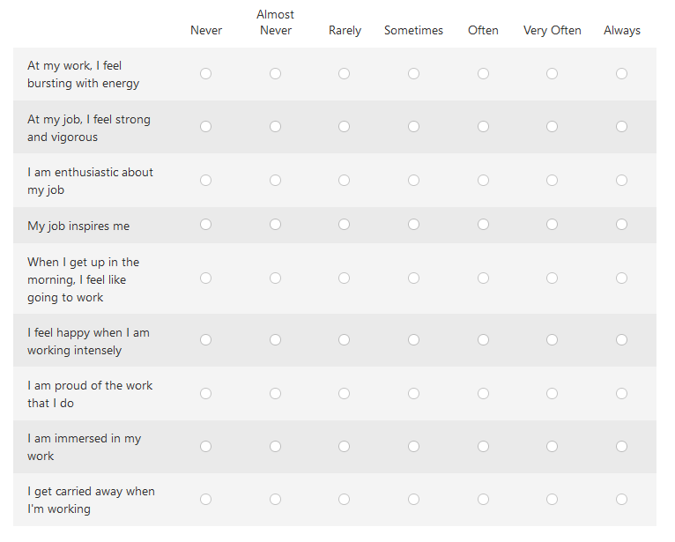

- Please read each of the statements below which are activities that your organisation may or may not do. Score each statement on what you believe is its level of execution (or level of maturity) within your organisation, from '0 = Does not Do' to '5 = Core Part of Business'.
This question is not trying to ask what your organisation 'would like to do', rather it aims to discover what are the activities your organisation actually does, and how big a part of the business processes and culture they are.

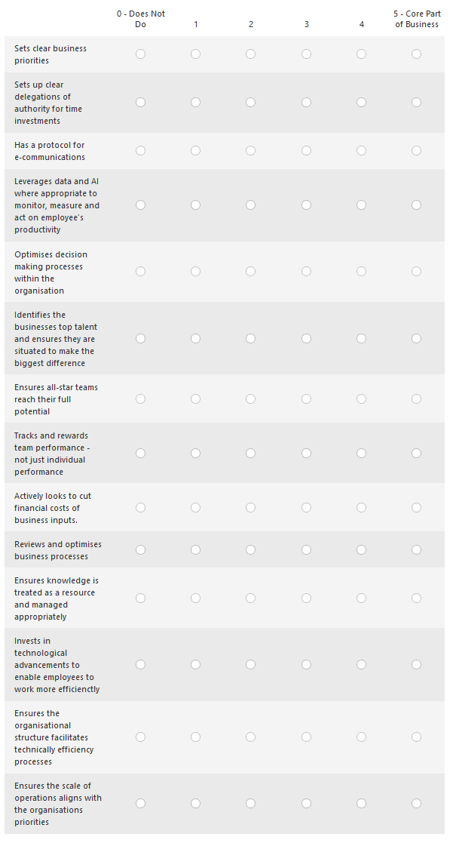

Appendix B – Correlations Table
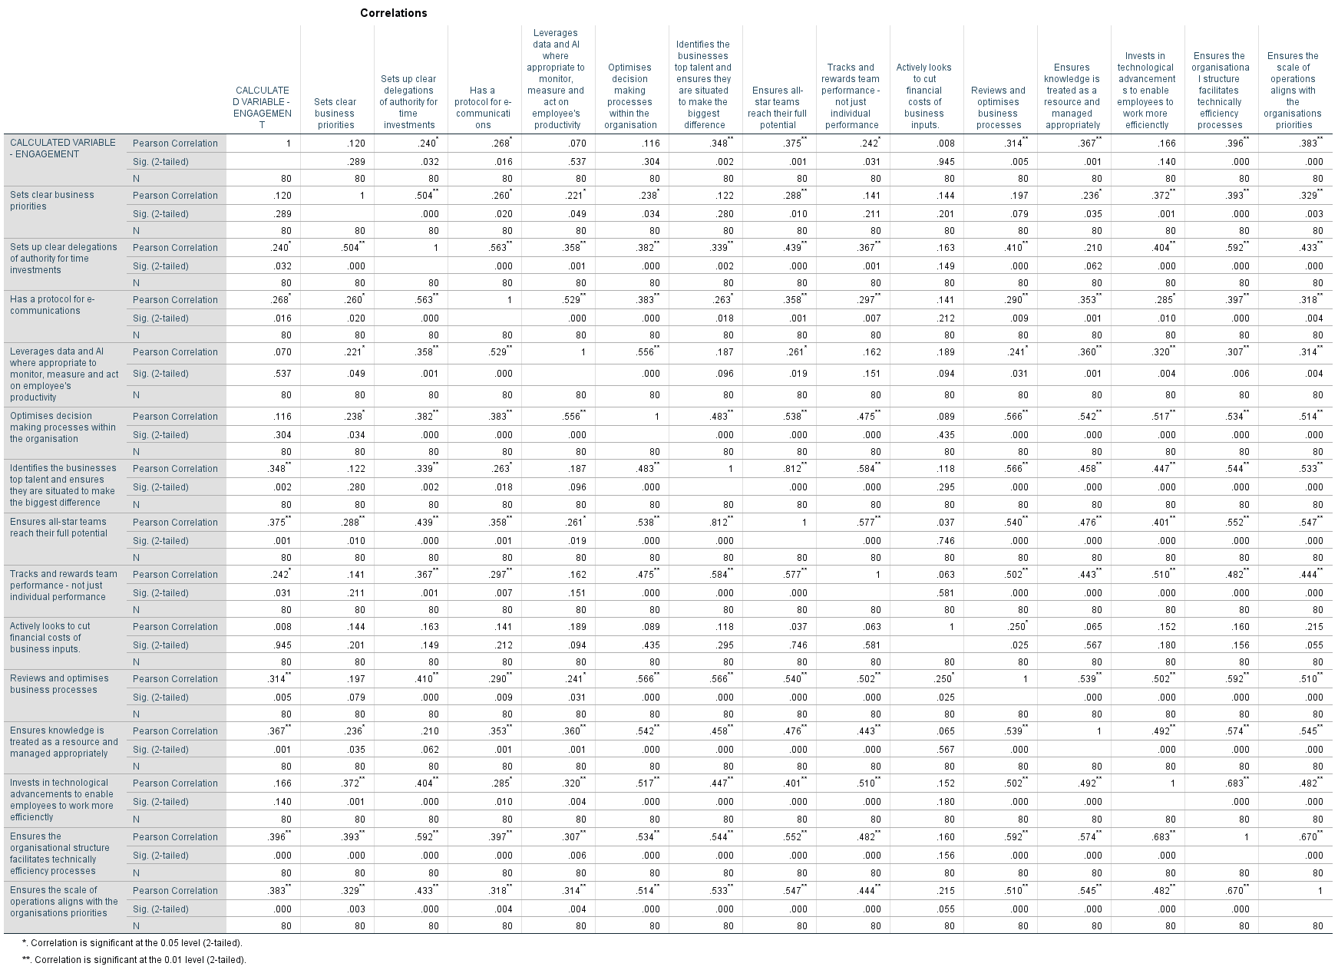

Intentionally Blank

