Name: Mariana Cocos

Student Number: 2024061

Module Title: The Global Business Environment LCBB4005

Lecturer: Dr Rexon Nting

Assignment 2 Title: Environmental Analysis of an Industry

Environmental Analysis of an Industry

Electric Vehicles Industry

Table of Contents

1. Introduction …………………………………………………………………………………………….3

2. Electric vehicle market structure ……………………………………………..………………..4

3.Survival and success factors for the industry with consideration to megatrends.4

4. The impact of the pandemic on the industry ………………………….…………….….…7

5. Conclusion …………………………………………………………………………………………...10

6. References …………………………………………………………………………………………...11

Figure 1. World market shares of top six companies in electric vehicles sales in 2021 until June Source: Cleantehnica.2021……………………………………………………………………………………. ……….6

Figure 2. Covid 19- measures at TESLA. Source: (Tesla,2020) …………………………………………...8

1.Introduction

The major features of current international economy are multiple options for production, developed networking, international trade, global debt, and financial vulnerability. In addition to that the macroeconomic policies that aim to provide a stable economic environment, stable markets, development, and employment protection. Not only that but also, the global mechanisation and virtualisation feature that plays an important role in economic development and business relationships, global sustainability, growth slowdown attributed to weaker trade and low investment activities, inflation etc. (United Nations, 2020) One of the leading players in electric vehicles industry is Tesla. It has made notable advances in the electric automotive industry on global level. Nevertheless, there are various factors that impact upon business trajectory such as digitalisation, technological advancements, sustainability, and Covid-19 pandemic.

This report aims to investigate electric vehicle industry. The analysis will answer the following questions. How the electric vehicle market structure influences the industry? What is the impact of the pandemic on electric vehicle industry? What are the survival and success factors for the industry with consideration to megatrends?

First, the electric market structure will be discussed. Second the challenges and success factors are analysed in corelation to changing value chain dynamics, the implications of Covid-19, Industry greening and digitalisation megatrends. Third, the focus is centred on a more detailed analysis of the impact Covid-19 has on industry and Tesla’s measures related to it.

2. Electric vehicle market structure

There are two market structure perfect and imperfect competition. The market structure has a high influence upon company strategies. The electric vehicles industry operates in oligopoly market. This market is characterised by high barriers to enter for new firms, a few large firms dominate the market and there are price makers. The businesses within oligopoly compete in different ways and it is closely connected to the objectives set by the firms weather it is to build a brand for themselves or increase the profit.
Porter argued that “there are tendencies for large industry scale to attract new entrants, who can make it tougher for existing leaders, particularly if the firms are well established”. (Porter, 1998)

3. Survival and success factors for the industry with consideration to megatrends

The electric vehicles have grown very fast due to high technological developments and the need to provide sustainable solutions to reduce pollution as climate change is global issue threating out entire existence. Government spends millions on supporting the development of the industry, encouraging therefore the purchase of electric cars. Despite the occurrence of multiple disruptions in operations in recent years because of pandemic electric cars had a record year in 2020 where Europe is the biggest market. (IEA, 2021)
Some of the megatrends affecting the industry are changing value chain dynamics mainly driven by technological developments, the impact of Covid-19, industry greening and digital transition.

Changing value chain dynamics

The transition from ICE-powered cars to EVs was a high step towards transportation. The traditional power sources will be still required in many markets for the foreseeable future. On the other hand, some prominent companies have already reported an all-electric line-up within the next few years. It has a significant impact on changing the value chain. Likewise, trends such as mobile systems and autonomous driving have been revving the role of software, data, and electronics. Therefore, these trends will push further changes in the automotive GVC. (Brown , et al., 2021)

The implications of Covid-19

As mentioned previously, Covid 19 had a negative impact on many industries and a devastating footprint on global economy. However, this megatrend accelerated the electronic vehicles industry. According to Broom (2021) “The 2020 may have been the year that electric cars came into their own, sales of EVs were up across the world, even in the US, tax breaks and COVID-related discounts have been fuelling sales, batteries and performance have improved”.

Industry greening

In the upcoming years, the transportation industry must undertake massive changes in its structure to survive and maintain its position in the global market. By adapting to new goals and implications related to climate changes it will support the industry in smooth development. The European Commission established multiple initiates to address these issues, precisely the attention is directed towards limiting vehicles emissions and improving the circularity of cars. (Brown , et al., 2021) Based on (Figure 1. World market shares of top six companies in electric vehicles sales in 2021 until June. Source: Cleantehnica,2021). Tesla has a top position for EV’s and BEV’s, followed by Volkswagen group. Tesla is the top innovator and over companies are the fast followers.

World market shares of top six companies in electric vehicles sales in 2021 until June
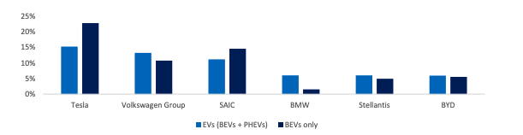
Figure 1. World market shares of top six companies in electric vehicles sales in 2021 until June. Source: Cleantehnica, 2021

Digitalisation

Digitalisation is another influential factor that implies both positive and challenging outcomes for industry development. The automotive sector is shifting from a hardware to a software orientation. Also, it increases the value of digital products and services.
The EV industry is placed well in terms of innovation. The future trends in EV are connectivity along with software architecture and the new features of autonomous driving. But many strategic competencies lie with global, large companies. For example, the US and Chinese organisations have the tools to support these developments.
As discussed in this section, the electric cars industry has developed very fast due to high technological developments, the need to provide sustainable solutions to reduce pollutions and other factors that can have a double effect, positive and negative on the industry and specific organisations. So, the key megatrends that determine the industry course are changing value chain dynamics mainly driven by technological developments, the impact of Covid-19, industry greening and digital transition. All these have a crucial role in the future of electric vehicle industry.

4. The impact of the pandemic on the industry

The Covid 19 pandemic is generating an international disturbance for many industries and day to day life of people. The disastrous impact is deeply felt by everyone, especially with the occurrence of new variants of Covid-19 that leads the world in further uncertainties and concerns.
The operations of the Electric vehicles industry have undergone changes to ensure the companies comply with new laws and regulations in terms of protecting employees, remote working, international trading operations, etc. The necessity to embrace pragmatic processes to respond to this crisis is a top priority for organisations and governments. Because these challenges are not a matter of the past, it is problematic to presume which approaches are the most compelling to uphold the businesses. The governmental programs, on the other hand, were trying to provide the necessary support for business to maintain their activity and survive via loans and furlough schemes.
Tesla Motors applied multiple efforts to strengthen its role and address the challenges. Some solutions, Tesla delivered include guiding its internal process for preventing the spread of Covid-19 among employees. It focused on safety by equipping and changing its operations to meet safety objectives. (Tesla, 2020)
Tesla crisis management team put in place guidance for employees in accordance with existing regulations to ensure safe return for employees at their workplace. The measures include increasing cleaning, and disinfestation in work areas like common areas customer areas and other. Also producing and providing disinfectant to use in work areas whenever possible, enforcing social distancing and adding barriers PPE or other precaution where required. Other measures include controlling access to facilities and implementing temperature cheque and symptom screenings at some locations besides that some measures such as adjusting work shifts to reduce the number of people in particular areas at one time. Some company policies include implementing the procedures for suspected or confirmed COVID cases, provide personal protective equipment such as face covering gloves etc. Tesla implemented touchless services for those that have customer interactions and suspended visitors and tours in most of the locations. (Tesla , 2020)

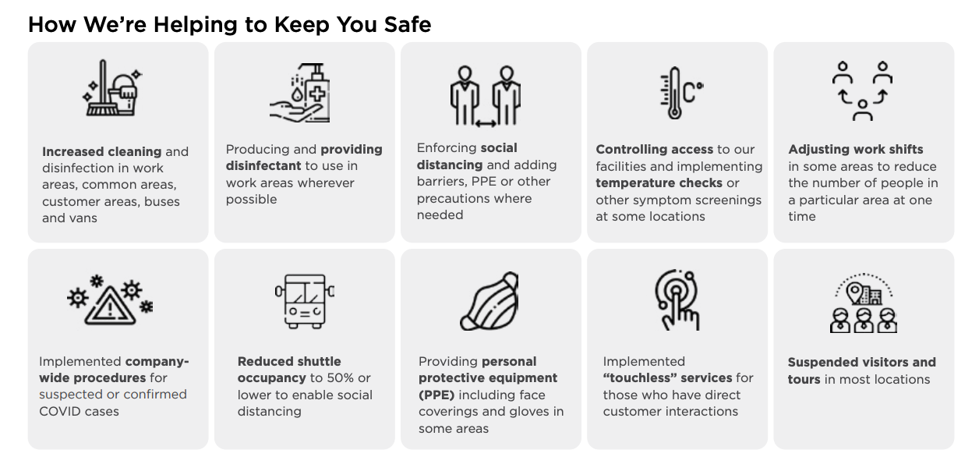

Figure 2. Covid-19 measures at Tesla. Source: (Tesla, 2020)

Because the global pandemic spreads even if the vaccination rates are high, the electric vehicles players must prepare for new challenges ahead. According to Hausley , et al., (2020) “The automotive market is among the hardest hit. Over the long term, COVID-19 could have a lasting impact on mobility as it drives change in the macroeconomic environment, regulatory trends, technology, and consumer behaviours”.
Over the short term, the crisis can slow the growth of cutting-edge technologies in e-mobility such as autonomous driving due to less effective management, lack of employees to adapt to the new business environment, and other barriers. Looking ahead businesses can implement plans for scaling up operations. One way to do so is by focusing on areas that had a limited impact. According to Fields (2020) one of the advantages Tesla has over its competitors been the consumer experience of ordering online, they do not have to travel to buy Tesla’s products compared to other car makers, it can be done over the internet in just a few minutes. Therefore, Tesla has been delivering a lot of products outside US. However, this may change because of high tendencies of traditional companies to shift to electric cars.
According to (Wen, et al., 2021) a direct and short-term impact of COVID-19 during the lockdown period, is the decrease of travel demands. Therefore, it decreases consumer's willingness to buy vehicles. In addition to that, loss of confidence in economic development after the pandemic makes buyers cautious while making purchasing decisions especially for such expensive goods such as electric cars.
At the beginning of 2020, lockdown rules blocked manufacturing facilities and supply chains. The lockdown affected electric vehicles sales. Despite that, there were indications of electric vehicle market resilience for two primary reasons, policy support and continued reductions in battery costs which delivered fertile ground for ongoing EV uptake. (Gorner & Paoli, 2021)
Hence, Covid 19 pandemic has created massive disturbances in electric vehicles industry. On the other hand, because of a high need to combat climate change electric vehicles are supported and encouraged by government due to lower impact on environment. Tesla is at the top of market share for EV’s. (Figure 1. World market shares of top six companies in electric vehicles sales in 2021 until June. Source: Cleantehnica, 2021). According to Fields (2020) one Tesla’s advantages over its competitors is innovation and possibility to order online. Also, Tesla put crisis management team in place to ensure safe return for employees at their workplace.

5. Conclusion

The electric vehicles industry operates in an oligopoly market structure where a few firms dominate it. The market structure determines the companies’ behaviour in terms of goals, price strategies, demand, supply, and other important elements for company growth and development. The rapid growth of technology and liberalisation of governmental policies allows organisations to engage more effectively than ever before.

The electric cars industry has evolved very fast because of high technological developments, the need to provide sustainable solutions to reduce pollutions, and other factors. Covid 19 pandemic is among the factors that created tremendous disturbances in the electric vehicles industry. Tesla is at the top of the market share for EV’s. (Figure 1. World market shares of top six companies in electric vehicles sales in 2021 until June. Source: Cleantehnica, 2021)

The company should maintain its position by keeping up with new trends and developments and applying innovative strategies to overcome potential barriers.

6. References

- Brian Collie, A. W. A. W., 2020. Covid 19's Impact on the Automativ Industry. [Online]
Available at: bcg.com
[Accessed 19 December 2021]
- Broom, D., 2021. 2020 was a breakthrough year for electric vehicles. Here’s why. [Online]
Available at: weforum.org [Accessed 19 December 2021].
- Brown , D. et al., 2021. The Future of the EU Automotive Sector, Luxenbourg: Policy Department for Economic, Scientific and Quality of Life Policies Directorate-General for Internal Policies.
- Fields, S., 2020. Analysts say Tesla has been delivering, despite the pandemic. [Online]
Available at: https://www.marketplace.org/2020/10/21/tesla-third-quarter-results-auto-industry-covid-19-pandemic/
[Accessed 19 December 2021].
- Gorner, M. & Paoli, L., 2021. How global electric car sales defied Covid-19 in 2020. IEA.
- Hausley , S. et al., 2020. The impact of Covid19 on future mobility solutions: McKinsey Center for Future Mobility.
- Higgins, T., 2020. Tesla Pulls Ahead in the Coronavirus Era After Ellon Musk;s Years of Strugle. Wall Street Journal , pp. 6-10.
- EA, 2021. Global EV Outlook 2021, Paris: IEA, https://www.iea.org/reports/global-ev-outlook-2021.
- Tesla , 2020. Tesla Return to Work Playbook. [Online]
Available at: https://www.tesla.com/sites/default/files/blog_attachments/Tesla-Return-to-Work-Playbook.pdf
[Accessed 19 December 2021].
- United Nations, 2020. World Economic Situation and Prospects. New York : United Nations .
- Wen, W., Yang, S., Zhou, P. & Gao, S. Z., 2021. Impacts of COVID-19 on the electric vehicle industry: Evidence from China. Renewable and Sustainable Energy Reviews, 144(1364)

