Student name: Mirish Salieva
Student number: 1913122
DSR – BMSW4003
Lecturer name: Terry Walcott
Contents
- Introduction
- Advantages and Disadvantages of VLE
- Advantages and Disadvantages of VLE, Literature Review
- Results of the research, Questionnaire Experience
- Conclusion, References

Introduction

Virtual learning is a learning experience that we could use our technology devices both internal and external. The patch of distance learning is complex in nature because it is self-assured of design of various academic fields in addition to its own concept, demonstrate, and theories. Although according to (Farhad Saba,2014) research in distance education can be traced back to the 1930s when researchers were examining the effectiveness of educational radio, it is only now that inquiry in distance education is beginning to show the maturity that is required for such a complex and multifaceted occurrence. Evidence of this maturity can be found in rigorous quantitative and the classes are takes places in online environments and lectures and students can chat and communicate through the Web cameras. A virtual learning environment is elegant way of presenting teaching and learning for both teachers and students. Good VLE gives a students chance by time improve their learning style. When we start our study for the year 2020/21, we did not know that we are going to experience the online study and develop new skills. For the past few months, we learn and adapt to the virtual learning environment, and that give us chance to think and analyse about what are advantages and disadvantages of virtual learnings. I did some research and tried to put in questioners form and ask others students about their opinion what they thinking and how they found virtual learning, of course in some point, I will share my thoughts and what was difficult for me and how I improve my learning skills with distance learning. Although in our life technology takes very important role of it, we all maybe will experience online learning at school or in our workplace.

Advantages and disadvantages of VLE
What are an advantages and disadvantages of distance learning? How was that affect my learning as a new student? The online courses are being designed equally, whatever device we use, so we have access to all programs and resources which makes easy process of learning. Let’s begin with some advantages what I found during my online study experience.
. Flexibility
The most obvious advantage is flexibility, is easy to access from everywhere, even if your workplace allows you can join the class from there. The modules are available always, and we can access from anywhere and from any device. When we are in online classes same time, we can use our second devices to the research or find relevant material for our study.
. Reason to stay home
They are different reasons student prefer to study from home, some people don’t want or are not able to attend the physical class. Some people have other responsibilities, as in our case we are all mature students, some have kids to look after or to look after of family member. The most and obvious advantage it is that you don’t have to participate physically in class, all you need is Internet connection.
. Reduced costs and save time
The other advantage is reducing cost and time. Although nothing changes in our course fee as we meant to be in class, but we saved from other expenses. In our busy life we all know that time is very important, with online learning we save time from travelling, we save from traveling cost and from other small costs that usually we spend during the class.
. Equal opportunity
In online environment the students have a chance to keep them self anonymous and feel more safe. The students with fear about discrimination for their age, physical appearance, disability, race and dress are largely absent. In virtual learning they will focus their attention to the relevant subject instead worrying about some discrimination. Some of the students feel very shy to participate and not that productive at class as they can be behind the computers.
. Creative teaching
In the online environment the students collaborate with other groups and create magnificent learning experience. The courses are created and transformed with full advantages of the new technologies. Student can use all the futures of the technology and online resources provided by their schools. The online education supports can be obtained and used in best way to improve study and creativeness.
While we discuss about advantages of online education but there are some disadvantages for which we can analyse. There are potential treats to the success of any online education. The lack of tutor support or experiencing technical issues are among of some disadvantages.
. Lack of face to face interaction
The most obvious dissatisfaction of the majority of the students are no face to face interaction, they can communicate with their classmates and exchange ideas and knowledge. Building some relationships with the lecturer and other students not going to be easy and will need much time end effort for that. For some students are easier to concentrate when they see their lectures physically.
. No self-discipline
When you are not self-discipline person the online education is going to be big challenge. The fact is many people learn easier through in class activities and given training. Although, even with design support our learning performance can decrease. Base of my research I found people more concentrate during the physical classes then in online environment.
. Poor teaching style
The other issues a facing students are teaching styles of the lecturers. The online environment can be difficult for the lecturers as well. The all teachers have different styles of teaching, some can put more effort to adopt to this situation, some can just do what they have to without productivity and any extra support for the students.
. Distraction
There many students who just join the class but in mean time handle their social media accounts, chat with friends talk with relatives. The students with kids are distracted by their child and cannot pay attention and most of the things they missing during online classes. Although some students attend the classes but mostly at the end of the class asking others for summaries the subject, as result of distractions.
. Unpleasant to read
Very often students feels uncomfortable while staring at the screen for hours. There is are few issues students are facing suchlike, back pain, vision problems, headache and ect. It is quite understandable for that reason if students does not feel like want to study or to read after online classes, staring at the computers can case health problems . The other thing is when someone feels pain in their body it is really difficult to concentrate to the certain task or study.
Literature review
Developing digital learning skills is a key point for the successful learners. But the role of lecturers is very important as they have to always engaging with the students. Self-discipline is great skills, but is not possible to everyone to be able to do so, the lecturer easily can check them and keep them active. According to (itslearning.com) is important to give voice and choice, with ensuring they have chance to speak and choice of way to learn. It is good to keep them active with real time activities and to be given them opportunity to ask and discuss some of their ideas. We have been using this system for many years in both face-to-face and online courses. ‘’ Teachers can use the tools in the platform to access students and 360-degree reports to give feedback to the students individually and communicate with them ‘’says (Prof. Dr. Ergun Akgun Director of the Distance Education Unit at Bahchelievler University, Turkey).

Results of the research
The research we done show us there is group of people prefer distance learning than physical one as we point in above there is so many reasons for that. The results deepening also of the participator age, responsibilities, discipline and how much they want to study. The online education supports are always available that’s makes studying process easier. From the results we can see there is less satisfaction of the group communications and interaction between students and lectures. If there is less interaction from students during online classes is of the result of that they just receiving information, in case of one-way communication. Interactive communication is exchange of idea’s sharing information receiving feedback from other site users. The students need more in class activities.
Questionnaire experience
In fact, for the very first time I’ve created my on questionnaire, I was really pleased with the results I found. The different opinions made me to think and analyse how we are all settled in a various way. Although they all have, they on priorities and viewing points, some are really satisfied with the online education, some needs physical classes to contribute and some are satisfied with a both ways. For the student for my very first year I was so excited and the same time nervous to create my on survey. However, I know this is very begging of my research and data collection but was really enjoyable experience. Although, I have to learn lot more about and increase my knowledge.
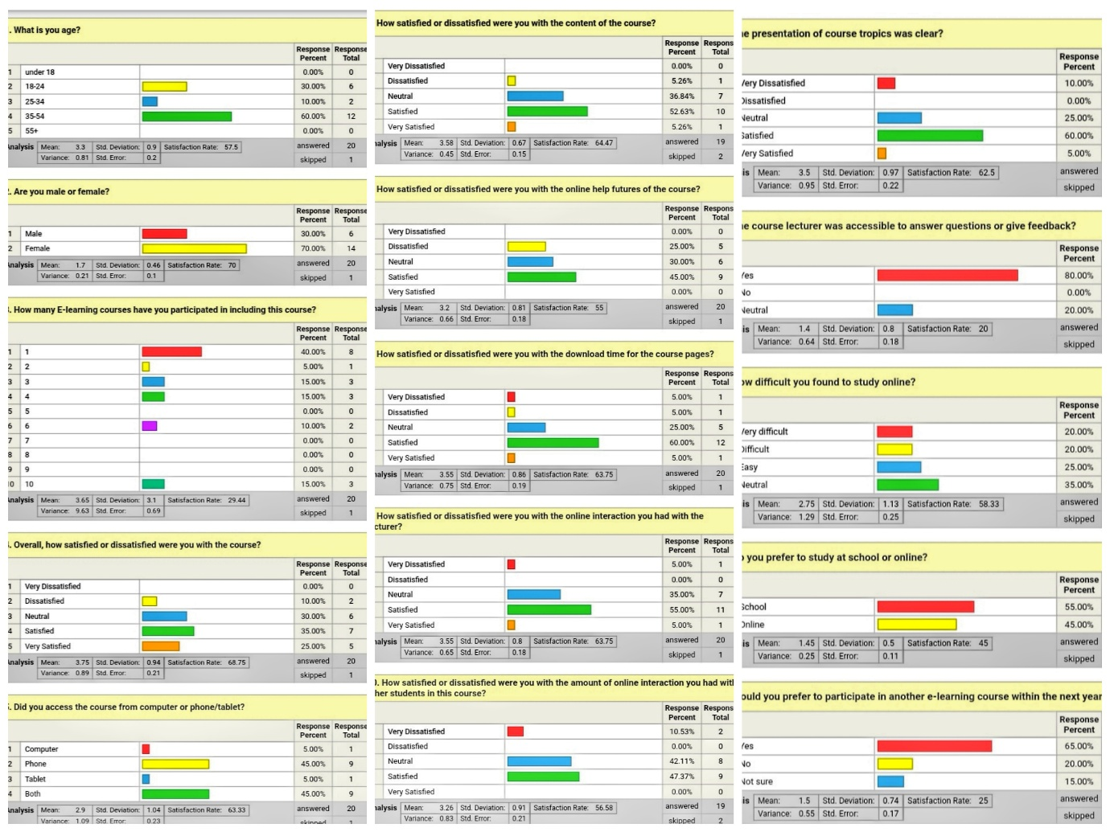

Conclusion
When we moved to virtual learning, I was very disappointed at the time, but the support we received from the lecturers and the University made thinks easy to understand. With research I’ve done I improve my understanding and skills and understanding, that if you want to study there is so may ways and opportunities gives you distance learning. When we begin the module DSR most of us was very skeptic, a we were worried how we can cope and understand the things from distance. However, we all experience challenge for the year 2020, but improve our digital skills from distance as we have to do by our self. We eliminate all our fears and tried to improve, and continue to do so. Base on my side and research it was really difficult to work in group activities from distance. They were several issues we faced, not all are online at the same time, no organized or less, not listening each other, technology issues and etc. During online classes we had less option to talk about our fears, as we could not interact with other students we faced technical issues and sometimes to be fear just sit behind the computer and listen is not easy and understandable. As a mature student in higher education, who was working the same time it was good to the study online, but I can include that we need more in class activities, to show our understanding and knowledge of the certain subject. We can benefit also if we can have some homework or to work with different classmate a received feedback from our teacher. In other point of view nothing can replace paper book, actual library not the virtual one, where we are struggling to log in and find what we are looking.
References

Caroline, July 2020,
http://www.easy-lms.com/knowledge-center/courses/advantages-and-disadvantages-of-online-courses/item10402
Farhad Saba, June 2014
http://www.reserchgate.net/publication/263350967_Methods_Study_in_Distance_Education_A_Critical_Review_of_Selected_Recent_Literature
(Prof. Dr. Ergun Akgun Director of the Distance Education Unit at Bahchelievler University, Turkey).
http://itslearning.com/global/manage-remote-learning/

