BA DEGREE ASSIGNMENT SPECIFICATION
SCHOOL OF TOURISM & HOSPITALITY
Student name: | Raluca Suciu | Student number: | 2022597
Programmes: | BA International Hotel Management
Module: | Managing Food and Beverage Operations | Module Level (4, 5, 6): | 6
Module code: | BMIH6002 | Contribution to Overall Module Assessment (%): | 50%
Lecturer: | Christopher Wilkin  Rodrigo Fernandes Aguilera | Internal Verifier: | Lola Villard
Assignment Title: | Student Learning Log (1250 Words +/-10%) | Assignment No: | 1 of 2
Hand Out Date: | w/c 24th of April 2023  Wednesday 2nd of June 2023 by 23h59 | Submission deadlines: | Monday 12th of
 | w/c 24th of April 2023  Wednesday 2nd of June 2023 by 23h59 |  | June 2023 by
Draft Deadline: | w/c 24th of April 2023  Wednesday 2nd of June 2023 by 23h59 | Return date of provisional | 23h59
 | w/c 24th of April 2023  Wednesday 2nd of June 2023 by 23h59 | marks & written feedback: | 10th of July 2023 by
 | w/c 24th of April 2023  Wednesday 2nd of June 2023 by 23h59 |  | 23h59

Table of Contents
Introduction 3
Vocational Development 4
Self-development 4
Academic development 5
Conclusion 8
Reference 9

List of Figure
Figure 1: DMAIC Model 5
Figure 2: Gibbs Reflective Cycle 6

Introduction
The placement in the foods and beverage section is for learning the foods and beverage operations in the hotel and hospitality industry. The main objective of the placement is to teach the students about the practical and merge academic knowledge into a field. The reflection report is based on the placement of The Dorchester London in the food and beverage department (Goh & Murillo, 2021). Here I have improved my self-management and other kinds of skills so that I can improve my academic skills as well. Here I have used the DMAIC model and the Gibbs reflective model for the reports. Finally, I have concluded the report with some of my thoughts regarding the missed opportunities during the placement in the hotel.

Vocational Development
I was able to accomplish my goals and obtain a thorough grasp of the sector during my employment at The Dorchester in the food and beverage department. I was able to improve my abilities in food service, food production methods, and management/supervision systems linked to food and beverage operations thanks to the whole experience, which served as a strong basis for my professional growth. My clear objective during the placement was to gain an understanding of managing food and beverage operations in the food and beverage industry (Pol & Patil, 2021). My placement also aimed to help me hone my customer service abilities. I had the chance to engage with a variety of clients while working at The Dorchester and offer them first-rate service.
My cooperation and communication skills were able to grow as a result of my placement at The Dorchester in terms of self-development. Working together with co-workers from diverse departments, I promoted efficient coordination and communication to guarantee efficient operations. My capacity to adapt, solve problems, and deal with difficult situations professionally increased while working in a fast-paced and dynamic setting. I recognised several "lost" chances in addition to the many worthwhile ones that the placement offered. I regret not getting greater exposure to the back-end processes, such as inventory management and cost control, due to time restrictions and the responsibilities of the position. These are important components of food and beverage operations that I would have liked to learn more about to have a comprehensive grasp of the sector.

Self-development
During my internship at The Dorchester, I saw a management problem with guest relations and communication that affected the food and beverage division's overall operational effectiveness. The issue was that the kitchen staff took too long to receive client choices and dietary needs, which caused inconsistent delivery of individualised dining experiences. My use of the approach allowed me to find practical answers to this problem (Goh & Jie, 2022). I evaluated internal communication procedures and client feedback to determine the impact. It soon became clear that the absence of a streamlined and effective method for recording and transmitting visitor preferences was the root cause of delays, misunderstandings, and misinformation in the kitchen.
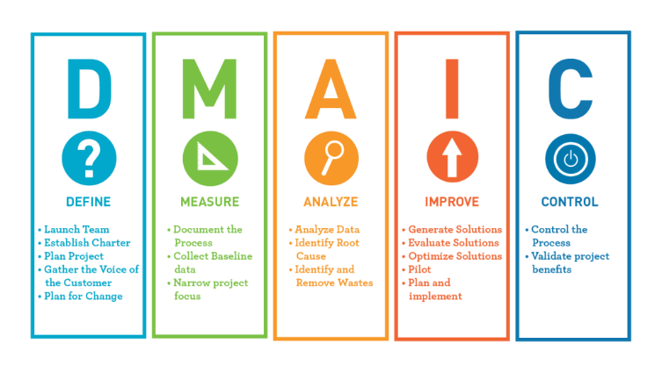
Figure 1: DMAIC Model
Source: (Yu & Huang, 2022)
Create a training programme to instruct all employees on how to communicate with guests effectively, with a focus on the significance of appropriately recording and relaying preferences and dietary needs. Establish a single system or database where pertinent departments may store and retrieve information about visitor preferences and dietary needs (Ahmed, 2019). This will simplify communication, lessen mistakes, and provide staff members with instant access to information.
Encourage improved lines of communication between the front-of-house and kitchen employees. Regular briefings, meetings, and feedback sessions help promote a cooperative atmosphere and ensure that any updates or changes to guest requirements are conveyed right away. Feedback from workers and customers is used for assessing the situation. The guest service for communication must be adjusted and continuously improved to support regular audits.

Academic development
I actively acquired and implemented important skills in self-management and growth, task management, using initiative to solve difficulties at work, communication, and the application of information during my placement at The Dorchester. I may demonstrate my improvement in these areas by utilising the Gibbs reflective cycle to reflect on my experiences.
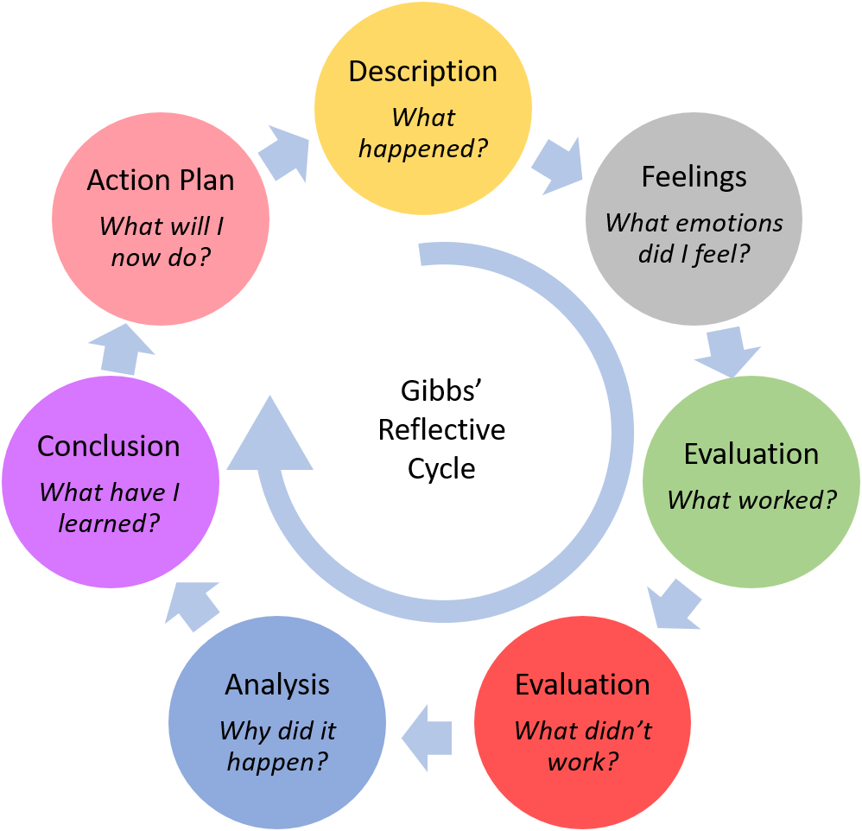
Figure 2: Gibbs Reflective Cycle
Source: (Markkanen & Anttila, 2020)
The Gibbs reflective model requires identifying the cause first. Then the problem solver will use their insight for solving and realizing the failure or success of the situation. After the success is identified it is important to analyse and finally conclude the situation. The final action will be depending on all the reviews of these situations.
At first, I conducted self-reflection using the Gibbs Reflective Model to identify my self-management and personal development strong points and opportunities for growth. I understood how crucial it was to establish specific goals and aggressively look for chances to advance. I came up with a list of precise steps to pursue self-improvement through self-reflection and feedback from supervisors (Wood, 2013). I displayed self-management and a dedication to personal improvement by creating objectives and constantly reviewing my progress.
I considered particular situations when I had to juggle several duties and obligations using the Gibbs Reflective Model as a framework. I assessed my task-management strategy and noted development opportunities. I became aware of the necessity of using time management strategies and good work prioritisation via contemplation. I used tactics like making task lists, dividing difficult work into smaller, more doable activities, and establishing reasonable deadlines. My task management abilities increased as a result of using these strategies and critically evaluating their performance.
Using the model, I have reviewed and evaluated the response from the customer. Through the analysis, I have improved methods for addressing the issues and developing problem-solving. I actively sought a good opportunity to suggest practical responses to the problems, which improved my problem-solving ability. I assessed my communication abilities within the Gibbs Reflective Model framework by thinking back on certain situations where good communication was critical (Wallace & Darlington, 2018). I evaluated my communication style, seeing both its advantages and shortcomings. I saw the value of clear comprehension, active listening, and adjusting communication with various people. I improved my communication abilities and promoted productive cooperation with co-workers and visitors by putting the lessons learned through reflection into practice. Finally, I reflected on the model for improving academic skills. I identified specific instances where I have applied my knowledge learned from the academic institutes. Thus I have reinforced continuous improvement through academic skills.

Conclusion
I have actively worked to build important abilities in self-management and growth, task management, using initiative to solve challenges at work, communication, and the application of information during my time at The Dorchester (Munguía-Serrano & Tolentino-Mayo, 2020). I have continually worked to get better in these areas via reflective participation and proactive participation. I have established specific goals, used time management strategies, taken the initiative to solve problems, improved my communication abilities, and used my theoretical knowledge in real-world contexts. I have thereby greatly increased my competency in these areas, setting myself up for success in the food and beverage sector in the future.

Reference
Ahmed, S. (2019) ‘Integrating DMAIC approach of Lean Six Sigma and theory of constraints toward quality improvement in healthcare’, Reviews on Environmental Health, 34(4), pp. 427–434. doi:10.1515/reveh-2019-0003.
Goh, E. and Jie, F. (2022) 'Managing food wastage in hotels: Discrepancies between injunctive and descriptive norms amongst hotel food and beverage managers, British Food Journal, 124(12), pp. 4666–4685. doi:10.1108/bfj-05-2021-0513.
Goh, E. and Murillo, D. (2021) ‘Living through the lives of hospitality students during work-integrated learning (WIL) internships: An application of the critical incident technique to explore factors affecting students’ will experience’, Journal of Hospitality & Tourism Education, pp. 1–12. doi:10.1080/10963758.2021.1963755.
Markkanen, P. and Anttila, M. (2020) ‘A reflective cycle: Understanding challenging situations in a school setting’, Educational Research, 62(1), pp. 46–62. doi:10.1080/00131881.2020.1711790.
Munguía-Serrano, A. and Tolentino-Mayo, L. (2020) ‘Nutritional quality of hidden food and beverage advertising directed to children: Extent and nature of product placement in Mexican television programs’, International Journal of Environmental Research and Public Health, 17(9), p. 3086. doi:10.3390/ijerph17093086.
Pol, R.S. and Patil, H. (2021) ‘Perception of final year hotel management students towards working in hotel industry’, ATITHYA: A Journal of Hospitality, 1(2). doi:10.21863/atithya/2015.1.2.017.
Wallace, A. and Darlington, G. (2018) ‘Accuracy of parental reporting of preschoolers’ dietary intake using an online self-administered 24-H recall’, Nutrients, 10(8), p. 987. doi:10.3390/nu10080987.
Wood, R.C. (2013) Key concepts in hospitality management. London, London: Sage.
Yu, C.-M. and Huang, T.-Y. (2022) ‘Construct six sigma DMAIC improvement model for manufacturing process quality of multi-characteristic products’, Mathematics, 10(5), p. 814. doi:10.3390/math10050814.

