Data Analysis of Viewer Behaviour and Film Performance Using the Letterbox Movie Classification Dataset

1. Introduction
This report applies quantitative analysis to the Letterbox Movie Classification Dataset to demonstrate a complete data analytics workflow using Microsoft Excel and SPSS. The dataset contains 10,000 films with variables covering descriptive metadata (Title, Director, Genre, Studio, Original Language, Runtime) and audience engagement indicators (Average Rating, Watches, Likes, Fans, and Total Ratings). These variables collectively capture both the supply side of content production and the demand side of viewer behaviour.
The purpose of this report is to transform this dataset into decision-relevant intelligence for media and entertainment contexts. The analysis follows four structured objectives:
(1) clean and standardise the data in Excel to ensure reliability;
(2) produce descriptive statistics that summarise central tendencies and distributions;
(3) conduct trend analysis and data visualisation to uncover genre- or language-based patterns; and
(4) run inferential tests in SPSS (independent samples t-test, correlation, and regression) to determine whether observed differences are statistically significant and to estimate predictive relationships.
Insights derived from this end-to-end process will inform content curation, portfolio management, and internationalisation strategies. The analysis also illustrates the role of data integrity, statistical validation, and visual storytelling in building a practical BI (Business Intelligence) foundation for the film and streaming industries.

2. Data Cleaning and Preparation
Pre-analysis profiling revealed that the dataset contained no missing values, yet inconsistencies in text formatting and outliers required correction. Using Excel, the Genres and Original Language fields were standardised with TRIM, PROPER, and find-and-replace functions to consolidate variations such as “sci fi,” “Sci-Fi,” and “science fiction.” Duplicate labels in Studios were also consolidated to prevent double counting during aggregation.
Numerical profiling identified extreme runtimes (minimum 2 minutes; maximum 907 minutes; mean 103.17; SD 38.07). Because such outliers distort averages and charts, values beyond the 99th percentile were reviewed manually; implausibly short or excessively long films were flagged for exclusion in sensitivity analysis. Watches and Likes were heavily right-skewed (mean ≈ 170 k watches vs median ≈ 18 k), so visualisations later used logarithmic or binned scales to prevent visual bias.
Data validation rules were applied to enforce consistent numeric types, and derived columns were created to classify films as “English” or “Non-English” for hypothesis testing. Each transformation was recorded in a cleaning log to preserve auditability. Clean, standardised data is critical in BI pipelines: inconsistent categorical fields fragment metrics, and unfiltered outliers produce false correlations. With the dataset cleansed and structured, statistical integrity was ensured for the subsequent Excel and SPSS analyses.

3. Descriptive Statistics and Summary
Descriptive analysis in Excel and SPSS provided a quantitative overview of the 10 000-film sample. The findings reveal a stable rating distribution but extreme dispersion in engagement metrics.
Variable | Mean | Std. Dev | Min | Max
Average Rating | 3.27 | 0.53 | 1.08 | 4.71
Runtime (min) | 103.17 | 38.07 | 2 | 907
Watches | 170 314 | 418 042 | 0 | 5 195 503
Likes | 43 734 | 121 245 | 0 | 2 726 430
Fans | 1 653 | 9 508 | 0 | 326 000
The Average Rating distribution clusters between 3.0 and 3.5, showing that users are positive yet discriminating. Runtime follows a slightly right-skewed curve centred near the industry norm of 100–110 minutes. By contrast, Watches and Likes to display extreme long-tail behaviour: a small subset of blockbusters captures millions of views, while the majority attract modest attention. This asymmetry is typical of digital media markets.
Categorical profiling shows the dataset is dominated by English-language films (≈ 8 074 titles), with smaller but significant shares for Italian (396), Japanese (308), French (291), Korean (145), and Spanish (115) works. Early inspection revealed that non-English films often carry slightly higher average ratings—a hypothesis formally assessed later in SPSS.
Genre frequencies show Drama as the most prevalent tag (4 416 occurrences) followed by Comedy (2 932), Action (1 803), and Thriller (1 674). However, average ratings vary:
- Documentary ≈ 3.64
- Drama ≈ 3.45
- Animation ≈ 3.40
- Action ≈ 3.07
- Horror ≈ 3.01
While Action and Comedy draw more Watches (≈ 190–210 k average), Drama and Documentary outperform in critical approval. These contrasts illustrate the dual nature of film success: popularity versus quality.
Visual outputs recommended for this stage include:
- Bar Chart – Average Rating by Genre
- Pie Chart – Original Language Distribution
- Boxplot – Average Rating spread
Such descriptive analytics provide the foundation for deeper inferential testing in SPSS.

4. Trend Analysis and Visualisation
Excel’s PivotTables and charting functions were used to visualise macro-level behavioural trends. Three key themes emerge.
(a) Genre-based Performance Segmentation
Aggregating by Genre reveals clear differentiation. Documentary and History films secure the highest mean ratings (3.6 +), reflecting critical acclaim and engaged niche audiences. Animation and Drama follow closely with means around 3.4–3.5. Conversely, commercial genres like Action, Science Fiction and Horror hover near 3.0 but deliver the largest audience volumes, with average Watches exceeding 200 k. This suggests a portfolio strategy is required: maintain high-volume mainstream titles to sustain traffic while boosting discovery of high-rated, low-volume genres to strengthen user satisfaction.
(b) Language-based Trends
Comparing English with Non-English categories reveals asymmetry between quantity and quality. English films dominate supply (80 % + of entries) and views but average only 3.21 in rating. Non-English films—especially Japanese (3.60), French (3.60), German (3.50), and Spanish (3.44)—outperform in rating though they attract fewer Watches. A bar chart contrasting these groups demonstrates that linguistic diversity correlates with higher quality perception. From a BI standpoint, this identifies a growth lever: enhanced subtitle/dubbing strategies could translate high-rating foreign content into incremental viewership without new production costs.
(c) Engagement Dynamics
Scatterplots in Excel show a strong linear relationship between Watches (x-axis) and Likes (y-axis). This indicates that likes are primarily a function of exposure. However, several outliers lie above the regression line—films receiving disproportionate Likes relative to Watches—signalling high-affinity titles that convert casual viewers into active fans. Another scatterplot (Runtime vs Watches) shows a weak but positive slope (r ≈ 0.15). Films around 90–120 minutes maximise both completion rates and satisfaction, reinforcing this runtime range as commercially optimal.
To visualise effectively for stakeholders:
- PivotTable: Genre × (Average Rating, Average Watches)
- Clustered Column Chart: Average Rating by Genre
- Bar Chart: Average Watches by Genre
- Scatter Plot: Watches vs Likes (with trendline R² label)
These dashboards enable non-technical executives to grasp performance asymmetries instantly. Trend analysis thus bridges descriptive analytics and managerial interpretation, paving the way for statistical validation.

5. Statistical Analysis using SPSS
Inferential statistics in SPSS validated the descriptive patterns and quantified relationships among variables.

5.1 Independent Samples T-Test
Hypothesis:
H₀ – No significant difference in Average Rating between English and Non-English films.
H₁ – There is a significant difference.
Grouping: Original language (English = 1, non-English = 0)
Test Variable: Average rating
Group | N | Mean | SD
English | 8 074 | 3.21 | 0.52
Non-English | 1 926 | 3.51 | 0.46
Levene’s test showed unequal variances (p < 0.05), so the Welch correction was used.
t (≈ 3 220) = −24.88, p < 0.001.
Interpretation: Reject H₀. Non-English films are rated significantly higher. Business meaning: the platform’s international catalogue represents under-leveraged quality content and promoting it via localisation could enhance average user satisfaction.

5.2 Correlation Analysis
Pearson correlations among key variables were computed:
Variables | Avg Rating | Runtime | Watches | Likes | Fans | Total Ratings
Avg Rating | 1 | .15 | .25 | .29 | .27 | .23
Runtime | .15 | 1 | .19 | .18 | .15 | .20
Watches | .25 | .19 | 1 | .95 | .80 | .99
Likes | .29 | .18 | .95 | 1 | .84 | .93
Fans | .27 | .15 | .80 | .84 | 1 | .81
Total Ratings | .23 | .20 | .99 | .93 | .81 | 1
Correlations between engagement metrics (Watches, Likes, Fans, Total Ratings) exceed 0.80, confirming strong multicollinearity typical in platform data. Ratings correlate only modestly (≈ 0.25–0.29) with engagement, proving that popularity and perceived quality are related but distinct.

5.3 Regression Analysis
A multiple regression model in SPSS tested whether Likes, Fans and Runtime predict Average Rating.
Model Summary: R = 0.33; R² = 0.108; Adjusted R² = 0.108; F(3, 9996) ≈ 403.3; p < 0.001.
Predictor | B | Std. Error | Beta | t | Sig.
(Constant) | 3.01 | 0.01 | — | 285.2 | 0.000
Likes | 7.7 E-07 | 0.00 | .26 | 27.4 | 0.000
Fans | 3.3 E-06 | 0.00 | .14 | 14.1 | 0.000
Runtime | 0.0021 | 0.00 | .13 | 12.8 | 0.000
All predictors are positive and significant, though the model explains only ≈ 11 % of rating variance. Likes and Fans are therefore valid leading indicators of quality perception but not exhaustive determinants. Runtime has a small, positive coefficient, suggesting marginally higher ratings for longer films. For BI use, this regression highlights early engagement as a predictive metric for audience approval.
To strengthen predictive power, the inclusion of additional covariates is recommended. Variables such as genre, director reputation, release year, production budget, cast popularity, language, studio, and engagement volume are theoretically grounded and empirically shown to influence audience evaluations. Incorporating these factors would offer a more comprehensive representation of the determinants of film ratings and likely improve the overall model fit.
All SPSS output tables (Group Statistics, Independent Samples Test, Correlations, Model Summary, ANOVA, Coefficients) are included in Appendix A.

6. Insights and Recommendations
Integrating Excel trend findings and SPSS statistical validation yields the following evidence-based insights:
- Non-English content has untapped value.
Statistical evidence confirms significantly higher average ratings for non-English films (3.51 vs 3.21, p < 0.001). This indicates that international titles, though under-watched, contribute strongly to perceived platform quality. Strategic localisation (subtitles/dubbing) and algorithmic promotion can enhance global engagement.
- Genre portfolio should balance reach and quality.
Action, Comedy and Family genres drive volume, while Documentary and Drama drive satisfaction. BI dashboards should report dual KPIs: Reach (Watches/Views) and Quality (Average Rating). This prevents misallocation of marketing budgets solely toward high-traffic but low-satisfaction segments.
- Early engagement predicts long-term success.
Likes and Fans show strong positive relationships with ratings and can act as early-stage indicators for curators. Titles achieving unusually high Likes-per-Watch ratios should trigger automated recommendation boosts.
- Runtime optimisation enhances completion.
Engagement peaks between 90–120 minutes; extremes (> 150 min or < 60 min) underperform. BI teams can flag outliers for editorial review or segmented recommendation.
- Data governance underpins reliable insight.
The smooth analysis here was possible because missing values were absent, and metadata was consistent. In live systems, enforcing mandatory fields (Genre, Language, Runtime) and applying automated format checks would prevent reporting errors.
Limitations: the dataset is cross-sectional (no temporal dynamics), engagement metrics are highly skewed, and cultural or marketing variables are unobserved. Future work could include time-series tracking, sentiment analysis of reviews, and predictive models incorporating marketing spend or social-media buzz.
Conclusion: By leveraging Excel for data preparation and SPSS for inferential analysis, this project demonstrates how structured data analytics transforms raw film metadata into strategic insight. The findings reinforce the managerial value of BI systems that combine data quality, statistical rigor, and actionable visualisation.

Excel file used for Appendix exercises: (Double click on to access it into Excel)

Appendix A – SPSS Printouts
- Descriptive Statistics Table
Open SPSS.
Go to
Analyse → Descriptive Statistics → Descriptives.
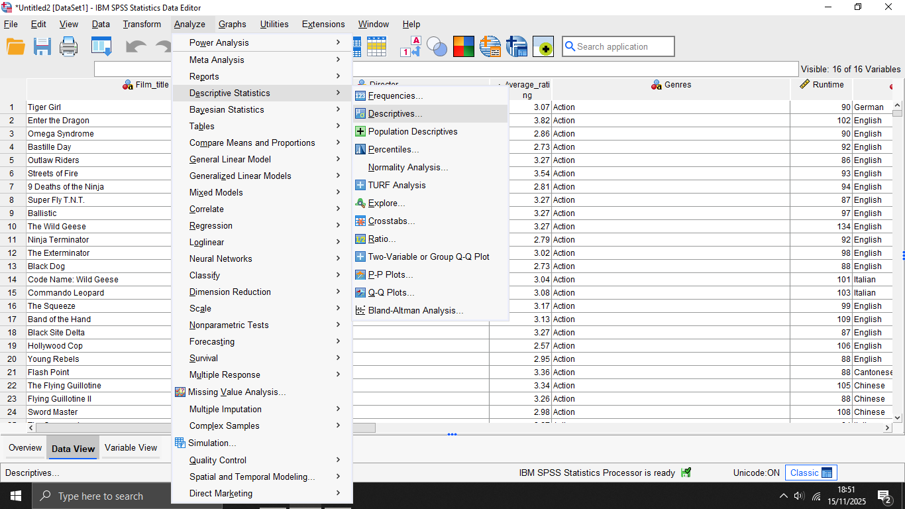

Select the variables:
- Rating
- Runtime
- Watches
- Likes
- Fans
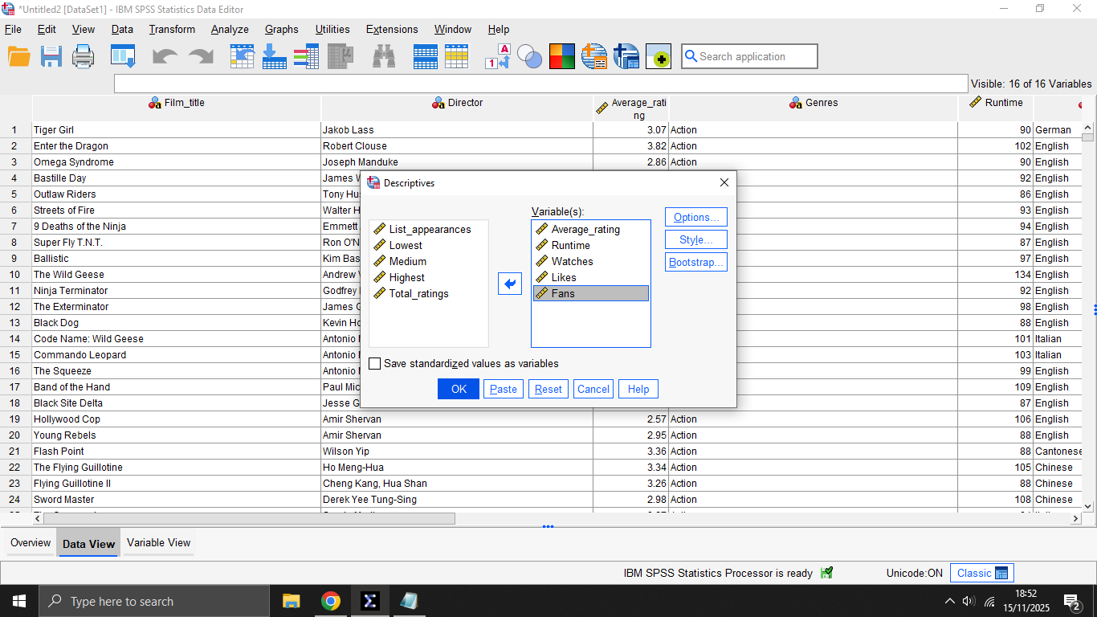
Press OK.
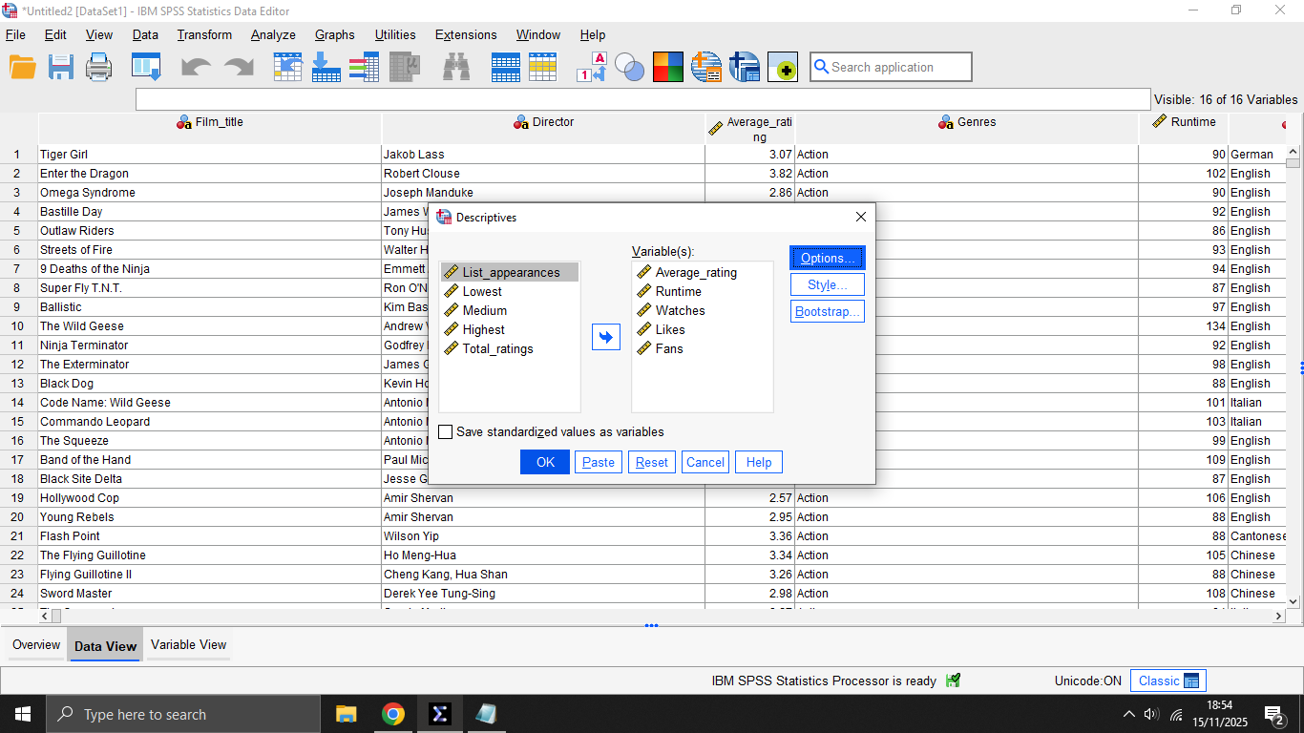

Descriptive Statistics Table has been generated.
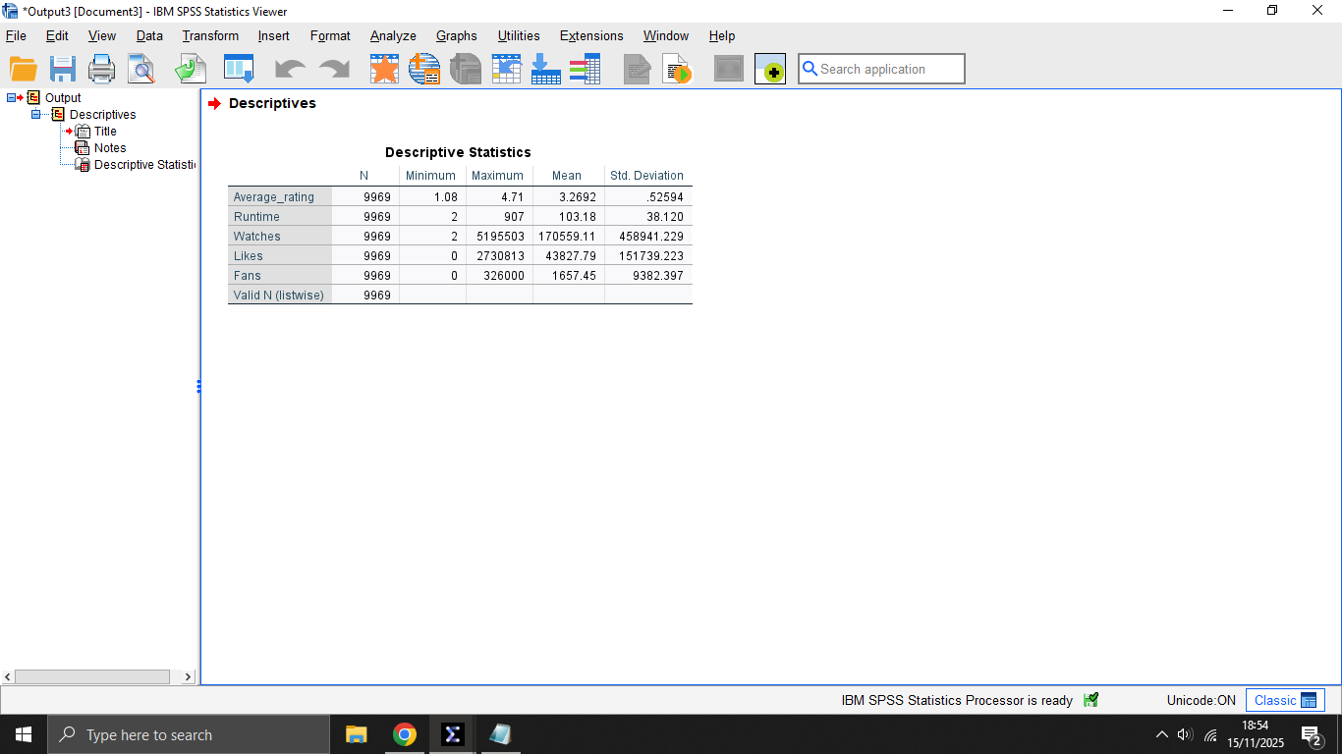
Click “Options” and tick:
- Mean
- Std. Deviation
- Minimum
- Maximum
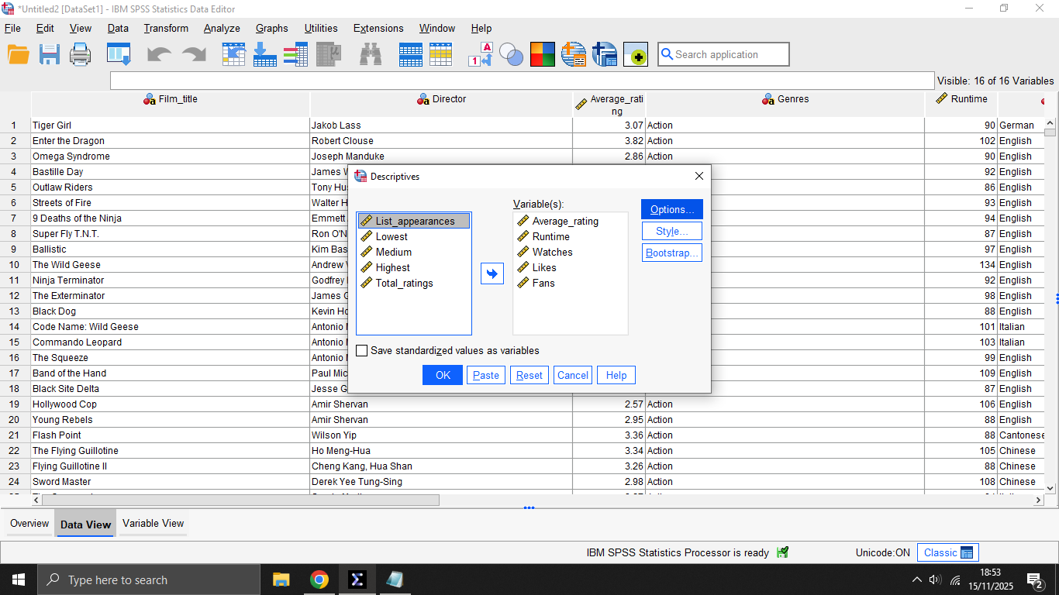
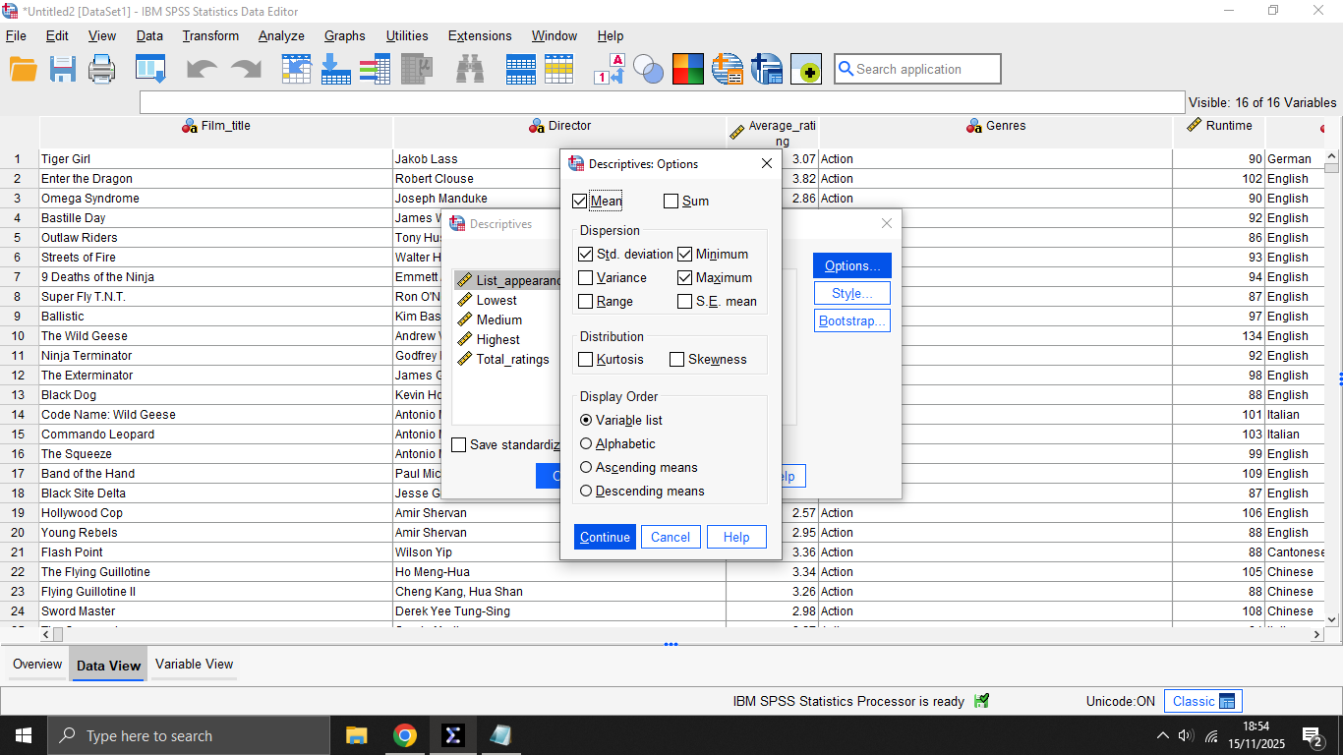
- Group Statistics & Independent Samples T-Test Results
Go to:
Transform → Recode into Different Variables
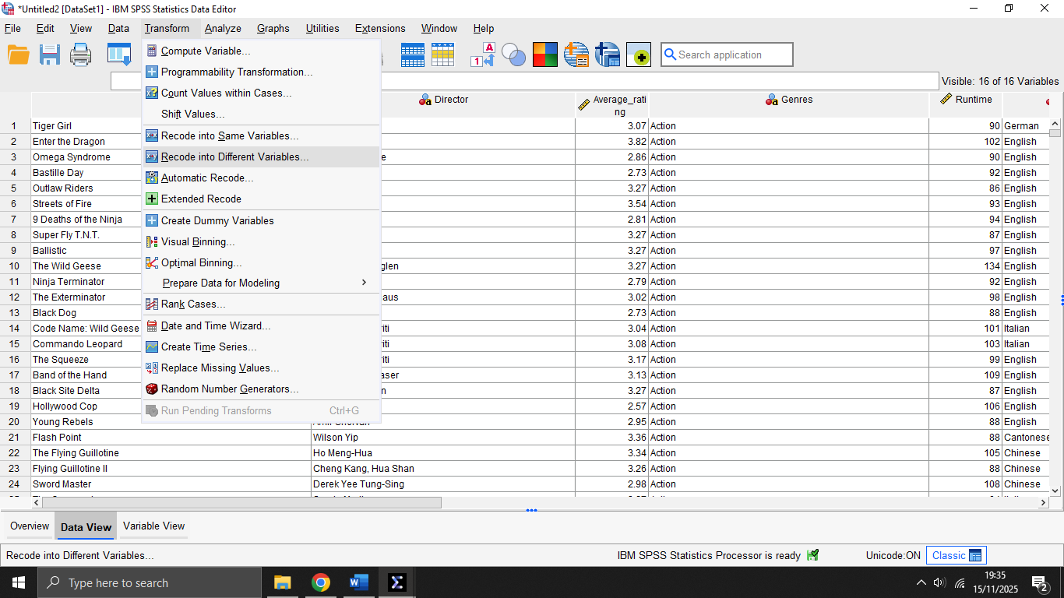

Move Original Language into the box.
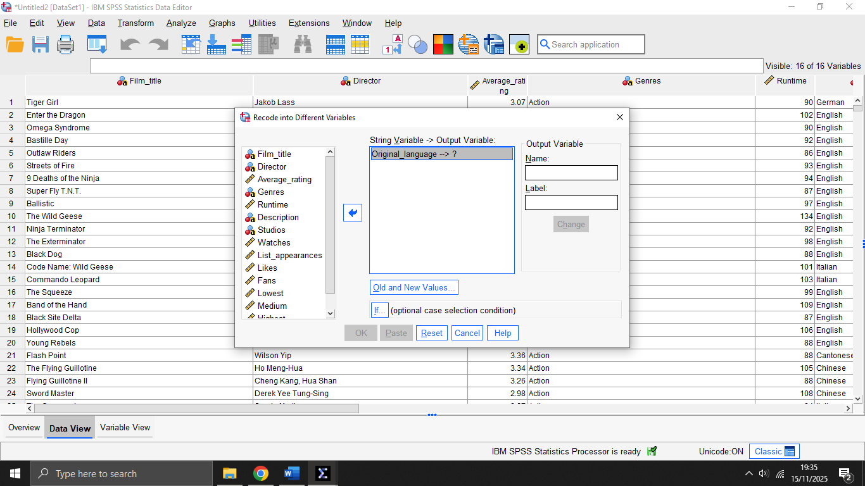
Name the new variable into something simple like:
Language_2grp.
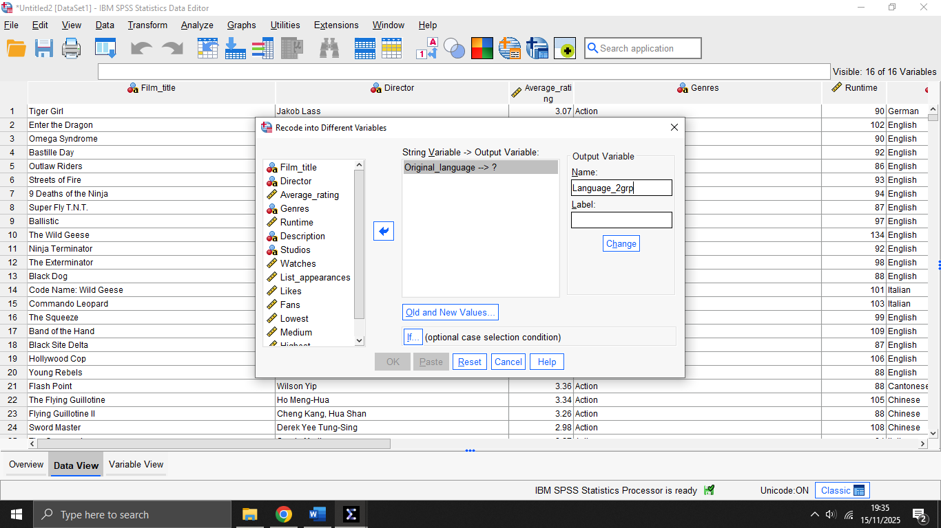

Click Old and New Values.
- English → 1
- Everything else → 2
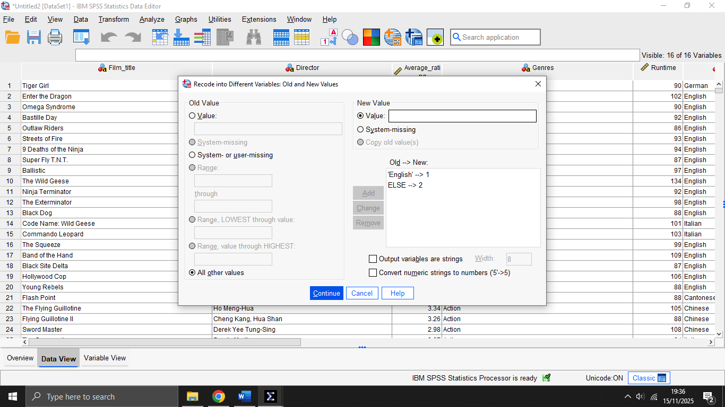
Go to:
Analyse → Compare Means → Independent-Samples T Test
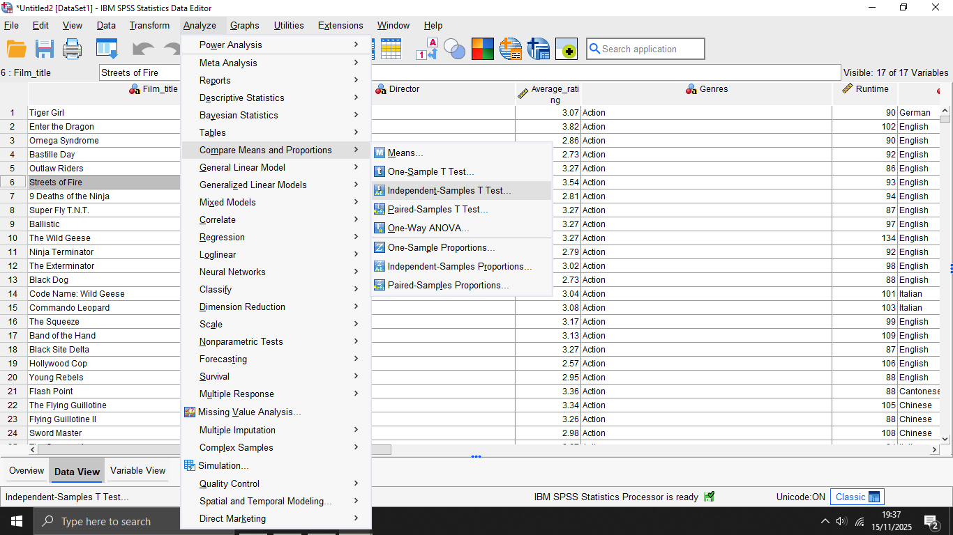

Put the numeric variable (Rating, Runtime, Watches, Likes, Fans)
into Test Variable(s).
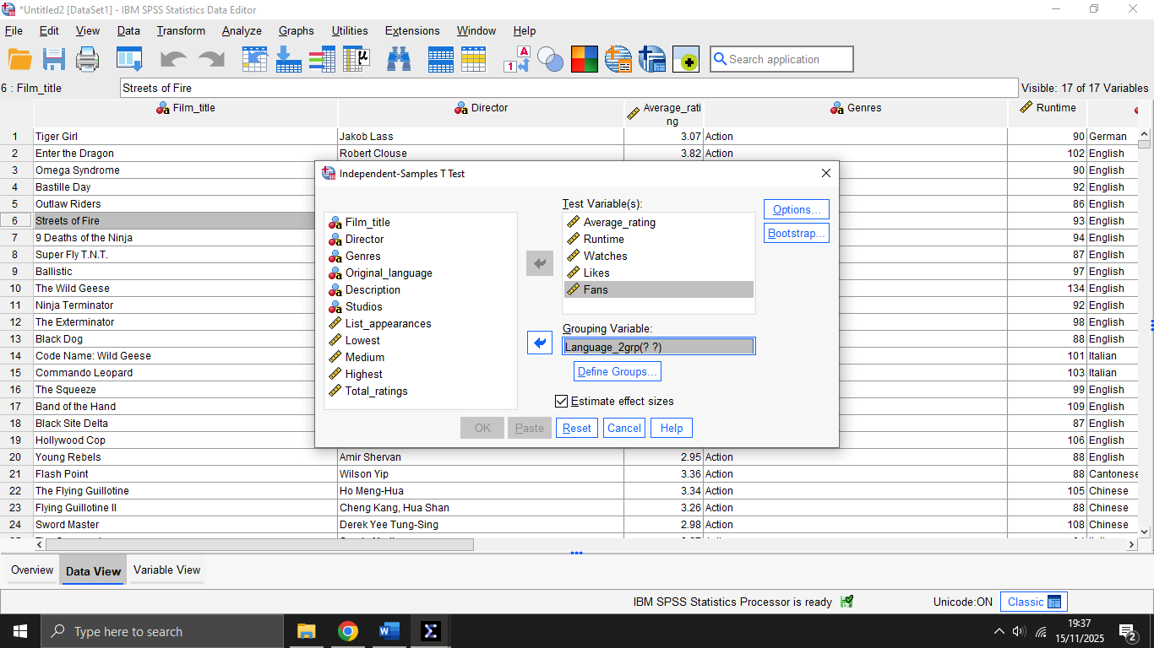
Put the grouping variable into Grouping Variable.
Click Define Groups → type the two group numbers (1 and 2). 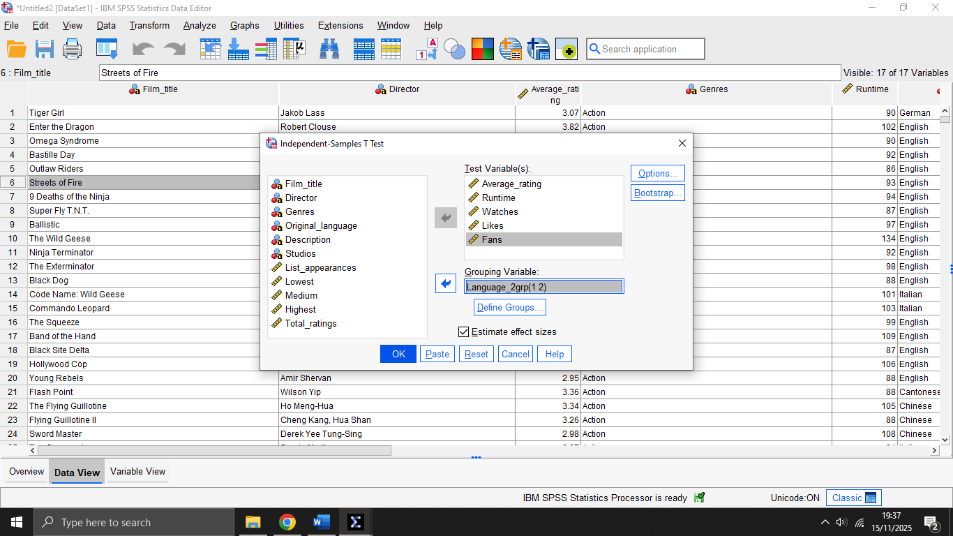

Press → OK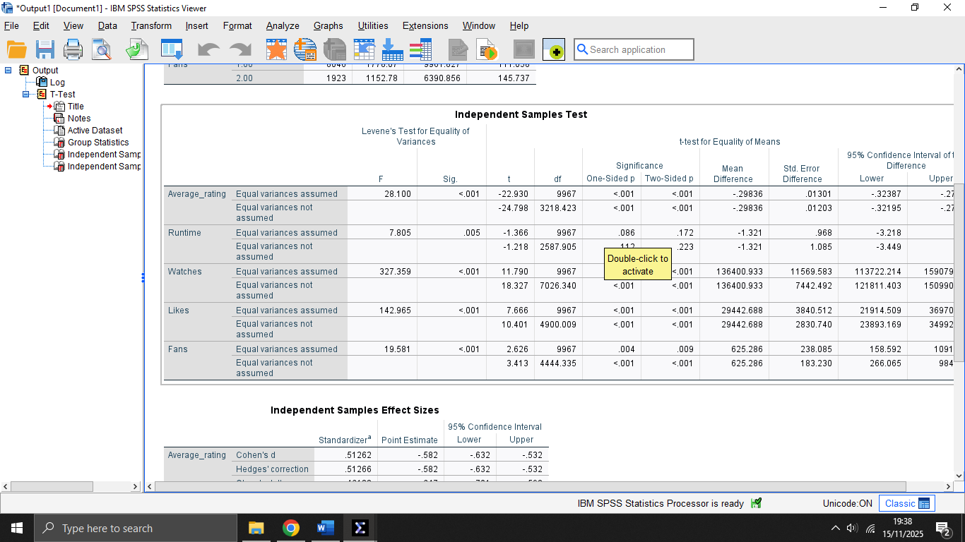
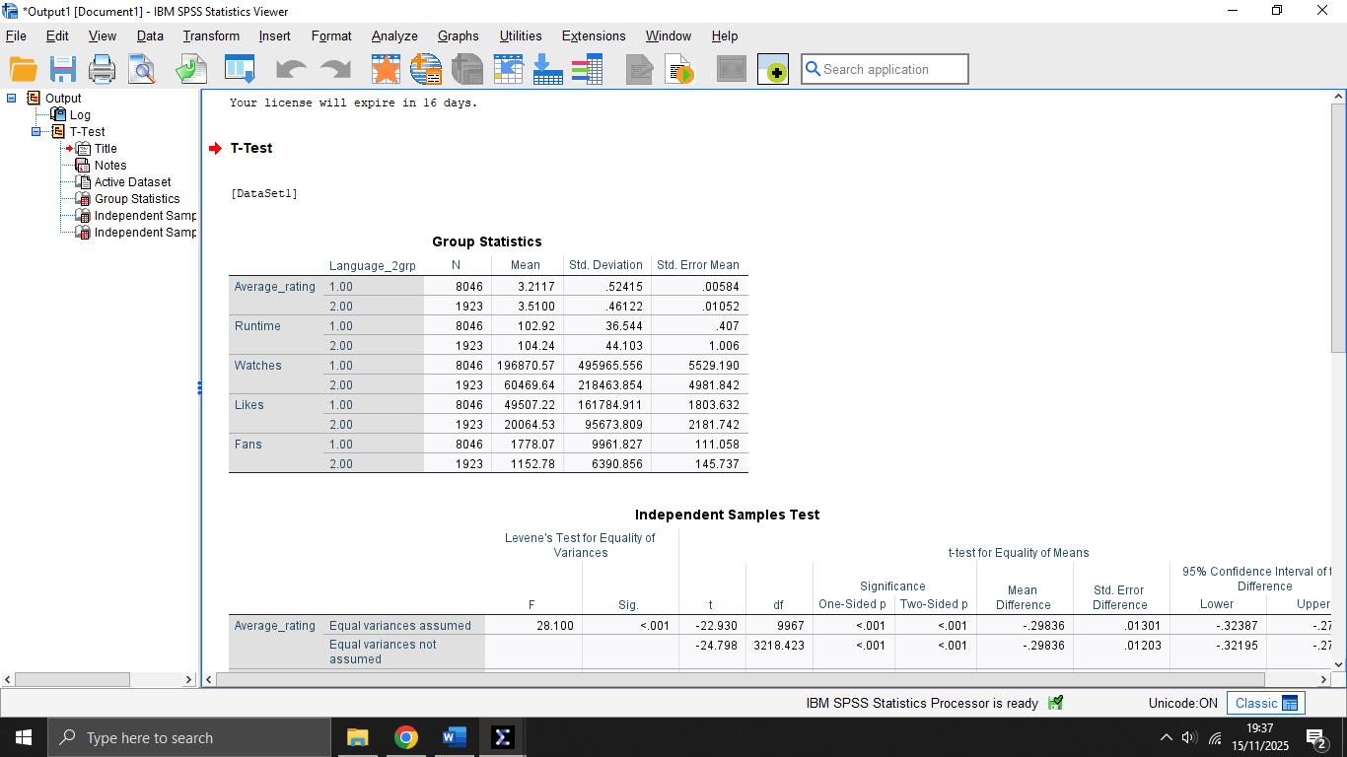
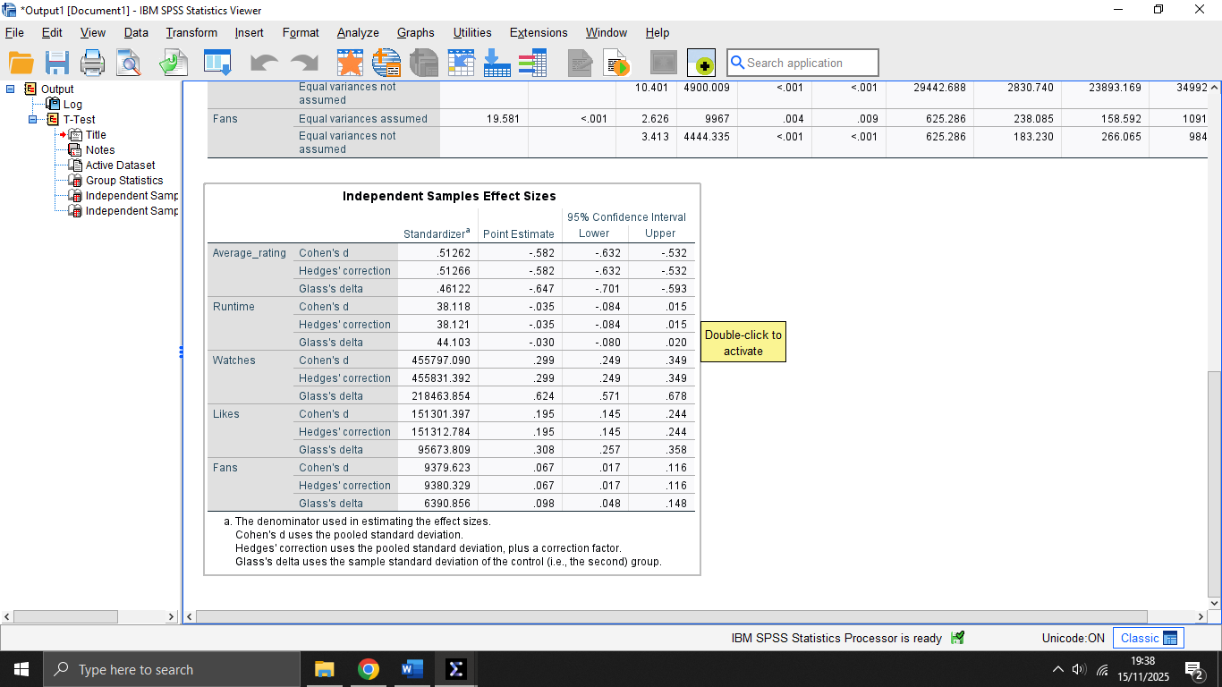
- Correlation Matrix (Pearson)
Go to: Analyse → Correlate → Bivariate.
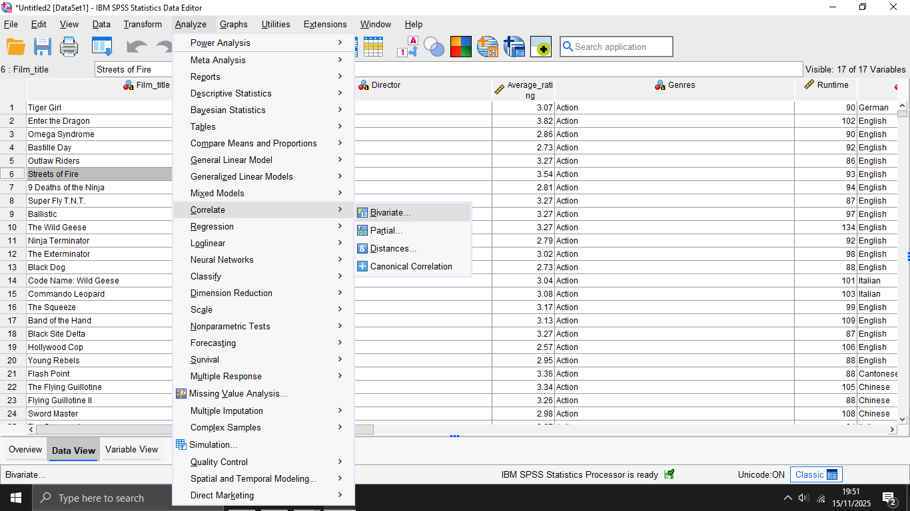

Select the numeric variables (Rating, Runtime, Watches, Likes, Fans).
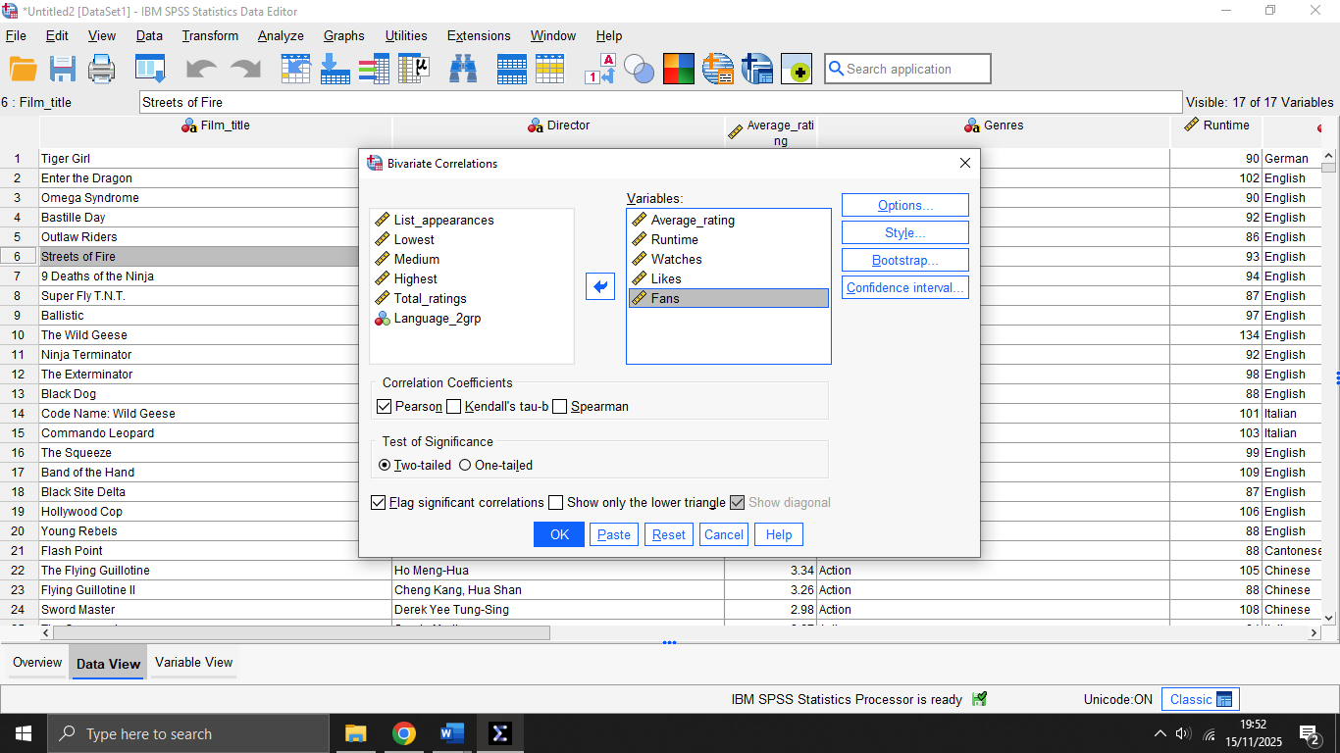

Make sure Pearson and Flag significant correlations is ticked.
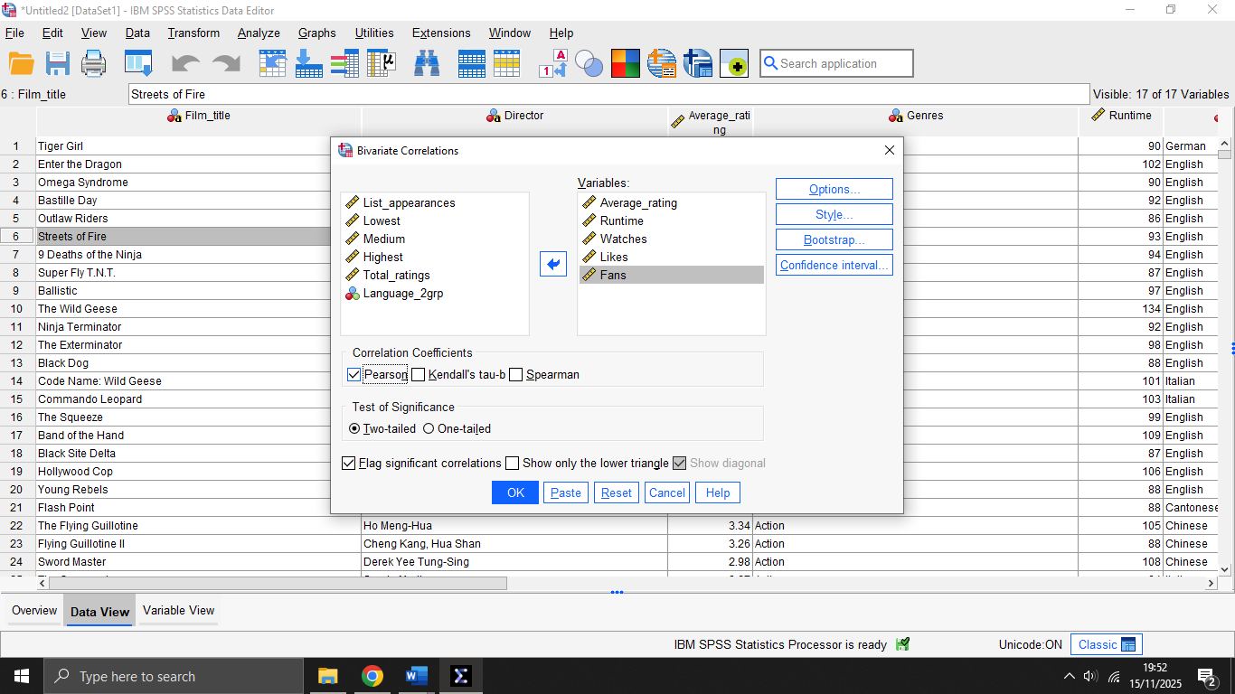

Press OK.
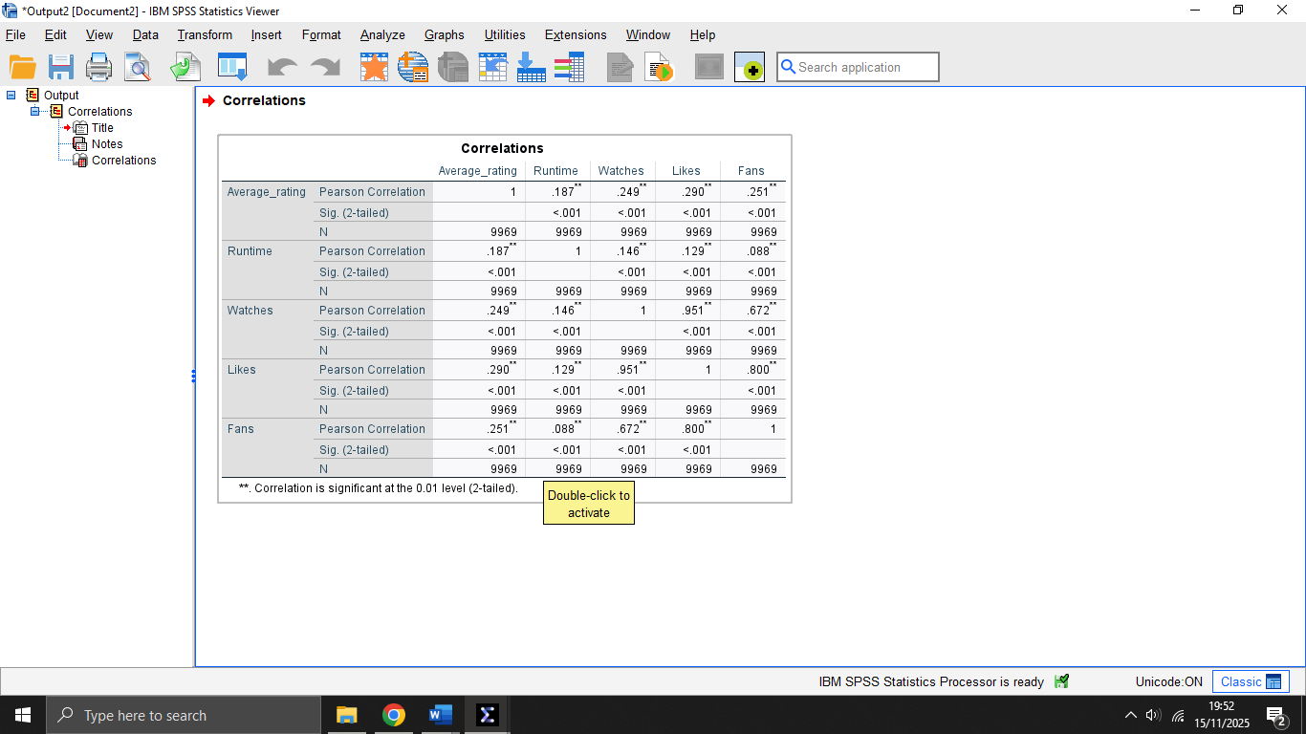
- Regression Model Summary, ANOVA and Coefficients
Go to: Analyse → Regression → Linear.
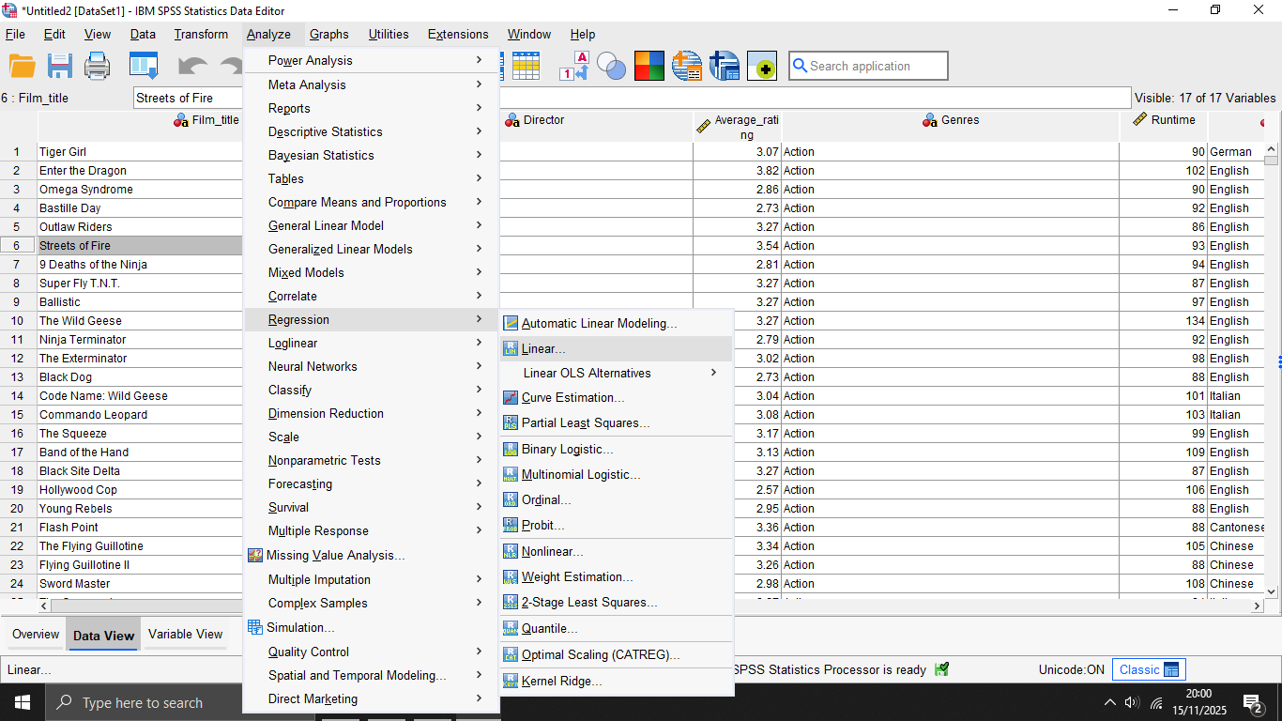

Put the dependent variable (Ratings) into Dependent.
Put the independent variables (Runtime, Watches, Likes, Fans) into Independent(s).

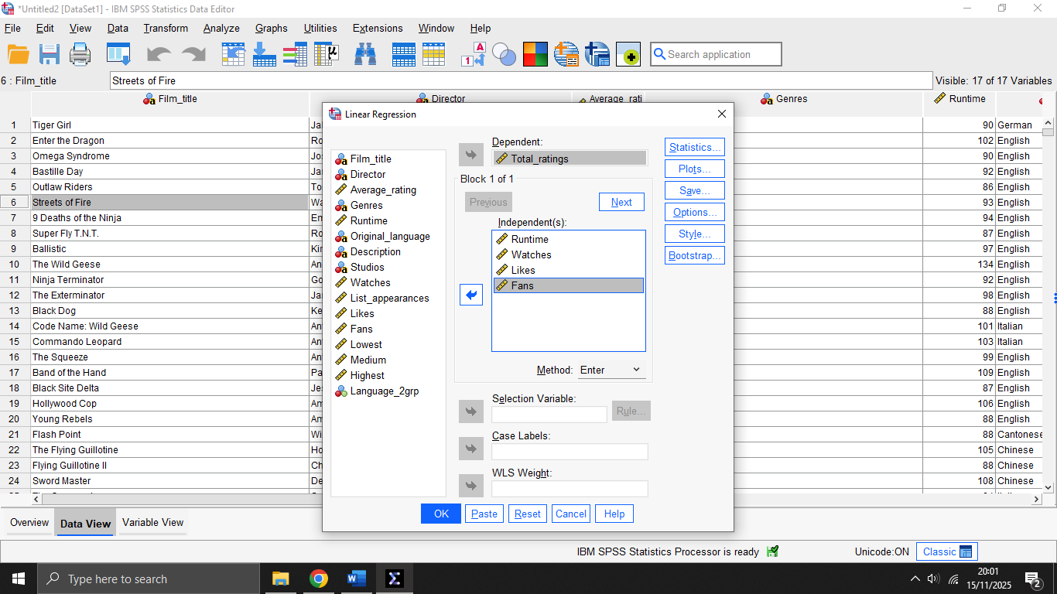

Click OK.
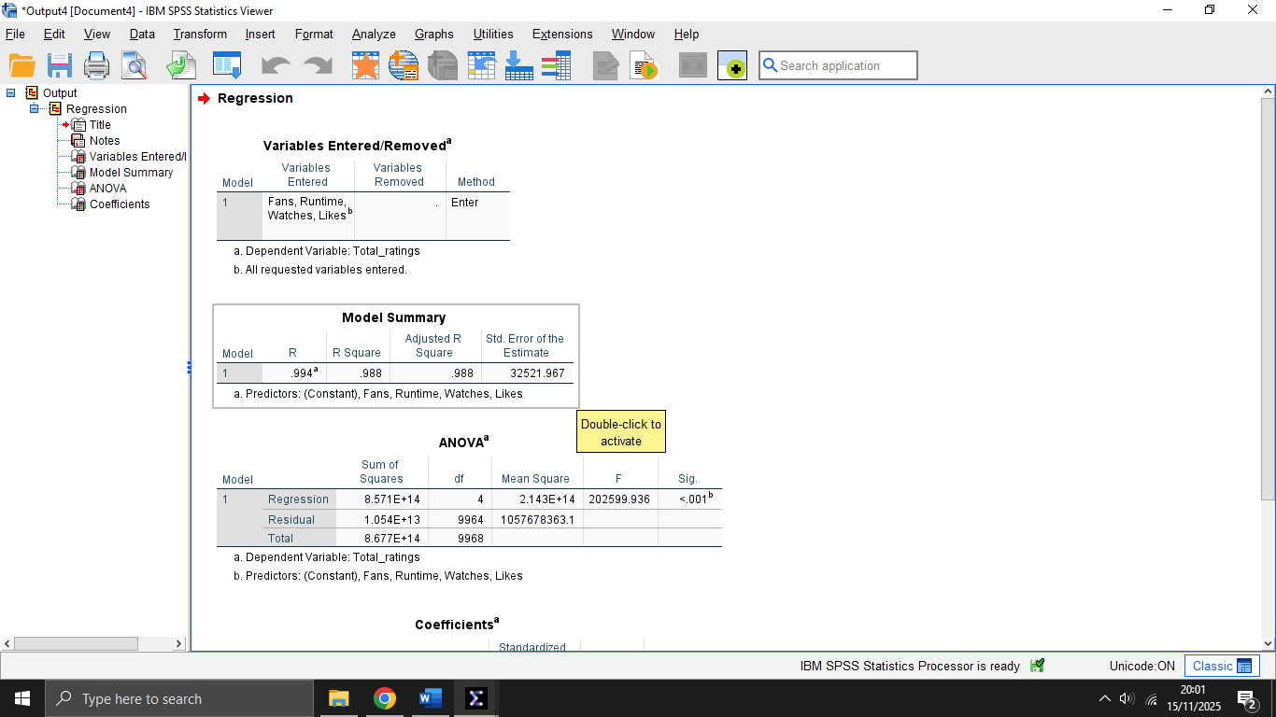

Appendix B – Excel Printouts

1. Average rating by Genres

Pivot Table
Select the whole dataset (Ctrl + A).
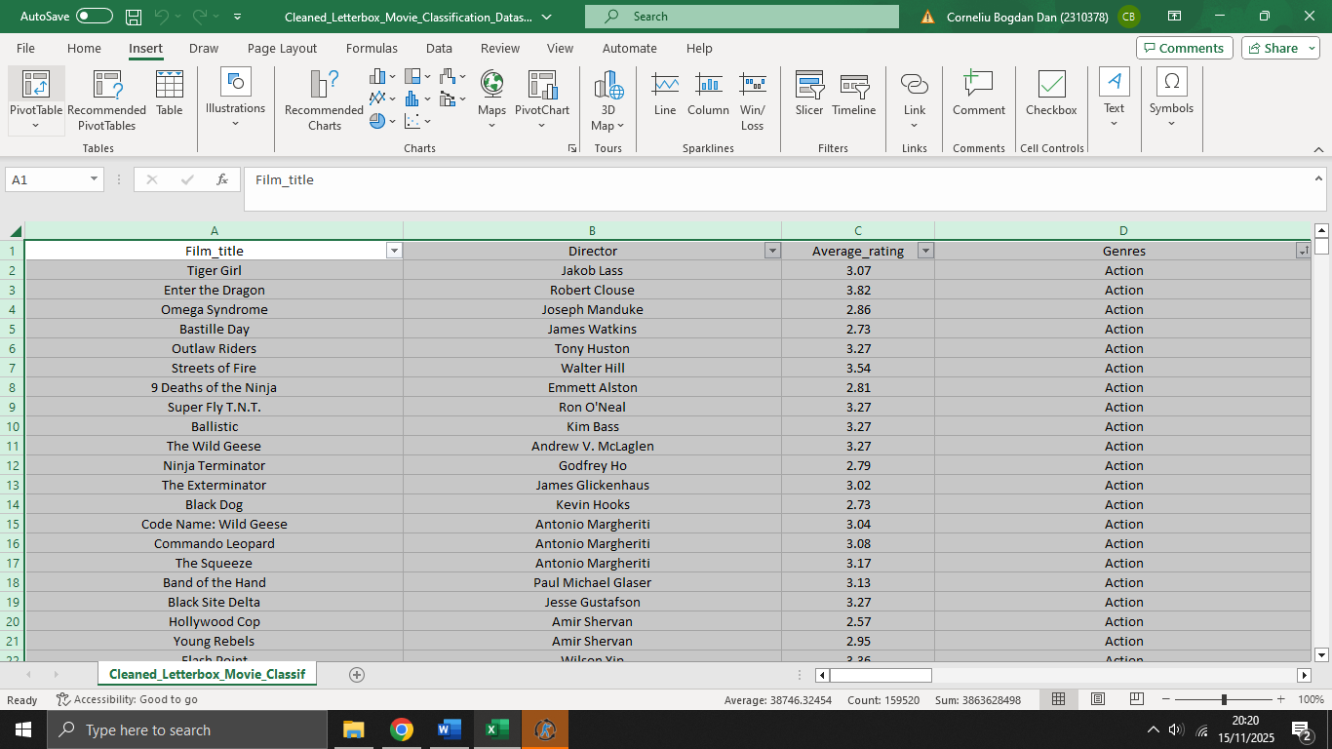
Go to Insert → PivotTable.
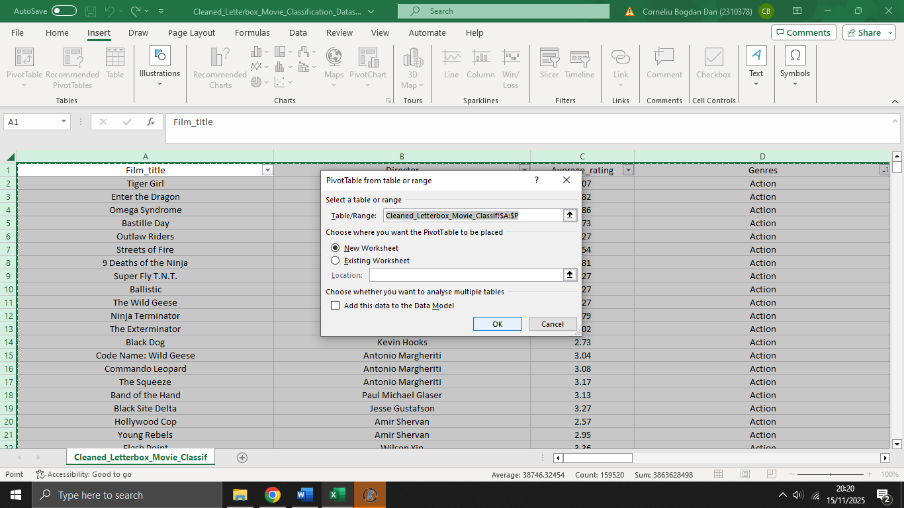
In the PivotTable fields:
Drag Genre → Rows.
Drag Rating → Values.
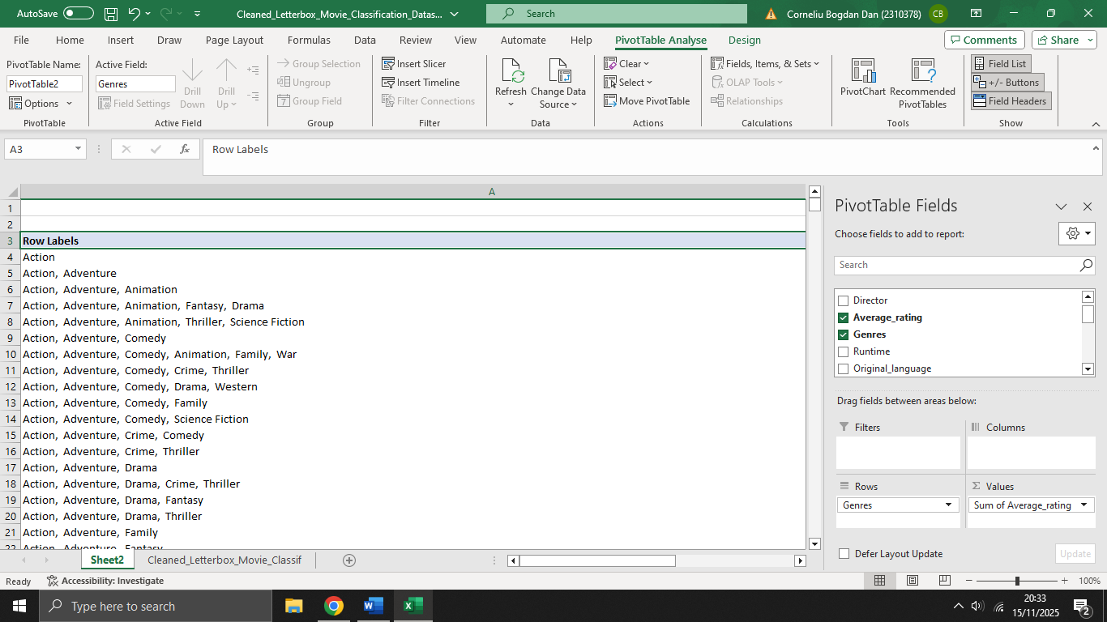

Excel will default to Sum of Rating.
Change it:
Click the little dropdown on Sum of Rating
Select Value Field Settings
Choose Average
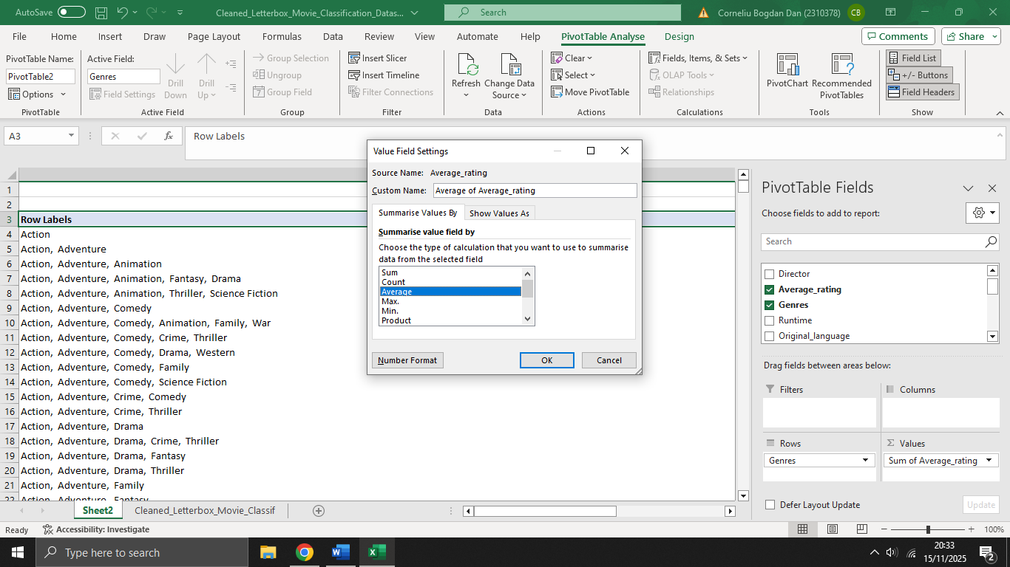
Bar chart - Go to Insert → Column Chart.
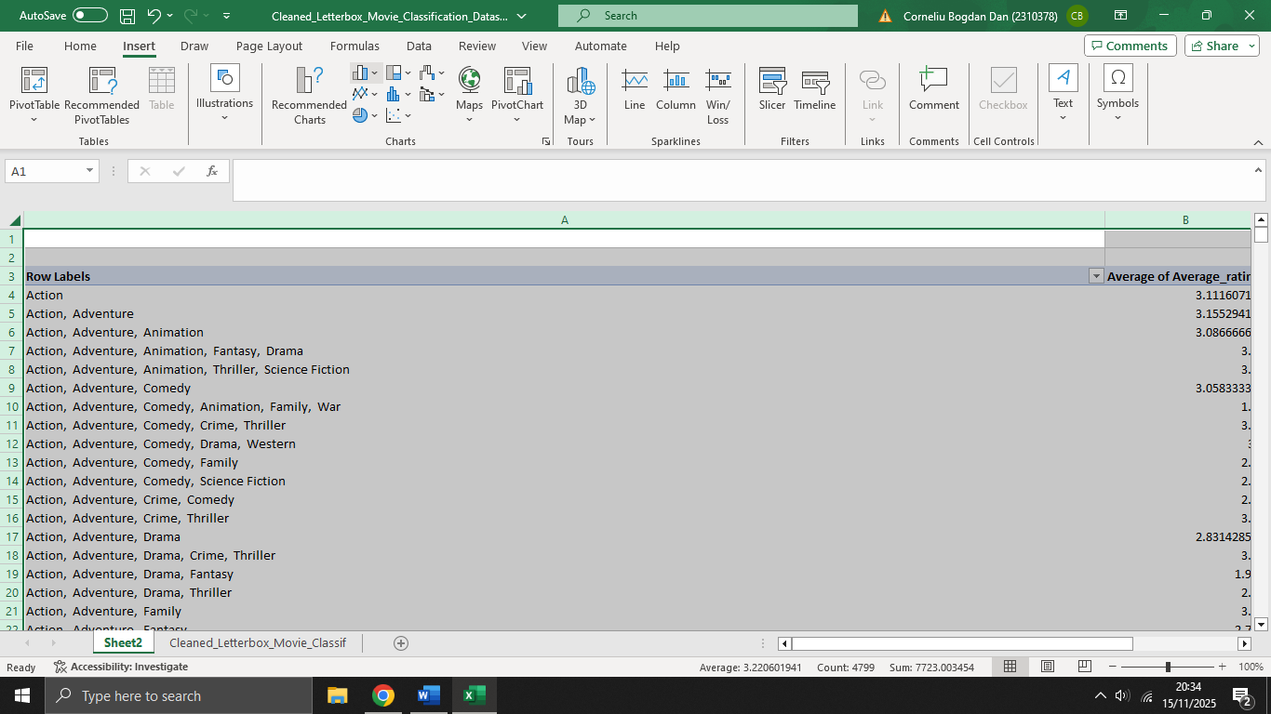
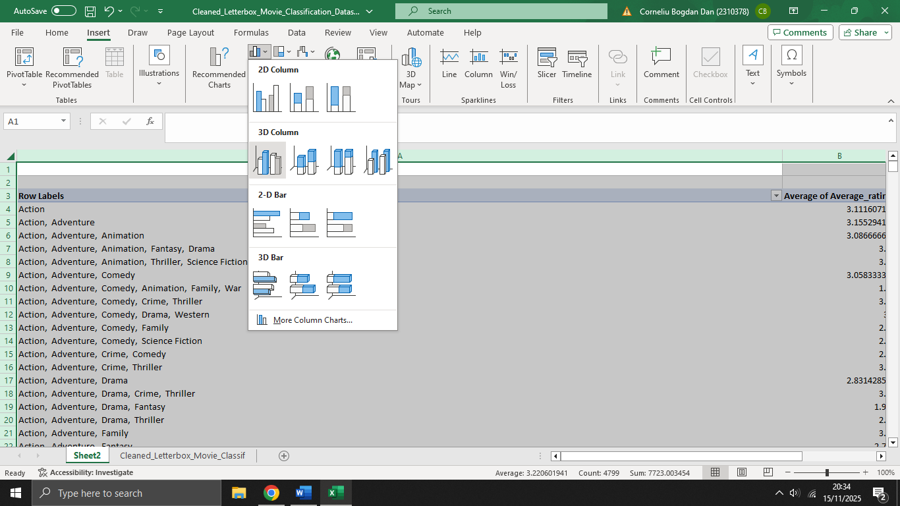
Pick a basic 3-D bar.
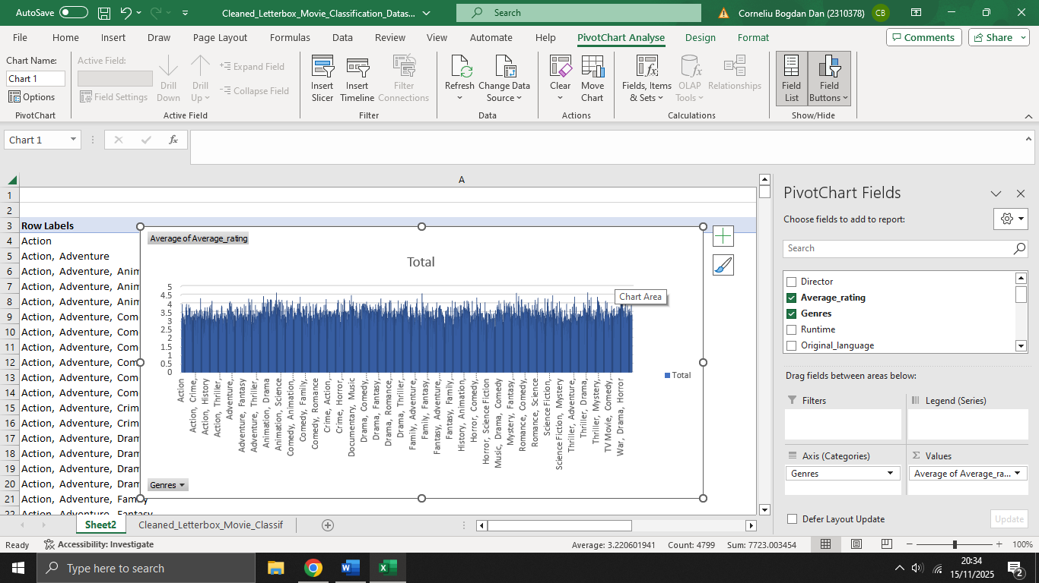

2. Average watches by Genres

Pivot Table
Select the whole dataset (Ctrl + A).
Go to Insert → PivotTable.

In the PivotTable Fields:
- Drag Genre → Rows.
- Drag Watches → Values.
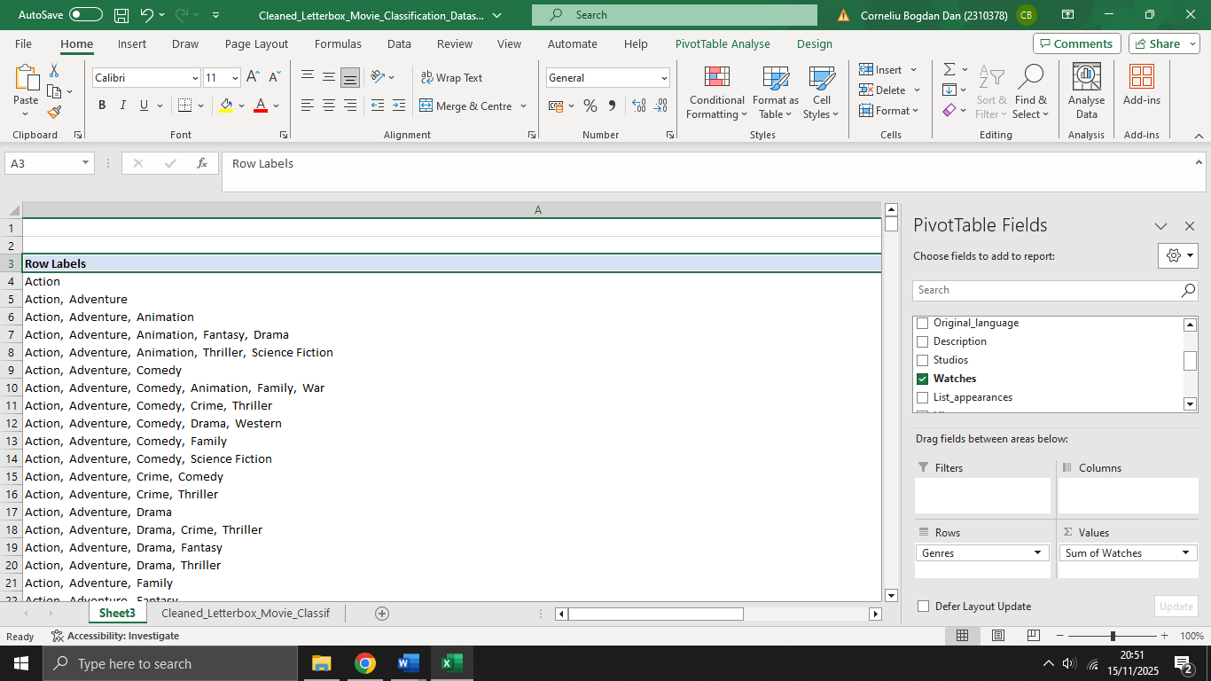
Make a Bar Chart → Press Insert → 3D Column.
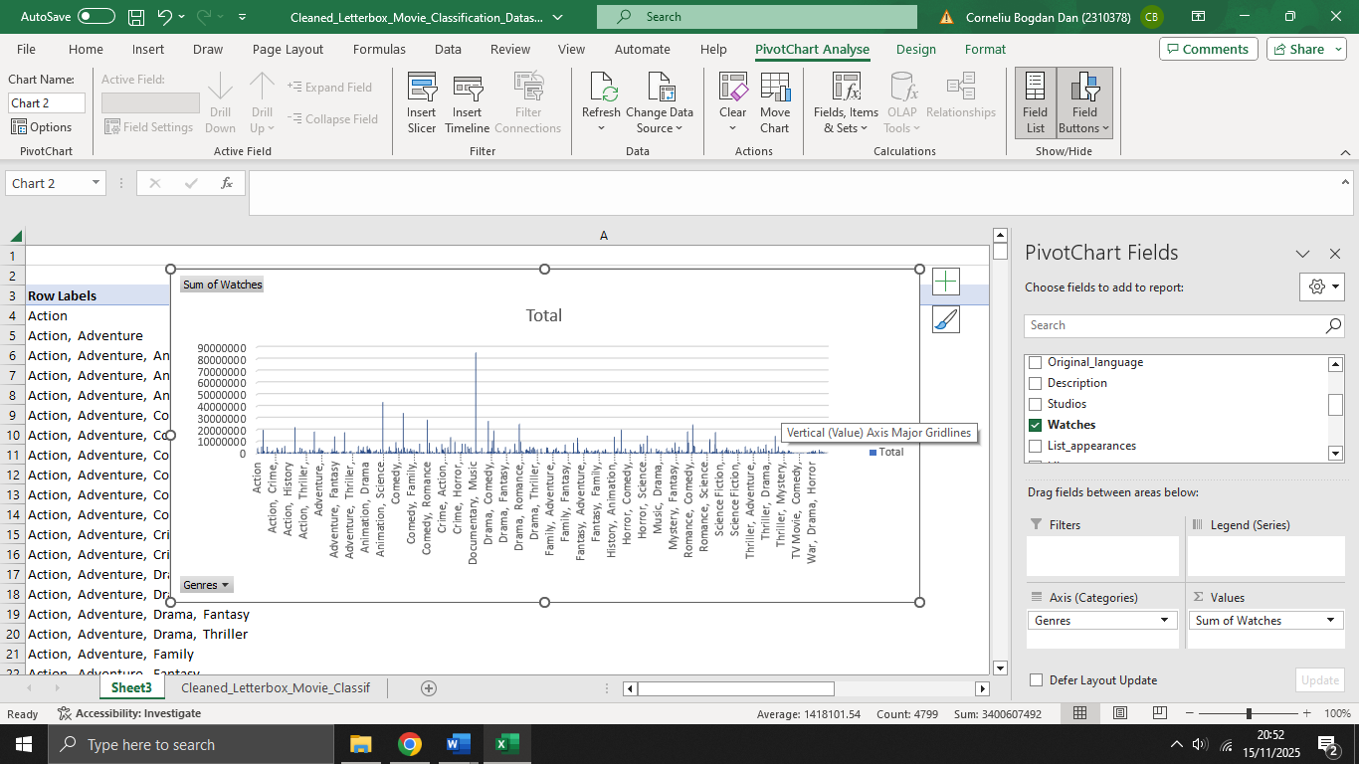

3. Distribution of languages – Pie chart

Pivot Table
Select the whole dataset (Ctrl + A).
Go to Insert → PivotTable.

In the PivotTable Fields:
- Drag Original Language → Rows.
- Drag Original Language → Values.
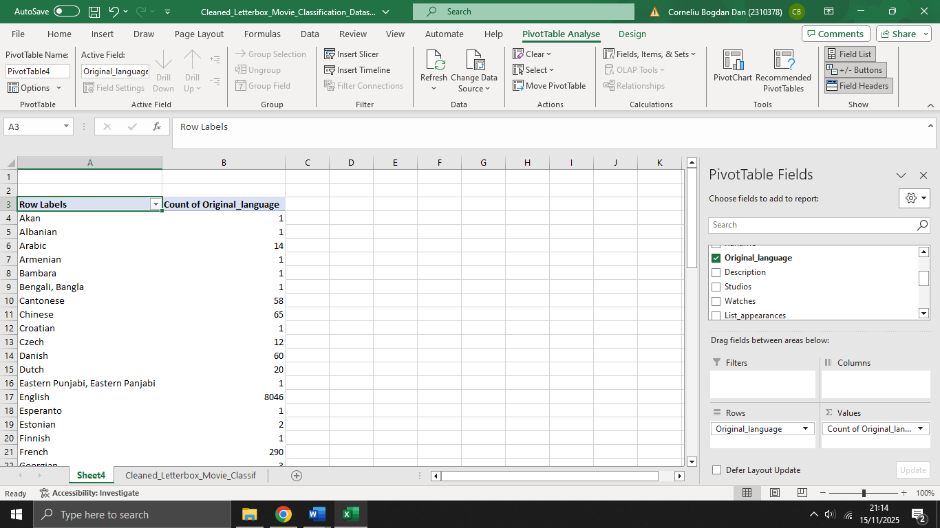
Excel will default the Values field to Count.

Pie Chart
Go to Insert → Pie Chart.
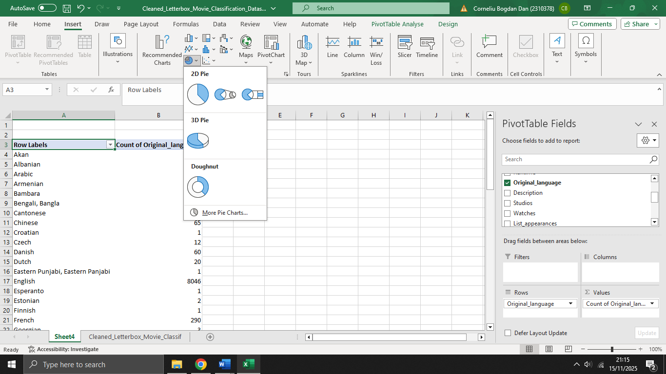

Pick the standard 2D pie.
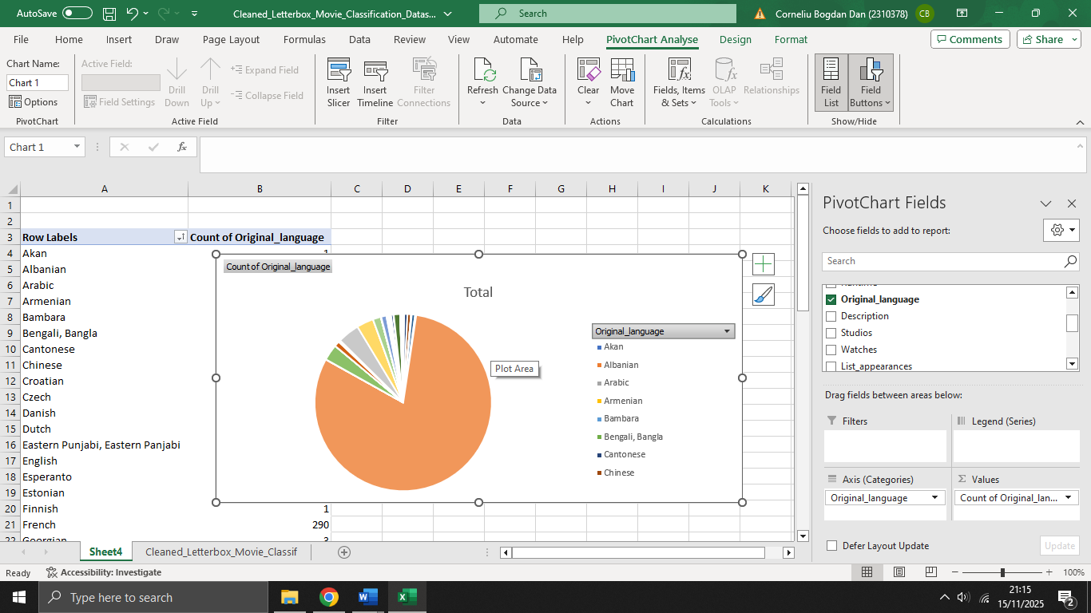

4. Watches vs Likes – Scatter plot
Click on the Watches column.
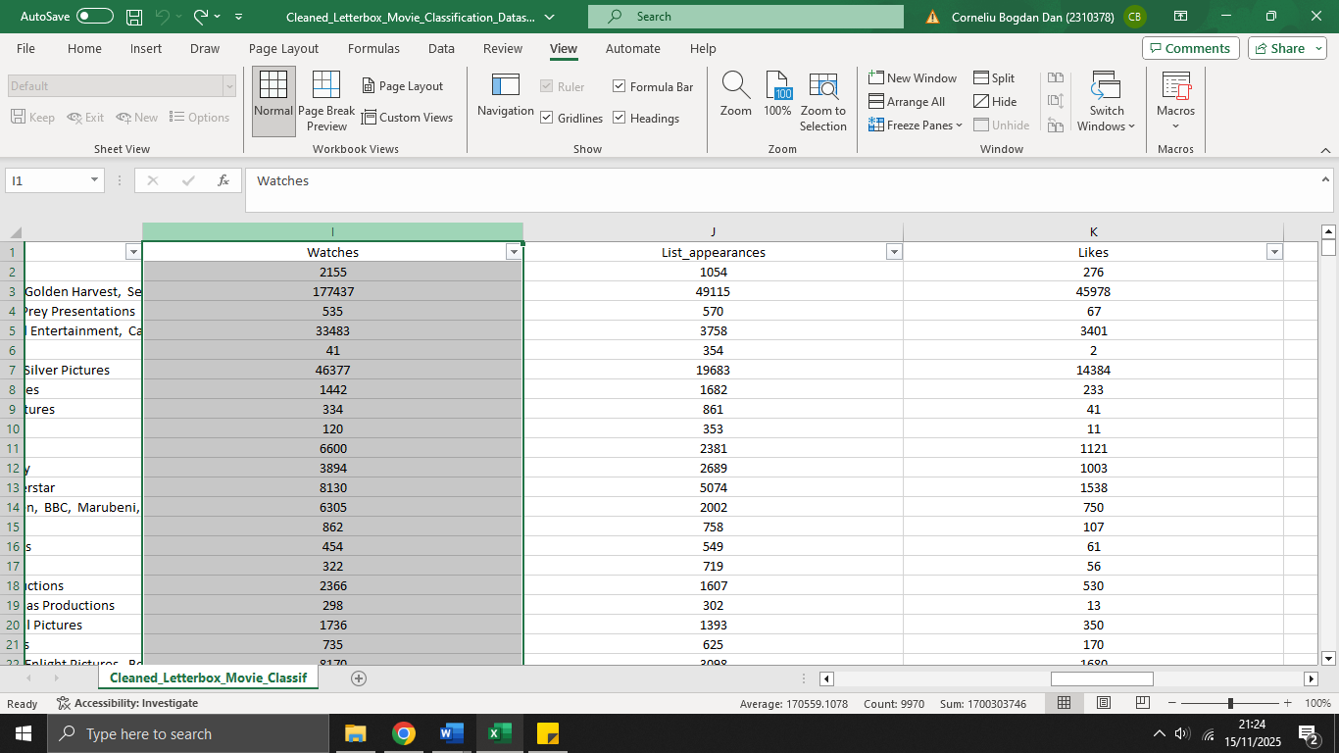
Hold Ctrl and click on the Likes column.
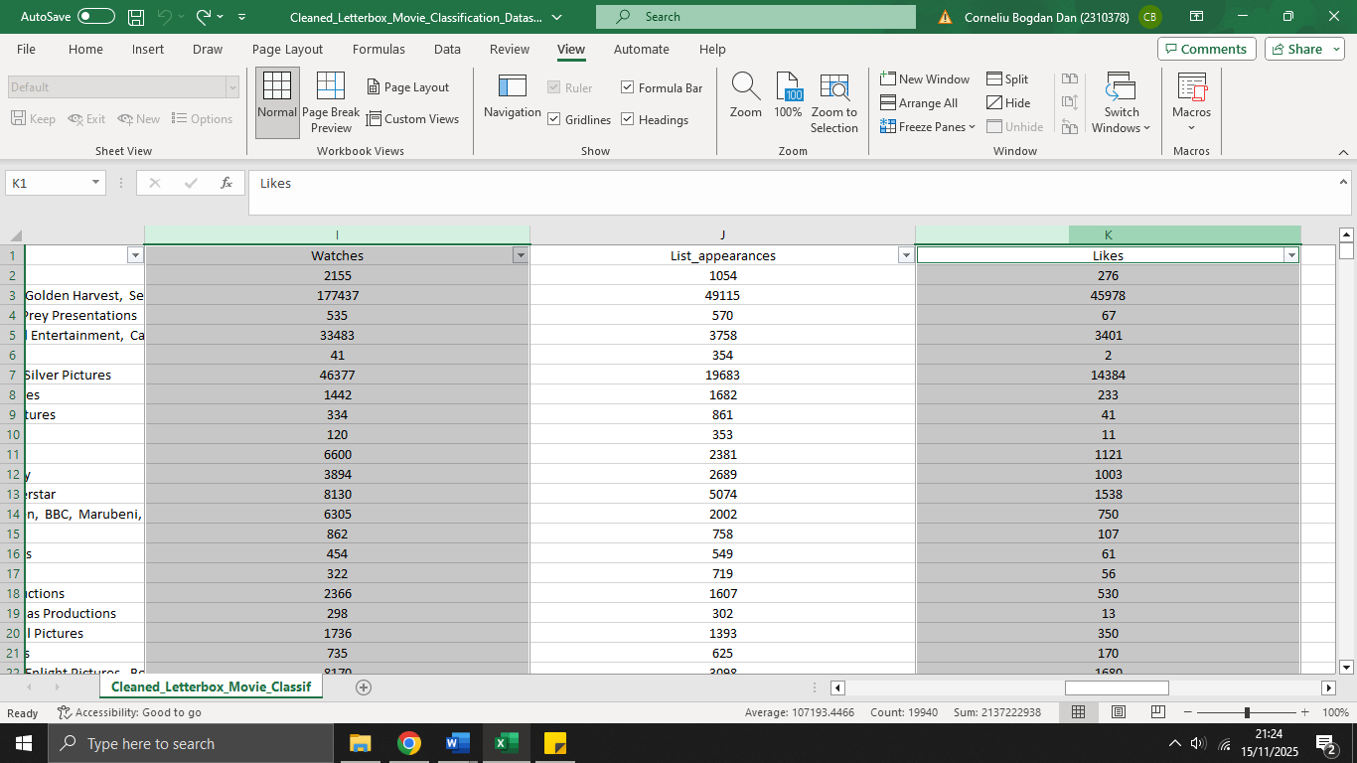
Go to:
Insert → Scatter → the first basic scatter chart.
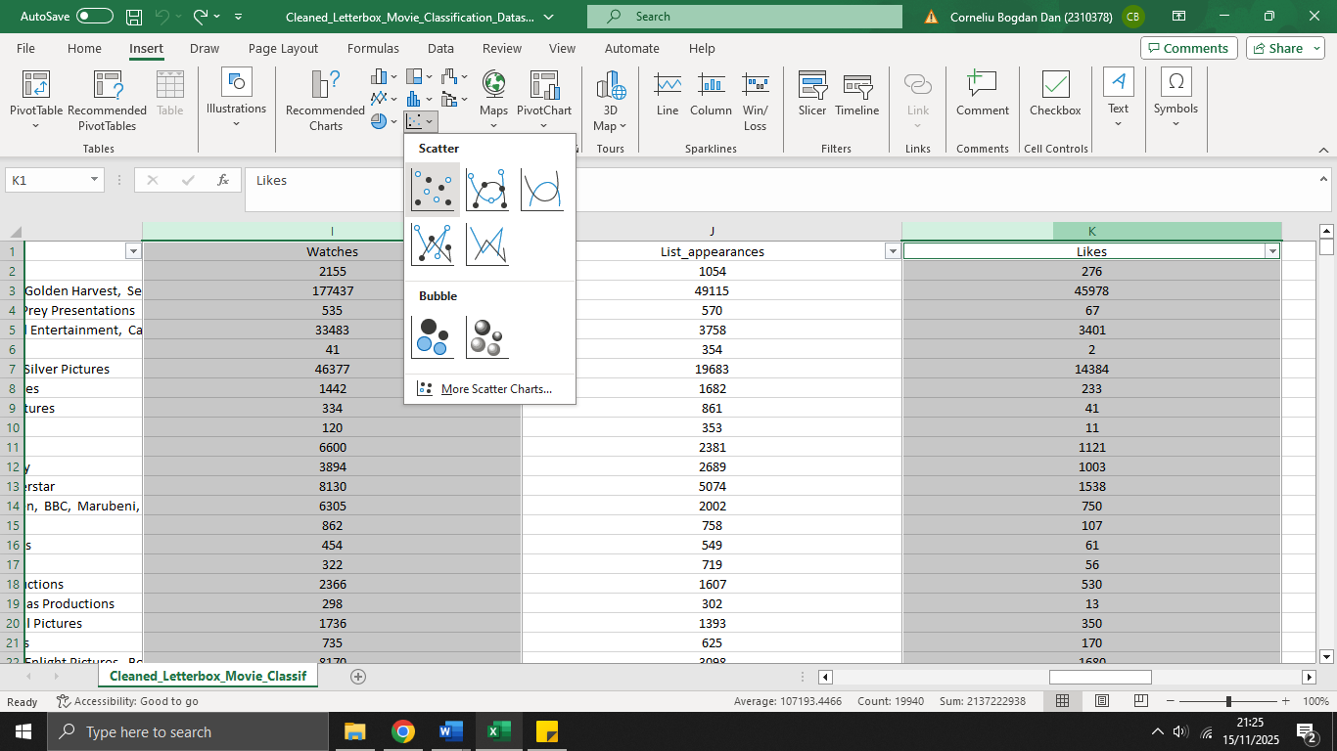

Excel auto-plots:
- Watches on X-axis
- Likes on Y-axis


