Name : Shikder Sujan
Student Number : 2115669
Programme : BA Developing Leadership & Management
Module : People Management
Module Code : BMSW5010
Word Count : 1954
Date of Submission : 01/11/2022

Executive Summary

People management is an ongoing process that involves recruiting, developing and retaining skilled workers. Skilled human resource is the highest achievement of an organization whose effective management is one of the most important tasks of the organization. One of the main tasks of People management is to create efficient and necessary manpower for the organization. Through People management, optimal utilization of all material and immaterial resources of the organization can be ensured. By taking the right measures at the right time, the desired utilization of material resources can increase production and improve service quality.

The most important role in this report has been played by my Honourable teacher Marie Pitson’s weekly class lecture, online notes and slides.

In addition, as a part of research, information also colleted from various academic areas to prepare the report, including: academic books, journals, websites, newspaper etc.

Several findings are included in this report such as Effective leadership, Effective teamwork, Motivation of employees, Flexible working, Treating staff equally, Performance management etc.

Table of Contents

INTRODUCTION 5
MAIN BODY 5
Evaluation on roles and skills of managers in effectively managing people resource 5
Analysing how organizations successfully manage performance of workforce 12
CONCLUSION 13
REFERENCES 14

INTRODUCTION
People management is mainly defined as the process of lading, hiring, making teams for supporting the organizational goals and objectives. Effectively managing the people in the business mainly engages working with teams towards achieving the shared goals. Certain roles and skills required by the manager for supporting effective people management. This report provide details about critically evaluating the roles and skills needed by managers as effective leadership, effective team working, motivation of employees, the flexible working and treating staff equally. Also, discussing the theories, models used by managers. In addition to this, evaluating how organizations successfully manages the performance of their workforce. The report will provide a detailed understanding in context with importance of effective management and leadership within the organization which can help in efficient evaluation of employees’ performance and guide them towards attainment of business goals and objectives.

MAIN BODY

Evaluation on roles and skills of managers in effectively managing people resource
Managers are the people within the organization who are responsible for effective management of resources to meet the goals and objectives. The management of the business entity are organized by various functions which are operations, marketing, finance and human resource. People management is a part of human resource management. People mamagement includes: training & development, recruitment, compansation, benefits etc. The effective management of human resource are known as human resource management who have various roles and skills (Piopiunik and et.al., 2020). The roles of managers in effective management of workforce are:
- Development of HR policies and practices in accordance with organizations overall strategies and procedures.
- Development of effective workplace through encouraging equality and diversity.
- Hiring and retention of efficient and skilled employees.
- Building and maintaining a strong relationship between employees and managers by responding to their requests and resolving grievances (Stone, Cox and Gavin, 2020).
- Proving with training and development opportunities for career growth and development of employees.
- Ensuring compliance of all laws and rules related to human resource.
- Maintain benefits and pay schedules and rewarding employees on the basis of their performance.
There are various skills which are required in HR managers:
- Business management and leadership skills,
- Interpersonal and communication skills,
- Strategic thinking and planning skills,
- Time management and multi tasking skills,
- Workplace culture development skills,
- Critical thinking and problem solving skills,

Effective Leadership
Leadership is the ability of individuals of an organization who can influence and guide employees towards accomplishment of organizational goals and objectives (Sayyadi, 2019). Every manager of the company must be an efficient leader but it is not necessary that every leader to be managers (Isa and et.al., 2019). The role and responsibility of leaders are:
- Setting of direction: Creation of strategies for future which can help in growth and development of organization.
- Alignment of people: Communicating with employees of organization regarding their roles and responsibilities and empowering them towards accomplishment of their duties (Tourish, 2019).
- Motivating employees: Motivating employees through rewarding them with incentives on the basis of their performance which can boost their morale and commitment towards entity.
Effective leadership can be defined as redefining company's vision and setting a culture for attainment of vision and mission (Leithwood, 2019). There are various skills which are required for effective leadership:
- Effective communication skills,
- Flexible to change,
- Self awareness,
- Strong ethics and standard along with knowledge of laws related to human resource,
- Lead by example,
- Good motivators,

There are various leadership styles which are followed by managers of the organization to ensure effective management of workforce.
Democratic leadership: In this leadership style, the managers involves their employees in the decision making process.
Autocratic leadership: In this leadership style the directions comes from the top level mangers and middle and lower level managers and employees are required to follow the same (Sacavém and et.al., 2019).
Laissez- faire leadership: The leaders of the organization provides complete freedom to its employees in taking decisions.
Transformational leadership: Under this leadership style the employees of entity are encouraged to transform and adapt the changes.

Effective Teamwork
Team refers to the group of individuals who perform interdependently towards accomplishment of common goals and objectives. Group and team are two different terms which are used interchangeably (Scholl, 2018). Group can be termed as collection of people who coordinate their efforts while team is a group of individual who share common vision and goals. In an organization to achieve success teamwork plays an important role. Teamwork helps in finding solution for any problem effectively and quickly as it involves multiple sharing of ideas for dealing with problems (Yakubu, 2018). As teamwork is the backbone of effective communication as it promotes sharing of experience and views which help in overall development of both organization and employees. It also helps in timely completion of work and employees are able to learn new skills from their team members. It improves efficiency of employees and provide more learning opportunities.
Various authors have given different types of theories about effective teamwork, among which the theory of Bruce Tuckman (1965) and Meredith Belbin (1981) are the most accepted.
How a group develops is the central theme of the Tuckman model. It is helpful in training people for teamwork and working to their full potential.
Achieving targets by demonstrating collective strength is the core theme of the Belbin team role. It helps to reduce the weaknesses and adapt to the changing goals. It enables teams to come together in a changing environment and utilize each individual's skills to achieve goals.

Effective team
There are various principles or elements which ensures development of effective team within the organization which helps in enhancement of performance and productivity (AlArafat and Doblas, 2022).
- Common goals and objectives,
- Must have effective leader who can guide and direct ream members,
- Develop trust and support relationship,
- Respect and value diversity and multicultural,
- Resolving conflicts and disputes,
- Establishment of rules and policies,
- Specified and appropriate skills which are required for common project (Tripathy, 2018).
- Coordination and interaction with each other,
- Effective communication,
- Well defined decision making process and involvement of each member,

Motivation of Employees
Motivation: Motivation refers to the steps taken by managers or leaders of organization to inspire employees to put all their efforts towards achieve of business success.
Performance: Performance in context with employees can be defined as how employees meet their duties and responsibilities which is being segregated to them.
Motivation and performance is related with each other as motivation is the force which leads to excellent performance of employees within the organization. There are various factors which motivates employees of the organization in enhancing their performance (Herron, 2022). Each and every individual within the business entity have different needs and it is responsibility of managers and leaders to identify those needs and work towards fulfilment of employees needs. The motivation can be in quantitative as well as qualitative. There are different theories of motivation which are followed by leaders of companies to ensure meeting of employees needs to effectively motivate and satisfy them.

Maslow's hierarchy of needs
There are five categories of human needs in accordance to their behaviour which can motivate them in effective performance. These needs are reflected in pyramid shape which includes physiological needs, esteem needs, love and belongingness, safety and self actualization (Lee, 2019). According to Maslow (1943), individual moves towards next stage when then attain formal needs. It is the responsibility of leaders to identify employees requirements in accordance to these categories and try to meet them step by step. This will ensure higher motivation and performance enhancement along with this, employees will be committed towards company.

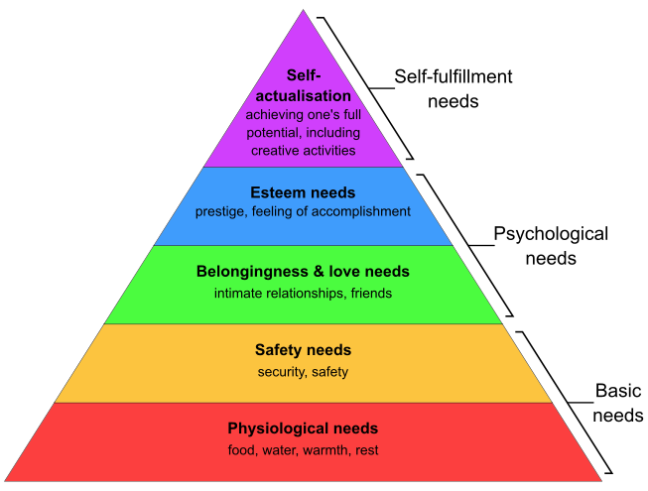

Figure 1: Maslow's hierarchy of needs

Along with this, there are several other motivational theories which are followed by organizations in order to ensure higher employees motivation and retention. Motivation theories includes Herzberg's hygiene theory, Vroom theory of motivation, Porter and Lawler expectancy theory, etc.

Flexible Working and Treating Staff Equally
Flexible working: Flexible working refers to way or manner of working which suits the employees and their needs. For instance, working from home, working for a fixed time as per employment law, etc.

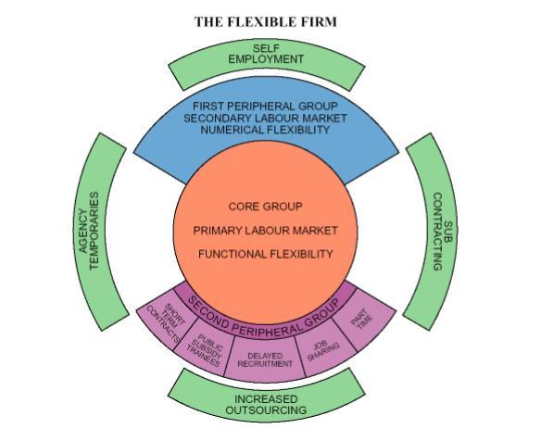
Figure 2: Flexible firm model

Flexible firm model (Atkinson theory, 1984)
According to this theory, the employees of the organization must be provided by effective working arrangements and hours which is convenient for them (Yunus and Mostafa, 2022). There are three different forms of flexibility within organization: Functional flexibility, numerical flexibility and financial flexibility. Along with this, there are two dimensions of flexibility which includes flexibility in employment and flexibility in work.
Equality and diversity:
Equality: Equality at workplace refers to providing equal and fair job opportunities to employees according to their qualification and skills (Mousa, Massoud and Ayoubi, 2020) .
Diversity: Diversity at workplace refers to multicultural environment where employees are hired from different culture and backgrounds, age groups, gender, etc.

Importance of equality and diversity within workplace
- Equality and diversity enables in effective motivation and encouragement to employees so that they can meet their roles and responsibilities.
- Employing employees from different culture can enable business in building a strong and effective team with diverse specialization (Khan and et.al., 2019).
- It helps in encouraging employee loyalty and retention.
- Encouragement of equality and diversity develops a positive work culture within organization.
- The employee turnover cost can be reduced if employees develop trust and respect for each other and their culture.

Analysing how organizations successfully manage performance of workforce
Performance Management
Performance management refers to an ongoing process which helps in continuous evaluation of employees performance and development of plan and strategy for enhancement of performance (Murtazoqulov and et.al., 2022). Performance management is essential as it enables organization in retaining talents, keeping employee engaged and identifying leaders (Helmold and Samara, 2019). The aim of performance management are:
- To take corrective measures to improve performance,
- To sustain effective performance,
- Motivate employees by rewarding them according to their performance,
- To communicate organization strategies, goals and expectations from employees,
Performance management process: The managers of the business entity follows steps in order to ensure accomplishment of aim of performance management. The steps of performance management are: Identifying and defining business goals and objectives, performance planning, delivering and monitoring of performance, assessing and providing rewards (Tweedie and et.al., 2019). HR management of companies have adapted various performance evaluation software and technologies which helps in effective management and evaluation of performance of employees and motivating them to enhance their performance (Tseng and Levy, 2019). Employees are also providing with training and development programs which enables in generating new skills and knowledge which is essential in overall development of employees. Managers of companies set KPIs and benchmarks which helps in evaluation of employees performance and filling of any gaps.

CONCLUSION
From the above report it can be concluded that it is significant to develop mangers skills which can help in effective management of human resource leading to overall enhancement in productivity and profitability of organizations. The report had highlighted various roles of managers which also included various concepts such as effective leadership, effective teamwork, motivation and equality and diversity within workplace. There was a detailed discussion on performance management and its importance within organization.
Recommendations
- Every organization is required to set KPIs or benchmarks which can help in effective evaluation of employees' performance and identifying areas for improvement.
- The managers and leaders of entity must have specific skills o ensure effective fulfilment of their duties and responsibilities.
- HR managers must develop a diverse work culture which can reduce the cost of employee turnover.
- Different motivation theories can be followed by organizations which can enable in employee motivation and enhancement of performance.

REFERENCES
Books and journals
AlArafat, M. and Doblas, M., 2022. Impact of Effective Teamwork on Employee Performance: The case of the Telecommunication Companies in the Kingdom of Bahrain. iKSP Journal of Innovative Writings. 2(2). pp.07-19.
Helmold, M. and Samara, W., 2019. Progress in performance management: Industry insights and case studies on principles, application tools, and practice. Springer.
Herron, M. M., 2022. Social Media Bullying in the Workplace: Impacts on Motivation, Productivity, and Workplace Culture. In Research Anthology on Combating Cyber-Aggression and Online
Isa, K. and et.al., 2019. Leading happiness: Leadership and happiness at a workplace. International Journal of Recent Technology and Engineering. 8(3). pp.6551-6553.
Khan, N. and et.al., 2019. Diversity in the workplace: An overview of disability employment disclosures among UK firms. Corporate Social Responsibility and Environmental Management. 26(1). pp.170-185.
Lee, H. W., 2019. Moderators of the motivational effects of performance management: A comprehensive exploration based on expectancy theory. Public Personnel Management. 48(1). pp.27-55.
Leithwood, K., 2019. Characteristics of effective leadership networks: A replication and extension. School Leadership & Management. 39(2). pp.175-197.
Mousa, M., Massoud, H. K. and Ayoubi, R. M., 2020. Gender, diversity management perceptions, workplace happiness and organisational citizenship behaviour. Employee Relations: The International Journal. 42(6). pp.1249-1269.
Murtazoqulov, O. R. and et.al., 2022. Workplace Performance Management. European Journal of Life Safety and Stability (2660-9630). 17. pp.183-187.
Piopiunik, M. and et.al., 2020. Skills, signals, and employability: An experimental investigation. European Economic Review. 123. p.103374.
Sacavém, A. and et.al., 2019. An integrative literature review on leadership models for innovative organizations. An integrative literature review on leadership models for innovative organizations. pp.1741-1751.
Sayyadi, M., 2019. How effective leadership of knowledge management impacts organizational performance. Business Information Review. 36(1). pp.30-38.
Scholl, W., 2018. Effective teamwork—A theoretical model and a test in the field. In Understanding group behavior (pp. 127-146). Psychology Press.
Stone, R. J., Cox, A. and Gavin, M., 2020. Human resource management. John Wiley & Sons.
Tourish, D., 2019. Is complexity leadership theory complex enough? A critical appraisal, some modifications and suggestions for further research. Organization Studies. 40(2). pp.219-238.
Tripathy, M., 2018. Building quality teamwork to achieve excellence in business organizations. International research journal of management, IT and social sciences. 5(3). pp.1-7.
Tseng, S. T. and Levy, P. E., 2019. A multilevel leadership process framework of performance management. Human Resource Management Review. 29(4). p.100668.
Tweedie, D. and et.al., 2019. How does performance management affect workers? Beyond human resource management and its critique. International Journal of Management Reviews. 21(1). pp.76-96.
Yakubu, Y., 2018. INTEGRATION AND DISINTEGRATION IN ORGANIZATIONS: ROLE OF HUMAN RELATIONS MANAGEMENT THEORY. 4TH SOCIAL SCIENCES. p.146.
Yunus, S. and Mostafa, A. M. S., 2022. Flexible working practices and job-related anxiety: Examining the roles of trust in management and job autonomy. Economic and Industrial Democracy. 43(3). pp.1340-1368.

