Students are required to Complete a SWOT Analysis of a Youth Work organisation with which you are familiar, highlighting potential for innovation and creativity for future developments.
With in this essay the writer will give a clear description of what a Swot analysis is and how it is used, the writer will draw upon their own experiences and complete a Swot analysis on a university placement they have previously worked at. The writer will give information on what a swot analysis is and briefly outline some of the history and origins of swot analysis. The writer will out line the strengths and limitations to swat analysis and will outline other resources that may be more suitable for use.

Swot analysis stands for strengths, weakness, opportunity and threats. Swot analysis is a strategic planning and reviewing technique used but a person or an organisation to identify strengths and weaknesses, opportunities and threats they may have. Swot is used to review the progress and productiveness of an organisation or project and aims to identify what works within a project or organisation, what doesn’t work so well, opportunities to be explored and challenges or threats that may Impact upon the project. It allows for clear objectives to be outlined and made clear to all persons involved with the organisation or project, it can be used review internal and external risk factors to a project organisation or business, thus allowing for opportunities to overcome these risk factors. This can allow for a competitive edge over competitors or similar projects. (Valentin, 2001)

The origins of swot analysis are unclear and up for speculation with most professionals crediting the creation of swot analysis to Albert Humphreys who lead a convention at the Stanford instate of research in the 1960s and 1970s, however Humphreys never claimed credit for the creation himself, Humphreys looked at fortune 500 companies and lead a research project which ultimately lead to the development of the team action modal, this modal is a management concept witch allowed groups of executive to view and manage change with in there business’ or organisations. Swot analysis is thought to have originated from Humphreys ‘steak holders concept and swot analysis’. However King (2004) recognised that the origin of swot analysis was up for speculations and was hard to pain point who created swot and when it was created. King cites Haberburg (2000) as stating that swot was a concept used by professionals in Harvard with in the 1960s. (Business.qld.gov.au, 2017) (Morrison, 2016) (Friesnter, 2011)

Swot analysis has been praised and held with in the highest regards by organisations as a reviewing tool but has also be criticized for its limitations. A limitation to swot analysis is the dept of a threat or problem within an organisation may spark more questions than answered, the complexity of these issues may result in a lot of work for the organisation that may be better spent elsewhere. Another limitation is that there may be a threat that shows more than one way to over come it and it may be hard to choose a path to success. A swot analysis may generate a lot of information on an organisation, some of this information may not be useful or benefit the organisation. Some factors may be considered as a strength also a weakness and would require an in-depth research to a discussion to resolve. (Friesnter, 2011)
An alternative to swot analysis is Soar analysis, Soar analysis maintains two of the four areas within swat analysis, these are strength and opportunity and adds Aspiration and results instead of weaknesses and threats. Aspirations in Soar analysis looks at who a company wants to serve, what they want to be doing. And results show where the company wants to go and make a plan on how they will get there, also if the plan is being followed. (Why Analysis, n.d.)
The main differences of these two analysis systems are soar looks to be more positive and forward thinking, sour eliminates the negatives factors and encourages aspirations and forward development. Soar analysis may be more useful to smaller less developed businesses and organisations helping look forward to future development. Swot looks to be more troubleshoot orientated and competitive, highlighting what an organisation does well and alternatively what it doesn’t to so well, it looks and external threats and how they will affect internally to the project. Swot may allow companies to develop an advantage over competitors. Both systems have their advantages. (Valentin, 2001) (Why Analysis, n.d.) (Business.qld.gov.au, 2017)

Swot analysis may be presented in the form of a matrix with strength, weakness, opportunity and threats as headings, using these headings organisations can revise and identify how to develop their organisation to its maximum potential. Here is an example of a blank SWOT analysis matrix (Mindtools.com, n.d.)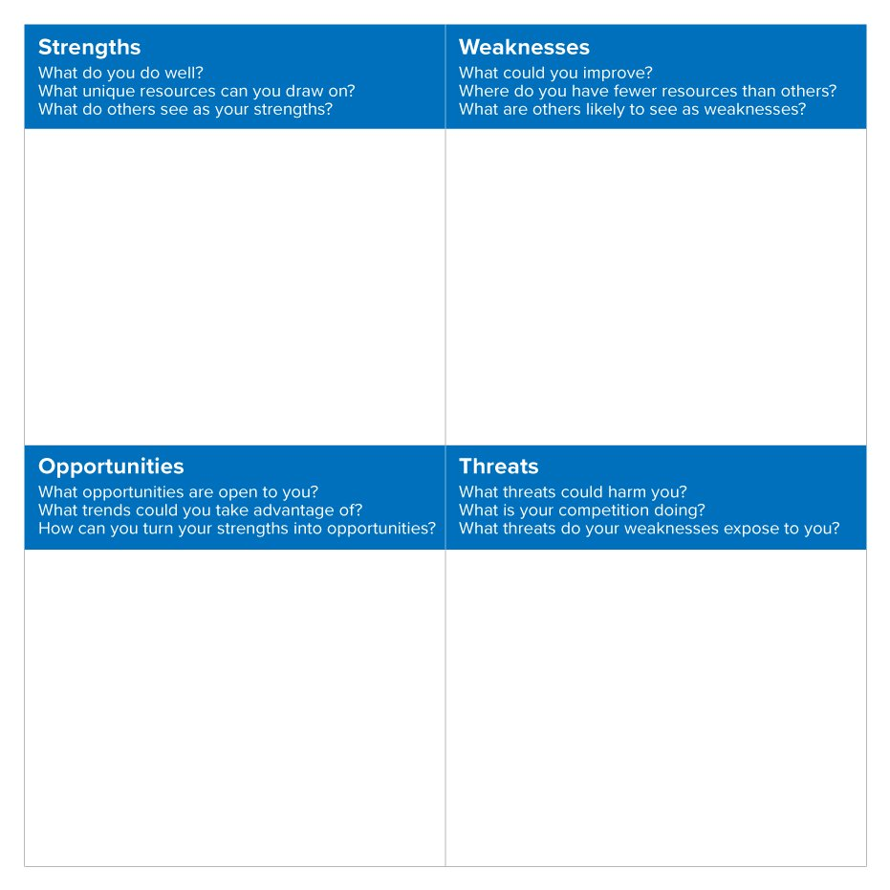
SWOT was to have originated from his
‘Stakeholders Concept and SWOT Analysis.’
SWOT was to have originated from his
‘Stakeholders Concept and SWOT Analysis.’
SWOT was to have originated from his
‘Stakeholders Concept and SWOT Analysis.’
SWOT was to have originated from his
‘Stakeholders Concept and SWOT Analysis.’
SWOT was to have originated from his
‘Stakeholders Concept and SWOT Analysis.’
SWOT was to have originated from his
‘Stakeholders Concept and SWOT Analysis.’
SWOT was to have originated from his
‘Stakeholders Concept and SWOT Analysis.’
When doing a SWOT analysis it is helpful to use a matrix as this helps you focus, it is also beneficial using the matrix as its good way to simplify your analysis. The matrix is simple to use during teams, and individually. Swot analysis can be as in depth or as vague as it needs to be to the researcher’s discretion.

Usually when conducting a swot analysis, researchers will start with where their project or business is exceeding, the strength column focusses on positive internal factors in the organisation. This column is essential as it can help a business or organisation identify the core strengths and positivity’s, it is also essential for decision making, development and planning. Analysing your strengths allow you to see what points of your business or organisation is flourishing, by doing this organisations are able to identify what they are doing well to make this happen and use it to make further positive developments. For example; In a youth work context, analysing strengths will help understand the positive impact the youth centre and youth workers are having on the young people. by analysing what works youth workers are able to build upon these strengths, whether it is a particular session or the overall work taking place within the centre, there is always room to grow and develop.

The next step of your SWOT analysis is to identify the weaknesses involved with the business or organisation. Listing the weaknesses is beneficial as it can show you where you can grow and improve. During this part of the swot analysis, analysing the weaknesses is going to give you the opportunity to revise where the organisations is under performing. this will then help towards resolving these weaknesses and improving the business or organisation. Overall, knowing the weaknesses will able the organisation to aim higher and achieve more. For example, in a youth centre youth workers could use the weaknesses identified to analyse what could be improved upon to make the youth centre a more enjoyable and effective place for young people to attend, this may include changing a session that may not work or if the approach used when working with young people doe not seem affective then the way the youth workers work with young people may need to be adapted.

After analysing the strengths and weaknesses, it is now time to look at opportunities within the business or organisation. Opportunities contribute to the overall success of a business or project; this is because identifying and grasping opportunities are a great way to develop. An effective way to identify an opportunity is to listen to the customers or young people, and their feedback/suggestions. This information will then help identify business or organisations opportunities that will expand and develop current services. For example, in a youth-based environment a survey would be a good quantitative source of feedback, the young people would have a chance to voice their opinions and ideas, this could include more resources, field trips, or longer sessions. This would then lead to opportunities to grow as a youth centre.

The last section is to look at the threats that may affect a business or organisation, one of the biggest external threats towards a business is their competitors. For example, in a youth work context, two youth centres may have their youth clubs on the same day. This will then be up to the young people to decide which one to attend. Analysing what the opposition have to offer will give you the opportunity to assess your threats and give you room to improve and upstage your competitors. A youth centre could do this by putting in place a trip at the end of the month for all the young people that attend the youth club. This is an effective way to entice young people to attend the youth club. (Morrison, 2016)
Swot analysis is a useful tool for youth workers, youth workers are constantly reflecting upon their own practice, using a swot analysis a youth worker would be able to reflect and analyse a whole project or organisation to develop it to the maximum potential. Youth workers may choose to include young people in the swot analysis, as youth work is young person lead and focused. One of youth works values are;
youth work seeks to go beyond where young people start, in particular by encouraging them to be critical and creative in their responses to their experience and the world around them and supporting their exploration of new ideas, interests and creative ability. (Cywu.org.uk, 2008)

Young people are able to provide feedback and inside youth workers may lack. This will allow for a better overall youth club that the young people will enjoy participation in. young people may not want to partake in the swot analysis, but it is important that young people have the opportunity to have their voice heard as is their right. This empowers the young people as they are making decisions on matters that affect them, as stated in the U.N.C.N.C article 12,
Every child has the right to express their views, feelings and wished in all matters affecting them, and their views considered and taken seriously. The right applies at all times, for example during immigration proceedings, housing decisions or the child’s day-to-day home life
(Unicef UK, 1992)

The writers swot analysis will focus on their previous placement, the placement was a young persons independent living facility with additional support attached, youth people were encouraged to access the support provided but this was not essential. The placement has the capacity to house eleven young people at any one time, these young people can be a mix of male and female with the age range of sixteen to twenty-five. The placement was a homeless young person’s project that provides young people with a place to live and help young people search for permanent residence and work. The placement provides life skills training for the young people and aims to improve their holistic development. The placement is one project within a big organisation spared over several locations in the United Kingdom, thus the project has many over heads. The placement has five main staff members that deal with the day to day support of the young people, two night support staff members who are available for the young people during the night and one manager that over sees the organisation and the young people. staff members work three twelve hour shifts over three days and then have three days off. The main room of the building is fairly small in size but is used to its full potential, the young people use this room as a common area, Young people often bring their games consoles and movies to watch on the tv in a group. This is where most of the activities take place. The placement organises activities such as breakfast clubs or games nights for the young people, but these are not on a regular basis due to staff rotation. The placement has a high turnover of young people due to the nature of the project. When a young person moves on from the project it is up to the staff members to clean and repair their flat ready for the next young person to move in. this placement does some very good work but there is also room for improvement witch the writer will highlight in their swot analysis.
Strength | Weakness
- Positive environment  - Helps young people  - Committed staff  - Fulfils a need | - Young person participation  - Substance misuse problems  - Limited space  - Long hours for staff
Opportunities | Threats
- To educate young people on substance misuse  - To provide activities more frequently  - To revise and look at the staffing structure | - Young people turn over  - Over heads

Strengths of the writer’s placement include; the placement provides a supportive positive environment for the young people; it allows the young people to grow and have fun in a friendly environment. Young people feel relaxed and are open with staff within this project. This project helps young people to get fanatically stable, it supports young people to find work or education. Staff help young people with their needs this could be help with shopping, benefits or taking the young people to appointments. Staff at this placement are highly committed to their jobs they work long hours and have been known to come in on their days off to help with a project or event such as the Halloween party. This placement fulfils its need, it takes young people that would other wise be living on the street and supports them to get back on their feet, in work or in education with a stable living accommodation.
The weaknesses to this placement are, the young people do not always participate in activities due to the activates being so irregular this means that young people sometimes make plans or choose to go out with their friend instead of participating. Also, some of the activities are held in the morning when most of the young people are still asleep. Some of the young people are known to misuse substances such ad cannabis or alcohol, this can be a barrier to the participating to the project, this also encourages other young people to partake in the substance misuse making the placement like a vacuum. Another weakness to the placement is the space, this placement is very limited on space although they use the common room often and for many different activities, it can often get full of people and becomes quite confined. This space often limits the activates put on with the young people making some activates not suitable for this placement. The last weakness the writer identified is the long staff hours, staff work twelve hour shifts three days in a row, I can imagine that staff get quite tired on the third day. This will take a toll on the staff and may make them grouchy and irritable, although the writer has not seen this during their placement.
The opportunities of this placement is that with the substance misuse weakness there is opportunity to educate the young people on substance misuse, this may resolve the issue or at the least allow the young people to have the information they need to be cautious when drinking or taking drugs. Another opportunity is to have scheduled activates each week that different members of staff can run, if staff show consistency with the activities young people may want to show up each week. These activates can help new residents get to know the staff and other young people within the placement, thus helping social integration. With the space weakness there is opportunity to network with other organisations to run activates with lager groups, these can intergrade the young people into their community.
Threats to the opportunities and progression of the placement is the young people may not engage with the substance misuse activity and may not turn up or alternatively it may not apply to all the young people. also, young people may not want to turn up to an activity outside of the placement witch would prevent networking with other organisations. Another threat is over heads may get in the way of doing Certain activates or making changes such as the staff hours. And the biggest threat my placement face is whether the young people they are working with will be around due to young people moving into their own house or moving back to family homes.

In conclusion a swot analysis is a very effective way to evaluate a business or organisation, it identifies the way to move forward strive to achieve a goal. Swot can be used as a group or as an individual and can be adapted and applied to any situation such as sport or business. Swot analysis can be used for an in-depth analysis or a short quick analysis. Swot analysis isn’t the only analysis tool that can be used to identify how to progress withing an organisation, but it is affective and serves a purpose. Youth workers should keep in mind the benefits to a swot analysis as it is not very time consuming and can really help develop a struggling project.

References
Analysis, W. (n.d.). Why SOAR Analysis May Be Better Than SWOT Analysis QuickBooks Canada. [online] QuickBooks Canada. Available at: https://quickbooks.intuit.com/ca/resources/business/why-soar-analysis-may-be-better-than-swot-analysis/ [Accessed 14 Dec. 2019].
Business.qld.gov.au. (2017). Benefits and limitations of SWOT analysis | Business Queensland. [online] Available at: https://www.business.qld.gov.au/starting-business/planning/market-customer-research/swot-analysis/benefits-limitations [Accessed 13 Dec. 2019].
Cywu.org.uk. (2008). Benefits of youth work. [online] Available at: https://www.cywu.org.uk/assets/content_pages/187799973_Benefits_Of_Youth_Work.pdf [Accessed 16 Dec. 2019].
Friesnter, T. (2011). history of swot analysis. [online] reserchgate.net. Available at: https://www.researchgate.net/publication/288958760_History_of_swot_analysis#:~:targetText=First%20time%20Stanford%20University's%20Albert,%22%20(Friesner%2C%202009)%20. [Accessed 13 Dec. 2019].
King R.K.(2004), ENHANCING SWOT ANALYSIS USING TRIZ AND THE BIPOLAR CONFLICT GRAPH: A case study on the Microsoft corporation, proceedings of trizcon2004, 6th annual altshuller institute.
Mindtools.com. (n.d.). SWOT Analysis: – How to Develop a Strategy For Success. [online] Available at: https://www.mindtools.com/pages/article/newTMC_05.htm [Accessed 16 Dec. 2019].
Morrison, M. (2016). The Complete History and Guide to SWOT Analysis. [online] RapidBI. Available at: https://rapidbi.com/swotanalysis/ [Accessed 13 Dec. 2019].

Valentin, E.K. (2001), SWOT analysis from a resource-based view – journal of marketing
theory and practice, 9(2): 54-68.
Valentin, E.K. (2001), SWOT analysis from a resource-based view – journal of marketing
theory and practice, 9(2): 54-68.
King R.K. (2004), ENHANCING SWOT ANALYSIS USING TRIZ AND THE BIPOLAR CONFLICT
GRAPH: A Case Study on the Microsoft Corporation, Proceedings of TRIZCON2004, 6th
Annual Altshuller Institute.
King R.K. (2004), ENHANCING SWOT ANALYSIS USING TRIZ AND THE BIPOLAR CONFLICT
GRAPH: A Case Study on the Microsoft Corporation, Proceedings of TRIZCON2004, 6th
Annual Altshuller Institute.
King R.K. (2004), ENHANCING SWOT ANALYSIS USING TRIZ AND THE BIPOLAR CONFLICT
GRAPH: A Case Study on the Microsoft Corporation, Proceedings of TRIZCON2004, 6th
Annual Altshuller Institute.
King R.K. (2004), ENHANCING SWOT ANALYSIS USING TRIZ AND THE BIPOLAR CONFLICT
GRAPH: A Case Study on the Microsoft Corporation, Proceedings of TRIZCON2004, 6th
Annual Altshuller Institute.
King R.K. (2004), ENHANCING SWOT ANALYSIS USING TRIZ AND THE BIPOLAR CONFLICT
GRAPH: A Case Study on the Microsoft Corporation, Proceedings of TRIZCON2004, 6th
Annual Altshuller Institute.
Unicef UK. (1992). UN Convention on the Rights of the Child (UNCRC) - Unicef UK. [online] Available at: https://www.unicef.org.uk/what-we-do/un-convention-child-rights/ [Accessed 12 dec. 2019].
Valentin, E.K. (2001), SWOT analysis from a resorce-based view- journal of marketing theory and practive, 9(2); 54-68.

