BA International Hotel Management
Hotel Placement Research Project
BMIH6008

Student Name: Zomir Hussain Khan
Student ID: 2209207
Lecturer: Kathryn Flynn
Wordcount: 7500

Sustainable and digital front-of-house efficiency in managing guest experience and loyalty: a case study on Novotel Hotel

Executive Summary
The study examines how sustainability and digital front-of-house (FOH) innovations contribute to the efficiency of operations, guest satisfaction, and customer loyalty in the Novotel Hotel. The results indicate that sustainable activities, including energy conservation systems, water-saving devices, and waste minimisation activities, decrease the cost of operations and enhance the environmental image of the hotel. Digital solutions such as self-check-in kiosks, mobile room keys, AI-powered concierge services, and real-time operational dashboards enhance the service speed, personalisation, and staff productivity. Combined, these efforts make the guest experience continuous and environmentally friendly, which meets the changing traveller demands. The paper finds that sustainability and digital innovation integration not only lead to better efficiency and customer satisfaction but also, in the long term, to customer loyalty, making Novotel a progressive, responsible hospitality brand.

Contents
Executive Summary 2
List of Figures 5
List of Tables 5
Chapter 1: Introduction 6
1.1 Overview 6
1.2 Aim and Objectives 6
1.3 Research Questions 7
1.4 Report Structure 7
Chapter 2: Literature Review 8
2.1 Introduction 8
2.2 Sustainability in Hospitality 8
2.3 Digitalization in Front-of-House Operations 9
2.4 Integration of Sustainability and Digital Innovations 9
2.5 Customer Experience and Loyalty in Hotels 10
2.6 Research Gaps 11
2.7 Conclusion 11
Chapter 3: Methodology 12
3.1 Case Study Methodology 12
3.2 Data Collection 12
3.3 Data Analysis 13
3.4 Ethical Considerations 13
3.5 Limitations 13
Chapter 4: Findings and Discussion 14
4.1 Findings: Case Study Analysis 14
4.1.1 Overview of Novotel 14
4.1.2 SWOT Analysis of Novotel’s Sustainable and Digital Front-of-House Efficiency 15
4.1.3 PEST Analysis of Novotel’s Sustainability and Digital Initiatives 17
4.1.4 Competitor Analysis 20
4.1.5 Observational Insights from Placement 23
4.1.6 Performance Metrics Analysis 24
4.1.7 Cross-Tabulation Analysis: Sustainability & Digital Initiatives vs Guest Outcomes at Novotel 26
4.2 Discussion of Findings 27
4.2.1 Key Sustainable and Digital Front-of-House Practices at Novotel Hotel 27
4.2.2 Impact of Sustainable Practices and Digital Technologies on Operational Efficiency and Guest Satisfaction at Novotel Hotel 29
4.2.3 Contribution of Sustainability and Digital Front-of-House Strategies to Customer Loyalty at Novotel Hotel 30
4.2.4 Addressing the Research Questions 31
Chapter 5: Conclusion and Recommendations 32
5.1 Conclusion 32
5.2 Recommendations 33
References 36

List of Figures
Figure 1: Novotel Hotel 14
Figure 2: Hospitality Global Market Report 2025 18
Figure 3: DO SUSTAINABLE ACCOMMODATIONS MATTER TO TRAVELERS? 19
Figure 4: Key Hospitality Statistics 20

List of Tables
Table 1: SWOT Analysis of Novotel’s Sustainable and Digital Front-of-House Efficiency 15
Table 2Benchmarking of Sustainability and Digital Front-of-House Practices (Novotel vs Competitors) 20
Table 3: Performance Metrics Analysis 24
Table 4: Cross-Tabulation Analysis: Sustainability & Digital Initiatives vs Guest Outcomes at Novotel 26

Chapter 1: Introduction

1.1 Overview
Sustainability and digital innovation are two factors that are driving a major change in the hospitality industry. With the increasing number of competitors, hotels start embracing ecological friendly practices and using modern technologies to become efficient and maximize the satisfaction of visitors (Choi, 2023). In addition, current customers require environmental sustainability and online comfort, 78% of which would choose eco-friendly hotels and 85% of whom would appreciate such services like mobile check-in (Statista, 2022). This is why the merge of sustainable and digital solutions in front-of-house operations is now a crucial measure because the given sphere directly predetermines the first impressions and the general experiences of guests.
Accor is a flagship group hotel, which has many branches worldwide and a leading example of sustainable and digital transformation is Novotel Hotel. With more than 540 hotels in various countries around the world, with the major presence in the UK like London and Birmingham, Novotel tries to align its activities with Planet 21 scheme by Accor, which emphasizes energy consumption, waste disposal, and water savings (Accor, 2024). Meanwhile, the integration of digital solutions like self-check-in kiosks, mobile room keys, and AI-driven guest service systems has enhanced the work performance and the individualization of the services, which has taken place at the hotel.
Moreover, front-of-house activities, including reception, concierge and guest services, are critical in determining customer satisfaction and loyalty. Studies show that a sustainable and technology-focused management can increase the brand image and efficiency up to 10% (Anas Abudaqa et al., 2024). Thus, this paper explores how sustainability and digital front-of-house innovations implemented by Novotel will lead to the optimization of its operations, reinforce the customer experience, and create customer loyalty in the long term.

1.2 Aim and Objectives
Research Aim:
The aim of this research is to investigate how sustainable practices and digital front-of-house innovations at Novotel Hotel enhance operational efficiency, improve guest experience, and foster customer loyalty.
Research Objectives are:
- To identify the key sustainable and digital front-of-house practices implemented at Novotel Hotel.
- To evaluate the impact of sustainable practices and digital technologies on operational efficiency, and guest satisfaction at Novotel Hotel.
- To analyse how the integration of sustainability and digital front-of-house strategies contributes to customer loyalty at Novotel Hotel.
- To provide recommendations for enhancing guest experience and loyalty through sustainable and digital innovations in front-of-house management at Novotel Hotel.

1.3 Research Questions
- What key sustainable and digital front-of-house practices have been implemented at Novotel Hotel?
- How do these sustainable practices and digital technologies impact operational efficiency and guest satisfaction at Novotel Hotel?
- In what ways does the integration of sustainability and digital front-of-house strategies contribute to customer loyalty at Novotel Hotel?
- What recommendations can be proposed to further enhance guest experience and loyalty through sustainable and digital front-of-house innovations at Novotel Hotel?

1.4 Report Structure
This study is structured in five chapters. Chapter 1 presents the background of Novotel Hotel, the research aim, objectives, and essential questions. Chapter 2 critically analyzes the literature on sustainability, digitalization, guest experience, and loyalty in hospitality to determine areas of research gaps. Chapter 3 describes the case study methodology, including data collection and analysis plans. Chapter 4 shows results and explains them through the objectives of the research and the available literature. Lastly, Chapter 5 concludes key findings and offers practical guidance on how Novotel can improve guest experience, operational efficiency, and customer loyalty using sustainable and digital innovations.

Chapter 2: Literature Review

2.1 Introduction
The literature review explores research knowledge available on sustainability and digital front-of-house practices in the hospitality sector and their implications on operational efficiency, guest experience, and customer loyalty. It investigates the following major themes: green hotel initiatives, online innovations in guest services, sustainability and technology integration, and its impact on customer satisfaction and loyalty. The chapter also indicates gaps in literature which is used to deliver a context to the Novotel Hotel case study.

2.2 Sustainability in Hospitality
The concept of sustainability has taken center stage in hotel business as organisations strive to strike a balance between environmental responsibility and business performance. According to Kim et al. (2019), sustainability in the hotel industry covers the economic, environmental, and social aspects to reduce adverse effects and promote sustainability. Equally important, Dani et al. (2021) note that sustainable practices revolve around energy efficiency, waste minimization, water conservation, and environmentally-friendly amenities. Furthermore, Cozzio (2019) emphasizes that these measures improve the brand image and market position of a hotel and address ethical and regulatory demands.
The impact of sustainability on efficiency and guest satisfaction is becoming more pronounced. According to Pereira-Moliner et al. (2021), sustainable practices enhance operational efficiency, lower costs, and increase customer satisfaction. To give an example, hotels that use more energy-saving light systems and digital billing systems not only reduce costs but also draw in environmentally conscious customers. Moreover, as mentioned by Alipour, Safaeimanesh, and Soosan (2019), employee engagement is essential to effective implementation and stable quality of services.
Minor hotels also gain through sustainability strategies that link ethical responsibility to business performance. According to Calisto et al. (2021), these practices add value to both hotels and their guests. Hence, incorporating sustainable efforts is crucial in enhancing guest satisfaction, loyalty and overall performance thereby showing that there is a significant correlation between sustainability and competitive advantage in hospitality.

2.3 Digitalization in Front-of-House Operations
The digital technologies have been moved to the front-of-house management, and this changed the interactions with guests and operational processes. Wynn and Jones (2022) point out that mobile check-ins, self-service kiosks, and AI-based concierge systems are among the tools that simplify the processes and provide personalized services. In the same manner, Sabharwal and Jain (2025) state that through AI, big data, and automation, hotels can be able to predict their guests, allocate resources more efficiently, and improve the quality of their services.
The use of these online tools is much more effective and lessens employee workload. According to Shi and Zhong (2025), AI-aided systems have the potential to speed up the check-in processes, handle reservations, and monitor reservation requests in real-time to eliminate any manual error and allowing employees to spend more time on value-added interactions. Aluri et al. (2023) also point out that automation and digital workers enhance the operational productivity besides improving the guest experience by delivering services faster and more precisely.
Nevertheless, the use of digital systems is also difficult to implement. According to Efthymiou et al. (2020), technological revolution can invert the conventional frontstage and backstage roles, necessitating staff training and changes within the organization. Also, Shashwat and Rani (2023) note such barriers as the high initial cost, system integration, and possible employee and guest resistance. Thus, even though the digitalization process can provide a significant advantage to the efficiency of the front-of-the-house and guest satisfaction, it is important to plan and manage these issues to minimize the drawbacks and guarantee a successful implementation of the digitalization process into the hotel workflows.

2.4 Integration of Sustainability and Digital Innovations
Sustainability and the implementation of digital technologies are becoming a prominent approach to boosting the performance of hotels. According to Singh et al. (2024), digital tools are useful in achieving the desired efficiency in the work, managing the use of resources, and at the same time increasing the experience of the guests due to the combination of sustainable practices. This is supported by Pastor (2025), who says AI-enabled energy management and smart guest services could enable hotels to balance environmental responsibility and service quality to provide competitive advantage. Nevertheless, Ilnytska-Hykavchuk (2025) argues that the effect on the satisfaction of the guests can be minimal when digital solutions are poorly designed or seen as non-personalized, emphasizing the importance of a thoughtful system design.
Additionally, Kolobkova et al. (2021) write that technology can help in achieving the sustainability goals, but in certain cases, such factors as the high cost and the lack of staff training can negate its power, and the beneficial outcome can be the insignificant operational or experience gains. Hussein et al. (2024) introduces a different point of view, demonstrating that hotels using digital innovation as an eco-innovation can provide positive environmental impact, as well as gain better loyalty among their guests, which means that effective adoption can produce tangible benefits. Another important fact that Kalefa and Gado (2024) also highlight is that merging of ecological and technological approaches enhances the brand image and the performance of the organization, but they warn that the alignment with the organizational culture and staff involvement is essential.
Nevertheless, Dinh et al. (2025) believe that AI and digital systems can promote green innovation, and the success of them is based on the constant monitoring and the adjustment to the expectations of the guests. Patwary et al. (2024) establish that the green information and digital tools are used strategically to enhance sustainable performance and customer loyalty. Consequently, although implementing sustainability and digitalization can potentially be a highly valuable experience, it has no automatic success and must be planned, with the input of staff and compatibility with the perception of guests to produce significant results.

2.5 Customer Experience and Loyalty in Hotels
The quality of interactions, emotional reactions, and perceived value received by guests throughout their stay are described as multidimensional phenomena known as guest experience, whereas customer loyalty is the desire to visit again, recommend, and engage with a hotel long-term (Uludag, Andrlić, and Omoruyi, 2024). Lin, Nugraha, and Hsu (2025) state that sustainable operations, including energy-saving facilities and other green amenities, can contribute to increased guest satisfaction and loyalty. Nevertheless, Yusof et al. (2017) warn that sustainability is not a panacea to loyalty especially when some initiatives are seen as shallow or incompetently executed, which means that operational efficiency and the quality of supplied services are also essential.
Digital convenience can also have an effect on loyalty, but the effect is subtle. According to Alhassan et al. (2025), mobile check-ins, automated concierge, and digital loyalty programs can be highly effective in improving efficiency and personalization, which will positively affect the level of guest satisfaction. On the contrary, Ilnytska-Hykavchuk (2025) asserts that not well-formulated digital systems can be perceived as impersonal, which can negatively affect interaction and loyalty. Likewise, Karim and Rabiul (2024) state that the sustainability and digital efforts can only convert into loyalty when they are coupled with the delivery of consistent services and good operational results, which is why the process of satisfaction plays the mediating role.
Further, incorporation of sustainability with digital innovations may intensify the loyalty of guests, yet the evidence is rather controversial. Singh et al. (2024) and Dinh et al. (2025) report positive results on efficiency and loyalty, and Kolobkova et al. (2021) demonstrate that the benefits are canceled by high costs, staff challenges, or poor implementation. Therefore, improving customer loyalty should not only be achieved by adopting green and digital solutions but also by following the alignment of the solutions with the expectations of the guests and the proper management of operations.

2.6 Research Gaps
Although the current literature addresses sustainability and digitalization in the hotel industry, the gap is significant in those studies that focus specifically on the front-of-the-house processes and the way they interplay in shaping the operational efficiency, the guest experience, and the loyalty. A majority of the research concentrates on sustainability or the digital innovations in single-subject research, neglecting the real challenges in its practical implementation and actual perception of the guest. The Novotel Hotel offers an appropriate setting to fill the gap because its marketing actively integrates both eco-friendly strategies with state-of-the-art front-of-house solutions, which are worth critically analyzing along with their effect on performance, customer satisfaction, and retention.

2.7 Conclusion
Both sustainability and digital innovations are significant factors in improving operational efficiency, guest experience, and customer loyalty in hotels. Sustainability enhances brand image, decreases resource consumption, and boosts guest satisfaction, and digital tools simplify front-of-house operations and personalize the services. Nevertheless, the success of all these strategies lies in how the strategies are implemented, how the staff is involved and how the strategies are harmonized with the expectations of the guests.

Chapter 3: Methodology

3.1 Case Study Methodology
The study follows the case study approach with a specific study on the Novotel Hotel, which is a branch of the Accor group to examine the impact of sustainable operation, digital front-of-house innovations on operational efficiency, customer experience, and customer loyalty. Case study methodology is suitable to study complicated context-specific phenomena in the real-life context (Heale and Twycross, 2018). It enables the incorporation of the academic literature, first-hand observations during the placement, and secondary data to create a complete picture of sustainability and digital strategies implementation process and how they are perceived in a hotel setting (Rashid et al., 2019).
The approach offers an integrated approach as it encompasses interrelationships between operational behaviours, employee conduct, and consumer reactions (Priya, 2021). It is especially useful in hospitality studies because it provides more contexts of front-of-house activities that can be lost in a quantitative questionnaire or some generalizations (Alpi and Evans, 2019). Also, the case study method allows investigating the pragmatic issues of how the staff can be adopted to the use of digital devices or how efficient eco-programs can be and evaluating their overall effect on the guest satisfaction and loyalty level. Case studies are not as generalizable as they might be limited, but they are priceless in terms of detailed, applied research that aims at connecting the theory with the operational practice and offering practical implications to the management of the hotel.

3.2 Data Collection
The research is based on the experiences at the hotel Novotel placement, the information learned during the placement with the help of the corresponding materials, and the major sources of secondary data. The data collection will follow the ethical provisions of the approved ethics form (Corti, 2018). The secondary sources involve scholarly publications, industry reports, the official site of Novotel, reviews of the guests, as well as platforms like TripAdvisor, as well as my observations of the front-of-house workings during the placement. These resources are useful to obtain information about the sustainability and digital practices of the hotel, experience of guests, and do not violate the privacy of people or involve direct interaction (Sherif, 2018).

3.3 Data Analysis
There is a thematic analysis of the data collected based on six-step steps outlined in Braun and Clarke (2019), such as identifying, analysing, and reporting essential themes. Key areas of sustainability, front-of-house digital innovations, operational efficiency, and guest satisfaction are evaluated. The findings of the placement and secondary sources are contrasted with the literature in order to identify strengths, weaknesses, and areas of improvement.
This tactic allows seeing the impact of sustainability and digital strategies on guest experience and loyalty clearly (Neuendorf, 2018). The synthesis of various sources makes the analysis actionable in order to improve operations at the hotel, and findings are evidence-based and practical (Caulfield, 2019).

3.4 Ethical Considerations
This study can be deemed as a low-risk study in terms of ethics since it does not imply any human subjects or gathering of sensitive information. The source of all the information utilized is either publicly available or can be obtained through direct observation during the placement of Novotel Hotel. The study complies with the existing ethical guidelines, such as GDPR regulations, and corresponds to the Coventry University Research Ethics and Integrity Code of Practice. To make sure that ethics were adhered to, an ethics approval form was submitted and approved before the research commenced.

3.5 Limitations
Although the case study method offers context-driven and specific information, it is not free of limitations. The most significant limitation is that the results of Novotel might not be applicable to properties of different sizes, operations, and geographical locations (Largan and Morris, 2019). There is also the issue of subjectivity, as the interpretation of data is strongly dependent on observation and analysis by the researcher (Bell et al., 2022). Moreover, the considered hotel also restricts the capacity to compare the results to other organisations or even industry standards (Hair et al., 2019).

Chapter 4: Findings and Discussion

4.1 Findings: Case Study Analysis

4.1.1 Overview of Novotel
Novotel is a leading French-based midscale hotel brand under the Accor brand, that was set up in 1967 and is known to serve the needs of business and leisure travellers. Novotel has more than 559 hotels in 65 countries that incorporate modern design, comfort, and sustainability to fulfill the needs of various guests (Accor, 2025).
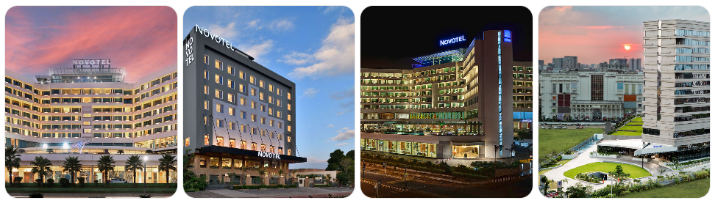
Figure 1: Novotel Hotel
Source: (Accor, 2025)
The development of the brand shows that it is strategically oriented to innovation and flexibility. Novotel pioneered ergonomics and organic bath products in their rooms in the 1990s as a way of improving the comfort of guests. By the 2010s, digital additions, including virtual concierge and multimedia tables, made Novotel the leader in the hospitality technological arena, enhancing operational effectiveness and guest interactions (Accor, 2025).
Sustainability has also been a focus of Novotel in its operations. There are energy saving systems, waste minimization efforts, and green facilities being put in place all over the world to indicate the increased interest in responsible travel. These efforts are also in line with the overall sustainability program of Accor, Planet 21, which emphasizes efficiency in energy and water, waste disposal and social responsibility (Accor, 2023).
Novotel is a part of Accor Group which enjoys vast world resources and brand synergies. This will enable the hotel to strike the right balance between quality guest experiences and innovative digital solutions and sustainability practices, which will support its competitive positioning within the midscale hospitality segment (Accor, 2023).

4.1.2 SWOT Analysis of Novotel’s Sustainable and Digital Front-of-House Efficiency
Table 1: SWOT Analysis of Novotel’s Sustainable and Digital Front-of-House Efficiency
Category | Key points
Strengths | - Strong sustainability credentials;  - Digital/efficiency gains evidenced;  - Large global footprint;  - Brand recognition.
Weaknesses | - Variation across properties;  - Potential guest friction with digital services;  - Cost/training burden;  - Integration of digital & sustainability may lag.
Opportunities | - High guest demand for eco + digital;  - Differentiation;  - Efficiency/cost savings;  - Data-driven loyalty;  - Expansion/new properties.
Threats | - Fast-evolving tech expectations;  - Risk of greenwashing;  - Technology/integration failures;  - High competition.
Source: Author
Strengths:
The close connection of Novotel with the Planet 21 sustainability program of Accor has allowed more than 91 % of its hotels to achieve sustainability goals in energy use, waste, and water use (Accor, 2023). The brand efforts, such as serving plant-based menu items, which it has already done in 39% of the hotels, and its work with WWF to make seafood sourcing sustainable, strengthen its environmental reputation (Melanie, 2025). Moreover, the digital innovations implemented by Novotel, including self-check-in kiosks, mobile key to the room, and AI-based guest services, have improved operational efficiency and guest satisfaction, and AI systems have decreased food waste by up to 16% in certain hotels (Melanie, 2023). It is also well-positioned to scale these initiatives, owing to its global reach, which has over 540+ hotels in 68 countries
Weaknesses:
With these advantages, Novotel experiences the lack of consistency in the application of sustainability and digital technologies to all guest locations, which results in uneven guest experiences. This dependency on technology also has the potential to reduce the personal element, and guests have complained of frustration when digital technology fails (Kindangen and Pandowo, 2022). Digital transformation is further curtailed by high implementation costs and insufficient training of its staff. Moreover, the implementation of the sustainability and digital systems is still incomplete in certain front-of-house spaces, which restricts the ability to obtain the full pipes of efficiency and personalisation advantages (Dung and Thang, 2022).
Opportunities:
The increasing consumer desire to consume eco-friendly and techno-enabled hospitality offers a significant opportunity to Novotel. Research indicates that 74% of travellers would stay in accommodations that are sustainable, and 85% appreciate digital check-in and keyless entry (Statista, 2024). Novotel can use a unique green digital guest experience to differentiate itself by integrating its environmental leadership with its digital innovation. The efficiency of operations and loyalty can be improved by expanding AI-based systems and data analytics, which can customise services based on the preferences of guests (Oo, 2023). Moreover, the continuous growth made by Accor conversions and new developments allows Novotel to incorporate sustainability and digital principles at the very beginning, which strengthens brand competitiveness and international homogeneity (Tu et al., 2024).
Threats:
The high rate of technological change and increasing competition are threatening Novotel, and it is estimated to have 60 % of hotel chains already serve guests via AI and 75 % intend to offer contactless check-ins by the year 2025 (Skift Research, 2025). This may result in the loss of its competitive edge in the event of failure to maintain pace. Also, a heightened sensitivity in the immediate neighbourhood of greenwashing implies that any perceived overstatement of its sustainability assertions might hurt its reputation (Moe, 2024). The economic factors, including inflation and increased energy prices, can also restrict the investments in digital systems, and the cybersecurity threats and system failures can jeopardise the trust of guests and the stability of work (Shashwat and Rani, 2023). As competitors such as Hilton Garden Inn and Holiday Inn keep improving their sustainability and digital initiatives, Novotel needs to keep innovating in order to remain the leader in the market.

4.1.3 PEST Analysis of Novotel’s Sustainability and Digital Initiatives
Political Factors:
Hotel operations are still affected by sustainability policies and environmental requirements in the UK and EU. The implementation of initiatives like the Net Zero Strategy in the UK encourages hotels to cut down emissions by 55 % by 2030, which corresponds to the Planet 21 framework of Novotel, which prioritizes energy and waste efficiency ( Accor, 2024). This orientation helps in compliance and increases the corporate reputation of Novotel, which provides it with a competitive edge in policy-based sustainability transitions.
Economic Factors:
By 2024, the global hospitality market is projected to rise by 6.1% to $5,244.22 billion, and to 5,523.92 billion, and by 2029, the market is expected to expand further to 7,011.13 billion (The Business Research Company, 2025). This consistent growth means an increase in travel demand and increased returns potential on sustainable and digital investments. Nevertheless, inflationary forces and rising energy prices drive Novotel towards smart technologies and renewable energy to remain profitable.
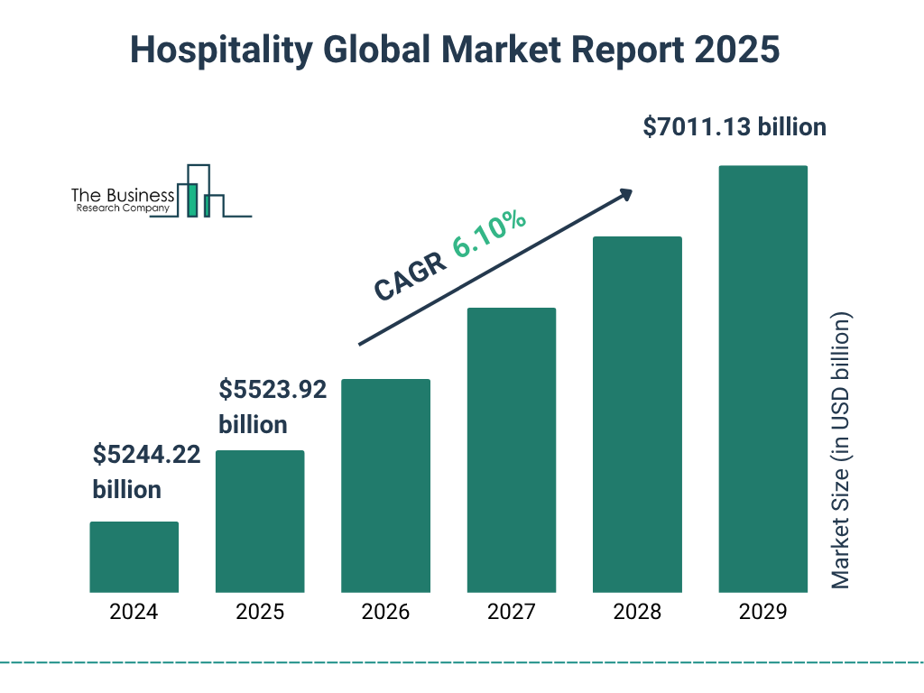
Figure 2: Hospitality Global Market Report 2025
Source: (The Business Research Company, 2025)
Social Factors:
The need of consumers to get eco-friendly and digitally improved experiences is constantly growing. The share of all travellers worldwide planning to spend their stays in sustainable accommodation grew by 78 % compared to 62 % in 2016 (Statista, 2024). In addition, location (41%), traveller needs (39%), and price (36%) seem to impact traveller decisions the most (Hub OS, 2024). This also demonstrates a twofold demand of guests on the comfort and environment, whereby Novotel is pressured to be affordable, environmentally responsible, and critical in delivering personalised services.
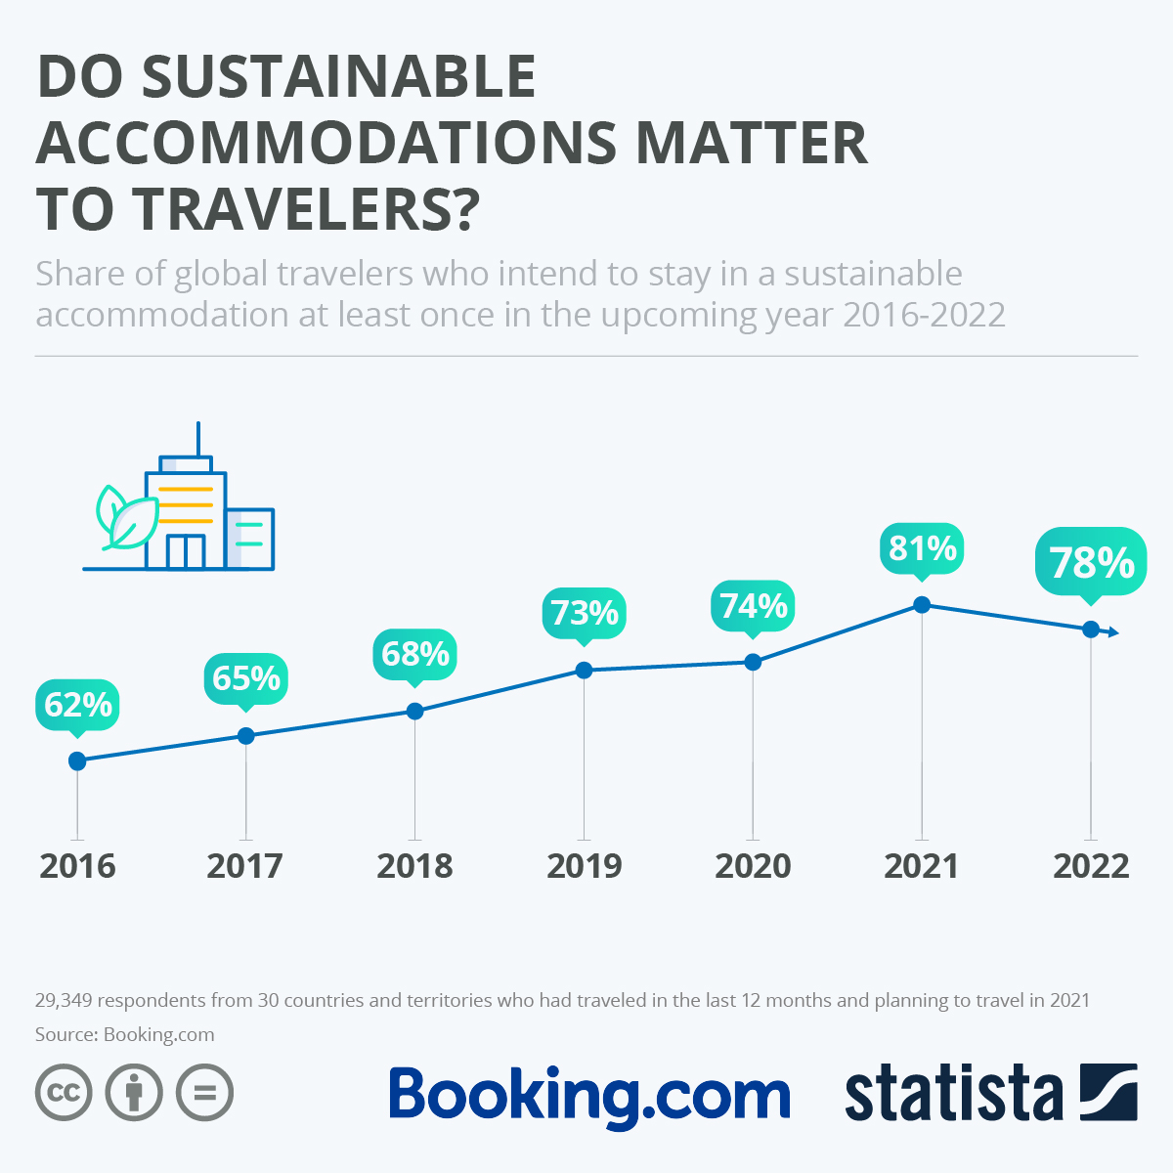
Figure 3: DO SUSTAINABLE ACCOMMODATIONS MATTER TO TRAVELERS?
Source: (Statista, 2024)
Technological Factors:
Digital transformation is one of the most important facilitators of service quality. The adoption of technology in the hospitality sector has resulted in a 135 % growth in online revenue, a 71 % decrease in guest complaints, and a 19 % improvement in customer satisfaction (Hub OS, 2024). The introduction of mobile check-ins, artificial intelligence chatbots, and smart energy systems at Novotel proves that technology can increase the efficiency of operations and the experience of guests (Accor, 2024).
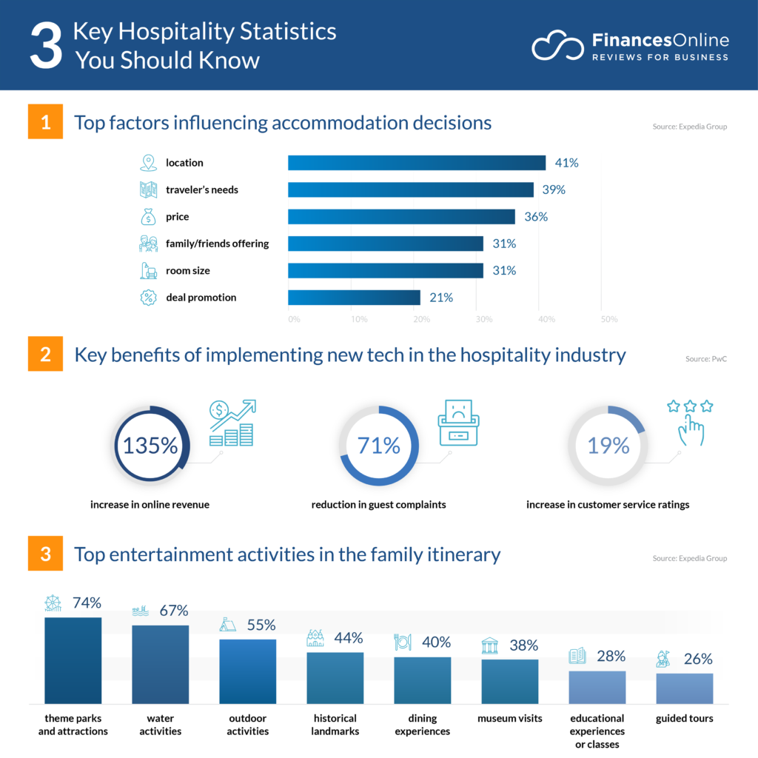
Figure 4: Key Hospitality Statistics
Source: (Hub OS, 2024)

4.1.4 Competitor Analysis
Table 2Benchmarking of Sustainability and Digital Front-of-House Practices (Novotel vs Competitors)
Criteria | Novotel (Accor Group) | Mercure (Accor Group) | Ibis (Accor Group) | Hilton Garden Inn | Holiday Inn (IHG) | Marriott Courtyard
Sustainability Framework | Planet 21: strong focus on energy, waste, and water reduction; carbon tracking in progress (Accor, 2023) | Local sourcing & culture: based sustainability; less standardised (Mercure Sapporo, 2025) | Energy efficiency and low-cost waste reduction, scaled globally (IBIS Hotel, 2025) | Travel with the Purpose of measurable carbon and water goals; advanced data reporting (Hilton, 2025) | Green Engage: online sustainability monitoring platform for all properties (IHG, 2024) | Serve 360: science-based sustainability targets; extensive annual ESG reporting (Marriott, 2024)
Digital Front-of-House Tools | Mobile check-in/out, digital keys, AI chatbot, e-receipts (Accor, 2023) | Limited automation; local digital adaptation (Mercure Sapporo, 2025) | Self-check kiosks, app booking, basic digital keys (IBIS Hotel, 2025) | Hilton Honours app with keyless entry, room control, and chat support (Hilton, 2023) | IHG One Rewards app; seamless mobile check-in and e-concierge (IHG, 2024) | Marriott Bonvoy app with AI-driven personalisation and voice assistance (Marriott, 2025)
Operational Efficiency | Efficiency improvement via digital and sustainable integration (Accor, 2023) | Moderate; varies by region | High due to standardisation and simplicity | Strong efficiency via AI analytics (Hilton, 2024) | High: IHG Green Engage tracks energy & digital efficiency metrics (IHG, 2024) | Excellent: real-time analytics drive optimisation (Marriott, 2024)
Customer Loyalty Integration | Linked with ALL loyalty program but limited AI personalisation (Accor, 2025) | Connected to ALL but low digital loyalty engagement | Basic loyalty integration | Advanced personalisation through the Hilton Honors ecosystem | Seamless loyalty–digital app integration | Highly personalised loyalty app with predictive service (Marriott, 2024)
Transparency & Reporting | Partial sustainability data disclosed; property-level variation (Accor, 2025) | Limited standardised reporting | Minimal | Public annual ESG reporting with KPIs (Hilton, 2024) | Real-time tracking and public dashboards (IHG, 202)5 | Full ESG and digital performance transparency (Marriott, 2024)
Competitive Position | Balanced in sustainability and digital innovation; needs stronger data transparency and uniform rollout. | Strong local sustainability focus; weak digital cohesion | Cost-efficient model, good scalability | Industry leader in personalisation & sustainability KPIs | High reporting transparency; strong digital ecosystem | Tech-driven service leader; benchmark for digital integration
Source: Author
Novotel is doing well in terms of balancing sustainability with digital transformation, and doing better than most of its midscale competitors in green innovation, but not better than the leading brands, such as Hilton and Marriott, in terms of data transparency and customized digital experiences. The emphasis on the standardization of digital services, the improvement of KPI reporting, and the increased individualization of loyalty based on AI would entrench Novotel in the competitive niche.

4.1.5 Observational Insights from Placement
At the Novotel Hotel, front-of-house work was thoroughly observed during the placement, so it seemed to be a good place to learn how sustainability and digital innovations are incorporated into the daily operations. These observations give information on how the hotel embraces operational effectiveness, customer satisfaction, as well as environmental concern.
Sustainable Practices
- Energy and Resource Saving: The hotel achieves energy efficiency through LED lighting in the hotel, motion sensors in the corridors, and energy-efficient HVAC. These steps lower the cost of operation and the Planet 21 sustainability goals of Accor.
- Waste Management: Recycling stations are located in the open spaces, and food waste management in the kitchen and restaurants is actively controlled. The guests are also advised to take part in the sustainability programs, e.g. not changing their linen daily.
- Water Conservation: Guest rooms are fitted with water-saving gadgets such as low-flow faucets and showerheads. Water use per floor is digitally monitored, with the help of which the management can see where improvements are necessary.
Online Front-of-House Innovations
- Self-Check-In Kiosks: Such kiosks will make the check-in system simpler, minimise waiting time, and enable the front desk personnel to concentrate on bespoke services.
- Mobile Room Keys: Visitors can enter the rooms with the help of a mobile application, which increases the level of convenience and reduces physical contact.
- AI-Based Guest Services: AI chatbots and virtual concierge systems should respond to simple requests, book rooms, and provide local information, which enhances response rates and leaves the staff to more sophisticated interactions.
- Operational Monitoring: Digital dashboards will display live information about the occupancy of rooms, the preferences of guests, and the state of housekeeping, and facilitate effective decision-making at the front desk.
Observations of Customer Service
- The interplay between convenience and sustainability is positively received, and eco-friendly activities and digital services increase satisfaction among the guests.
- Front desk employees can offer a more personal service since automated administrative functions are automated.
- Sustainability practices also affect the perception of long-term loyalty of the guests towards the brand.
Challenges Observed
- Technology Adoption: A portion of the guests expressed reluctance or lack of familiarity with self-check-in kiosks and mobile room keys and needed the assistance of the staff.
- Personalisation vs. Automation: Although online tools are efficient, some guests need human interaction, which explains that a moderate strategy is necessary.
- Lack of Knowledge of Sustainability Initiatives: Not every guest had complete knowledge about environmentally friendly programs, thus there should be an enhancement of communication and involvement in sustainability initiatives.
Key Insights
- Sustainable and digital development enhances the efficiency of operations and increases guest satisfaction.
- Digital systems enable the staff to concentrate on high-value interactions with the guests, which serve in personalised services.
- Sustainability initiatives affect the brand perception and customer loyalty positively.
- Effective communication is necessary to make guests participate in environmentally friendly initiatives and to promote the adoption of digital technologies without any difficulties

4.1.6 Performance Metrics Analysis
Table 3: Performance Metrics Analysis
KPI / Metric | Observation / Implementation | Performance / Trend for Novotel / Accor | Analysis / Strategic Insight
Energy & Water Consumption | Novotel uses low-flow fixtures, LED lighting, and digital monitoring under Accor’s sustainability plan. | Accor (2025) reports ~269 kWh/m² energy use per occupied room in 2024 (↓4% vs 2023) and ~500 L water per room. London Bridge site cut electricity by ~9% via “powerPerfector.” | Efficient actions reduce costs, improve sustainability, and enhance guest satisfaction through eco-friendly FOH operations.
Digital Front of House Innovation | Novotel applies mobile keys, contactless check-in, and digital concierge systems. | Novotel Guwahati introduced “Accor Key” in 2023 (FNB News, 2025). Accor (2025) highlights tech use for sustainable guest engagement. | Digital tools improve speed, reduce reception queues, and boost satisfaction. Data on adoption rates and time savings remain limited.
Loyalty Program Engagement | FOH experience drives loyalty through visible sustainable, and digital service quality. | ALL – Accor Live Limitless reached 100 M members (Melanie, 2025). Members spend 2× more than non-members. | Group-level loyalty growth reflects the impact of FOH innovations on guest retention and spending, though Novotel-specific data is limited.
Occupancy / Throughput Metrics | Digital FOH systems and green practices enhance efficiency and repeat stays. | AccorInvest reported ~3% energy reduction in 2023 despite higher occupancy (Accor, 2025). | Lower energy use with rising occupancy implies operational gains from FOH efficiency. Lack of property-level data limits precise evaluation.

Source: Author

4.1.7 Cross-Tabulation Analysis: Sustainability & Digital Initiatives vs Guest Outcomes at Novotel
Table 4: Cross-Tabulation Analysis: Sustainability & Digital Initiatives vs Guest Outcomes at Novotel
Initiative / Practice | Implementation at Novotel | Guest Satisfaction Impact | Guest Loyalty / Repeat Stay Impact | Analysis / Strategic Insight
Energy & Resource Efficiency | Use of LED lighting, motion sensors, efficient HVAC, and Planet 21 monitoring | Guests appreciate visible eco-efforts; it improves satisfaction | Builds loyalty among environmentally aware guests | Lowers costs, enhances eco-brand image, and drives repeat stays.
Waste Management & Recycling | Recycling bins, food waste tracking, and optional linen change | Guests value visible sustainability actions | Encourages loyalty from eco-conscious visitors | Reinforces brand trust and sustainable identity.
Water Conservation | Low-flow fixtures, digital water tracking | Positively perceived by sustainability-minded guests | Small but steady loyalty boost | Reflects environmental care and reduces operating costs.
Self-Check-In Kiosks | Touchscreen kiosks for quick check-in/out | Reduces wait time; higher satisfaction | Enhances loyalty via convenience | Improves efficiency and frees staff for personalised service.
Mobile Room Keys | App-based keyless entry via Accor App | Increases satisfaction through ease and privacy | Supports loyalty through seamless experience | Promotes app use and connects with loyalty offers.
AI-Powered Guest Services | Chatbots and a virtual concierge for routine requests | Faster responses, high satisfaction for tech-savvy guests | Strengthens loyalty for digital users | Streamlines service and gathers data for personalisation.
Digital Dashboards & Monitoring | Real-time tracking of occupancy and guest preferences | Improves service accuracy and reliability | Indirectly boosts loyalty through consistent service | Enables proactive management and efficient FOH operations.
Sustainable Food & Beverage Options | Plant-based dishes, local sourcing, and sustainable seafood | Strong satisfaction among health and eco-focused guests | Increases loyalty via responsible dining experiences | Aligns sustainability with personalisation and brand appeal.
Guest Communication on Sustainability | In-room info, signage, app notifications on eco-actions | Informed guests report higher satisfaction | Drives loyalty when messages feel authentic | Encourages engagement and enhances perceived brand integrity.
Source: Author

4.2 Discussion of Findings

4.2.1 Key Sustainable and Digital Front-of-House Practices at Novotel Hotel
The results suggest that Novotel Hotel has been very effective in incorporating sustainable and digital front-of-house (FOH), which has strengthened its operational effectiveness, customer satisfaction, and customer loyalty. Motion sensors, LED lighting, energy-efficient HVAC systems, and water-saving devices are all examples of sustainability initiatives realised, which are in line with the Planet 21 framework of Accor. They are consistent with the previous studies that stressed that energy and resource efficiency could not only help lower the costs of operations, but also improve the perception of the environment by the guests (Pereira-Moliner et al., 2021; Kim et al., 2019). The use of waste management, such as recycling points and monitoring the food waste, also promotes sustainable practices, which are in line with the results by Dani et al. (2021) and Calisto et al. (2021), which assert that observable maintenance practices affect the brand image and guest satisfaction.
These sustainability initiatives are supplemented by the digital FOH innovation, which improves the delivery of services and convenience. Self-check-in kiosks, mobile room keys, AI chatbots, as well as virtual concierge systems, facilitate interactions with guests and save time on waiting lines and enable employees to work on personalised services. These results can be compared to Wynn and Jones (2022) and Sabharwal and Jain (2025), who mention that digital technologies help to increase the efficiency of operations and improve guest experiences. Room occupancy and housekeeping real-time dashboards give data-based operational management, which is congruent with Shi and Zhong (2025) and Aluri et al. (2023), who point out that digital control and automation of the services are the best method to optimise the quality of services and staff efficiency.
The cross-tabulation analysis also confirms that the integration of sustainability and digital practice has a positive effect on guest satisfaction and loyalty, which is also supported by Singh et al. (2024) and Dinh et al. (2025), who state that integrated eco-digital strategies positively influence the operational performance and customer engagement. The guests experience a contemporary and environmentally-friendly experience, which contributes to returning to the hotel and working with the loyalty programs, including Accor Live Limitless (ALL).
However, limitations exist. The difference in the use of technology among properties may result in inconsistent experiences, and not all guests are ready to utilise digital tools, which will also have to be addressed by the staff members, which is also mentioned by Efthymiou et al. (2020) and Shashwat and Rani (2023). Moreover, sustainability efforts might be less known without active promotion, which is reported by Yusof et al. (2017) with superficial or improperly communicated sustainability measures that do not necessarily affect loyalty.
In general, the results indicate that sustainability and digital FOH integrated into strategic operations at Novotel help increase the efficiency of operations, the experiences of guests, and their loyalty, and emphasise the necessity of regular implementation, development of personnel, and effective communication with guests..

4.2.2 Impact of Sustainable Practices and Digital Technologies on Operational Efficiency and Guest Satisfaction at Novotel Hotel
As the results suggest, the implementation of sustainability and digital technologies by Novotel Hotel has a quantifiable impact on performance and customer satisfaction. Sustainable projects, such as LED lighting, motion sensors, optimised HVAC systems, water-saving equipment, and digital monitoring, express the conformity to the Planet 21 framework by Accor. Such actions can not only minimise the amount of the utility consumed and the expenses involved in the operation but also design environmentally conscious operations, which support the previous research findings that resource-efficient systems have a beneficial effect on the operational performance and the workload of the staff (Pereira-Moliner et al., 2021; Kim et al., 2019). Operation optimisation, waste management practices, including tracking of food waste and recycling programs, also contribute to the results of Dani et al. (2021) and Calisto et al. (2021), who have highlighted that visible environmentally-friendly actions lead to a rise in efficiency and brand perception. According to placement observations, these sustainability measures enable the FOH staff to deliver resources in a more planned manner, which has led to better operational processes and service delivery.
Such sustainability initiatives are supported by digital innovations such as the simplification of guest interactions and front-of-house operations. Self-check-in kiosks, mobile room key, A.I.-driven virtual concierge, and real-time operational dashboards help eliminate administrative bottlenecks, allowing staff to give attention to personalised guest interaction. Such findings align with the literature by Wynn and Jones (2022), Sabharwal and Jain (2025), and Shi and Zhong (2025), which point out that AI and digital systems not only make the processes more efficient but also promote service quality. The cross-tabulation analysis indicates that the combination of convenience and sustainability is positively received by guests, especially by tech-savvy and environmentally conscious travellers, which is in line with the findings by Singh et al. (2024) and Dinh et al. (2025), who contend that integrated eco-digital strategies can lead to high guest satisfaction.
However, limitations remain. The differences in digital usage between properties may also lead to unequal guest experiences, and not all guests are accustomed to automated systems, which means they may need a worker to take care of them, as raised by Efthymiou et al. (2020) and Shashwat and Rani (2023). Also, the lack of knowledge about sustainability initiatives among guests diminishes the possible effectiveness in terms of satisfaction, which is in line with the findings by Yusof et al. (2017) about the need to provide a clear communication of sustainability programs.
Altogether, sustainable and digital FOH projects of Novotel play an important role in making the operations more efficient through the consumption of fewer resources and optimisation of the work process, at the same time making the guests experience a greater level of convenience and personalisation and demonstrating their accountability to the environment. Such results support the fact that sustainability and digital innovation integration an essential variables in contemporary hotel performance, operational efficiency, and long-term loyalty rates of the guests.

4.2.3 Contribution of Sustainability and Digital Front-of-House Strategies to Customer Loyalty at Novotel Hotel
The results suggest that the implementation of the sustainability and digital front-of-house (FOH) strategies by Novotel Hotel produces a quantifiable and positive influence on customer loyalty. The initiatives made sustainable, such as energy and water consumption, waste management, and environmental guest services, maximise the credibility of the hotel as being environmentally friendly. Such observable measures as recycling stations, vegetarian menu options, and the involvement in the Accor Planet 21 program establish a connection between hotel values and the values of environmentally-conscious travelers, which supports prior studies stating that sustainability as a factor shapes the company perception, and repeat visits occur (Lin, Nugraha, and Hsu, 2025; Alipour, Safaeimanesh, and Soosan, 2019). The validity of these sustainability measures in both guest satisfaction and indirectly loyalty creation is supported by placement observations that ensure that the measures help to maintain the ethical and responsible image of the hotel.
Digital innovations also strengthen loyalty by increasing convenience, as well as personalisation and engagement. Self-check-in kiosks, mobile room keys, AI-driven virtual concierge services, and real-time operational dashboards simplify operations and decrease wait time and allow personnel to offer customised services. Such additions bring a smooth, contemporary guest experience, a fact that is echoed by Wynn and Jones (2022), Sabharwal and Jain (2025), who show that digital tools in the operation of FOH increase customer satisfaction, which is an antecedent of loyalty. Besides, these technological touchpoints reinforce the integration with Accor Live Lab (ALL) loyalty ecosystem because guests feel more valued in the membership program when sustainable and digital efforts become apparent and working.
The sustainability and digital initiative against the guest satisfaction and loyalty measures are analysed through cross-tabulation, which shows a positive correlation. Visitors who are subjected to both green initiatives and effective online offerings say that they are more satisfied, as well as more likely to join loyalty programs. Nevertheless, there are still restrictions: the lack of consistency in using digital tools across the properties, and the uncertainty of guests about technology use can lead to lower impact on loyalty immediately, and the lack of communication on sustainability initiatives can become a constraint to engagement, which Yusof et al. (2017) and Shashwat and Rani (2023) have also noticed.
In general, it can be concluded that the combined strategy of sustainability and digital FOH provided by Novotel has a significant impact on customer loyalty. This approach toward environmentally conscious actions and the production of services with technological improvement enhances the rate of returning to the hotel, promotes involvement in the loyalty program, and supports the competitive standing of the hotel among contemporary travellers who tend to be environmentally conscious and technologically advanced. This illustrates the strategic significance of integrating green efforts with digital innovations towards sustainable goals of attaining strong brand loyalty.

4.2.4 Addressing the Research Questions
Novotel Hotel has adopted essential sustainable initiatives, like the use of energy-efficient systems, water saving devices, minimised waste, and ecological amenities, together with digital front-of-house, including self-check-in kiosk, mobile room keys, AI-based concierge, and real-time dashboards. These programs make operations more efficient by making better use of resources and staff distribution, as well as making guests happier with the locus of convenience, customisation, and open environmental accountability. Customer loyalty is also enhanced by both the sustainability and digital FOH approach, which ensures customer loyalty because guests appreciate environmentally friendly practices and digital operations that ensure they make repeat bookings and take part in the ALL loyalty program of Accor. Weaknesses like normal technology use, lack of awareness among the guests reveal avenues of improved performance, although generally, Novotel has a strong relationship among operational innovation, guest satisfaction, and loyalty

Chapter 5: Conclusion and Recommendations

5.1 Conclusion
This study has critically discussed how sustainability and digital front-of-house (FOH) practices have been integrated in the Novotel Hotel and their effects on efficiency in operations, satisfaction of the guests and the loyalty of the customers. The research paper emphasises that Novotel has managed to introduce various environmentally friendly interventions such as economical lighting systems, movement-activated heating and air conditioning systems, water-saving appliances, waste management programmes and visible sustainability, which are in accordance with the Planet 21 framework of Accor. In addition to these, innovative digital implementations which include self-check-in systems, room keys on their mobile phones, intelligent virtual concierge services, and operational dashboards have made their front-of-house services leaner, helped to lessen the load on the administration, and provided staff with the time and space to engage guests on a personal level.
These mixed sustainability and digital strategies have shown that they lead to a large boost in operational efficiency through more efficient resource utilisation, more effective staffing, and the elimination of operational bottlenecks. People feel beneficial about the two-thronged emphasis on convenience and environmental accountability, which leads to a greater level of satisfaction and increased interest in the Accor ALL loyalty program. The study also presents drawbacks such as uneven use of digital by each property and insufficient awareness of guests about sustainability efforts, which show areas that need additional enhancement to improve results.
In general, the research highlights the strategic relevance of the integration of sustainability and digital innovation in front-of-house management. The strategy of Novotel does not only strengthen its competitive standing in the midscale hospitality division, but also shows that eco-conscious and high-tech practices can achieve objective advantages in terms of operational performance, customer experience, and retention. The study offers meaningful information to hospitality practitioners who aim to strike a balance between environmental sustainability and technological development as a way of realizing sustainable development and long-term customer relationships.

5.2 Recommendations
The following recommendations are expected to streamline the sustainable and digital efforts of the hotel, fill in the gaps, and facilitate competitiveness in the long run in the midscale hospitality industry.
- Standardise Digital Front-of-House Practices Across Properties: Although Novotel has already introduced self-check-in kiosks, mobile room keys, and AI-based concierge services in certain properties, it may create discrepancies in guest experience due to one set of properties having more of these elements than others. It is suggested that a unified digital protocol should be created to be applied to all hotels, with a coherent process of check-in and check-out, mobile key systems, digital concierge services, and built-in operational boards. Standardisation will enhance uniformity, operational effectiveness, and uniformity in the quality of service provision, which will strengthen the brand credibility.
- Enhance Guest Awareness and Engagement in Sustainability Initiatives: It was observed that not every guest knew eco-friendly programs completely. Novotel ought to enhance communication by various means, such as in-room information, digital messages using a mobile app, and clear markings in the common spaces which indicate recycling points, water and energy efficiency, and further choices such as linen and towel reuse. Education can be achieved through engagement campaigns, like rewarding guests who opt to use sustainable options, to enhance their involvement and reinforce the environmental brand image of the hotel.
- Invest in Comprehensive Staff Training Programs: Employee preparedness is crucial in implementing the sustainability and digital strategies successfully. The use of digital tools, sustainability practices, and guest interaction strategies, integrating technology with a personal approach, needs regular training programs. Improving the skills of the workers will minimise mistakes, provide a trouble-free process of implementing new systems, and enable employees to support new arrivals who might lack technological awareness, increasing the degree of customer satisfaction.
- Expand Data Analytics for Personalisation and Resource Optimisation: The predictive guest services can be implemented through the use of AI and real-time dashboards, which may predict requests related to room services or customised recommendations after previous stays. Also, operational data may streamline housekeeping schedules, track energy and water use, and detect inefficiencies. This will decrease the expenses of operation, increase the sustainability scores, and increase individualised guest experiences.
- Integrate Sustainability and Digital Initiatives into Loyalty Programs: Connections between the environmentally conscious practices and online comfort to the Accor ALL loyalty program can promote frequent visits and motivate participation. Some of these include awarding points to those who want to choose not to have their linens laundered daily, use mobile keys to the rooms, or engage in sustainability activities. The emphasis of these initiatives in the loyalty app will support brand values and emotional relationships with environmentally friendly travellers.
- Implement Continuous Monitoring and Feedback Mechanisms: It is necessary to regularly determine the key performance indicators (KPIs), which include: check-in/out times, guest satisfaction rates, occupancy rates, energy and water consumption, and uptake of digital tools. Also, it is feasible to seek the opinion of guests about digital services and sustainability practices to review areas of improvement, and the management can make informed changes and ensure the high quality of services.
- Introduce Gamification and Incentives for Guest Participation: To promote sustainable behaviour, Novotel can introduce gamification features in its mobile application, eco-challenges, rewards when appropriate objects are reused, or leaderboards to involve guests. This way, sustainability becomes interesting and participatory, which enhances the chances of engagement and ensures loyalty.
- Collaborate with Technology and Sustainability Partners: Collaborating with technology companies to modernise digital technology or with non-governmental organisations to offer sustainability awards can be a credibility boost, a source of innovation, and a leadership statement in responsible hospitality practices. The addition of smart energy management systems or higher environmental certification will make Novotel even more differentiated in the midscale market, for instance.
- Promote Eco-Digital Branding in Marketing Efforts: The combination of sustainability and digital convenience in marketing messages, which can be communicated through social media, web, and booking platforms, has the potential to draw environmentally aware and tech-conscious tourists to the hotel and enhance its brand vision and increase the number of bookings.
Through adopting these suggestions, Novotel will be in a position to streamline the operations of the FOH, improve operational efficiency, enhance guest satisfaction of the guest and increase customer loyalty. The combination of a uniform digital activity, visible and participatory sustainability initiatives, empowerment of staff, and personalisation based on data will ensure the strong competitive positioning of Novotel as well as sustainable growth and a contemporary, guest-centred experience.

References
Accor (2023). Accor – Webzine. [online] Accor.com. Available at: https://webzine-actionnaires.accor.com/09_2021/en/article/129/environmental-commitment.html.
Accor (2024). Sustainable hospitality. [online] Accor.com. Available at: https://group.accor.com/en/group/sustainable-hospitality.
Accor (2025). Book a hotel for a family holiday or business trip | Novotel. [online] novotel.accor.com. Available at: https://novotel.accor.com/a/en/europe.html.
Accor (2025). Sustainable Stays. [online] Accor.com. Available at: https://group.accor.com/en/group/sustainable-hospitality/sustainable-stays.
Alhassan, F., Alhassan, M., Abdallah, A.H., Salman, T. and Titiakaa, O.R., (2025). The Impact of Service Quality, Digital Innovation, and Loyalty Programs on Customer Satisfaction and Loyalty in Luxury Hotels. International Journal of Innovation and Development, 2(3).
Alipour, H., Safaeimanesh, F. and Soosan, A., (2019). Investigating sustainable practices in hotel industry-from employees’ perspective: Evidence from a Mediterranean Island. Sustainability, 11(23), p.6556.
Alpi, K.M. and Evans, J.J., (2019). Distinguishing case study as a research method from case reports as a publication type. Journal of the Medical Library Association: JMLA, 107(1), p.1.
Aluri, A., Gupta, R. and Brown, E., (2023). Investigating the Impact of Automation, Digital Worker, and Artificial Intelligence on the Hospitality Industry. Journal of Hospitality & Tourism Cases, p.21649987251356946.
Anas Abudaqa, Geraldina, I., Mohamad Rakhmansyah, Miftah, M. and Sipho Dlamini (2024). Sustainable Management Strategies to Enhance Business Competitiveness in the Technology Sector. Aptisi Transactions on Management (ATM), [online] 8(3), pp.231–240. doi:https://doi.org/10.33050/atm.v8i3.2359.
Bell, E., Harley, B. and Bryman, A., (2022). Business research methods. Oxford university press.
Braun, V. & Clarke, V., (2019). Using thematic analysis in psychology. Qualitative research in psychology, 3(2), pp. 77-101.
Calisto, M.D.L., Umbelino, J., Gonçalves, A. and Viegas, C., (2021). Environmental sustainability strategies for smaller companies in the hotel industry: doing the right thing or doing things right?. Sustainability, 13(18), p.10380.
Caulfield, J., (2019). How to do thematic analysis.
Choi, H.H., (2023). Construction of a Restaurant Service Quality Scale in the Front-of-House (Doctoral dissertation, The University of Mississippi).
Corti, L., (2018). Data collection in secondary analysis. The SAGE handbook of qualitative data collection, 1, pp.164-181.
Cozzio, C., (2019). The Concept of Sustainability in Hotel Industry: Current dominant orientations and future issues. International Journal of Sustainable Development, 22(1-2), pp.61-87.
Dani, R., Tiwari, K. and Negi, P., (202). Ecological approach towards sustainability in hotel industry. Materials Today: Proceedings, 46, pp.10439-10442.
Dinh, H.T., Nguyen, N.H., Nguyen, A.N. and Bui, T.T.K., (2025). Harnessing AI and digital innovation for green innovation and sustainable performance. Journal of Hospitality and Tourism Insights, pp.1-19.
Dung, N.N. and Thang, V.C., (2022). CONTACTLESS SERVICES IN VIETNAM'S HOSPITALITY INDUSTRY: CASE STUDIES OF THE JW MARRIOTT HANOI AND THE NOVOTEL HANOI THAI HA HOTEL. VNU Journal of Foreign Studies, 38(6), pp.30-43.
Efthymiou, L., Orphanidou, Y. and Panayiotou, G., (2020). Delineating the changing frontstage and backstage segregation in high-end and luxury hotels. Hospitality & Society, 10(3), pp.287-312.
FNB News (2025). FNB News - Novotel Guwahati unveils Accor Key for enhanced guest experience | FNB News. [online] Fnbnews.com. Available at: https://www.fnbnews.com/Top-News/novotel-guwahati-unveils-accor-key-for-enhanced-guest-experience-76005?utm_source=chatgpt.com [Accessed 4 Nov. 2025].
Gouda, R.M. and Halim, Y.T., (2025). The role of sustainable social media content in enhancing customer loyalty in the hospitality industry. Future Business Journal, 11(1), p.130.
Hair Jr, J., Page, M. and Brunsveld, N., (2019). Essentials of business research methods. Routledge.
Heale, R. and Twycross, A., (2018). What is a case study?. Evidence-based nursing, 21(1), pp.7-8.
Hilton (2023). Hilton Honors App with Contactless Check-In. [online] Hilton. Available at: https://www.hilton.com/en/p/hilton-honors-mobile-app/.
Hilton (2025). Our Hotels | Travel with Purpose | Hilton TWP. [online] Travel With Purpose | Hilton TWP. Available at: https://travelwithpurpose.hilton.com/our-hotels/.
Hub OS (2024). Digital transformation in the hospitality industry - Hub OS. [online] Hub OS. Available at: https://hubos.com/digital-transformation-in-the-hospitality-industry/.
Hussein, H., Albadry, O.M., Mathew, V., Al-Romeedy, B.S., Alsetoohy, O., Abou Kamar, M. and Khairy, H.A., (2024). Digital leadership and sustainable competitive advantage: leveraging green absorptive capability and eco-innovation in tourism and hospitality businesses. Sustainability, 16(13), p.5371.
IBIS Hotel (2025). Sustainability - IBIS Dubai One Central. [online] IBIS Dubai One Central. Available at: https://www.ibisonecentral-dubai-world-trade-centre.com/sustainability/ [Accessed 4 Nov. 2025].
IHG (2024). IHG Mobile App. [online] IHG. Available at: https://www.ihg.com/content/us/en/support/mobile.
IHG (2024). InterContinental Hotels Group Corporate Responsibility. [online] IHG. Available at: https://www.ihg.com/content/us/en/about/corporate-responsibility.
Ilnytska-Hykavchuk, H., (2025). Innovation as a Tool for Sustainable Development of the Hotel Industry. Економіка розвитку систем, 7(2), pp.56-60.
Kalefa, H. and Gado, S., (2024). Enhancing hotel sustainability through ecological and technological integration. JES. Journal of Engineering Sciences, 52(1), pp.145-174.
Karim, R.A. and Rabiul, M.K., (2024). The relationships of corporate sustainability, customer loyalty, and word of mouth: the mediating role of corporate image and customer satisfaction. Journal of Quality Assurance in Hospitality & Tourism, 25(3), pp.421-441.
Kim, Y.H., Barber, N. and Kim, D.K., (2019). Sustainability research in the hotel industry: Past, present, and future. Journal of Hospitality 1Marketing & Management, 28(5), pp.576-620.
Kindangen, A.N.V. and Pandowo, M., (2022). ANALYTICAL HIERARCHY PROCESS (AHP) APPROACH ON CONSUMER PREFERENCE IN HOTEL SELECTION DURING COVID-19 PANDEMIC (CASE STUDY: NOVOTEL HOTEL, SWISS BELL HOTEL, FOUR POINTS HOTEL). Jurnal EMBA: Jurnal Riset Ekonomi, Manajemen, Bisnis dan Akuntansi, 10(3), pp.01-08.
Kolobkova, V.A., Romanov, A.A. and Frolova, E.A., (2021). Digital technologies in the hotel industry: new prospects for sustainable development. In Socio-economic Systems: Paradigms for the Future (pp. 387-394). Cham: Springer International Publishing.
Largan, C. and Morris, T.M., (2019). Qualitative secondary research: A step-by-step guide.
Lin, C.C., Nugraha, K.S. and Hsu, Y.J., (2025). The Effect of Sustainable Development Goals on Customer Satisfaction, Customer Loyalty and the Role of Brand Image in Green Hotels. Advances in Management and Applied Economics, 15(1), pp.1-7.
Mahiette, M. (2023). Accor encourages its properties to measure their food waste Reduction can only be achieved... [online] Accor. Available at: https://press.accor.com/food-waste-ai-supporting-accor-hotels.
Mahiette, M. (2025a). A unique and fast-growing loyalty program combining stays at unbeatable prices and exclusive... [online] Accor. Available at: https://press.accor.com/all-accors-award-winning-loyalty-program-reaches-100-million-global-members.
Mahiette, M. (2025b). Paris, 21 May 2025 – Ahead of World Ocean Day (8 June), Novotel... [online] Accor. Available at: https://press.accor.com/novotel-celebrates-one-year-of-ocean-commitment-and-sustainable-partnership-with-wwf.
Marriott (2024). csr-marriott. [online] csr-marriott. Available at: https://serve360.marriott.com/.
Marriott (2025). Marriott Bonvoy Events. [online] Marriottbonvoyevents.com. Available at: https://marriottbonvoyevents.com/news-and-highlights/article/674/how-marriott-s-ai-initiatives-will-empower-event-planners.
Mercure Sapporo. (2025). Sustainability and Environmental Policy - Mercure Sapporo. [online] Available at: https://mercuresapporo.com/the-hotel/sustainability/ [Accessed 4 Nov. 2025].
Moe, A.K., (2024). Dining Service Quality, Customer Satisfaction And Revisit Intention of Le'Cellier Restaurant at Novotel Hotel (Aung Kyaw Moe, 2024) (Doctoral dissertation, MERAL Portal).
Neuendorf, K.A., (2018). Content analysis and thematic analysis. In Advanced research methods for applied psychology (pp. 211-223). Routledge.
Oo, T.T., (2023). Factors Affecting Customer Satisfaction on Novotel Yangon Max Hotel (Thant Thazin Oo, 2023) (Doctoral dissertation, MERAL Portal).
Pastor, R., (2025). Digital Transformation and Sustainability in the Hospitality Industry: Pathways for Innovation and Competitiveness. Journal of Business and Tourism Management, 1(1), pp.32-43.
Patwary, A.K., Tosun, C., Sharif, A., Ismail, N.A. and Abuelhassan, A.E., (2024). Measuring sustainable business performance in Malaysian hotels: The roles of green information, green innovation strategic orientation, and digital technology implementation. International Journal of Hospitality Management, 123, p.103935.
Pereira-Moliner, J., López-Gamero, M.D., Font, X., Molina-Azorín, J.F., Tarí, J.J. and Pertusa-Ortega, E.M., (2021). Sustainability, competitive advantages and performance in the hotel industry: A synergistic relationship. Journal of Tourism and Services, 12(23), pp.132-149.
Priya, A., (2021). Case study methodology of qualitative research: Key attributes and navigating the conundrums in its application. Sociological Bulletin, 70(1), pp.94-110.
Rashid, Y., Rashid, A., Warraich, M.A., Sabir, S.S. and Waseem, A., (2019). Case study method: A step-by-step guide for business researchers. International journal of qualitative methods, 18, p.1609406919862424.
Sabharwal, D. and Jain, V., (2025). Transforming Hospitality Through AI, Big Data, and Automation: The New Era of Service Innovation. In Addressing Contemporary Challenges in the B2B Hospitality Sector (pp. 309-336). IGI Global Scientific Publishing.
Shashwat, K. and Rani, M., (2023). Technological transformation in hospitality industry: An overview. Sustainable development goal advancement through digital innovation in the service sector, pp.133-151.
Shashwat, K. and Rani, M., (2023). Technological transformation in hospitality industry: An overview. Sustainable development goal advancement through digital innovation in the service sector, pp.133-151.
Sherif, V., (2018), March. Evaluating preexisting qualitative research data for secondary analysis. In Forum qualitative sozialforschung/forum: Qualitative social research (Vol. 19, No. 2).
Shi, H. and Zhong, Z., (2025). Research on Evaluation of Hotel Digitization Effect Assisted by Extreme Learning Machine in Artificial Intelligence Environment. International Journal of High Speed Electronics and Systems, p.2540199.
Singh, R., Gehlot, A., Akram, S.V., Thakur, A.K., Gupta, L.R., Priyadarshi, N. and Twala, B., (2024). Integration of advanced digital technologies in the hospitality industry: a technological approach towards sustainability. Sustainable Engineering and Innovation, 6(1), pp.37-56.
Skift Research. (2025). Hotel Technology Priorities 2025: Innovation, Integration, and Impact. [online] Available at: https://research.skift.com/reports/hotel-technology-priorities-2025-innovation-integration-and-impact/.
Statista (2022). Infographic: Do sustainable accommodations matter to travelers? [online] Statista Daily Data. Available at: https://www.statista.com/chart/28162/how-much-do-sustainable-accommodations-matter-to-travelers/?srsltid=AfmBOoo2w99Fh44wf9hQFEVqzowGF154knBz0Z96iy2i67FDcI7MpL3L [Accessed 4 Nov. 2025].
Statista (2024). Infographic: Do sustainable accommodations matter to travelers? [online] Statista Daily Data. Available at: https://www.statista.com/chart/28162/how-much-do-sustainable-accommodations-matter-to-travelers/?srsltid=AfmBOopSKy6SG7R9RARDh7cZ6BpCjJj0gECgtfGxfh4ooxiIehRgSPwZ [Accessed 4 Nov. 2025].
The Business Research Company (2025). Hospitality Market Analysis, Size And Trends Global Forecast To 2022-2030. [online] www.thebusinessresearchcompany.com. Available at: https://www.thebusinessresearchcompany.com/report/hospitality-global-market-report.
Tu, H.A., Nhung, P.T.H. and Dung, N.N., (2024). The factors of customer experience that affect loyalty at Novotel Hanoi Thai Ha Hotel, Vietnam. European Journal of Social Sciences Studies, 10(1).
Uludag, O., Andrlić, B. and Omoruyi, D., (2024). The role of green consumer brand engagement in shaping brand loyalty through digital marketing in the hotel industry. Sustainability, 16(23).
Wynn, M. and Jones, P., (2022). IT strategy in the hotel industry in the digital era. Sustainability, 14(17), p.10705.
Yusof, Y., Awang, Z., Jusoff, K. and Ibrahim, Y., (2017). The influence of green practices by non-green hotels on customer satisfaction and loyalty in hotel and tourism industry. International Journal of Green Economics, 11(1), pp.1-14.

