Dissertation
Research title:
Evaluation of opportunities and challenges in DAO implementation in UK’s Financial Service Sector

Module Code: LCBB6000
Lecturer: Caroline Walsh

Student name: Alin Florin Carare
Student ID: 2246440
University of Wales Trinity Saint David
Submission date: 02.04.2026

Abstract
DAOs provide unexpected benefits or present significant emerging opportunities in the financial sector, driven by the UK government's aim to become a global hub for crypto asset innovation. scalability and effectiveness are common challenges related to DAOs, faced by companies and individuals when they adopt the entity. In the context of the present study, the grounded theory is considered as an effective research strategy is selected. The main reason for selecting this methodology is to gain in-depth insights on experiences and perspectives within the UK financial services sector. Secondary data collection method has been adopted in the study and the nature of the study is qualitative in nature. Consideration of qualitative analysis provides deeper understanding, theme development, and interpretation of the data. In present study, qualitative data analysis technique is considered and themes are designed.
Findings indicate that the UK financial sector is prepared to adopt DAO based on four key determinants, including compliance with regulation, technological infrastructure, human resources, and clarity of governance. Obedience is the key to preparedness. Financial institutions need to fit the DAO structures with the current rules and regulations, such as anti-money laundering, consumer laws, and capital requirement rules. Key suggestion is to focus on the development of the robust governance model. It is vital to strongly focus on the implementation of governance structure where there is strong balance in between decentralization and efficiency.

Table of Contents
Abstract 2
Chapter 1: Introduction 6
1.1 Introduction 6
1.2 Background 6
1.3 Problem statement 6
1.4 Significance of the study 7
1.5 Aim, Objectives and Research Questions 7
1.5.1 Aims 7
1.5.2 Objectives 7
1.5.3 Research Questions 8
1.6 Rationale 8
1.7 Outline of the study 8
1.8 Summary 8
Chapter 2: Literature review 9
2.1 Introduction 9
2.2 Different background aspects to the concept 9
2.3 Theoretical frameworks 10
2.4 Risks and barriers in adoption of DAOs 11
2.5 Organisational and technological readiness factors for effective DAOs adoption 13
2.6 Ways for safe and successful implementation of DAO 14
2.7 Research gap 15
2.8 Summary 15
Chapter 3: Research methods and methodology 17
3.1 Introduction 17
3.2 Research philosophy 17
3.3 Research approach 17
3.4 Research strategy 18
3.5 Data collection 18
3.6 Sampling 18
3.7 Data analysis 19
3.8 Time prospect/timeline 19
3.9 Ethical considerations 20
3.10 Summary 20
Chapter 4: Data analysis and discussions 21
4.1 Introduction 21
4.2 Analysis 21
4.2.1 UK financial sector employees view DAO opportunities as innovative and high-growth, but uncertain due to regulatory and adoption risks 21
4.2.2 There are perceived risks and barriers to the adoption of DAOs, such as regulatory uncertainty, security concerns and lack of institutional trust. 22
4.2.3 Organisational and technological readiness for DAOs is moderate, but limited by regulatory and expertise gaps 24
4.2.4 DAO adoption readiness relies on compliance, infrastructure, skilled staff, and clear governance 25
4.2.5 Administrative theory is adopted by businesses for the effective use of DOA in UK financial sector 27
4.3 Discussion 28
4.4 Conclusion 28
Chapter 5 Conclusion and recommendations 30
5.1 Conclusion 30
5.2 Recommendations 30
5.3 Contribution of the research 31
5.4 Suggestions for further research 31
5.5 Limitations 31
5.6 Summary of the chapter 31
References 32

Chapter 1: Introduction

1.1 Introduction
The rapid evolution of blockchain technology has introduced Decentralized Autonomous Organizations (DAOs) as a radical alternative to traditional corporate governance, particularly within the UK’s highly regulated financial services sector. Unlike conventional institutions, DAOs operate through automated smart contracts and community-based voting, promising enhanced transparency and operational efficiency. However, as the UK seeks to maintain its position as a global financial hub, the integration of these decentralized models faces significant scrutiny regarding legal accountability and alignment with existing regulatory frameworks. This research evaluates the current landscape of DAO implementation by synthesizing industry reports and academic discourse to identify the critical opportunities and systemic challenges that define this technological transition in the British market.

1.2 Background
DAO stands for a decentralized autonomous organization, which is recognized as a community-owned company run by code on a blockchain, instead of a central authority, where individuals vote on actions and decisions by using tokens (Van Vulpen and Jansen, 2023). The DAO works effectively in the corporate world as it encodes new rules and regulations, written into smart agreements, specifying how it operates. Members submit proposals, and other individuals vote for them. If a member proposal passes or is approved, the smart deal directly executes the agreed-upon action. The purpose of DAOs is to permit like-minded people to pool assets and make collective actions and decisions for shared reasons, often related to crypto projects, online communities, and venture funds (Augustin et.al 2023). They also aim to develop more democratic, secure, and effective ways to manage the traditional business structure.
This study originates from the growing tension between this technological push for decentralization and the necessity for institutional stability within the British financial landscape.

1.3 Problem statement
The implementation of DAO is a key research issue as it has a direct or indirect impact on UK financial sector growth and success in the competitive landscape and complex business environment. The problem is resolved by collecting empirical data on the chosen topic and using relevant methods. The benefits and disadvantages related to DAO create interest among researchers to study more about the topic.

1.4 Significance of the study
The research is essential and valuable as it supports gaining more information on barriers and challenges experienced by companies in the sector, along with employees, while adopting and implementing DAOs. The study is also significant as it allows determining and analyzing the extent to which organizations in the industry prepare and plan for the implementation of DAOs. This analysis is vital because the transition to code-based smart contracts within the UK’s financial services presents a complex set of operational hurdles and a persistent tension between technological autonomy and legal accountability. By evaluating the gap between technological ambition and regulatory compliance, particularly regarding FCA standards, the research offers a consolidated view of institutional readiness often missing from global analyses. Furthermore, identifying risks such as security vulnerabilities and governance attacks is crucial for moving these decentralized structures from niche experiments to sustainable, mainstream financial entities.

1.5 Aim, Objectives and Research Questions

1.5.1 Aims
Evaluating opportunities and threats of the implementation of the DAOs in the UK’s financial services industry

1.5.2 Objectives
- To study the perceptions that employees have regarding opportunities related to DAO in the UK financial sector, by examining current UK regulations and guidance from the Financial Conduct Authority (FCA), the Prudential Regulation Authority (PRA), and the Bank of England (BoE).
- To identify whether there are perceived risks and barriers to the adoption of DAOs.
- To determine the degree of organisational and technological readiness to introduce the DAOs.
- To make suggestions on the most appropriate methods towards safe and successful implementation of DAO.

1.5.3 Research Questions
- What are the perceived opportunities in the adoption of DAOs by workers in the financial industry?
- What threats or obstacles can occur while using DAO in UK?
- To what extent do financial institutions prepare to the systems of DAO?
- Why and how can organisations improve the safe, effective and future-ready adoption of DAO?

1.6 Rationale
The key rationale of the study is to determine and comprehend the views of candidates of the UK financial industry in relation to opportunities associated with DAO. It helps in understanding the opinions of employees and work on areas for betterment by providing strategic recommendations based on overall analysis.

1.7 Outline of the study
The outline or structure of the overall investigation includes five different chapters. The first one is the introduction, representing the purpose of the study. The second chapter is a literature review providing insights into the understanding and knowledge of various aspects of the chosen topic. The third chapter is research methodology, also representing the methods used to complete the study. The fourth chapter is data analysis, providing a systematic analysis, interpretation, and discussion of findings. The fifth chapter is the conclusion, limitations, and recommendations.

1.8 Summary
Therefore, it is concluded that the study is significant for readers as it allows them to comprehend the benefits and drawbacks associated with the implementation of DAO in the sector. From the above chapter, it is also summarised that the research plays a vital role in filling the research gap as it addresses missing points and solves the research issue.

Chapter 2: Literature review

2.1 Introduction
A decentralized autonomous organisation directly or indirectly influences a number of sectors in varied ways (Shenk et.al 2023). Thus, by operating without a central authority, a DAO allows members to coordinate and collaborate on varied projects. Along with providing benefits, a DAO creates complications or develops challenges for companies in the financial sector to survive for a long period of time.

2.2 Different background aspects to the concept
From the viewpoint of Van Vulpen and Jansen (2023), DAOs provide unexpected benefits or present significant emerging opportunities in the financial sector, driven by the UK government's aim to become a global hub for crypto asset innovation. Investment and asset management are appropriate examples of opportunities related to DAOs from the perspective of individuals. For example, a DAO allows for collective asset management and ownership, enabling stakeholders to pool funds for crypto-currency, real-world assets, and NFT investments (Augustin et.al 2023).
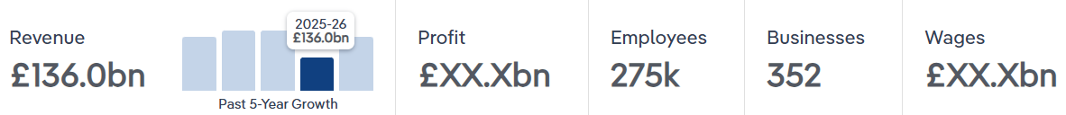
Figure 1:Banks in the UK
(Source: Maher, 2025)
The UK financial service sector is a leading economic driver, with UK banks predicted to generate 66.8 billion in profit as of 2026, marketing them as the most profitable sector. In 2025, the industry generated 136.0 billion in profits and contributed 208.2 billion to the country's economy (Maher, 2025). By grabbing the investment and management opportunity, the sector also experiences unexpected growth, which in turn provides more benefits in bulk, as shown in the diagram above.

On the other hand, Naudts (2023) argued that legal and compliance is a better opportunity associated with a DAO as it provides legal companies a chance to create legal wrappers that enable a DAO to interact with basic legal systems, such as incorporating as an organisation, to protect individuals from unlimited liability. It is a fact that DAOs are highly viewed not only as technological experiments, but as an entity that needs robust legal and compliance models or frameworks to move from niche plans to mainstream, scalable, and sustainable businesses (Furnari and Villani, 2025). However, it is noticed that the compliance and legal landscape currently present substantial opportunities and significant risks for innovation. As the United Kingdom improve its regulatory model, there is a high demand for better services to aid DAOs comply with AML(Anti-Money Laundering), financial promotion regulations and KYC (Know Your Customer).

2.3 Theoretical frameworks
As per the views of Saurabh et.al (2023), scientific management is better than other theories of organisational management. The main reason behind the selection of this theory is that it allows firms to focus on increasing output ethically through task specialization and standardized work.
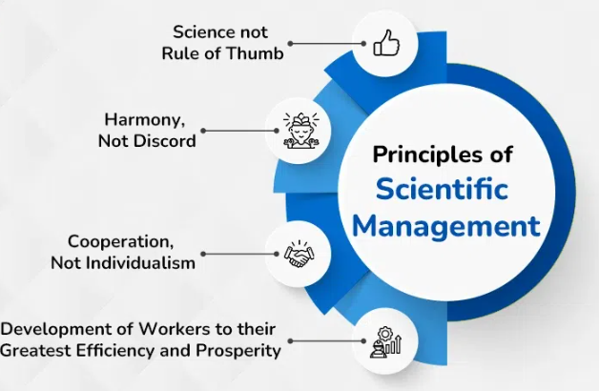
Figure 2: Principles of Scientific Management
(Source: GFG, 2025)
According to the above diagram, the theory comprises four different principles, including science does not rule of thumb, harmony not discord, cooperation not individualism and development of workers to their effectiveness and prosperity (GFG, 2025). The consideration of all these principles helps in implementing a new concept, such as DAOs, in an effective and systematic manner. The best thing about the scientific management theory is that its principles provide a framework for addressing functional or operational bottlenecks, structuring governance, and improving task coordination in DAOs. The theory also helps in the implementation or adaptation of DAOs through task optimization, workflow standardisation, algorithmic control, and improving decision-making, as well as increasing financial efficiency.
Meanwhile, Dianov and Isroilov (2022) argued administrative theory is more useful than other models or frameworks of organisational management. It is helpful in implementing DAOS as it allows individual person to concentrate on structuring companies and managing them effectively through formal, top-down, hierarchical lines of authority. The theory is effective as it also emphasizes on 14 principles of effective organisational management (Agustian et.al 2023). Administrative management theory, which concentrates on structuring companies for effectiveness through defined roles, rules, and procedures, provides a strong framework for implementing DAOs. It helps in establishing clear rules, which a person needs to follow completely for the purpose of obtaining and providing expected results. DAOs are flat; however, they also need specialized roles.
The management principle of the theory aids in managing these roles to ensure efficiency and accountability. The theory also supports the successful adoption of DAOs by moving the attention of companies ahead, creating transparency and accountability. It concentrates on orderly operations and functions. In addition, the model also plays vital role in the adoption of the same concept by providing resource management guidance or direction.

2.4 Risks and barriers in adoption of DAOs
Axelsen (2024) stated that the advent of the smart contracts and Ethereum blockchain, along with the subsequent recognition that the venture functions of an organisation can be replicated by a blend of smart contracts on a blockchain, was what brought the concept of DAOs. Security vulnerabilities fall under the list of major risks associated with the adoption of DAOs (Bhattacharya, 2024). Thus, a decentralized autonomous organisation heavily depends on smart contracts, and flaws in the code, which can be exploited to drain treasuries, as demonstrated by high-profile hacks.
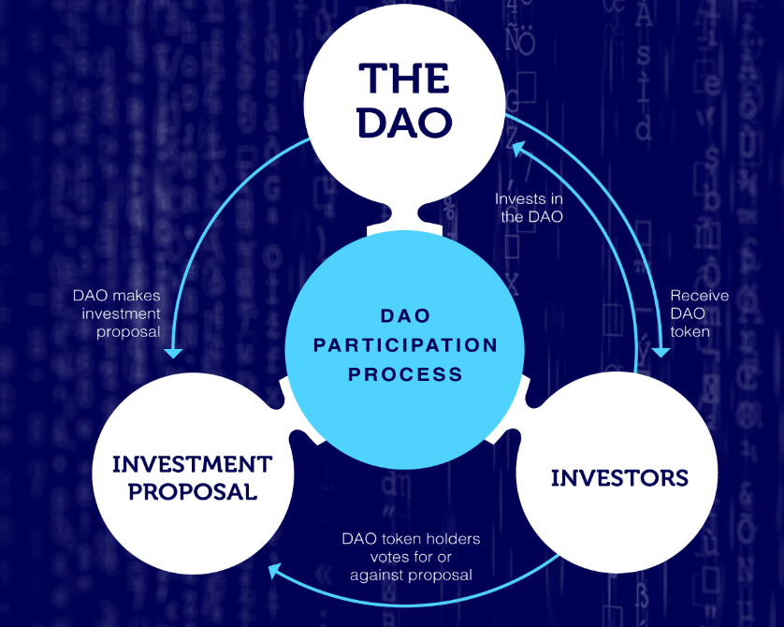
Figure 3: The origin of DAOs
(Source: FT, 2026)
As per the above illustration, DAO participation procedures consist of different phases. For example, to become a participant of a DAO, it is important for companies to make an investment proposal, and investors vote for or against the proposal (FT, 2026). It seems a structured and systematic process. However, the adaptation of this entity comes with major challenges or risks. According to Naudts (2023) governance attacks and power concentration are key risks in DAOs. Despite a decentralized ethos, voting power often rests in the hands of a few people. Governance attacks may also occur, where malicious actors take control of the entity to drain resources.
In accordance with, Shenk et.al (2023), scalability and effectiveness are common challenges related to DAOs, faced by companies and individuals when they adopt the entity. It can be said that the effectiveness of decision making become slow and inefficient as a decentralized autonomous organisation grows in complexity and size. Coordinating votes and reaching consensus among a large, decentralized membership or partnership delays important actions and decisions (Saurabh et.al 2023). The main reason behind the emergence of these barriers or risks is dependence on the underlying blockchain infrastructure. As a DAO grows in member count and transaction volume, they usually encounter problems related to high expenses, technical ineffectiveness, and slow decision-making.

2.5 Organisational and technological readiness factors for effective DAOs adoption
Furnari and Villani (2025) argued that an effective adoption of a decentralized autonomous organisation relies on key organisational factors. For example, robust governance is the main factor that had a positive impact on the adaptation of the DAO, as the overall process needs well-developed decision-making and an effective management process to avoid centralization. The factor is important for developers, investors, and public sector companies to take into account before adopting a DAO. Strong governance is distinct by on-chain accountability, transparency, and clear, executable policies and rules (Axelsen, 2024). Thus, they help in addressing high risk, fostering trust, and handling the immature nature of early DAOs.
Meanwhile, Bhattacharya (2024) argued that high community engagement is an appropriate organisational factor that helps in effective adaptation and implementation of DAOs. It is a fact that decentralization is maintained by active engagement or participation of individuals, as low engagement often leads to centralization by a few effective, high token holders. The consideration and analysis of this factor is essential for the adoption and long term growth of DASs, as it drives governance involvement, trust, and operational resilience in a system that lacks centralised management and traditional ways (Satyroet.al 2024). A high level of engagement ensures that the DAO reflects the collective willpower of its members, rather than being controlled by a limited number of people.
According to Mahmoud (2022), technological readiness for effective DAO adoption also needs a robust, user-friendly, and secure infrastructure that bridges blockchain abilities with a company's needs. Smart contract infrastructure or development is a technological factor. Smart contracts are immutable upon deployment, which means they are high-profile targets for hackers. Rigorous, third-party security investigations are non-negotiable to protect against re-entrancy attacks (Shenk et.al 2023). A better IT infrastructure helps in eliminating reasons behind the emergence of these attacks and cyber security issues, according to which it becomes easier for individuals and businesses to adopt a DAO.

2.6 Ways for safe and successful implementation of DAO
From the viewpoint of Küng and Giaglis(2024), technical security is an appropriate way for safe and successful implementation of DAO as it the main aspect of this overall implementation. Thus, technical security moves the process from a high-risk experiment of a valid, trustworthy entity. DAOs are code in law systems, where policies and rules are automatically executed and monitored by smart contracts (Boss, 2023). An appropriate security measure play vital role as it needs to be proactive, ongoing and rigorous to prevent capital assets and ensure management integrity.
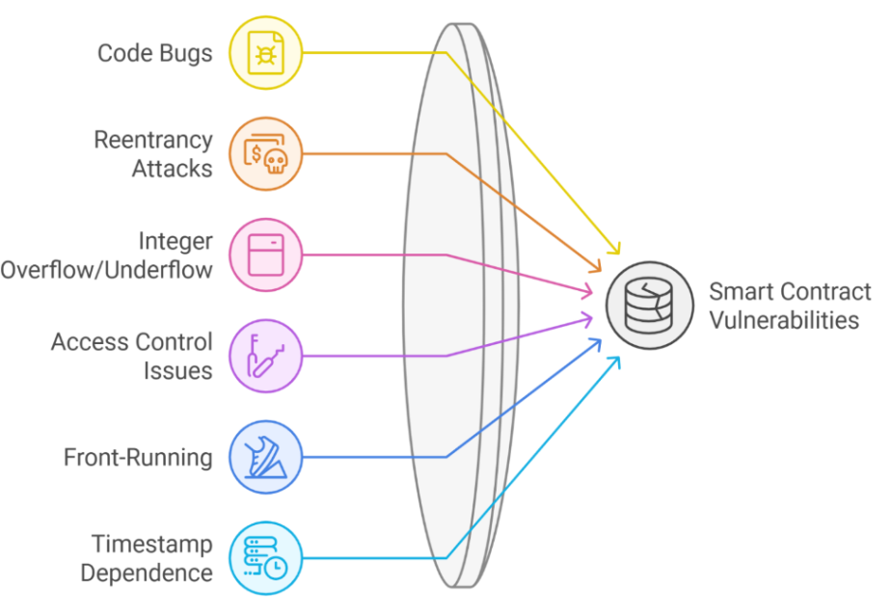
Figure 4:DAO Security
(Source: RI, 2025)
According to the above graph, code bugs, re-entrancy attacks, access control issues, integer overflow, timestamp dependence, and front-running are common smart contract weaknesses in DAP, put negative impact on successful implementation (RI, 2025). Satyro et.al (2024) argued that an effective decision-making structure is preferable, as it allows companies to implement DAOs successfully and effectively without facing the above issues or complications. A well-specified and developed structure is important as it changes a chaotic, decentralized group into an effective, secure, and trustworthy entity (Mahmoud, 2022). By codifying policies, defining accountabilities, and aligning incentives, a decision-making structure helps in mitigating risks of governance capture, stagnation, and security breaches.
On the other hand, Boss (2023) argued that risk management is essential for the successful and safe implementation of a DAO because it helps in determining, analysing, and mitigating the unique technical, financial, and legal risks inherent in blockchain, autonomous structures. By adopting this way, organisations obtain the desired outcome as it moves them beyond eliminating loopholes associated with DAO and overcoming its code as law weaknesses (Boss and Sifat, 2023). It ensures regulatory compliance, security, and sustainable growth and governance. Risk identification and effective management mandate independent audits that enable individuals to find vulnerabilities before DAOs implementation.

2.7 Research gap
Despite increasing interest in DAO as an innovative governance and operational model, there is limited observable evidence on how DAO can be effectively integrated within the UK financial sector’s existing regulatory models and institutional services. While prior studies have explained the theoretical benefits of DAO adoption, there remains a lack of systematic research into the practical challenges and opportunities specific to the UK context, including risk management, scalability, etc. This gap is usually evident in comparative analyses that examine the differential impact of a DAO implementation across varied segments of the UK financial service system, and in determining frameworks that settle decentralized governance with consumer protection mandates and statutory accountability.
It is also analysed that there are many studies conducted on the effectiveness of DAO; however, a limited description of ways for successful and safe implementation of DAO in previous research created a knowledge gap. Thus, the main purpose of the study is to fill the knowledge or literature gap effectively. Therefore, all missing points are planned to be included in the present investigation, which contribute to increasing its worth or value. By addressing a research gap, a person helps in delivering expected results or findings based on which companies make practical decisions.

2.8 Summary
Therefore, it is concluded that proper implementation of DAO in the overall sector, based on the benefits, challenges, and risks associated with this decision, helps in reaching targets and achieving goals. The UK financial service sector has obtained the opportunity to provide more employment opportunities to unemployed and skilled people after adopting a DAO, as it reshaped the ways in which companies collaborate with communities, individuals, and ventures. Moreover, from the above chapter, it is also determined that proper implementation and understanding of scientific management and administrative theory support effective management of ventures and employees in the sector.
Chapter 3: Research methods and methodology

3.1 Introduction
The third chapter is important for structuring in an appropriate manner, as it contributes to enhancing knowledge and provides a better understanding to readers in relation to applying appropriate research methodologies and methods. It helps in comprehending appropriate justifications of applied techniques. The chapter introduces a specific research philosophy, approach, strategy, method, tool, and time plan, along with research ethics.

3.2 Research philosophy
A research philosophy is understood as a significant guide, as it defines how a person considers the world and valid knowledge, as well as value they hold, as their consideration shapes decision-making, which influences the selection of the right method (Ali, 2024). Positivism, realism, and interpretivism contribute to enhancing the effectiveness of conducting research on a specific topic. Therefore, for the understanding perception that staff members have regarding chances related to DAO in the financial sector, the interpretivism research philosophy is selected over the remaining two. The main reason behind the selection of this research philosophy is to find valid knowledge related to the area of interest. It enables researchers to find right information using the past research studies facts (Maretha, 2023).

3.3 Research approach
Individuals develop an appropriate plan for conducting many studies, which includes the intersection of philosophy, strategies, and research approaches. It introduces deductive and inductive as two important research approaches (Yuwono and Rachmawati, 2023). To ensure that the study is reliable, valid, and systematic, the inductive over the deductive research approach is considered. The rationale for choosing the inductive approach is to have theoretical information and consider the facts in subjective manner related to the topic, as it enable understand and analyse the already concepts and presents relevant data. It enables the researcher to draw specific conclusions from established theories and examine them using existing literature and previously published data. This approach is suitable for theoretical research, as it relies on secondary sources rather than conducting surveys or collecting primary data.

3.4 Research strategy
A systematic, high-level plan that supports the overall process of completing research from defining a specific aim and question to collecting and analysing data is known as a research strategy (Lalonde et.al 2023). Case studies, surveys, experiments, archival and grounded theory, fall under the category of research strategies. In the context of the present study, the grounded theory is considered as an effective research strategy is selected. The main reason for selecting this methodology is to gain in-depth insights on experiences and perspectives within the UK financial services sector. Grounded theory enables the researcher to collect rich, detailed data and systematically analyze it to develop concepts and present a theory already showcased in the data. This approach focuses on depth of understanding rather than focusing on large sample sizes. It also allows having patterns and themes identification based on theoretical facts.

3.5 Data collection
Primary and secondary are two different, but useful data collection techniques (Steleżuk and Wolanin, 2023). For the purpose of conducting the qualitative study, the secondary technique is taken into account. The key reason for selecting this approach above others is to gather pertinent and trustworthy data from reputable current sources. By using previously published studies, papers, and scholarly literature, secondary studies enable the researcher to gain important insights about the risks and obstacles related to DAO adaptation. This method preserves consistency and lowers the possibility of data collecting errors while ensuring the access to a large variety of verified information. As a result, secondary data sources are used in the study instead of survey and interview.

3.6 Sampling
Sampling techniques are categorized into two main types: probability and non-probability. Simple random, cluster, and stratified are probability methods, and convenience and quota are non-probability techniques (Ali, 2024). As the research study is dependent on secondary information so no sampling strategy is chosen. There is no need to choose a particular set of respondents because the study does not require collecting primary data from participants. Rather, the study makes use of published data relevant to the research issue, industry reports, and existing scholarly works. During collection method, the researcher has focused on selecting reliable sources without any consideration of sample process.

3.7 Data analysis
Quantitative and qualitative are two common data analysis techniques that a person prefers to select based on the type of their study (Sreekumar, 2023). Thus, the qualitative data analysis technique is considered as it is suitable for conducting the theoretical research on the selected area of interest. The motive to select the qualitative over the quantitative is to present subjective and theoretical data in respect to address problem and accomplish research objectives. Consideration of qualitative analysis provides deeper understanding, theme development, and interpretation of the data. In present study, qualitative data analysis technique is considered and themes are designed. It means secondary sources interpretation is done in a thematic manner and is researcher-focused on interpreting textual information to provide meaningful insights.

3.8 Time prospect/timeline
Time prospects in a study refer to the strategic planning, realistic estimation, and scheduling of the time needed to complete each activity of a research project (Zhanget.al 2024). A proper and comprehensive time prospect or Gantt chart is produced below to ensure the present research is prepared and accomplished within the stipulated deadline.
Activities/Weeks | Week 1 | Week 2 | Week 3 | Week 4 | Week 5 | Week 6 | Week 7 | Week 8
Topic selection
Designing the aim, objectives and research questions
Literature review
Methods or methodologies selection
Data collection
Data analysis
Conclusive and recommendations
Submission

3.9 Ethical considerations
In the present research no direct human participants are considered for the data collection process and the research is based on secondary research. It means there is no such ethical consideration present in the study, but key focus of researcher is towards protection from plagiarism issues. All sources used in the research are appropriately cited and acknowledged. Along with this, data is properly presented considering the data de-identification and it facilitates to ensure regarding the effective interpretation. The study is clearly valuing secondary research principles to have accurate completion.

3.10 Summary
From the above chapter, it is summarised that proper justification behind the selection of the interpretivism, inductive, secondary data collection method to ensure on relevance and validity of key findings. As an appropriate specification or reason, specify that the decision for choosing research method is suitable and relevant for conducting this qualitative study. By combining an interpretivist philosophy with an inductive approach, this study dives into existing literature to uncover how financial staff truly perceive the potential of DAOs.

Chapter 4: Data analysis and discussions

4.1 Introduction
The introduction of Decentralised Autonomous Organisations to the UK financial services industry has a lot of promise and complicated regulatory and operational issues. DAOs are also associated with decentralised governance, automation via smart contracts, and increased transparency, but the issue of compliance, security, and institutional preparedness is also vitally important (Boss and Sifat, 2023). Through this chapter of data analysis and discussion, employee perceptions, risks, organisational readiness, adoption determinants, and theoretical implications will be evaluated to give a structured discussion on how opportunities and challenges affect the idea of DAO implementation in the UK financial environment.

4.2 Analysis
To ensure the study remains focused and consistent, the following analysis will refer to the research questions established in Chapter 1.

4.2.1 UK financial sector employees view DAO opportunities as innovative and high growth, but uncertain due to regulatory and adoption risks
Workers in the UK financial market have become more inclined to believe in the power of the Decentralised Autonomous Organisations as a new type of organisation that can change the realm of financial services. DAOs are blockchain-based, which allows decentralised governance, automated smart contracts, and open decision-making. The asset management, decentralised finance, and tokenised investment platforms are all high-growth opportunities associated with digital assets and DAOs to professionals in the banking and asset management sectors, as well as in fintech and insurance (Paoletti and Orsini, 2023). In cities with innovation, like London, where business and regulatory bodies, including the Financial Conduct Authority and the Bank of England, engage with employees, they realise that DAOs are part of the larger strategy of digital transformation. As Figure 5 (Chmiel, 2024) shows, the UK’s fintech sector is growing fast, building the foundation needed for these types of innovations to actually take off. They are related to quicker settlement systems, cross-border financial involvement, and programmable compliance systems. The roles relating to DAOs are viewed as a strategically valuable career advancement by younger professionals, especially those who have been exposed to the blockchain ecosystems.
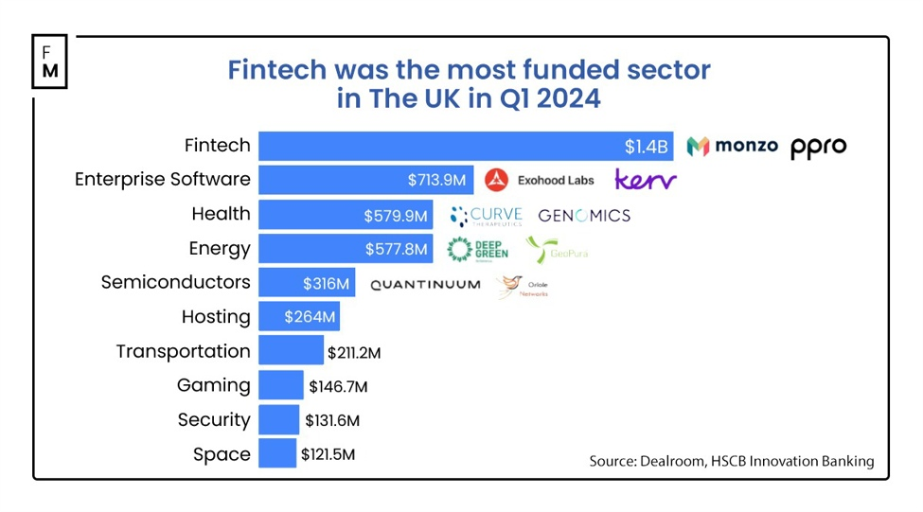
Figure 5: Growth of Fintech service in the UK
(Source: Chmiel, 2024)
There is, however, a notable uncertainty in the formation of perceptions. Uncertainty on token regulation, including the classification of tokens, liability and governance structures, is a cause of hesitation. The questions of the enforceability of smart contracts under UK corporate law and the lack of clearly established accountability mechanisms can also be of concern. Perceived risk exposure is further enhanced in market volatility in decentralised finance (Boss, 2022). Employees fear that hasty adoption in the absence of regulating side effects may put institutions at a loss of both image and money. The technological vulnerabilities that increase the adoption risk are cybersecurity threats and smart contract coding errors. Hence, UK financial workers are less prone to exaggerating the optimism of innovation and the high growth potential and being cautious due to regulatory and operational risks.

4.2.2 There are perceived risks and barriers to the adoption of DAOs, such as regulatory uncertainty, security concerns and lack of institutional trust.
There are various perceived risks and structural impediments in the adoption of Decentralised Autonomous Organisations within the UK financial sector. The greatest limitation is regulatory uncertainty. Even though the government of the UK has shown interest in establishing the country as a hub of crypto-asset innovations, detailed legislation on DAOs in particular is underdeveloped. In the absence of the categories of tokens, governance tokens, and liability structures, organisations will encounter legal uncertainty in the accountability, taxation, and protection of the investors (Curry, 2025). Security issues are also another impediment. DAOs are strongly based on smart contracts that are provided on blockchain networks. Historical coding vulnerabilities, hacks, and governance exploits have been associated with significant financial losses occurring in decentralised finance ecosystems. To the established financial institutions that work within the framework of rigid risk management, this exposure is in conflict with conservative compliance standards. There are no standardised auditing guidelines on the use of DAO smart contracts, which adds to perceived technological risk. In Figure 6 (Sheikh and Sifat, 2024) perfectly captures this dilemma: the very things that make DAOs attractive, anonymity, flexibility, and transparency, are exactly what create these massive hurdles. For instance, the overlap between anonymity and flexibility makes 'Crisis Management' nearly impossible because there is no central authority to step in when things go sideways.
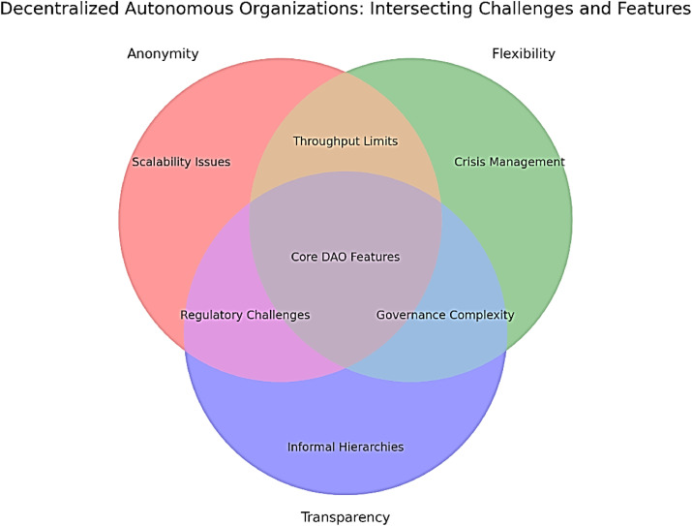
Figure 6: Challenges related to DAO
(Source: Sheikh and Sifat, 2024)
There is also the aspect of institutional trust as a hindrance. Traditional finance works with hierarchical governance structures with executives and boards of directors that can be identified. DAOs, in their turn, spread the power among token holders, which may weaken accountability. Top management might doubt the compatibility of decentralised governance and fiduciary obligations and regulatory reporting. In addition, it is possible that investor confidence is influenced by the anonymity or pseudonymity of blockchain participants. The other challenge is operational integration. The implementation of the DAO structures in the current IT infrastructure is expensive in terms of spending and technology (Naudts, 2023). Beyond the tech, the real roadblock is that DAOs operate without a central authority, making it nearly impossible for banks to fulfill their legal 'Know Your Customer' obligations or verify the source of funds to prevent money laundering.

4.2.3 Organisational and technological readiness for DAOs is moderate, but limited by regulatory and expertise gaps
The organisational and technological preparedness to adopt DAO in the UK financial sector can be described as average but limited. In technology, most developments in the UK have already been made by investing in digital transformation, cloud computing, and blockchain experimentation. Pilot programmes that imply the use of distributed ledger technology indicate that the basic infrastructure abilities are available. London, Manchester, and Edinburgh show indications of increased technical adoption of blockchain-based platforms through fintech ecosystems. Moreover, preparedness is still disproportionate among institutions. Big financial institutions and Fintech companies have a greater technological potential and cybersecurity infrastructure, and a smaller firm might not have appropriate infrastructure (Küng and Giaglis, 2024). The implementation of DAO demands the sophisticated development of smart contracts, blockchain, and real-time systems of governance monitoring. Such features require experienced programmers and regulatory profilers who have knowledge of decentralised systems and regulatory requirements. Deficiency in talent specialised in blockchain is a constraint to technological preparedness.
Organisational preparedness is also ambivalent, and though innovation departments are keen on experimentation, compliance and legal departments usually raise concerns since the regulations are unclear. The fact that UK company law does not explicitly recognise DAOs leads to confusion when it comes to structuring the corporation. Financial sector risk management systems are robust and are traditionally developed to support a centralised operation (Weidener and Boltz, 2025). To develop these frameworks to fit the decentralised governance models, structural adaptations are necessary. It is also the cultural preparation that would affect adoption, and employees should be prepared to work in the collaborative and token-based governance forms. The technological capability is in its primitive form, yet the knowledge shortage, regulatory uncertainty, and organisational restructuring needs inhibit the extensive use of the DAO in the UK financial domain.

4.2.4 DAO adoption readiness relies on compliance, infrastructure, skilled staff, and clear governance
The UK financial sector is prepared to adopt DAO based on four key determinants, including compliance with regulation, technological infrastructure, human resources, and clarity of governance, as shown in the diagram bellow. Obedience is the key to preparedness. Financial institutions need to fit the DAO structures with the current rules and regulations, such as anti-money laundering, consumer laws, and capital requirement rules (George et.al2023). To minimise the uncertainty and legal risk, there should be clear regulatory guidance from the authorities. Infrastructure is also important, which is technological. The institutions should ensure the safe integration of blockchain, sound smart contract auditing, and cybersecurity. The DAO systems should be able to integrate with the current financial databases and reporting systems.
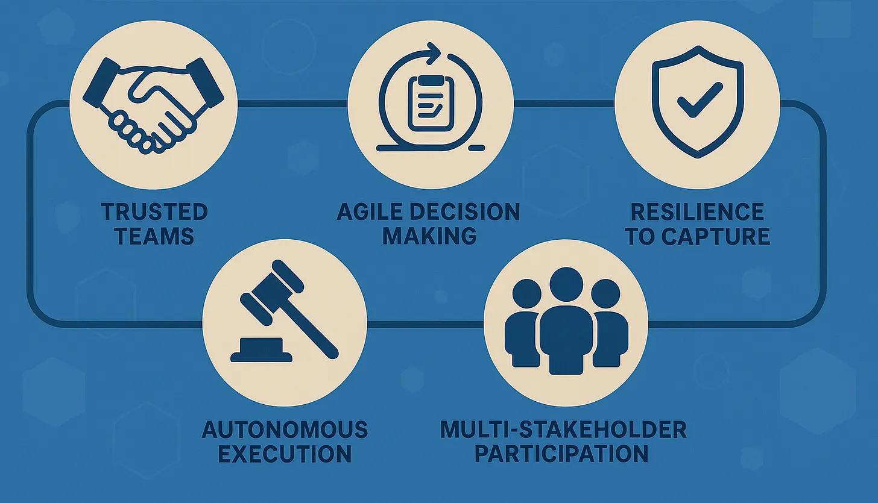
Figure 7: Considerations of DAO Governance
(Source: Cryptocurrency and Friends, 2025)
Another determining factor is skilled human capital. Implementation of DAO needs blockchain engineers and cybersecurity specialists, a trusted team, stakeholder participation, regulatory compliance and governance analysts. The knowledge deficiencies in decentralised governance mechanisms and token economics should be overcome through training programmes and recruitment strategies. In the absence of skilled staff, operational and compliance risks become extremely high. Effective governing structures are necessary for accountability. DAO systems are required to specify voting rights, dispute resolution systems and executive oversight processes. Moderated by institutional control, hybrid governance models that incorporate elements of decentralised decision-making can increase preparedness through moderate innovation and compliance (Moneva et.al 2023). Companies also need to perform risk analysis in order to determine reputational risk and financial instability. Pilot projects that are structured might result in increased preparedness through testing of the DAO systems under controlled conditions. Finally, preparedness is multidimensional, and it is necessary to align the regulation, technology, expertise, and transparency of governance.

4.2.5 Administrative theory is adopted by businesses for the effective use of DOA in UK financial sector
Administrative theory offers an organised approach to the management of organisational efficiency and governance, which will be useful in the successful usage of the DAOs in the UK financial industry (Udo et.al 2024). Classical administrative theorists like Henri Fayol(1916) stressed on concepts like division of work, authority, responsibility, unity of command and coordination. Those principles are also applicable in the process of adapting governance structures that are decentralised. Division of work can be operationalised in the case of DAO, using well-defined smart contract functions and role-based access control. Power and accountability should be evenly distributed through the use of open tokens of voting. Even though power in the case of DAOs is decentralised, accountability mechanisms should not be implied, but be expressed as required by fiduciary duty in financial institutions. Administrative theory advocates that coordination processes should be instituted in order to avoid fragmentation in governance.
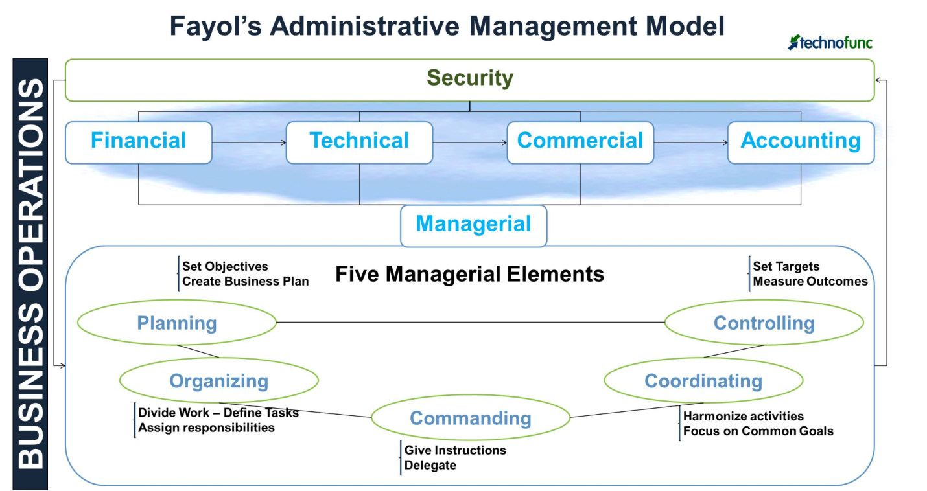
Figure 8: Administrative Theory
(Source: Technofunc, 2026)
In addition, the planning, organising, commanding, coordinating and controlling, as discussed by Fayol in the diagram above, can inform the design of governance at DAO. Planning also makes sure that the goals of DAO are in line with institutional strategies. Governance roles and technical infrastructure are defined through organising (Technofunc, 2026). The coordination will guarantee cooperation among the institutional stakeholders and the token holders. Operational integrity is ensured by controlling mechanisms, such as compliance monitoring and auditing. Through the incorporation of the principles of administrative theory into the implementation of the DAO, the UK financial institutions can minimise the structural ambiguity and improve the efficiency of the governance. Instead of overthrowing the conventional management structures, DAOs can be incorporated into administrative systems.

4.3 Discussion
The qualitative research design is followed in this dissertation, and the secondary research method is considered to assess the opportunities and challenges of implementing the concept of DAO in the UK financial services sector. Scientific management theory and administrative theory are used to facilitate the discussion of findings to give it a structured analytical prism. The interpretation of the secondary data of efficiency, automation, and performance improvement is supported by the scientific management theory of Frederick Winslow Taylor. Using industry reports, academic literature, and regulatory publications, it is possible to analyse the themes of cost reduction, process optimisation, and operational transparency of DAO structures. This theoretical approach can be used to clarify the role of smart contracts and decentralised systems in bringing tangible productivity and efficiency into workflows of financial institutions (Udo et.al 2023). Administrative theory offers a framework that could be used to analyse governance, coordination, and regulatory issues that are detected in the secondary data, as offered by Henri Fayol. The matters of accountability, distribution of authority, compliance, and organisational control mechanisms are viewed in light of the concepts of planning, organising and controlling as discussed by Fayol. These theories combined contribute to the qualitative study by connecting the evidence, which is documented with the existing management concepts, so that the discussion of the DAO implementation can be organised in a more theoretical way and structured in a more critical manner.

4.4 Conclusion
Conclusively, the implementation of DAO in the UK financial services sector has the potential for transformation but is limited by regulatory, governance, and expertise issues. Although the prospect of efficiency, automation and transparency is substantial, the willingness to adopt lies in the ability to comply with the clarity of the compliance, technological prowess and a well-organised governance system. Scientific management and administrative principles are theoretically applied to reinforce insight into operational advantages as well as structural constraints. Regulatory directions, development of institutional trust and strategic organisational adaptation to strike a balance between accountability and decentralisation will be required to implement it sustainably.

Chapter 5 Conclusion and recommendations

5.1 Conclusion
Based on analysis, it can be concluded that numerous opportunities along with challenges are linked with implementation of DAO in the UK financial service industry. Further, it has been witnessed that DAO opportunities are mainly witnessed are high and innovative by the financial sector employees. At the same time, challenges are present in the form of regulatory and legal risks which influence the overall functions of the firm in a negative manner. First objective of the study was to study about the perceptions that employees have in relation with the opportunities related to DAO in the UK financial sector. This objective has been attained where it has been identified that level of innovation and high growth is present when the organisation is decentralized autonomous and at the same time key functions are conducted in an efficient manner.
Second objective was related with threats which can arise while using DAO in UK. Lack of institutional trust, regulatory uncertainty and security related issues are present. These challenges directly influence the functioning of DAO in the market.
Third objective was to determine the degree of organisational and technological readiness to introduce the DAOs. It has been identified that organisational and technological readiness is moderate and at the same time it is limited to expertise and regulatory gaps.

5.2 Recommendations
Based on analysis certain suggestions are present which can be easily considered for the effective implementation of DAO.
First key suggestion is to focus on the development of the robust governance model. It is vital to strongly focus on the implementation of governance structure where there is strong balance in between decentralization and efficiency.
Second main suggestion is to focus on the smart contracts audits. This area is most vital as through audit of the smart contracts it is possible to avoid any sort of losses or hacks and in the long run performance of the firm can surely improve.
Lastly it is suggested to focus on implementation of the conflict resolution. Through this particular suggestion it will be possible to address all the disputes such as on chain arbitration tools.

5.3 Contribution of the research
The research conducted is highly significant for the organizations who wishes to implement DAO into their processes and systems. At the same time, another contribution of the research is that it will provide strong knowledge to the professionals and experts, and it will be possible for them to take best possible advantage of the concept of DAO.

5.4 Suggestions for further research
In the near future some areas are present where further research can be carried out. Firstly, in near future primary research can be conducted for understanding the feasibility of implementing DAO into the operations of the business. Second area of further research is related with focusing on implementation of the plan for dealing with the issues related with DAO.

5.5 Limitations
One of the key limitations associated with the current study is related with that only secondary data collection method has been employed in the study. Moreover, no such primary method is part of the study. Another limitation is that only opportunities and threats linked with implementation of DAO is part of the study.

5.6 Summary of the chapter
From the entire chapter it is clear that DAO has certain pros and cons which needs to be considered before its implementation. At the same time, its implementation is a key challenge where it is vital to focus on adoption of the effective implementation framework so that businesses can take best possible advantage of this concept.

References
Agustian, K., Pohan, A., Zen, A., Wiwin, W. and Malik, A.J., (2023).Human resource management strategies in achieving competitive advantage in business administration. Journal of Contemporary Administration and Management (ADMAN), 1(2), pp.108-117.
Ali, I.M., (2024). A guide for positivist research paradigm: From philosophy to methodology. Idealogy Journal, 9(2).
Augustin, N., Eckhardt, A. and de Jong, A.W., (2023). Understanding decentralized autonomous organizations from the inside. Electronic Markets, 33(1), p.38.
Axelsen, H., (2024). DAOs and Blockchain for Regulated Finance (Doctoral dissertation, Doctoral dissertation, School of the Faculty of Science, University of Copenhagen).
Bhattacharya, M., (2024).DAOs for Impact.
Boss, S. and Sifat, I.,(2023). DAO Disruption Across Industries. Available at SSRN 4445422.
Boss, S., (2022). DAOs and the future of governance.
Boss, S., (2023). DAOs: Legal and empirical review. Blockchain & Society Policy Research Lab Research Nodes, 2.
Chmiel D, (2024). British Fintech Startups Raise $1.4B, Reclaim Throne as Top VC Destination. [Online].Available Through:<https://www.financemagnates.com/fintech/british-fintech-startups-raise-14b-reclaim-throne-as-top-vc-destination/>. [Accessed on 24th February 2026].
Cryptocurrency and Friends, (2025). Learning From Failures to Build Better DAOs.[Online]. Available Through:<https://www.cryptofrens.info/p/learning-from-failures-to-build-better>. [Accessed on 24th February 2026].
Curry, D., (2025). Limitations of trust and legitimacy in blockchain: exploring the effectiveness of decentralisation, immutability and consensus mechanisms in blockchain governance. International Journal of Public Sector Management, 38(1), pp.98-117.
Dianov, S. and Isroilov, B., (2022).Formation of effective organisational management systems. Sustainable Development and Engineering Economics, (1), pp.28-45.
FT, (2026).The origin of DAOs.[Online]. Available Through: https://www.futurelearn.com/info/courses/introduction-to-daos-decentralised-autonomous-organisations/0/steps/361878#:~:text=Ethereum%2C%20'The%20DAO'%2C,investment%20decisions%20of%20the%20DAO.. [Accessed on: 7thFebruary 2026]
Furnari, S.L. and Villani, C., (2025, June). Regulation of financial protocol DAOs: Addressing the problems of decentralization and AI governance. In European DAO Workshop (pp. 115-134). Cham: Springer Nature Switzerland.
George, A.S., Sagayarajan, S., AlMatroudi, Y. and George, A.H., (2023). If/then democracy: Exploring the world of decentralized autonomous organizations (daos). Partners Universal International Research Journal, 2(2), pp.241-274.
GFG.(2025). Principles of Scientific Management.[Online]. Available Through: <https://www.geeksforgeeks.org/business-studies/principles-of-scientific-management/>. [Accessed on: 7thFebruary 2026]
Küng, L. and Giaglis, G.M., (2024). DAOs' Business Value from an Open Systems Perspective: A Best-Fit Framework Synthesis. arXiv preprint arXiv:2406.12445.
Lalonde, M., Oudin, L. and Bastin, S., (2023). Urban effects on precipitation: Do the diversity of research strategies and urban characteristics preclude general conclusions?. Urban Climate, 51, p.101605.
Maher, J., (2025). Banks in the UK. [Online]. Available Through: https://www.ibisworld.com/united-kingdom/industry/banks/3670/. [Accessed on: 6th February 2026]
Mahmoud, A.I.A., (2022). Exploring the potential of DAOs: a comprehensive study of decentralized autonomous organizations.
Maretha, C., (2023). Positivism in philosophical studies. Journal of Innovation in Teaching and Instructional Media, 3(3), pp.124-138.
Moneva, J.M., Scarpellini, S., Aranda‐Usón, A. and Alvarez Etxeberria, I., (2023). Sustainability reporting in view of the European sustainable finance taxonomy: Is the financial sector ready to disclose circular economy?. Corporate Social Responsibility and Environmental Management, 30(3), pp.1336-1347.
Naudts, E., (2023). The future of DAOs in finance: In need of legal status (No. 331). ECB Occasional Paper.
Paoletti, G. and Orsini, M., (2023). Governance mechanisms in the blockchain era: an in-depth comparative study of DAOs and FinTech companies.
RI., (2025). DAO Security.[Online]. Available Through: <https://www.rapidinnovation.io/post/dao-security-protecting-smart-contracts-from-vulnerabilities>. [Accessed on: 5thFebruary 2026]
Satyro, W.C., Contador, J.C., Gomes, J.A., Monken, S.F.D.P., Barbosa, A.P., Bizarrias, F.S., Contador, J.L., Silva, L.S. and Prado, R.G., (2024). Technology-organization-external-sustainability (TOES) framework for technology adoption: critical analysis of models for industry 4.0 implementation projects. Sustainability, 16(24), p.11064.
Saurabh, K., Rani, N. and Upadhyay, P., (2023). Towards blockchain led decentralized autonomous organization (DAO) business model innovations. Benchmarking: An International Journal, 30(2), pp.475-502.
Sheikh, S. and Sifat, I., (2024). Built to last, not to scale: The long run of decentralised autonomous organisations. Journal of Innovation & Knowledge, 9(3), p.100513.
Shenk, M., Van Kerckhoven, S. and Weinberger, J., (2023). The Crown, the Market and the DAO. Stan. J. Blockchain L. &Pol'y, 6, p.244.
Sreekumar, D., (2023). What is research methodology? Definition, types, and examples. Paperpal Blog-Academic Writing Guides.
Steleżuk, A. and Wolanin, M., (2023).Primary research using quantitative methods in social sciences. ZeszytyNaukoweWyższejSzkołyTechnicznej w Katowicach, 16.
Technofunc, (2026). Administrative Theory by Fayol. [online]. Available Through:<https://www.technofunc.com/index.php/leadership-skills-2/leadership-a-management/item/fayol-s-administrative-theory>. [Accessed on 24th February 2026].
Udo, W.S., Ochuba, N.A., Akinrinola, O. and Ololade, Y.J., (2024). Theoretical approaches to data analytics and decision-making in finance: Insights from Africa and the United States. GSC Advanced Research and Reviews, 18(3), pp.343-349.
Van Vulpen, P. and Jansen, S., (2023). Decentralized autonomous organization design for the commons and the common good. Frontiers in Blockchain, 6, p.1287249.
Weidener, L. and Boltz, L., (2025). Challenges of DAOs in decentralized science: a qualitative analysis of expert interviews. Frontiers in Blockchain, 8, p.1641294.
Yuwono, M.A. and Rachmawati, D., (2023). Combined methods. Can this solve the differences between deductive and inductive methods in qualitative research?. Moroccan Journal of Quantitative and Qualitative Research, 5(3).
Zhang, K., Wen, Q., Zhang, C., Cai, R., Jin, M., Liu, Y., Zhang, J.Y., Liang, Y., Pang, G., Song, D. and Pan, S., (2024). Self-supervised learning for time series analysis: Taxonomy, progress, and prospects. IEEE transactions on pattern analysis and machine intelligence, 46(10), pp.6775-6794.

