Qualification: CIPD Diploma in Applied Human Resources
Module Name: Understanding Employee Engagement in the Organisation
Word Count: 3482
Student Name: Catherine Evans Student Number: 1919841
CIPD Membership Number: 49835269

By signing below, I confirm that the work/evidence presented is my own, unaided work. I understand the regulations pertaining to candidate malpractice and the action that may be taken as a result.

Signed: C. A. Evans Date: 1st February 2022

  - Define employee engagement.
Employee engagement can be defined in many different ways with Kahn (1990) focusing on how people ‘employ and express themselves physically (through high levels of energy and commitment), cognitively (fully engrossed in work and unable to detach) and emotionally (pride and enthusiasm’ whilst engaging in their work, whereas the CIPD (2017) define it as a combination of commitment to the organisation and its values, plus a willingness to help out colleagues. It cannot however be assumed that all employees will automatically be engaged and it cannot be ‘required’ as part of an employment contract. Employees are more likely to go the ‘extra mile’ if employee engagement is high and this was proved at the Software company Intuit where highly engaged employees were 1.3 times more likely to be high performers. (SHRM, 2006)
Macloed (2009) says that employee engagement can be the key to ‘unlocking productivity and transforming working lives’ and his Engage for Success report describes employee engagement as maximising individual and organisational performance by building on the energy, commitment and desire to do a good job that most employees have on their first day at work.
Research carried out by the CIPD and Kingstown University in 2015 identified two types of employee engagement:
Transactional – carries out the job but not committed to the organisation and will leave if a better offer arises. More concerned about pay, bonuses and holidays than organisational success.
Emotional – employees are engaged with the organisation, passionate about their job, perform well, loyal through good and bad times. High trust levels between employee and employer.
Purcell (2010) advises that employers need to understand that there are different drivers of engagement and it is not a ‘one size fits all’ concept but can include:
- Leadership – employee engagement needs to start at the very top of the organisation by collaborating, interacting and sharing ideas both ways – this keeps the employees involved and engaged.
- Career development – this is increasingly important with Millennials seeking learning and career development or they are likely to exit organisations at an early stage. (LinkedIn, 2019)
- Communication – Real-time connecting with the employees to solve problems is important for an employee engaged workforce.
- Diversity – A diverse work culture is essential for an engaged workforce ensuring equal opportunities for all.

1.2 Compare and contrast employee engagement with other related concepts.
A concept that is closely related to employee engagement is organisational commitment. The CIPD (2021) tells us that employees who have organisational commitment will perform effectively, have increased innovation and also be happier, healthier and fulfilled in their job.
Meyer and Allen (1991) characterised an employee’s commitment to their organisation as three mindsets:
- Affective commitment – emotionally attached employee that enjoys being part of the organisation.
- Continuance commitment – employees remain attached to the organisation due to the perceived costs of departure.
- Normative commitment – employees feel morally obliged to stay due to the employer investing resources in them.
Engagement and commitment can lead to increased business results within the organisation. Armstrong (2009) tells us that engagement is job/role related whereas commitment is organisation related. Research carried out shows that engagement and commitment within different sectors vary with employees in the voluntary sector being the most engaged. (CIPD Working Lives Index, 2019)
Job satisfaction is defined as contentment in one’s role which leads to contentment in life, security and confidence and is also closely related to employee engagement. Employees can be engaged but still need to be satisfied to remain within the organisation. Whereas employee engagement is the level of involvement the employee feels within their role, job satisfaction relates to the below factors. (Toolbox HR, 2021)
- Compensation – competitive pay allowing for better quality of life
- Benefits – package allowing well-being (both physical and mental) and childcare.
- Work-life balance – home working, shorter commutes and paid leave to allow for employees to spend more family time which can also contribute towards employee engagement.
- Recognition – employees like to feel appreciated both formally and informally. This can also contribute to employee engagement.
CIPD research also shows us that whilst working in the public sector is generally linked with high-quality jobs there is lower satisfaction due to lower pay, poor quality of working relationships and higher conflict at work. (CIPD Working Lives Index, 2019)

2.1 Describe the typical HR, leadership and cultural elements likely to be found in an organisation characterised by high levels of employee engagement.

Harvard Business Review (2018) tells us that many organisations focus on controlling employees’ behaviour which can have a negative effect on innovation, commitment and performance. Organisations such as Netflix whose core philosophy is people over process values integrity, excellence, respect, inclusion and collaboration and has a culture of freedom and responsibility. (McCord, 2018) Cultures such as this can lead to improved employee engagement.

High levels of employee engagement are also found in organisations where employees are involved in the decision making. In an Engage for Success case study, Innocent Smoothies are an organisation where employees are encouraged to suggest new ways of working or new products to improve the business. Their motto is ‘just go with it’ – employees are confident to suggest ideas, whether large or small as better to fail than not to try.

Organisations with high employee engagement have low turnover. An example of this is ITSU who were suffering from high turnover and an inability to fill vacancies. The company not only introduced a masterclass to upskill their employees to become fish cutters, receiving a pay increase for their newly acquired skills but also introduced a Fish Pro competition with impressive prizes to make them feel valued and engaged. ITSU now received over 600 applications every week from people eager to join the organisation.

Many organisations use benefit platforms to enhance employee engagement. Within Dyfed Powys Police we have the Vectis card and also the Blue Light discount card. Perkbox is another platform used by over 5000 organisations to show that they care, connect and celebrate with their employees. Deloitte’s Talent Survey also showed recognition as a factor in organisations with high levels of engagement – with Dyfed Powys Police we hold an annual recognition award ceremony for employees – voted for by colleagues, partners and members of the public.

2.2 Evaluate the need for alignment between employee engagement and other organisational factors.
Alignment is important within organisations as employers need to link the employee roles and the organisation’s objectives to ensure success and engage employees. The engagement strategy needs to be linked to the strategic strategy and alignment of employees’ duties and goals will lead to higher levels of engagement.
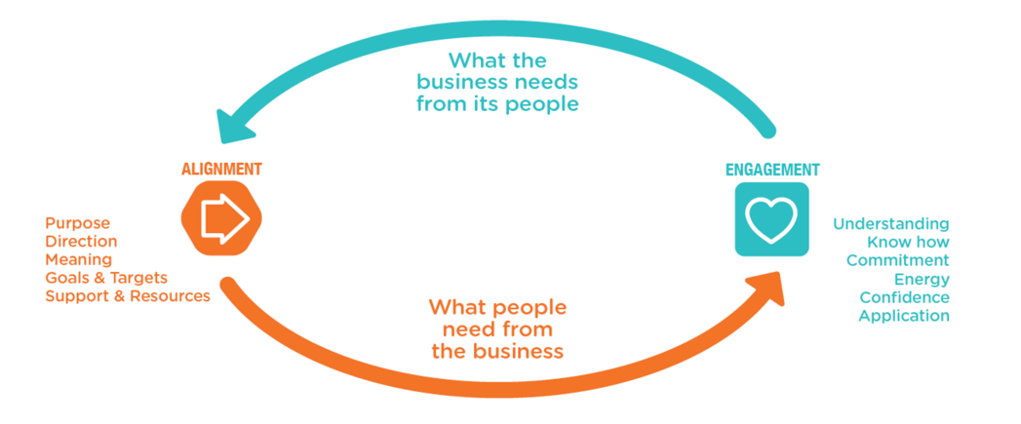

(Purpleworks, nd)
As can be seen in the above diagram all areas of organisations need to be aligned to ensure successful employee engagement. Engage for Success (2015) tells us about the Allied Irish Bank who in the 2007 financial crash closed 70 branches reducing their workforce from 24,000 to 11,000. They identified that they needed their employees to pull in the same direction to re-build an organisation that both customers and employees had faith in. Their vision included aligning employees to their strategy so they knew what part they were to play and to increase employee engagement by motivating employees to be proud of the bank. This was achieved by upskilling leaders and conducting surveys (transactional engagement) and also transformational engagement by listening and involving employees by providing 1:1 coaching and online brand jam to allow employee input. These changes created hope for the future and a feeling of improving employees’ quality of life.
By building a high level of trust, employees feel empowered – employees that are both introverted and extroverted will bring forward their ideas to improve organisations. This high trust, low process culture within organisations is vital for success. (Hubbard, 2016)

3.1 Explain why employee engagement is an increasingly vital dimension of HR strategy and practice.

MacLeod (2009) tell us that employees who are engaged and motivated are the most competitive weapon that organisations can hold and identified four enablers as below:

Enabler | Definition
Strategic Narrative | The narrative of where the organisation is heading and why providing the employees with purpose and meaning increases engagement.
Engaging Managers | Managers that organise work efficiently and effectively make employees feel supported and valued, providing autonomy and empowerment.
Employee Voice | Employees that are listened to will see that their opinions matter and can make a difference in outcomes.
Integrity | Organisations that live out their values and have a positive ethos result in trust and integrity allowing employees to go the extra mile instilling the same values.
Source: MacLeod and Clarke 2009

Increased employee engagement also has an impact on levels of absenteeism, turnover, wellbeing, innovation and organisational outcomes. In a survey carried out by Hay over 94% of the world’s leading companies believed that employee engagement had allowed them to achieve a competitive advantage. (Calder, 2019)

Changes in the business environment due to globalisation and other external factors such as Brexit, also need to be considered and Managers need to have the relevant skills to effectively implement employee engagement policies and processes.

Johnson (2004) tell us that employee engagement shows results and can be linked to organisational outcomes such as:

- Loyalty – engaged employees can lead to customer engagement where there is a connection both mentally and emotionally between the customer and the organisation. (Bates, 2004)
- Retention – employees who are satisfied with their work are 85% likely to remain with the same organisation (Levinson, 2007) and stay even if the organisation was struggling compared to only 27% of disengaged employees remaining (BlessingWhite, 2008)
- Productivity – in a study of 50,000 employees by Corporate Leadership Council (2004) the engaged employees performed over 20% better.
- Organisational Performance – increased employee engagement and culture can increase organisational performance leading to success, however, Balain and Sparrow (2009) suggest that successful organisational performance is the reason for increased employee engagement.
- Profit – increased productivity, loyalty, sales and retention levels can lead to increased profit. Employees that feel involved contribute more financially. (Levinson, 2007)
- Organisational change – engaged employees accept change as organisations are more agile adapting to changes.

3.2 Evaluate the potential benefits, for different parties, of high employee engagement.
Macleod (2009) tells us that engagement can be a win for employees, the organisation and the country. High levels of engagement lead to higher performance within organisations, ( CIPD, 2021) for the below parties:
Employees – with good quality jobs and services will be happier and healthier which will lead to increased productivity, innovation, high morale and job satisfaction. (CIPD, 2021) The employees will promote the employer brand by becoming advocates, whereas disengaged employees harm the brand. Macleod (2009) tells us that there is an increasing understanding of the importance of employee engagement within the public sector and this is evident in Dyfed Powys Police with the introduction of a staff survey on employee engagement.
Managers – as research shows that employees leave managers rather than organisations it is important to ensure that the managers participate and manage employee engagement. SHRM (nd) tell us that only 26% of managers think that employee engagement is how they think, plan and do their work, however, engaged employees will go the extra mile to help the manager achieve the organisational goals and objectives. Engaged employees are easier to manage and therefore it is beneficial for the manager.
Customers – engaged employees deliver a higher quality customer service. (HR News, 2018) Customers are more likely to remain loyal to organisations when they receive a good service. The CEO of Amazon keeps an empty chair in all meetings at the head of the boardroom table to remind everyone that the customer is the most important stakeholder in any discussions. (Forbes, 2012). Amazon understands and aligns with customer goals by tracking performance across measurable goals with 80% being related to their customer objectives.
Satisfied customers and employees inevitably lead to increased profit. Hutchinson and Purcell (2003) compared four Tesco stores and found when managers moved from top-down management and allowed employees autonomy the sales increased.
Country – Gallup research has discovered that an engaged workforce allows organisations to recover, rebound and regrow during times of economic crisis. The recent pandemic was evident in this where some organisations’ excelled and others created lasting damage to their brand.
Heroes | Villains
Timpson – Over 5,500 employees retained on full pay whilst shops closed. | JD Weatherspoon – encouraged staff to find new jobs and refused to pay for supplied beer.
Morrisons – Provided £10m of food to the food banks after employees worked an extra hour daily | FTSE 100 – 18 companies used furlough for wages despite paying executives £3.6m during the pandemic
Admiral – gave all customers £25 cash-back due to reduced driving and claims also LV Insurance provided free business cover to allow members to volunteer for covid. | Cunard – continued to sell cruises to countries that had closed its borders.

  - Identify key sources of employee engagement related data.

The CIPD (2021) tells us that it is important to measure employee engagement and Robinson (2007) believes it can show employers the extent of employees’ pride, trust, willingness to go the extra mile and their belief in the organisation enabling them to perform efficiently and effectively. There are different ways that organisations can measure engagement including using internal staff surveys, pulse surveys and also external surveys developed by large consultancies and survey companies which allow organisations to benchmark against others. Within Dyfed Powys Police we use an external staff survey developed by Durham University to measure employee engagement.
As organisations increasingly move to connecting online, society generates increasing data traces. (Unesco, nd). There are different types of data analytics including:

Macro-Level – commonly used by public sector organisations - data from a third party ie. CIPD, ONS, national surveys – real-time data from meso/micro levels benefitting from benchmarking and data integration.
Micro-Level – data obtained from sample surveys – people specific within organisations including satisfaction surveys, exit questionnaires, absenteeism reports and stay interviews.
Meso Level – commonly used in public/private sector - research data on the study of groups or teams – self-reported

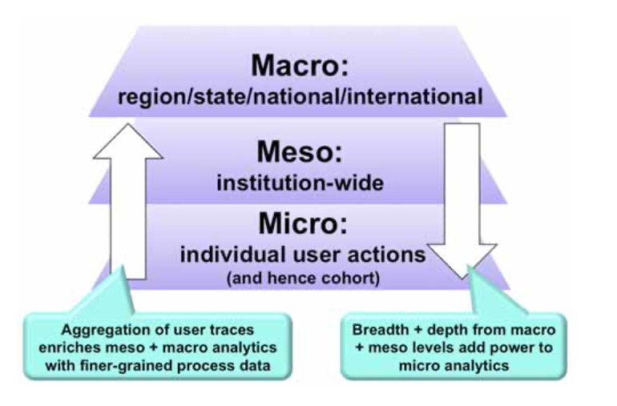
Unesco

The CIPD Good Work Index and UK working lives survey is used by many organisations as it benchmarks over the previous year the good work carried out in the UK and how things have changed and also gives employer’s direction on how to improve job quality. The 2021 report was dominated by the pandemic and its resulting impact, however, it encourages embracing improving jobs, fairness at work and positive outcomes for employees post-pandemic.

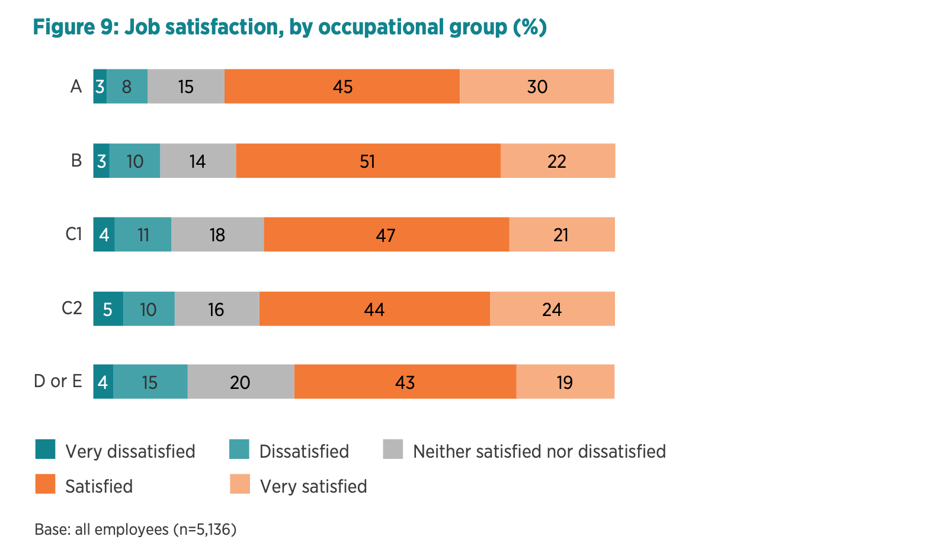
CIPD data example (UK Working Lives, 2019)

Gallup is one of the leading global providers of employee engagement tools and has been carrying out surveys for over 20 years pioneering the concept. (HR Magazine, 2019) The Gallup Workplace Audit Q12 survey includes 12 questions used to measure employee engagement and at a macro level, they say that over 87% of the UK workforce is unengaged.

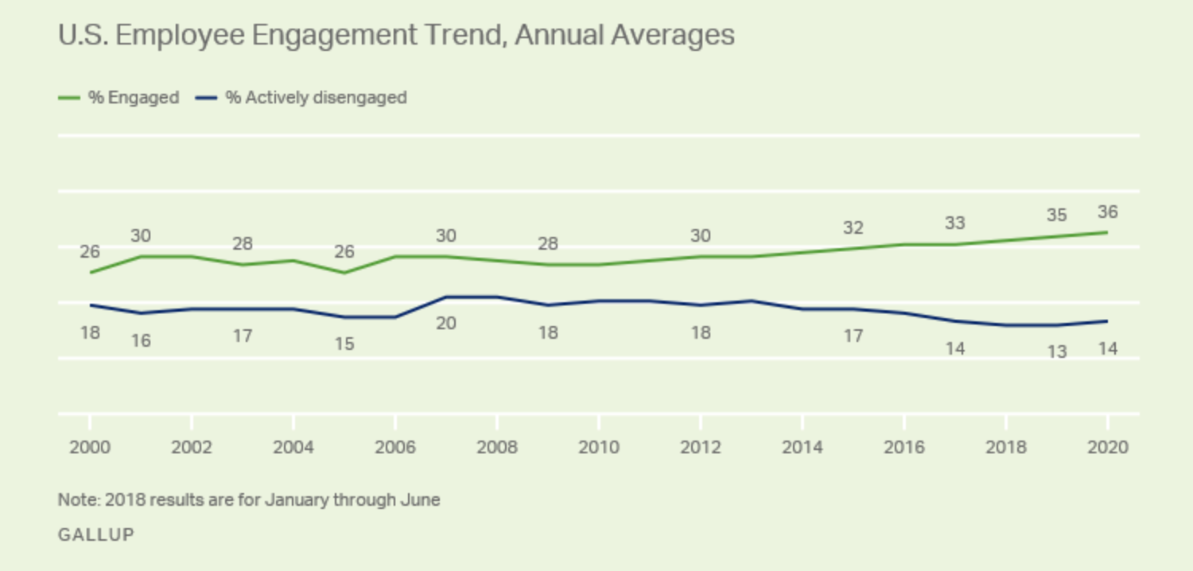
Gallup data example (Gallup, 2021)

The Office of National Statistics is the UK’s largest producer of data. (ONS, nd) ONS carry out an Annual Population survey using pay, hours and contracts as the key indicators of job quality and use small units of the large survey to look at differing demographic characteristics.

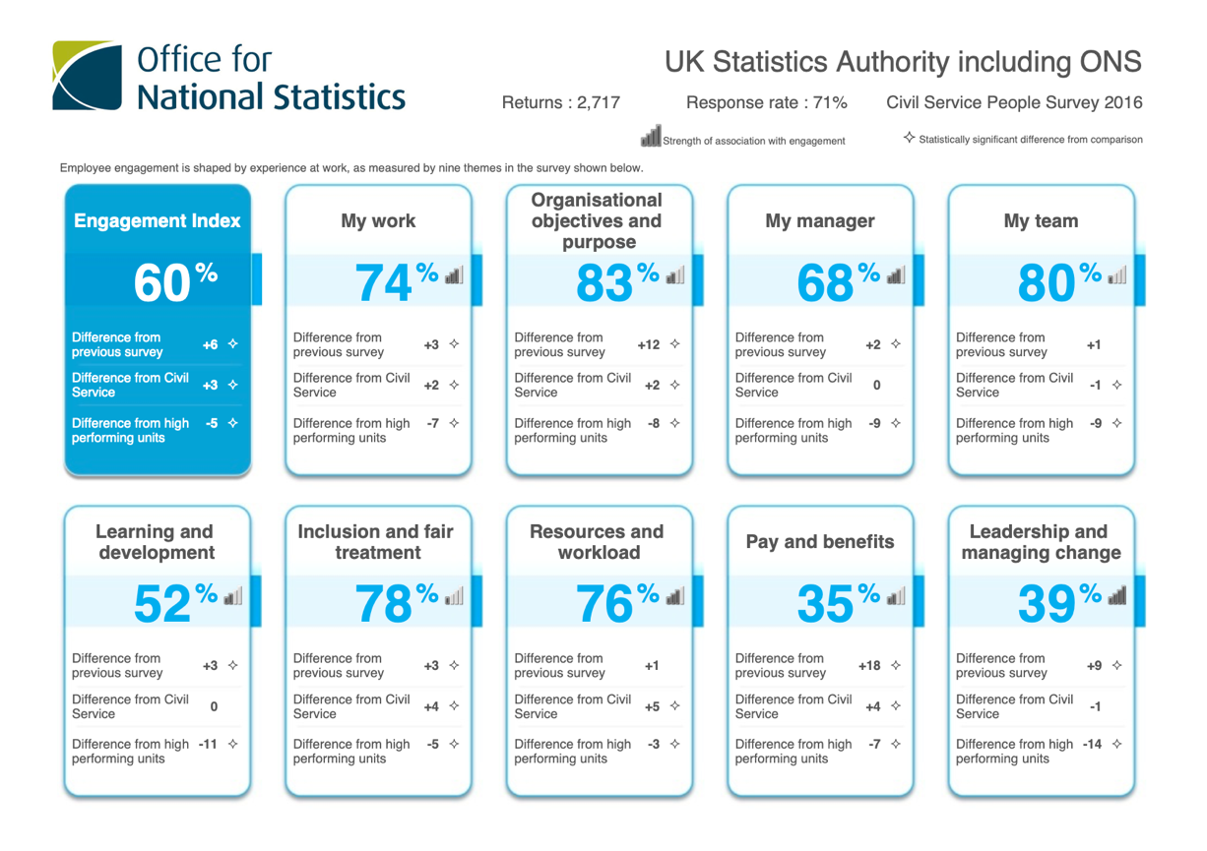
ONS data example

Employee feedback is an important measure and engagement surveys can be used as a measure to show how well organisations are doing. (Balain and Sparrow, 2009) However, employees must be aware that their feedback will be actioned so they appreciate the value of the survey. Turnover data, exit and stay questionnaires, sickness rates and operating outcome data can also be used to measure employee engagement within organisations. When Qatar holdings took over Harrods in 2010 they introduced an employee survey focussing on employee engagement – they have now completed four annual surveys with turnover halving and over 91% of employees in the latest survey stating that they are proud to work for Harrods. (Engage for Success, nd)

  - Describe key trends in employee engagement and differences linked to gender, demographic and other factors.

Work environments are ever-changing but never more so than during the recent pandemic. Quantum (2021) tells us that organisations have had to adapt and focus on what matters most to employees to engage and retain them.

The CIPD Good Work Index survey completed in 2021 built upon the previous survey in 2019 but also included data from a survey that the CIPD completed mid lockdown. This survey showed that employee engagement had increased with over two-thirds of employees satisfied overall. Work pressure has increased over the decades and the Skills and Employment survey carried out in 2017 states that this may be due to technological changes, recession in economies and customer demand and CIPD Megatrends (2014) stating that workplace intensity is likely to keep increasing, although the impact on working lives will be regulated by the employer, employee and the policies put in place.
Macleod (2009) stated that employee engagement can be a triple win and individuals, organisations and the country have recognised this with employee engagement increasing rapidly.
LinkedIn details an Employee Wellbeing report carried out by Glint in 2021 that shows employee satisfaction increasing by 4% between January and March 2021, this is higher than before the covid pandemic and is likely due to organisations ensuring that employees are supported and have the relevant resources to do their job. Remote working has increased employee engagement and organisations are building on virtual systems to ensure diversity and inclusion. The CIPD analysis of the Labour Force Survey found that other variations of working flexibly have however dropped over the last twelve months which is likely due to the flexibility of home working.
Deloitte’s Global Human Capital Trends report highlights the importance of diversity within the workplace increasing levels of employee engagement and this has increased by 74% in the last three years.
Research carried out by Gallup has identified the following differences in employee engagement:
- Employees with a further education qualification are less engaged than employees without.
- Generation X and Millennials have increased engagement only if they connect to what the organisation stands for and has aligned values, and are given the resources to allow them to do what they do best. But they are also more likely to move jobs many times during their career.
- Employee engagement is at its highest during the first six months of employment

The CIPD Good Work Index survey in 2021 showed that within the UK employee engagement and job satisfaction has increased from 2011 when it was 50% to almost 70% in 2021. The survey showed no difference between men and women but a higher engagement amongst senior managers and higher-paid employees. Workers within the voluntary sector also had higher engagement levels and discretionary effort. This was low in manual and casual workers. Less than 25% of precarious workers were identified to be engaged within their roles.
Bean (2016) identified that younger employees have higher engagement levels with 25-34 having the highest and 45-54 having the lowest engagement. However, some organisations have shown increased employee engagement with an older workforce including B&Q. 28% of their workforce is over the age of 50. (Engage for Success, nd)
Organisations with 500-1000 employees had the highest engagement and organisations with over 10,000 had the lowest.
Harvard Business Review (2021) tells us that 20% of disabled employees still feel unengaged in the workplace, although this has decreased since 2014 when the government introduced the Disability Confident Employer scheme which Dyfed Powys Police is part of. This scheme was introduced to encourage employers to understand, recruit, develop and retain disabled employees.
In a report by the CIPD (2017) approximately 60% of employees both BAME and white British felt that their organisations had an inclusive culture and good employee engagement. Within Dyfed Powys Police we have an equality and diversity team along with a positive action team to ensure that our diverse workforce and applicants are supported.

4.3 Evaluate the future for employee engagement, based on current trends.

Newman (2021) tells us that in a survey pre-pandemic carried out by Gallup 64% of employees were unengaged and 15% disengaged. The pandemic has caused major disruption and uncertainties to the workplace which has had an effect on employee engagement and moving forward organisations need to make employee engagement a priority.
I believe that organisations that transitioned to remote working will remain as it has been shown that it can work. However, a recent survey by McKinsey (2020) showed that 63.2% of male remote working parents were engaged, compared to 38.5% of females, and therefore long-term this could have a detrimental effect.
Burnout is another aspect of remote working that can have an impact on engagement. In a survey by Blind (2020) 73% of employees felt burned out, compared to only 60% pre-pandemic. The work-life balance of employees can be affected by home working and the inability to disconnect is concerning. In 2014 Google introduced an experiment ‘Dublin goes Dark’ where employees had to check in their devices to prevent working late. This may be something that organisations may have to investigate for remote workers – perhaps where laptops have to disconnect by a set time every evening.
Employee engagement has been shown to increase as the work-life balance improves.
75% of employees have felt isolated socially over the pandemic period due to remote working and social distancing, and according to Yohn (2020), organisations will need to focus on re-connecting employees by showing empathy, understanding and showing increased personality in their communications and interactions.
Employee recognition is another area that has become more important. Remote working has removed the personal connection and interactions where praise may have been awarded. It is important that employees feel recognised and organisations are expected to start using employee recognition platforms to reward and give incentives to employees. Within Dyfed Powys Police we have a Vectis card, Blue Light and also carried out an online award ceremony to recognise employee contribution. We have also received a certificate for our efforts throughout the pandemic.

Bibliography
Armstrong, A. (2000). Armstrong’s Handbook of HRM Practice (11th Ed.) London: Kogan Page.
Balain S, Sparrow P (2009), Engaged to Perform: A new perspective on employee engagement: Executive Summary, Lancaster University Management School
Bates S (2004), ʹGetting engagedʹ, HR Magazine, 49(2), 44–51
Bean, S., (2016). Younger workers more engaged at work than middle-aged staff - Workplace Insight. [online] Workplace Insight. Available at: <https://workplaceinsight.net/younger-workers-engaged-work-middle-aged-staff/> - Accessed 14 January 2022
BlessingWhite (2011) Employee Engagement Report. Available at: http://www.digitalopinion.co.uk/files/documents/Employee_Engagement_Report_Blessing_White_%202011.pdf – Accessed 15 January 2022
Business.linkedin.com. (2021). Employee Wellbeing Report. Available at: <https://business.linkedin.com/content/dam/me/business/en-us/glint/pdf/glint-may-2021-employee-well-being-report.pdf> - Accessed 14 January 2022

Calder (2019). Rules of engagement. Counsel Magazine. Available at: <https://www.counselmagazine.co.uk/career-hub/articles/rules-of-engagement2> -Accessed 8 January 2022

CIPD (2017). Addressing the Barriers to BAME. Available at: <https://www.cipd.co.uk/Images/addressing-the-barriers-to-BAME-employee-career-progression-to-the-top_tcm18-33336.pdf> - Accessed 14 January 2022

CIPD (2010) Creating an engaged workforce. Available at: <https://engageforsuccess.org/wp-content/uploads/2015/10/Creating_engaged_workforce1.pdf> - Accessed 5 January 2022

CIPD (2017) Developing Managers to Support Employee Engagement | Reports. Available at: <https://www.cipd.co.uk/knowledge/culture/well-being/developing-managers-report> -Accessed 1 January 2022

CIPD (2021) Employee Engagement & Motivation | Factsheets. Available at: <https://www.cipd.co.uk/knowledge/fundamentals/relations/engagement/factsheet> - Accessed 2 January 2022

CIPD. (2021). Good Work Index | Survey report. Available at: <https://www.cipd.co.uk/knowledge/work/trends/goodwork#gref> - Accessed 9 January 2022

CIPD (2020). Measuring UK job quality. Available at: <https://www.cipd.co.uk/news-views/nutshell/issue-93/job-quality> - Accessed 11 January 2022

CIPD. (2014). Megatrends: Are we working harder than ever? | CIPD report. [online] Available at: <https://www.cipd.co.uk/knowledge/work/trends/megatrends/working-harder> - Accessed 14 January 2022

CIPD (2021). Organisational Commitment Summary. Available at: <https://www.cipd.co.uk/Images/organisational-commitment-scientific-summary_tcm18-89566.pdf> -Accessed 3 January 2022

CIPD (2019) UK Working Lives Summary. Available at: <https://www.cipd.co.uk/Images/uk-working-lives-summary-2019-v1_tcm18-58584.pdf> - Accessed 22 December 2021

CIPD People Profession. (n.d) Itsu: Cutting-edge engagement. Available at: <https://peopleprofession.cipd.org/get-started/case-studies/itsu> - Accessed 3 January 2022
Corporate Leadership Council (2004), Driving Performance and Retention Through Employee Engagement. Available at: https://www.stcloudstate.edu/humanresources/_files/documents/supv-brown-bag/employee-engagement.pdf - Accessed 13 January 2022
Deloitte Insights. (2021). The worker-employer relationship disrupted: If we are not a family, what are we?. [online] Available at: <https://www2.deloitte.com/us/en/insights/focus/human-capital-trends.html> - Accessed 14 January 2022

Engage for Success. (n.d) Case Study: Employee Innovation at Innocent. Available at: <https://engageforsuccess.org/case-studies/case-study-employee-innovation-at-innocent/> - Accessed 10 January 2022

Engage for Success (n.d.) Case Study: Increasing employee engagement through the HRM (Harrods) - Engage for Success. Available at: <https://engageforsuccess.org/case-studies/case-study-increasing-employee-engagement-through-the-hrm-harrods/> - Accessed 14 January 2022

Engage for Success. (n.d.) Making Allied Irish Bank a great place to work again. Available at: <https://engageforsuccess.org/case-studies/making-aib-a-great-place-to-work-again/> - Accessed 2 January 2022

Engage for success (2012). Nailing the evidence. Available at: <https://engageforsuccess.org/nailing-the-evidence> - Accessed 5 January 2022

Forbes.com. (2012). Jeff Bezos gets it. Available at: <https://www.forbes.com/global/2012/0507/global-2000-12-amazon-jeff-bezos-gets-it.html?sh=24989da55fad> - Accessed 8 January 2022

Gallup (2013). How Employee Engagement Drives Growth. Available at: <https://www.gallup.com/workplace/236927/employee-engagement-drives-growth.aspx> - Accessed 12 January 2022

Gallup ( n.d). How to Improve Employee Engagement in the Workplace. Available at: <https://www.gallup.com/workplace/285674/improve-employee-engagement-workplace.aspx> - Accessed 2 January 2022

Gallup (2021) U.S. Employee Engagement Rises Following Wild 2020. Available at: <https://www.gallup.com/workplace/330017/employee-engagement-rises-following-wild-2020.aspx> - Accessed 20 December 2021

Gov.scot. (2021). Young people's experiences of precarious and flexible work – Evidence Review. [online] Available at: <https://www.gov.scot/publications/young-peoples-experiences-precarious-flexible-work-evidence-review/pages/4/> - Accessed 14 January 2022
Green, F, Felstead, A, Gallie, D and Henseke, G (2018) Work Intensity in Britain – First Findings from the Skills and Employment Survey 2017, London: Centre for Learning and Life Chances in Knowledge Economies and Societies, UCL Institute of Education.
Harvard Business Review (2018). How to Give Employees Structure Without Stifling Them. Available at: <https://hbr.org/2018/05/structure-thats-not-stifling> -Accessed 12 January 2022

Harvard Business Review. (2021). Make It Safe for Employees to Disclose Their Disabilities. [online] Available at: <https://hbr.org/2021/06/make-it-safe-for-employees-to-disclose-their-disabilities> - Accessed 14 January 2022

HR Magazine (2019). Is engagement fact or fiction?. Available at: <https://www.hrmagazine.co.uk/content/features/is-engagement-fact-or-fiction> - Accessed 5 January 2022

HR News. (2018). The link between employee engagement and customer service. Available at: <http://hrnews.co.uk/link-employee-engagement-customer-service/> -Accessed 4 January 2022

Hubbard, J., (2016). Why a high trust, low process culture is a must. [online] Linkedin.com. Available at: <https://www.linkedin.com/pulse/why-high-trust-low-process-culture-must-jeremy-hubbard> - Accessed 2 January 2022

Iite.unesco.org. (2022). Available at: <https://iite.unesco.org/files/policy_briefs/pdf/en/learning_analytics.pdf> - Accessed 20 January 2022

Johnson M (2004), The new rules of engagement: life‐work balance and employee commitment, The Chartered Institute of Personnel and Development
Levinson E (2007b), Authentic CSR Creates Higher Employee Engagement. Available at: www.interactionassociates.com/ideas/2007/08/authentic_csr_creates_higher_e mployee_engagement_.php - Accessed 8 January 2022
Levinson E (2007). Developing High Employee Engagement Makes Good Business Sense, Available at: www.interactionassociates.com/ideas/2007/05/developing_high_ employee_engagement_makes_good_business_sense.php – Accessed 8 January 2022
LinkedIn (2021). 2021 Workplace Learning Report. Available at: <https://learning.linkedin.com/resources/workplace-learning-report> - Accessed 5 January 2022

MacLeod, D. and Clarke, N. (2009) E Engaging for success: enhancing performance through employee engagement. Available at: <https://engageforsuccess.org/wp-content/uploads/2015/08/file52215.pdf> -Accessed 2 January 2022

McCord, P. (2018). Patty McCord | Speaker | TED. Ted.com. Available at: <https://www.ted.com/speakers/patty_mccord> -Accessed 10 January 2022

McKinsey (2020) COVID-19 and the employee experience: How leaders can seize the moment. Available at: https://www.mckinsey.com/business-functions/people-and-organizational-performance/our-insights/covid-19-and-the-employee-experience-how-leaders-can-seize-the-moment - Accessed 17 January 2022
Meyer, J.P. and Allen, N.J. (1991) A three-component conceptualization of organizational commitment. Human Resource Management Review. Vol 1, No 1. pp61–89.
Newman, D., (2021). The New Future Of Work Requires Greater Focus On Employee Engagement. Forbes. Available at: <https://www.forbes.com/sites/danielnewman/2021/06/21/the-new-future-of-work-requires-greater-focus-on-employee-engagement/?sh=3373d4e24e65> - Accessed 14 January 2022

Purcell, J., Hutchinson, S., Kinnie, N., Rayton, B and Swart, J. (2003) Understanding the People and Performance Link: Unlocking the black box. London Chartered Institute of Personnel and Development.

Purpleworks (n.d) Alignment and Engagement. Available at: <https://www.purpleworks.com/alignment-and-engagement/> -Accessed 4 January 2022
Robinson D (2007), ʹEngagement is marriage of various factors at workʹ, Thought Leaders. Available at: https://employeebenefits.co.uk/issues/march-2007/staff-engagement-is-marriage-of-various-factors-at-work/ - Accessed 8 January 2022
Shrm (n.d.) Developing and sustaining employee engagement. Available at: <https://www.shrm.org/resourcesandtools/tools-and-samples/toolkits/pages/sustainingemployeeengagement.aspx> - Accessed 12 January 2022

Toolbox HR. (2021). Employee Engagement vs. Job Satisfaction: Key Differences and Metrics. Available at: <https://www.toolbox.com/hr/engagement-retention/articles/employee-engagement-vs-job-satisfaction-differences/> -Accessed 2 January 2022

Usblog.teamblind.com. (2020). The Evolution of the Burnout - Covid 19 Edition. [online] Available at: <https://usblog.teamblind.com/wp-content/uploads/2020/05/StateofBurnoutCovid19.pdf> - Accessed 14 January 2022

Vance, R., (n.d.) Employee Engagement and Commitment. Shrm.org. Available at: <https://www.shrm.org/hr-today/trends-and-forecasting/special-reports-and-expert-views/documents/employee-engagement-commitment.pdf> - Accessed 4 January 2022

Wickham, N., (2020). Why is Employee Engagement Important? 14 Benefits Backed By Research. [online] Quantumworkplace.com. Available at: <https://www.quantumworkplace.com/future-of-work/14-benefits-of-employee-engagement-backed-by-research> - Accessed 14 January 2022

Wired (nd) Covid Heroes and Villains. Available at: https://moodle.uwtsd.ac.uk/pluginfile.php/394098/mod_resource/content/1/WIRED%20article%20on%20COVID%20Heroes%20and%20Villains.pdf – Accessed 6 January 2022

Yohn, D., (2020). How To Make An Emotional Connection Virtually. [online] Forbes. Available at: <https://www.forbes.com/sites/deniselyohn/2020/04/07/how-to-make-an-emotional-connection-virtually/?sh=3f08e0616f05> - Accessed 14 January 2022

