University of Wales Trinity Saint David
Wales Institute of Science and Art

Electronic Circuits Testing and Applications.

Electrical Control Systems ACHA4010

Alex White
2204063
March
Contents
1 Task 2 1
1.1 Scope Time Division Calculations (4) 1
1.2 Function Generator output sine wave (3) 1
1.3 Unsmoothed Rectifier Wave (3) 2
1.4 Smoothed Rectifier Wave with capacitor (3) 3
1.5 Drop in Voltage Question (4) 3
1.6 Different Voltage Readings Question (5) 3
1.7 Rectifiers use in Automotive applications Question. (4) 3
1.8 Probing Question (4) 4
2 Task 3 5
2.1 Scope Time Division Calculations (4) 5
2.2 Function Generator output square wave (3) 5
2.3 Capacitor charge and discharge wave marked at correct points. (3) 6
2.4 Basic Capacitor Calculations (3) 7
2.5 Capacitor discharge table (4) 7
2.6 Gradient Plot and calculations (4) 8
2.7 Capacitor Uses (5) 9
2.8 Inaccuracies Question (4) 9
3 References 10

Task 2

Scope Time Division Calculations (4)
F=1/10 = 0.1 second

Function Generator output sine wave (3)
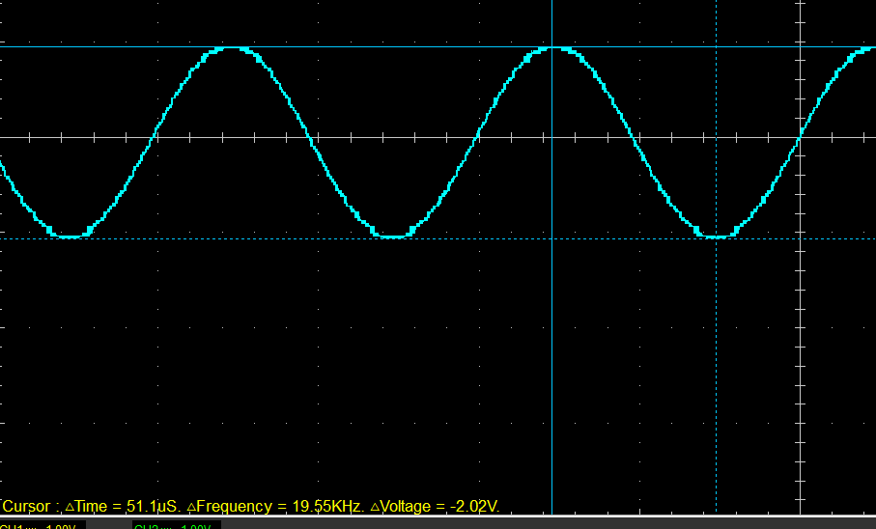
Frequency = 19.55KHz
Voltage = 2.02V
Time = 51.1uS

Unsmoothed Rectifier Wave (3)
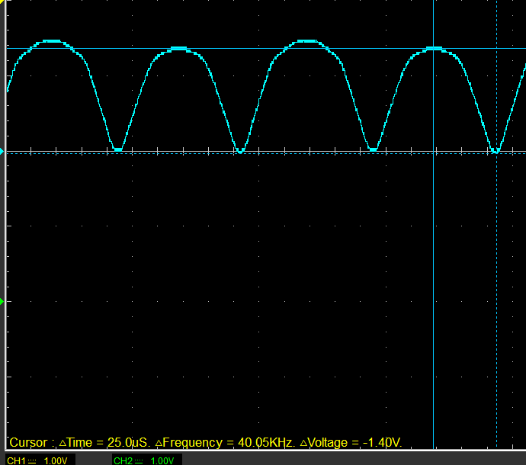
Voltage = 1.4V
Frequency = 40.05KHz
Time = 25uS

Smoothed Rectifier Wave with capacitor (3)
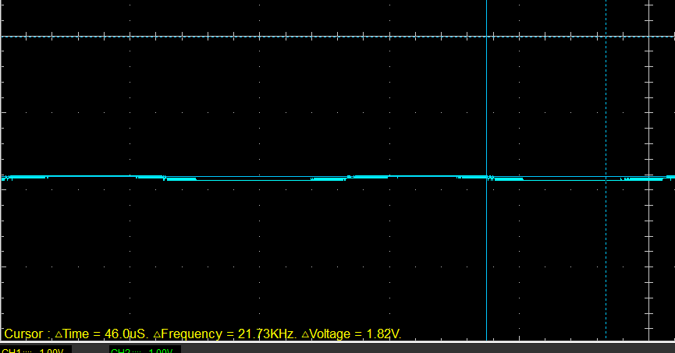
Frequency = 21.73 KHz
Voltage = 1.82V
Time = 46uS

Drop in Voltage Question (4)
The rectifier DC output is lower voltage then the peak of the sine wave input because the sine wave is an alternating current while the rectifier is a direct current. The reason for this is that with AC waveform the current crossing zero will extinguish the arc. However, with DC there’s zero crossing, so the contacts are limited to a much lower voltage so that there’s not enough electrical field to keep the arc lit while the contacts pull apart.

Different Voltage Readings Question (5)
Peak positive input voltage = 5V
Peak to peak voltage = 2.02V
Root mean square = 0.7142
RMS or root mean square represents the DC current/voltage that dissipates the same amount of power as the average power dissipated by the alternating current/voltage.

Rectifiers use in Automotive applications Question. (4)
Rectifiers are used when you want electricity to flow in one direction and not in the opposite direction (converts alternating current into direct current). They're used to control the flow of electricity from the alternator to the rest of the car's electrical system, as the alternator polarity reverses on each revolution. They are also used where you don't want circuits to cross feed. For instance, there often is a rectifier that keeps your high beam signalling switch from feeding voltage back to the rest of the system. There are different types of rectifiers like a half wave rectifier which is important for many components such as the battery, lights and other accessories which require a lower power direct current to operate. The second type is a full wave rectifier which is ideal for high power applications. The use of a capacitor filter at the output of half wave or full wave rectifier results in stable DC voltage which is important as it eliminates the ripples.

Probing Question (4)
You can’t probe the input of a function generator on one channel while probing the rectifiers of the output at the same time because the generator has ground referenced inputs. This means connecting both channels at the same time would short out portions of the rectifier bridge as you are unable to ground the circuit. To allow for simultaneous probing you would have to use a scope with floating input channels, or you can use external differential probes which measures voltage difference between any two input points.

Task 3

Scope Time Division Calculations (4)
Time period = RxCx20
= 220 x (104x10^-6) x 20 = 0.4576
Time division = /10
0.4576/10 = 0.04576

Frequency = 1/time period
1/0.4576 = 2.18 Hz

Function Generator output square wave (3)
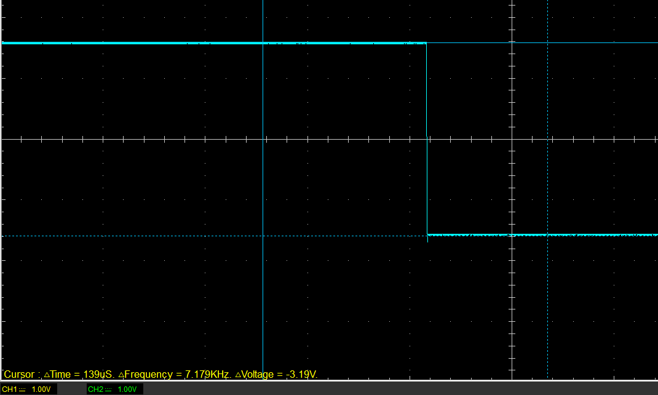

Frequency = 7.179KHz
Voltage = 3.19V
Time = 139uS

Capacitor charge and discharge wave marked at correct points. (3)
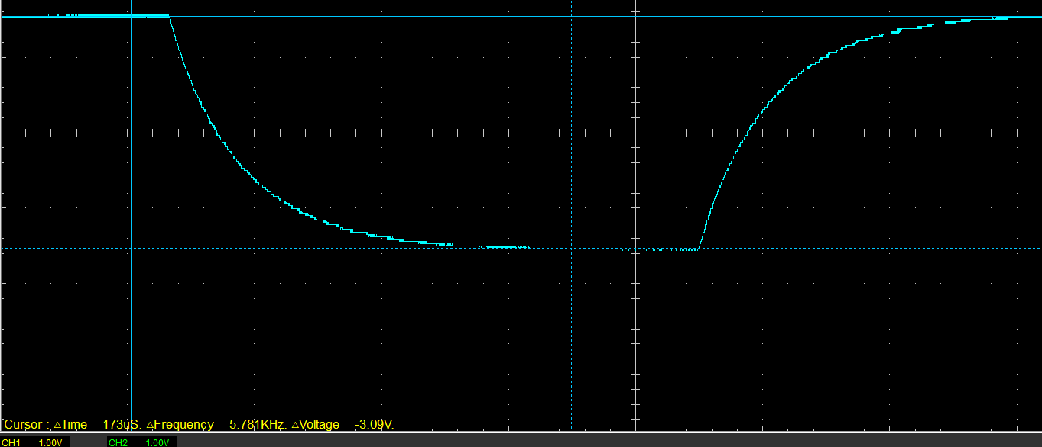
A
B
A = Charging
B = Discharging
(Peak(V) – start (V) x 6.32% + Start (V)) = V top cursor
(1.5-0) x 0.632 + 0 = 0.948V
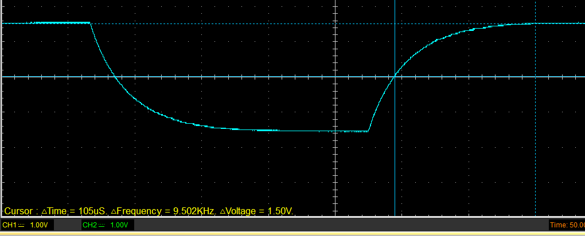

Frequency = 9.502KHz
Voltage = 1.5V
Time = 105uS
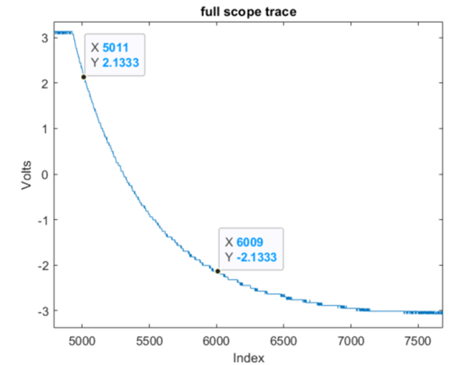

Basic Capacitor Calculations (3)

Time constant = R x C
(105x10^-6) sec = 10 x C
C = (105x10^-6) / 10
C = 1.05x10^-5 Farads
C (µF) = 1.05x10^-5 x 100000 = 105 µF

Capacitor discharge table (4)
Time (s) | Voltage (V) | Voltage + (V+) | ln (V) | dy = y2 – y1  dy = ln(V)2-ln(V)1 | dx = x2- x1  dx = Time2 – Time1 | dy/dx
0.04996 | 2.3216 | 7.3216 | 1.990829 | x | x | x
0.05107 | 1.3176 | 6.3176 | 1.843339 | -0.14749 | 0.00111 | -132.8730
0.05218 | 0.5647 | 5.5647 | 1.716443 | -0.12690 | 0.00111 | -114.3210
0.05329 | -0.1255 | 4.8745 | 1.584018 | -0.13243 | 0.00111 | -119.3020
0.05440 | -0.6902 | 4.3098 | 1.460891 | -0.12313 | 0.00111 | -110.9240
0.05551 | -1.0667 | 3.9333 | 1.369479 | -0.09141 | 0.00111 | -82.3538
0.05662 | -1.3804 | 3.6196 | 1.286364 | -0.08312 | 0.00111 | -74.8786
0.05773 | -1.6941 | 3.3059 | 1.195709 | -0.09065 | 0.00111 | -81.6710
0.05884 | -1.9451 | 3.0549 | 1.116747 | -0.07896 | 0.00111 | -71.1368

Gradient Plot and calculations (4)
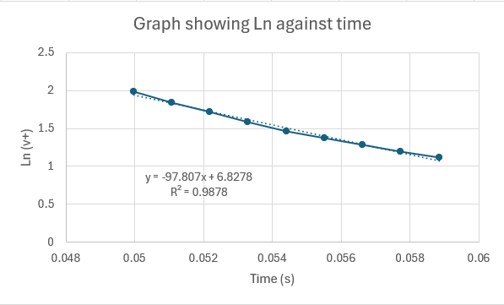

Capacitor Uses (5)
- energy storage - temporary battery on circuits
- pulsed power and weapons - low-inductance high-voltage capacitors are used to supply huge pulses of current for many pulsed power applications
- power conditioning – used to smooth the output of a full or half wave rectifier.
- signal coupling – used to separate the AC and DC components of a signal.
- decoupling – used to decouple one part of a circuit from another.
- motor starters – non polarised starting capacitor used to help start the rotor spinning.
- EVC series capacitors – used in a resonant circuit for non-contact recharging equipment in vehicles.
- Distributor – used on older cars, the capacitor reduces the voltage difference across the distributor.
- Alternator – main function is to suppress electrical noise generated by the alternator.
- Hybrid cars – use large capacitors in their inverter module which converts DC supply from the cars battery into AC output which is used to power the vehicle.

Inaccuracies Question (4)
Measurement error can be caused by multiple different things including faulty measuring instruments, human error, and natural variation in the data. Faulty measuring instruments can produce inaccurate readings, while human error can occur when the data collector makes mistakes in recording or interpreting the data. For example, in the test conducted the bread board and wires used often have dodgy connections which could give weak signals meaning data being read is inaccurate. On top of this the frequency generator used in the test are not the best quality and can often give the wrong frequency especially if they are low on battery. Methods of reducing measurement error include using more precise measuring equipment (like a better frequency generator). Another way to reduce errors would be to repeat the experiment so you have multiple variables which can allow you to identify and correct for systematic error.

References
(Format to Harvard style as per handbook)
Wikipedia (2023) Applications of capacitors, Wikipedia. Available at: https://en.wikipedia.org/wiki/Applications_of_capacitors (Accessed: 19 March 2024).
Murata (2023) Ceramic capacitors for automobiles: Products & markets: Murata’s Technical Magazine Metamorphosis no.17, Murata Manufacturing Co., Ltd. Available at: https://corporate.murata.com/en-eu/more_murata/techmag/metamorphosis17/productsmarket/capacitor#:~:text=These%20large%2Dcapacitance%20monolithic%20ceramic,for%20non%2Dcontact%20recharging%20equipment. (Accessed: 19 March 2024).
Jimson (2023) What is the main function of an alternator suppression capacitor? Available at: https://www.film-capacitors.com/what-is-the-main-function-of-an-alternator-suppression-capacitor/#:~:text=The%20primary%20function%20of%20an,radio%20or%20the%20ignition%20system. (Accessed: 19 March 2024).
EXRO (2023) What is a traction inverter? ev inverters explained, What Is a Traction Inverter? Available at: https://www.exro.com/industry-insights/what-is-a-traction-inverter#:~:text=In%20the%20context%20of%20electric%20vehicles%2C%20an%20inverter%20is%20an,motor%20that%20drives%20the%20vehicle. (Accessed: 19 March 2024).
Z, D. (1965) How does a distributor condenser prevent contact burning?, Motor Vehicle Maintenance & Repair Stack Exchange. Available at: https://mechanics.stackexchange.com/questions/73721/how-does-a-distributor-condenser-prevent-contact-burning#:~:text=%2D%2D%2D%2D%2D%20the%20capacitor,voltage%20after%20the%20distributor%20High. (Accessed: 19 March 2024).
Gonzalez, G., Ciekurs, P. and Hebbar, S. (2019) What is an automotive rectifier and why would I need one? , Quora. Available at: https://www.quora.com/What-is-an-automotive-rectifier-and-why-would-I-need-one (Accessed: 20 March 2024).
FasterCapital (2024) Measurement error: The art of minimizing inaccuracies in data collection, FasterCapital. Available at: https://fastercapital.com/content/Measurement-error--The-Art-of-Minimizing-Inaccuracies-in-Data-Collection.html#:~:text=Measurement%20error%20can%20be%20caused,recording%20or%20interpreting%20the%20data. (Accessed: 20 March 2024).
Khan Academy (2023) What is RMS value? (& why should we care?) , Khan Academy. Available at: https://www.khanacademy.org/science/in-in-class-12th-physics-india/x51bd77206da864f3:alternating-current/x51bd77206da864f3:rms-values-of-current-voltage/v/what-is-rms-value-why-should-we-care (Accessed: 20 March 2024).

Weiss, B. (2020) Why can’t the input and output signal be observed simultaneously ..., Qu. Available at: https://www.quora.com/Why-can-t-the-input-and-output-signal-be-observed-simultaneously-in-oscilloscope-for-the-full-wave-rectifier-circuit (Accessed: 21 March 2024).
D, J. (1966) Why does a circuit breaker voltage rating differ between AC and DC?, Electrical Engineering Stack Exchange. Available at: https://electronics.stackexchange.com/questions/545821/why-does-a-circuit-breaker-voltage-rating-differ-between-ac-and-dc#:~:text=With%20the%20AC%20waveform%2C%20the,while%20the%20contacts%20pull%20apart. (Accessed: 21 March 2024).

