Nathan Morgan
1801338
Enterprise & Innovation Group project
Individual report

Contents
Personal Ideation 2
Development 3
Design Research 4
Financial plan 6
Conclusion 8
References 8
Appendix – 1 Personal reflection 9
Appendix 2 – trip to BT Tower 10
Appendix 3 – Team progress sheets 20

Personal Ideation
As a team we had a solid idea for the product, but I had my own thoughts on the potential application of a universal key, but the project focus is on specifically a car key.
To me the product is an adaptable solution that can be used to gain entry to locked locations and vehicles, the key will be a manageable device that allows you to customise what it can access and provide enhanced security measurements with the motto of less is more. The product will be relatively inexpensive making it more obtainable to the masses and as development progresses, we will be able to reduce costs by improving the manufacturing process, refining the product with user feedback and more customisation options for the key itself, such as an array of cases or extra memory for larger databases of keys, or an independent internet connection that allows direct communication with the authentication server.
My implementation of the product would provide a much higher level of security that will be a unique selling point of the device. The other unique selling point is the fact that you can manage the key to have many vehicles to one key, rather than many keys for many vehicles. This solution will be advantageous in a scenario such as an employee needs access to a fleet of vehicles and rather than having a huge key chain to access each, they simply have one key with a management interface on a web application that allows us to add more vehicles and users to the vehicles very quickly if you have the keys and vehicle data on file. But adding to the file shouldn’t be a problem either. The system ultimately wants to be adaptable so these keys could be then integrated with your house door or even your garage, why have more when less is more?

Development
Throughout the design of the product I had a lot of control of the components and layout of the device, to start with we theorized what the MVP would be, this set the scope of what I needed the device to achieve.
With this scope in mind I researched the market for components that would have the form factor and the capability to perform as intended.
With some [1] research on how car thieves are currently stealing vehicles from the current wireless key systems ours will fill the role of having enhanced security. The initial ideal for countering this technique is to use a combination of software routines and sensors for gauging distance and stages of authentication. The technique being used will counter car thieves using an RF signal repeater to capture the keys identity and replay it back to the vehicle, now we plan a different approach the scenario that involves the key only transmitting once activated with a fingerprint and while within range of the vehicle, then the key is active until it is removed from the vicinity of the vehicle.
Here we have the early development stages circuit diagram, created by Nathan Morgan using circuitio [2]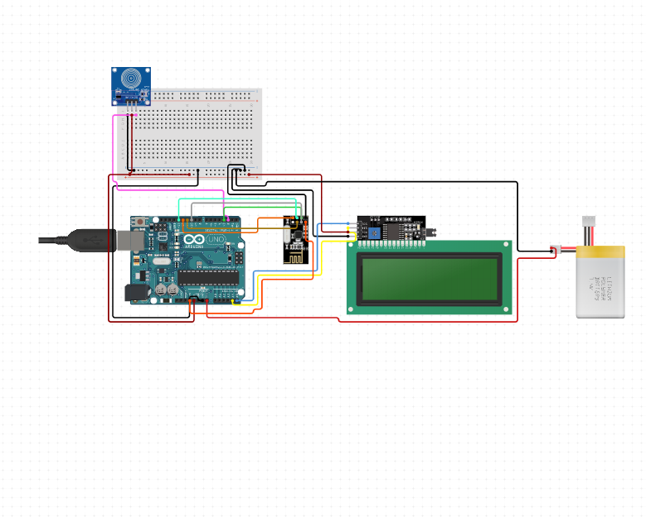 [2]
In this prototype design you can see some rather bulky components that won't be used in the final prototype, our research showed that there are just as capable prototype boards with a 10th of the form factor of the Arduino uno [3]. After this we proceeded to use the Arduino nano [4], this tiny chip will be sufficient for a working prototype, but again this is just for the prototype, and with time a bespoke system will be manufactured that will be designed with the performance requirement needed and compact it all down to one small circuit board that will fit snugly inside a small key. This is the goal of reducing the size and finding a manufacturer that can create these circuit boards in bulk as we require. After some research we found a local company [5] that can meet the demands but ultimately we will be producing them on site to reduce overheads in the future.

Design Research
To begin with we assessed what the prototype can achieve, so I made a mock-up using [2]This have us a basic understanding of how it would be wired, then I looked into the types of libraries I would need to drive the components, for this I found we would need the
Adafruit_GFX_Library [6], and the Adafruit_SSD1306 library [7]
These will allow us to interact with and display symbols and characters on the screen. These libraries are large on the system memory of the microcontroller, so we will have to look at extracting the parts of the library that are essential to trim the memory footprint significantly.
After the research for the display was complete, I investigated communicating with a Bluetooth module and this turned out to be easy to do using the serial communication protocol provided by Arduino. This allows for communication with any device that is connected.
You can then create a web application that can communicate over this protocol to effectively control and receive information with the device. This is an ideal solution to the communication method.
Next I investigated the fingerprint scanner we ended up using and found a wide variety of documentation for the devices. This led me to using the library included in the appendix. This is the standard library that was adapted to be used with Arduinos rather than the standalone software developed by the manufacturer.
Here are some photos of the key being built by Nathan Morgan

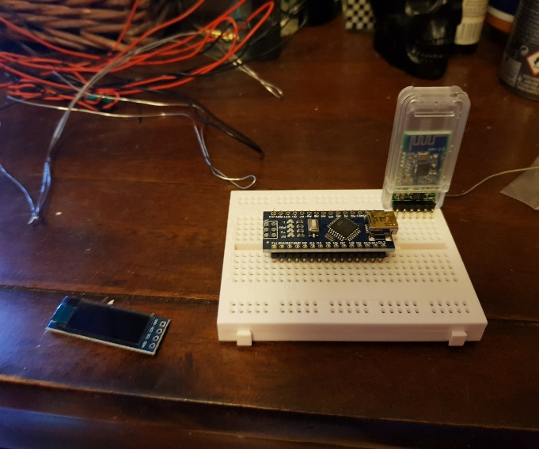Here you can see the OLED, Arduino, and Bluetooth module

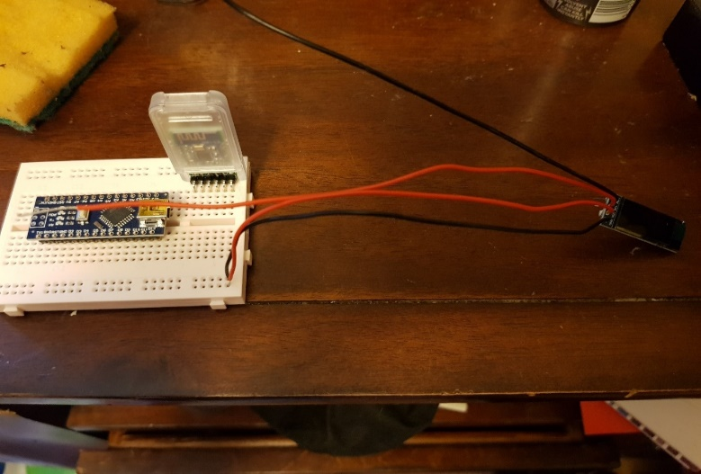Here you can see the OLED wired up to the power rails
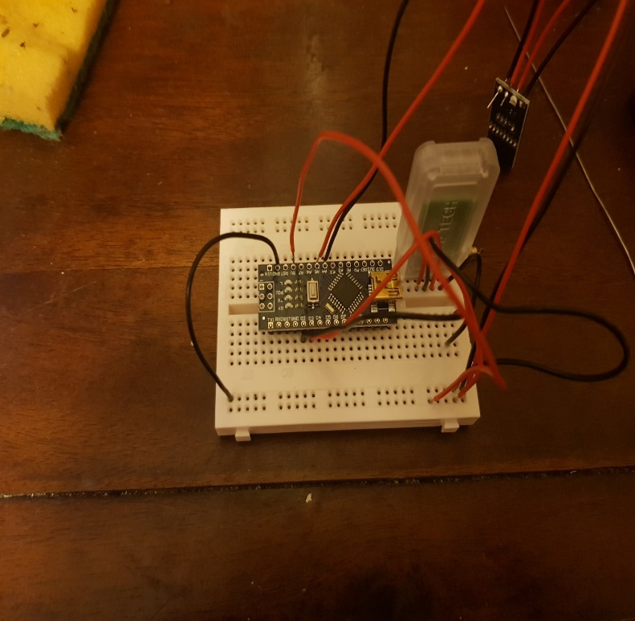 Here you can see the Bluetooth module, the OLED wired up.

Financial plan
Cost of raw parts £71.23 as seen in this cost breakdown spreadsheet I created
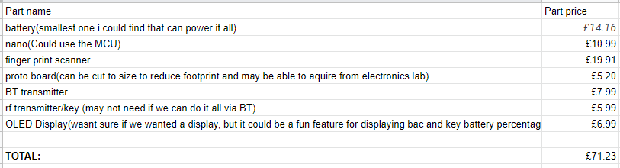 [8]
For selecting a merchant account, I used Mertchantmachines [9] comparison website
It gave us a comprehensive breakdown of merchant account providers in the United Kingdom, where PayPal UK came out on top with options for international payments for when we expand our ecommerce sector.
We intend to bring a full ecommerce platform for marketing and selling the devices internationally, and directly linking with the web application for managing the device for further remote access to your devices. The web page will also have all the key information a customer would require in one place, such as sales testimonials, tutorials for setting up the device and expansions on functions.
At the core of design of the webpage and web application we would like to completely avoid external adverts and show the customers our products that they don’t own or new announcements where you would typically see adverts.
Another core principle is the security and integrity of the customers data. This will largely be covered by GDPR [10] but as a company that has security at the heart of the design, we will be taking all the appropriate measures to uphold our reputation for our security. And using a highly reputable web provider we found here [11] and the company is BlueHost [12].
With any Ecommerce platform you need good marketing to generate traffic, so advertising on sales platforms such as Facebook and Amazon could help drive traffic to our ecommerce web site where the customer will see our full range of products and our future products.
An initial investment to make 100 units and funding for an advertisement campaign, at roughly £10,000 would be incredible, we could look at crowd source investing platforms such as Kickstarter using discounts on future products as incentives [13]and to gauge interest and provide a discounted rate on the first couple hundred units to start the ball rolling and spread word of mouth. Then we can look at investors obtained through demonstration and a targeted advertising campaign looking at vehicle owners with modern keys. This could be further marketed by giving a couple of free units to popular YouTube sensations in the motoring world and the home automation sector, these two target demographics would be an ideal customer base as they’re already interested in the type of technology that we are trying to push. This would be also interesting from a feedback perspective to get the opinion of valued members of their respected communities and online circles.
In the earlier stages we don’t really need a book-keeper, but we could use book keeping software such as quick books [14], to start tracking our finances early so we can have sturdy record keeping. This will help as the company develops and we need to solicit an accountant or a bookkeeper to help our annual report and help with the tax calculation.
The development concept we wish to use is kaizen, this means continuous improvement and re-evaluating our production every cycle to increase productivity, reduce costs and improve workforce communication, taking every voice to consideration. [15]
Here is the initial cash-flow forecast that also shows the sales estimates, the return on investment and budgeting 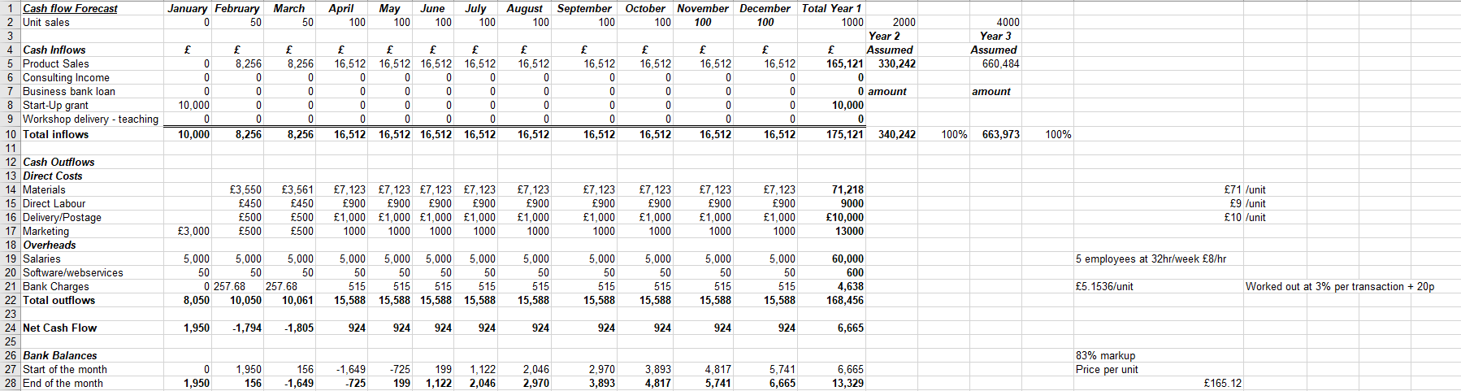

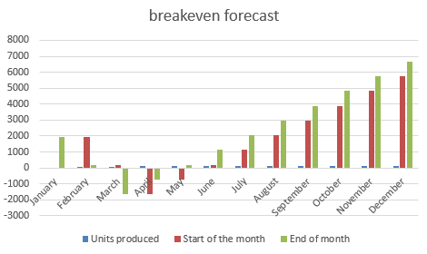
This Breakeven forecast shows that we should start to turn a profit in May, when this happens, we can start to re-asses production and adjust our methodology to increase our long-term forecast profit. And then the company can look at re-investing more back into the workforce.

Conclusion
In conclusion, the product could break even within 3 months if sales targets are met, we have a very innovative product that we wish to bring to market, as our company grows our price will decrease as we intend to invest back into the production and training of staff. The sales projections are in a worst case scenario and if we were to get a better start than forecasted our production can double with a few changes to contracts with suppliers and the out-sourced manufacturing until we are at a position to self-produce in mass.

References

[1] | N. Thomason, “prevent relay attacks,” leasing.com, [Online]. Available: https://leasing.com/car-leasing-news/relay-car-theft-what-is-it-and-how-can-you-avoid-it/.
[2] | circuitio, circuitio, [Online]. Available: https://www.circuito.io/, .
[3] | arduino. [Online]. Available: https://www.arduino.cc/.
[4] | arduinoNano, “Arduinonano,” arduinoNano, [Online]. Available: https://store.arduino.cc/arduino-nano.
[5] | https://www.pcbtrain.co.uk/products-and-services, “pcb train,” pcb train, [Online]. Available: https://www.pcbtrain.co.uk/products-and-services.
[6] | adafruit, “GFX-Library,” [Online]. Available: https://github.com/adafruit/Adafruit-GFX-Library.
[7] | [Online]. Available: https://github.com/adafruit/Adafruit_SSD1306.
[8] | N. Morgan, “Google sheet for parts,” [Online]. Available: https://docs.google.com/spreadsheets/d/1bmgemsgvt0YmwMwqHBTbwHeinoKVUz9n5ISqxN2S8CI/edit?usp=sharing.
[9] | merchantmachine, “compare merchant accounts,” merchantmachine , [Online]. Available: https://merchantmachine.co.uk/providers/.
[10] | gov, “gdpr,” [Online]. Available: https://gdpr-info.eu/.
[11] | techradar. [Online]. Available: https://www.techradar.com/uk/web-hosting/best-web-hosting-service-websites .
[12] | bluehost. [Online]. Available: https://www.bluehost.com/?country=US&utm_source=google&utm_medium=genericsearch&kclickid=00fbb342-8633-4a41-b834-09d0ceb02e48&kenshoo_ida=Blue%20Host%20IDA&gclid=Cj0KCQiAkePyBRCEARIsAMy5ScuPrCIK6yCuhtj3kfftQwby0AQ2c01_ZCjKNufTVdmJmSZCL_DXBu4aAhBHEALw_wcB.
[13] | Kickstarter. [Online]. Available: https://www.kickstarter.com/.
[14] | q. books, “accounting softwre,” quick books, [Online]. Available: https://quickbooks.intuit.com/uk/accounting-software/.
[15] | Kaizen, “Leanproduction,” [Online]. Available: https://www.leanproduction.com/kaizen.html.
[16] | https://tenstep.com/use-this-five-step-approach-to-manage-project-finances-2/, “five step approach to manage project finances,” tenstep, [Online]. Available: https://tenstep.com/use-this-five-step-approach-to-manage-project-finances-2/.

Appendix – 1 Personal reflection
My reflection on the enterprise and innovation group project
By Nathan Morgan

Over the last two semesters we have had lectures on EIGP, and it has brought many areas of my personal development to light and taught me about several areas of business development through the in class seminars and the extra curriculum activities and the research required for the group project.
I have developed several technical skills because of the enterprise and innovation project, it has taught me about electrical design, researching, and overcoming obstacles and adapting to the situation, it has also taught me about team working and systems used for managing time.
And development techniques used in the industry to work more efficiently as a team and distributing the workload effectively using each team members strength to its potential
The part that will stick with me the most is the in-class seminars and the insight provided by these industry experts, these have helped me shape my future and will be considered in many aspects of my daily life. And the development of my career, I believe these talks are an essential part of seeing what we’re working towards. And motivate us on an individual level. The EIGP project has taught me a wealth of knowledge about team working and development techniques used to plan and design our product within a set timescale, the project has also taught me a lot about the types of systems in place and their vulnerabilities.

Appendix 2 – trip to BT Tower
Review of attendance at industry networking event at the BT tower
On Wednesday the 4th of March there was a networking event at the local BT tower, where we saw the system used to test the deployment of a new infrastructure, The testing centre was very interesting to see, and how the system is built to be robust and give feedback to the administration of when a fault arises and how to deal with it. The trip was very exciting to see the new system in place and then we got to see the old system and see how the two compare, and then we got to see the testing stations on the 3rd floor that allows the testing of several different IOT devices and monitor the throughput. The testing centre is used to test all equipment before deploying it to the consumers, And BT has quite the variety of products so this testing facility will be a pinnacle of deployment for BT.

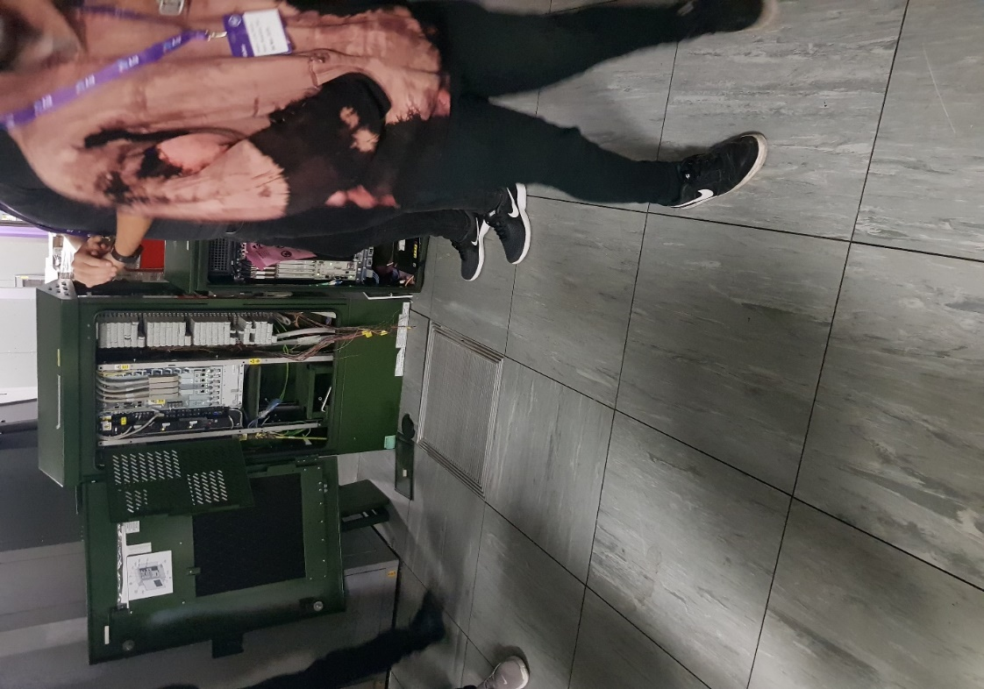smaller form cabinet
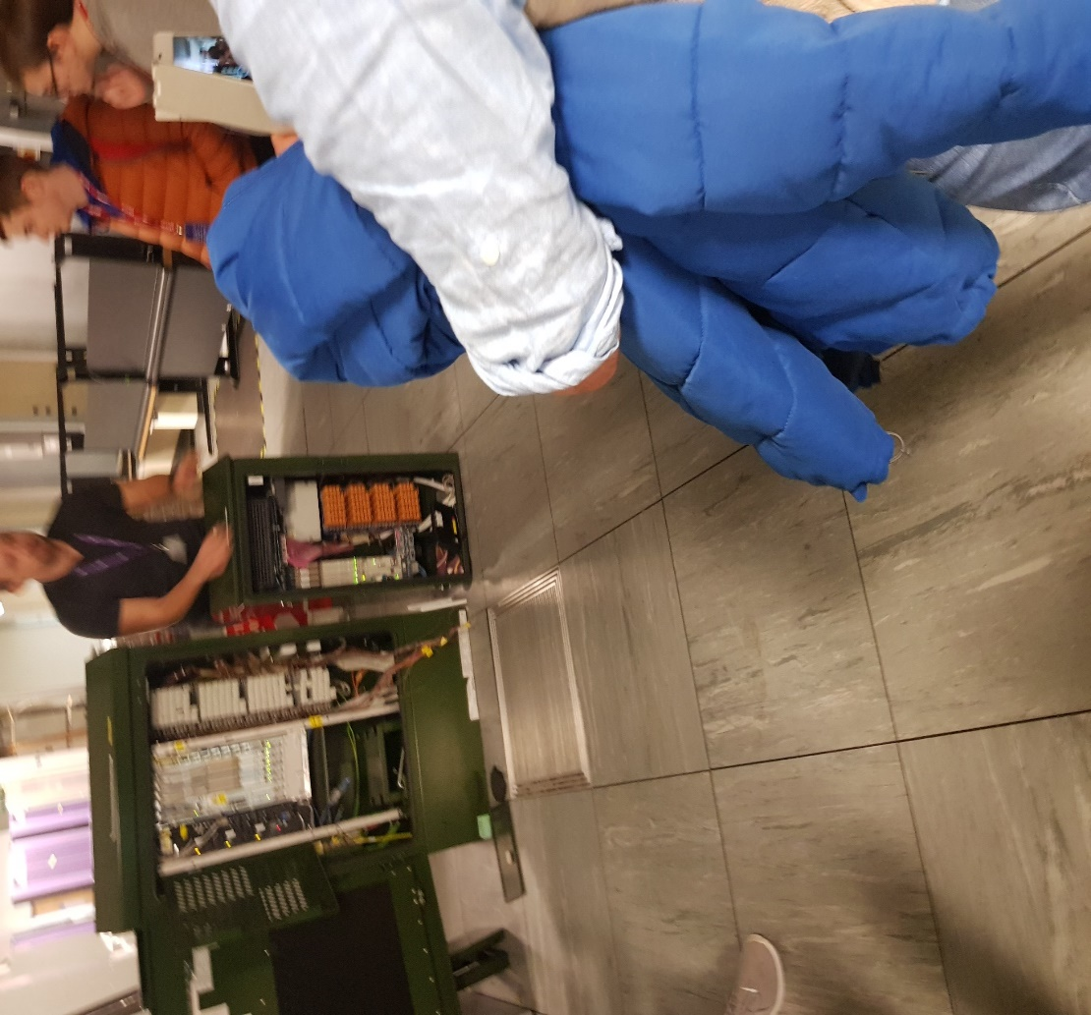The new style cabinet with the side box bolted on the side 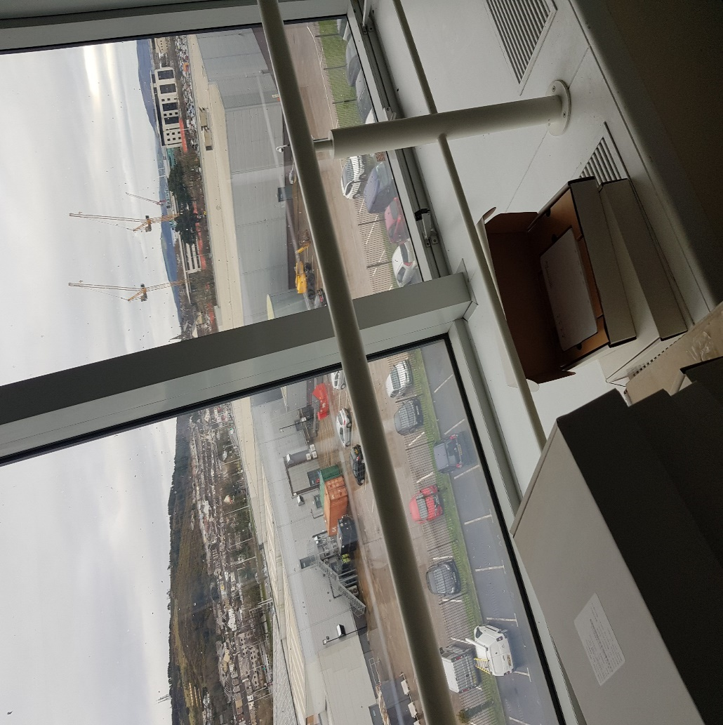a nice view 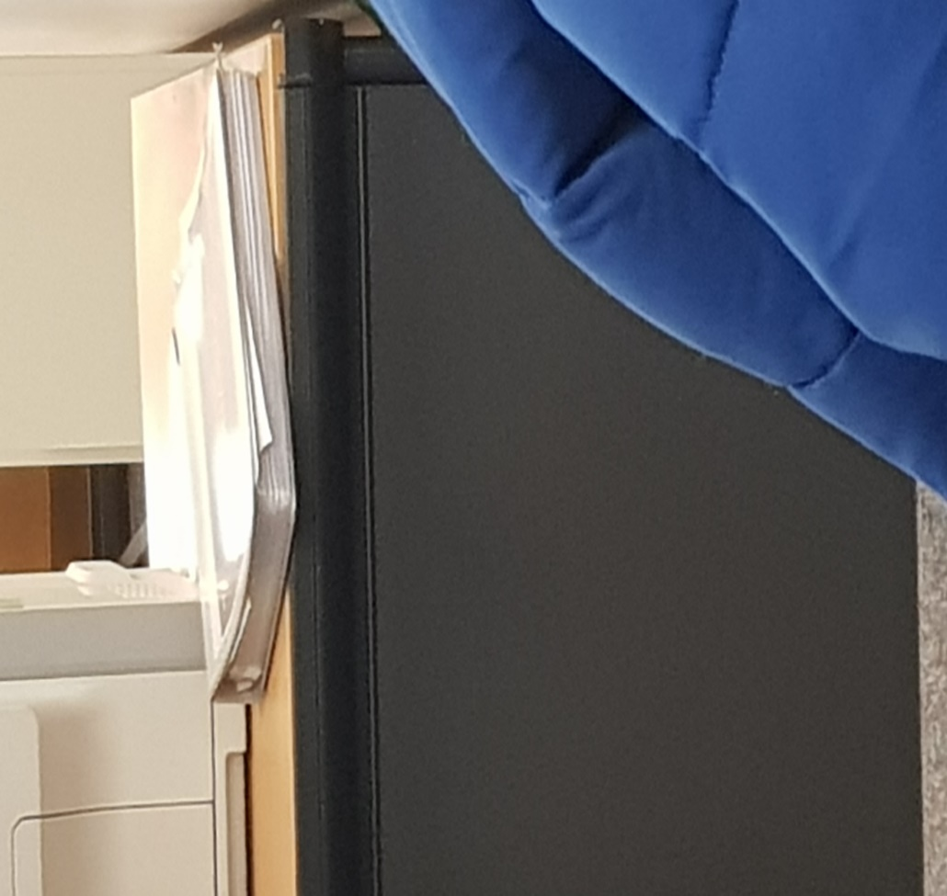the holy grail of troubleshooting
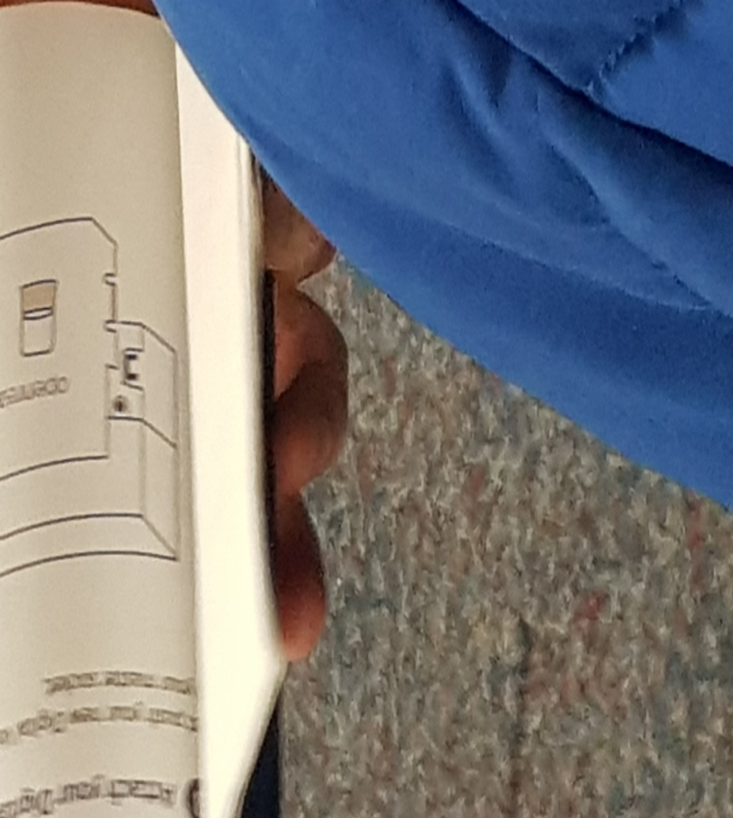The smaller pocket size version to be sent out to customers
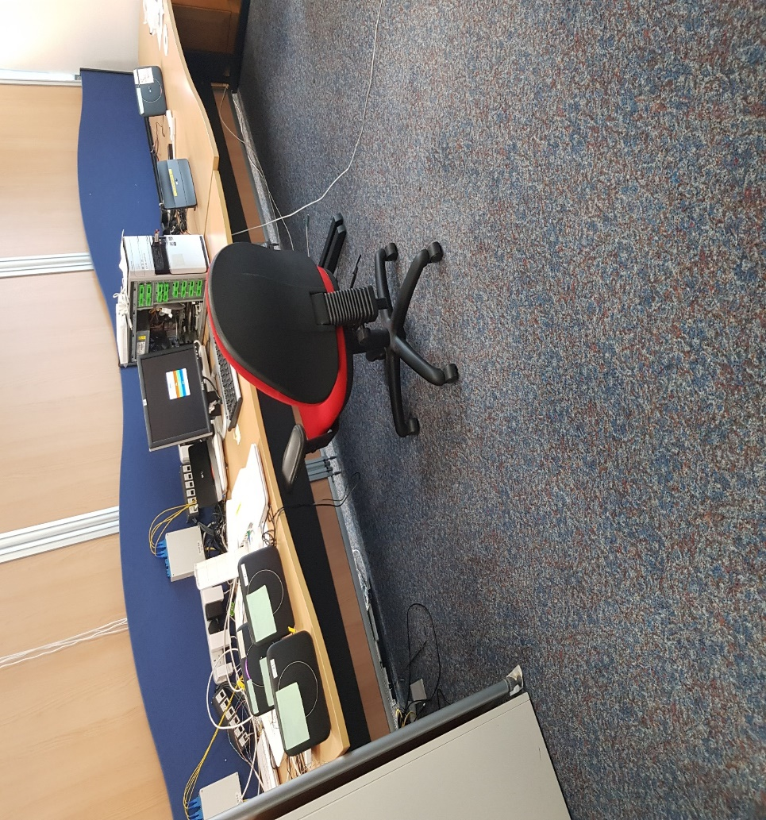Testing bench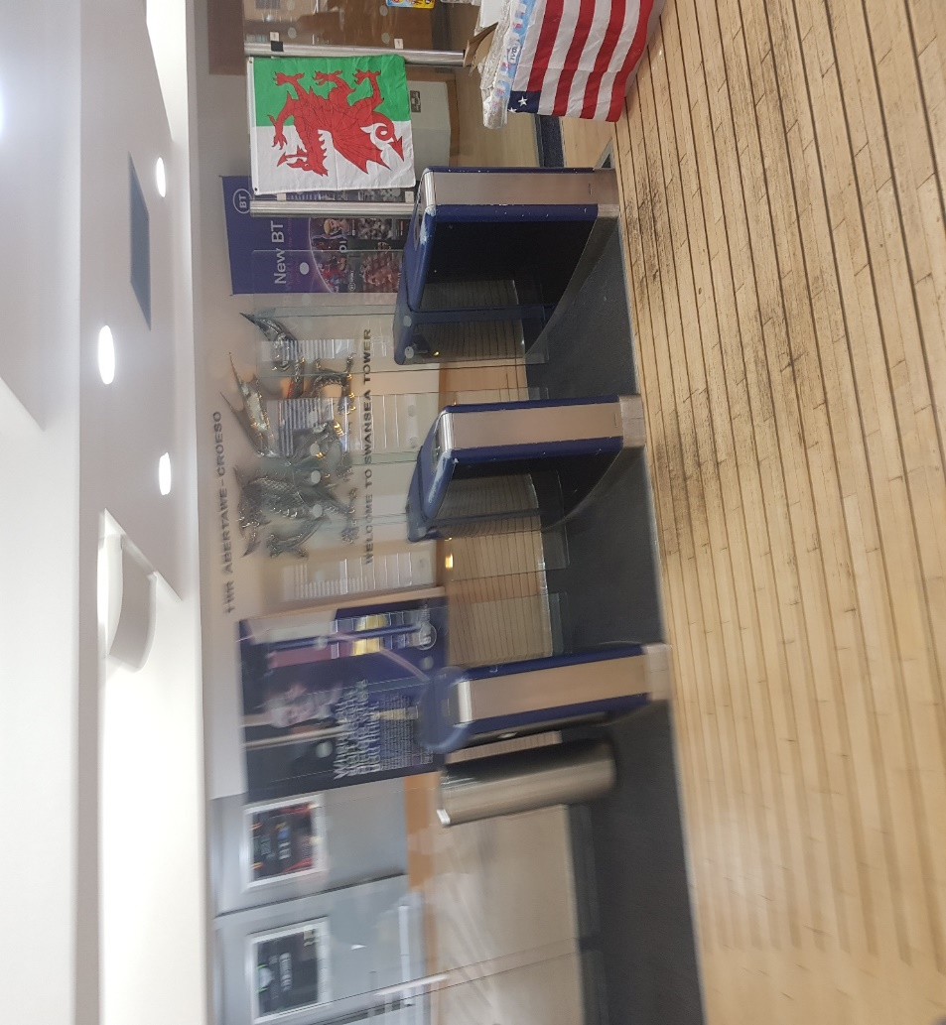The entrance 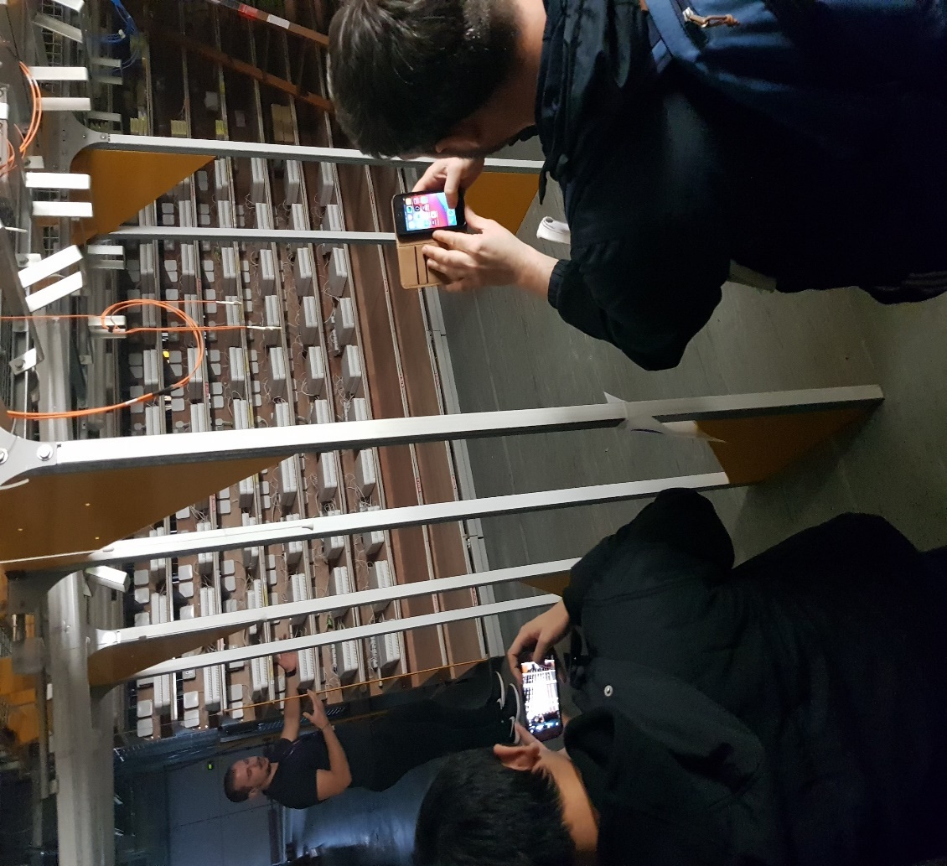New testing facility
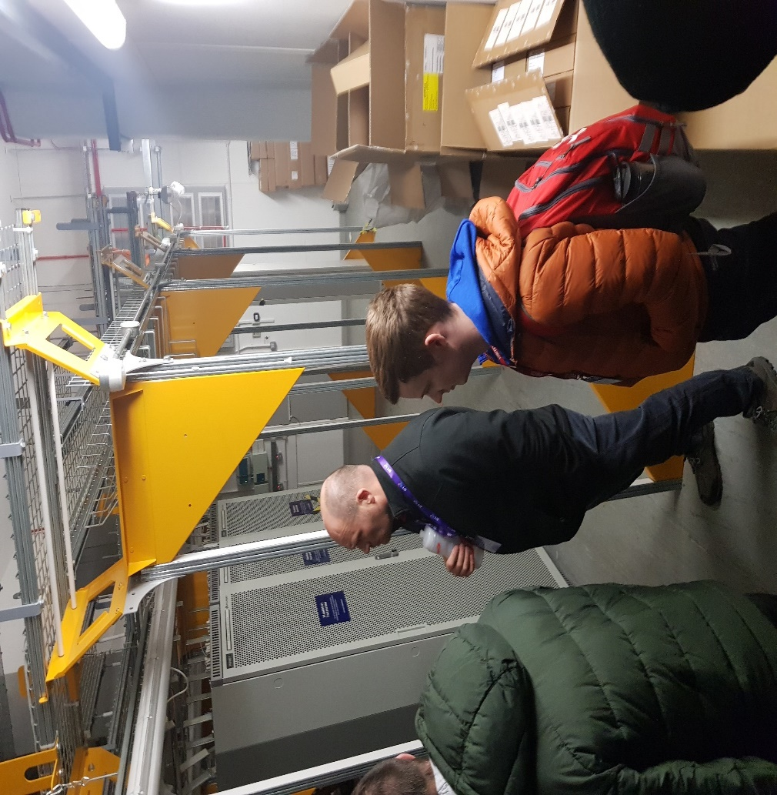Side View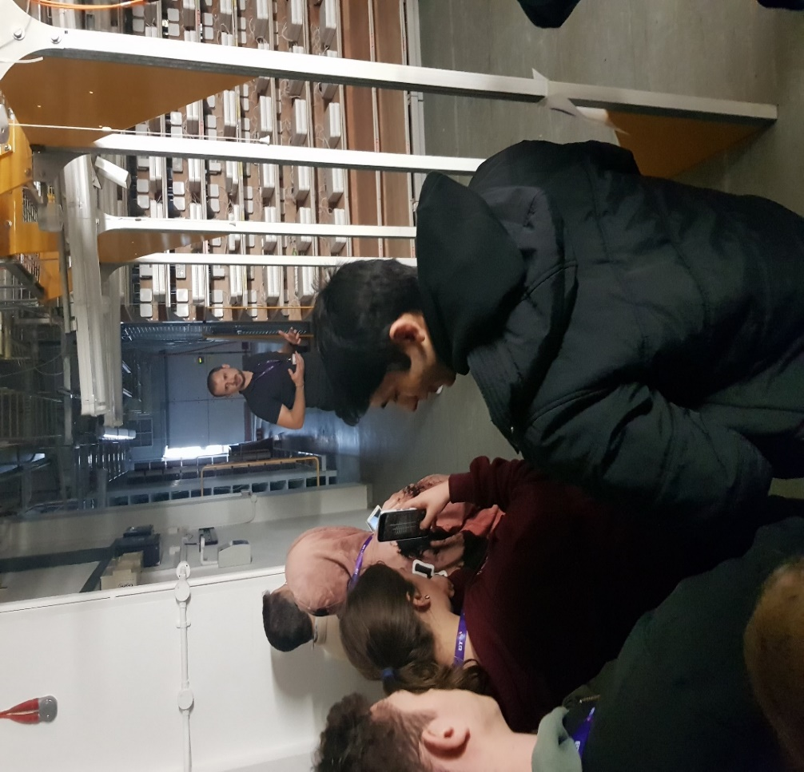Another shot of the “end user devices”
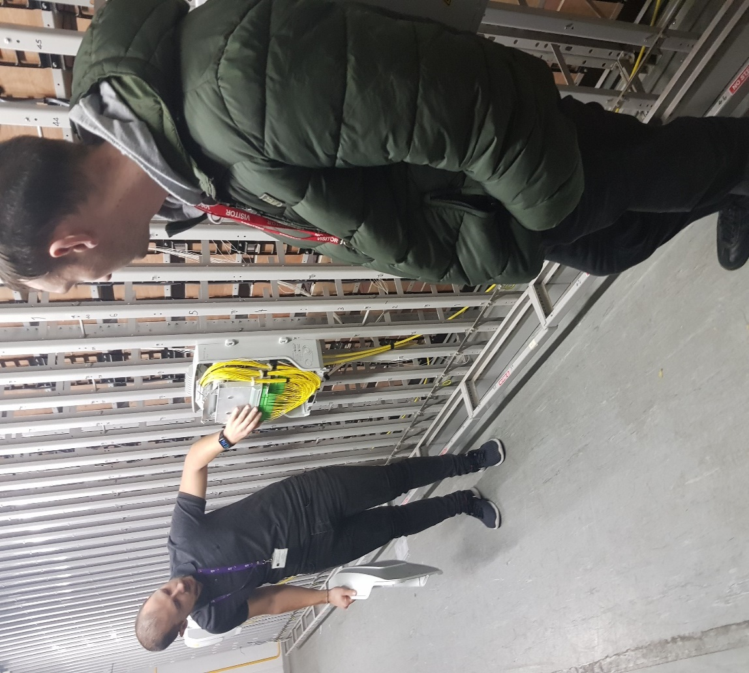The cabinet that routes to the end user devices
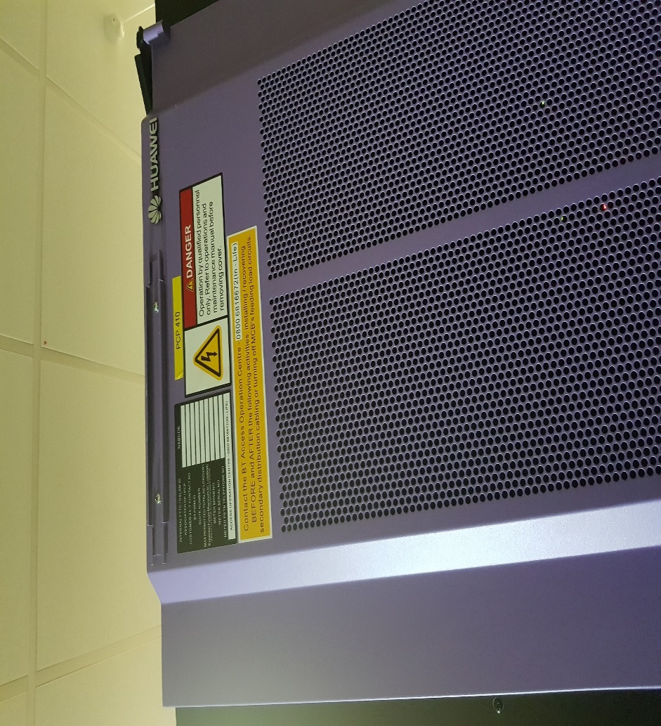HUWAEI Cabinet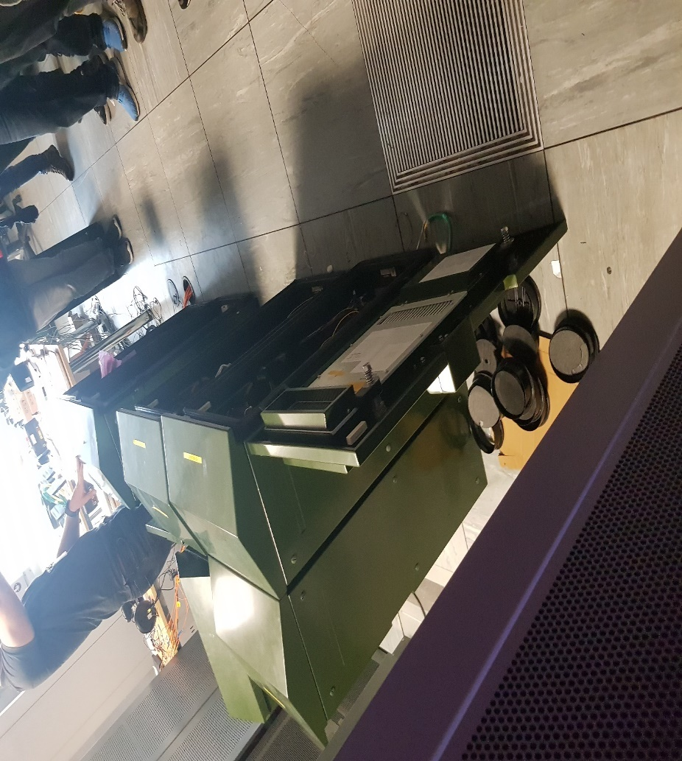a selection of cabinets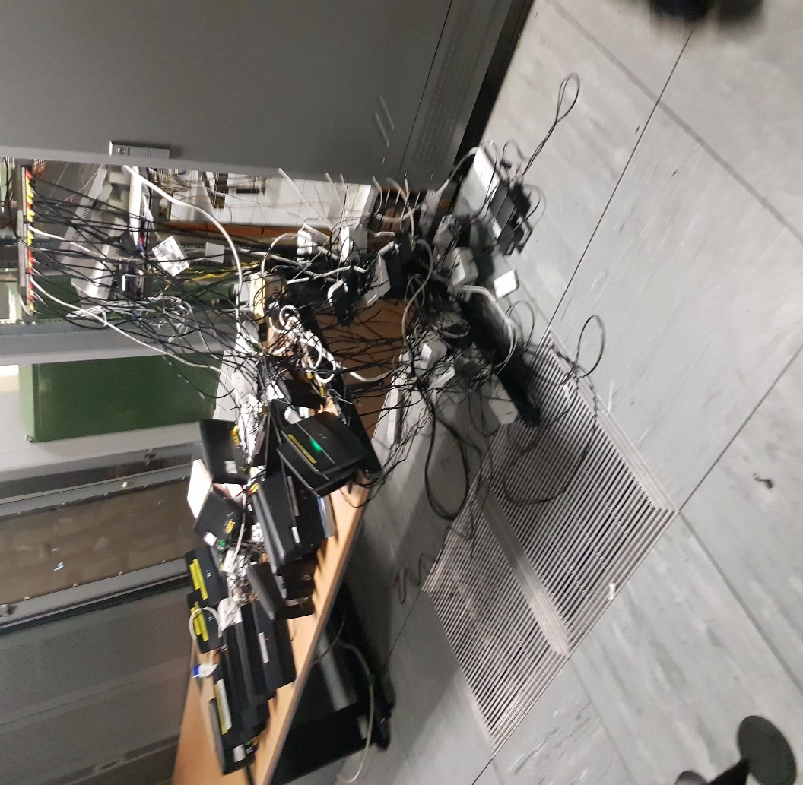A testing bench 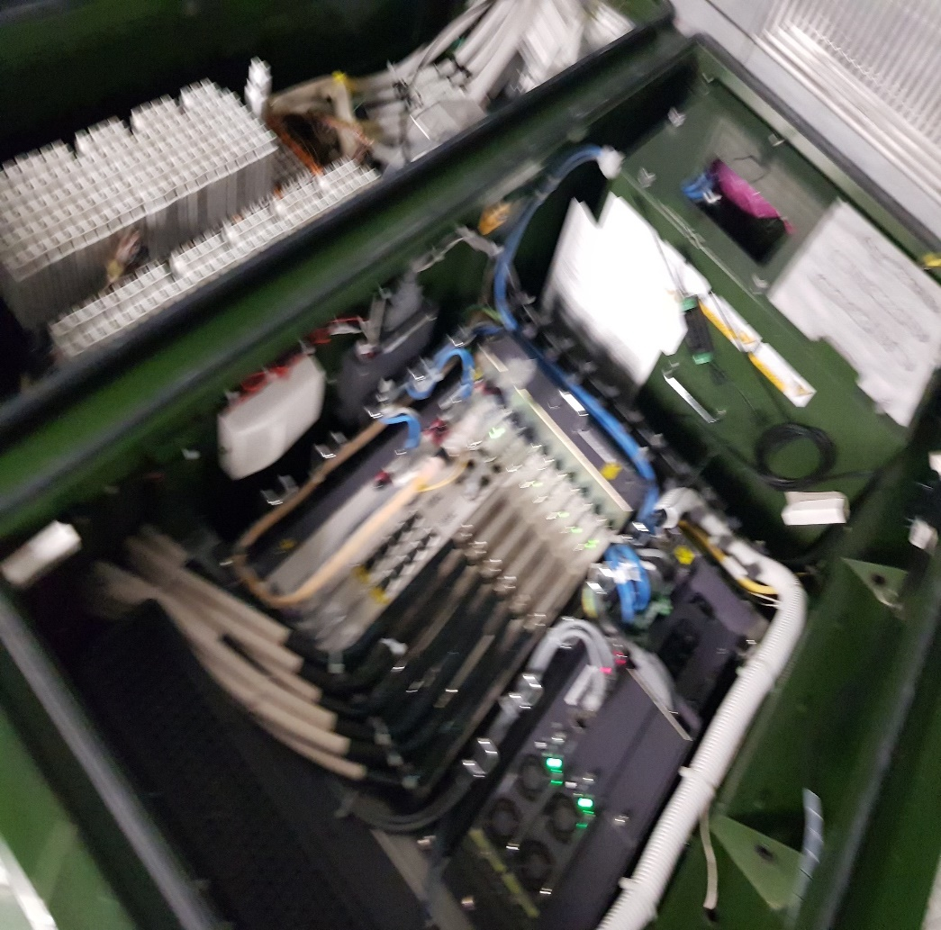inside the new cabinet 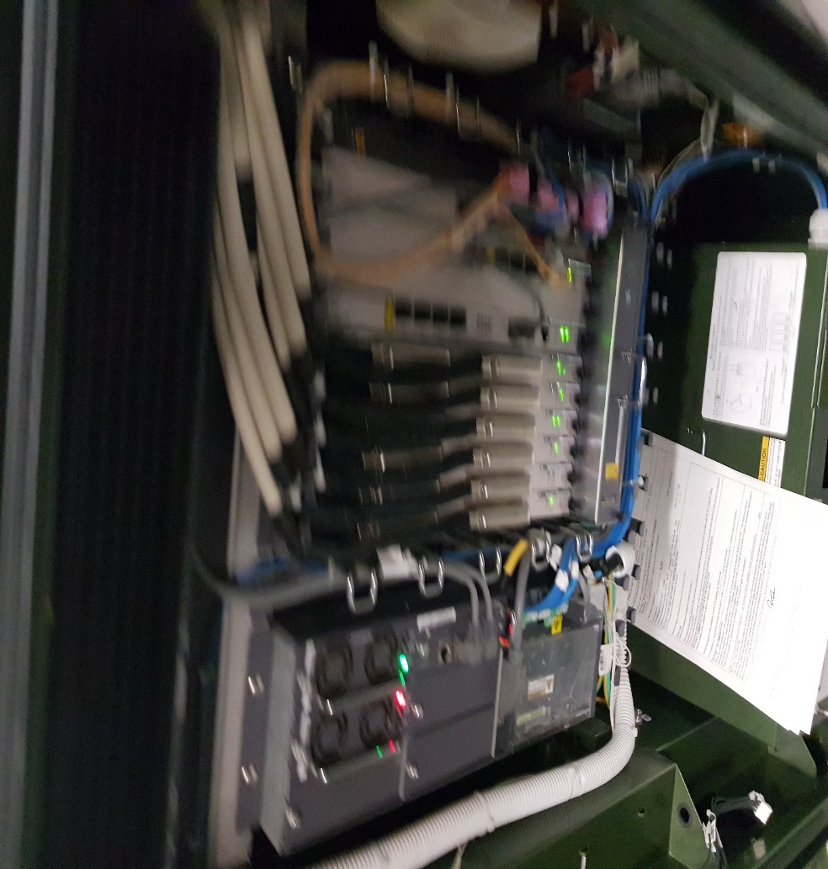inside the cabinet

Appendix 3 – Team progress sheets
------------------- TEAM PROGRESS SHEET -------------------------
Team Name: Ddraig Coch Enterprise
Team Member Names & Roles:
DA: Dan Algie- Web Development / Database Management / Marketing.
RM: Ryan Morgan – Web Development / Database Management / Printing Engineer.
NM: Nathan Morgan- Software Engineer / Electronic Engineer / Marketing.
MD: Martin Dunn – Software Engineer / Electronic Engineer / Marketing.
AS: Anthony Smith – Web Development / Database Management / Printing Engineer / Current PM
------------ ---------- ----------- ------------- ------------- ------------ ----------- ------------ --------- --------- ---------- ---

Weekly Progress report 1:
Date: 06/11/2019
In-Attendance: AS, DA, RM, NM, MD. Apologies: - Absent: -
Team Goals:
To implement an innovated project which will obtain a group consensus.
> Individual Updates:
AS Update: Amass a list of different ideas which could be used as the group project, and research how unique each concept is.
NM Update: researched different parts for the project, including alternatives with different size footprints for adapting to the consumer needs.
DA Update: Researched different types of keys to see which would be more suitable type of key to suit our ideas.
RM Update: Researched different methods of creating web applications.
MD Update: Forming a list of innovative projects to talk in the group

> Team discussion:
Notes: As a group, it was decided to individual submit ideas that could potentially become the focus of the group project. After many debates, it was decided that the biometric Car Key would be the most viable choice.
- Individual team roles have been set.
- Compile a list of components required to create the device.
- Contact sources, that will be necessary to fund the product and supply equipment to create the prototype.
- Design a business logo and distribute a survey as part of the marketing strategy.
> Individual Actions:
AS Actions: design the group logo and cement each individual position within the group.
NM Actions: Converted survey into a digital format and market it amongst social circles using an online medium https://forms.gle/JVc8jqfbpSwbzCJD9
DA Actions: researched different types of car keys around the world.
RM Actions: Will investigate similar competitors.
MD Actions: investigate other products to make ours unique
------------ ---------- ----------- ------------- ------------- ------------ ----------- ------------ --------- --------- ---------- ---

Weekly Progress report 2:
Date: 13/11/2019
In-Attendance: AS, DA, RM, MD. Apologies: - Absent: - NM
Team Goals:
Compile a Moscow Chart, which will identify possible features for the product.
Investigate potential competitors in the market and complete a competitor Analysis
Research legal requirements, trends in the market and identify what is needed to create the product. This can be summed up in a PEST Analysis.
Contact Potential Partners that may benefit from the prototype or may be pivotal in the design and implementation of the device.
> Individual Updates:
AS Update: make a list of potential organisations and create a form of communication.
NM Update: Some interesting reading: https://sciencediscoveries.degruyter.com/non-invasive-method-measure-blood-alcohol-levels/
List compiled of parts, for the prototype
https://docs.google.com/spreadsheets/d/1bmgemsgvt0YmwMwqHBTbwHeinoKVUz9n5ISqxN2S8CI/edit?usp=sharing
Spreadsheet of survey results:
https://docs.google.com/spreadsheets/d/1RlzjcpFbTmgHmKoOgZpqktBENGMoUMPC47GWu_-tfgI/edit?usp=sharing

DA Update: educating myself on PEST analysis looking into government regulations and looking into the economic growth & costs and how our company can help grow technology.
RM Update: Investigated similar competitors of the car key industry, generally car manufactures prefer to manufacturer their own keys in house, however there is a market of universal car keys, with gadget like features
MD Update: checked price points on competitor products
> Team discussion:
Notes: The decision was made to separate into small groups and tackle the team goals. The members of the group that were present, completed a MOSCOW chart, highlighting the functionality of the device which could be adopted to the prototype.
- MD and DA to complete competitor Analyse.
- RM and Nm to complete PEST Analyse.
- AS to Identify potential partners.
> Individual Actions:
AS Actions: Sent communication to several organisations that may have influence on the prototype, or display interest in a financial manner.
NM Actions:
DA Actions: got up to date with the government regulations on products
RM Actions: Looking into web applications, UI design concepts to make Cark-E more user friendly
MD Actions: finding any products that would relate to ours.
------------ ---------- ----------- ------------- ------------- ------------ ----------- ------------ --------- --------- ---------- ---

Weekly Progress report 3:
Date: 20/11/2019
In-Attendance: AS, RM, NM. Apologies: - Absent: - DA, MD
Team Goals:
To come together as a group and start to put forward concepts, that will define the key features.
> Individual Updates:
AS Update: tried to identify what would be possible for the requirements of the key
NM Update: researched alternative micro controllers to look for more memory overhead and integrated wifi.
DA Update: absent due to illness
RM Update: Finalised UI Design, put concept forward to team. Daniel Algie to provide database relationship diagram to aid in design process.
MD Update: Absent due to family emergency

> Team discussion:
Notes: As a group, we highlighted what would be possible for the project by creating a Moscow chart, which created clarity on the path we would take with the key.
> Individual Actions:
AS Actions: Start to gather information and look at other tech that is available
NM Actions:
DA Actions: Looked into Entity relationship diagrams
RM Actions: Design a logo that better reflects the brand image of Cark-E, Prepare PowerPoint theme.
MD Actions: Look into what level of programming would be needed for the prototype.
------------ ---------- ----------- ------------- ------------- ------------ ----------- ------------ --------- --------- ---------- ---

Weekly Progress report 4:
Date: 27/11/2019
In-Attendance: AS, DA, RM, NM, MD. Apologies: - Absent: -
Team Goals:
Create a complete presentation that is coherent by piecing together our individual PowerPoints.
> Individual Updates:
AS Update: The presentation was split in to five sections and I would identify the initial ideas section
NM Update:
DA Update: started working on my section of the initial pitch of the cark-e
RM Update: Produced a logo that is clean and simple in design, portrays the meaning of the product in question, implemented a generalised theme for group PowerPoint and encouraged team members to begin designing their slides.
MD Update: working towards creating a section for a group PowerPoint about market competitors.

> Team discussion:
Notes: we came together as a group to help each other identify what was to be included in the PowerPoint for the presentation
> Individual Actions:
AS Actions: completed the ideas section
NM Actions:
DA Actions: made PowerPoint on parts and software for the cark-e
RM Actions: Look into resources for 3D design, types of software that would better aid us. I.e. Tinker cad, finalise presentation on team management for next week
MD Actions: complete market competitors PowerPoint section.
------------ ---------- ----------- ------------- ------------- ------------ ----------- ------------ --------- --------- ---------- ---

Weekly Progress report 5:
Date: 04/12/2019
In-Attendance: AS, DA, RM, NM, MD. Apologies: - Absent: -
Team Goals:
To present first pitch as a group
> Individual Updates:
AS Update: presented my section of the PowerPoint
NM Update: presented my section of the powerpoint
DA Update: presented the pitch
RM Update: Present resources to the team for creating 3D imagery of the Cark-E prototype, Complete team presentation
MD Update: Present market competitors' section of PowerPoint

> Team discussion:
Notes: talked about the good and bad parts of the pitch to move forward for the next pitch
> Individual Actions:
AS Actions: discussed my research data
NM Actions: discussed lack of referencing on a per slide basis.
DA Actions: presented and discussed my section of the power point pitch
RM Actions:
MD Actions: Discussed different competitors on the market, and what makes us different
------------ ---------- ----------- ------------- ------------- ------------ ----------- ------------ --------- --------- ---------- ---

Weekly Progress report 6:
Date: 11/12/2019
In-Attendance: AS, DA, RM, NM. Apologies: - Absent: - MD
Team Goals:
Create a plan of action to move forward with the concept.
> Individual Updates:
AS Update: helped create a timescale with the group to move forward
NM Update: Researched techniques for reducing form factor of prototypes, looking at alternative proto boards to fit form factor of key
DA Update: looked how long it will take to create the database section and discussed the time frame
RM Update: Discussion regarding prototype timescale before Christmas break, RM makes team aware the construction of web application will begin once brand image is finalised
MD Update: Absent

> Team discussion:
Notes: show action plan in Gantt charts and discuss reasonable timetables
> Individual Actions:
AS Actions: helped create a chart using my input.
NM Actions: Researched different time management techniques for keeping the project on track
DA Actions: helped create the Gantt chart an discussed the time frame of the database section
RM Actions:
MD Actions: Absent but was showed the charts the group had made
------------ ---------- ----------- ------------- ------------- ------------ ----------- ------------ --------- --------- ---------- ---

Weekly Progress report 7:
Date: 18/12/2019
Christmas Break
------------ ---------- ----------- ------------- ------------- ------------ ----------- ------------ --------- --------- ---------- ---

Weekly Progress report 8:
Date: 25/12/2019
Christmas Break

------------ ---------- ----------- ------------- ------------- ------------ ----------- ------------ --------- --------- ---------- ---

Weekly Progress report 9:
Date: 01/01/2020
Christmas Break
------------ ---------- ----------- ------------- ------------- ------------ ----------- ------------ --------- --------- ---------- ---

Weekly Progress report 10:
Date: 08/01/2020
In-Attendance: AS, DA, RM, NM, MD. Apologies: - Absent: -
Team Goals:
start production on our sections of development
> Individual Updates:
AS Update: discuss with DA the options to create a database
NM Update: Ordered parts
DA Update: discuss with AS (Anthony Smith) options to create a database
RM Update: RM update team of any delays in web application production due to Christmas break, provides ideas to include within its construction
MD Update: Checking the work timetable as Christmas wasn’t planned for, updating the team on any delays

> Team discussion:
Notes: make sure the group is aware of their sections to work on
> Individual Actions:
AS Actions: researched different software to produce the best database.
NM Actions: await parts
DA Actions: researched different software applications to create the cark-e database
RM Actions: Research into effective user interfaces, prepare examples of mission statements for team approval
MD Actions: Researched into arduino programming for the development of the prototype.
------------ ---------- ----------- ------------- ------------- ------------ ----------- ------------ --------- --------- ---------- ---

Weekly Progress report 11:
Date: 15/01/2020
In-Attendance: AS, DA, RM, NM, MD. Apologies: - Absent: -
Team Goals:
team members advancing with their sections of development
> Individual Updates:
AS Update: Finalise the program options with DA to create the database
NM Update: awaiting parts
DA Update: finalised the program options with AS on how the database will be created
RM Update: RM delivers several examples of mission statement and request team vote to implement
MD Update: Looking into different ways to program different components of the Arduino, eg screen and fingerprint scanner

> Team discussion:
Notes:
> Individual Actions:
AS Actions: Researched data protection legislation guidelines.
NM Actions: awaiting parts
DA Actions: researched data protection protocol
RM Actions: Begin research into legal classification of a company, present findings at meeting next week
MD Actions: Begin some light programming tests within the Arduino suite to familiarise myself with the software
------------ ---------- ----------- ------------- ------------- ------------ ----------- ------------ --------- --------- ---------- ---

Weekly Progress report 12:
Date: 22/01/2020
In-Attendance: AS, DA, RM, NM. Apologies: - Absent: -MD
Team Goals:
Discuss in a group our positions in the development of the Key.
> Individual Updates:
AS Update: consultation with DA to discuss the tables and what information is needed for database
NM Update: awaiting parts
DA Update: discussed with AS what fields will store the data and what data will be stored
RM Update: Mission statement chosen; RM raises points regarding brand image, presents findings of legal classification, Cark-E will be established has a limited company once successful implementation of a prototype has been completed
MD Update: Absent

> Team discussion:
Notes: discussed our implementations
> Individual Actions:
AS Actions: Researched other database concepts used by other businesses. Consult DA with my findings.
NM Actions: awaiting parts but preparation and research has begun
DA Actions: sharping up on SQL ready for creating the database
RM Actions: Research into why brand image is important, present findings to team at meeting next week
MD Actions: Absent, was told the stages of peoples development via instant messaging
------------ ---------- ----------- ------------- ------------- ------------ ----------- ------------ --------- --------- ---------- ---

Weekly Progress report 13:
Date: 29/01/2020
In-Attendance: AS, DA, RM, NM, MD. Apologies: - Absent: -
Team Goals:
Check on the progress made by all members of the team and if any unseen situations have arisen.
> Individual Updates:
AS Update: created the tables for the database with DA, just need to populate them.
NM Update: awaiting parts – found all relevant libraries for the components
DA Update: created all tables needed for the database with AS
RM Update: Discuss the need for creating brand image to increase Cark-E awareness
MD Update:

> Team discussion:
Notes:
> Individual Actions:
AS Actions: investigated marketing and branding
NM Actions: Research similar projects and get guide prices for report
DA Actions: investigating into php to connect database
RM Actions: Prepare brand image examples for meeting next week
MD Actions:
------------ ---------- ----------- ------------- ------------- ------------ ----------- ------------ --------- --------- ---------- ---

Weekly Progress report 14:
Date: 05/02/2020
In-Attendance: DA, RM, NM, MD. Apologies: - Absent: - AS
Team Goals:
> Individual Updates:
AS Update: Absent due to illness
NM Update: some parts received, stll awaiting sensor
DA Update: due to illness of AS I tested if the tables would store data manually
RM Update: Discussion regarding brand image, present examples to team
MD Update:

> Team discussion:
Notes:
> Individual Actions:
AS Actions: Absent due to illness
NM Actions: bought a sensor from amazon, didn’t arrive with the relevant plug and cables ordered them
DA Actions: dropped all manual data to check database works
RM Actions: Complete Brand image proposal
MD Actions:
------------ ---------- ----------- ------------- ------------- ------------ ----------- ------------ --------- --------- ---------- ---

Weekly Progress report 15:
Date: 12/02/2020
In-Attendance: AS, DA, RM, NM, MD. Apologies: - Absent: -
Team Goals:
Continue with progress on development
> Individual Updates:
AS Update: Discussed the branding with RM and spoke to DA about teething problems with the database.
NM Update: extra parts arrived, construction has begun, the missing component is due on the 20th, but we are moving on without the component and hoping it turns up
DA Update: Accepted Rm finalised brand and discussed issues with database AS
RM Update: Present finalised Brand image of Cark-E to team for approval
MD Update:

> Team discussion:
Notes:
> Individual Actions:
AS Actions: looking into ways to iron out problems with database
NM Actions: constructing the product, tested individual components with their relevant libraries
DA Actions: looking at ways to improve database
RM Actions: Begin artboard of web application design
MD Actions:
------------ ---------- ----------- ------------- ------------- ------------ ----------- ------------ --------- --------- ---------- ---

Weekly Progress report 16:
Date: 19/02/2020
In-Attendance: AS, DA, RM, NM, MD. Apologies: - Absent: -
Team Goals:
get together as a group and show any progression in the development
> Individual Updates:
AS Update: present the database to team for approval
NM Update: Handover prototype for martin to do the programming.
DA Update: present database to team for approval
RM Update: Present web application design to team for approval
MD Update:

> Team discussion:
Notes:
> Individual Actions:
AS Actions: With DA, discuss how to store information via the sensor
NM Actions: Key required extra modifications due to a cable break
DA Actions: discussing and looking at how to store fingerprint into database with AS
RM Actions: Begin construction of web application
MD Actions:
------------ ---------- ----------- ------------- ------------- ------------ ----------- ------------ --------- --------- ---------- ---

Weekly Progress report 17:
Date: 26/02/2020
In-Attendance: AS, DA, RM, NM, MD. Apologies: - Absent: -
Team Goals:
> Individual Updates:
AS Update: awaiting web application from RM, in the meantime continue creating a functioning database with DA.
NM Update: fixed cable break
DA Update: waiting for completion of web application to connect to database
RM Update: Web application on way to completion, will finalise ready for delivery to DA and AS
MD Update:

> Team discussion:
Notes:
> Individual Actions:
AS Actions: research data on how to merge web application and database. Attended a presentation by Sean Varney on the topic of Virtual Production.
NM Actions: Further research into the financial side, finding manufacturers, looking at a cost break down
DA Actions: looking into ways to receive data from website to store database, attended Sean Varney talk on virtual production
RM Actions: Finish web application ready for delivery to DA to begin database implementation
MD Actions:
------------ ---------- ----------- ------------- ------------- ------------ ----------- ------------ --------- --------- ---------- ---

Weekly Progress report 18:
Date: 04/03/2020
In-Attendance: AS, DA, RM, NM, MD. Apologies: - Absent: -
Team Goals:
> Individual Updates:
AS Update: Attended a meeting with RM and DA to discuss web application and connecting the database
NM Update: Converged with the team to help with their sections while waiting for MD.
DA Update: meeting with RM and AS on finalising web application and discussing the database connection to website
RM Update: Meet with DA and AS to finalise web application design
MD Update:

> Team discussion:
Notes:
> Individual Actions:
AS Actions: applying the ideas suggested as a group with RM and DA
NM Actions: Showed my theoretical DB design.
DA Actions: moving forward with what was discussed with RM and AS
RM Actions: Begin testing of web application
MD Actions:
------------ ---------- ----------- ------------- ------------- ------------ ----------- ------------ --------- --------- ---------- ---

Weekly Progress report 19:
Date: 11/03/2020
In-Attendance: AS, DA, RM, NM, MD. Apologies: - Absent: -
Team Goals:
> Individual Updates:
AS Update: Testing the database with the website to ensure its problem free with team.
NM Update : unit testing and adjustments
DA Update: testing the database with the website to read in data results shared with team
RM Update: Confirmation of web application testing, results shared with team
MD Update:

> Team discussion:
Notes:
> Individual Actions:
AS Actions: attend a group session with DA and RM awaiting the programmed circuit to fuse it all together.
NM Actions: unit testing and adjustments
DA Actions: Meeting with AS RM connected database to website read in data and stored to database
RM Actions: Meet with DA and AS to finalise web application connection to database, Attend Paul Harwood seminar
MD Actions:
------------ ---------- ----------- ------------- ------------- ------------ ----------- ------------ --------- --------- ---------- ---

Weekly Progress report 20:
Date: 18/03/2020
In-Attendance: AS, DA, RM, NM, MD. Apologies: - Absent: -
Team Goals:
> Individual Updates:
AS Update: make sure everything connects and works with no problems, before the final pitch
NM Update: polishing and testing and pitch prep
DA Update: me and AS showed Working database to team ready for final demonstration
RM Update: Confirmation of working web application ready for demonstration
MD Update:

> Team discussion:
Notes:
> Individual Actions:
AS Actions: get together with the group to prepare for final presentation.
NM Actions: polishing and testing and pitch prep
DA Actions: preparing for the final pitch
RM Actions: Prepare for final pitch and demonstration next week
MD Actions:

Links to other appendices(unsure if this will work)

