How a school develops one aspect of its SDP: a report that critically reflects on the actions, impact and evidence base.

 | Targed/target | Yr hyn yr wyf wedi'i wneud yn yr aseiniad hwn  What I have done in this assignment...
Targed/Target 1 | Explain reasons for choice and try to account for what happens, considering different perspectives. | I reviewed previous assignments, reading comments and hopefully taking on board this advice.
Targed/Target 2 | Ensure you are clear about focus | Using the assessment specification open on my desktop to continually refer to.
Targed/Target 3 | Revise your use of the possessive apostrophe and semi-colon | Read through the referencing guide thoroughly and double checked

Introduction

Every school should have a development plan, also known as a ‘School Improvement Plan’ (SIP). This is to ensure that the school is continually growing and aiming to achieve at a high standard. The SIP includes areas that require further development and establishes consistency for all professionals and students within the school. For the purpose of this assignment, a rural school of roughly 225 pupils will be the focus. As of 2014, Estyn reported the school as having approximately 4% of pupils receiving free school meals (FSM), with 9% identifying as having additional learning needs (ALN). Approximately 9% of pupils come from an ethnic minority background, with minimal pupils speaking English as an additional language (EAL), none of the pupils use Welsh as a first language. None of the children were looked after by the local authority (Estyn, 2014).

For the purpose of this assignment the school will be referred to as school x. It was apparent from the schools SIP how much the school strives to follow a high standard, the following action point has been chosen based on the school’s strategic plan, “In response to Curriculum 2022, to develop a bespoke approach to Curricular Design piloting a connected learning approach linked to Expressive Arts” (School x, 2019 - 20, p. 20). This element was also experienced and witnessed during placement at school x.

Literature Review

Carr, et al. (2012, p.2) tell us that the school improvement plan (SIP) was developed from the No Child Left Behind Act 2001 originating in the United States. Many schools were continuing to perform at a low level, so the idea of annual progression was designed. Any school that continued to lapse would be known to be in a ‘school improvement’ status. However, Brighouse and Woods tell us, that until the book Fifteen Thousand Hours was published by Michael Rutter in 1979, the understanding of a school’s success was barely recognised or discussed, with the headteacher being at the forefront, whether the school was successful or not. This has changed dramatically as schools take on a more whole school approach to tackling improvement. An integral part of a successful plan requires discussing the aspects of the school that are of a high standard, what needs changing and what makes the school stand out from the rest (Steward, 2020 p.8). Identifying these areas are often completed during whole school inset days and after school meetings. When completing observations, based on the chosen inquiry, the Froebel Project is often used. This style guides the production of strategies and styles of learning, performed by the children. This information can be fed back to further improve techniques and teaching styles (Athey, 2007).

The SIP does not solely identify the need for improvement but also the effectiveness of leadership within the school environment. Hallet and Siraj-Blatchford (2014) cite Siraj-Blatchford and Manni (2007), who identify the Effective Leadership in the Early Years Sector (ELEYS) study, which untangles the research of positive impact on children’s well-being, social achievements, health and education. Effective leadership filters down to the main teaching and input within the classroom therefore, the SIP is of great importance, aiming at the professionals to deliver the best teaching to receive the best results. The Welsh Government (2014) tells us that sustainable school improvement is supported by effective long and short-term planning, linked to challenging targets, including self-evaluation, qualitative and quantitative data. When reflecting and feeding back, in relation to the SIP, the findings are generally shown to support the action point that was previously depicted for the annual review. The SIP combines many aspects including the Well-being of future generations act (2015). The act outlines 24 essential areas, each requiring a sustainable impact for the school and community. Within the act, it emphasises that public bodies should carry out sustainable development, setting clear and published objectives and take responsible steps to complete these. There are 7 goals set out in the act that each school should aim to achieve, viewing the professional setting as a small part of the bigger picture, incorporating resilience, cohesiveness and responsibility.

Atkins and Eberhart (2014) tells us that the arts in education is treated as a luxury rather than the standard compulsory lessons of literacy and numeracy. Alternatively, expressive arts should be seen as equally important. They express that each of the fields demonstrated such as music, poetry and dance contribute in facilitating change. This links directly to the SIP which aims at making change for the better throughout the whole school. Target 4 of the school’s SIP (linked to this piece of writing) details the schools aim of working in partnership to improve expressive arts. Clift and Stickley (2017) cites White (2009), outlining how partnership specifically engages individuals and groups in activities, to address both health inequalities and strengthen cohesion and community.

Development within a school aims at the children’s learning however supporting the educators is of equal importance. Maslow’s hierarchy of needs (1947) tells us that adults require a safe and secure environment, in order to attain the stage of love and belonging, also termed as community. Kline (2020) highlights Abraham Maslow’s Hierarchy of needs in the classroom. This popular motivation theory is often used in educational settings, identifying the needs of children, including belonging within a group, meeting their physical needs and feeling good about themselves. Welsh Government (2020) has guidance for each of the areas of learning experience (AoLE). The AoLE Expressive Arts is aimed at incorporating appreciation for other cultures and societies across the world and our local area. The guidance tells us that experiencing expressive arts, whether through dance, music, painting and various other forms, encourages learners physically, socially and emotionally, nurturing well-being, self-esteem and resilience. This links to Professor Graham Donaldson’s four purposes from his Successful Futures document (2015) of becoming healthy, confident individuals, ready to lead fulfilling lives as valued members of society, justifying Maslow’s theory.

Developing an Action Point

The SIP for this particular school was created outlining tasks that have been completed over 2018/2019, with a breakdown of the tasks to be carried forward or furthered during the school year 2019/2020. There are 12 sections to the contents including a breakdown of the context of the school and staffing structure, with their responsibilities. Vision is especially important for any school providing a sense of purpose and direction. 3 key areas are defined for this school’s vision: Inspire, Reflect and Transform, with each section breaking down the mindset behind the vision.

Evaluation of progress is broken down depicting the previous target with a draft evaluation of progress and the next steps that the school will follow. Priorities for 2019/20 are then broken down into targets, why it is a priority and how the funding will be streamed for the individual targets. Every SIP should detail the amount of grants received for what area and how the money is utilised. For this SIP there is an Education Improvement Grant (EIG), Professional Learning Grant (PLG), Cluster funding and School Improvement Grants (SIG). The basis for these grants varies. EIG is aimed at improving the quality of teaching and learning, addressing learner’s barriers to learning and improving inclusion, improving leadership and provision and engagement of learners (GWE, 2019). PLG should be utilised for practitioners to make changes to their practice in advance of the new curriculum. Cluster funding can be applied for, to support global learning within a group of schools. To apply, the cluster must have a minimum of 2 UK based schools and 2 schools from a participating country outside of the UK (British Council, 2020). Finally, the SIG enables schools to improve various areas of teaching, leadership and governance (GOV.UK, 2018).

Each target is assigned a leader to oversee, with team members and a governing body link. As with any plan, a success criteria is placed at the beginning of the target. An evaluation of the previous year is dissected into Foundation Phase and Key Stage 2, with the percentage of achievement and at which level. Research is recorded as either qualitative or quantitative, with the target broken down further into clear, specific actions to ensure the success criteria is met. The table records the personnel involved, start and completion dates, budget allocations, time frames, evaluation (to be completed in the Spring) and end of year impact.

Using the expressive arts, the cluster chose to develop ‘Creative Habits of Mind’ through Expressive Arts to improve pupil’s well-being and attitudes to learning. 4 stages have been designed to meet this improvement through an action plan. The first states that each school will choose a target class to be given the Creative Habits of Mind Assessment Wheel (see figure 1 below) to carry out a baseline of pupils’ learning depositions. This is then repeated at the end of the project to make comparisons.

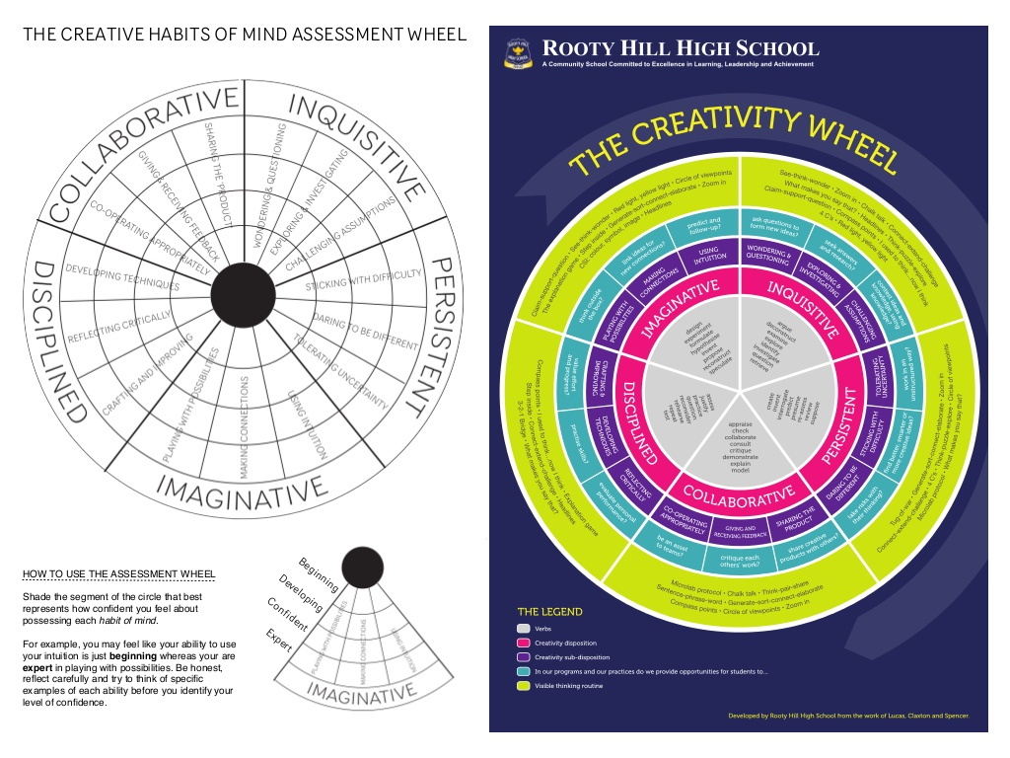
(Nicholls, 2015)

School x aimed their results at key stage 2. An example of a year group has been used for this assignment (see outcomes below).
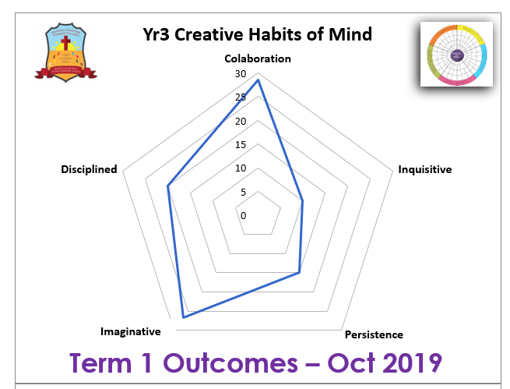
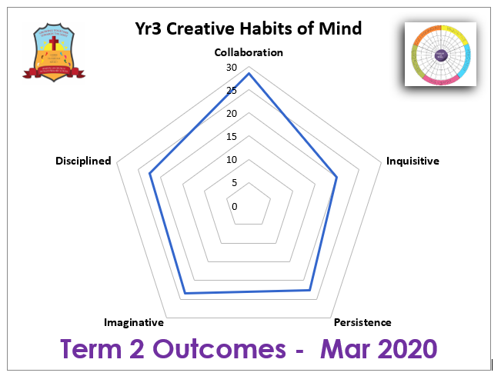

(Parry, 2019-20)

All of this data must be passed onto the Lead school for processing and analysis. Throughout the project, expressive arts provision will be developed in an innovative and connected way, underpinned by the Creative Habits of Mind Learning Dispositions. Pupils are taught to identify these learning dispositions in their class tasks and additional experiences. They are taught to self-evaluate the progress they are making and track this against the creative wheel. Each class teacher will analyse pupil progress in their learning dispositions and the lead school will make an analysis of the progress across the group of schools and share this data for benchmarking. During the spring term, a showcase event will be held at one of the group of schools, where teachers and pupils demonstrate their expressive arts outcomes in a carousel of activities, also known as rich tasks.

When completing each target area, headteachers within the group of schools, select the appropriate staff member to engage with the agreed focus. The schools are then able to develop an open, honest culture through sharing resources and documentation. All practitioners that are involved across the schools are then able to share the learning back in their own classroom, interpreting what they have learnt to other staff members. As a result of the practitioner’s involvement, the school can then make changes to their policy and practice with the goal of improving learning and teaching.

Reflection and evaluation

Completing a SIP is personal to each school. Schools may have similar areas they wish to develop and can work as groups to compare findings and complete training. This particular school chose to improve an area that is poignant to the new curriculum coming into force in 2022. This gives the school a head start, with the implementation of a specific area. Working with other schools ensures that improvements can be made using an individual response that may have been overlooked if confined to one school. Nonetheless, working collaboratively is essential to ensure improvement across the schools within the group.

Using the creativity wheel recognises the children’s personal evaluation of their work and themselves, however, may not allow the children to be confident in their response or may lack the capability of responding clearly without sufficient training. Although time consuming, it is imperative that the children are given the correct tools to concede an honest conclusion of results. There also needs to be a consistent approach to the assessment, ensuring that all teachers work collaboratively. A report by Bill Lucas (2016, p. 287) into the five dimensional model of creativity, argues that subjects need to be organised for creativity in an already time restrained classroom. He also questions the validity of using this particular tool as form of assessment.

From the evidence provided for year 3, there is a clear improvement in 2 areas, inquisitive and persistence. Other year groups also showed improvement with minimal to no decrease. Each clearly showed a maintained amount of collaboration across the board. Malomo (2014) tells us that children are inquisitive by nature, prone to investigate, examine, analyse and explore. This sheds some doubt into the validity of these results, whether this would be purely linked to creativity or to other subjects is unknown. Unfortunately, the results from other schools were unavailable, therefore not allowing the ability to establish a comparative of any clear improvements or deterioration.

School x ensured consistency throughout, using a set plan for the expressive arts with all schools following the same assessment tool. This particular action plan met with pedagogy, curriculum design and well-being, these being 3 of 18 focus areas within a school. As part of the improvement priority, it is recommended that a maximum of 3 priorities are focused on with evidence obtained from data, book scrutiny, examples of pupils work before and after, the learners voice, lesson observations and learning walks. Although deemed a thorough approach, the actual process and time required to enable an ongoing form of assessment in other subjects, may be questioned by professionals in its ability to provide a consistent overview. An evaluation of this action plan was unfortunately unavailable to fully understand the effects of this process on school x.

Conclusion

This assignment has outlined how a SIP is produced, put into practice and evaluated. On paper, the plan appears extremely important to a school’s development, however this is dependent on the delivery and data sourcing that is required to fully evaluate how and if this process is beneficial. Thorough planning can produce cohesion in schools, however, as with any form of planning, preparation is the key to success, highlighting that delivery needs to be monitored and overseen by leaders and professionals in the chosen fields. Carr, et al (2012) tells us that school improvement planning is required by all schools with a review submitted annually. Albeit a progressive process, these actions need to be ongoing and not purely for the benefit of an annual report, to ensure continual growth and high standards.

References

Athey, C (2007) Extending Thought in Young Children A Parent-Teacher Partnership. London: Sage.

Atkins, S., and Eberhart, H. (2014) Presence and Process in Expressive Arts Work: At the Edge of Wonder. London: Jessica Kingsley Publishers.

Brighouse, T., and Woods, D. (2000) How to Improve your School. London: Routledge.

British Council (2020) Connecting Classrooms through Global Learning. Available at: https://connecting-classrooms.britishcouncil.org/funding/what-is-funding-for/cluster-groups (Accessed: 13 March 2020).

Carr, M., et al. (2012) The School Improvement Planning Handbook: Getting Focused for Turnaround and Transition. Plymouth: Rowman & Littlefield Education.

Clift, S., and Stickley, T. (2017) Arts, Health and Wellbeing: A Theoretical Inquiry for Practice. Newcastle upon Tyne: Cambridge Scholars Publishing.

Estyn. (2014) A report on Pendoylan C.I.W. Primary School. Available at: https://www.estyn.gov.wales/sites/www.estyn.gov.wales/files/documents/Inspection%20report%20Pendoylan%20C.I.W.%20Primary%20School%202014%20%28English%20only%29_0.pdf.pdf.pdf.pdf.pdf.pdf.pdf.pdf.pdf.pdf.pdf.pdf.pdf.pdf (Accessed: 1 March 2020).

GWE. (2019) Education Improvement Grant. Available at: https://www.gwegogledd.cymru/education-improvement-grant/?lang=en
(Accessed: 13 March 2020).

Hallet, E., and Siraj-Blatchford, I. (2014) Effective and Caring Leaderships in the Early Years. London: Sage.

Gov.UK (2018) School Improvement Support. Available at: https://www.gov.uk/government/collections/school-improvement-support (Accessed: 13 March 2020).

Kline, T. (2020) Applying Maslow’s Hierarchy of Needs in Our Classrooms. Available at: http://www.changekidslives.org/actions-4 (Accessed: 13 March 2020).

Lucas, B. (2016) ‘A Five Dimensional Model of Creativity and its Assessment in Schools’, Applied Measurement in Education, 29(4), pp. 278-290. DOI:10.1080/08957347.2016.1209206.

Malomo, A. O. (2014) Child Inquisitive. USA: AuthorHouse.

Nicholls, J. (2015) Going deeper with habits of mind. Available at: https://www.slideshare.net/fotologic/going-deeper-with-habits-of-mind-march-2015
(Accessed: 13 March 2020).

Parry, A. (2019-20) SIG 17 Habits of Mind – Results. Internal Report [Anonymised producer] Unpublished.

Steward, R. (2020) The Gradual Art of School Improvement: A Practical Guide. Oxon: Routledge.

[School x] (2019-20) SIP Final 2019 – 20; [School x] South Wales: [School x]

Welsh Assembly Government (2020) Area of Learning and Experience Expressive Arts. Available at: https://hwb.gov.wales/curriculum-for-wales/expressive-arts/
(Accessed: 13 March 2020).

Welsh Assembly Government (2014) School Development Plans Guidance. Available at: https://gov.wales/sites/default/files/publications/2018-03/school-development-plans.pdf
(Accessed: 6 March 2020).

Welsh Assembly Government (2015) Successful Futures Looking at the Curriculum and Assessment Arrangements in Wales A summary of Professor Graham Donaldson’s report. Available at: https://gov.wales/sites/default/files/publications/2018-03/succesful-futures-a-summary-of-professor-graham-donaldsons-report.pdf (Accessed: 13 March 2020).

Welsh Assembly Government (2015) Well-being of Future Generations (Wales) Act The Essentials. Available at: https://futuregenerations.wales/wp-content/uploads/2017/02/150623-guide-to-the-fg-act-en.pdf (Accessed: 6 March 2020).

