ACBA4002 Digital surveying
By Jake Roberts
Student Number: 2020633


(I.pinimg.com. 2022)

Contents Page
- Introduction (Page 3)
- History brief on surveying (Page 4,5)
- Classifications of Digital surveying (Page 6,7,8)
- The Tools and basics of Digital surveying (Page 8,9)
- The application of digital technologies in surveying list buildings (Page 10,12,13)
- Referencing and Citations (Page 14,15)

- Introduction
in this essay I will a short brief of the history and origins of digital surveying. I will also go into detail about the dynamics and the different areas of digital surveying. I will also touch base on the technologies involved in surveying listed buildings.

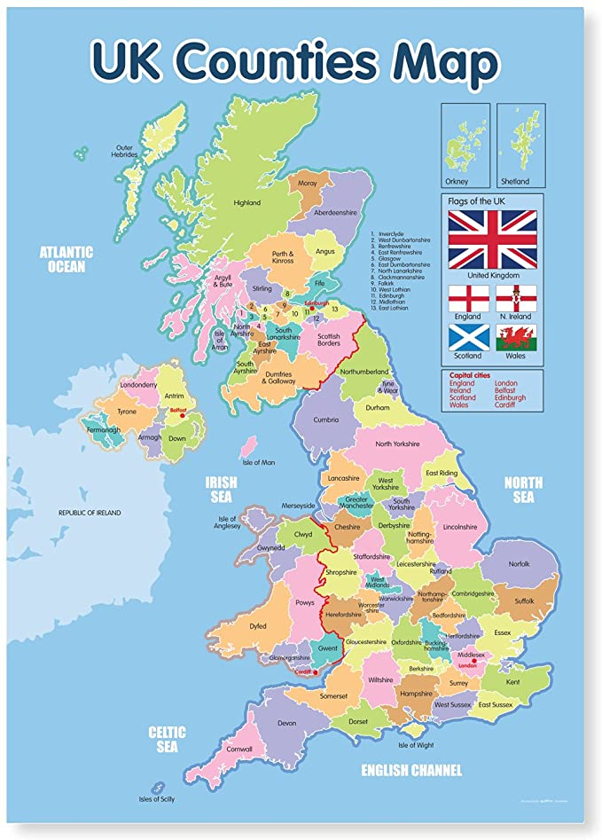
( Images-na.ssl-images-amazon.com. 2022.)

2.0 History and Origins of Digital Surveying
Picture
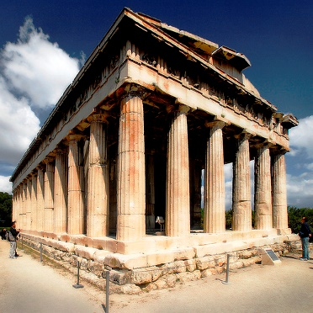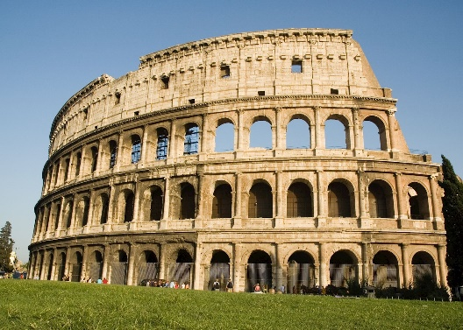
(Bing.com. 2022. Bing.) (ancient Rome - Bing, 2022)

Surveying is a common method in which an area is measured using certain systems. This creates consistency in the construction period of project developments. This back dates to pre historic times such as ancient Greece, ancient Egypt, early Roman period, The Roman period, the British post roman period, the Gothic period, Tudor period and the modern-day period.
Ancient Greece
There were three main units of measurement during the ancient Greek period these included the following digit, foot and 1 Stadion. There were also three different ways in which length was measured by the ancient Greeks. Schoinon is a cord of a standard length this can vary due to humidity making it an inconsistent method of measuring length. Halysis was a metallic chain that was also used to measure length this was more effective in harsh conditions than the cord but could have potentially been heavy for using over a long period of time. Kalamos was another method this was a measuring rod in the forms of a reed or wood. Again this could shrink and extract in humid and dry conditions.
Roman Empire
In the early Roman period, the method used for measuring distance was an object called an odometer. This was in the shape of chariot on 4 wheels. The wheels were 4 foot in diameter and would rotate 400 times per Roman mile. When in motion the box on the chariot would drop a pebble every 400 turn to locate the mile. Then by measuring they would simply just count the pebbles to gauge the distance. This method was created by Marcus Vitruvius Pollis who was a famous architect during the early Roman period. Other methods of measuring were discovered Roman empire such as Dioptra, Libella and Charobates.

Britain post Roman period including the Gothic period and Tudor.
In 1085-1086 period William the conqueror commissioned the doomsday book. This was a survey to map out Britain but excluding northern areas. This allowed William the conqueror to split the country up into county’s so he could collect taxes from the Land owners of each area. William the conqueror actually died before the published.
(National Geographic Channel, 2022)

Traditional Methods of measuring
The following methods are currently used by trades and other occupations through out the construction industry and for domestic use. Chain, tape measures, ranging/ Gauging pole, compass, plumb bob and line, plane table.
Digital surveying Methods
The following methods are used by engineering and civil companies. When surveying and mapping out sites and areas of land. This is currently the most advanced methods in the surveying history. Electronic theodolite, electronic distance measurement (EDM), total station, Global positioning system (GPS), electronic levels and lasers. The use of these technologies can be uploaded into computer software’s and shown over a period of time using different devices. This will create a fast efficient and accurate way of data transfer creating a quality output to professionals in relevant areas.
- Classifications of Digital Surveying
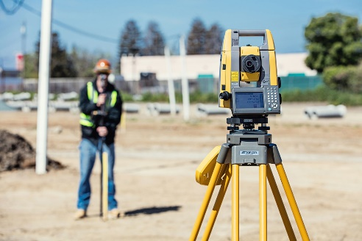
(Total station surveying - Bing images, 2022)
Classifications of surveying
The main 5 classifications of digital surveying is:
- Stake out and setting out
- Computing
- Mapping
- Field work
- Research analysis and decision making
Methods of digital surveying
There are two main methods of digital surveying:
- Plane surveying- this is where the earth’s surface is seen as a plane surface, any curvatures or extra land masses are ignored during the survey. The line joining two separate stations is considered as a straight line. The triangle formed by all three points is considered as the plane. The angles of the triangles are then considered to be the plane angles. All these factors are the making of a plane survey.
- Geodetic surveying – This is where the earths surface is not flat as in a straight line and is in fact curved. The curvature and land mass is taken into account. The line a joining two separate stations is called the curved line. The triangle formed by all three points is called a s spherical. The angles of the triangle is called a spherical. All these points make up a Geodetic survey this in fact the opposite to plane surveying and will be used when the terrain is uneven to the eye.
The Different types of Surveys and what they are used for
- Cadastral surveys- this survey is generally for demarcation of properties, boundaries, corners. This survey also includes towns and provincial jurisdictions in urban and rural areas. These surveys can be used in several situations in construction a common example is service drawings and site location.
- City surveys- are surveys that show the outline of the cities in question. They can also show lines of expansion for infrastructure. This will also show monuments and older buildings along with locating property’s lines.
- Construction survey- these are the surveys that are taken on site by engineers and architects. This is a way of capturing data and displaying date to site teams. The certain items they display is are grades, reference lines, dimensions, ground configuration and the location of structures.
- Forestry survey- this is a survey that a lines with forest management and the conservation of forest lands. This will also out line the forest boundaries and different types of trees and shrubbery.
- Hydrographic survey- This a survey that shows water courses such as lakes, reservoirs, harbours, oceans and rivers. These surveys are important for navigation, resources, flood control, irrigation, construction and more technical options such as hydro-electric power plants.
- Industrial survey- this is a survey that shows big industrial units along with ship buildings., aircraft hangers and complex machinery. This will generally map out industrial estates for manufacturing of goods, docks and airports.
- Mine survey- a mine survey shows under ground excavations and tunnel runs of areas that used to be mined. These surveys are accessible though the mine authorities. this is critical information when doing any enabling works on construction sites.
- Photogrammetric survey - is surveys taken by photographic equipment showing land mass this method is delivered by the use of ground stations and aircrafts.
- Route survey- are the definition of earth works, railways, highways, canals and other linear objects this is a survey used for planning permission and other industrial litigation.
- Topographic survey – this a survey outlining the change in elevation on land mass. This will also pick up historic sections of land such as castles and mounds.
4.0 Tools and Equipment used for Surveying
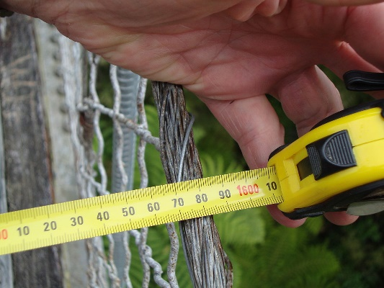
(Measuring tapes for surveying - Bing, 2022)
Linear Measurements and Equipment
- All steel tapes are designed to measure certain lengths under certain temperatures and a certain pull when fully extended. The general temp and pull for tapes are 20°c and at 50N of pressure. When taking measurements using a steel tape you will work with an accuracy of 1 in 10,000 if you are careful or for example 3mm for a 30-metre distance. Fibreglass tapes are a tape that is made up of fibreglass strands embedded in PVC. So, this tape can be used in wet conditions. Fibreglass tapes are lighter and mor flexible which means its less likely to break rather than the steel tapes. They stretch more when pulled creating an accuracy of 1- 10,000. The are many errors that can accrue when using tapes such as human error of observation, twists/dips in the tape, variations in temperature, variations in tension, and poor alignment. Other linear measurements can be used by such things as measuring wheels, and measuring Rods. There are mechanical options such as Lasers, these can measure not only linear measurements but also area and angles of rooms. The only main problem that you can get is picking the laser up in bad light, battery’s being faulty, water damage and it being knocked out of alignment. Other measuring equipment that is used for surveying energy loss and moisture content. These are thermal cameras and protimeters.

Levelling Equipment
There are two main methods of levelling these are rise and fall and height of collimation. There are two types of measuring these are building/dumpty levels and digital levels. the digital levels will be used along with a tripod on flat ground and a levelling staff to reflect the height in which you are working to including below and above ground. This equipment is most commonly used for highways, railways and other forms of construction. This method would be carried out by competent engineer. Theodolites and total station are also used for mapping construction sites. The equipment used for this is a station on a tripod, a Prizm on a pole and datum points located throughout site. This is a form of GPS surveying and data control. This method is very accurate using past and present data.

  - The Application of Digital Technologies in Surveying Listed Buildings.
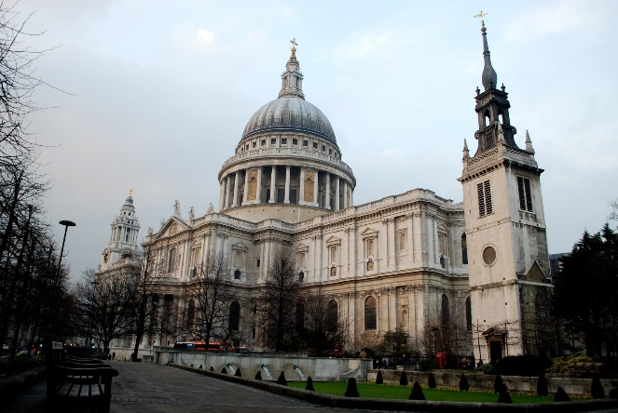
(St. Paul's Church London - Bing, 2022)
Listed building Survey
‘’A listed building in the United Kingdom is a building which has been placed on the Statutory List of Buildings of Special Architectural or Historic Interest. There are just under 500,000 buildings in the UK to which this applies.
A listed building may not be demolished, extended or altered without special permission from the local planning authority (who typically consult the relevant central government agency, particularly for significant alterations to the more notable listed buildings). Exemption is provided for some church buildings in current use for worship, although in such cases the church organisation operates its own permissions procedure.
For a building to be included on the list, it must be a man-made structure that survives in something at least approaching its original state. Most structures on the list are buildings, but other structures such as bridges, monuments, sculptures, war memorials, and even milestones and mileposts may also be listed. Ancient uninhabited or unmaintained structures, such as Stonehenge, are generally classified as Scheduled Ancient Monuments rather than Listed Buildings.
All buildings built before 1700 which survive in anything like their original condition are listed, as are most of those built between 1700 and 1840. The criteria become tighter with time, so that post-1945 buildings have to be exceptionally important to be listed. A building has normally to be over 30 years old to be eligible for listing.
In England and Wales, listed buildings are classified in three grades:
- Grade I buildings are of exceptional interest, sometimes considered to be internationally important. Just 2.5% of listed buildings are Grade I.
- Grade II* buildings are particularly important buildings of more than special interest. 5.5% of listed buildings are Grade II*.
- Grade II buildings are nationally important and of special interest. 92% of all listed buildings are in this class and it is the most likely grade of listing for a private residential building.
Scotland currently uses categories A, B and C rather than grades. The assessment criteria for the categories differs slightly from the English and Welsh system, so a category B building in Scotland is not necessarily equivalent to a grade II* building in England.
Owners of listed buildings are, in some circumstances, compelled to repair and maintain them and can face criminal prosecution if they fail to do so or if they perform unauthorised alterations. When alterations are permitted, or when listed buildings are repaired or maintained, the owners are often compelled to use specific (and potentially expensive) materials or techniques. This, in turn, increases the cost of insuring the building. Listing can also limit the options available for significant expansion or improvement. For these reasons, the law allows owners of listed buildings to object to the listing, and in some cases buildings may be removed from the listing altogether (although this is rare).
The creation of the statutory list was prompted by damage to buildings in World War II. Previously, only major ancient monuments had either state recognition or statutory protection. The Town and Country Planning Act 1947 codified the adhoc processes developed during the war and created the first formal list of listed buildings.
Following a major public outcry at the demolition of the art deco Firestone Factory in 1980, the government instituted a major resurvey of buildings to ensure that nothing which merited preservation had been missed off the original lists. The mid to late 80s saw the largest number of buildings added to the list, with over 36,000 being added in 1987 alone. By 1989 the process was largely complete, and subsequent years have seen much fewer buildings added. In 2013, only 420 buildings were listed, the fewest annual total since The Town and Country Planning Act 1947 came fully into force. Following the completion of the 1980s review, the new procedures were included in The Planning (Listed Buildings and Conservation Areas) Act 1990 which now governs the principles by which buildings are added to the lists.
Numbers have increased slightly in recent years, with 1,156 being added in 2016. Many of the more recent additions have been war memorials and other war-related structures, which were not originally considered to merit listing. But, with the centenary of WWI taking place from 2014 to 2018, many structures associated with the era are being reassessed.
Newer buildings continue to be added to the lists as they are identified and become eligible. The majority of newer buildings are those which had not previously been old enough or unique to be listed, or which have acquired a place in popular culture as a result of their use rather than purely on their architectural merit. An example of the latter is the recently listed Abbey Road Studios.’’
(Stuff, G., 2022. About Listed Buildings.)
Planning
Planning looks into a few main factors which are mainly to do with research, analysis and decision making. The research will involve looking at the following data and information:
- Os data/historic maps/topography
- Asbestos Register plans
- Fire plans
- Previous planning applications
- Original property Dead’s
- Building file/o and m manuals
- As built drawings
All of the above builds the information need when looking at any alterations of any work to a listed building this will be done by qualified and competent architect/engineer.

  - Referencing and citation
- Britishlistedbuildings.co.uk. Available at: <https://britishlistedbuildings.co.uk/site/about-listed-buildings/#.YhN8TYrP1PY> [Accessed 21 February 2022].
- Nationalgeographic.com. 2022. National Geographic Channel. [online] Available at: <https://www.nationalgeographic.com/tv/shows/doomsday-preppers> [Accessed 21 February 2022].
- I.pinimg.com. 2022. [online] Available at: <https://i.pinimg.com/originals/b4/35/c0/b435c06e2474badbf0b7213b4206f69b.jpg> [Accessed 21 February 2022].
- Images-na.ssl-images-amazon.com. 2022. [online] Available at: <https://images-na.ssl-images-amazon.com/images/I/71fs1mbzzKL._AC_SX679_.jpg> [Accessed 21 February 2022].
- <https://www.bing.com/images/search?view=detailV2&ccid=7Zux%2ftz6&id=F8704D1C6AF890E29A2E4971B372E4539C6A3897&thid=OIP.7Zux_tz6o3_zy3uOadkIXgHaFS&mediaurl=https%3a%2f%2fcdn.audleytravel.com%2f2797%2f1997%2f79%2f1024931-colosseum-rome.jpg&cdnurl=https%3a%2f%2fth.bing.com%2fth%2fid%2fR.ed9bb1fedcfaa37ff3cb7b8e69d9085e%3frik%3dlzhqnFPkcrNxSQ%26pid%3dImgRaw%26r%3d0&exph=1997&expw=2797&q=ancient+rome&simid=608022435657230851&FORM=IRPRST&ck=FE12C698A4BCE0B9FFDD91E002449DA4&selectedIndex=11&ajaxhist=0&ajaxserp=0> [Accessed 21 February 2022].
- Bing.com. 2022. mearuring tapes for surveying - Bing. [online] Available at: <https://www.bing.com/images/search?view=detailV2&ccid=7HjpB2%2bb&id=E392D3F69D4526E9C1E0189979996102B40425DB&thid=OIP.7HjpB2-bznBkryjL-ikM1gHaFj&mediaurl=https%3a%2f%2fth.bing.com%2fth%2fid%2fR.ec78e9076f9bce7064af28cbfa290cd6%3frik%3d2yUEtAJhmXmZGA%26riu%3dhttp%253a%252f%252fborchardsurveying.com%252fwp-content%252fuploads%252f2017%252f03%252ftape-measure.jpg%26ehk%3dgMe59ngfckI4DQxM7wF%252bBpH6mRj4lk4wpMWxt4WFDnQ%253d%26risl%3d%26pid%3dImgRaw%26r%3d0&exph=960&expw=1280&q=mearuring+tapes+for+surveying+&simid=607997134006412850&FORM=IRPRST&ck=C2A2A47DA2BAA389D30707A530B37EC8&selectedIndex=34&ajaxhist=0&ajaxserp=0> [Accessed 21 February 2022].
- Bing.com. 2022. total station surveying - Bing images. [online] Available at: <https://www.bing.com/images/search?view=detailV2&ccid=WIQyibrw&id=99370FFF6E38E14E9635F5DFC358BEE728234E95&thid=OIP.WIQyibrwCSQmUaNa416eQQHaE8&mediaurl=https%3a%2f%2fwww.positionpartners.com.au%2fwp-content%2fuploads%2f2019%2f07%2ftotal-station-hero.jpg&cdnurl=https%3a%2f%2fth.bing.com%2fth%2fid%2fR.58843289baf009242651a35ae35e9e41%3frik%3dlU4jKOe%252bWMPf9Q%26pid%3dImgRaw%26r%3d0&exph=720&expw=1080&q=total+station+surveying&simid=608013420521276899&FORM=IRPRST&ck=C28F59C64DC4ECB4BDA18B9C491276DD&selectedIndex=8&ajaxhist=0&ajaxserp=0> [Accessed 21 February 2022].
- Bing.com. 2022. St. Paul's Church London - Bing. [online] Available at: <https://www.bing.com/images/search?view=detailV2&ccid=EVjuI52T&id=92EFE85C7C7ECFF6AEE1670CEE45E8E59C19C518&thid=OIP.EVjuI52TjaRieF_R09aHNQHaE9&mediaurl=https%3a%2f%2fth.bing.com%2fth%2fid%2fR.1158ee239d938da462785fd1d3d68735%3frik%3dGMUZnOXoRe4MZw%26riu%3dhttp%253a%252f%252f1.bp.blogspot.com%252f-w-ZBBfeK3rA%252fUbbvG0z3WWI%252fAAAAAAAADII%252f8rd7fVGDLdQ%252fs1600%252fSt-Pauls-Cathedral-London.jpg%26ehk%3dwuVXX2KzTN80zBryzsfVk83jq5n9ZSqijDjP98KSi7E%253d%26risl%3d%26pid%3dImgRaw%26r%3d0&exph=1071&expw=1600&q=St.+Paul%27s+Church+London&simid=608006681723876394&FORM=IRPRST&ck=B22D4192537F5DB24B77629BE2110801&selectedIndex=8&ajaxhist=0&ajaxserp=0> [Accessed 21 February 2022].

