EGCE4002P: Academic Study Skills for Students
Student Number: 1902484 Eleanor Molyneux

Table of Contents
Portfolio Task 1 – Developing your skills: vision of success as a student-teacher 3
Create a digital mind-map of all the resources available to you as a university student 3
Complete the Current Skills Audit 4
Based on these two activities, write a short paragraph of what you think success would look like for you. 5
Portfolio Task 2 – Developing Critical Thinking 6
Read and complete the activities in on critical thinking skills. Write a short summary that identifies the key points. 6
Portfolio Task 3 – Developing Critical Writing 8
Write a short piece entitled: ‘What I think about Education in Wales’. The writing should be academic in style and should include at least three references. 8
References 10

Portfolio Task 1 – Developing your skills: vision of success as a student-teacher

Create a digital mind-map of all the resources available to you as a university student

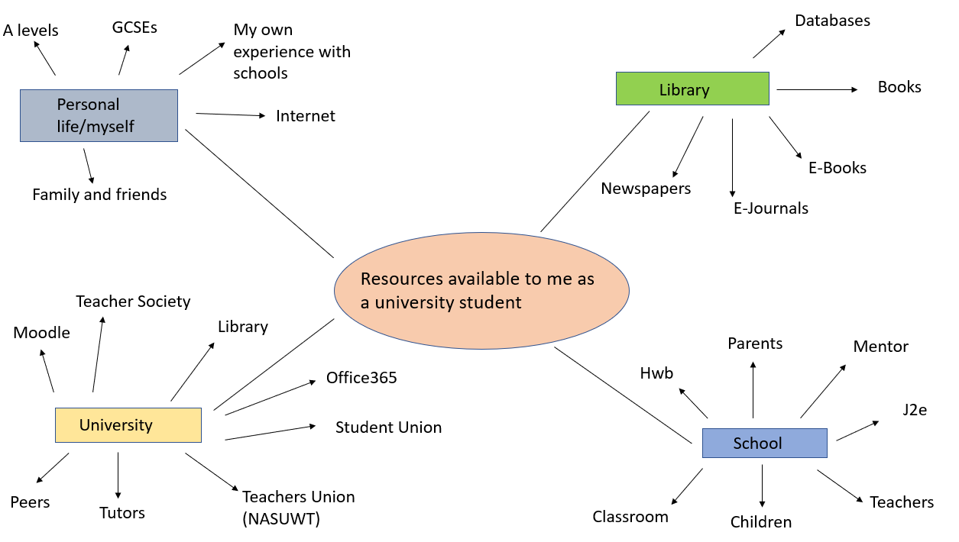

Complete the Current Skills Audit
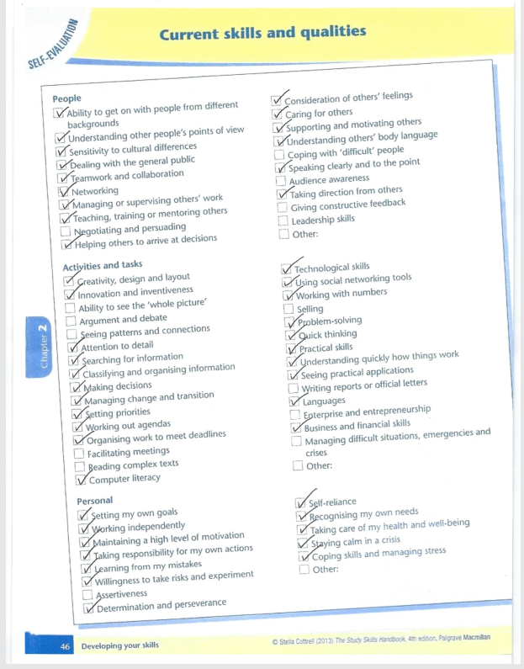

Based on these two activities, write a short paragraph of what you think success would look like for you.
When I think of success, I picture myself on my graduation day. Knowing that the determination and commitment that I have given, as well as the knowledge and experience that I have accumulated during my time at University, has led me to this important moment of my life. The high level of expertise from my peers that assisted me through each assignment and prepared me during my time on placement has all built up and allowed me to obtain a high honours degree. The realisation that from this moment forward, my degree along with the variety of skills that I have improved during my time, and the new skills that I have gained over the past three years will allow me to pursue my chosen career by being a teacher. A career that will give me the ability to influence children at some of the most important years of their development and provide them with the foundations that they will continue to build on for the rest of their lives. This is what I believe success to look like for me as a student-teacher.

Portfolio Task 2 – Developing Critical Thinking

Read and complete the activities in on critical thinking skills. Write a short summary that identifies the key points.

Chapter One from Stella Cottrell’s book titled ‘Critical Thinking Skills’ provides an in-depth view of what critical thinking is and the expertise that are linked to it. The chapter opens with the assumption that the necessary skills can be worked on, however, the reader needs to understand what critical thinking is and how to put it into practice. Cottrell explains ‘’Critical thinking is a complex process of deliberation which involves a wide range of skills and attitudes’’. (Cottrell, 2005)
Some of these skills include: -
- Recognising other people’s reasonings and conclusions
- Being able to look at the bigger picture
- Spotting false or unfair assumptions
- Presenting a point of view in a reasoned and structured way that persuades others
It also focuses on the obstacles that can affect the development of this type of thinking. Many people struggle to develop their critical thinking skills due to personal, emotional or affective reasons.

These can include: -
- Mistaking the meaning of criticism - some people assume that criticism must be negative and therefore they will avoid commenting, which can be discouraging due to no constructive criticism
- Misunderstanding information for understanding, this draws upon theorists Cowell, Keely, Shemburg and Zinnbauer. (Cowell, B., Keely, S., Shemberg, M. and Zinnbauer, M., 1995) who wrote about students that naturally refrain from learning how to think critically due to preferring to have facts and answers rather than learn the skills to support them in making decisions for themselves.

Such reasonings can create barriers when it comes to critical thinking. The chapter gives the reader an opportunity to reflect on how barriers such as these could be having a consequence on their own thinking potential and how they will control these going forward.

Cottrell also highlights some benefits to critical thinking such as: -
- Greater accuracy and precision
- Enhanced retention and observation
- The ability to identify key information within a piece of writing
- Being concise throughout your work

Ancillary skills like analysis, judgment and observation are also developed through critical thinking. The more these skills are improved on, the more confident you are to achieve a successful outcome following a complex issue.

Cottrell refers to theorist Ennis (Ennis, R. H., 1987) who identified the qualities that are linked with critical thinking. These qualities focused on the ability to consider sceptically and the ability to reflect in a reasoned way. Scepticism in critical thinking means questioning the evidence. It is important to be aware that you may only be seeing a single piece of the jigsaw puzzle.

Not only does this chapter give you researched and respected points of view from recognised experts, it also includes self-evaluation tools where you can rate how strongly you agree with the statements. Once completed it will provide a path as to what critical thinking skills the reader needs to develop, giving them priorities to focus on.
Overall this chapter informs us of the process of critical thinking, the range of skills and personal qualities that are needed. Once barriers have been identified, practice is put in place, and a sense of what needs to be developed going forward, this skill should improve.

Portfolio Task 3 – Developing Critical Writing

Write a short piece entitled: ‘What I think about Education in Wales’. The writing should be academic in style and should include at least three references.
“The school curriculum in Wales, as in England and Northern Ireland but not Scotland, has been statutory since 1988.” (Donaldson, 2017) current curriculum that children in Wales are taught is not up to date. As society and technology have changed with the times it is of importance that a curriculum is put in place that will meet the needs of children and young people in Wales, as well as preparing them for a future that they can succeed in. The Welsh Assembly Government acknowledged the concerns around the relevance and workability of the current curriculum and in March 2014, Professor Graham Donaldson was commissioned to analyse the current curriculum and assessment arrangements throughout schools in Wales. The aim of Donaldson’s review was to ‘’shape a successful and exciting future’’ (Donaldson, 2018) for students in Wales.

Donaldson and his team started by visiting schools across Wales, he met with Headteachers, Teachers, Students, Professionals, and so on, providing them the chance to put their views across. To assist them with the review they also did further research by looking at Estyn reports, Welsh Government policies and other reports. The response to Donaldson’s call for evidence was excellent, he gathered around 700 responses with over 300 of these coming from children and young people. The evidence received was a significant factor in Donaldson’s conclusions. (Donaldson, 2015) Some feedback that Donaldson received from teachers was that they wanted more control when it comes to making decisions about how and what to teach within the curriculum. They also explained that the current assessment arrangements in place were not supporting children’s learning abilities.

Children and young people communicated that they: -
- Thought the current curriculum was old-fashioned especially regarding technology, software, and digital skills
- They wanted more focus on life skills, personal confidence, and career advice within schools
- Children also mentioned that they want their learning to be enjoyable, engaging and not just loaded with the necessary information needed in order to pass exams and assessments (Donaldson, 2018)

I believe that Donaldson did the correct thing by gathering evidence from schools, as the people in this environment are seeing first-hand the troubles that the current curriculum is causing, and by using the evidence he could see what significant changes were needed in order to shape a new curriculum that meets the needs and wants of teachers and learners throughout Wales.

In February 2015, Donaldson released his independent review of the curriculum and assessment arrangements in Wales which he titled ‘Successful Futures’. ‘Successful Futures’ is a framework which will be rolled out to Primary Schools in 2022.

The framework consists of four purposes which will shape children to be: -
- “Ambitious, capable learners, ready to learn throughout their lives
- Enterprising, creative contributors, ready to play a full part in life and work
- Ethical, informed citizens of Wales and the world
- Healthy, confident individuals, ready to lead fulfilled lives as valued members of society” (Donaldson, 2017)

The four purposes are focused on shaping the younger generation to become well-rounded individuals, providing them with valuable life skills and knowledge that they will continue to build on and draw on throughout their lives. The framework encourages them to have a passion for continuous learning, become a valued member of society.

References
Cottrell, S., 2005. What is Critical Thinking?. In: S. Cottrell, ed. Critical Thinkng Skills. Basingstoke: Palgrave Macmillian, pp. 1-16.
Cottrell, S., 2013. The Study Skill Handbook. 4th ed. Basingstoke: Palgrave Macmillian.
Cowell, B., Keely, S., Shemberg, M. and Zinnbauer, M., 1995. Coping with Student Resistance to Critical Thinking. What the Psychotherapy Literature Can Tell Us, Volume 4, p. 43.
Donaldson, P. G., 2015. Successful Futures - Independant Review of Curriculum and Assessment Arrangements in Wales, Cardiff: Welsh Government.
Donaldson, P. G., 2017. A Systematic Approach to Curriculum Reform in Wales. Wales Journal of Education, Issue 1, pp. 7-11.
Donaldson, P. G., 2018. Successful Futures. [Online] Available at: https://gov.wales/sites/default/files/publications/2018-03/succesful-futures-a-summary-of-professor-graham-donaldsons-report.pdf?fbclid=IwAR0BnuYQs2OHMgckgy7MCvP2BLAy0BZqEudrUcJDGDLVFYwzXUpuBSQjV9g [Accessed 31st October 2019].
Ennis R. ,H., 1987. A Taxonomy of Critical Thinking Dispositions and Abilities. Teaching Thinking Skills: Theory and Practice, pp. 9-26.

