

Student Name : Amit Jagdishbhai Jikadra
Student ID : 2526285
Module Name : Financial Management
Module Code : LCMB7002

Lecturer’s Name : Dr Shengfeng Mei
Work Count : 5101
Submission Date: 24th April 2026
Term 1

Topic: Strategic CFO Challenge

Assignment title: Financial Performance and Management-Volkswagen

Table of Contents
1.0 Introduction 5
1.1 Overview of Volkswagen 5
1.2 Industry Context 5
2.0 Financial Health Check 5
2.1 Overview of Financial Performance (5 years) 5
Income Statement Analysis 6
Balance Sheet Analysis 7
Cash Flow Statement Analysis 8
2.2 Ratio Analysis 9
a) Profitability Ratios 9
b) Liquidity Ratios 9
c) Efficiency Ratios 9
d) Gearing Ratios 10
e) Investment Ratios 10
f) Cash Flow Analysis 10
2.3 Key Findings 11
Strengths 11
Weaknesses 11
Trends 12
3.0 Working Capital Management Analysis 12
3.1 Cash Operating Cycle 12
3.2 Evaluation 12
3.3 Recommendations 13
Improve Receivables Collection 13
Inventory Optimisation 13
Supplier Financing Strategies 14
3.4 Financing Options 14
Short-term vs Long-term Financing 14
Trade-offs and Implications 14
4.0 Strategic Financial Restructuring Plan 15
4.1 Current Financial Challenges 15
Debt Levels 15
EV Transition Costs 15
Profit Margin Pressure 16
4.2 Restructuring Options 16
Divestitures 16
Equity Financing 16
Strategic Partnerships and Mergers 17
4.3 Impact Evaluation 17
Shareholder Value 17
Capital Structure 17
Financial Flexibility 18
4.4 International & Ethical Considerations 18
Currency Risk 18
Inflation 18
Taxation 18
ESG Considerations 19
5.0 Investment Appraisal & Capital Budgeting 19
5.1 Methodology 19
5.2 Project Evaluation 19
Project A Analysis 19
Project B Analysis 20
Project C Analysis 20
5.3 Decision 20
Recommended Project 20
Justification 21
5.4 Capital Rationing Decision 21
Budget = £100 million 21
Best Combination of Projects 21
Justification 22
6.0 Conclusion 22
6.1 Summary of Key Findings 22
6.2 Final Strategic Recommendations 22
7.0 References 24
8.0 Appendices 27
Appendix A: Ratio Calculations 27
Appendix B: Ratio Graphs 28
Appendix C: Investment Appraisal Workings 31
Appendix D: CCC 36
9.0 AI Acknowledgement 37

1.0 Introduction

1.1 Overview of Volkswagen
The Volkswagen Group is a large automotive manufacturer in the world, with a rich portfolio of brands, such as Volkswagen, Audi, Porsche, and Skoda. The firm has good international representation and market share in Europe, China and North America (Volkswagen, 2024). Over the last few years, Volkswagen has experienced a strategic shift to electric mobility, which was initiated by regulatory forces and sustainability objectives (Hojzakaova, 2025). This shift has necessitated a significant financial input and organisational restructuring.

1.2 Industry Context
Electric vehicles (EVs) are rapidly replacing traditional cars in the global automotive market due to environmental regulations, technological innovation, and evolving customer tastes and preferences. This change has been boosted by the policies of the European Union to eliminate internal combustion engines, which have a profound impact on companies like Volkswagen.

2.0 Financial Health Check

2.1 Overview of Financial Performance (5 years)

Income Statement Analysis
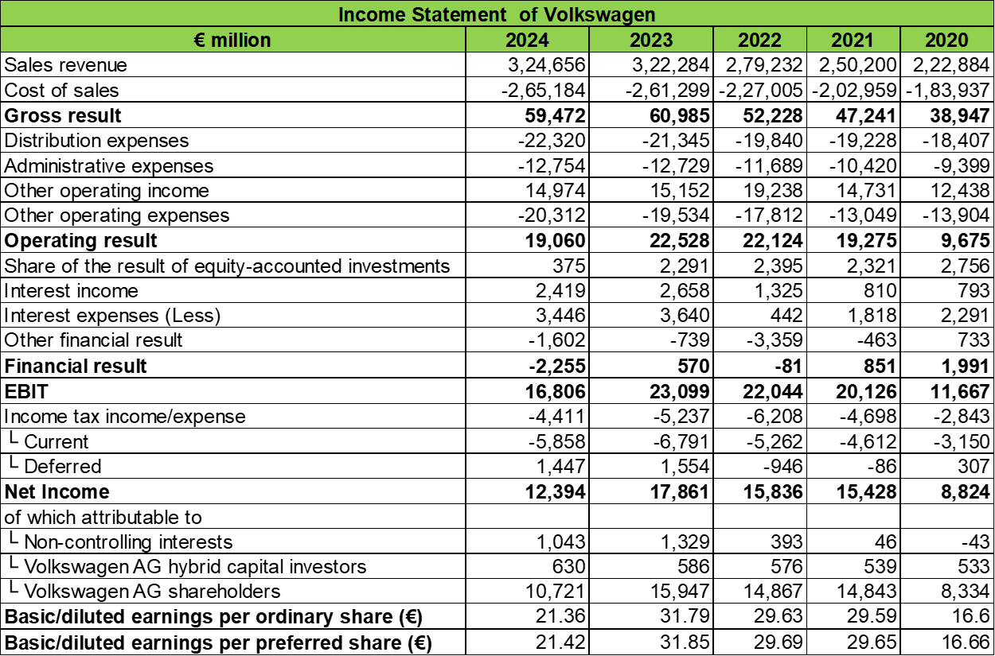
The financial performance of Volkswagen has been generally increasing but fluctuating within the 2020-2024 period. The revenue rose sharply, reaching in 2020 and 2024, respectively, the levels of €222,884 million and the level of 324,656 million, which is good evidence of an active market and the growth of electric vehicles. Gross profit increased by 38,947 million to 59,472 million, which shows better efficiency in operations. Nevertheless, the operating profit decreased in 2023 (22,528 million) to 2024 (19,060 million), indicating an increase in cost pressure, especially due to EV investment and production expenses. Profitability is also a problem as net income decreased in 2023 (€17,861 million) to 2024 (€12,394 million). Nevertheless, the earnings are still higher than in 2020, which indicates financial stability over the long term (Volkswagen, 2024).

Balance Sheet Analysis
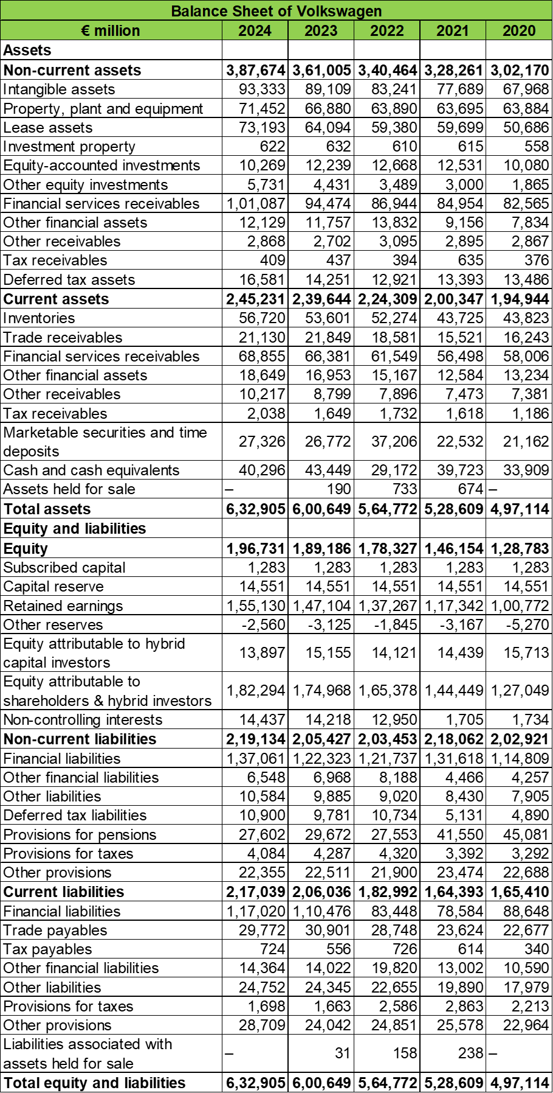
The balance sheet of Volkswagen depicts continuous growth and good growth in assets within the five-year span. The assets grew to 632,905 million in 2024 compared to 497,114 million in 2020 as a result of growing investments in intangible assets (93,333 million to 67,968 million) and financial services receivables. There was also an increase in equity, which rose to 196,731million as opposed to 128,783million that means better retained earnings and financial stability. Nonetheless, the level of liabilities is also significant, as total liabilities are over 436 billion in 2024 due to high levels of borrowing to finance the operations and EV transformation. The rise in financial obligations, especially between the years 2020 and 2024, which is between the period of €114,809 million and 137,061 million, indicates the use of debt financing. This organization underscores a growth-financial risk balance (Łabucki et al., 2026; Volkswagen, 2024).

Cash Flow Statement Analysis
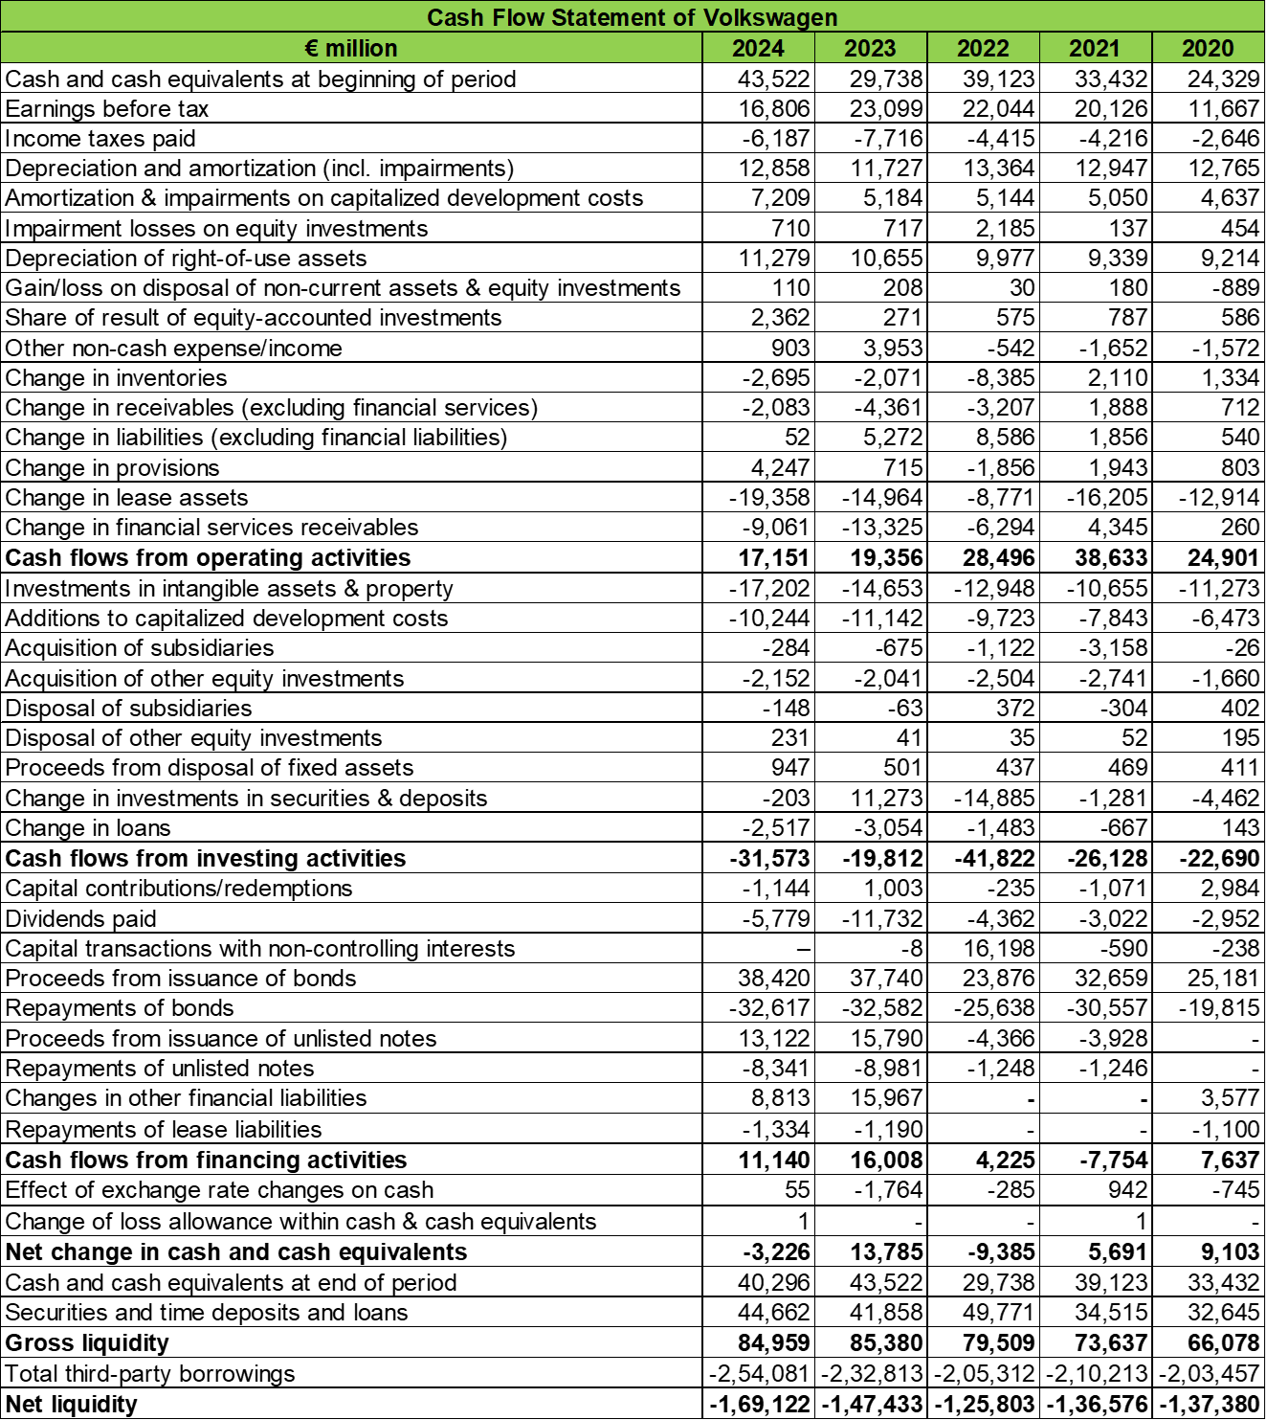
The cash flow performance of Volkswagen shows that it experienced varying liquidity levels and high levels of investments between 2020 and 2024. The cash flow operating ratio fell to €17,151 million in 2024 compared to the previous year (2021) of €38,633 million, indicating a decrease in efficiency in cash generation, partially because of heightened working capital needs and costs associated with EV. The cash flow investment in 2024 of -€31,573 million was very negative, as it was the result of constant capital expenditure on technology and production capacity. Cash flows financing became positive during recent years, and in 2024, it is expected to be positive with a value of €11,140 million, showing that it is borrowing more to finance the growth. These movements did not affect cash and cash equivalents, which remained fairly stable at €40,296 million in 2024, with liquidity maintained, but with negative net liquidity, because of high debt levels (Volkswagen, 2024).

2.2 Ratio Analysis

a) Profitability Ratios
The profitability of Volkswagen has been decreasing over the past few years, whereas it was previously rising. The Return on Equity (ROE) rose in 2020 to 6.85% and reached its highest level in 2021 at 10.56%, which shows lower returns to shareholders. On the same note, the Net Profit Margin declined to 3.82% in 2024 compared to 6.17% in 2021, which indicates an increase in the operating cost and a decline in profitability. This is because there is a high investment in electric vehicle (EV) technology and rising costs of production that have tightened margins. The shift towards sustainable mobility has demanded a high level of financial investment, impacted the short-term profitability and targeted the long-term development (Özdemir and Kırhasanoğlu, 2025; Lundgren and Viganò, 2024; Volkswagen, 2024). [See Appendix A]

b) Liquidity Ratios
The current ratio decreased by 1.23 in 2022 to 1.13 in 2024, which means that there is less financial flexibility in the short term. Equally, the acid-test ratio decreased by 0.95 in 2021 to 0.87 in 2024, indicating that it can barely fulfil its short-term commitments without the use of inventory. The cash ratio declined from 0.20 to 0.19 from 2020 to 2024 respectively. These trends indicate that there is a growing working-capital pressure, probably because of increased costs of operation and venture into EV production. Effective management of working capital is consequently needed to ensure the financial stability of a capital-intensive industry (Kayani et al., 2025; Yousaf, 2022; Volkswagen, 2024). [See Appendix A]

c) Efficiency Ratios
The efficiency ratios of Volkswagen show that the company has a moderate performance in its operations with fluctuations. Receivables turnover ratio rose by 13.72 in 2020 to 15.36 in 2024 and indicates improved credit management and quicker receivables collections. The inventory turnover ratio is a mixed performance with an increase in 5.09 in 2020 to 6.01 in 2023, which dropped slightly in 2024 to 5.72. This shows inconsistency in the efficiency of managing inventory, which could be a result of disruptions in the supply chain and the fluctuation in production demand. The “asset turnover” and “fixed asset turnover” are increased from 2020 to 2024. The EV transition can also be a cause of inventory issues, with new technologies needing new production processes (Łabucki et al., 2026; Zaino et al., 2024). [See Appendix A]

d) Gearing Ratios
The gearing ratios of Volkswagen indicate that it uses a high amount of debt financing, but there has been a slight improvement over the years. The debt-to-equity ratio declined to 2.22 in 2024 after it was 2.86 in 2020, showing slow improvement of the capital structure. Nevertheless, the company is still highly leveraged. The times interest earned ratio decreased significantly between 11.07 in 2021 and 4.88 in 2024, indicating that the company could not cover interest expenses as well. The large percentage of 49.87 in 2022 is not a result of long-term operation but rather a short-term financial indicator. Financial risk has increased due to increased borrowing to fund EV investments and technological transformation (Graham, 2022; Volkswagen, 2024). [See Appendix A]

e) Investment Ratios
The investment ratios of Volkswagen give conflicting indications on the returns to shareholders and market value. The dividend payout ratio was also rather steady (0.24-0.28), which signifies a stable dividend policy. Nevertheless, the price-to-earnings (P/E) ratio dropped to 2.13 in 2024 downward compared to 4.90 in 2020, indicating less investor trust or devaluation. This fall could be indicative of the uncertainty linked to the company switching to electric vehicles and the risk of investing in large amounts of capital. Capital budgeting decisions need to be effective to promote shareholder value (Purnamasari and Adriza, 2024; Volkswagen, 2024). [See Appendix A]

f) Cash Flow Analysis
The cash flow ratios of Volkswagen show that the company is experiencing a decline in their cash generation ability over the past five years. The operating cash flow ratio has decreased from 0.24 in 2021 to 0.08 in 2024, indicating a decreased capability of meeting the short-term liabilities using operating cash flows. Likewise, the cash flow to debt ratio declined to 0.04 in 2024 as compared to 0.10 in 2021, which means a reduction in the ability to meet debt obligations. The “free cash flow” is declined from 2020 (0.90) to 2024 (0.49). These tendencies imply the rise in financial pressure because of high capital spending and investment in EV development. The continuity of cash flow will play a vital role in sustaining further growth and financial stability (IEA, 2024; Volkswagen, 2024). [See Appendix A]

2.3 Key Findings

Strengths
Volkswagen has several financial strengths in the five years period, especially when it comes to increasing revenues and assets. In the year 2020, the sales revenue stood at a very high level of €222,884 million which declined to 324,656 million in 2024 showing that there was a great demand in the market and that it is present globally. The company has been relatively steady in terms of profitability even in the face of industry challenges, with net income of over 12billion in the year 2024. The increase in receivables turnover is an indication of effective credit management and efficiency in its operations (Łabucki et al., 2026; Volkswagen, 2024; Zaino et al., 2024).

Weaknesses
Volkswagen has several financial weaknesses, especially as regards profitability and liquidity, in spite of its strengths. Net profit margin decreased in 2024 to 3.82% compared to 6.17% in 2021, reflecting growing cost pressures and a lack of operational efficiency. Equally, the 2024 returns on equity declined to 6.30, suggesting to shareholders a decrease in returns. The liquidity ratios have deteriorated, and the current ratio has decreased to 1.13, and the acid-test ratio to 0.87, indicating the possible short-term financial risk. High investments in the development of electric vehicles and the increased cost of production are key reasons behind these problems, as well as pressure on financial performance (Özdemir and Kırhasanoğlu, 2025; Kayani et al., 2025; Volkswagen, 2024).

Trends
The financial performance of Volkswagen shows growth, decline and fluctuation in the five years. There is a steady increase in revenue and total assets, which is brought about by growth and electric vehicle technology investment (Lundgren and Viganò, 2024; IEA, 2024; Volkswagen, 2024). Nonetheless, the measures of profitability, like net profit margin and return on equity, show a downward trend due to inflated costs and competition. There are also downward trends in cash flow and liquidity ratios, reflecting decreased financial flexibility.

3.0 Working Capital Management Analysis

3.1 Cash Operating Cycle
The cash operating cycle of Volkswagen is moderate and has some variations in the past five years. The decrease in inventory days was from 71.77 days in 2020 to 63.77 days in 2024, which depicts better inventory management, though a bit volatile. Receivable days were very steady, decreasing from 2020 to 23.76 in 2024, indicating good control of credit and quicker collection. Payable days fluctuated, decreasing from 37.14 days in 2020 to 33.47 days in 2024, suggesting slightly quicker payments to suppliers. Overall, the cash conversion cycle improved from 61.23 days in 2020 to 54.05 days in 2024, although it peaked at 55.04 days in 2022. All these trends imply a better working capital efficiency, though the cycle stability is still affected by the continued changes in working with EVs (Kayani et al., 2025; Yousaf, 2022; Volkswagen, 2024). [See Appendix D]

3.2 Evaluation
The working capital management of Volkswagen shows a medium efficiency, with a positive change of its cash conversion cycle, which fell to 54.05 days in 2024 compared to 61.23 days in 2020. The days outstanding receivables and lower inventory holding days reflect that they have good control of their operation and better cash flow management. Nevertheless, the liquidity ratios are relatively low, and the operating cash flow is decreasing, which indicates that there are some liquidity risks involved. The 2024 current ratio (1.13) and acid-test ratio (0.87) show minimal financial flexibility in the short term. Further, low payable days also means that the cash outflows will be quicker, and this can cause a liquidity strain. These uncertainties are further compounded by major investments in capital equipment to produce EVs and transform to technology, which puts an additional burden on working capital needs (Kayani et al., 2025; Yousaf, 2022; Volkswagen, 2024).

3.3 Recommendations

Improve Receivables Collection
In order to improve its receivables collection, Volkswagen needs to adopt a more stringent credit control policy and use digital payment systems. Receivable days have been boosted to 23.76 days in 2024, but additional improvements can be made to strengthen liquidity. The company can embrace the use of automated invoicing, early payment discounts and enhanced credit risk evaluation to reduce delays. Additionally, the incorporation of data analytics can be used to create high-risk customers and optimise collection strategies. Increased receivables turnover would enhance cash inflows and facilitate operational financing, especially at capital-intensive EV expansion. The timely operation of the supply chain of receivables is essential to the preservation of the financial stability of a competitive and fast-changing industry (Kayani et al., 2025; Yousaf, 2022).

Inventory Optimisation
Volkswagen needs to concentrate on improving inventory levels by using high-demand forecasts and integrating the supply chain. Despite a lower inventory day of 63.77 days in 2024, there have been fluctuations which point to inefficiencies in stock management. Just-in-time (JIT) systems and digital inventory tracking will help the company to minimize holding costs and enhance turnover (Łabucki et al., 2026; Zaino et al., 2024). Since EV production is a complicated process, coordination with suppliers and production planning should be enhanced. Proper inventory optimisation would lead to the reduction of the excess inventory and minimisation of the risks of obsolescence and the working capital performance. This is essential, especially in an industry that is experiencing a high rate of technological change and product innovation.

Supplier Financing Strategies
Volkswagen can enhance its working capital status by implementing supplier financing techniques like paying long-term and implementing supply chain financing programmes. The payable days fell to 33.47 days in 2024, representing quicker outflows of cash, which can result in limited liquidity. Negotiating extended credit terms and reverse factoring allow Volkswagen to sustain the relationships with suppliers, as well as increase the cash flow. The strategies enable suppliers to get early payments at the hands of financial institutions and Volkswagen to have longer payment cycles. This strategy helps regulate the liquidity without impacting the operations, particularly at the time of heavy investments in EV technologies and other infrastructures (Kayani et al., 2025; Volkswagen, 2024).

3.4 Financing Options

Short-term vs Long-term Financing
Volkswagen has the potential to employ both short-term and long-term finance to assist its working capital and strategic investments. Bank overdrafts and trade credit are short-term finance sources that offer flexibility to run day-to-day operations and liquidity requirements. Long-term funding, on the other hand, such as bonds and equity, is better adapted to finance large-scale investments like electric vehicle development and infrastructure (Graham, 2022; Volkswagen, 2024). Since Volkswagen is a capital-intensive company, long-term capital is necessary to maintain its stability, and short-term sources to facilitate efficiency in its operations. A balanced financing strategy enables the company to maintain a healthy liquidity level and long-term growth.

Trade-offs and Implications
There is a trade-off between short-term and long-term financing. Short-term financing is usually cheaper and more lenient but exposes itself to greater refinancing and liquidity risks in case of default on obligations (Purnamasari and Adriza, 2024). The long-term financing is more stable and less repayment pressure but tends to be more expensive and long-term (Graham, 2022). In the case of Volkswagen, the high level of dependence on debt financing has exposed it to financial risk, as indicated by the high level of gearing. Nevertheless, to finance EV investments and technological transformation, there is a need to invest in the long term. As such, a balance between cost, risk, and financial flexibility depends on an ideal combination of sources of financing (Volkswagen, 2024).

4.0 Strategic Financial Restructuring Plan

4.1 Current Financial Challenges

Debt Levels
Volkswagen has a high debt ratio, which is a key reason why it is under pressure in terms of finances, as indicated by its gearing ratio and balance sheet structure. The debt-to-equity ratio of the company was above 2.0 in the previous years, which implies that the company heavily depends on external financing. As much as debt financing allows expansion, it raises financial risk and interest payments. The deterioration in the times interest earned ratio to 4.88 in 2024 shows a decreased ability to pay interest. This scenario strains cash flows and financial security, especially at times of economic instability. The necessity of debt-sustainable financing is thus of high priority to the financial sustainability in the long term (Graham, 2022; Volkswagen, 2024).

EV Transition Costs
The shift to electric vehicles at Volkswagen is one of the significant financial challenges. The transformation demands a lot of capital investment in research and development, production facilities, and battery technology (Černá, 2026). These expenses have greatly augmented the operational costs and diminished profitability levels. As emphasized in the literature on the industry, EV production is associated with increased start-up costs compared to traditional vehicles with internal combustion engines, especially with battery production and technological advancement (Özdemir and Kırhasanoğlu, 2025). Moreover, the European Union regulatory requirements to eliminate internal combustion engines also contribute to this change, compelling Volkswagen to spend a lot of money within a short period.

Profit Margin Pressure
The profitability of Volkswagen has been declining over the past few years, which indicates higher operational expenses and competition. The net profit margin declined to 3.82 percent in 2024 as compared to 6.17 percent in 2021, which implies that the company became less efficient in translating revenue into profit. This loss is mainly because of the increasing production costs, supply chain disruption, and heavy investment in EV technologies. Moreover, stiff competition by international firms, including Tesla and BYD, has added further pressure on prices and margins (Lundgren and Vigano, 2024; Zaino et al., 2024).

4.2 Restructuring Options

Divestitures
Divesting non-core assets or unproductive areas of business is one of the strategic alternatives that Volkswagen can utilize. The company can create liquidity through selling or restructuring less profitable business units and concentrating on its core business segments, which include electric mobility and digital transformation. Divestitures also have the capability to enhance efficiency in operations and to make the organisation simpler. Volkswagen is a brand with a long list of brands, selective divestment would simplify the company and improve profitability (Łabucki et al., 2026).

Equity Financing
The possible restructuring strategy is equity financing that will decrease the use of debt and enhance the capital structure. Volkswagen is able to raise capital through issuing new shares or equity capital increases by investors to strengthen its equity base and to lower the financial leverage. This would reduce the interest payments and increase financial stability. Equity financing can dilute the ownership of the existing shareholders, but this has long-term advantages as it minimizes financial risk and contributes to sustainable growth. Considering the magnitude of investment needed to transform into an EV, equity financing will be instrumental in facilitating strategic initiatives without raising debt levels (Graham, 2022; Volkswagen, 2024).

Strategic Partnerships and Mergers
Strategy alliances or mergers are also options that Volkswagen can consider in order to share the cost and risks involved in technological innovation. Cooperation with technology companies, battery producers, and other automotive companies can contribute to efficiency and faster development. The partnership enables the firms to enjoy economies of scale, share research and development costs in addition to accessing new markets. These collaborations are especially useful in the context of the EV transition, where it decreases the financial load and enhances competitiveness. It is possible that strategic alliances would be able to help Volkswagen grow in the long term, as well as reduce financial risks tied to substantial investments (Ladeira and Ferreira, 2025; Zaino et al., 2024).

4.3 Impact Evaluation

Shareholder Value
The proposed reorganizing plans can increase the value of the shareholders through increased profitability and lessening financial risk. Divestitures can produce short-term cash flows, and equity financing enhances the financial position of the company. Strategic partnerships have the potential to result in cost reduction and innovation and can add to the value creation in the long-term. However, shareholders may be concerned about short-term impacts such as dilution or restructuring costs. Hence, it is necessary to communicate and align the strategies so that these efforts are seen as positive in the eyes of investors (Purnamasari and Adriza, 2024).

Capital Structure
Restructuring will have dire effects on the capital structure of Volkswagen. Equity financing and divestitures can help to reduce debt levels and enhance financial leverage. A more balanced capital structure improves the stability of the company to withstand economic changes and lessens the risk of being financially distressed. Nevertheless, it is important to have an ideal balance between debt and equity since overdependence on equity can lead to a higher cost of capital. Thus, Volkswagen needs to make careful decisions regarding its financing to reach an efficient and sustainable capital structure (Graham, 2022).

Financial Flexibility
Financial flexibility is important to allow Volkswagen to act upon changes in the market and invest in the future opportunities. Flexibility of the company can be increased through restructuring strategies to increase liquidity and to decrease debt. This helps Volkswagen to be flexible to changes in technology, regulations and competition. Better cash flow management and availability of various sources of financing are other factors that enhance financial resilience (Volkswagen, 2024).

4.4 International & Ethical Considerations

Currency Risk
Volkswagen is a global company prone to currency fluctuations that may affect its financial performance. The volatility of exchange rates impacts revenues, costs and profitability, especially in the global market. These risks can be alleviated by effective hedging policies and diversification of geographical locations. Currency exposure is a crucial aspect of financial performance that should be managed to ensure the stability of the globalised economy (Lodeira and Ferreira, 2025).

Inflation
Inflation is also a major disadvantage to Volkswagen, which has caused the cost of production to go higher and consumer demand to be impacted. An increase in the price of raw materials, labour and energy can decrease profit margins (Subramaniam, 2022). To overcome these issues, Volkswagen will have to practice cost-controlling and pricing policies to sustain profitability amidst the inflationary circumstances (IEA, 2024).

Taxation
Taxation policies in various countries impact the financial performance and strategy of Volkswagen. Profitability can be affected by changes in corporate tax rates, environmental taxes, and incentives to produce EVs (Boostani et al., 2024). The firm needs to make sure it adheres to international taxation laws and maximizes its tax policy to increase financial efficiency (Černá, 2026).

ESG Considerations
Environmental, social, and governance (ESG) are also key to the reputation and success of Volkswagen in the long run. The shift of the company towards electric vehicles is in line with the sustainability and regulatory factors. Enhancing ESG activities may increase stakeholder confidence, find investment, and promote long-term value generation (Meloni, 2025). Sustainable practices are increasingly important in the automotive industry, making ESG a key consideration in financial restructuring (Hojzáková, 2025; Lundgren and Viganò, 2024).

5.0 Investment Appraisal & Capital Budgeting

5.1 Methodology
Investment appraisal techniques are used to evaluate the financial viability of projects. Payback Period (PBP) is used to determine the time it takes to recoup the initial investment, and Accounting Rate of Return (ARR) is used to determine profitability on an accounting basis (Graham, 2022; Purnamasari and Adriza, 2024). Net Present Value (NPV) and Profitability Index (PI) evaluate value creation through discounted cash flows, and Internal Rate of Return (IRR) evaluates the rate of return on a project. These techniques aid in sound financial decision-making.

5.2 Project Evaluation

Project A Analysis
Project A shows moderate performance in terms of finances, with limitations. The Net Present Value (NPV) is £8.676 million pounds, which means that the project is valuable to the firm. The Profitability Index (PI) is also acceptable, with a value of 1.174 being greater than 1. Nonetheless, the project does not break even in five years, as indicated by the Payback Period (PBP), which is not realized. Also, the Internal Rate of Return (IRR) is not high at 2.722% and indicates low returns in contrast to the 10% discount rate. There is also low profitability with the Accounting Rate of Return (ARR) at 1.6%. In general, the project is less desirable since it generates value but has low returns and cannot be recovered quickly. [Referred to Appendix C]

Project B Analysis
Project B demonstrates the same, but a bit worse performance than Project A. The NPV of £8.301 million shows that there is value creation, and the PI of 1.166 proves that the project is viable. The project has predictable cash flows annually, which minimizes uncertainty and risk. But just like Project A, the Payback Period does not recover the initial investment within five years, which implies slow recovery of the initial investment. Project A has an IRR of 3.263% that is marginally more than that of Project A but is far lower than the desired 10% return, which restricts its appeal. The ARR is 2.0%, which implies a low level of profitability. Project B is not a good choice because its returns are not very good, even though it is stable. [Referred to Appendix C]

Project C Analysis
Project C has a different performance profile that provides higher returns but is more variable. The NPV value of £1.984 million is positive and much less than that of Projects A and B, which suggests that there is little value creation. The PI of 1.040 is marginally acceptable. Nonetheless, the project has the greatest IRR of 8.587%, which is nearer to the 10 percent discount rate; hence, it is not much less appealing in terms of returns. The ARR of 6.0% is also the highest among the three projects, indicating better profitability. Nonetheless, the Payback Period is not obtained in five years, which indicates a slow cash recovery. Project C is thus risky yet has the potential of higher returns as opposed to other projects. [Referred to Appendix C]

5.3 Decision

Recommended Project
According to the outcome of the investment appraisal, Project C is the most appropriate project. It has a smaller Net Present Value (£1.984 million) than Projects A and B, but provides the highest Internal Rate of Return (8.587%) and Accounting Rate of Return (6.0%). These signals imply increased profitability possibilities when compared to the other projects. Also, the Profitability Index value of 1.040 proves the fact that the project is financially viable. Projects that have a greater potential for returns are preferable in a capital-intensive and fast-growing industry. Thus, Project C is believed to be the best option, as it is both financially viable and better in terms of its returns.

Justification
The choice of Project C is based on the current financial status and risk environment of Volkswagen. High costs of EV investment are putting the company under pressure to diminish profitability and are straining its budget. Here, a project that has a greater payoff, like Project C, is more in line with the requirement of enhancing financial performance. The project has a lower NPV, but its IRR is higher which demonstrates that it is more efficient in bringing returns, which is essential in the long-term development of Volkswagen (Lundgren and Viganò, 2024; IEA, 2024). Nevertheless, Project C is also riskier because it has fluctuating cash flows and payback delays. The company has a healthy asset base and has a strategy of continuous transformation, which means that it can handle this risk and reap better returns.

5.4 Capital Rationing Decision

Budget = £100 million
In the case of capital rationing, Volkswagen has a maximum investment budget of £100 million, which implies that only two projects can be selected because the initial investment in each of the projects is different, with each project costing an initial amount of £50 million. This constraint necessitates the rigorous use of financial resources in a bid to maximise returns and work towards the strategic goals. Capital rationing focuses on the value of choosing projects that will give the best value and profitability using scarce resources. In that regard, the decisions to be made should focus on high-return projects and good utilisation of capital. The use of capital budgeting models (NPV, IRR, and PI) will help to make sure that investment decisions are financially sound and are in the maximisation of shareholder value (Graham, 2022; Purnamasari and Adriza, 2024).

Best Combination of Projects
Project A and Project B are the most suitable combination of projects, as they offer the greatest combined Net Present Value (£8.676 million + £8.301 million = £16.977 million) and create the most value compared to the rest of the combinations. The profitability indices of both projects are also high (over 1), and this proves that the two projects are financially viable. Even though Project C has a better IRR, it has a lower NPV, hence less appealing when coupled with a second project with a budget constraint. Projects A and B are chosen to achieve stable and consistent cash flows, with less risk and greater total returns. Thus, this combination is the best to maximise the financial benefits in the £100 million budget.

Justification
Projects A and B are selected due to their value maximisation and risk considerations. The total of these projects has the highest NPV, which is one of the significant indicators of the creation of shareholder value. Moreover, the cash flows of both projects are relatively predictable and stable, thus making the financial risk less than that of Project C, which is more unpredictable. The financial issues faced by Volkswagen as of today, such as the deteriorating profitability and significant investment needs, place stability as a priority (Purnamasari and Adriza, 2024). Project C is less appropriate in capital limitations, even though it has a higher IRR, because it has a lower total value contribution. Hence, Projects A and B would be a good balance between financial returns and exposure to a lower risk.

6.0 Conclusion

6.1 Summary of Key Findings
The analysis shows that the revenue and asset growth of Volkswagen has been high within the five years, as the company has not only expanded globally but also invested in electric vehicles. Nevertheless, indicators of profitability, liquidity, and cash flows demonstrate decreasing tendencies, which indicate increasing expenses and financial strains. The level of efficiency is also relatively stable, whereas gearing levels show that the company still depends on debt financing. The firm is resilient, but it experiences temporary financial difficulties as a result of changing the industry and making capital-intensive investments.

6.2 Final Strategic Recommendations
It is suggested that Volkswagen should put emphasis on increasing cost efficiency and management of the working capital in order to increase liquidity. The company would want to consider equity funding and selective dispositions of non-core assets to reduce the levels of debt. The financial burden of technological innovation should be shared through strategic partnerships. Moreover, better cash flow management and a balanced capital structure will be necessary to sustain long-term expansion and financial stability in a fast-changing car industry.

7.0 References
Boostani, P., Pellegrini-Masini, G. and Klein, J., 2024. The role of community energy schemes in reducing energy poverty and promoting social inclusion: a systematic literature review. Energies, 17(13), p.3232. https://www.mdpi.com/1996-1073/17/13/3232
Černá, T., 2026. Phasing Out Internal Combustion Engines in the EU: A Multi-Level Governance Analysis of Volkswagen's Role in European Climate Policy. https://dspace.cuni.cz/bitstream/handle/20.500.11956/206935/130448980.pdf?sequence=1
Graham, J.R., 2022. Presidential address: Corporate finance and reality. The Journal of Finance, 77(4), pp.1975-2049. https://onlinelibrary.wiley.com/doi/pdfdirect/10.1111/jofi.13161
Hojzáková, K., 2025. Revving Up Sustainability: EU's Green Automotive Revolution: EU Policies and Market Dynamics in Germany, Slovakia, and Sweden—A Comparative Analysis of Volvo and Volkswagen. https://www.diva-portal.org/smash/get/diva2:1967762/FULLTEXT01.pdf
International Energy Agency (IEA). 2024. Global EV Outlook 2024. Paris: IEA. Available at: https://www.iea.org/reports/global-ev-outlook-2024 [Accessed 14th April 2026]
Kayani, U.N., Gan, C., Choudhury, T. and Arslan, A., 2025. Working capital management and firm performance: Evidence from emerging African markets. International Journal of Emerging Markets, 20(4), pp.1530-1547. https://www.emerald.com/ijoem/article-pdf/20/4/1530/9675333/ijoem-03-2022-0490.pdf
Łabucki, I., Kowalski, O. and Runiewicz-Wardyn, M., 2026. The role of technological transformation in enhancing efficiency and productivity in the automotive industry: Case studies of Toyota, Tesla, and Volkswagen (No. 155). TIGER Working Paper Series. https://www.econstor.eu/bitstream/10419/339247/1/1965192777.pdf
Ladeira, C.S. and Ferreira, J.J., 2025. Multinational enterprises in global value chains using MCA approach: mapping the field and future research. International Marketing Review, pp.1-47. https://www.emerald.com/imr/article/doi/10.1108/IMR-03-2025-0104/1278977
Lundgren, L.S.V. and Viganò, V., 2024. Interplay between Sustainability and Financial Performance: A Mixed-Methods Analysis in the Automotive Industry. https://gupea.ub.gu.se/bitstreams/86e7a52c-0796-4c02-b7b8-93c5abd044a2/download
Meloni, E., 2025. When Innovation Becomes Crisis: Organizational Inertia, National Culture, and the Challenge of Disruptive Change. The Case of Volkswagen and the EV Market. https://archive.johncabot.edu/bitstreams/ac21ad0f-7c89-4cff-b87e-74bb6f90442c/download
Özdemir, M. and Kırhasanoğlu, Ş., 2025. Electric Vehicle Production Costs and Financial Impacts. Değişen ve Dönüşen İş Dünyasında Muhasebe Bilimi Araştırmaları, p.21. https://www.researchgate.net/profile/Mert-Testere/publication/399133761_Degisen_ve_Donusen_Is_Dunyasinda_Muhasebe_Bilimi_Arastirmalari/links/695b9b5506a9ab54f84ebec1/Degisen-ve-Doenuesen-Is-Duenyasinda-Muhasebe-Bilimi-Arastirmalari.pdf#page=28
Purnamasari, P. and Adriza, 2024. Capital budgeting techniques and financial performance: a comparison between SMEs and large listed firms. Cogent Economics & Finance, 12(1), p.2404707. https://www.tandfonline.com/doi/pdf/10.1080/23322039.2024.2404707
Subramaniam, M., 2022. How smart products create connected customers. MIT Sloan Management Review, 64(1), pp.33-37. http://professormohan.com/files/how-smart-products-create-connected-customers.pdf
Volkswagen. 2020. Volkswagen's annual report for 2020. Available at: https://www.annualreports.com/HostedData/AnnualReportArchive/v/OTC_VWAGY_2020.pdf [Accessed 14th April 2026]
Volkswagen. 2022. Volkswagen's annual report for 2022. Available at: https://www.annualreports.com/HostedData/AnnualReportArchive/v/OTC_VWAGY_2022.pdf [Accessed 14th April 2026]
Volkswagen. 2024. Volkswagen's annual report for 2024. Available at: https://www.annualreports.com/HostedData/AnnualReports/PDF/OTC_VWAGY_2024.pdf [Accessed 14th April 2026]
Yousaf, M., 2022. Working capital management efficiency: a study of certified firms from the EFQM excellence model. Financial Internet Quarterly, 18(3), pp.21-34. https://www.econstor.eu/bitstream/10419/266905/1/1298.pdf
Zaino, R., Ahmed, V., Alhammadi, A.M. and Alghoush, M., 2024. Electric vehicle adoption: A comprehensive systematic review of technological, environmental, organizational and policy impacts. World electric vehicle journal, 15(8), p.375. https://www.mdpi.com/2032-6653/15/8/375

8.0 Appendices

Appendix A: Ratio Calculations
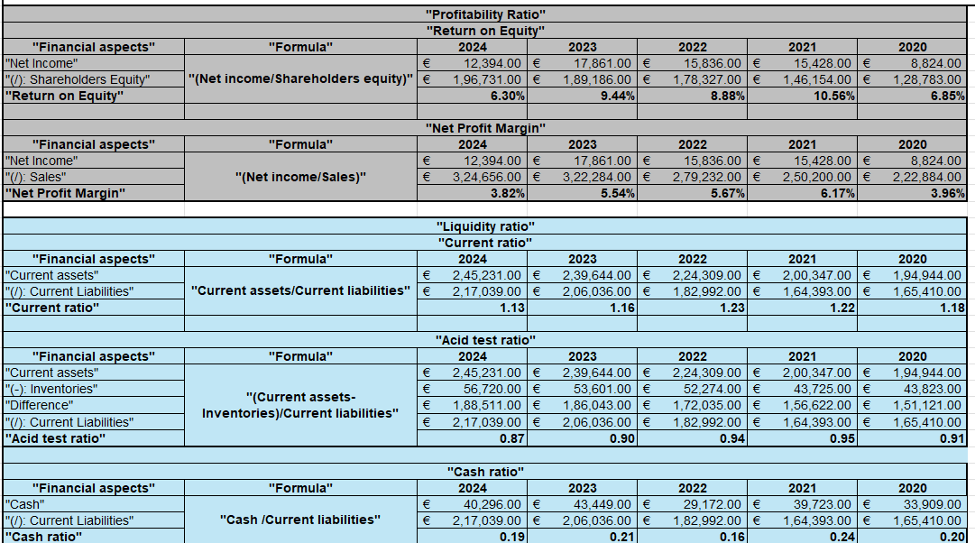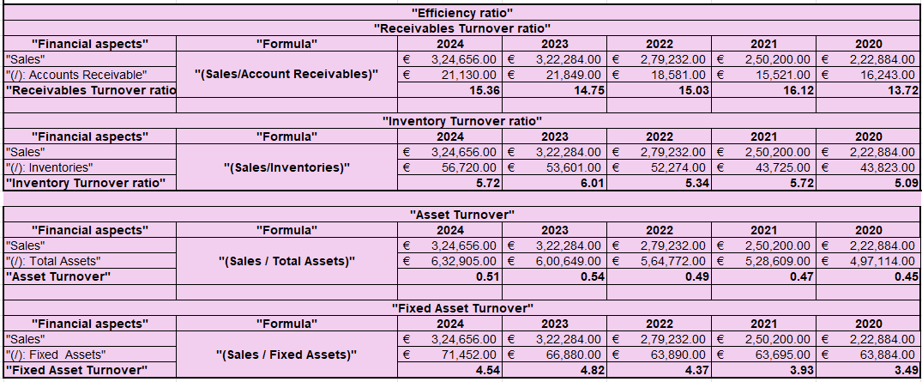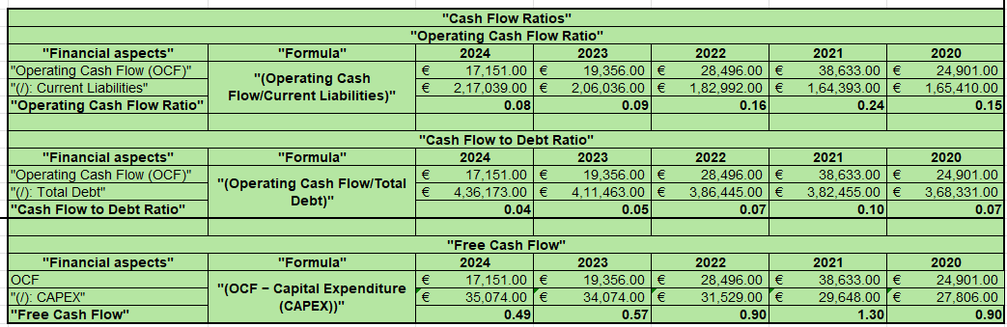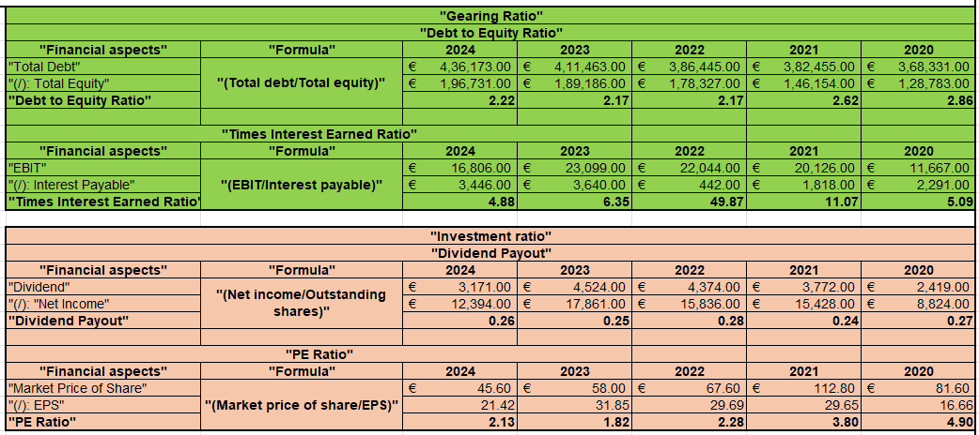
(Source: MS-Excel)

Appendix B: Ratio Graphs
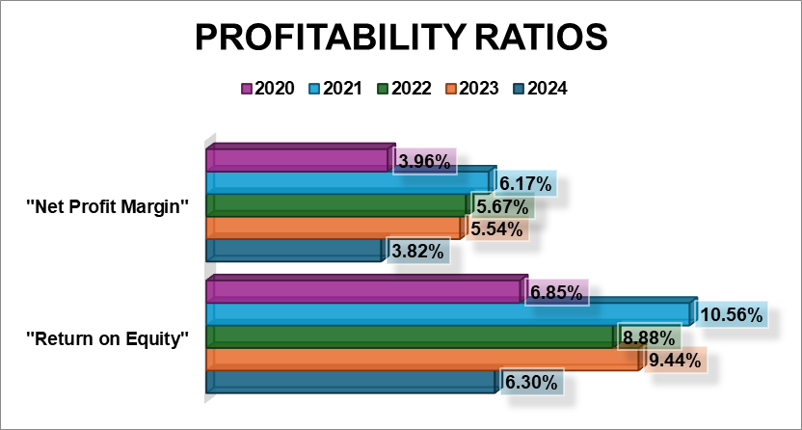
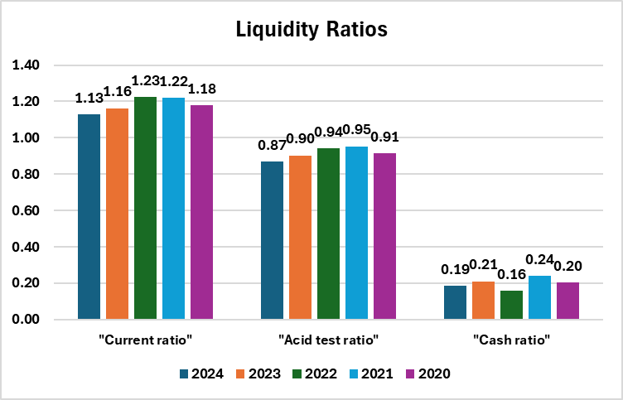
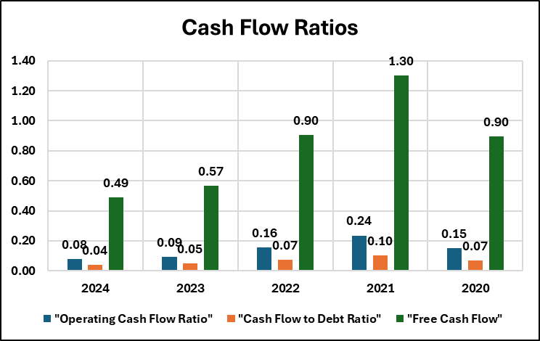
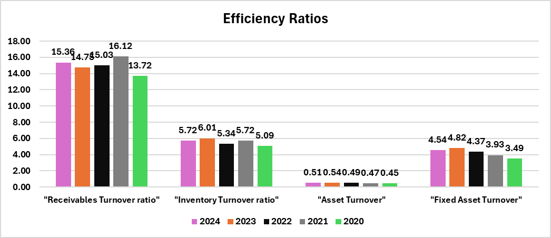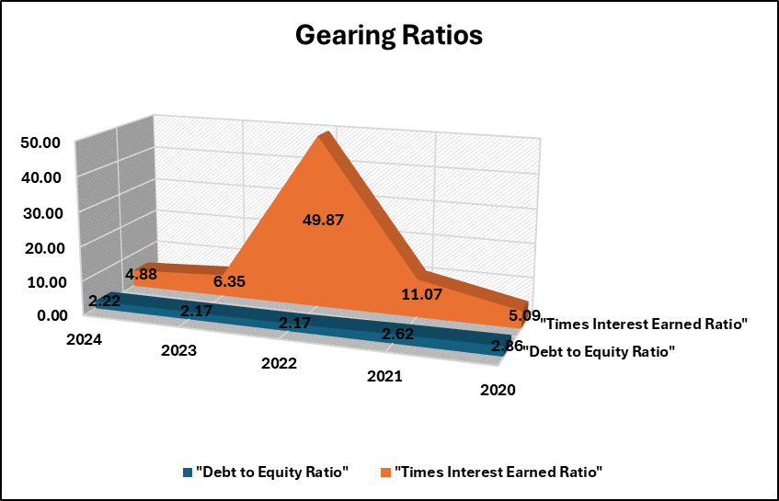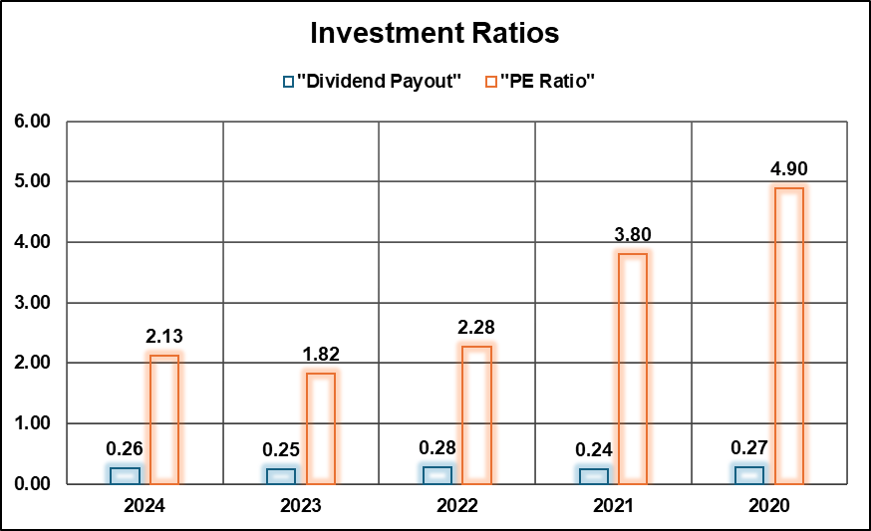
(Source: MS-Excel)

Appendix C: Investment Appraisal Workings
"Year" |  |  | "Cash Flow" |  |  | "Discounting Factor @10%" |  |  | "Present Value"
0 |  |  | -£ 50.00 |  |  | 1.000 |  |  | -£ 50.00
1 |  |  | £ 10.00 |  |  | 0.909 |  |  | £ 9.09
2 |  |  | £ 12.00 |  |  | 0.826 |  |  | £ 9.92
3 |  |  | £ 14.00 |  |  | 0.751 |  |  | £ 10.52
4 |  |  | £ 10.00 |  |  | 0.683 |  |  | £ 6.83
5 |  |  | £ 8.00 |  |  | 0.621 |  |  | £ 4.97
"Net Present Value (NPV) of Project A" |  |  |  |  |  |  |  |  | -£ 8.676
"Profitability Index (PI) of Project A" (NPV+Initial investment)/Initial investment) |  |  |  |  |  |  |  |  | 1.174
"Year" |  |  | "Cash Flow" |  |  | "Discounting Factor @10%" |  |  | "Present Value" |  |  | Cumulative
0 |  |  | -£ 50.00 |  |  | 1.000 |  |  | -£ 50.00 |  |  | -£ 50.00
1 |  |  | £ 10.00 |  |  | 0.909 |  |  | £ 9.09 |  |  | -£ 40.91
2 |  |  | £ 12.00 |  |  | 0.826 |  |  | £ 9.92 |  |  | -£ 30.99
3 |  |  | £ 14.00 |  |  | 0.751 |  |  | £ 10.52 |  |  | -£ 20.47
4 |  |  | £ 10.00 |  |  | 0.683 |  |  | £ 6.83 |  |  | -£ 13.64
5 |  |  | £ 8.00 |  |  | 0.621 |  |  | £ 4.97 |  |  | -£ 8.68
"Payback Period (PBP) of Project A" |  |  |  |  |  |  |  |  |  |  |  | Not Recovered
Year |  |  | Cashflow |  |  | "Discounting Factor @10%" |  |  | Present value
0 |  |  | -£ 50.00 |  |  | 1.000 |  |  | -£ 50.00
1 |  |  | £ 10.00 |  |  | 0.909 |  |  | £ 9.09
2 |  |  | £ 12.00 |  |  | 0.826 |  |  | £ 9.92
3 |  |  | £ 14.00 |  |  | 0.751 |  |  | £ 10.52
4 |  |  | £ 10.00 |  |  | 0.683 |  |  | £ 6.83
5 |  |  | £ 8.00 |  |  | 0.621 |  |  | £ 4.97
"Internal Rate of Return (IRR) of Project A" |  |  |  |  |  |  |  |  | 2.722%
"Year" |  |  | "Cash Flow" |  |  | "Depreciation" |  |  | "Present Value"
0 |  |  | -£ 50.00 |  |  | 0.00 |  |  | -£ 50.00
1 |  |  | £ 10.00 |  |  | 10.00 |  |  | £ -
2 |  |  | £ 12.00 |  |  | 10.00 |  |  | £ 2.00
3 |  |  | £ 14.00 |  |  | 10.00 |  |  | £ 4.00
4 |  |  | £ 10.00 |  |  | 10.00 |  |  | £ -
5 |  |  | £ 8.00 |  |  | 10.00 |  |  | -£ 2.00
"Accounting Rate of Return (ARR) of Project A" |  |  |  |  |  |  |  |  | 1.600%
"Year" |  | "Cash Flow" |  |  | "Discounting Factor @10%" |  |  | "Present Value"
0 |  | -£ 50.00 |  |  | 1.000 |  |  | -£ 50.00
1 |  | £ 11.00 |  |  | 0.909 |  |  | £ 10.00
2 |  | £ 11.00 |  |  | 0.826 |  |  | £ 9.09
3 |  | £ 11.00 |  |  | 0.751 |  |  | £ 8.26
4 |  | £ 11.00 |  |  | 0.683 |  |  | £ 7.51
5 |  | £ 11.00 |  |  | 0.621 |  |  | £ 6.83
"Net Present Value (NPV) of Project B" |  |  |  |  |  |  |  | -£ 8.301
"Profitability Index (PI) of Project B" |  |  |  |  |  |  |  | 1.166
"Year" |  | "Cash Flow" |  |  | "Discounting Factor @10%" |  |  | "Present Value" |  |  | Cumulative
0 |  | -£ 50.00 |  |  | 1.000 |  |  | -£ 50.00 |  |  | -£ 50.00
1 |  | £ 11.00 |  |  | 0.909 |  |  | £ 10.00 |  |  | -£ 40.00
2 |  | £ 11.00 |  |  | 0.826 |  |  | £ 9.09 |  |  | -£ 30.91
3 |  | £ 11.00 |  |  | 0.751 |  |  | £ 8.26 |  |  | -£ 22.64
4 |  | £ 11.00 |  |  | 0.683 |  |  | £ 7.51 |  |  | -£ 15.13
5 |  | £ 11.00 |  |  | 0.621 |  |  | £ 6.83 |  |  | -£ 8.30
"Payback Period (PBP) of Project B" |  |  |  |  |  |  |  |  |  |  | Not Recovered
Year |  | Cashflow |  |  | "Discounting Factor @10%" |  |  | Present value
0 |  | -£ 50.00 |  |  | 1.000 |  |  | -£ 50.00
1 |  | £ 11.00 |  |  | 0.909 |  |  | £ 10.00
2 |  | £ 11.00 |  |  | 0.826 |  |  | £ 9.09
3 |  | £ 11.00 |  |  | 0.751 |  |  | £ 8.26
4 |  | £ 11.00 |  |  | 0.683 |  |  | £ 7.51
5 |  | £ 11.00 |  |  | 0.621 |  |  | £ 6.83
"Internal Rate of Return (IRR) of Project B" |  |  |  |  |  |  |  | 3.263%
"Year" |  | "Cash Flow" |  |  | "Depreciation" |  |  | "Present Value"
0 |  | -£ 50.00 |  |  | 0.00 |  |  | -£ 50.00
1 |  | £ 11.00 |  |  | 10.00 |  |  | £ 1.00
2 |  | £ 11.00 |  |  | 10.00 |  |  | £ 1.00
3 |  | £ 11.00 |  |  | 10.00 |  |  | £ 1.00
4 |  | £ 11.00 |  |  | 10.00 |  |  | £ 1.00
5 |  | £ 11.00 |  |  | 10.00 |  |  | £ 1.00
"Accounting Rate of Return (ARR) of Project B" |  |  |  |  |  |  |  | 2.000%
"Year" | "Cash Flow" |  |  | "Discounting Factor @10%" |  |  | "Present Value"
0 | -£ 50.00 |  |  | 1.000 |  |  | -£ 50.00
1 | £ 5.00 |  |  | 0.909 |  |  | £ 4.55
2 | £ 10.00 |  |  | 0.826 |  |  | £ 8.26
3 | £ 20.00 |  |  | 0.751 |  |  | £ 15.03
4 | £ 25.00 |  |  | 0.683 |  |  | £ 17.08
5 | £ 5.00 |  |  | 0.621 |  |  | £ 3.10
"Net Present Value (NPV) of Project C" |  |  |  |  |  |  | -£ 1.984
"Profitability Index (PI) of Project C" |  |  |  |  |  |  | 1.040
"Year" | "Cash Flow" |  |  | "Discounting Factor @10%" |  |  | "Present Value" |  |  | Cumulative
0 | -£ 50.00 |  |  | 1.000 |  |  | -£ 50.00 |  |  | -£ 50.00
1 | £ 5.00 |  |  | 0.909 |  |  | £ 4.55 |  |  | -£ 45.45
2 | £ 10.00 |  |  | 0.826 |  |  | £ 8.26 |  |  | -£ 37.19
3 | £ 20.00 |  |  | 0.751 |  |  | £ 15.03 |  |  | -£ 22.16
4 | £ 25.00 |  |  | 0.683 |  |  | £ 17.08 |  |  | -£ 5.09
5 | £ 5.00 |  |  | 0.621 |  |  | £ 3.10 |  |  | -£ 1.98
"Payback Period (PBP) of Project C" |  |  |  |  |  |  |  |  |  | Not Recovered
Year | Cashflow |  |  | "Discounting Factor @10%" |  |  | Present value
0 | -£ 50.00 |  |  | 1.000 |  |  | -£ 50.00
1 | £ 5.00 |  |  | 0.909 |  |  | £ 4.55
2 | £ 10.00 |  |  | 0.826 |  |  | £ 8.26
3 | £ 20.00 |  |  | 0.751 |  |  | £ 15.03
4 | £ 25.00 |  |  | 0.683 |  |  | £ 17.08
5 | £ 5.00 |  |  | 0.621 |  |  | £ 3.10
"Internal Rate of Return (IRR) of Project C" |  |  |  |  |  |  | 8.587%
"Year" | "Cash Flow" |  |  | "Depreciation" |  |  | "Present Value"
0 | -£ 50.00 |  |  | 0.00 |  |  | -£ 50.00
1 | £ 5.00 |  |  | 10.00 |  |  | -£ 5.00
2 | £ 10.00 |  |  | 10.00 |  |  | £ -
3 | £ 20.00 |  |  | 10.00 |  |  | £ 10.00
4 | £ 25.00 |  |  | 10.00 |  |  | £ 15.00
5 | £ 5.00 |  |  | 10.00 |  |  | -£ 5.00
"Accounting Rate of Return (ARR) of Project C" |  |  |  |  |  |  | 6.000%
(Source: Ms-Excel)

Appendix D: CCC
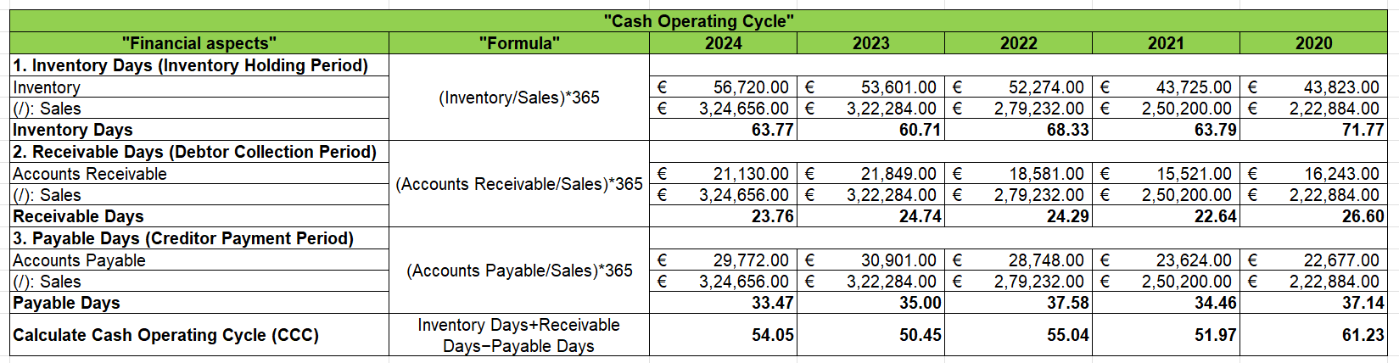
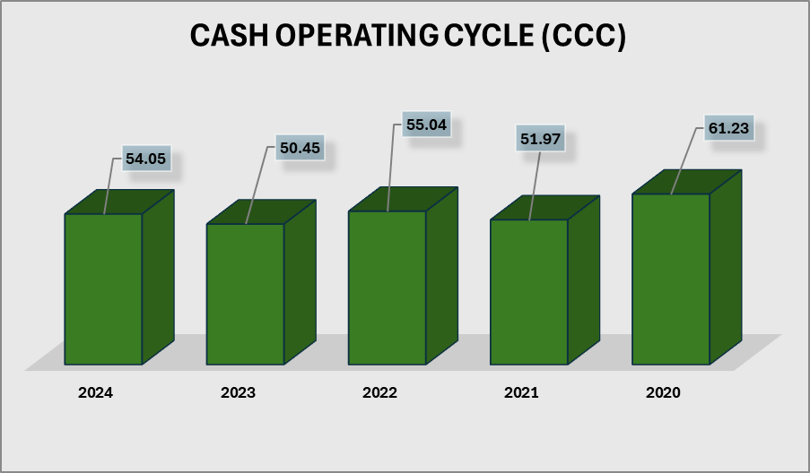
(Source: Ms-Excel)

9.0 AI Acknowledgement
I have used AI tools only to take ideas to create structure, creativity and cross check myself there is nothing which is left for the preparation for this assessment.

