Assignment 2 : Lighting layout and sound index calculations

Written by: Brandon Davison
Student number: 2110521

Contents
Task A 2
Calculate room index 2
Utilisation Factor 2
Number of lamps required 2
Spacing of the lights 3
Layout of the lights 3
Task B 4
Calculate the overall sound reduction index for the wall 4
Task B - Continued 6
Discuss the implications of the factors of frequency and wavelength in: 6
Building fabric resonance 6
Partition wall construction technique 7
Insulation material choice 7
References 8
‌Bibliography 8

Task A

Calculate room index
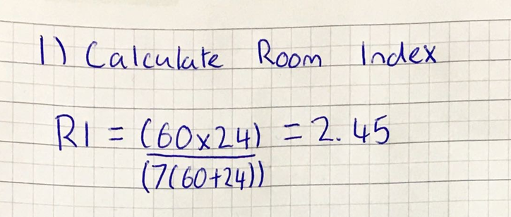

Utilisation Factor
Using the table we already know we are using a recessed louvre with an LOR of 50%. We know the ceiling reflectance is 0.3 and the wall reflectance is 0.5. Also we have already calculated the room index which is 2.45. Which we can round up to 2.50. Using the table we can determine that the utilisation factor is 0.46.

Number of lamps required
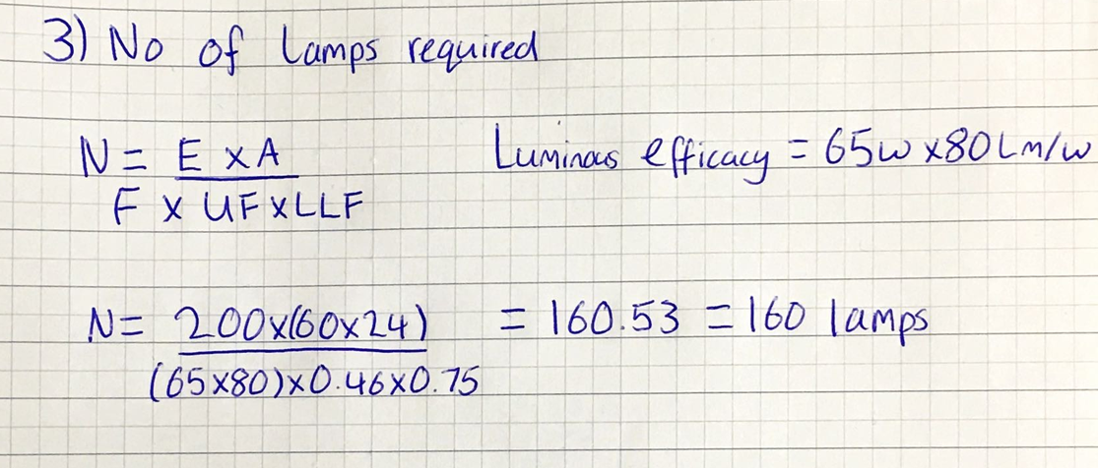

Spacing of the lights
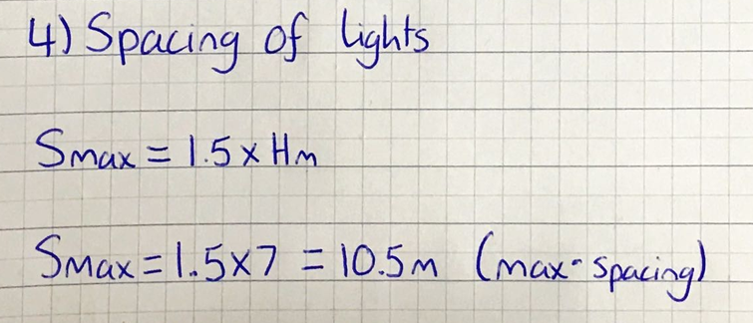

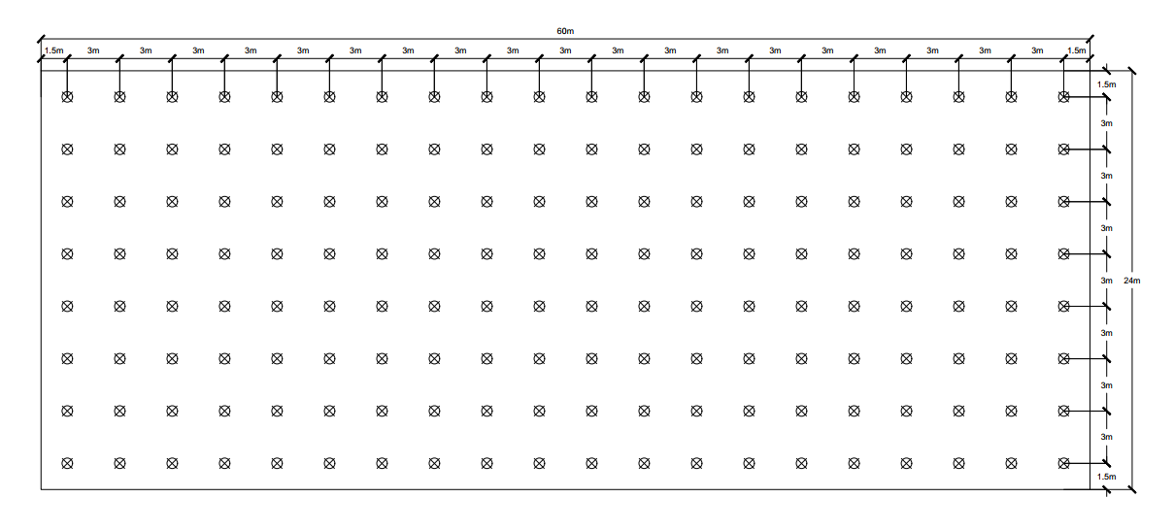
Layout of the lights
The room measures 60mx24m.Here is the layout of the 160 lights. They are spaced 3m away from each other uniformly across the room. The outside strips of lights are 1.5m away from the wall. The indicated areas across the drawing are the centres of the recessed louvres.

Task B

Calculate the overall sound reduction index for the wall

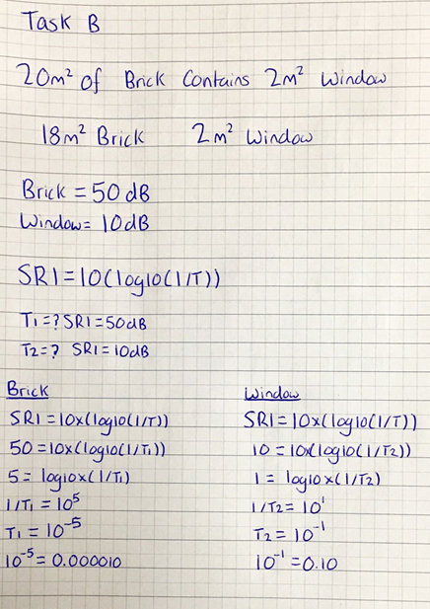

Task B - Continued
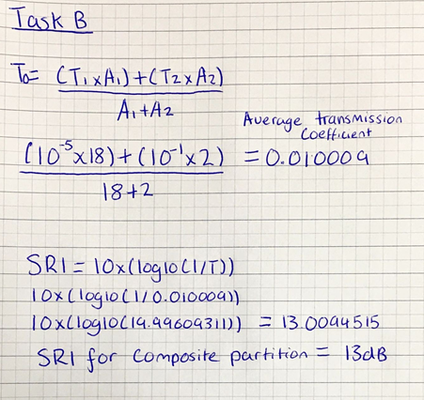

Discuss the implications of the factors of frequency and wavelength in:

Building fabric resonance

All entities have a so called natural frequency which is a reoccurring frequency specific to that particular entity. This all suggests that each individual object has a different vibration upon impact, depending on what the object is and its characteristics. Wood has a different resonance to steel etc. So in conjunction how would said resonance travel through a building? Reducing resonance in buildings increases comfort levels and improves quality of life so different products such as acoustic dampeners, insulation and changing the natural frequency of a material can reduce resonance.
Many mechanical systems experience resonance such as cars, washing machines, boilers and etc. But rarely do they affect structural integrity. But if the resonance frequency is correct then catastrophic failure can occur. An interesting example of this is according to an account, 74 soldiers walked in synch over a bridge, this created the required resonance frequency to collapse the bridge (Milzarski, 2021). So although unlikely the correct resonance could lead to catastrophic failure within all structures.
There are different ways to prevent resonance, different types of resonance require different solutions. Typically increasing the natural frequency above any possible frequencies is the purpose. Although sometimes the objective is to shift the natural frequency by decreasing it so no resonance would be present. The different solutions within a building would be the following,
- Adding stiffness - By having reinforced / stiffer materials this increases natural frequency.
- Increasing mass – By increasing the mass by having denser materials this decreases natural frequencies.

These are very few of the ways to change the natural frequency of materials that may reside within a building.

Partition wall construction technique

When constructing a partition wall inside a household, office spaces and etc it is important to denote possible issues pre-construction with regard to wavelengths and frequency and how they interact with said partition walls. One of these possible issues could be as simple as the WIFI not working in a room within the house due to the router being in a stone wall room which would prevent / slow any waves trying to enter or exit. So the construction makeup of the walls is very important (Also placement of the modem / router) especially in an office setting where they may require an uninterrupted supply of WIFI to perform their job. The wall makeup should take into account different materials that could be used to ensure the desired value of the signal that would need to be achieved.
When low-frequency sounds travel through a wall, they don't lose as much energy. This means they are more clearly heard through a wall compared to a higher frequency sound which loses more energy upon passage through a wall. This is due to longer wavelength and low-frequency noises producing resonance (vibrations) inside the wall's structure. Partition walls can also be constructed to negate the sounds in a particular room or shield said room from outside noise. This can be done through acoustic boards, thick insulation, frequency dampeners and etc. These can all be used in conjunction to provide the required sound insulation.

Insulation material choice

Different types of insulation provide different levels of sound insulation. Also different types of sound insulation. Sound moves as a vibration when the sound comes into contact with a wall. This means to soundproof the wall the vibration would have to be dampened. So products such as acoustic mineral wool would be placed between timber stud to aid in absorbing an airborne sound that would be present in the cavity of the stud wall. Acoustic mineral wool provides a great level of sound dampening and acoustic insulation. Although using acoustic mineral wool will sacrifice heat insulation properties.
There are other products that are made up of different materials to form a sound proofing board. Typically these boards are made up of the following,

- Acoustic plasterboard – This provides sound dampening and can be skimmed to provide further mass which will further sound proof this layer.
- Mass loaded vinyl – This part of the board provides a further layer of soundproofing as it acts as a sound barrier. Although in this instance it’s a component in a board, mass loaded vinyl can be used on its own to provide a soundproofing layer in walls, ceilings and floors.
- Closed cell foam – This layer provides sound dampening and also vibration dampening.

These are the 3 most typical components seen in sound proofing boards and when used in conjunction provide high levels of sound insulation. Using these boards as an alternative to the acoustic mineral wool insulation allows the cavities between studs to be filled with heat insulation. Although for maximum soundproofing you would have to use the acoustic mineral wool as general insulation roll has negligible affect on sound dampening as it lacks the mass.

References
Milzarski, E. (2021). What science says about the ‘marching on bridges’ myth. [online] We Are The Mighty. Available at: https://www.wearethemighty.com/military-life/soldiers-marching-over-bridges-myth/ [Accessed 3 May 2022].

‌Bibliography
Boguslaw Butrylo and Agnieszka Choroszucho (2009). The influence of partition walls inside rooms on the distribution of the electromagnetic field and the... [online] ResearchGate. Available at: https://www.researchgate.net/publication/298897145_The_influence_of_partition_walls_inside_rooms_on_the_distribution_of_the_electromagnetic_field_and_the_quality_of_transmission_data [Accessed 3 May 2022].
‌ Soundstop.co.uk. (2022). How to Soundproof a Wall. [online] Available at: https://www.soundstop.co.uk/wall-insulation.php [Accessed 3 May 2022].
‌ Soundproofingstore.co.uk. (2022). What is the best sound proof acoustic insulation? [online] Available at: https://www.soundproofingstore.co.uk/soundproofing-insulation#:~:text=The%20acoustic%20mineral%20wool%20is,acoustic%20performance%20and%20reducing%20reverberation. [Accessed 3 May 2022].
‌ Designingbuildings.co.uk. (2015). Impact sound. [online] Available at: https://www.designingbuildings.co.uk/wiki/Impact_sound#:~:text=Sound%20is%20transmitted%20in%20buildings,generation%20and%20transmission%20of%20sound. [Accessed 3 May 2022].
‌ Milzarski, E. (2021). What science says about the ‘marching on bridges’ myth. [online] We Are The Mighty. Available at: https://www.wearethemighty.com/military-life/soldiers-marching-over-bridges-myth/ [Accessed 3 May 2022].
‌ and, I. (2022). Natural Frequency Formula: What Is It and Why Is It Important? [online] Cadence.com. Available at: https://resources.pcb.cadence.com/blog/2020-natural-frequency-formula-what-is-it-and-why-is-it-important [Accessed 3 May 2022].
‌

