Electric car industries in Europe

Module Title: The Global Business Environment (LCBB4005)
Lecture Name: Dr. Kenny Tang
Student Name and Number: Nikoletta Dudas (1814105)

Table of Contents
Introduction: 2
Main Body: 2
Political: 3
Economic: 4
Social 5
Technology 5
Environmental 6
Legal 6
Summary Table: 7
Porter’s Five Forces analysis 7
Summary Table about the profitable and not profitable sectors 10
Conclusion 11
References: 11

Introduction:
The history of the automobile industries it began in the 1900s, the automobile business has changed a lot over the years. The automotive industry has entered the history with petrol and diesel engines. Nowadays this is the most dynamic development industry. Car manufacturing is a difficult and complex industry, they are giving jobs for millions of people around the world. The industry is innovative and constantly growing due to changing mobility needs and concepts, increasing demand in eco-friendly and efficient transportation and improving the technology. The spread of electric cars has an impact not only the car industry, because the manufacture of electric cars fundamentally shook the automotive industry. The propose of the essay to analyse the spread of electric cars and its impacts, based on PASTEL and Five Forces analysis.

Main Body:
1, PESTEL Analysis:
The PESTEL analysis is a framework which can help for the marketers, to analyse the macro-environmental factors that can impact on an organisation.
PESTEL sends for:
P- Political
E- Environment
S-Social
T-Technological
E- Economic

L- Legal

Site: (Academy, 2019)

Political:
One of the key elements in the car Industries operation is the political effects.

1, Taxes:
The automobile industries are heavily engaged by politics. The different countries are charges of different amount of taxes for the car industries. All newly produced cars have to comply with EU vehicles emission standards and regulations known as Euro Standards. The UK Government has introduced financial measures to favor cars with lower CO2 emissions, if the automobile has a high CO2 emission rate there will be high TAX charge. (GOV.UK, 2019) That is one of the reasons that Volvo has engaged itself in the production of electric cars.

2, Brexit:
The Brexit does not just mean the UK is leaving from the European Union, it is affected by the global market, especially to the automobile industries. Brexit is already having an impact in the European Union and in the UK. The trade relationship has changed, which means heavier exchange of goods and will lead to higher prices. “51% of all exported UK-built cars were bought by costumers in the European Union last year. In fact, more than 8 out of 10 passenger cars made in the United Kingdom are exported.” (Acea.be, 2019) In total the automotive industry employs more than 850.000 people in the UK, and the sector adds more than £20 billion values for the UK economy. The uncertain situation of Brexit does not favour the automotive industries either.

3, Better air Quality:
Many cities, like London, want to become as a zero-emission city, to achieve this goal the existing car park combination need to change. Much more electric cars are needed by private users as well as in public transport. The London Taxi trade has already invested more than £100 million in the electric taxies. (London City Hall, 2019) This is a big opportunity for the car manufactures, such a large investment can help for some of the car companies to gain a larger market share.

Economic:

1, Reduce Carbon footprints
Nowadays the price is a strong influence factor on the purchase of the car. The electric cars are priced in the luxury category, and the maintenance costs are also there. Therefore, it is very important to make the long-term use attractive with different benefits for the consumers. In the UK, from 1 April in 2017 need to pay a rate based on a vehicle’s CO2 emission, the first time it is registered. (GOV.UK, 2019)
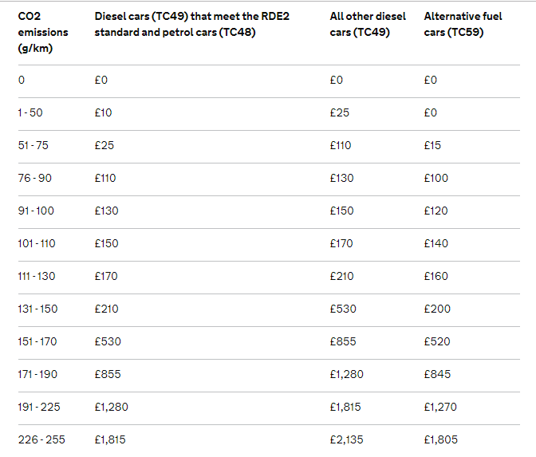
Site: (GOV.UK, 2019)
As we can see in the picture above, the electric car owners receive significant discounts, this can boost the sales of electric cars.

2, Driving benefits
Electric cars have a significantly lower maintenance cost than traditional cars. For example, there is no vehicle tax to pay on electric vehicles or discounted parking. (Westminster City Council, 2019) With these discounts, consumers can make significant savings, which is a strong argument for buying electric cars.

3, Manufacture consolidation
The Volvo in 2017, it was announced that, from 2019 onwards, all newly introduced Volvo models will be fitted with electric propulsion. With this company, the era of purely internal combustion engine vehicles will come to an end. (Media.volvocars.com, 2019) This decision will help the company to focus more deeply on electric car production in the future, which will lead to a strengthening of its market position.

Social
1, Prefer renting to buying
The high purchase cost of electric cars is still causing a major problem. In that case, many residential users prefer to rent the car, as opposed to buying. There is another reason for this, besides the high prices and a rapid development of technology. And with electric technology developing so quickly, new and improved models of electric cars are hitting the market at the rapid rate. (Gibson, 2019) Consumers demands for electric cars are significantly higher than for conventional cars and of course, this has to be taken into account at the time of manufacture.

2, Environmentally friendly cars
With the world becoming more eco-conscious, the peoples are turning to electric cars to help reduce gas emission and improve air quality.” According to the UK Government transport is the cause of roughly 25% of the UK greenhouse gas emission, so these vehicles are putting their diesel- or petrol-powered counterparts to shame.” (Bater, 2019) This new “green worldview” is a huge opportunity for electric car manufacturers.

Technology
1, Battery Technology
The biggest challenge right now in electric car manufacturing is doing the right battery. Many companies have started to deal with it since the right battery is the biggest weakness at present in electric cars. The big technology and car companies are too aware of the limitation of lithium-ion batteries. That is a fact, why we are on the verge of the power revolution. The specialists are getting closer and closer to the answer, how they can prepare a better battery, thereby increasing the availability of electric cars.
2, Self-driving cars
The idea of self-driving cars divided society. If we do this perfectly, we will probably have significantly less traffic jams and more liveable cities in the future (Zenmo.com, 2019) Avoiding the self-driving market, at the moment it seems to be very far away, but if the idea succeeds, our views on travel and transport will change radically.
3, Charging stations
With the proliferation of electric cars, more charging points will be needed. Their design also entails more technical innovations. It includes increased demand for electricity, different payment options after charging, and the final formation for the charging station. This is a huge opportunity for companies that are not involved in the car industry, but they know other technologies.

Environmental
1, Reduce Carbon emission
The climate agreement from 195 nation in 2015(Unfccc.int, 2019) and other initiatives lead to a stronger need for energy-efficient transportation. Different governments have reacted to this by tightening the limit on CO2 emission. This encourages car manufacturers to produce more environmentally friendly and EV cars. As a result of these and the increasing fuel costs, electric cars are going more popular.
2, Climate Change
Climate change is changing our consumer habits. There is a need to restrict the use of internal combustion engines. The number of electric cars in traffic will increase, but probably not as quickly as is being demanded. Unfortunately, electric cars batteries contain elements that have been rated as critical. (JYUnity, 2019) In that case, the electric cars are more environmentally friendly like the traditional cars, but they still need improvement.

Legal
1, Governments lows
The UK Government, aims to eliminatel petrol and diesel cars and vans by 2040. (GOV.UK, 2019) Automotive companies are trying to adapt to this new situation and put even more emphasis on the electric car industry.
2, Congestion charge and Low emission zones
The owners of electric car do not have to pay congestion charges and the ultra-low emission zone is free for theme as well in the UK. In Deutschland the electric car owners are in the same situation in the low emission zones, they do not have to pay the fees. (User, 2019)

Summary Table:
Factors | Ranking | Explanation
Political  1, Tax  2, Brexit  3, Better Air Quality | High  High  Medium | Political effects strongly influence the car industry, strong governmental support boost future EV sales and growth.
Economic  1, Reduce Carbon footprints  2, Driving Benefits  3, Manufacture consolidation | High  Medium  High | Manufacturing companies and suppliers have made significant investments in the industry. Moderate growth in economic, job creation, low interest rates can motivate the consumers to buy electric cars.
Social  1, Preferring Renting to Buy  2, Environmentally friendly cars | Low  Medium | The consumers do not see the long-term savings in an investment in an electric car vehicle. New opportunities for the new start-up companies, because the users have become to the different car rental options. The EV cars are available in a high price.
Technology  1, Battery Technology  2, Self-Driving Cars  3, Charging Stations | High  Medium  Medium | The strong demand and support are boosting the innovation rate for the EV industry. Economic and Political variables are affecting the technological development positively.
Environmental  1, Reduce Carbon emission  2, Climate Change  3, E-Quality | High  Medium  High | Many governments are tightening their CO2 emission due to environmental awareness. These environmental changes give impetus to the electric car industry.
Legal  1, Governments lows  2, Congestion charges and  Ultra- low emission zones | Medium  Medium | Lows made by different governments, are make electric vehicle manufacturing companies even more competitive, although these measures have not yet proved to be sufficiently effective.

Porter’s Five Forces analysis (Porter, 1980):
The porter’s Five Forces is a model that analyse and identify five competitive forces that shape every industry and helps determinate the industry’s weaknesses and strengths. The model was published in Michael. E Porter’s book, “Competitive Strategy” in 1980. (Investopedia, 2019) The five forces are New entrance into the industry, Power of Suppliers, Power of costumers, Threat of substitute product, Competition of Industry. This part of the essay will analyse the car industries by Five forces.

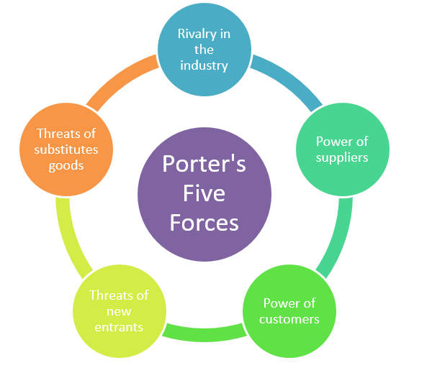

Site: (Master Assignment, 2019)

1, Power of Suppliers- Low
This aspect of the Five Forces shows how suppliers can ensure the availability of the materials, thereby influencing the market. If there are few suppliers in the market, their influence will increase, if many they will lose from this fortress. For the electric car industry, the supplier power is at a low level. There is a large number of companies supplying the convention as well as the electric automotive. And the innovations are coming more often from the side of the manufacturer, that is the key elements why the suppliers have less power. (Shindeldecker, 2016). And not least the EV is a new technology, in the supplier side have a piece of knowledge, but this may not be accompanied by financial background.

2, Power of costumers- High
The demand for the car is very high, it follows that the customer power is strong. Electric cars are very popular with private consumers as well as businesses and fleet operators. Nowadays the increased environmental awareness and the long-term saving of fuel costs are motivating more customers to buy electric cars. (Author), 2019) However due to the strong substitution and competition in the industry, the power is with the buyers. Another factor, that increases the power of buyers is the high prices of electric cars. Because electric cars are currently in the luxury category, therefore a strong competitive situation has arisen between the manufacturing companies. The buyers have the ability to go for substitute products and services and the extent of product differentiation between various electric vehicles manufacturers. Therefore, customers can choose their model based on quality, price, and service. The solution on the part of the car manufacturers, to mitigate the power of buyers, can be a batter customer service, and building strong loyalty.

3, The threat of Substitutes- Very High

It is certainly one of the most powerful influencing factors. There are many different alternatives to replacing electric cars, such as hybrid cars, public transport and more. There is a huge competition in the industry, the technological developments are expensive, which have an impact on the selling price of the finished product. These factors, mobile technology innovations and the spread of environmentally conscious lifestyles, are created a new industry among residential users. Some provider, such as Uber (Uber, 2019), takes over passenger transport at a lower cost than the taxi companies. Different providers, like Zipcar (Zipcar.com, 2019) offers for their costumer’s car hire for a few hours without a driver. That kind of services is weakening the car manufacturers market power because in that case, many people do not have to buy a car if they want to use only rarely.

4, Threat of New Entrants- Low
The electric car technology is very high cost, and too much risk to the entrant to this sector, in that case, the barriers to entry to the industry is high. The manufacturing of electric vehicles requires high investment in production lines, therefore of that the growth in the electric car industry will, for the most part, come from conventional manufacturers, who already have a piece of knowledge and the infrastructure. (Author), 2019) For example, Tesla has started to produce own patented batteries. (Forbes.com, 2019) As of this time, no other companies have developed a comparable battery that could compete with Tesla.

5, Rivalry in the Industry- Very High
The Global electric vehicle market has been steadily expanding since 2010. (Theicct.org, 2019) The key automotive companies are engaged an intense rivalry. Demand for electric cars has increased significantly, as we can see in the accompanying figure.
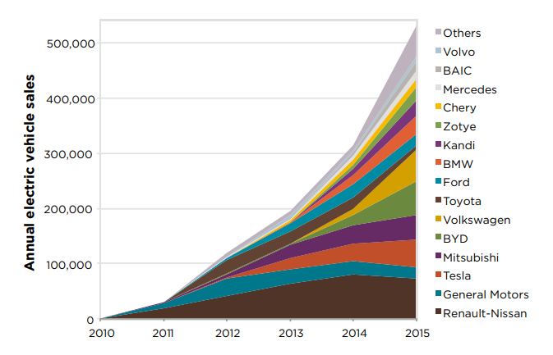
Site: (Theicct.org, 2019)
In the future the intense rivalry increases the strong growth rates, therefore the new companies in the market, like Tesla (Tesla.com, 2019) NIO (Nio.com, 2019) can get the bigger part from the market. That is why the automotive companies who are currently playing a significant role in the industry, they are willing to invest a large amount in the production of electric cars. (Kable 2016)
As Porter’s Five Forces analysis proves, the competition in the industry is very high. The Electric-Mobility Industry is in currently in this early phase and is expected to grow in the next few years. (Store.marketline.com, 2019) The spread of environmentally conscious lifestyles is seeing a great demand for EV vehicles. Whit the boom in the electric car industry, production of diesel and petrol engines is no longer profitable. This change will also affect oil companies, because of the proliferation of electric cars will require significantly less petrol and diesel, this may weaken their role in the market. Some companies like Shell has already responded to the changes and began to build an electric car charging network. (Shell.co.uk, 2019)
Summary Table about the profitable and not profitable sectors:
Profitable | Not Profitable
Technology enterprises | Diesel engines
Battery developer | Petrol Engines
Charging points reticulation | Oil Industries
Electricity Industry

Conclusion:
As we have seen from the above analyses, the electric car production is only the in its initial phase. The automotive industry is facing in huge changes in how successful it is dealing with problem depends solely on leaders and on the economy from prominent researchers who are working day by day to be newer technologies to produce product that are important to everyone and to advance in world market competition.

References:

(Author), D. (2019). GRIN - Automotive E-Mobility. Industry Analysis. [online] Grin.com. Available at: https://www.grin.com/document/368183 [Accessed 21 Aug. 2019].
Academy, P. (2019). Marketing Theories - PESTEL Analysis. [online] Professionalacademy.com. Available at: https://www.professionalacademy.com/blogs-and-advice/marketing-theories---pestel-analysis [Accessed 19 Aug. 2019].
Acea.be. (2019). [online] Available at: https://www.acea.be/uploads/news_documents/Brexit-facts_figures_March_2019.pdf [Accessed 19 Aug. 2019].
Bater, E. (2019). The environmental pros and cons of electric cars. [online] Admiral.com. Available at: https://www.admiral.com/magazine/guides/motor/the-environmental-pros-and-cons-of-electric-cars [Accessed 25 Aug. 2019].
Forbes.com. (2019). Tesla Battery Patent Application Refines Liquid Cooled Batteries. [online] Available at: https://www.forbes.com/sites/sebastianblanco/2018/09/10/tesla-battery-liquid-cooling-patent-application/ [Accessed 22 Aug. 2019].
Gibson, T. (2019). Electric cars: why you should lease. [online] The Telegraph. Available at: https://www.telegraph.co.uk/cars/driving-for-less/reasons-to-lease-an-electric-car/ [Accessed 25 Aug. 2019].
GOV.UK. (2019). Plan for roadside NO2 concentrations published. [online] Available at: https://www.gov.uk/government/news/plan-for-roadside-no2-concentrations-published [Accessed 25 Aug. 2019].
GOV.UK. (2019). Vehicle tax rates. [online] Available at: https://www.gov.uk/vehicle-tax-rate-tables [Accessed 19 Aug. 2019].
Investopedia. (2019). Porter's 5 Forces Definition. [online] Available at: https://www.investopedia.com/terms/p/porter.asp [Accessed 21 Aug. 2019].
Jones, R. and Sabbagh, D. (2019). Nissan warns of Brexit concerns as U-turn at Sunderland confirmed. [online] the Guardian. Available at: https://www.theguardian.com/business/2019/feb/03/nissan-confirms-new-x-trail-will-not-be-built-in-sunderland [Accessed 19 Aug. 2019].
JYUnity. (2019). Electric cars are coming – but where do we get raw materials? - JYUnity. [online] Available at: https://jyunity.fi/en/thinkers/electric-cars-are-coming-but-where-do-we-get-raw-materials/ [Accessed 25 Aug. 2019].
Kable, G. (2016). Mercedes-Benz set to release four EVs by 2020. Retrieved from
Langridge, M. and Edwards, L. (2019). Future batteries, coming soon: Charge in seconds, last months and power over the air. [online] Pocket-lint. Available at: https://www.pocket-lint.com/gadgets/news/130380-future-batteries-coming-soon-charge-in-seconds-last-months-and-power-over-the-air [Accessed 25 Aug. 2019].
London City Hall. (2019). Mayor sets out plans for London’s electric vehicle future. [online] Available at: https://www.london.gov.uk/press-releases/mayoral/mayor-sets-out-londons-electric-vehicle-future [Accessed 19 Aug. 2019].
Master Assignment. (2019). Porter Five Forces Analysis: The Example Of IKEA. [online] Available at: http://www.masterassignment.com/porter-five-forces/ [Accessed 22 Aug. 2019].
Porter, M. (1980). Competitive strategy. New York: Free Pr.
Shell.co.uk. (2019). EV drivers welcome. [online] Available at: https://www.shell.co.uk/motorist/welcome-to-shell-recharge.html [Accessed 25 Aug. 2019].
shindeldecker, d. (2016). Electric Automotive (e-Mobility) Industry will change the automotive market in the next five years.
Store.marketline.com. (2019). Global Hybrid & Electric Cars - Marketline Report Store. [online] Available at: https://store.marketline.com/report/ohme4485--global-hybrid-electric-cars/ [Accessed 25 Aug. 2019].
Tesla.com. (2019). Electric Cars, Solar Panels & Clean Energy Storage | Tesla. [online] Available at: https://www.tesla.com/ [Accessed 22 Aug. 2019].
Theicct.org. (2019). [online] Available at: https://theicct.org/sites/default/files/publications/Next%20Gen%20EV%20Tech_white-paper_ICCT_31102016.pdf [Accessed 22 Aug. 2019].
Uber. (2019). Get an Uber Ride - Download the Passenger App | Uber. [online] Available at: https://www.uber.com/us/en/ride/ [Accessed 21 Aug. 2019].
Unfccc.int. (2019). The Paris Agreement | UNFCCC. [online] Available at: https://unfccc.int/process-and-meetings/the-paris-agreement/the-paris-agreement [Accessed 25 Aug. 2019].
User, S. (2019). Germany. [online] Urbanaccessregulations.eu. Available at: https://urbanaccessregulations.eu/countries-mainmenu-147/germany-mainmenu-61 [Accessed 25 Aug. 2019].
Westminster City Council. (2019). Electric vehicles. [online] Available at: https://www.westminster.gov.uk/electric-vehicles [Accessed 25 Aug. 2019].
Zenmo.com. (2019). How self-driving cars will lead to small, shared, electric vehicles that will save our cities and climate – ZEnMo simulations. [online] Available at: https://zenmo.com/how-self-driving-cars-will-lead-to-small-shared-electric-vehicles-that-will-save-our-cities-and-climate/ [Accessed 25 Aug. 2019].
Zipcar.com. (2019). Zipcar UK - Car Sharing | An Alternative to Car Hire with Zipcar. [online] Available at: https://www.zipcar.com/en-gb [Accessed 21 Aug. 2019].

