ECDE7012 - Research Design and Management in Education
Component 1: Literature Review
Student number: 1750093

International educational reform over the last thirty years has included a significant focus on the structure of the curriculum within a state educational system (Kelly, 2009). These include a shift from ‘learning about’ to ‘learning to’ (Donaldson, 2015) and a shift in the conception of the relationship between the teacher and the curriculum. This has been typified by a move away from a ‘teacher proof curriculum’ (Kelly, 2009) to one in which teachers are viewed as active participants in the creation and enactment of a curriculum at the school and classroom level (Sinnema, Nieveen and Priestly, 2020).
Within the context of Wales (one of the four nations that make up the United Kingdom (OCED, 2020)), this curriculum reform has been underpinned by the work of Donaldson (2015) and the subsequent work of Pioneer Schools (Arad Research, 2018). This has repositioned the curriculum in Wales away from that of England (to which policy had previously been closely aligned (Evans, 2015)) and brought it more in line with similar ‘21st Century’ curricular being developed around the world (Sinnema, Nieveen & Preistley, 2020). The enactment of the Curriculum for Wales (Welsh Government, 2024) demonstrates those two key shifts outlined above, both in the conception of how what is to be taught is conceptualised and shared, and in the role of the teacher as curriculum maker.
Despite what may, on paper, appear to be a significant change, reports from student-teachers engaged on a History PGCE programme at one of the Initial Teacher Education Partnerships in Wales suggest that in a majority of the classrooms in which they have been placed, little has changed. There has been little change in the topics taught from those that would have been experienced by a student-teacher on a PGCE twenty years ago. While the evidence of assessment practices is less clear, there is little evidence of change in this domain either. This stands in contrast to the views expressed by many of the teachers engaged in the work at the early stages of the curriculum development, who expressed hope for the development of a more relevant, more connected and more engaging curriculum (Haywood et al., 2020)
It is this tension that this study aims to explore. The challenge of curriculum, and of educational reform more broadly is extremely important in Wales, a country which in the last twenty years has consistently underperformed in educational outcomes compared to its neighbours (OECD, 2020). It is also internationally relevant as a number of countries wrestle with similar problems of realising ambitious curriculum reform programmes (Sinnema, Nieveen & Preistley, 2020). It also has a personal interest. As a former history teacher I was engaged in the process of curriculum reform and development for much of my career, and found it both professionally rewarding and personally fulfilling. More recently, as an early career researcher I was able to witness firsthand the enthusiasm and commitment of colleagues who drafted the new national framework which underpins Curriculum for Wales. Finally, my role as a PGCE History tutor gives me a first-hand window in largely unchanged classrooms practices in schools across South Wales.
Priestley et al. (2011) argue that the idea of ‘curriculum development’ is more complex and multilayered than may at first appear. They argue that from a teachers perspective, the act of curriculum making is one of engaging with a process of interrelated layers which may (but will not always be) working in concert toward a common goal. These layers (or sites) are described as:
- Nano – in the classroom with a group of students
- Micro – the school level, working with other teachers in planning and resource creation
- Meso – working with other beyond the school on the production of guidance, examples, research and communication
- Macro – constructing policy frameworks
- Supra – transnational debates (for example, the role of comparisons such as PISA)

These layers may or may not be underpinned by a theoretical model of curriculum. The extent to which there is a coherent theoretical model which underpins this within a given jurisdiction is a live one in Wales, given the emerging findings from ‘Camau i’r Dyfodol’ project (Makara Fuller, Singh & Morrison-Love, 2023a; Makara Fuller, Singh & Morrison-Love, 2023b) which suggests a low level of coherence within the emerging system in Wales. Priestely and Humes (2010) have argued that one of the less focussed on featured of what are sometimes called ‘21st Century’ curricula is the lack of internal coherence, and can contribute to an implementation gaps that leads to outcomes that fall short of the original policy aspirations.
In my previous assignment, I proposed an ecological model for considering the range of factors on an individual teacher engaged in the process of curriculum making within a classroom. An inner layer considers the internal conceptions and beliefs held by that individual. The next layer considers the availability of resources, set against other demands on their time. The final layer considered the external conceptions held within the system in which they work. The whole model is divided in two, with the general curriculum being considered in dialogue with the history curriculum.
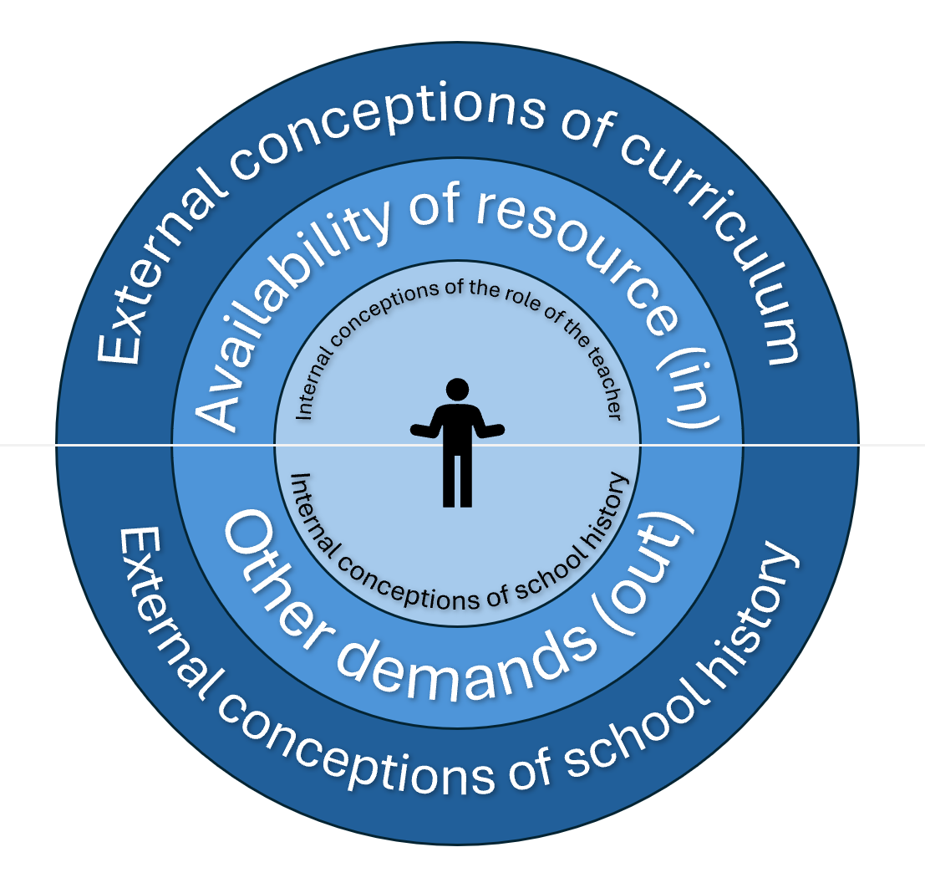
Figure 1: an ecological model of the influences on the history teacher as curriculum maker

That continues to be a helpful framework around which to organise a review of further current relevant literature.

Starting from the centre, it may be helpful to consider how an individual teacher’s internal conceptions can have an influence on their approach to curriculum making, and the choices they may make. Schiro (2012) identifies five lenes through which individual teachers make decisions within a specific curriculum orientation. These are:
- beliefs about knowledge;
- beliefs about learning;
- conceptions of the role of the learner (although he uses the term ‘children’);
- ideas about teaching (or perhaps more specially the role of the teacher as an agent of curricular enactment);
- the role of students as evaluators of the system.

These ideas don’t emerge from one specific empirical study, however Schiro is well regarded in this field, and this work has been widely referenced by other authors. It raises some significant issues for future study in this area as it proposes that far from being commonly understood, terms such as ‘learning’, ‘teaching’ and knowledge’ are actually conceptualised and understood by different teachers in very different ways. The validity of Schiro’s work is increased by the way that the work of previous theorists are considered and aligned with this new model. It is further enhanced by the analytical, neutral tone taken which contrasts with the more explicitly opinionated tone of, for example, Kelly (2009). While at first glance the American focus of the work may call its usefulness into question, the identification of the characteristics which can be compared to other settings actually increases its use in this context. This may go some way to explain why it is Schiro’s model which Smith (2024) uses to develop a model of UK history teacher positionality

If we consider the application of these ideas to conceptions of history specifically, the work of Smith (2019) looking at history teachers in Scotland is especially relevant. While the education system in Scotland has some significant differences to that of Wales, there are a growing number of similarities. This study found that where teachers did not have access to, or did not engage with the theoretical debates about the nature of historical knowledge, resulting curricular can be narrow, fragmented, and driven by instrumental justifications for content selection. He argues that an education system must provide the space and means to allow those designing the curriculum to engage with ideas and debates that lie beyond their day to day practice.
The paper draws on 21 interviews with teachers, and provides a methodological framework which may be helpful in future study. By asking more broad and open questions the author hoped to capture a more authentic response, which could be later coded and analysed. One weakness with this methodology is that any immerging conclusions could not be tested back with the original participants, and so the risk of meanings being lost, or imposed by the researchers is perhaps higher than with some of the other papers considered.
Similar findings were found from a smaller sample of teachers in England (Harris and Reynolds, 2018), while Ormond (2017) found that in New Zealand the experience of creating a school level curriculum was overwhelming for many schools and teachers. Taken together, these papers suggest that the interplay between the personal conception of school history and that laid out in the macro level (if there is a coherent conception laid out at all) plays a part in the success of any school history focussed curriculum making project, and could be an important aspect of any further study.

Beyond the level of conception are more practical considerations, considered in the middle layer of the model. Marangio & Heyting (2022) present an account from Australia detailing the introduction of psychology as a new curriculum subject. They identify five themes that shaped the experience of their participants, including time, guidance, and the quality of the network in which the teachers operated. None of the five themes were entirely positive or negative; however, the lack of guidance and the demand for personal time highlight the extent to which the success or failure of this new initiative depended on individual teachers.
The Welsh government has been reluctant to provide any centralised examples, perhaps for fear of undermining the new professional identity of teachers as curriculum makers. However, Hughes and Lewis (2020) found that teachers in Wales did not see a tension between the use of ‘off the peg’ materials and their own professional autonomy. The extent to which a lack of resources to kick start a more wide ranging curriculum review within the context of history may be a factor that is worth exploring in future research.
There doesn’t seem to be a study that looks specifically at the impact that other demands on teacher’s time can impact efforts at curriculum making. However the launch of the new range of GCSEs, including a History qualification which has some significant changes to the content being considered may impact the capacity of curriculum innovation in the 11-14 age range. (REF)
The outer layer of the model considers the impact of external conceptions both of curriculum in general, and of history as taught in school specifically, impact on curriculum making at the nano and micro level.
When considering general conceptions of curriculum, Kelly (2009) identifies three main approaches:
- Curriculum as content and education as transmission.
- Curriculum as product and education as instrumental.
- Curriculum as process and education as development.
He also argues that this is often under considered in the development of curriculum, and that a lack of coherence can impact negatively on the successful of the reform.
Alternatively, Schiro (2013) analysed the behaviour of actors within different education systems (as opposed to their stated beliefs, which he argues are often contradicted by observed practices). He identified the following four ‘ideologies’, along with their main aim for the curriculum.
- Scholar academic – argues that the main purpose of the curriculum is induct learners into key disciplinary knowledge
- Social efficiency – values workplace and citizenship skills
- Learner -centrism – promote the individual’s growth and development
- Social reconstructionism – values the creation of a fairer and more socially just society.
This provides a framework for participants to consider and may go some way to address the issues of a lack of shared definitions of terms outlined above.
In the context of school history, The Curriculum for Wales (Welsh Government, 2024) represents a potentially significant change in the way in which school history is conceptualised in Wales. By making the subject part of the Humanities AoLE, and by emphasising the common links between the subjects, it intends to encourage teachers to design an inter-disciplinary curriculum. However, the extent to which the profession already had a shared understanding of the disciplinary nature of school history which then be applied to this new setting is open to question, and has not been the subject of any published research. In fact, in the last five years of the journal ‘Teaching History’, only one article has mentioned Welsh history, and that was from a teacher in Oxford who wanted to use Welsh history as a topic in her classroom. As such, while there is much scholarship being undertaken on school history in England, there seems to be far less (in fact, none) in Wales.

Smith (2024) builds on the work of Schiro to apply his ideas to school history, arguing that there are four conceptions of school history arranged in the intersection of two axis. On one is mapped the onto-epistemic beliefs about what history is. On the other, set at 90 degrees, are beliefs about what content is most important. Smith argues that most discussions around school history conflate these two separate elements, and that the under appreciation of the complexity results either in politicised sloganeering. It may also be possible to argue that this lack of a clear picture may be a contributing factor the relatively conservative amount of change that seems to be taking place in Wales. Without a clear framework for making decision about what and how to change, it may be easier to stick with what we already have.

Having considered how literature has contributed to the framing of this study, it may be helpful to consider the way in which the particular approach offered by grounded theory has been applied to studies of curriculum development.
The proposed research methodology for this study in grounded theory. A number of general texts on Grounded Theory (for example, Thornberg, 2017) identify education as one of the fields where grounded theory is used as a research framework. When searching research databases for papers that reference both grounded theory and curriculum, several relevant papers have been identified.
Fischer and Viens (2022) use a grounded theory methodology to explore teachers’ perspectives (in this case, on the pedagogy used in language study abroad). By using a grounded theory approach to coding, the researchers were better able to interrogate some of the differences in expressed beliefs of participants and their pedagogical choices. There are overlaps between this study and the proposed focus here. That said, from the account, there is little that could not have been achieved by an alternative coding approach (their account is very similar to that of someone using something like a thematic analysis (Denscombe, 2021)), and their discussion focusses on their findings more than an evaluation of their choice of theoretical framework. However, it is clear that grounded theory can provide a framework in which this sort of investigation can be undertaken.
Similarly, Fang (2018) used a grounded theory approach to underpin a study into the development of interdisciplinary general education course in the Higher Education context. In this study, grounded theory provided the opportunity to test, challenge and amend initial findings (identified as a strength of the approach by Bryant and Charmaz (2007)) and later to develop a more generalisable theory which can be tested in other similar contexts. Both of these features of grounded theory have a direct relevant to the proposed study. There is an ambition to be able to adapt and amend emerging ideas as the phases of the research are undertaken, with the possibility for ideas to be relatively rapidly identified and tested with other participants (Mruck & Mey, 2007). In addition, it is hoped that any findings may be applicable to settings beyond those explored in the study itself.

Based on all the evidence above, it is possible to identify a specific issue at the heart of this proposed research – the mismatch between the promise of curriculum reform and the lived experience of beginning teachers in history teachers in South Wales. It aims to undertake an empirical study of some of the issues and tensions initially highlighted by Hughes, Makara and Stacey (2020).
In doing so, this research seeks to explore the experiences and understanding of history teachers in Wales in relation to classroom level curriculum realisation, and aims to uncover their views on the ways in which national policy, school systems and personal belief interact at the site of practice. By understanding and contrasting the experiences of individual teachers within the system, the study aims to better understand the ways in which these sometimes competing influences can align to encourage or stifle curriculum innovation.
The proposed research question for this study is:
What are the key influences and barriers that affect the realisation of Curriculum for Wales in Years 7-9 among history teachers?

This research aims to explore the experiences and views of a number of teachers in a range of secondary settings. In doing so, there are four specific objectives.
- It aims to uncover both their previous views on curriculum, and their beliefs about the role of the teacher in the development and enactment of that curriculum.
- It aspires to explore their experiences of the development of a school-level curriculum that meets the demands of Curriculum for Wales, and the extent to which that experience has changes or reinforced their previously held views and beliefs.
- It looks to examine the extent to which their educational philosophies align with those proposed in Curriculum for Wales, and with the way that that Curriculum has been enacted at the school and classroom level.
- Finally, it looks to explore their understanding of the enablers and barriers in the development of their local curriculum, and their aspirations for future development based on how satisfied with the progress they feel they have made so far.

In the next part of this assignment, consideration will be given to the development of an appropriate research design to achieve the above.

