Analysis of Data Centre Technologies

Ralitsa Nikolova
BSc Cloud Computing
UWTSD
London, UK
r.nikolova@uwtsd.ac.uk

Abstract—Data centres in the past couple of decades became the backbone for business processes and management. The design and building of a data centre are a highly complex task with multiple aspects to consider. It is accompanied by great capital expenditure and business risks. This paper sets out the basic factors a business should be familiar with before starting the building process. A critical analysis is done of the data centre technologies through time and its sustainability in the future.
Keywords—data centre, network design, spine-leaf topology, data centre design

Introduction
Data centres and their underlying technology are the foundation of today’s technological environment. The communication technologies, big data management and analysis, cloud computing and business intelligence are some of the areas directly connected to and dependant of the existence, functioning and growth of the data centre technologies. No longer an emerging technology, data centres have been around for decades now [1], where at the very beginning they have been in use mostly for hosting independent businesses data and services. For example, Google’s first data centres [2] were used to host their search services, Gmail and with the rapid growth of the company – the many more aspects of it, that we know today.
When talking about data centres, it is only natural to think about cloud computing. They are the hosts, the infrastructure and the platform that supports cloud computing technology in every aspect. It is the backbone that cloud services lie on. Services such as renting, buying, sharing or reusing IT resources like storage, database management, web-services, network infrastructure, software applications, and even CPU and memory [3]. Cloud computing solutions and their main characteristics such as on-demand service, metered use, rapid elasticity, broad network access and multi-tenant environment for resource pooling can be extremely beneficial for small to medium-sized companies. It is a solution that does not need an initial capital investment for the design, building and maintenance of a private data centre. Companies do not concern themselves with the cost of maintaining all systems up and running, since in most cases the infrastructure, including a variety of underlying hardware and software resources are provided by a third party [4].
Different is the case with the merge of universities TSD and SMU. As an enterprise of their size the newly created UWTSD have decided to invest into the creation of their own centralised data centre facility, to host and support their IT operations and equipment. Thus, leading to the aim of this paper - to research and propose the most suitable, cost-effective and sustainable architecture design, which will entirely cover UWTSD’s needs and keep their capabilities open for growth. Achieving this aim can be accomplished by completing the following objectives:
- Investigate existing work on Data Centre Technologies (DCT), the current trends and how they can be applied on the design for UWTSD’s data centre.
- Define and analyse the tools and technologies behind the most appropriate data centre architecture, its benefits and challenges with implementing and deploying it for full operation.
- Critically analyse related papers on the energy consumption and environmental issues that come with such an initiative.
- Draw conclusions and give recommendations for future analysis.

Reasearch Methodology

Used method
Given the needs of this paper, secondary research has been conducted. Gathering and critically analysing information about the research domain in general – the data centre technology, its purpose and application in the current business environment, and gradually narrowing the research to the specific topic in question – designing and proposing a data centre architecture to meet the capacity of UWTSD. This involves collecting secondary data on the investigated topic, such as books, articles, journals, conference papers etc. After analysing the gathered data, it can be generalised to serve cases similar to the researched one. The main focus of using this methodology is the reliability and validity of the data collected.

Approach
Using a deductive approach, in the form of an extensive literature review, a research is conducted in support or opposition of a created data centre design and its main characteristics. This way the idea is either confirmed or modified to become more suitable for the purpose of the proposal.

Sources
The credibility of the data is achieved by using authentic web sources, online academic libraries, materials from educational institutions and digital libraries, such as IEEE Xplore Digital Library [5], ACM [6], Elsevier.

Literature Review

Timeline
It can be said that data centre as a term started to gain popularity in the late 90s. But the characteristics and services they provide are set to be connected to the beginning of computing science [7]. Following this train of thoughts, the history of data centres, can be considered as far as 1600s when Blaise Pascal invented the first mechanical calculating machine or when Gottfried Leibniz improved the binary system, which will prove to be the foundation of machine computation in the future [7]. Then jumping ahead to the beginning of the 20th century and the pre-industrial era, when the mechanical calculators were perfected and the computer science revolution in the second half of the 20th century, with the invention of the transistor in 1948 and the first general-purpose microprocessor – Intel 4004 in 1971 [8]. About the same time, people were familiar with the far relatives of data centres – the mainframes, and with Moore’s prediction to be proven in 1975 [9], could we start talking about desktop computers. These are times, when heavy duty machines as the mainframes were costly to manage and maintaining an up-time for a few days was considered an achievement. Main requirement for the mainframe was reliability. High performance, efficiency and environmental impact were not of such priority at that moment. That slowly started to change and keeping data uncorrupted started to become of greater importance [10].
The next technological revolution came in the 1990s when Internet was born and the old mainframe-rooms became the foundation and standard for today’s data centre infrastructure. After that, the demands started to change. Network connectivity had to become faster, applications – agile. Hardware components became more affordable, companies rushed to invest in their own modular racks and the ‘.com’ activities, which also desire higher-speed connectivity [11]. This is also the time when standardisation in data centre performance came along. A data centre in its full, is not only a facility that houses computer hardware, it is the entire physical environment that surrounds it, along with the personnel, who maintain and keep the equipment up and running [7]. This includes some of the following examples.
- Power supply systems, including backup power systems (UPS, generators).
- Environmental control components, such as air conditioning, chillers, humidifiers.
- Fire prevention and protection.
- Physical security and access control systems, surveillance.
- Cable routing – raised floors or overhead cable trays.
- Control room.
Reference [7] is extremely comprehensive, explaining the various physical units that a standard data centre should hold, in order to be fully operational and in compliance with the purpose and functionalities it is intended for. The above said is supported by Uptime Institute, who created a classification model with standard requirements for designing and building a data centre – the four-tier classification system. It is not a mandatory requirement for a data centre to be certified with a specific class, although certification is an option which would be a world-renowned admission of quality [12]. It can be used as a standardisation tool for owners to decide what is the operational shell of their data centre, for it to meet their business needs. It is infrastructure oriented and focuses on some main criteria, but not on a specific technology for meeting the criteria [12]. Tier I to IV data centres do not compete for quality. Although, each Tier encompasses the requirements of the previous one and builds on it, they are all created to be the most suitable fit, depending on the business needs.
Data centres became a core necessity for the business. When the market overfloated and many leading enterprises went out of business, another technological boom emerged. Virtualisation and co-location became a solution to issues like high capital expenditure (Capex), large facilities, power consumption, cooling and reduced the holistic cost of building and maintaining equipment of that level.
The concept of the cloud became more resilient. By outsourcing the housing of infrastructure, hardware and software, requirements like security, fault tolerance, performance and scalability became more achievable. Which brings us to today’s shape of the data centre, which is the heart of providing a variety of computing services to the individual as well as the enterprise.

Pressing matters
These are the days of increasing technological demand, a concept, well known worldwide. Higher performance, faster networking, greater security of data, larger storage capacities are a few of the ever-growing requirements that not only shape today’s IT market, but also become part of customer’s SLAs (Service Level of Agreement). This, in addition to the indispensable need of reliability, inevitably puts a huge amount of pressure on enterprises for providing and fulfilling these demands by the use of more powerful equipment. Powerful equipment however, is automatically coupled with higher resource consumption and therefore, environmental impact [13].
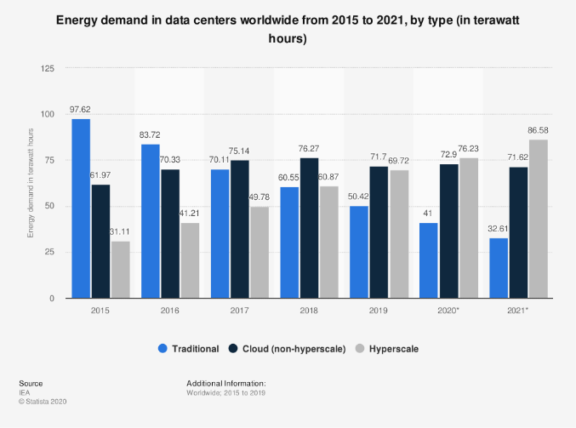
Fig. 1. Global data centres energy demand by type (2015 - 2021)
An issue so prominent, that today is the number one measurement for sustainability of data centres and the entire technology around them. Attention has been drawn to businesses and researchers and many studies have been published on the matter. After the revision of numerous papers, some main concepts have been drawn. Indisputably, the primary concern is energy consumption – how to reduce it and make it efficient [13], [14] and [15]. It is the source of issues like increased operational cost of the data centre and increased carbon dioxide emissions. The power usage in an average data centre is usually divided between the actual IT equipment, servers etc. and the physical facility surrounding them, like cooling, backup power, lighting and other electricity consumers around the building [15]. For optimizing the Power Usage Effectiveness (PUE) of the data centre, the total facility usage needs to drop drastically and since cooling (for equipment and equipment rooms) is the major player here, most of the solutions must be oriented towards it. References [13] and [15] state several ways of optimizing the cooling systems in a data centre.
- Air-flow organisation – the room layout plays a big role here. Raised floors and appropriate air-flow direction, so that the cold air is not mixed with hot air before it reaches its destination.
- Air conditioning – after optimizing the air-flow, a good idea is to set the thermostat a couple of degrees higher. The cooling operation lowers the effort for keeping the needed temperature.
- “Free” cooling – taking advantage of the geographical resources – environmental temperature and evaporating cooling towers are just a couple of examples.
- Using renewable energy – solar, wind, hydro energy and more.
- Utilizing the waste heat
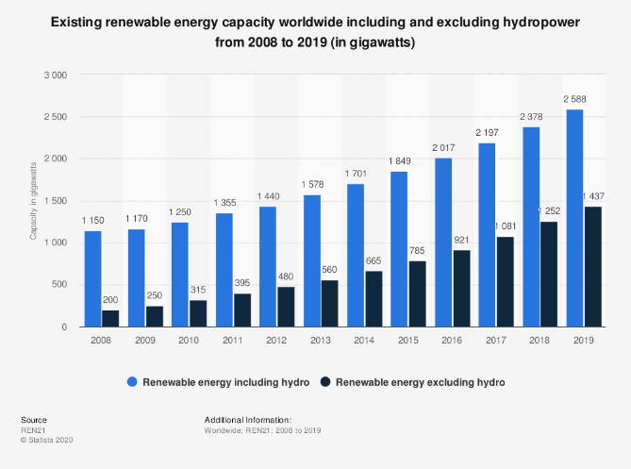
Fig. 2. Hydropower and renewable energy capacity (2008 - 2019)
[13] and [15] also talk about other measures for reducing power usage and lowering the carbon footprint. Measures like encouraging recycling and reuse of equipment, efficiency of water consumption [16], optimizing the energy efficiency of the equipment, minimizing back-up power consumption by replacing UPS systems with batteries and other technological innovations that can keep the data centre sustainable for a long period of time. Reference [17] give more comprehensive understanding about energy consumption, power conversion, energy-adaptive computing and hierarchical power control. Any of these concepts is directed towards one goal – green data centre, which will not only save you money, but most importantly – the environment.

Considerations
When planning for a data centre, many aspects need to be considered. A data centre is a facility with intricate design and complex components which house and share huge amounts of data, services, applications, even hardware resources, but most importantly – the company’s sensitive data. Designing and building one is accompanied by extensive planning and research of business needs and requirements. Is there a need of a data centre and what services does it need to provide? According to [18] there are three important items to consider when undertaking a project like this.
- What are the facilities and equipment setup that the company already owns? Is there a need of upgrading, expansion and would they be feasible and cost-effective? Would a cloud-model or colocation be a better option, considering the cost of these services? This decision has already been made by UWTSD. A new data centre shall be built.
- How to achieve the corporate goals by fitting the correct IT infrastructure and how the company’s IT needs have changed and will change in the future? This is where a revision of the amount and types of data that will be stored in the data centre, is done. How it will be migrated, stored and accessed and by who?
- Physical environment – location (available power supply at a suitable cost, available broadband service), size, cooling solutions, fire suppression systems, scalability potential.
To help with the decision making [13] published a table categorizing types of businesses to their acceptable Tier level classification, stating that for a University data centre a Tier I or II level can be applied. And since the case is, merging two universities together, with double the data to manage, the appropriate decision would be to comply with Tier II requirements. According to Uptime Institute, Tier II facilities build upon a Tier I typical cooling systems and back-up power supply, allowing for better maintenance management and planned repairs, and for better disruption prevention [14]. This is done by installing redundant capacity components, which in need, could be removed without shutting the whole system down. Planned maintenance, on the other hand, will be done during a full shut down of the system due to the single path of power distribution [15].

Design and Architecture
All of the aspects listed above are followed by considerations about the data centre architecture and network design, which include important criteria of a properly functioning data centre, such as scalability, availability, performance, security and manageability. These criteria are met after a careful planning of what the entire enterprise network would look like and are more comprehensively explained in the next chapter. Basic modules of the network are server farms (Internet, Extranet and Intranet) – the core component of a data centre architecture. A data centre could be designed to support only one type of server farm, or any combination of the three. Bearing in mind that each server farm has different requirements for security and management [19].

Internet Server Farm
This type of server farm is intended for users that reside somewhere on the Internet and use it to access the servers through a web browser. It is located at the edge of the company’s network, meaning that Internet access goes through it. It is typical to have an Internet Server Farm in a data centre of an enterprise providing web services to their clients. Great concerns here become the security and scalability due to the large number of users that have access to these services. Two kinds of Internet server farms can be defined – dedicated and DMZ. The dedicated internet server farm is intended for large-scale enterprises whose business is directly dependent on the Internet connectivity, such as e-commerce services or Internet provider services. In the case of UWTSD there is no need of a dedicated Internet server farm. A DMZ server farm would host all web-based applications, which can be accessed from anywhere on the Internet, including by the company’s users after the proper authentication. Such applications would be the university web site, digital library, any type of student portal etc.

Intranet Server Farm
It is intended for internal use only. This is the cluster of servers which contain the company’s most sensitive data, internal software applications and resources, and only company’s users have any access to it. The intranet servers do not allow access to internet users. The exception being a company’s internal user, connecting from outside the company’s network through a dedicated VPN connection (Virtual Private Network).

Extranet Server Farm
Designed to provide direct access to a specific range of internal company resources to users outside the company’s network. Those would be, trusted users like business correspondents, and the direct and fast connection with enterprise facilities will be of huge advantage for business process. Security plays a huge role here, since the enterprise is allowing access to external users. The connectivity here can also be accomplished through a VPN connection.
The common thing between the three types of server farms is that they have the same design shell. Only the difference is that each one has specific requirements for access permissions, security and management.

Network design and topology
To give a general idea of how the proposed network topology would work, a brief explanation is given about the Multilayer network topology first. Because of its modular design, it has some advantages like ease of troubleshooting and implementation [19]. The more significant aspect, however, is the network layers – core, aggregation and access.
Designed for use in large-scale data centres, the core layer acts as a backbone high speed connection, allows for implementing administrative access policies and most important – it is a way of increasing port density, meaning better scalability.
The aggregation layer combines modules for different networking services. It uses the core layer switches to establish connection between different modules. It is also the line of contact between the access and the core layer switches, hence the purpose of deploying security and optimization services on this level – load balancers, firewalls, IDSs (Intrusion Detection Systems).
Finally, the access layer switches are the ones connected to the end devices – servers and hosts. It is the access point of connection between the user and the network. To provide redundancy, each access layer switch is connected to at least two aggregation switches.
Keeping this in mind, a very popular data centre topology in modern day data centres is introduced by Cisco - the spine-leaf topology [20].
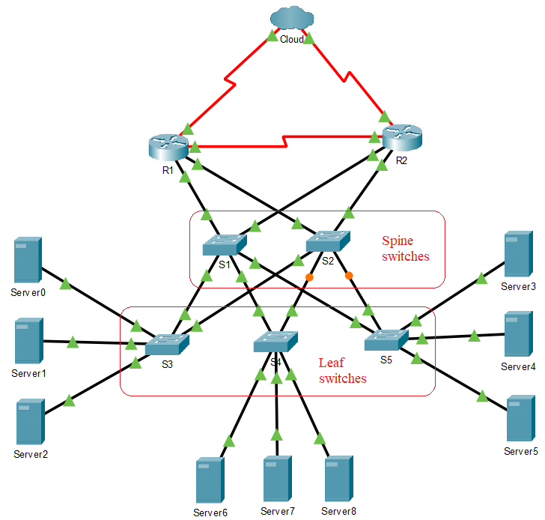
Fig. 3. Spine-leaf data centre topology
In this topology the switches are implemented in two layers. In a typical 3-layer network, the network devices are usually configured to have redundant paths, in order to ensure the network’s fault tolerance. This is usually done by configuring Spanning-Tree Protocols (STP). How this works is, the STP creates a loop-free topology, by creating more than 1 route for delivering packages, but all ports except one of them (the root bridge) are deactivated. In a case of failure in the primary route, the protocol provides a backup route, until the primary is back online. This way multipathing is not supported and the scalability is limited [20].
This type of work is quite slow in performance when it comes to a data centre and the huge load it needs to bear. And this is where the spine-leaf changes the game. The distinctive feature of this topology is that every leaf switch is connected to every spine switch. No modules are implemented and the connectivity server-to-server is significantly improved, as it only takes one “hop” to reach from one leaf to another. This significantly reduces the latency of packages. Also, every other leaf is there as a redundant component to be used in case of sudden failure. Which also guarantees the availability of the network. This implementation is a huge advancement in performance, but also scalability. There is no need for the spine switches to be connected to each other - every leaf is connected to every spine, which also implies that all ports on a spine switch are available for leaf switches. This creates a large number of routes that can carry traffic and the growth of the network becomes quick and easy.
On a similar topic, with the use of spine-leaf topology and the rapid growth of the network, network automation comes along and the use of SDN controllers (Software-Defined Network) provides cheaper and less complicated manageability. Another tool that can be used for more proper management of a large spine-leaf data centre topology, is Cisco’s FabricPath [20]. It is a technique which utilizes IS-IS routing protocol, builds a routing table of different devices [21] and learns the topology of the network. This way it selects different paths for the flow and can even assign multiple routes to the same destination, achieving efficient distribution of the traffic.

Load balancing
When the demand for server connectivity is increasing and the workload for a server is reaching its capacity, there are two options for handling it. One is upgrading the components of the machine, to improve its performance. The other solution is adding one more server to unload the workflow towards the old one [20]. But the equal distribution of the workflow does not happen without help. It is done by a load balancing component. This is a device, mounted on the route between the clients and the servers and acts like dispatcher, forwarding equal amounts of workflow towards each server.

Security
Data centre security plays a crucial part of maintaining the reliability of the facility. Date centres are the home of incredibly sensitive information. Personal details, financial details, passwords, codes, medical history, business-critical data and any other kind of information that one way or another finds itself on the web. Protecting data is of utmost importance, and security measures must be implemented on every possible layer of the data centre facility – physical security, network security, software security, social engineering security [22].
- Physical security – the first most basic rule should be, granting access to a minimum amount of people. Other examples are alarms, video surveillance, security guards, mantraps. Access authentication can be controlled by using electronic cards, biometrics, code panels etc.
- Network security – the data centre network is vulnerable to intrusion, such as ARP poisoning or Man-in-the-Middle attacks [23]. Since attack of these kinds are very hard to detect, it is a good practice to implement an Intrusion Prevention System (IPS). Also, the use of VPN connections is a basic requirement at this point.
- Software security – first line of defence against unauthorized access to any software or web application is the password. Strong password policies, MFAs (multi-factor authentication) and biometric authentication is the way to ensure the secure access.
- Social engineering – this includes training and educating people on good practices when it comes to preventing from accidental disclosure of sensitive information [22].

Conclusion
This paper is concerned with analysing data centre technology, its strengths and weaknesses, advantages and disadvantages. It goes through the timeline of data centres’ evolution and identifies the most pressing trends in keeping the technology sustainable. Along with that, a data centre architecture design is described as a proposal for the most appropriate for UWTSD’s needs and requirements. The processes that the enterprise needs to go through and the decisions it needs to make are also set out.
As a recommendation, before undertaking a project of this scale, the university might consider colocation or private cloud computing solutions for their centralized operations, depending on their specific needs and cost of the cloud services. This could prevent future losses from aging data centre environment, security breaches or not meeting future business requirements.

References

[1] | K. D. Foote, “A Brief History of Cloud Computing,” 2017. [Online]. Available: https://www.dataversity.net/brief-history-cloud-computing/. [Accessed 09 May 2020].
[2] | S. Rosenblatt, “Take a Trip Down Memory Lane to Google's First Data Center,” CNET, A RED VENTURES COMPANY, 06 Feb 2014. [Online]. Available: https://www.cnet.com/news/take-a-trip-down-memory-lane-to-googles-first-data-center/. [Accessed 27 12 2020].
[3] | K. E. Narayana, S. Kumar and D. Jayashree, “A review on Different Types of Deployment Models in Cloud Computing,” International Journal of Innovative Research in Computer and Communication Engineering, vol. 5, no. 2, pp. 1475-1481, Febtuary 2017.
[4] | M. S. Gendron, Business Intelligence and the Cloud, Reprint ed., Connecticut: Wiley, 2014.
[5] | IEEE, “About IEEE Xplore,” IEEE, 01 01 2021. [Online]. Available: https://ieeexplore.ieee.org/Xplorehelp/overview-of-ieee-xplore/about-ieee-xplore. [Accessed 02 01 2021].
[6] | ACM, “ACM Digital Library,” ACM, 01 01 2021. [Online]. Available: https://dl.acm.org/. [Accessed 02 01 2021].
[7] | R. Balodis and I. Opmane, “History of Data Centre Development,” in Reflections on the History of Computing: Preserving Memories and Sharing Stories, A. Totnall, Ed., Berlin, Springer, 2012, pp. 180-203.
[8] | S. Cass, “Chip Hall of Fame: Intel 4004 Microprocessor,” IEEE Spectrum, 02 July 2018. [Online]. Available: https://spectrum.ieee.org/tech-history/silicon-revolution/chip-hall-of-fame-intel-4004-microprocessor. [Accessed 03 01 2021].
[9] | D. Rotman, “We’re not prepared for the end of Moore’s Law,” 24 February 2020. [Online]. Available: https://www.technologyreview.com/2020/02/24/905789/were-not-prepared-for-the-end-of-moores-law/. [Accessed 03 01 2021].
[10] | L. Coors, “A brief history of data centres,” Interxion - A digital Realty Company, 07 September 2016. [Online]. Available: https://www.interxion.com/uk/blogs/2016/09/A-brief-history-of-data-centres. [Accessed 03 01 2021].
[11] | J. Woods, “The evolution of the data center : Timeline from the Mainframe to the Cloud,” SiliconANGLE Media Inc., 05 March 2014. [Online]. Available: https://siliconangle.com/2014/03/05/the-evolution-of-the-data-center-timeline-from-the-mainframe-to-the-cloud-tc0114/. [Accessed 03 January 2021].
[12] | W. P. Turner IV, P. E. and K. G. Brill, “Industry Standard Tier Classifications Define Site Infrastructure Performance,” The Uptime Institute, Santa Fe, 2001.
[13] | Q. Zhang, S. Yang, X. Zheng and M. Cao, “System-wide sustainability factors and strategies for big data center,” in 15th International Conference on Service Systems and Service Management (ICSSSM), Hangzhou, China, 2018.
[14] | H. I. Bahari and S. S. M. Shariff, “Review on data center issues and challenges: Towards the Green Data Center,” in 6th IEEE International Conference on Control System, Computing and Engineering (ICCSCE), Batu Ferringhi, Malaysia, 2016.
[15] | B. Weihl, E. Teetzel, J. Clidaras, C. Malone, J. Kava and M. Ryan, “Sustainable Data Centers,” XRDS, vol. 17, no. 4, pp. 8-12, 2011.
[16] | V. D. Reddy, B. Setz, G. S. V. R. K. Rao, G. R. Gangadharan and M. Aiello, “Metrics for Sustainable Data Centers,” IEEE TRANSACTIONS ON SUSTAINABLE COMPUTING, vol. 2, no. 3, pp. 290-303, 2017.
[17] | K. Kant, M. Murugan and D. H. C. Du, “Enhancing Data Center Sustainability through,” ACM Journal on Emerging Technologies in Computing Systems, vol. 8, no. 4, pp. 33:2 - 33:20, 2012.
[18] | P. Rafferty, “Before You Start Building a New Data Center, Consider These Three Things,” 18 Dec 2018. [Online]. Available: https://www.datacenterknowledge.com/print/168398. [Accessed 03 01 2021].
[19] | M. Arregoces and M. Portolani, Data Center Fundamentals, Indianapolis: Cisco Press, 2009.
[20] | N. Shamsee, D. Klebanov, H. Fayed, A. Afrose and O. Karakok, CCNA Data Centre - DCICT 640-916, Indianapolis: Cisco Press, 2015.
[21] | A. Scarfó, “The Evolution of Data Center Networking Technologies,” in First International Conference on Data Compression, Communications and Processing, Palinuro, 2011.
[22] | VMWare, “Data Center Security,” VMWare Inc., 2021. [Online]. Available: https://www.vmware.com/topics/glossary/content/data-center-security. [Accessed 03 Jan 2021].
[23] | J. Umawing, “When three isn’t a crowd: Man-in-the-Middle (MitM) attacks explained,” 2018. [Online]. Available: https://blog.malwarebytes.com/101/2018/07/when-three-isnt-a-crowd-man-in-the-middle-mitm-attacks-explained/. [Accessed 06 May 2020].

