ESSAY
How to retain and engage employees throughout the employee lifecycle

Student name: Alice Catalina Gheorghe
Module title: Personnel resourcing and Development
Module code: BMIH5005
Lecturer Names: Emma Roberts
Introduction
Developing and managing employee retention is the process of building a healthy communicative way for a company. Most of the companies provide the best accommodations which developed the attention of the employees and manage to bring positive environmental factors in the workplace (Cipd.co.uk, 2023). The factors that bring the overall positive ambience in the office culture depend on developing the healthy communication bond and increased level of employee productivity. A company manage to maintain employee retention throughout their life cycle and that helps to gain the level of development and growth. There are a few steps for engaging the employees for their employee life cycle (Marriott.com, 2023). These steps are commendable and manage to develop the overall configuration of the employee recruitment process. Those steps are defining the whole process of developing the blueprint of the employee lifecycle. Most of the big companies provide effective facilities and also manage to gain a good working experience for their employees as well (Customer1st.co.uk, 2023).
Hotel Marriott is focused on employee retention and manages to develop the overall productivity level throughout the employee’s life cycle (Marriott.com, 2023). The authority of the company developed an effective recruitment process, show appreciation for their employee’s personal opinions and encourage productive feedback from the employees. There are many offers for the employees to grow their abilities. Hotel Marriott provides the on boarding process for its new employees. Hire and integrated employees for the productivity orientation process and developed their vision and values for the beneficial growth of the organization. The authority of the Hotel Marriott is providing positive working experiences for their employees and this helps to attract new employees. Developing their working efficiency and promoting their levels throughout their employment helps to manage employee retention and also gain employee orientation (Cipd.co.uk, 2023). Hotel Marriot provides and prepares healthy circumstances for their employees and provided healthy accommodation which gives the overall working benefits for their working progress.
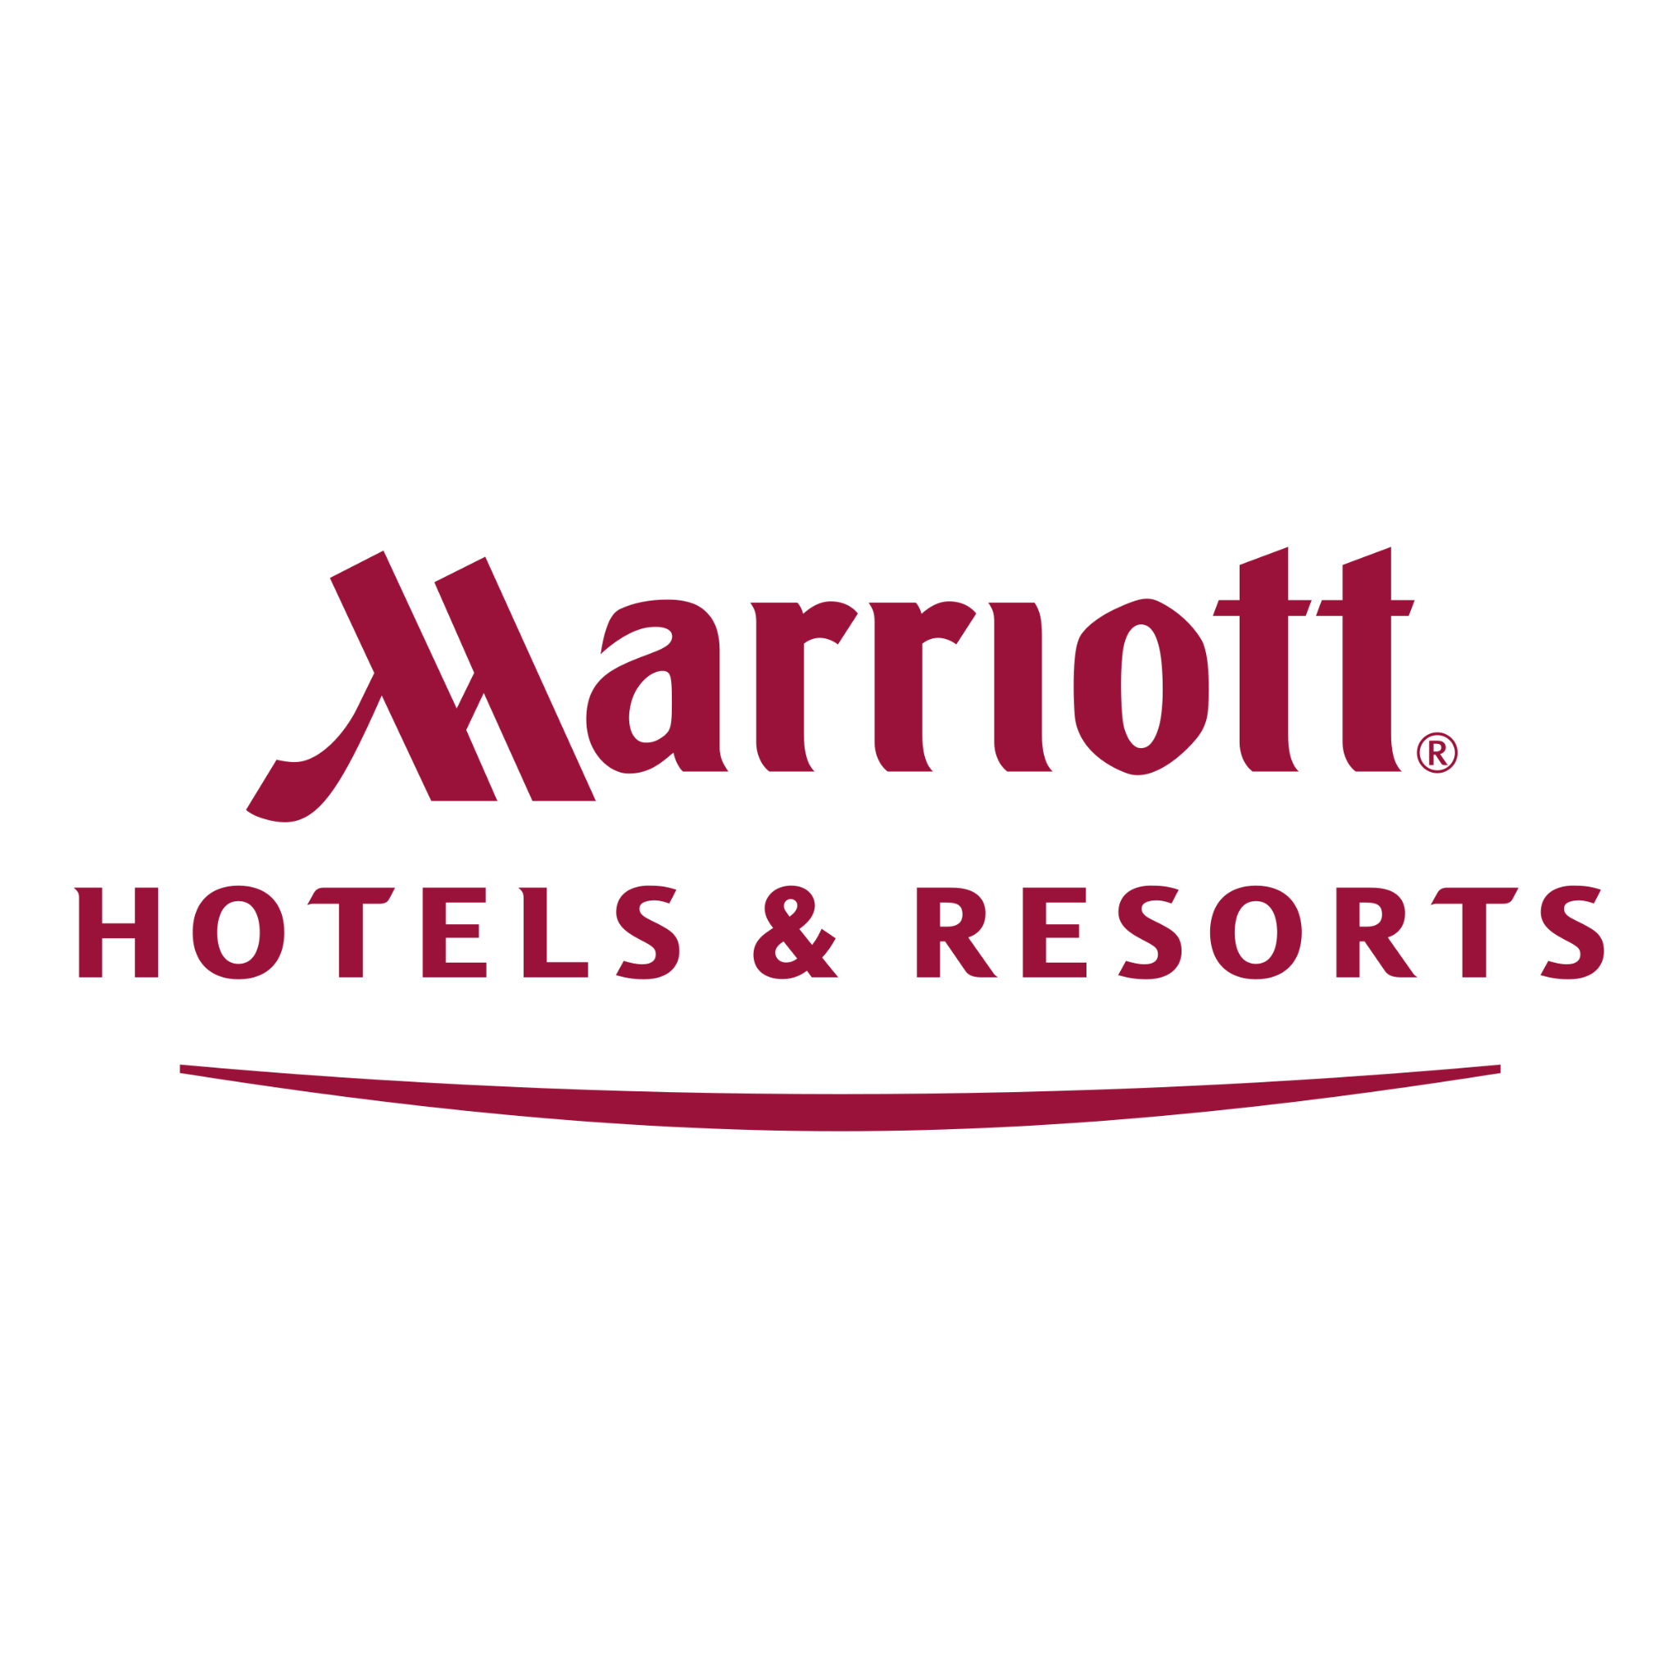
Figure1: Official logo of Hotel Marriott
(Source: Marriott.com, 2023)

Main Body
To develop the management process and employee retention the HR department plays a vital role in every organization. In preparing the company to maintain the quality of the service and efficiency of their services it is important to gain the overall circumstances of the workplace environment. The HR department plays a crucial role in managing the employee lifecycle. The recruitment process, onboarding, development, retention and separation depend on the diversity of the HR team (Torrington et al., 2020). In the lifecycle of the employee, HR maintains effective communication and orientation of the productivity level. This help to gain a beneficial impact on the overall performance of the individual employee and the team as well. Developing and managing talent is an important part of HR’s working process which helps to build the coordinated recruitment process (Indeed.com, 2023). The HR department handles employee engagement and reviews the working progress of the employees. Developing new strategies to enhance the skills of the employees is a vital role of HR.

Managing and developing talent is important for every organization where the employees acknowledge their working roles and skills. The employees gain a clear concept of the effective tool they need for developing the working progress. This helps to enact low errors in working professionals. Hotel Marriott manages to develop the talent of employees through an effective recruitment process and onboarding (Indeed.com, 2023).

The lifecycle of the employee depends on the various stages which define the nature of the retention and engagement of the employees. Developing a clear concept of the process of employee retention helps to manage the quality level of the service. Hotel Marriott depends on this process of employee retention which gives a justified way of effective management. Attraction is the first step of the employee life cycle. This step provides the employee with a good image of their target company and the willpower to appoint them there. Companies focus on the promotion of their image in the employment market to gain more skilful employees for their company. Developing the cultural background and attractive compensation attracted the employees. Hotel Marriott attracted employees by their great workplace culture (Horn, 2009). Recruitment is the second stage of the lifecycle of the employees. This stage mainly depends on the HR department of the company. The HR team try different platforms for recruiting more skilful employees. Hotel Marriott depends on the specification of the recruitment process and also involves their existing employees in this. Onboarding is the next stage of the employee life cycle. Discussing the job description, values and vision of the company helps to outline the success of the company from the employee's perspective. Following up the process of developing the integration with the employees is one of the most important parts of the employee life cycle. Development is the fourth stage where the employees improved their professionalism and developed external learning and access the internal skills as well. In this stage, the company encourage their employees to gain effectiveness in their working skills and be responsible for their self-development within teamwork (Marchington and Wilkinson, 2016). Hotel Marriott is developing the employee’s skills by giving them effective training processes and organizing various seminars and workshops as training sessions. Rewarding the employees for skilful performance helps to increase the motivation level which promotes the overall development. Retention is the next stage of the employee’s lifecycle in a particular company. This stage helps to navigate the employees to perform their best for the company’s sake. A positive organizational culture helps to emerge the retention of employees. Open communication and inspiring the employees for their development within the company's progress is defining employee retention. Hotel Marriott focuses more on this stage in the employee life cycle. They collected authentic and genuine feedback from the employees regularly helping to generate and motivate the employees to perform better. Understanding the strong motivations of various employees from various departments and producing authentic confirmations for their working progress helps to generate the overall working development of the individual employee and team as well. Separation is the last stage of the employee life cycle. This stage shows the overall nature of the employment process and it also focuses on the developing nature of the future recruitment process of the employee. This stage is the ending point of an employee’s lifecycle where the separation process is defined through the resignation. This stage opens new possibilities for the employees to apply and start a new career (Murton et al., 2010). In this stage, the employee asks for honest feedback and is reminded of the reason for leaving the company. Hotel Marriott provides beneficial circumstances for their employees before they resigned from their posts. The authority provided feedback papers for collecting genuine and honest reviews from employees who want to separate themselves from the company. This is helpful for the future growth of the company. Hotel Marriott maintains a clean inspection of the recruitment and resignation process of employees.

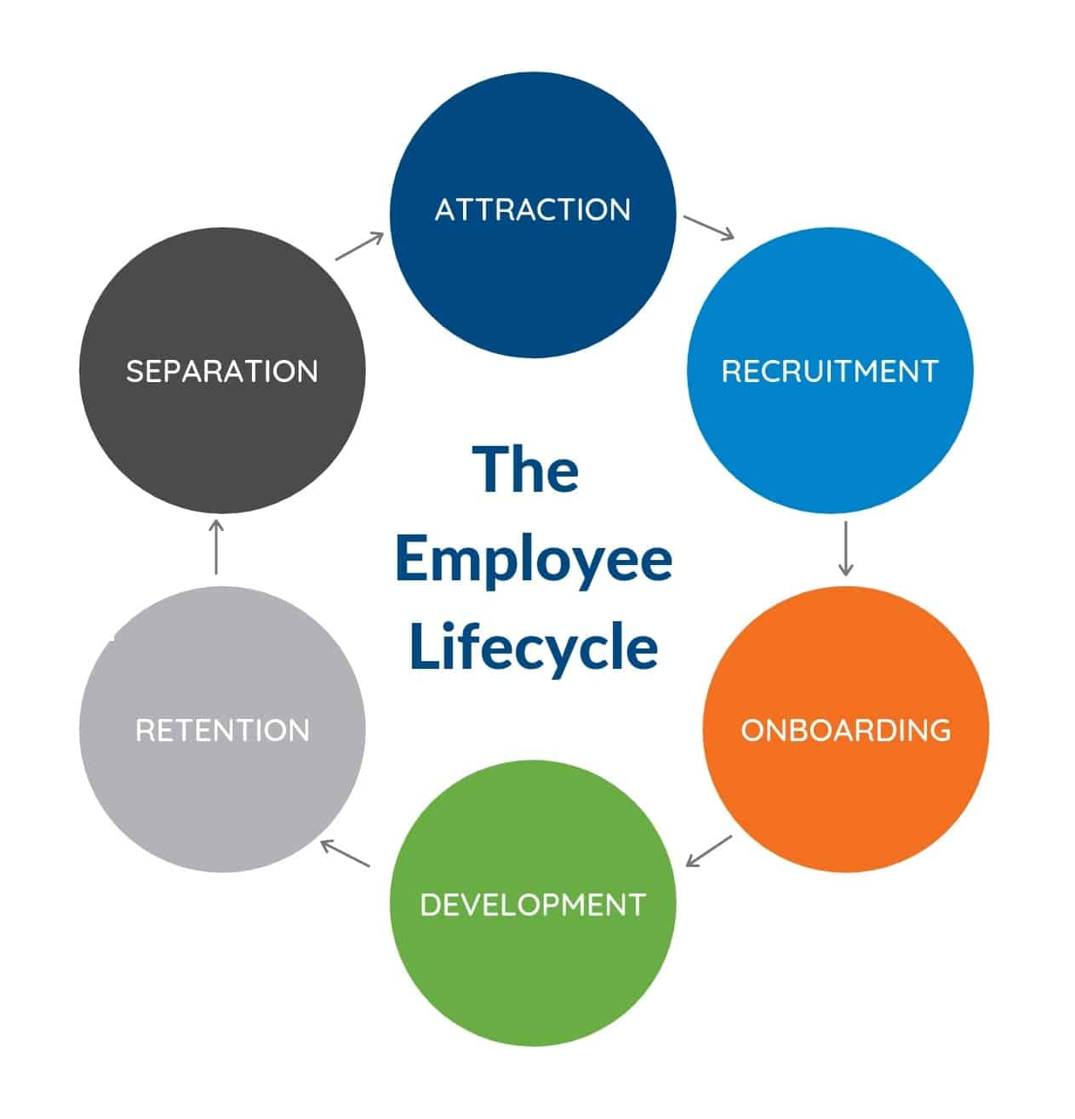
Figure 2: The Employee Lifecycle
(Source: Cciconsulting.com, 2023)

In developing organizational performance it is important to gain a clear perspective of employee’s performance and also depends on the nature of the company. Maintaining the employee’s performance is also a key element which depends on the retention process of the employees and is also beneficial for the overall growth of the company (Gallagher, 2016). From a personal view, developing organizational performance is important to gain a positive organizational culture which attains a higher level of productivity. Building strong communication between the team members helps to gain the efficient nature of the working performance. Hotel Marriott developed a strong communication network among every working team. They follow up in dedicative ways to include the diversification of the workforce (Dockethq.com, 2023). Maintaining the whole working progress for their employees gives a beneficial impact on developing organizational performance and it creates an impeccable reputation in hotel industries (Customer1st.co.uk, 2023). From an individual perspective, developing the performance of the teams is important to gain the motivational influence which develops the organisational performance. Hotel Marriott enhances the constructive power of developing and focusing on the overall growth of the organization by improving the performance of the team. Focusing on building the most effective and flexible experiences for the employee’s performance helps to maintain and engage more workplace diversity (Instituteofcustomerservice.com, 2023).

Hotel Marriott is one of the most reputable hotel industries in the United Kingdom. This hotel provided effective facilities and the best accommodation not only for their customers but also for their working employees (Johnston et al., 2012). The retention power of the employee management provided complete guidance which developed the ambience and positive work culture. The overall accommodation of this hotel depends on the growing nature of the hotel industry which provided and influences the workforce among the employees. The employees of Hotel Marriott have beneficial accommodations for performing well and establishing the nature of a positive working environment (International Journal of Human Resource Management). The employee life cycle in Hotel Marriott goes through six stages which define the nature of the organizational performance. The recruitment process is transparent and maintains healthy diversity. While the onboarding process in Hotel Marriott depends on the enlightenment of the skill enhancements of the employees. The development stage is carried through the training session and employee retention depends on the process of maintaining the organizational bond between them. The final stage of separation is also fruitful and effective in Hotel Marriott (Customer1st.co.uk, 2023). The hotel practices the effective feedback-gathering process from their previous employees as it is part of their customs (Marriottvacationsworldwide.com, 2023).
Hotel Marriott manages the effective skills of their employees as it provided complete guidance and also encouraged the nature of employee retention. The life cycle of the employees is defined through the development of the skill enhancement courses for the employees (Armstrong and Taylor, 2020). HR plays a crucial role in maintaining the level of the employee’s performance and also enhancing the quality of the services. This makes a significant impact on levelling up the performance of the employees and enhances the skilful performances. The overall growth of the company depends on the nature of employee retention. In the employee life cycle, the retention stage defines the overall development and measures all the further recommendations that an organisation should indulge in (Marriott.com, 2023). Every part of the company maintains their level of performance which includes and enhance the workforce and providing a developing nature for the finance, socio-cultural and societal ground. Hotel Marriott provided the workforce potential for their employees which creates the intense attraction towards their company. The positive appearance and teamwork dynamics maintain the reputable image in the market and also provide working progress. Hotel Marriott maintains work skill orientation and employee diversification which build a strong communication network in the international market (Friedman, 2012).

Conclusion
The essay is all over defining the nature of the employee life cycle. The potential ways which can be perfectly predictable are to gain employee engagement and employee retention. The first part of this essay is elaborated on the keen knowledge of the employee life cycle and discussed the importance of this for an organisation. The main body is depicted the various stages of the employee life cycle and also narrates the role of Hotel Marriott as an example of this. The overall perception of this essay depends on the situations of the employee lifecycle and how it works in favour of developing the organization’s reputation. There are points which developed the basic structure of the employee life cycle. The narration on the ground nature of employee attraction, recruitment, onboarding, development, retention and separation helps to modify the basic structure of the company’s working progress. This maintains and balances workforce diversity and also introduced the basic working nature of an organisation. As an example, Hotel Marriott gives fine examples of these stages of the employee life cycle and provides a clear concept of managing the potentiality of the employment and workplace environment. The working dynamics and the relatable working progress helps to analyse the factors which elaborated the basic working nature of Hotel Marriott.

References
Websites
Cciconsulting.com, 2023 Available at: https://cciconsulting.com/building-engagement-at-every-stage-of-the-employee-lifecycle (Accessed on 9th May 2023)
Cipd.co.uk, 2023 Available at: www.cipd.co.uk/cpd (Accessed on 9th May 2023)
Customer1st.co.uk, 2023 Available at: https://www.customer1st.co.uk (Accessed on 9th May 2023)
Dockethq.com, 2023 Available at: https://www.dockethq.com/resources/importance-of-teamwork-in-your-organization (Accessed on 9th May 2023)
Indeed.com, 2023 Available at: https://www.indeed.com/career-advice/career-development/talent-management (Accessed on 9th May 2023)
Instituteofcustomerservice.com, 2023 Available at: www.instituteofcustomerservice.com (Accessed on 9th May 2023)
Marriott.com, 2023 Available at: https://www.marriott.com/default.mi (Accessed on 9th May 2023)
Marriottvacationsworldwide.com, 2023 Available at https://www.marriottvacationsworldwide.com (Accessed on 9th May 2023)
Journals/Books
Armstrong, M. and Taylor, S. (2020) Armstrong's Handbook of human resource management practice. 15th edition. London, United Kingdom: KoganPage.
Friedman, A. (2012) Continuing professional development: lifelong learning of millions. London: Routledge.
Gallagher, K. (2016) Essential study and employment skills for business and management students. Oxford: Oxford University Press.
Horn, R. (2009) The business skills handbook. London: Chartered Institute of Personnel and Development.
International Journal of Human Resource Management: Available at: www.cipd.co.uk/journals
Johnston, R. Clark, G. Shulver, M (2012). Service Operations Management,Pearson, London
Marchington, M. and Wilkinson, A. (2016) Human resource management at work. 6th ed. London: Chartered Institute of Personnel and Development.
Murton, A, Inman, M., O’Sullivan, N. (2010) Unlocking Human Resource Management, Hodder Education
Torrington, D, Hall, L, Atkinson, C, & Taylor, S (2020), Human Resource Management PDF EBook, Pearson Education, Limited, Harlow. Available from: ProQuest Ebook Central.

