A marketing plan is written for
The Ritz-Carlton
Student Name: Faruque Ahmed
__________________________________________________
Student ID number: 2235171
___________________
Marketing Essentials BMIH4005
Lecturer: Luciana Saurdi
Word Count: 1196

________________________________
Contents
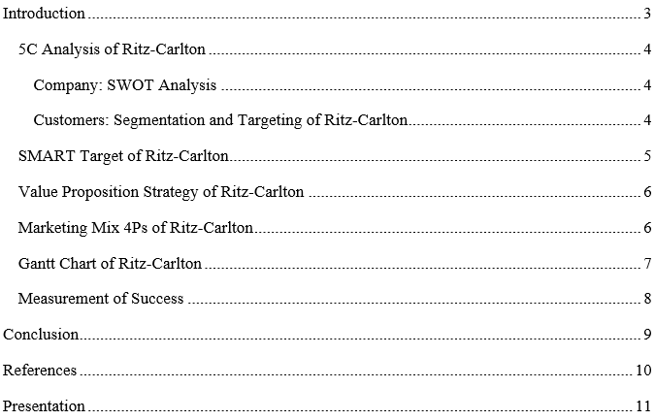

Introduction
Marketing planning refers to the idea of implementing a strategy in the organisation to advertise its products and services. The marketing plan will be developed to determine the market, targets, and objectives and set the plan according. When an organisation is set, it needed a proper marketing plan to reach its customer base and audiences. This report will be covering various marketing plans for the American Multinational Hotel Company Ritz-Carlton. This report will cover the 5C analysis, SMART Target, Marketing Mix, Gantt Chart and the control of the Ritz-Carlton company. This report will provide this market plan to get a competitive analysis of the company.

5C Analysis of Ritz-Carlton

Company: SWOT Analysis
Strength
- 70 Global Presence
- Empowered Employees
- Valued Parent Company
- Loyal customer base
Weakness
- Brand name luxury perception
- Decreasing bottom line
Opportunity
- Special packages and corporate goods line up
- Evaluation of the world tourism market
- A novel destination for tourists.
Threat
- Increasing overall cost
- Intense global competition (Davenport and Beers, 1995)

Customers: Segmentation and Targeting of Ritz-Carlton
Ritz-Carlton hotels are the premium destinations of the world. The target customers of the company are mostly upper-level people and corporate giants (Housden, 2008). Their market and target segmentation about the market is that company will target business executives, celebrities, international sportsmen, leisure travellers etc.

Competitors: Perceptual Positioning Map, Bowman’s strategy clock of Ritz-Carlton
The hotel company have placed their geographic position in the core premium places. This has brought the company premium customers competing with their competitors. For their position, their perceptual position map strategy, they have premium customers (Dev et al., 2010). Their Bowman’s Strategy clock strategy is that they set their price to the premium position. Their target audiences are the people who can add extra money for luxury and comfort.

Collaborators: B2B Relationships, Partnerships, and Franchises of Ritz-Carlton
The company has given B2B training to their employees for learning. This training helps the company staff to get into a good relationship with the partners and franchises of the company. Ritz-Carlton is affiliated with the biggest hotel chain Marriott International (Ghauri, 2014). The hotel also has franchised with Arlington and Newbury Streets.

Climate: PESTLE
- Political: Government Stability, Easy Tax Policy
- Economic: Moderate inflation rate and interest rate
- Technological: Good technological infrastructure and internet penetration
- Social: Good demographic and higher educated person
- Legal: Health safety and employment law
- Environmental: Recycling and waste management (Partlow, 1993)

SMART Target of Ritz-Carlton
The company targets audiences with the thinking of adding additional money for more comfort and luxury. So the target audiences are premium customers mostly. So the highest mission and target of the company is to get the highest comfort for the customers who seeks comfort and premium services. The company’s motive is to have a good ambience for its customers (Chaffey et al., 2019). For the positions, the premium places of the geographic areas are the top priority. Their business is run with honesty and dignity.

Value Proposition Strategy of The Ritz-Carlton
Many organisations conduct business, but the value proportion is an important thing. When the customers are to deliver the benefits of the company to the target audiences, they need to set their value standards to the highest positions. That’s why they want to feel the customer warm and relaxed. Because the customer, who is paying extra for comfort are the people who want the most luxury and comfort anyways (Kaplan, 2006). So the company pays a large amount of time in comforting their customers with their standards.

Marketing Mix 4Ps of Ritz-Carlton
Marketing Mix 4Ps of Ritz-Carlton are the product, price, place and promotion. The elaboration of the marketing mix is discussed below:
- Product: As the hotel wants its customers to feel the most luxurious and relaxed feel, the product's strategy is organised according. They provide professional services to create a luxurious atmosphere. They provide big rooms, private bathing and a comfortable atmosphere and also they upgrade their services with new gadgets often (Clow and Baack, 2013). They have facilities like parking lots, gymnasiums with top gadgets, flowering interiors all over, great room services etc.
- Price: Their pricing strategy is very premium. As they want to add some extra comfort, they seek premium service charges for the things. So the pricing strategy of the hotel is very high due to this. The hotels are also at premium locations, which helps the customers to get out of the hotels and get into fancy places (Sucher et al., 2001). With all these, the hotel charges a premium price to its customers.
- Place: The hotel chain started at premium places in the United States. After a few years of succession, they have opened hotels in 30 more countries to cope with the competition. And their every branch is the most premium place of the specific countries.
- Promotion: The company has their official website and promotion through several media. In this promotion, the company develops their products and services for premium customers. But as the company is premium, it heavily relies on the talking of the people and the experience of the person directly (Kotler et al., 2020). This is the promotional strategy of the company.

Gantt Chart of Ritz-Carlton
The Gantt Chart of the hotel Ritz-Carlton shows the feasibility study of the starting time to the commission time. The Gantt Chart development is provided below:
Stage | Task | Activity by Weeks from the Start of the Feasibility Study
Stage | Task | Jan |  |  |  | Feb |  |  |  | Mar |  |  |  | Apr
Stage | Task | 1 | 2 | 3 | 4 | 1 | 2 | 3 | 4 | 1 | 2 | 3 | 4 | 1 | 2 | 3 | 4
Conceptualisation | Develop project Brief
Conceptualisation | Decide the responsibility and involved people
Design | Stakeholder analysis
Design | Define the client's need
Design | Availability and cost of land
Design | Gather information
Design | Evaluation constraints
Implementation | Perform the feasibility study
Commission | Revision
Commission | Confirmed the feasibility study has prepared the confirmed report

Figure 1: Gantt Chart of Ritz-Carlton
Source: (Bowie et al., 2017)

Measurement of Success
The success of any hotel company is measured by the positive response of the customers. The customers have a great review of the hotel. The survey showed that there are several new customers in the company that are satisfied with the services (Jobber et al., 2020). It is not only considered a five-star hotel, but also it got several awards. The awards include Malcolm Baldrige National Quality Award. No other company have got this award two times, but Ritz-Carlton did. The customers showed heavy interest in the company which helped the company to increase its profit gradually.

Conclusion
The Ritz-Carlton company is doing a great service in the international hotel chain. The succession of the hotel chain is seen in the expansion of the business in other countries of the world and also in the upgrading of their services day by day. The whole success comes from the marketing planning it has organised that has included the marketing mix, Gantt Chart, SMART Target, 5C Analysis etc. The services are good, but the recommendation that the customer has is that the dining should have more varieties (Smith and Zook, 2020). If this improves, the competitiveness of the company can reach the highest peak level.

References
Bowie, D. Buttle, F. Brookes, M & Mariussen, A (2017), Hospitality Marketing. 3rd ed, Routledge,
Chaffey, D and Ellis- Chadwick, F. (2019) Digital Marketing. 7th ed, Pearsons, London.
Clow, K & Baack, D (2013), Integrated Advertising, Promotion and Marketing Communications. 6th ed, Pearson, London
Davenport, T.H. and Beers, M.C., 1995. Managing information about processes. Journal of management information systems, 12(1), pp.57-80.
Dev, C.S., Thomas, J.H., Buschman, J. and Anderson, E., 2010. Brand rights and hotel management agreements: lessons from Ritz-Carlton Bali’s lawsuit against the Ritz-Carlton hotel company. Cornell Hospitality Quarterly, 51(2), pp.215-230.
Ghauri, P N (2014) International Marketing, 4th Ed, McGraw Hill, London
Housden M (2008), Marketing Research & Information, Butterworth Heinemann, Oxford.
Jobber, D. and Ellis-Chadwick, F (2020), Principles and practice of marketing. 9th ed. London.
Kaplan, R.S. and Norton, D.P., 2006. Alignment: Using the balanced scorecard to create corporate synergies. Harvard Business Press.
Kotler, P., Armstrong, G., Harris, L. and He, H., 2020. Principles of marketing. 8th European ed,
London
London: Pearson Education Limited.
Partlow, C.G., 1993. How Ritz-Carlton applies “TQM”. Cornell Hotel and Restaurant Administration Quarterly, 34(4), pp.16-24.
Smith PR & Zook ZE (2020) Marketing Communications. 7th ed, Kogan Page, London
Sucher, S.J. and McManus, S.E., 2001. The Ritz-Carlton Hotel Company.

Presentation
Slide 1
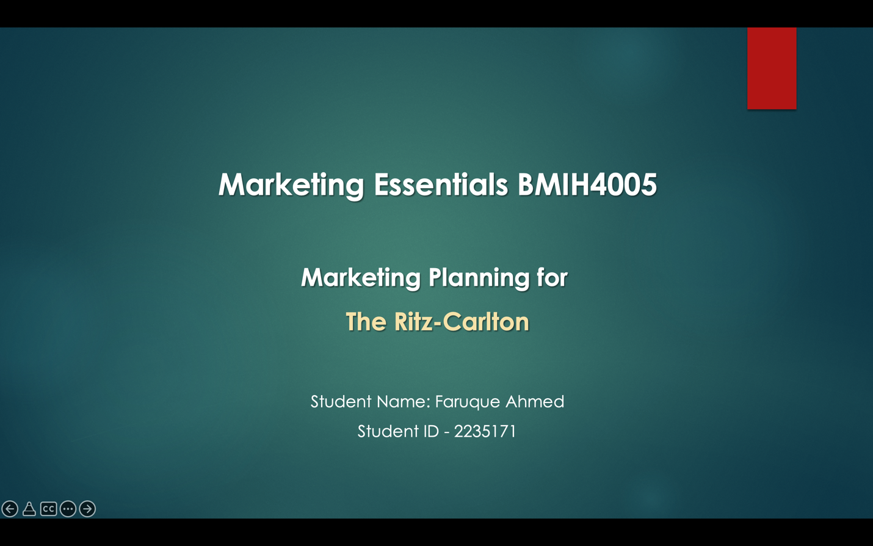

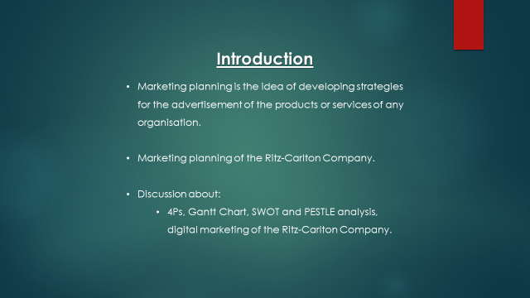Slide 2

Introduction
Marketing planning is the idea of developing strategies for the advertisement of the products or services of any organisation (Ingram, 2020). This presentation is designed to know the marketing planning of the Ritz-Carlton Company. There will be a discussion about the 4Ps, Gantt Chart, SWOT and PESTLE analysis, and digital marketing of the Ritz-Carlton Company.
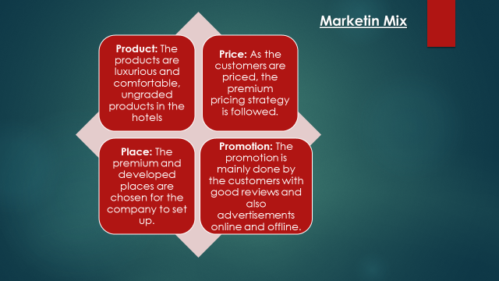Slide 3

Marketing Mix
- Product: The products are luxurious and comfortable, ungraded products in the hotels
- Price: As the customers are priced, the premium pricing strategy is followed (Dillard et al., 2000).
- Place: The premium and developed places are chosen for the company to set up.
- Promotion: The promotion is mainly done by the customers with good reviews and also advertisements online and offline (Alsetoohy et al., 2019).
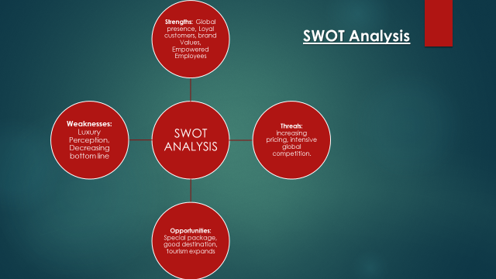Slide 4

SWOT Analysis
- Strengths: Global presence in 70 countries, Loyal customers, parental brand Values, Empowered Employees
- Weaknesses: Luxury Perception, Decreasing bottom line
- Opportunities: Special package and corporate good package, good destination situation, world tourism expands
- Threats: increasing everything’s pricing, and intensive global competition (GURL, 2017).
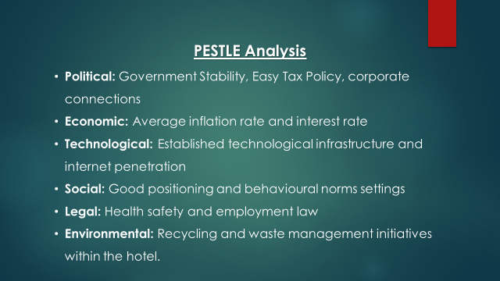Slide 5

PESTLE Analysis
- Political: Government Stability, Easy Tax Policy, corporate connections
- Economic: Average inflation rate and interest rate
- Technological: Established technological infrastructure and internet penetration
- Social: Good positioning and behavioural norms settings
- Legal: Health safety and employment law
- Environmental: Recycling and waste management initiatives within the hotel (Zalengera, 2014).
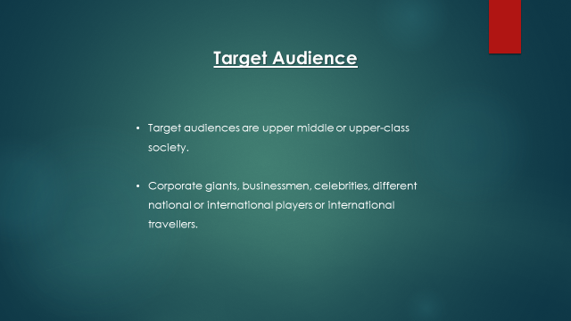
Slide 6

Target Customers
As the hotel provides premium services, its target audiences are upper middle or upper-class society (Dev et al., 2010). They want their services to reach out to corporate giants, businessmen, celebrities, different national or international players or international travellers (Tigu et al., 2013). Their pricing is premium for those people who seeks luxury and comfort rather than money.
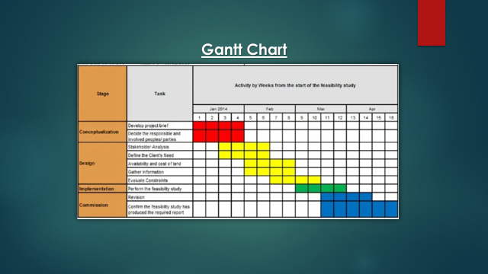Slide 7

Gantt Chart
Gantt Chart is followed to visualise the tasks that are needed to be done in the first place with the proper allocation of time (Wilson, 2003). The Ritz-Carlton hotel has developed a Gantt Chart that shows the activities of four months from the project period to the last phase (Kent, 1990).
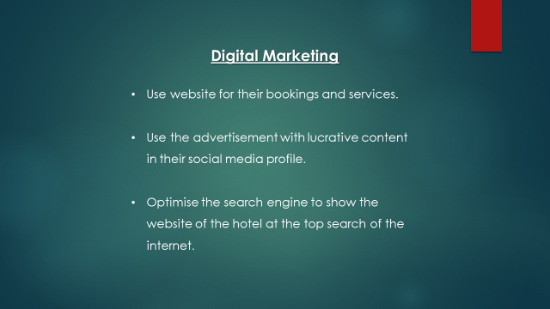Slide 8

Digital Marketing
Ritz-Carlton company has used the strategy of digital marketing. They use a website for their bookings and services (Bala et al., 2018). They also use the advertisement with lucrative content in their social media profile. They optimise the search engine to show the website of the hotel at the top search of the internet (Lee et al., 2017).
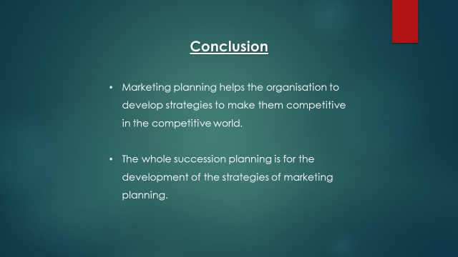
Slide 9
Conclusion
Marketing planning helps the organisation to develop strategies to make them competitive in the competitive world. The Ritz Carlton company is a luxurious hotel chain and one of the most successful hotels in the whole world (Yeung, 2006). The whole succession planning is for the development of the strategies of marketing planning.

Slide 10
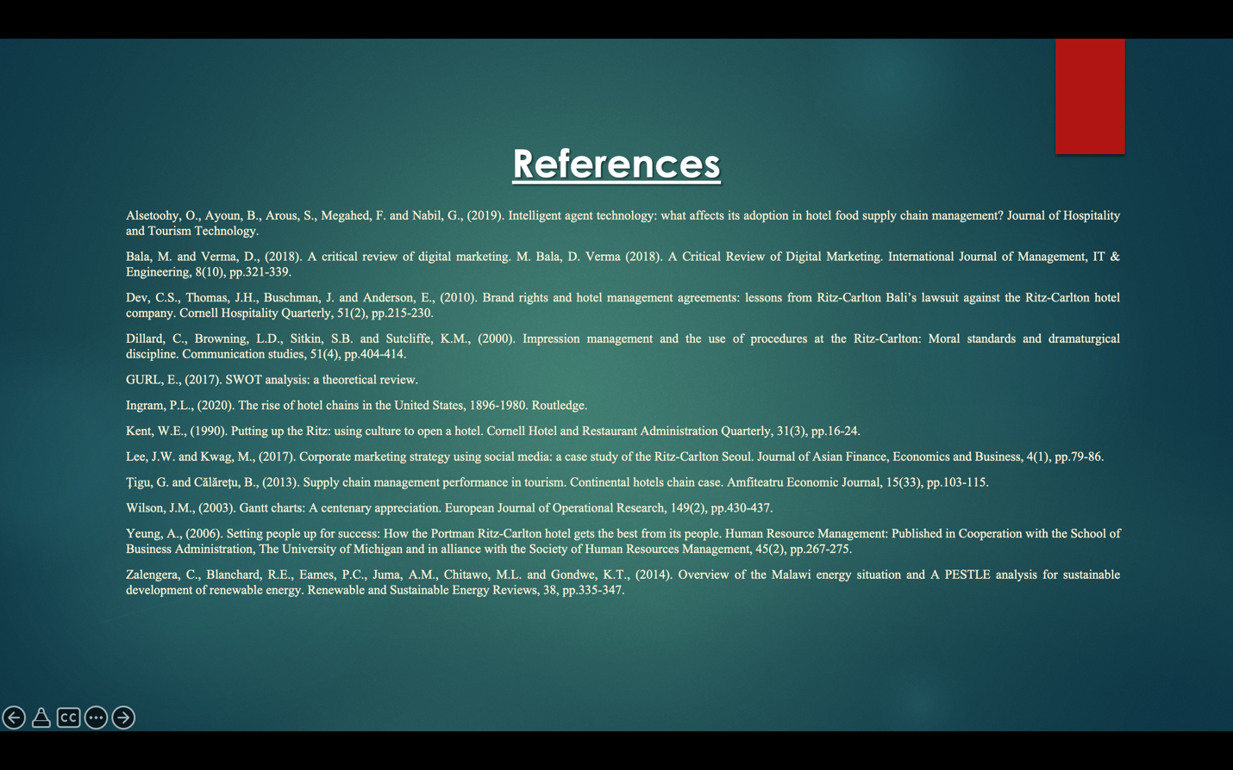
References
Alsetoohy, O., Ayoun, B., Arous, S., Megahed, F. and Nabil, G., (2019). Intelligent agent technology: what affects its adoption in hotel food supply chain management? Journal of Hospitality and Tourism Technology.
Bala, M. and Verma, D., (2018). A critical review of digital marketing. M. Bala, D. Verma (2018). A Critical Review of Digital Marketing. International Journal of Management, IT & Engineering, 8(10), pp.321-339.
Dev, C.S., Thomas, J.H., Buschman, J. and Anderson, E., (2010). Brand rights and hotel management agreements: lessons from Ritz-Carlton Bali’s lawsuit against the Ritz-Carlton hotel company. Cornell Hospitality Quarterly, 51(2), pp.215-230.
Dillard, C., Browning, L.D., Sitkin, S.B. and Sutcliffe, K.M., (2000). Impression management and the use of procedures at the Ritz‐Carlton: Moral standards and dramaturgical discipline. Communication studies, 51(4), pp.404-414.
GURL, E., (2017). SWOT analysis: a theoretical review.
Ingram, P.L., (2020). The rise of hotel chains in the United States, 1896-1980. Routledge.
Kent, W.E., (1990). Putting up the Ritz: using culture to open a hotel. Cornell Hotel and Restaurant Administration Quarterly, 31(3), pp.16-24.
Lee, J.W. and Kwag, M., (2017). Corporate marketing strategy using social media: a case study of the Ritz-Carlton Seoul. Journal of Asian Finance, Economics and Business, 4(1), pp.79-86.
Ţigu, G. and Călăreţu, B., (2013). Supply chain management performance in tourism. Continental hotels chain case. Amfiteatru Economic Journal, 15(33), pp.103-115.
Wilson, J.M., (2003). Gantt charts: A centenary appreciation. European Journal of Operational Research, 149(2), pp.430-437.
Yeung, A., (2006). Setting people up for success: How the Portman Ritz‐Carlton hotel gets the best from its people. Human Resource Management: Published in Cooperation with the School of Business Administration, The University of Michigan and in alliance with the Society of Human Resources Management, 45(2), pp.267-275.
Zalengera, C., Blanchard, R.E., Eames, P.C., Juma, A.M., Chitawo, M.L. and Gondwe, K.T., (2014). Overview of the Malawi energy situation and A PESTLE analysis for sustainable development of renewable energy. Renewable and Sustainable Energy Reviews, 38, pp.335-347.

