University of Wales Trinity Saint David
Wales Institute of Science and Art


Electronic Circuits Testing and Applications
Vehicle Electronics

Isaac Revans
2304556
Date
Contents
1 Task 3 1
1.1 Scope Time Division Calculations (6) 1
1.2 Function Generator output square wave (6) 1
1.3 Capacitor charge and discharge wave marked at correct points. (6) 1
1.4 Basic Capacitor Calculations (6) 1
1.5 Capacitor discharge table (5) 1
1.6 Plot log(V) Gradient (5) 1
1.7 Gradient Calculations and Compare(8) 1
1.7.1 Gradient Calculations 1
1.7.2 Comparison table 1
1.8 Capacitor Uses (5) 1
1.9 Inaccuracies Question (4) 1
1.10 Risk Question (10) 1
2 References 2

Task 3

Scope Time Division Calculations (6)
One full waveform lasting ${40}_{t}$ , therefore $T={40}_{t}=40RC$ where t = RC
The time constant of the RC circuit is given by $t=RC$
One complete waveform was required to last ${40}_{t}$.Therefore, the total waveform period is T = 40RC
Since the oscilloscope screen has 10 horizontal divisions, the required time division is:
$\frac{time}{diiv}=\frac{T}{10}=4RC$
For $R=1kΩ$ and $C=0.1μF$:
$t=\left(1000\right)\left(0.1×{10}^{-6}\right)=100μs$, $T={40}_{t}=4ms$, $\frac{time}{div}=\frac{4ms}{10}=\frac{0.4ms}{div}$

Function Generator output square wave (6)

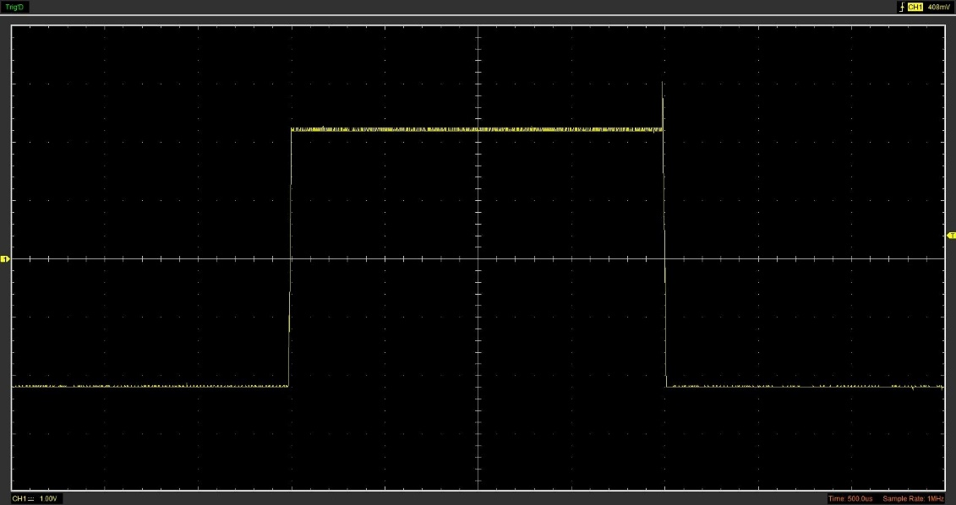
Figure 1: Square Wave
Figure one shows the square output of the wave

Capacitor charge and discharge wave marked at correct points. (6)
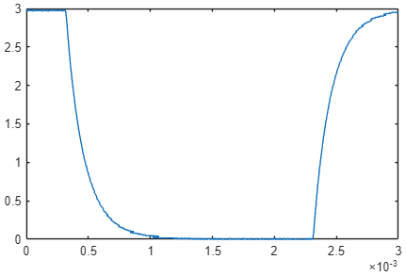
Figure 2: Matlab discharge output data

Basic Capacitor Calculations (6)

Capacitor discharge table (5)
Time (s) | Voltage (V) | ln (V) | dy = y2 – y1  dy = ln(V)2-ln(V)1 | dx = x2- x1  dx = Time2 – Time1 | dy/dx
0 | 0 |  | x | x | x
0.000039 | 0.6902 | -0.3707 | x | x | x
0.000078 | 1.2078 | 0.1888 | 0.5596 | 0.000039 | 14348.1
0.000117 | 1.5686 | 0.4502 | 0.2614 | 0.000039 | 6702.1
0.000156 | 1.8666 | 0.6241 | 0.1739 | 0.000039 | 4459.9
0.000195 | 2.0862 | 0.7353 | 0.1112 | 0.000039 | 2851.9
0.000234 | 2.2745 | 0.8218 | 0.0864 | 0.000039 | 221538
0.000273 | 2.4 | 0.8755 | 0.0537 | 0.000039 | 1377.1
0.000312 | 2.4784 | 0.9076 | 0.0321 | 0.000039 | 824.2
0.000351 | 2.5725 | 0.9449 | 0.0373 | 0.000039 | 955.5

Plot log(V) Gradient (5)

Gradient Calculations and Compare(8)

Gradient Calculations

Comparison table
 | Capacitance | Delta | Percentage difference
Actual | 1 µF | x | X
Marker Calculation
Gradient Calculation

Capacitor Uses (5)

Inaccuracies Question (4)

Risk Question (10)

References
(Format to Harvard style as per handbook)

