Destination Management: Edinburgh’s Castle

Student Name: Andreea Ionelia Girboiu
Student Id no.: 2119260
Module Name: BMIH5006
Lecturer Name: Ruth Taylor-Davies

The restaurant and hospitality business, which includes dining, lodging, including tourist attractions, has a considerable influence on the worldwide economy. Nevertheless, it is additionally well-known because of its negative environmental impact, which raises concerns regarding sustainability including social responsibility (CSR). The report in question investigates the connection between sustainability and earnings within the hotel industry. In the early 1950s, mathematician Milton Friedman said the primary job of Edinburgh’s Castle hotel sector was to maximize profitability (Muldoon et al., 2023). This paper reconsiders Friedman's standpoint within modern times when conservation alongside ethical behavior remains crucial.
This report focuses on CSR values implemented by Edinburgh’s Castle in the aspect of financial and social advantages. The study examines the economic factors as well as the impact that consumer preference in order to examine whether ecological alongside earnings meet within the hotel business at Edinburgh’s Castle. It provides suggestions for an even more environmentally friendly tomorrow. Historical backdrop, economic considerations, customer impact, including suggestions are all covered in detail, with illustrations and figures from the business that back them out.

The relevance of Milton Friedman’s theory in today’s world
The Economist, Milton Friedman made the well-known claim notion a company's main duty should be to maximise revenues during the middle of the twentieth century (Musiał and Lubszczyk, 2022). Throughout many years, such an outlook, based on a profit-first strategy, strongly affected corporate practices, particularly those working in the hotel sector at Edinburgh’s Castle. The prevalent assumption had been that a business's main obligation was to its stockholders, which led to a complete contempt for ecological alongside societal implications. Nevertheless, the globe faces rising ecological problems involving changing climates and shortages of resources, the cultural context requires reconsideration.
Money Alongside Community Accountability in the Modern Era
The terrain has changed considerably in the twenty-first century. Businesses are becoming more aware of the importance of adopting an approach regarding ecological and social accountability (Musiał and Lubszczyk, 2022). John Elkington's Triple Bottom Line shows this shift. It promotes the notion that achievement must be evaluated in addition through revenue, but additionally by the advantages it provides to individuals and the environment. In the case of Edinburgh’s Castle following and implementing the CSR values in the tourism sector improves the tourist preferences that have been advantageous economically and socially.
Elkington's structure, along with the three-layered bottom line
Three bottom lines are introduced by Elkington's framework that is Revenue, Individuals, alongside
Environmental concerns (Zaharia & Zaharia, 2021). Individuals and the Environment are concerned with the impacts on society and the natural environment, whereas Revenue is concerned with traditional monetary measurements. This broad perspective is utilized to analyze the tourism industry’s long-term viability and context. The next section examines how these aspects interact and when, in the modern world, prosperity and ethical business practices can coexist. Implementing the Elkington structure in the case of Edinburgh’s Castle, which involves the economy, people, and environment sustainability developed after the destination applied CSR.

Stability in finance alongside social stability
The quest for financial stability and economic sustainability was a fundamental component of the contemporary hotel sector at Edinburgh’s Castle. Despite Friedman’s emphasis on profit maximization, corporations in that area now see the need for both adaptation and financial sustainability (Mayer et al., 2020). Financial stability involves the adoption of strategies that ensure the long-term viability of the Edinburgh Castle hotel business while also producing revenue. Monetary resilience is critical in a business marked by macroeconomic uncertainty, evolving customer expectations, and increased competition. It focuses on strategies for surviving downturns and adapting to changing market conditions in the Edinburgh Castle hotel industry.

Example investigations: juggling environment alongside profits
The tourism industry has shown that being environmentally friendly can be profitable. Some lodging companies like Hilton Edinburgh Carlton and Mariott Hotels have introduced eco-friendly programs to attract environmentally conscious visitors and reduce costs. This shows that ethics and profitability can exist simultaneously. Additionally, small resorts that prioritize unique experiences over typical tourist attractions show the financial benefit of targeting specific audiences while supporting others.
Irridex concept of Doxey for tourism sustainability
A useful instrument for attaining environmentally conscious tourism includes Doxey's Irridex concept. This framework evaluates how tourists believe they influence the natural world, highlighting the need to strike an equilibrium between financial advantages alongside sustainability issues (Cheung and Li, 2019). This aids companies in recognizing the thin boundary that separates resource overuse from earnings margin. The tourism sector can improve its fiscal objectives alongside guarantee over time ecological and economic viability by utilising using Irridex methodology.

Businesses are being responsible towards sustainability and being consumer-driven
Desire from consumers toward sustainable practices
Throughout the hotel sector at Edinburgh’s Castle, there have been notable changes in client tastes in the past decade. More and more guests and travellers are looking for businesses that practice sustainability and ethical business practices (Han, 2021). This growing need demonstrates greater care for the environment rather than just being concerned with sustainable actions. The integration of environmental efforts within the everyday activities of lodging establishments, eateries, and different tourism businesses is being anticipated by customers. The modification in anticipation indicates sustainable practices have become an essential component in customers' decisions rather than only a sidebar consideration.
Sectorial efforts on reaction to shifting customer interests
Using a range of initiatives, such as energy-saving methods, waste management plans, and ethical product sourcing, Edinburgh's Castle Hotel company has responded to growing consumer demand for ecologically friendly operations (Kuokkanen and Sun, 2020). Companies have to change to stay relevant and meet client expectations, which is what spurred these initiatives. Additional eco-certifications and standards are available to direct and authenticate an organization's eco-friendly operations, which helps clients find and choose ethical solutions.
A reason to live together

Using cohabitation as an example, it would be more acceptable to reframe the old notion of firms vying for the loyalty of customers given how the environmental situation is changing (Guix and Petry, 2023). Companies that put profit over sustainability in response to increased consumer demand face a challenge from Edinburgh's Castle hotel industry. Everyone involved benefits from this cohabitation arrangement. By offering eco-friendly choices, lodging establishments and dining establishments draw in ethical patrons and eventually reduce expenses by optimizing their resources.

Future recommendations
Techniques for boosting sustainability-based profit
Going in advance, it is clear that the hotel sectors of Edinburgh’s Castle convergence of both sustainability and profitability is more than merely a passing fad rather, it is a permanent fact. In order to boost profit via environmentally friendly practices, businesses need to concentrate on a few crucial tactics (Lee et al., 2023).
- Investment into technologies- Adopt technologies that automate sustainability practices, lower waste, and improve the use of energy. Maintenance expenses can be greatly reduced by using reducing waste apps, and environmentally friendly lighting, alongside advanced systems for managing buildings.
- Environmental advertising- Using sustainable programs in advertising helps draw in environmentally conscientious clients. Edinburgh’s Castle Hotel sector can differentiate itself against rivals by emphasizing ethical practices in advertising collateral and through digital channels.
- Sustainable collaborations- Work alongside vendors and associates who uphold ecological values. This guarantees the procurement of environmentally friendly products, lowering the provision chain's overall greenhouse gas emissions.
- Participation by workers: Better efficient processes may arise from employees participating in environmental programs and education. In addition to offering creative solutions, motivated staff members are essential to the adoption of environmentally friendly operations practices.
Sustainability over the long term within tourism and hospitality
In order to be long-lasting, the hospitality industry needs to be dedicated, flexible, alongside forward-thinking. Companies ought to consider the following recommendations to guarantee continued achievement (Madanaguli et al., 2023).
- Constant enhancement- The idea of being sustainable is dynamic and changes over time. Maintain sustainable programs down current to ensure accordance with the most recent ecological laws and consumer demands by periodically evaluating and updating initiatives.
- Regulation conformity- Stay up to date on the laws that are changing in regard to ecological stewardship alongside sustainability. Additionally, being required by law, conformity shows a company's commitment to responsible corporate behaviour.
- Social responsibility- A company's relationships with others can be strengthened alongside trust can be fostered via involvement within local environmental initiatives.
Useful actions toward companies
Companies within the hotel sector at Edinburgh’s Castle may undertake the following doable actions to balance sustainability alongside revenue generation.
- Establish precise objectives including establishing straightforward goals for long-term viability that include garbage reduction, carbon emissions decrease, along with water and electricity conservation initiatives. Such objectives offer a path towards financial success (Xu et al., 2022).
- Investing within instruments alongside frameworks that assist in tracking and evaluating the effects of activities on the natural world. Statistics alongside metrics serve as crucial to arrive at well-informed judgments.
- Provide sustainable education to staff members across all ranks to make certain everybody remains supportive of eco-friendly efforts.
- Frequent reviewing- To locate opportunities for enhancement, perform regular reviews of environmental initiatives. These inspections have the ability to identify inefficiency while displaying chances for savings in expenses.

Environmental aspect within the hospitality industry
Effect of business upon the natural world
The hospitality industry has historically had a significant ecological impact due to water, electricity, and waste production (Achmad et al., 2022). Despite efforts to improve, the industry's size and scope continue to pose ecological concerns, especially given the current global emphasis on ecology. More action is needed to reduce the industry's negative environmental effects.
Changes in technologies and innovation
Recent shifts including innovative innovations are opening doors for the hotel sector at Edinburgh’s Castle to grow environmentally friendly. Resorts are being constructed and run differently thanks to sophisticated energy control systems, the IoT technologies enabling intelligent activities, including environmentally friendly building supplies (Kansakar et al., 2019). Whenever savings over time are considered, these advances present an opportunity to strike an equilibrium between revenue and sustainability.
The way Hilton eco-friendly projects as a visual illustration
The Hilton Edinburgh Carlton Hotel is actively pursuing a greener future through its “Travel with Meaning” campaign focused on issues such as child chances, local resilience, and equality. Their commitment to cutting waste, water use, and greenhouse gases through their relationship with the World Animal Fund demonstrates potential for sustainable development. As an industry leader, their actions pave the way for an environmentally conscious tomorrow.

Key to sustainability finance or environmental aspect
The effects of economic well-being on sustainability practices
In the restaurant and hotel industry at Edinburgh Castle, achieving economic resilience is crucial for achieving sustainability. Companies with strong finances can invest in environmentally friendly practices such as green technologies, lower waste policies, and charitable efforts. The potential for environmentalism in the Edinburgh Castle hotel sector is greatly impacted by its fiscal health.
An analytical framework for sustainable
The statement highlights that environmentalism should be viewed as an investment instead of an extra expense because of the long-term benefits it brings. Businesses should adopt a proactive approach towards balancing profitability and ecological sustainability. Implementation of a well-planned environmental strategy can lead to differentiation, brand recognition, and cost savings. The Triple Bottom Line approach, which considers environmental, economic, and social factors, can guide this strategy, and enhance economic resilience through sustainability.
Using the butler's life course approach in the tourism sector
The statement discusses Butler’s Life Course Approach and its applicability to the hotel sector at Edinburgh’s Castle. The approach recognizes different phases of exploration, engagement, expansion, and focus that tourism places undergo, and the statement suggests that businesses can use this framework to assess their progress on their environmental journey. It emphasizes the importance of tailoring sustainable development initiatives to the specific life cycle stage to optimize resource utilization.
The statement emphasizes the importance of economic resilience as a key element in sustaining sustainability within the tourism industry. It suggests that a sustainable development plan must include financial investments in environmentally friendly innovation and societal efforts, including consumer-driven sustainable adaptation. To achieve a prosperous and environmentally responsible future, resorts must adopt methods that balance profitability with environmental sustainability.

Tourism industry UK
Based on data from 2019 to 2022, London is the most visited city in the United Kingdom, with approximately 16 million visits. Edinburgh comes in second with 1.8 million tourists in 2022. However, compared to 2019, the number of visitors dropped by 26% in 2022, which occurred before COVID-19. There is a noticeable drop in visitors to Edinburgh's Castle following COVID-19. Approximately 1.3 million people are expected to visit Edinburgh's Castle in 2022.
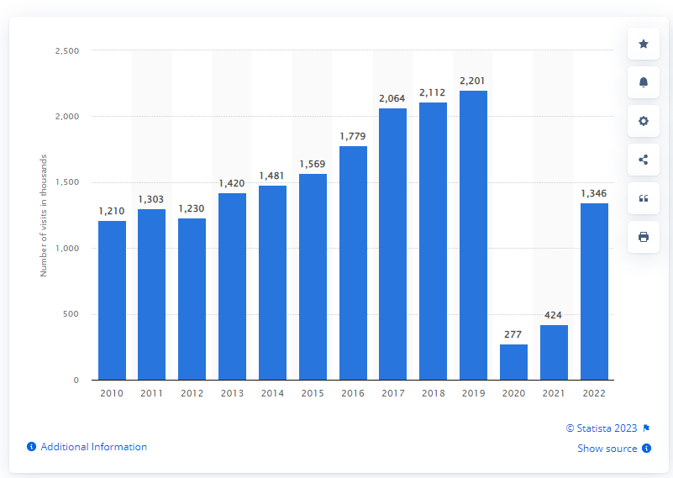
Figure 1statistics of visitors at the Edinburgh’s Castle in 2022
(Source: Statista, 2023)
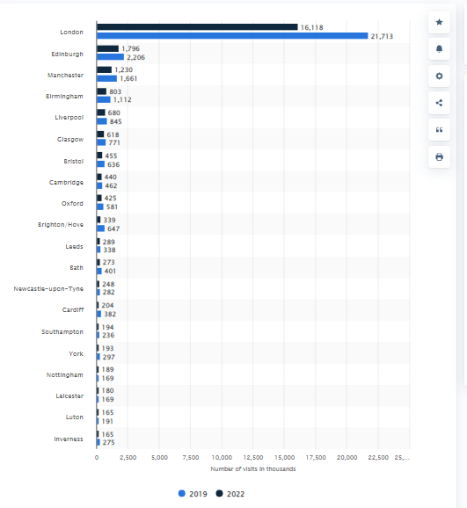
Figure 2 Most visited cities of the UK in 2019 to 2022
(Source: Statista, 2023)
In summary, the report concludes that CSR practices advocated by Milton Friedman can be successfully implemented in the modern era to increase profitability and sustainability, as demonstrated by examples like Hilton and Marriot’s greener program at Edinburgh’s Castle Hotel. It also suggests that using advanced technology and employee involvement in advertising can help the hospitality industry further implement CSR and environmental sustainability practices. Advancements in technology and innovation can sustain the business and fulfil CSR responsibilities.

References
Achmad, W. and Yulianah, Y., (2022) Corporate social responsibility of the hospitality industry in realizing sustainable tourism development. Enrichment: Journal of Management, 12(2), pp.1610-1616.
Cheung, K.S. and Li, L.H. (2019) Understanding visitor–resident relations in overtourism: Developing resilience for sustainable tourism. Journal of Sustainable Tourism, 27(8), pp.1197-1216.
Guix, M. and Petry, T. (2023) CSR managers as hybrid professionals: managing at the intersection of coexisting logics. Journal of Sustainable Tourism, pp.1-23.
Han, H. (2021) Consumer behavior and environmental sustainability in tourism and hospitality: A review of theories, concepts, and latest research. Journal of Sustainable Tourism, 29(7), pp.1021-1042.
Kansakar, P., Munir, A. and Shabani, N. (2019) Technology in the hospitality industry: Prospects and challenges. IEEE Consumer Electronics Magazine, 8(3), pp.60-65.
Kuokkanen, H. and Sun, W. (2020) Companies, meet ethical consumers: Strategic CSR management to impact consumer choice. Journal of Business Ethics, 166, pp.403-423.
Lee, S., Yeon, J. and Song, H.J. (2023) Current status and future perspective of the link of corporate social responsibility–corporate financial performance in the tourism and hospitality industry. Tourism Economics, 29(7), pp.1703-1735.
Madanaguli, A., Srivastava, S., Ferraris, A. and Dhir, A. (2022) Corporate social responsibility and sustainability in the tourism sector: A systematic literature review and outlook. Sustainable Development, 30(3), pp.447-461.
Mayer, C., Strine Jr, L.E. and Winter, J. (2020) 50 years later, Milton Friedman’s shareholder doctrine is dead. Fortune Magazine.
Muldoon, J., Gould, A.M., and Yonai, D.K. (2023) Conjuring-up a bad guy: The academy’s straw-manning of Milton Friedman’s perspective of corporate social responsibility and its consequences. The Economist, 68(2), pp.171-188.
Musiał, H.G. and Lubszczyk, M.M. (2022) The Issue of Corporate Social Responsibility in the Light of Milton Friedman's Views and Their Further Development.
Sanvitale, A.L. (2020) Corporate Social Responsibility in the Hotel Industry: A Study of Marriott International and Odyssey Hotel Group.
Statista (2023). Leading UK city destinations 2018. [online] Statista. Available at: https://www.statista.com/statistics/289010/top-50-uk-tourism-destinations/ (Accessed at: 29 October 2023)
Statista (2023). Number of visits to Edinburgh Castle in Scotland from 2010 to 2022. [online] Available at: https://www.statista.com/statistics/586822/edinburgh-castle-visitor-numbers-united-kingdom-uk/ (Accessed at: 29 October 2023)
Xu, L., Mohammad, S.J., Nawaz, N., Samad, S., Ahmad, N. and Comite, U. (2022) The role of CSR for de-carbonization of hospitality sector through employees: A leadership perspective. Sustainability, 14(9), p.5365.
Zaharia, R.M. and Zaharia, R. (2021) Triple bottom line. The Palgrave Handbook of Corporate Social Responsibility, pp.75-101.

