Database DRiven Website
Chloe Roberts – ROB19850920
HND Applied Computing
Databases and Application Development – ACCA5026
Submission Date – 18/05/2025

Table of Contents
1.0 Introduction 2
2.0 Entity Relationship Diagram (ERD) 2
3.0 SQL Injection 2
4.0 Defending Against SQL Injection 3
4.1 Anti-SQL Injection Defences 3
4.2 Weaknesses and Improvements 4
5.0 Conclusion 4
Bibliography 5
Appendices 5
Table of Figures 5
Appendix a – Version of PHP and MySQL used 6
Appendix b – Locations of Database files to be put in phpMyAdmin 6
Appendix c – Login users 6
Appendix d – Demonstration of the website 7

1.0 Introduction
This report discusses the use of SQL Injection within a database-driven website, and how measures can be implemented to protect the website from this code injection technique while implementing such measures into a database-driven website for client, Pannotina Co.

2.0 Entity Relationship Diagram (ERD)
Figure 1 displays the tables within the database and the relationships between each table to be created and displayed. It must also be noted that when adding to the database outside of the website itself, new jewellery options, designs, colours, crystals, and charms must be created in their respective tables before allocating them to a new product.
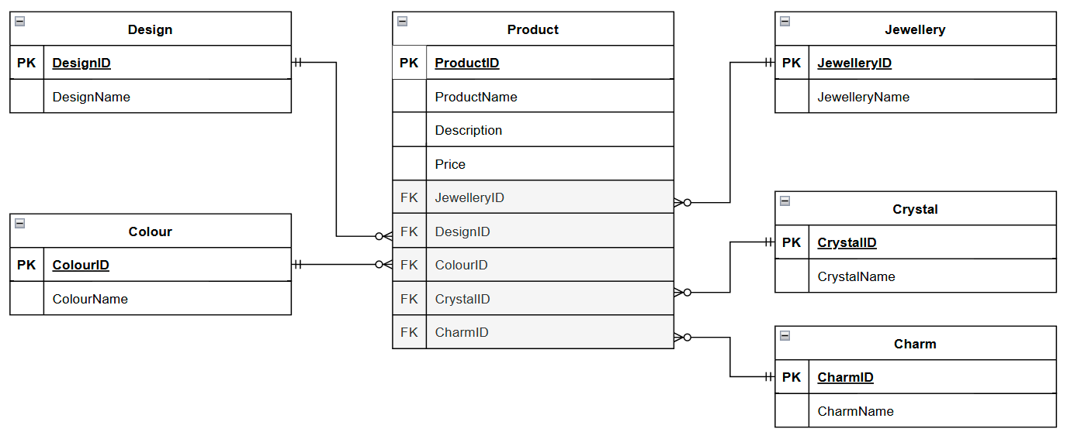
Figure 1 - PannotinaCoDB ERD

3.0 SQL Injection
SQL injection is a code injection technique that is a common web hacking technique with capabilities of destroying a database [1]. For these reasons, SQL injection can be problematic for websites since the web security vulnerability can enable attackers to interfere with database queries in order to gain unauthorised access to sensitive data including passwords, credit card details, and personal user information. Examples of SQL injection include the modification of an SQL query to obtain additional results that would have otherwise been hidden, changing a query to interfere with the application’s logic, UNION attacks, and blind SQL injection [2]. Anti-SQL injection defences can be implemented by filtering database user inputs, limit database procedures and code thereby restricting database code, maintaining applications and databases and keeping them updated, and monitor application and database inputs and communications to detect and block any SQL injection that could be malicious [3].

4.0 Defending Against SQL Injection

4.1 Anti-SQL Injection Defences
Another anti-SQL injection defence is the use of prepared statements as they separate the SQL of the database and the input from the user therefore making the users unable to utilise SQL injection to get into the database [4]. The effectiveness of this defence measure is the purpose behind its implementation in the login page on the website as shown in figures 2 and 3 in which figure 2 displays the code that implements the prepared statements and figure 3 displays the page that it is implemented for. This measure was implemented for the login page as the database cannot be accessed unless a correct username and password pair have been entered and therefore cannot be bypassed. However, this page can be bypassed but only if the individual knows the path to get to the dashboard or any other pages within the website as shown in the example in figure 4.
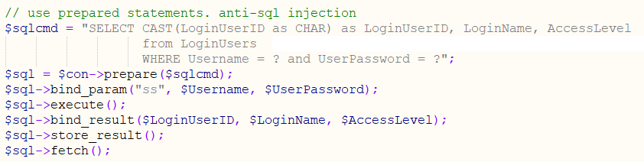
Figure 2 – Code Implementing Anti-SQL Injection Defence for the Login Page

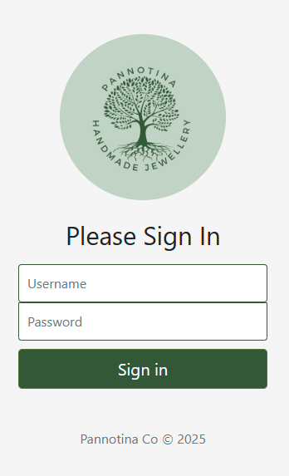
Figure 3 - Website display of page using Anti-SQL Injection Defence for the Login Page

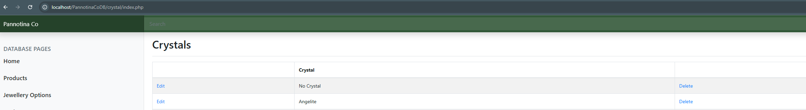
Figure 4 - Example of login bypass to database website

4.2 Weaknesses and Improvements
There is still room for improvement within the website including the use of dropdowns in product creation and using user-friendly names instead of the IDs for the foreign keys within the products table to provide easier creation and modification of records. This is due to the fact that currently, users that create or modify records are expected to know the id of each item in each category when it would be more beneficial for users to be able to select or enter the name stored in the table for ease of use and simplicity of the website. Future improvements also include ensuring full functionality for CRUD features including the updating and creation of records.

5.0 Conclusion
In conclusion, a database-driven website has been created to function as a catalogue alongside the website for mobile use while maintaining the theme and data while ensuring that the data stored is normalised and efficient for use and storage and enabling modification through the implementation of CRUD features within the website.

Bibliography

[1] | W3Schools, “SQL Injection,” W3Schools, [Online]. Available: https://www.w3schools.com/sql/sql_injection.asp. [Accessed 17 May 2025].
[2] | PortSwigger, “SQL injection,” PortSwigger, [Online]. Available: https://portswigger.net/web-security/sql-injection. [Accessed 17 May 2025].
[3] | C. Kime, “How to Prevent SQL Injection: 5 Key Prevention Methods,” eSecurity Planet, 16 May 2023. [Online]. Available: https://www.esecurityplanet.com/threats/how-to-prevent-sql-injection-attacks/#prevention-methods. [Accessed 17 May 2025].
[4] | S. Shea, “How to prevent SQL injection with prepared statements,” TechTarget, 29 November 2022. [Online]. Available: https://www.techtarget.com/searchsecurity/feature/How-to-prevent-SQL-injection-with-prepared-statements#:~:text=One%20of%20the%20top%20defenses%20against%20SQL%20injection%20is%20prepared%20statements.. [Accessed 17 May 2025].

Appendices

Table of Figures
Figure 1 - PannotinaCoDB ERD 2
Figure 2 – Code Implementing Anti-SQL Injection Defence for the Login Page 3
Figure 3 - Website display of page using Anti-SQL Injection Defence for the Login Page 3
Figure 4 - Example of login bypass to database website 3
Figure 5 - Login Page 7
Figure 6 - Admin Login 7
Figure 7 - User Chloe Login 8
Figure 8 - User Paul Login 8
Figure 9 - Home Page 9
Figure 10 - Products Page 9
Figure 11 - Products Page after Deletions 10
Figure 12 - Update Product Page 10
Figure 13 - Create Product 11
Figure 14 - Jewellery Page 11
Figure 15 - Jewellery Page after Deletion 12
Figure 16 - Create Jewellery Option 12
Figure 17 - Designs Page 13
Figure 18 - Designs Page after Deletion 13
Figure 19 - Create Design 14
Figure 20 - Colours Page 14
Figure 21 - Colours Page after Deletions 15
Figure 22 - Create Colour 15
Figure 23 - Crystals Page 16
Figure 24 - Crystals Page after Deletions 16
Figure 25 - Create Crystal 17
Figure 26 - Charms Page 17
Figure 27 - Charms Page after Deletions 18
Figure 28 - Create Charm 18

Appendix a – Version of PHP and MySQL used
PHP version 8.1.18 and MySQL version 8.3.0 were used.

Appendix b – Locations of Database files to be put in phpMyAdmin
The PannotinaCoDB database file is located within the PannotinaCoDB folder while the login users database file is located within the following path PannotinaCoDB/login/LoginUsers.

Appendix c – Login users
Admin:
Username – admin
Password – password

Chloe:
Username – chloe
Password – chloepassword123!

Paul:
Username – paul
Password – paulpassword123!

Appendix d – Demonstration of the website
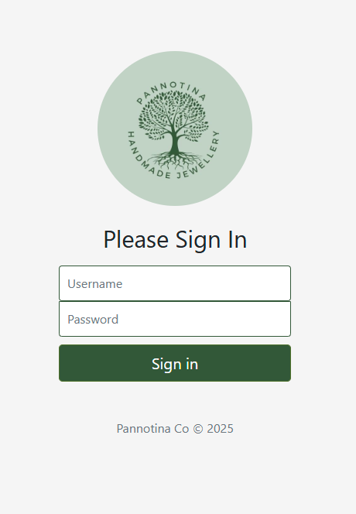
Figure 5 - Login Page

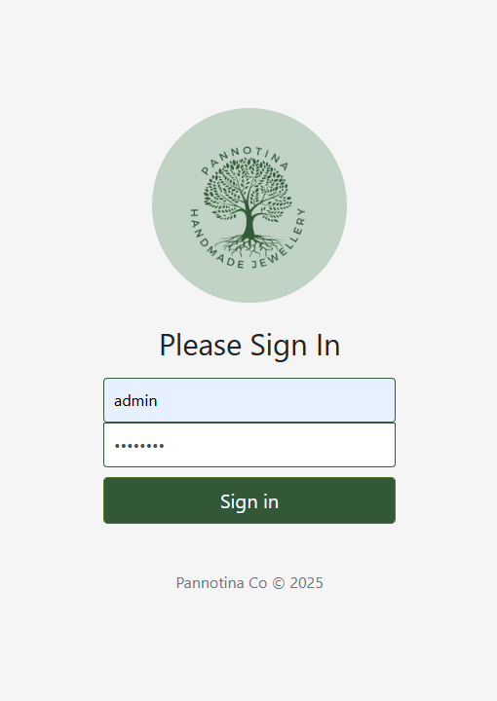
Figure 6 - Admin Login
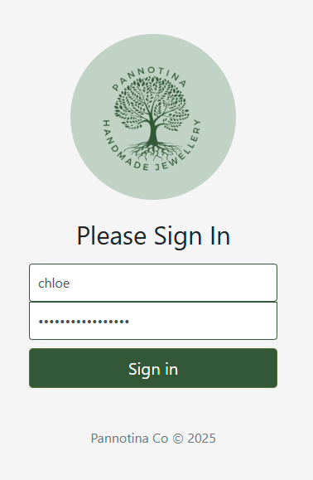
Figure 7 - User Chloe Login

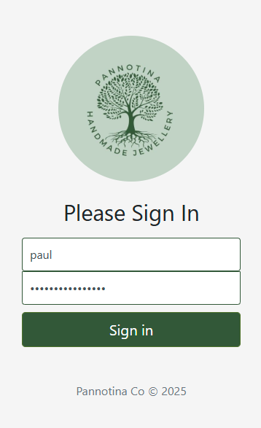
Figure 8 - User Paul Login
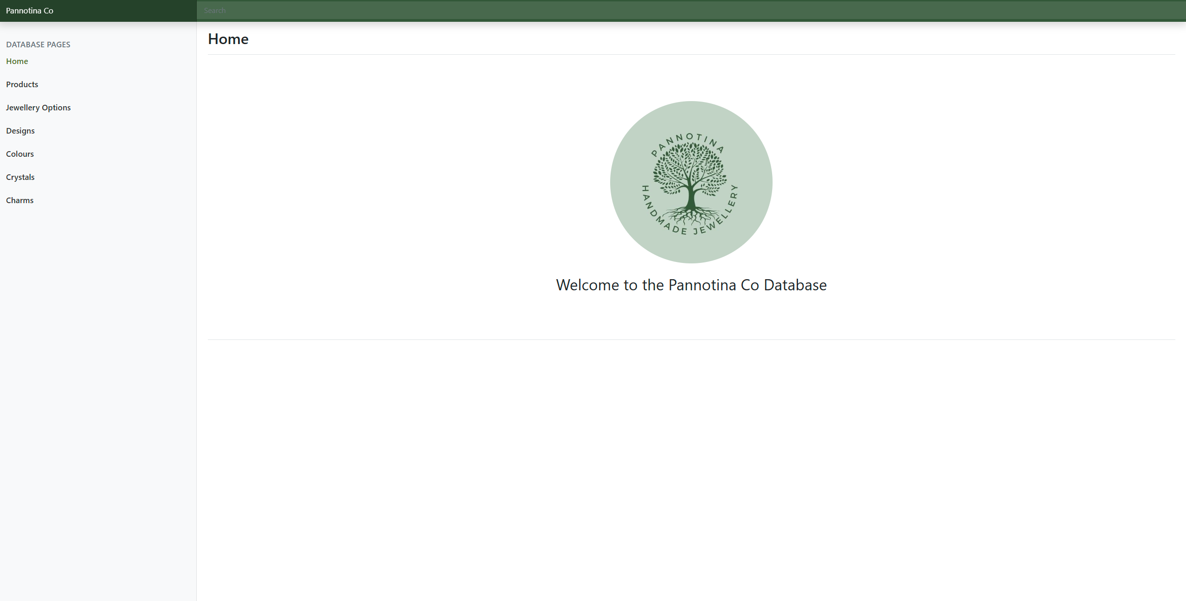
Figure 9 - Home Page

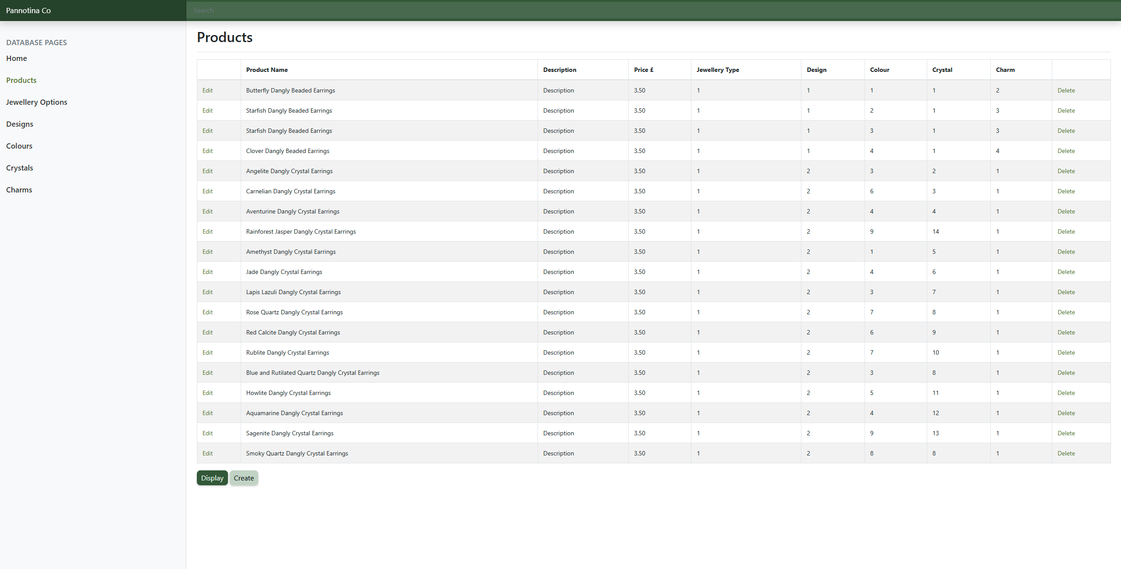
Figure 10 - Products Page
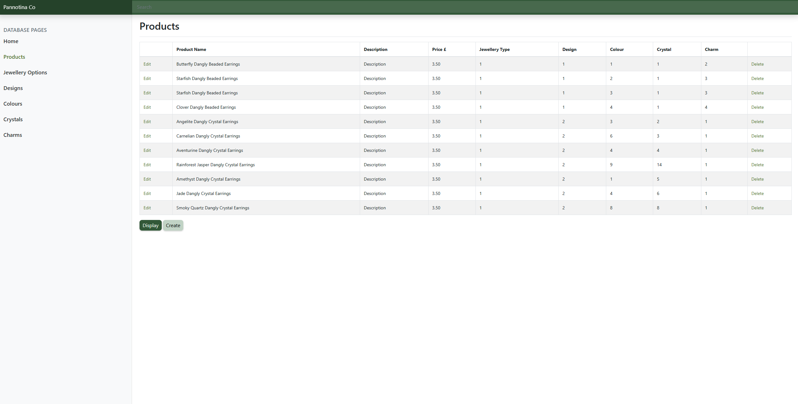
Figure 11 - Products Page after Deletions

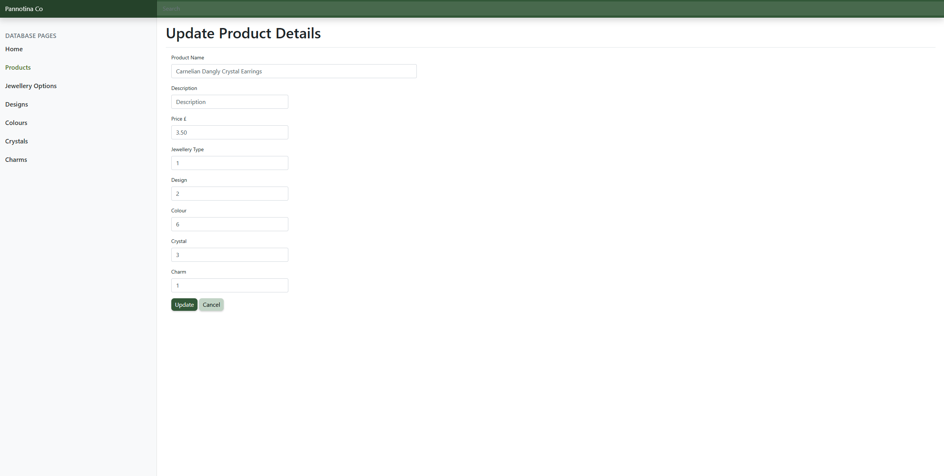
Figure 12 - Update Product Page
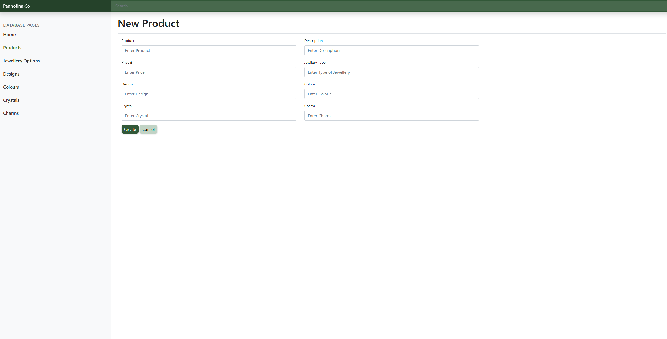
Figure 13 - Create Product

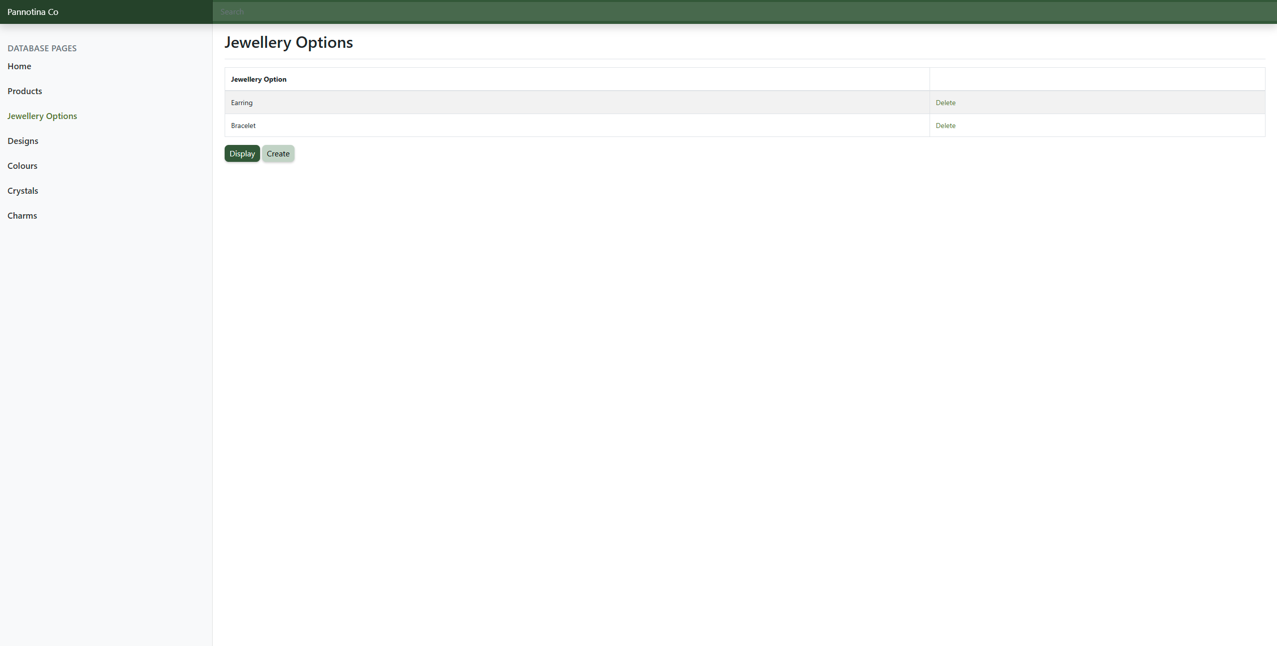
Figure 14 - Jewellery Page

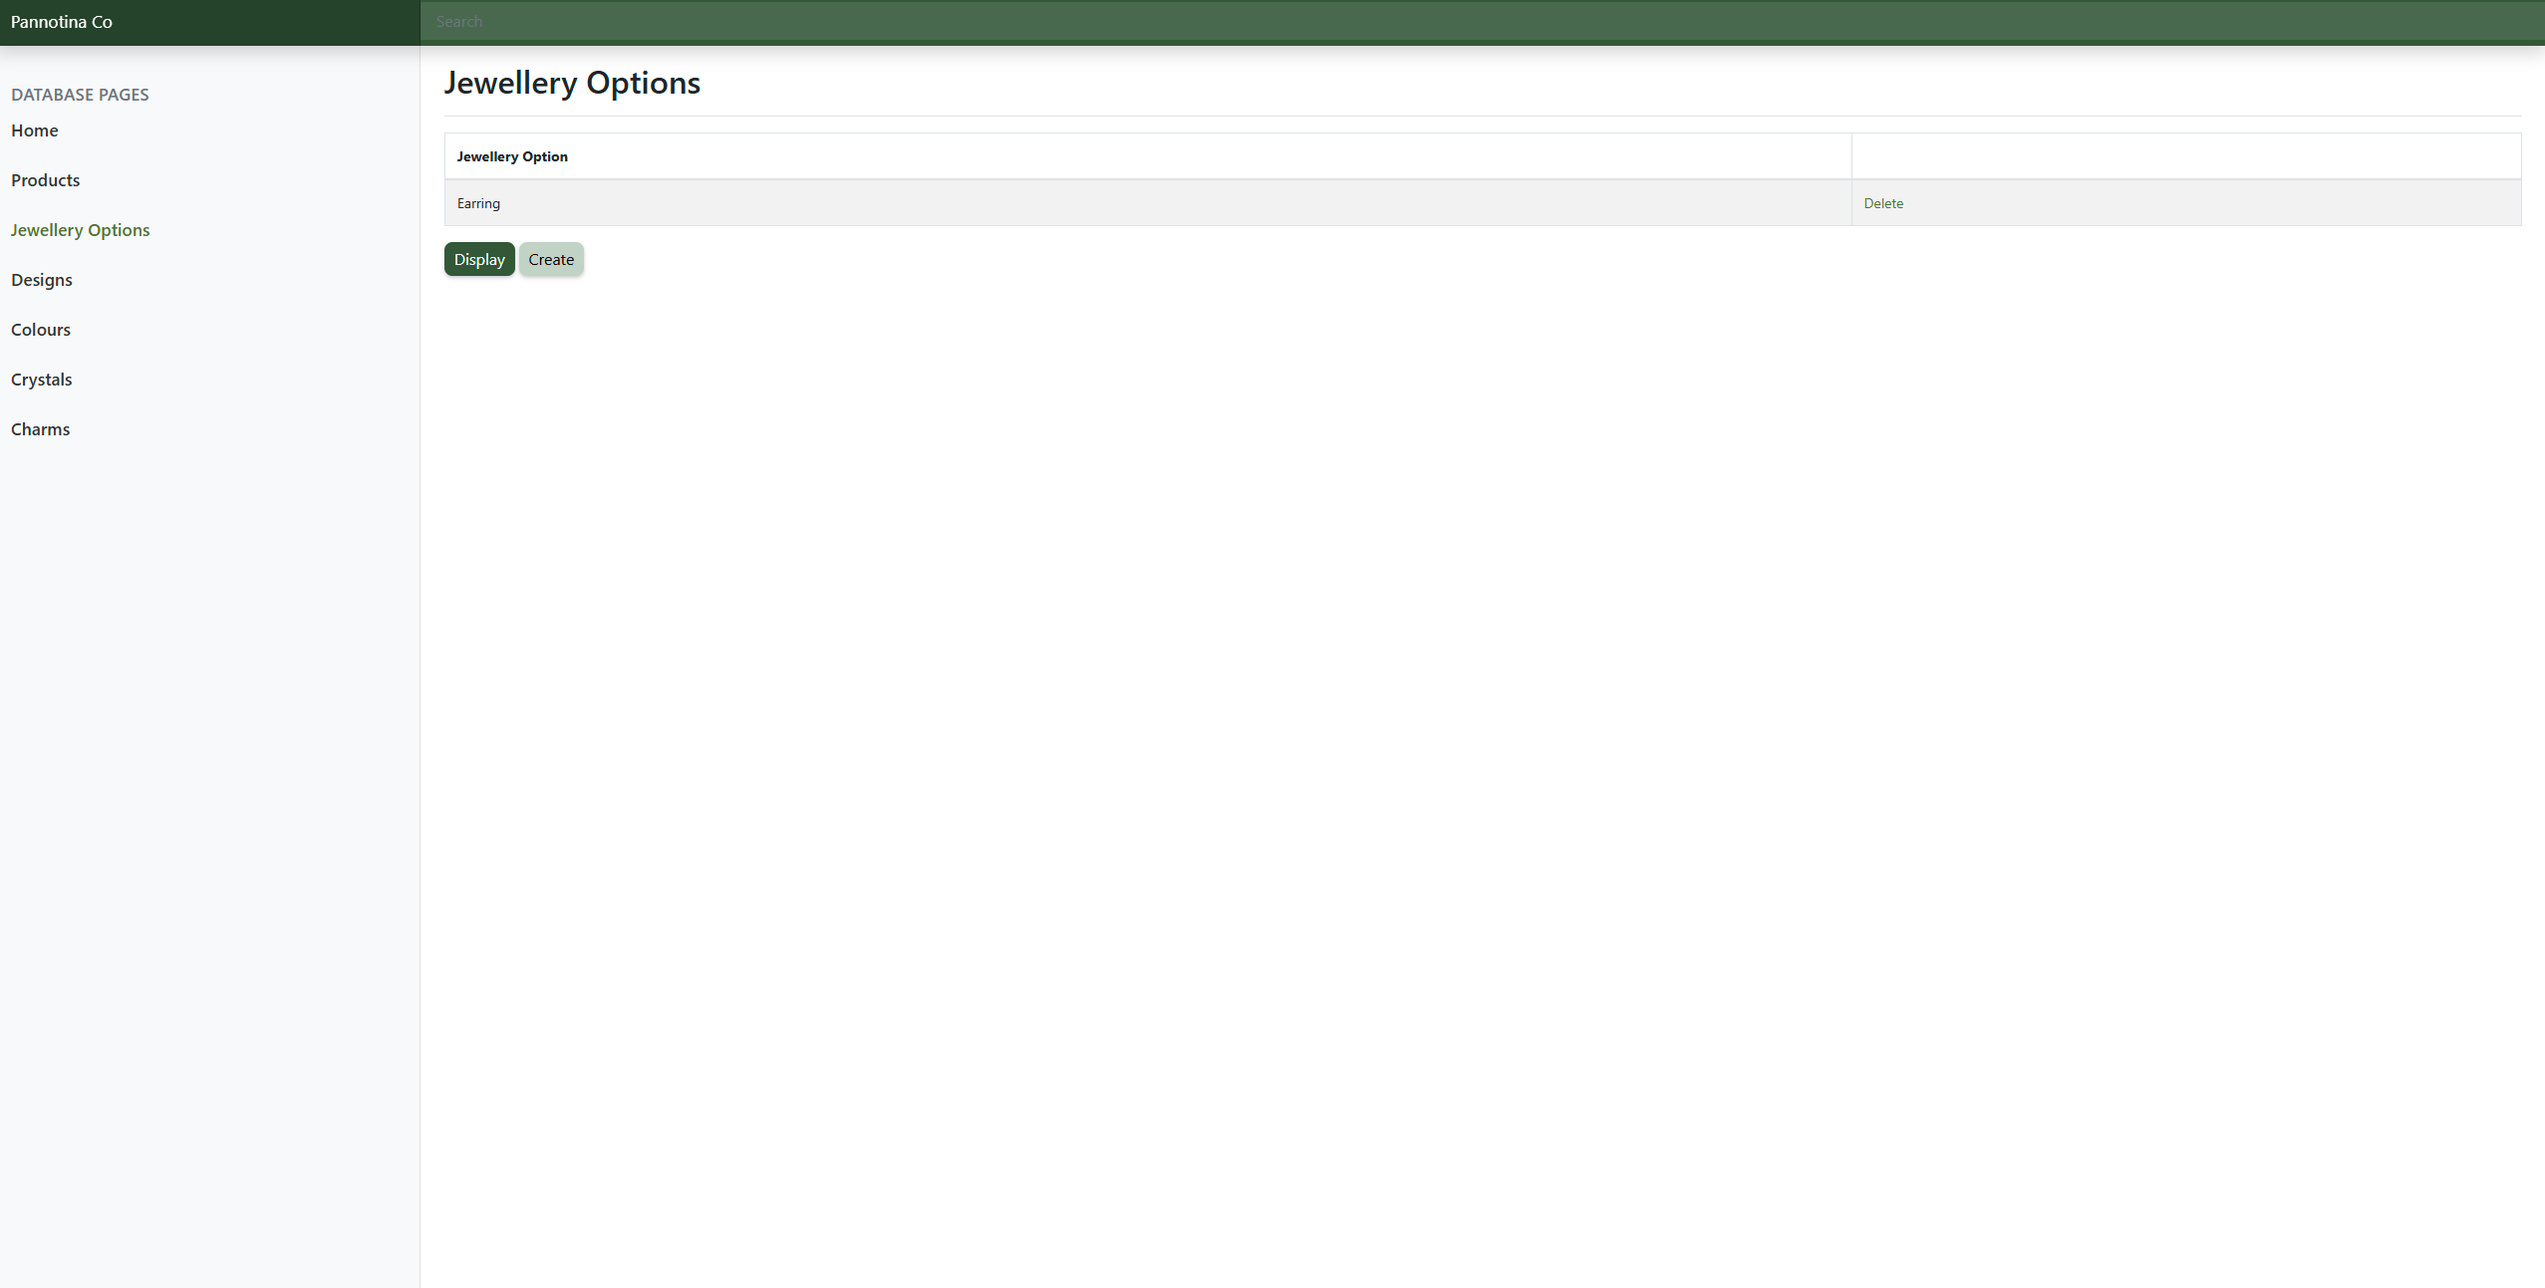
Figure 15 - Jewellery Page after Deletion

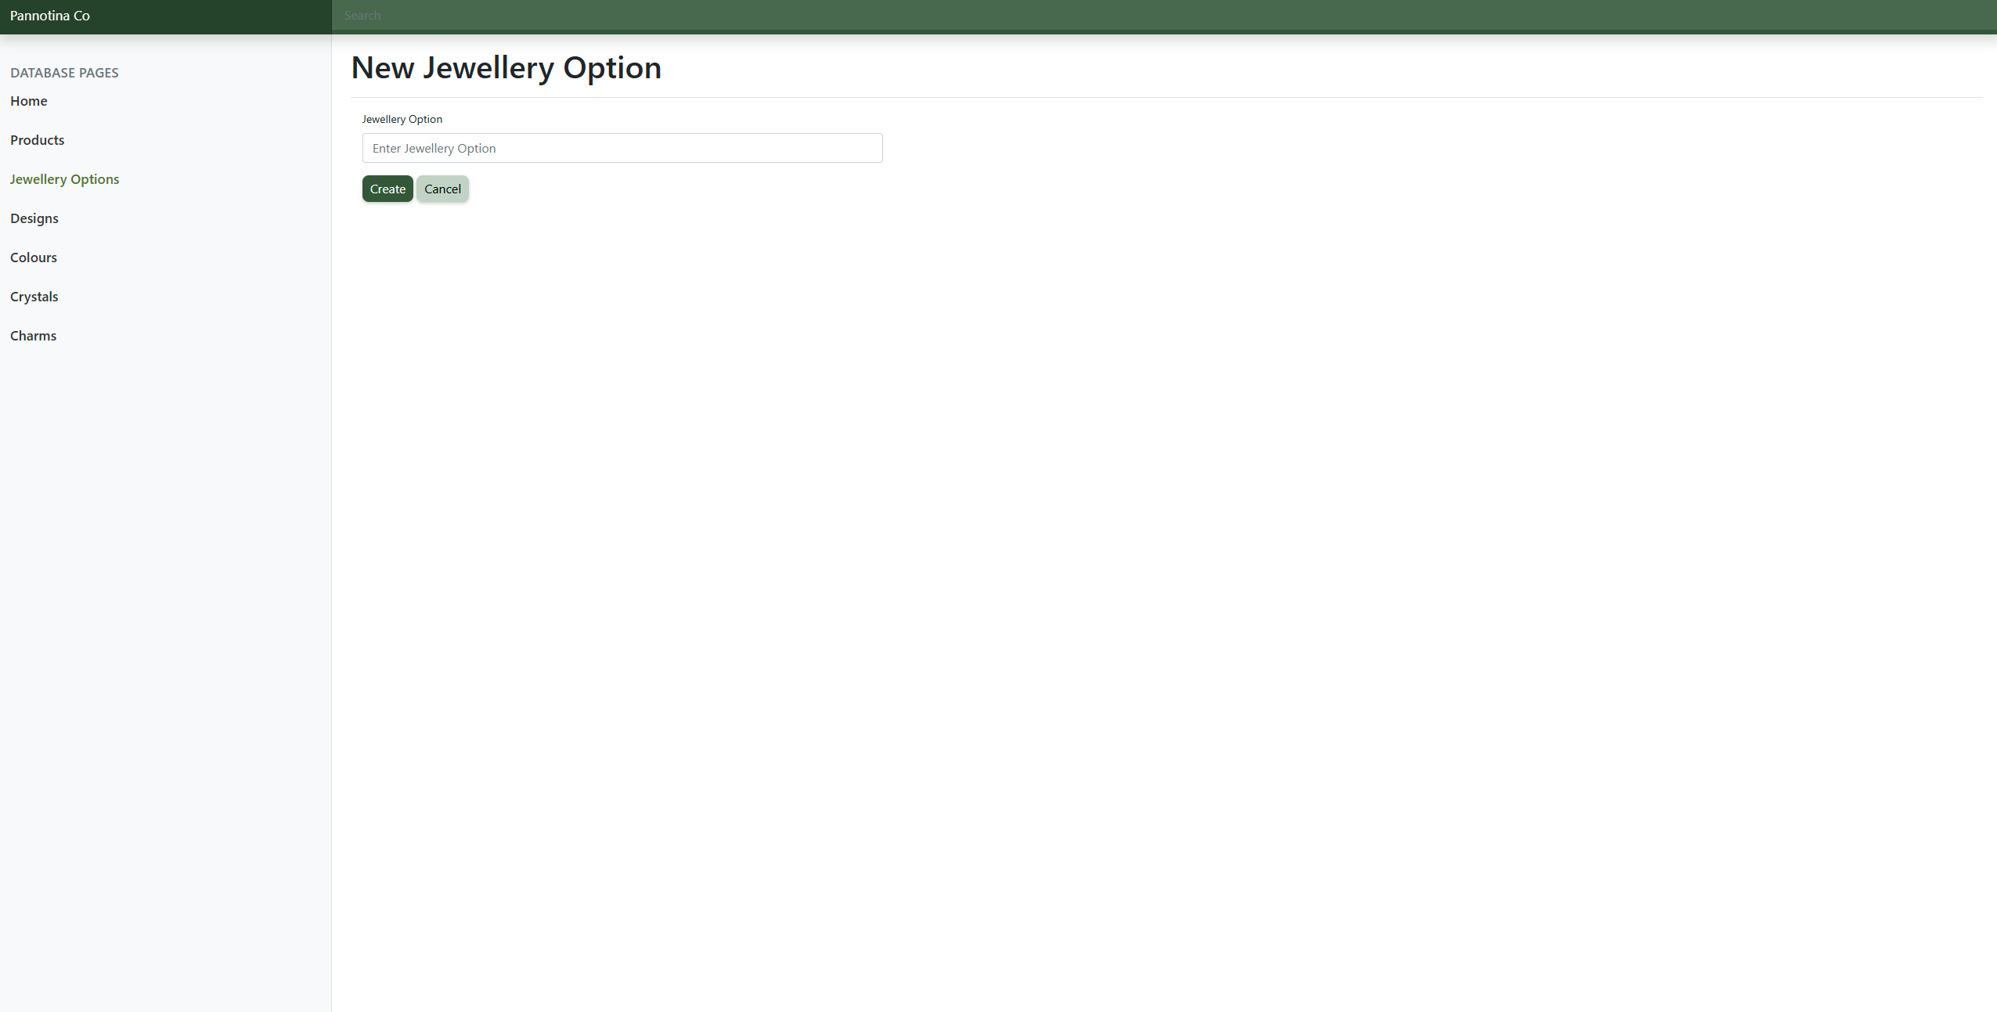
Figure 16 - Create Jewellery Option

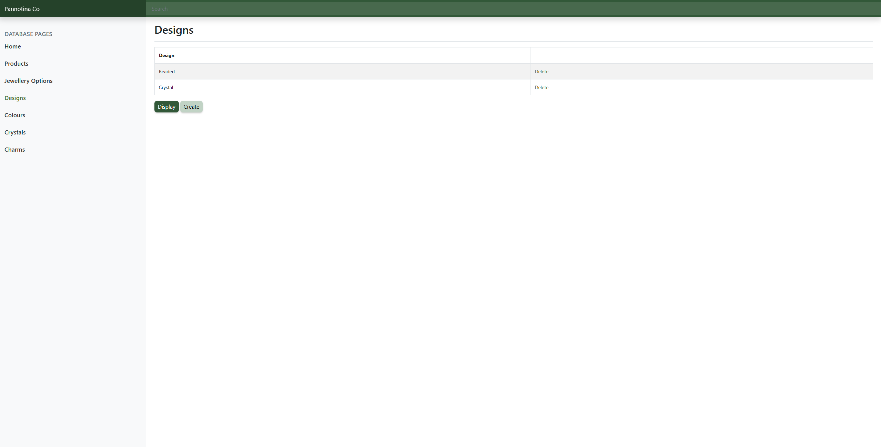
Figure 17 - Designs Page

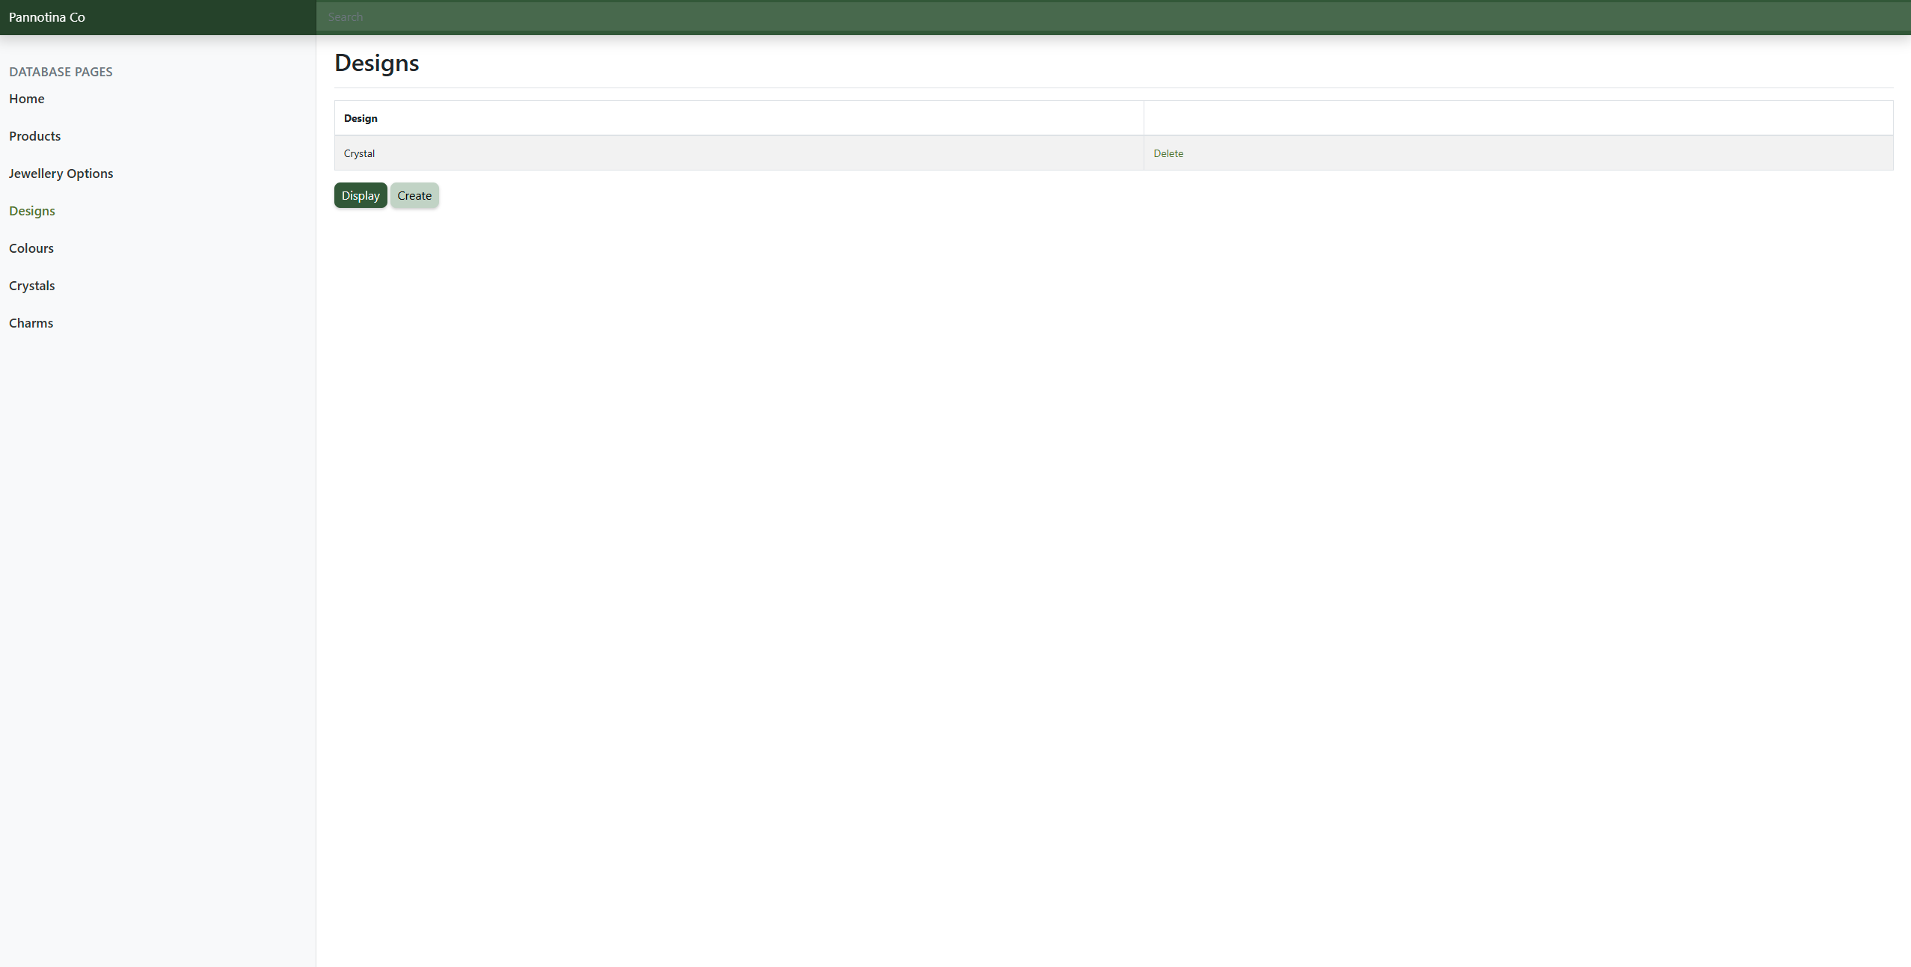
Figure 18 - Designs Page after Deletion

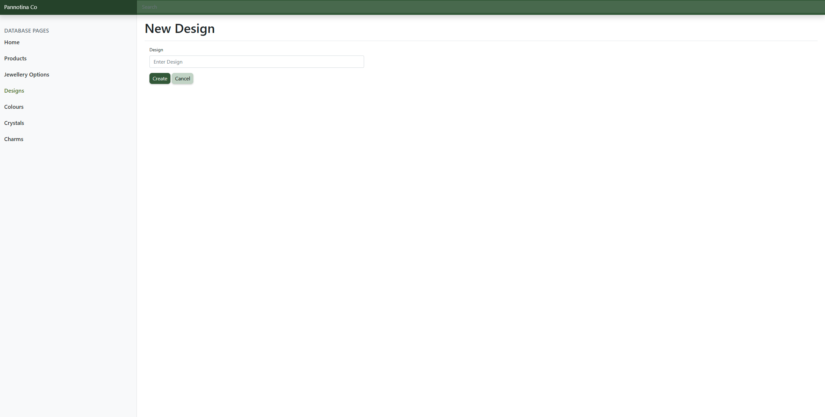
Figure 19 - Create Design

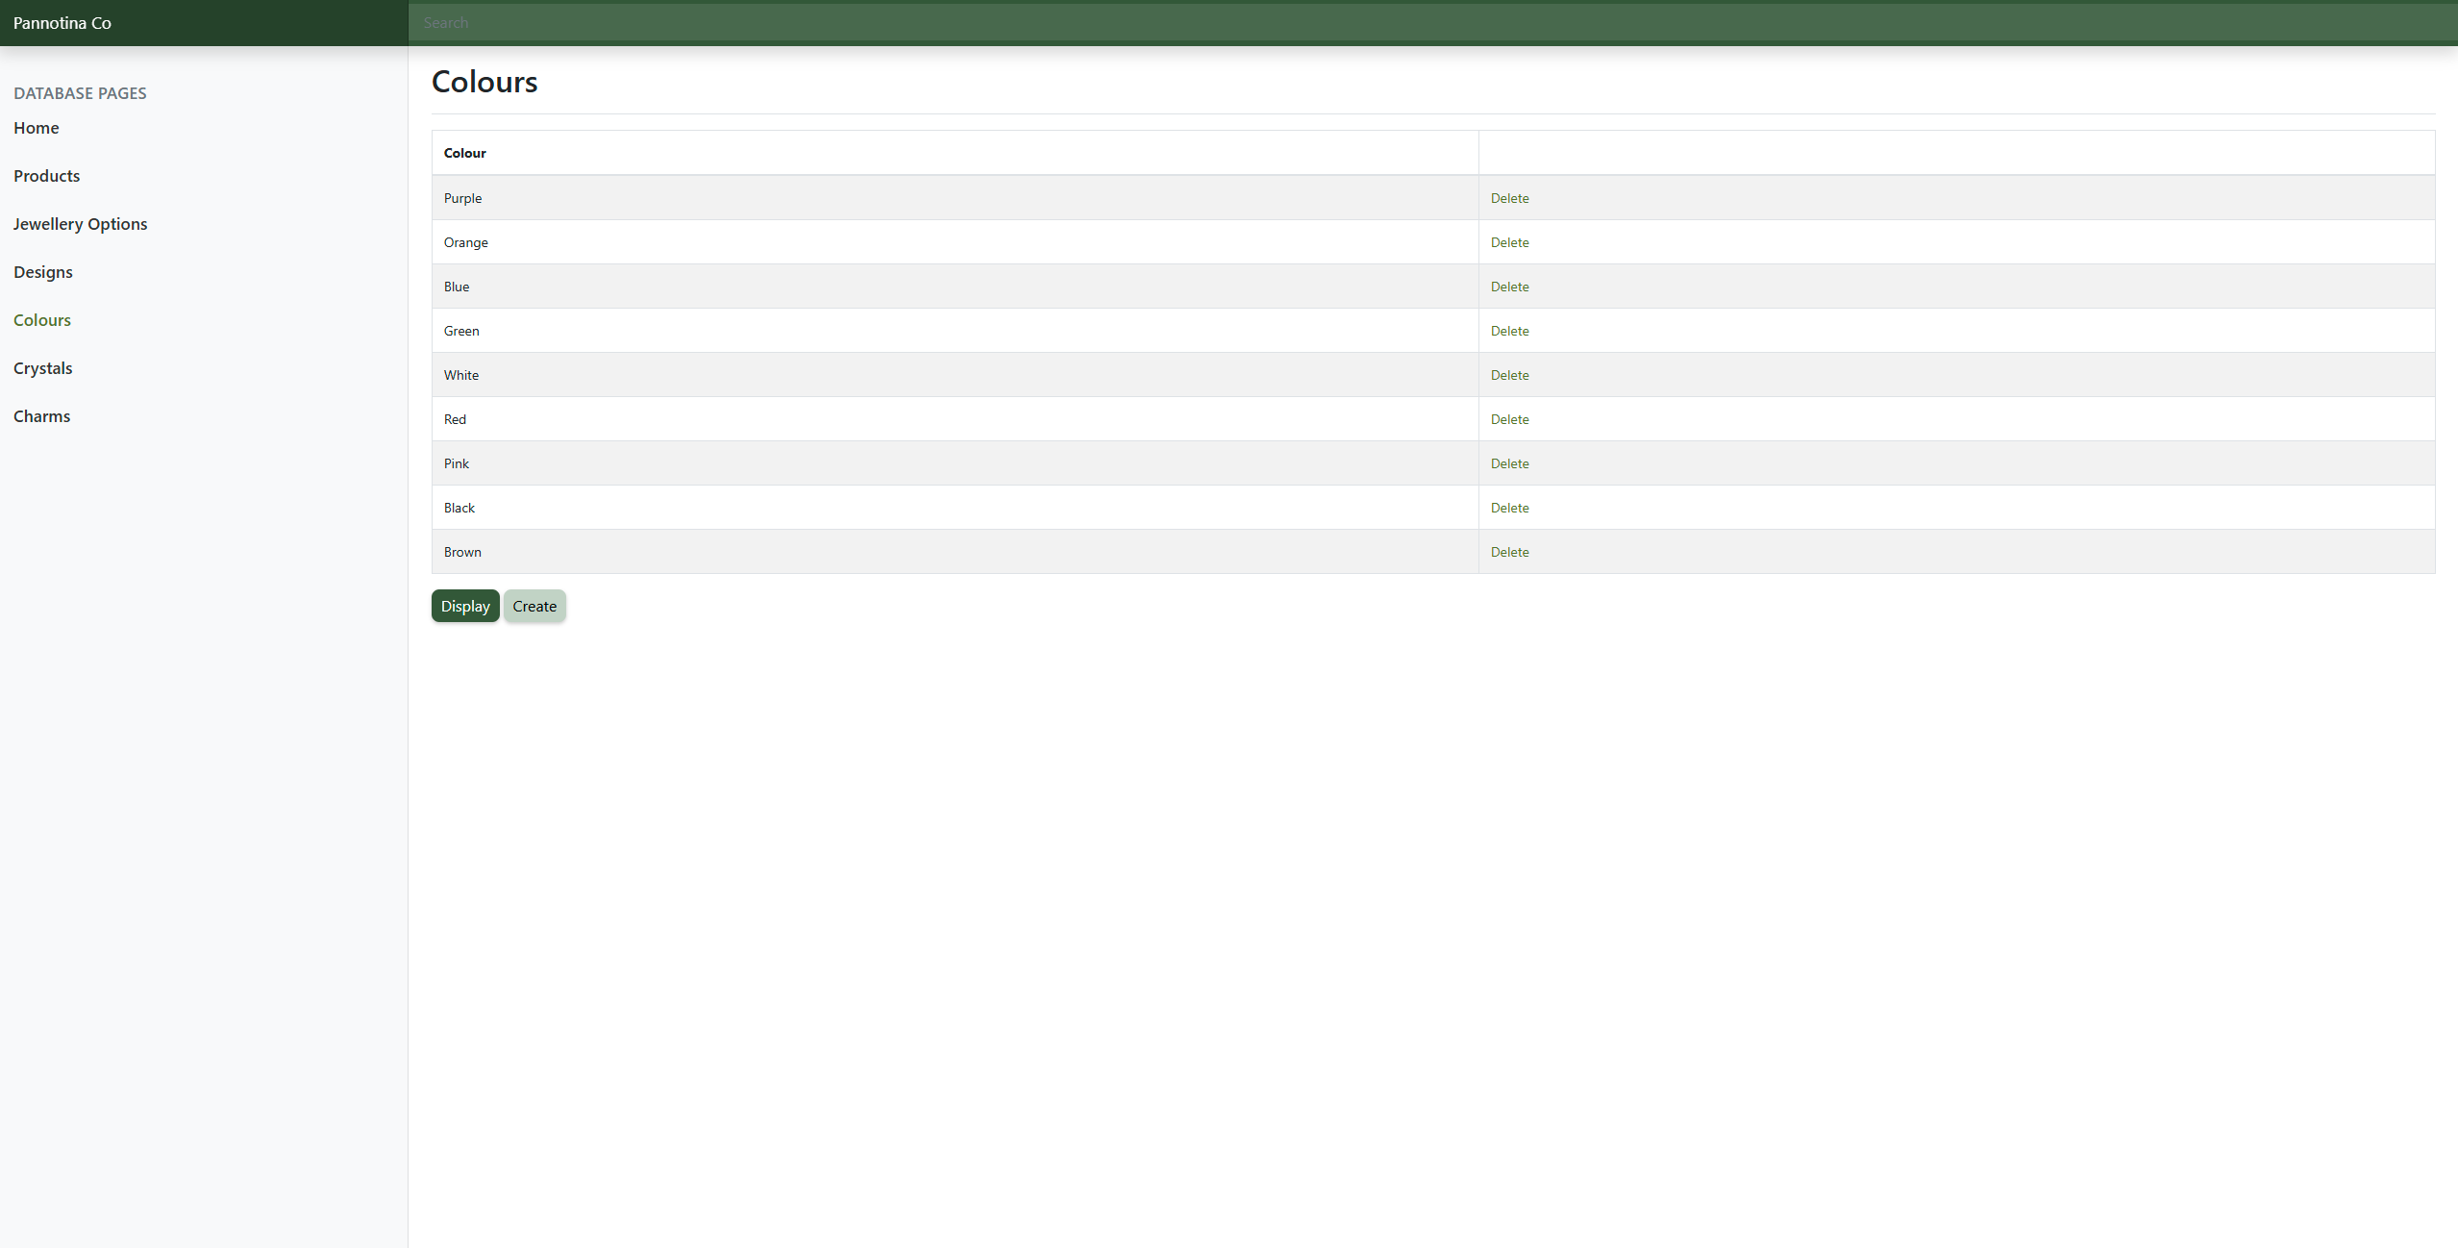
Figure 20 - Colours Page

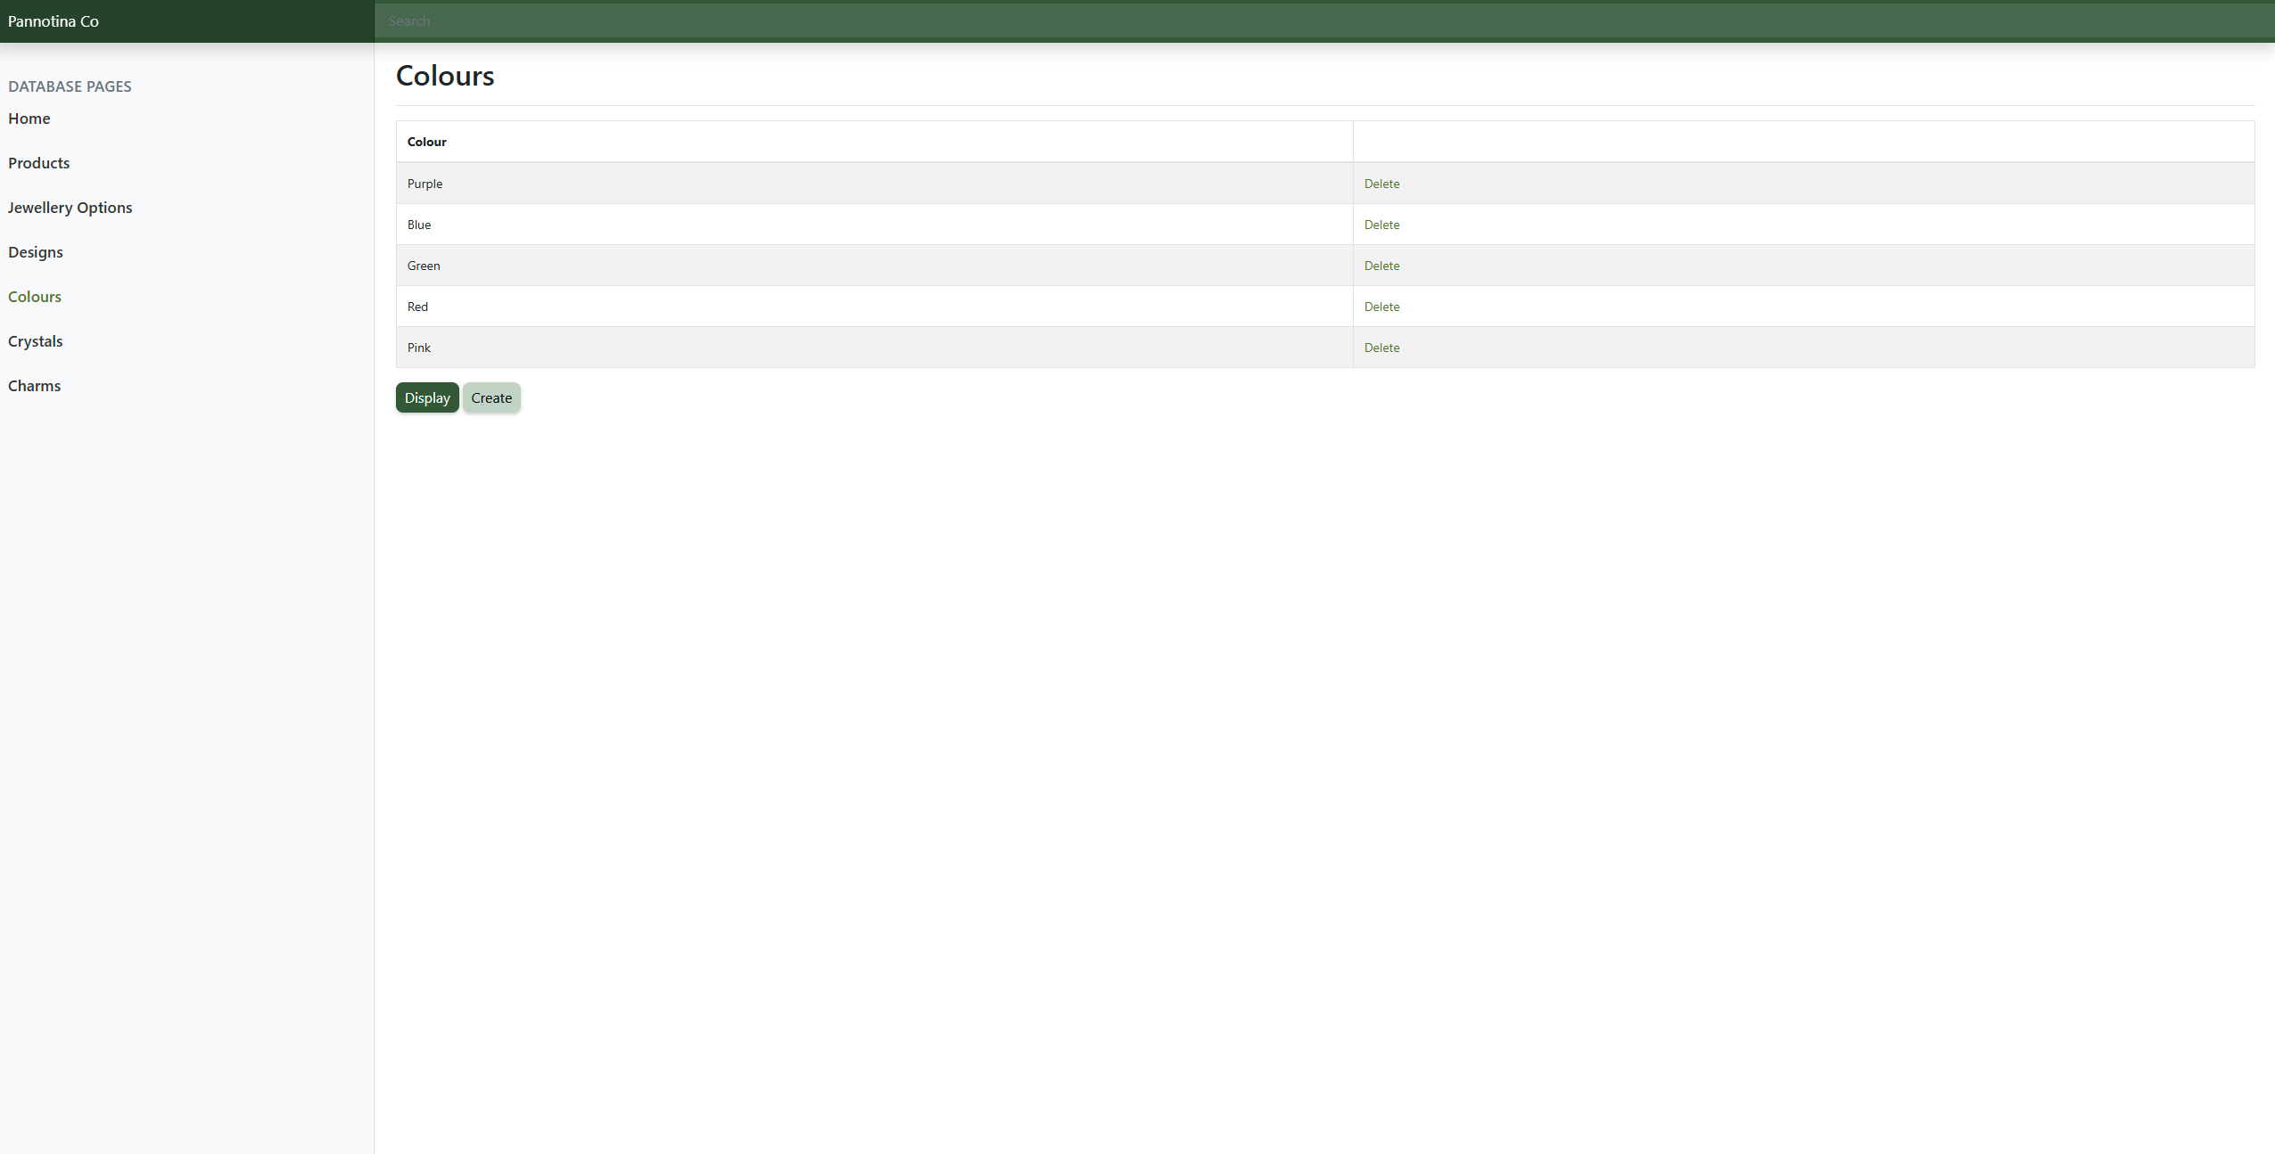
Figure 21 - Colours Page after Deletions

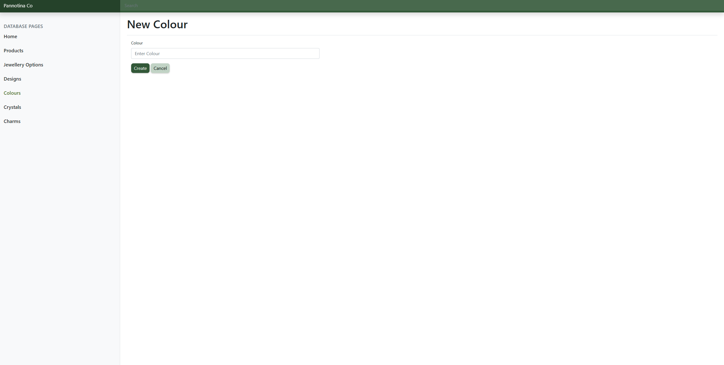
Figure 22 - Create Colour

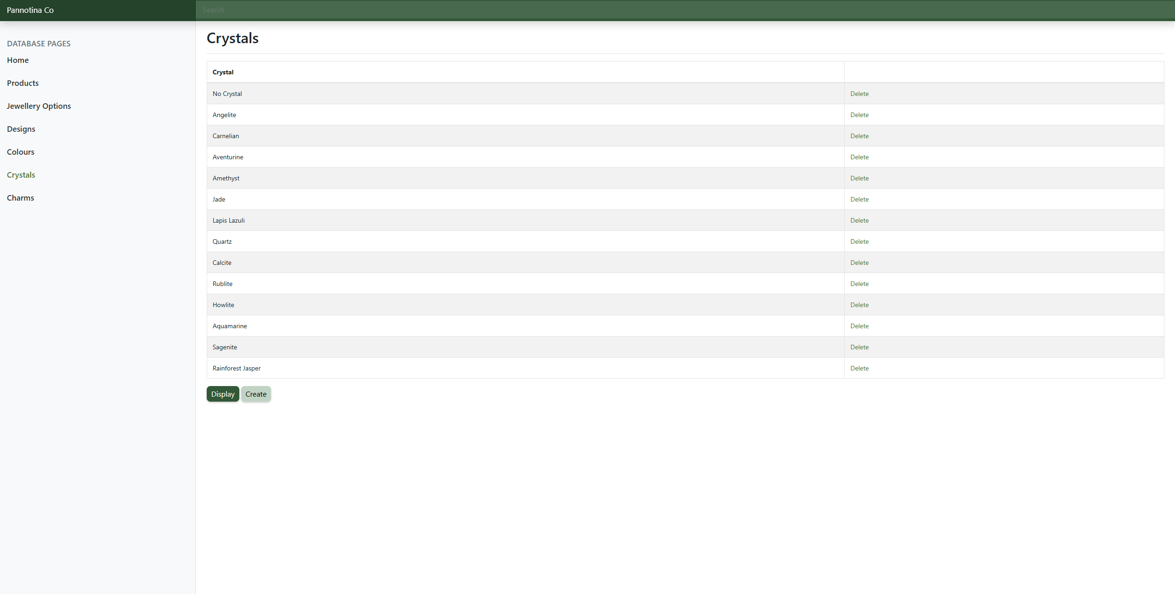
Figure 23 - Crystals Page

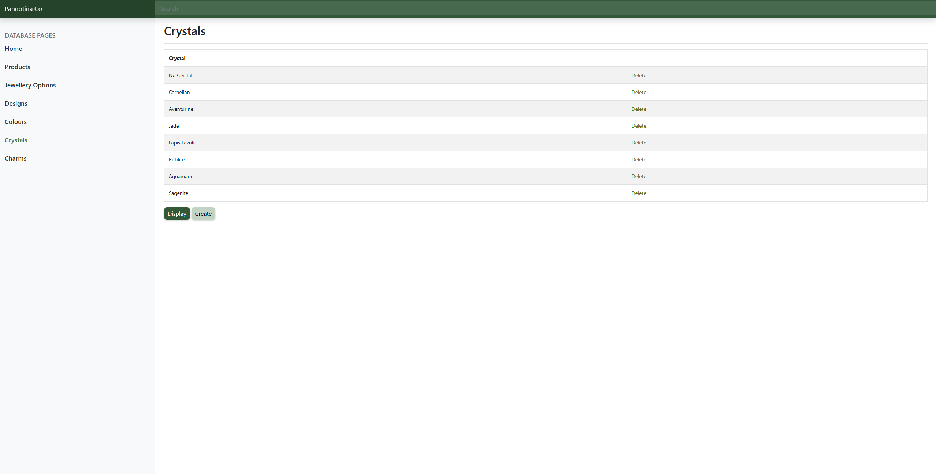
Figure 24 - Crystals Page after Deletions

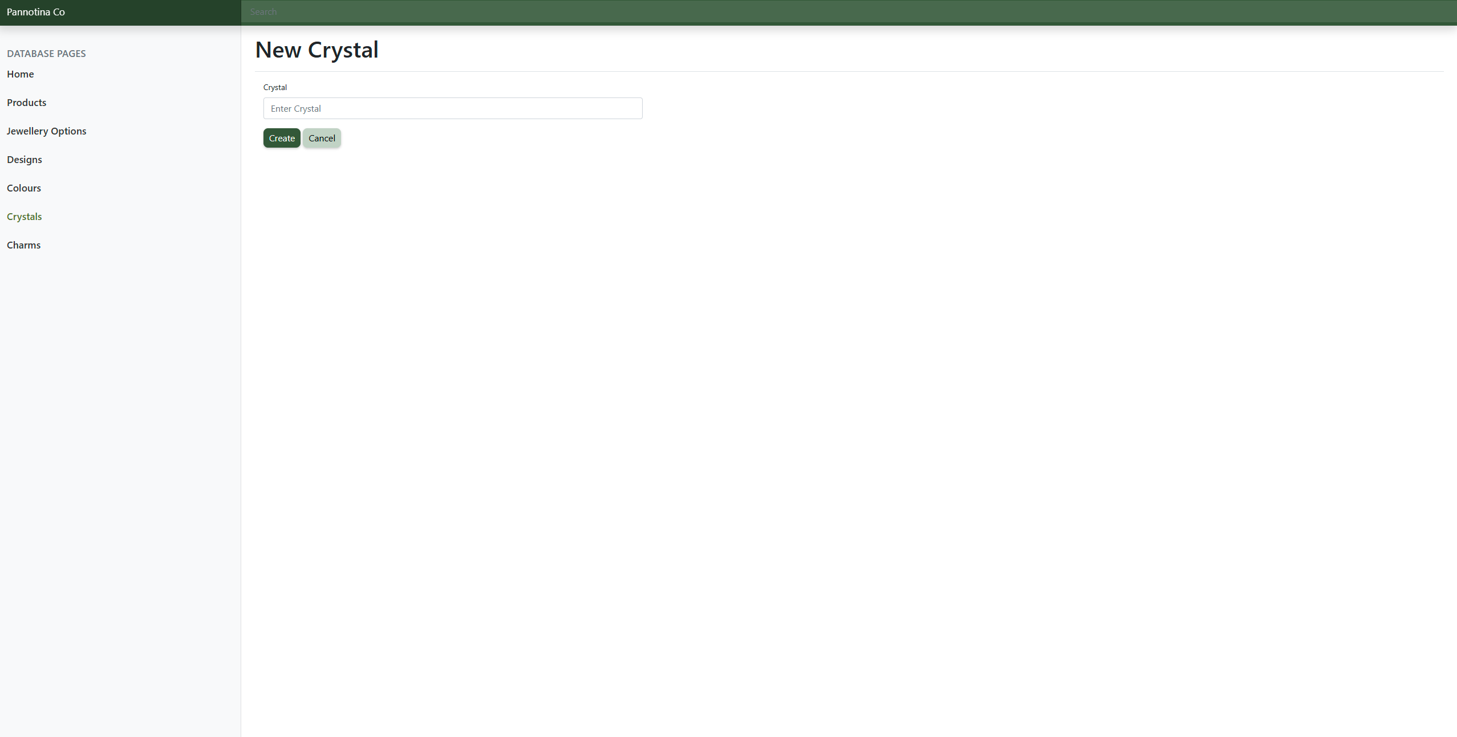
Figure 25 - Create Crystal

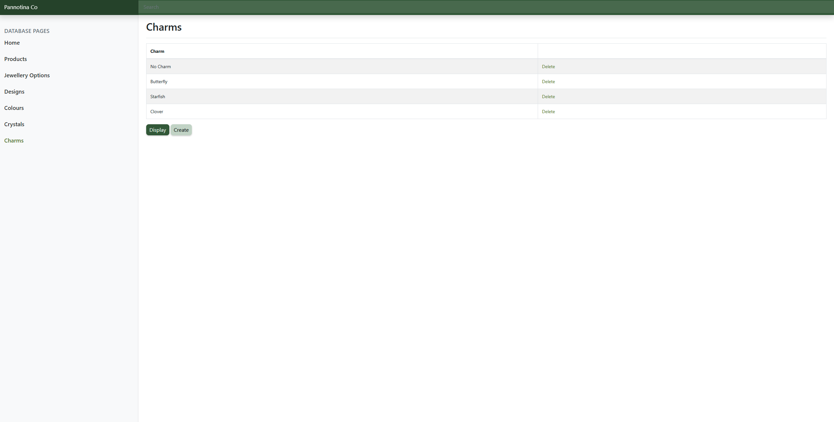
Figure 26 - Charms Page

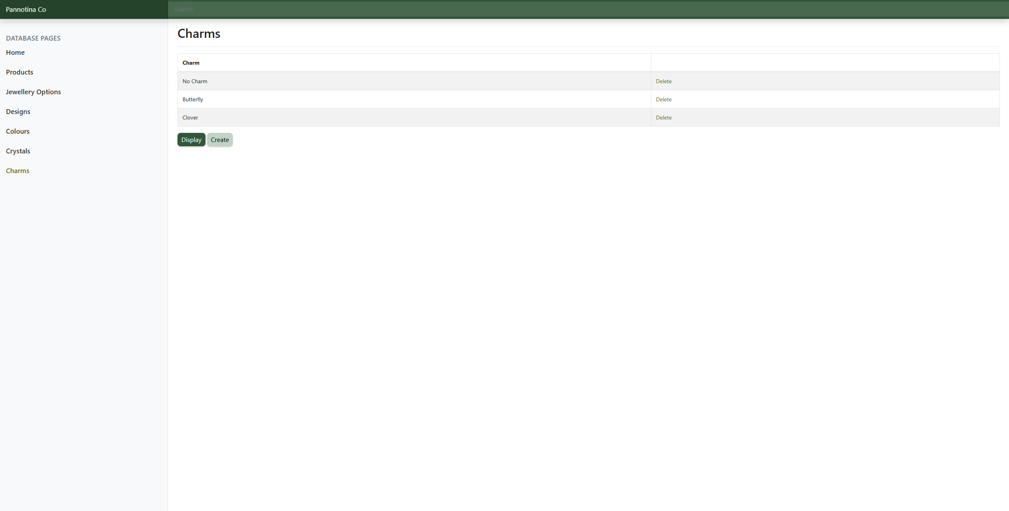
Figure 27 - Charms Page after Deletions

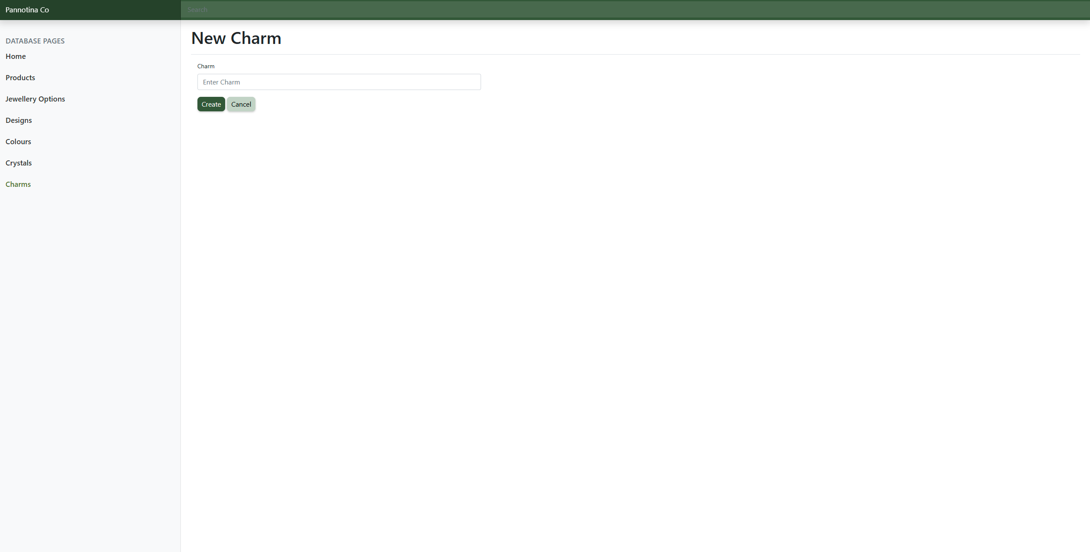
Figure 28 - Create Charm

