University of Wales Trinity Saint David
Wales Institute of Science and Art


Electronic Circuit Testing and Applications

Electrical Control Systems
ACHA4010

Jac Graham-Davies
2404810
30/03/2025
Contents
1 Task 3 1
1.1 Scope Time Division Calculations 1
1.2 Function Generator output square wave 1
1.3 Capacitor charge and discharge wave marked at correct points. 2
1.4 Basic Capacitor Calculations 2
1.5 Capacitor discharge table 3
1.6 Plot log(V) Gradient 3
1.7 Gradient Calculations and Compare 4
1.7.1 Gradient Calculations 4
1.7.2 Comparison table 4
1.8 Capacitor Uses 4
1.9 Inaccuracies Question 6
2 References 6

Task 3

Scope Time Division Calculations

t = 1/f
t = 1/250
t= 0.004s = 4ms
Time division = t/10 = 4ms/10 = 400µs
Closest time division to 400µs is 500µs, this will show one whole waveform.

Function Generator output square wave
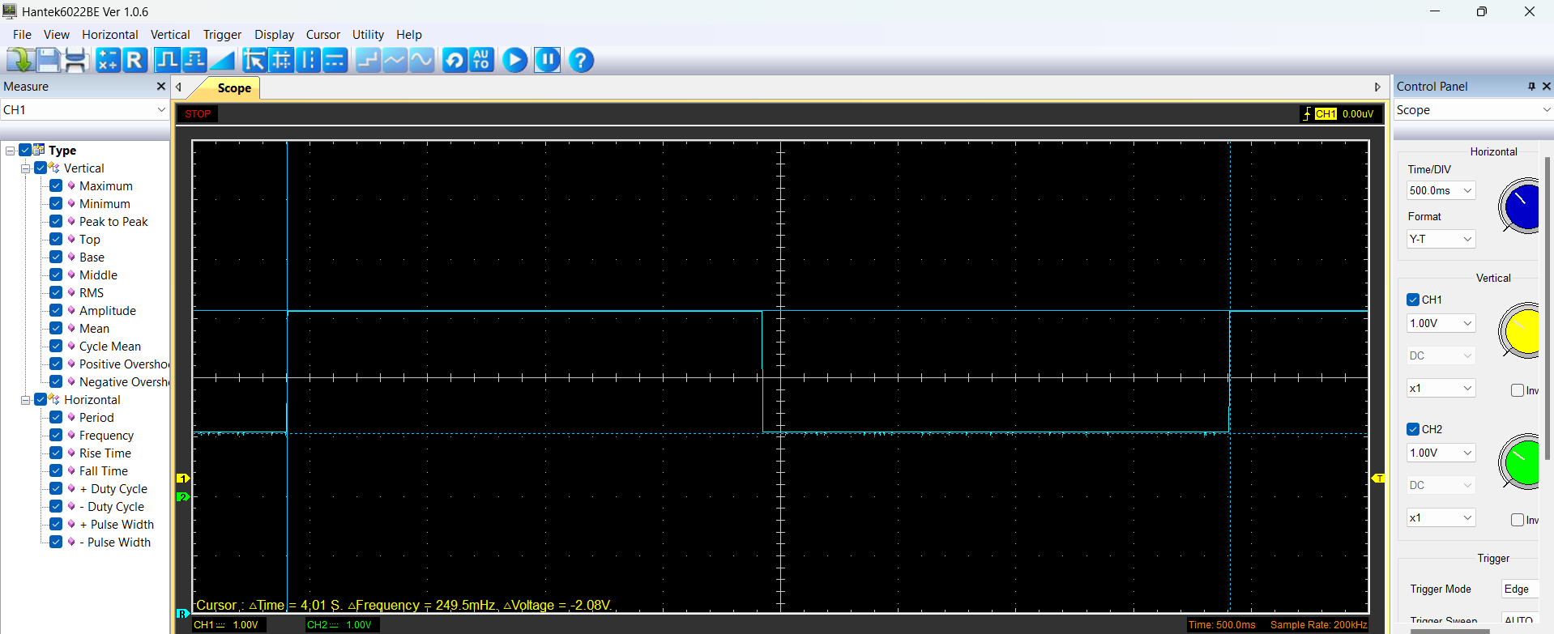

Capacitor charge and discharge wave marked at correct points.

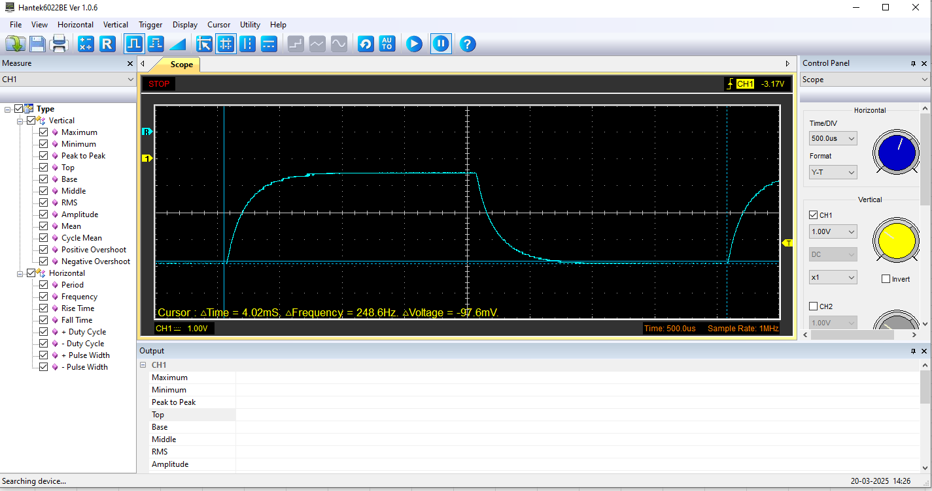

Basic Capacitor Calculations

Start voltage = 507mV
Peak voltage = 2.88v

Top cursor = (2.88 – (507*10^-3)) * 0.632 + (507*10^-3) = 2.01v

Time constant from 63.2% = 145µs
C = t/r = 145*10^-6 / 100 = 1.45µF

Capacitor discharge table
Time (s) | Voltage (V) | ln (V) | dy = y2 – y1  dy = ln(V)2-ln(V)1 | dx = x2- x1  dx = Time2 – Time1 | dy/dx
0.000545 | 2.5725 | 0.944878 | x | x | x
0.000561 | 1.9451 | 0.665313 | -0.27956 | 0.000016 | -17472.8
0.000578 | 1.4431 | 0.366794 | -0.29852 | 0.000017 | -17560
0.000595 | 1.0666 | 0.064476 | -0.30232 | 1.7E-05 | -17783.4
0.000611 | 0.8157 | -0.20371 | -0.26818 | 0.000016 | -16761.5
0.000628 | 0.5333 | -0.62867 | -0.42496 | 0.000017 | -24997.8
0.000645 | 0.3764 | -0.9771 | -0.34843 | 0.000017 | -20496
0.000661 | 0.2196 | -1.51595 | -0.53884 | 1.6E-05 | -33677.8
0.000678 | 0.1255 | -2.07545 | -0.5595 | 0.000017 | -32911.9
0.000695 | 0 | x | x | 0.000017 | x

Plot log(V) Gradient

Gradient Calculations and Compare

Gradient Calculations

Gradient = -22027
T = -1/gradient
T= -1/22027 = 4.54x10^-5
T = rc
4.54x10^5 = 100Ω*C
C = 4.54x10^5/100 = 0.454µF

Comparison table
 | Capacitance | Delta | Percentage difference
Actual | 1 µF | x | X
Marker Calculation | 1.45µF | 0.45µF | 45%
Gradient Calculation | 0.454µF | 0.546µF | 54.6%

Capacitor Uses
Capacitors play a crucial role in the electrical systems of modern vehicles, supporting both conventional internal combustion engine cars and the increasingly common hybrid and electric vehicles. Their primary function is storing and releasing electrical energy rapidly, which helps stabilise voltage, enhance performance, and support energy efficiency in various vehicle applications.
One significant use of capacitors in vehicles is power stabilisation. Automotive electrical systems often experience voltage fluctuations due to the switching of various components such as motors and sensors. Capacitors help to smooth out these fluctuations by temporarily storing charge and releasing it when necessary, ensuring a more consistent voltage supply to critical components like the engine control unit (ECU). This is vital for maintaining accurate sensor readings and reliable operation of electronic systems. According to Bosch (2014), capacitors improve the signal integrity within vehicle ECUs, contributing to the overall reliability and performance of vehicle electronics.
Another key application is in regenerative braking systems found in hybrid and electric vehicles. During braking, kinetic energy is converted into electrical energy, which needs to be stored quickly and efficiently. Capacitors, especially supercapacitors, excel in this due to their high-power density and fast charge-discharge capabilities. Unlike batteries, which may degrade faster under such rapid cycles, capacitors can handle frequent and intense charge-discharge events without significant wear. As noted by Chen et al. (2009), capacitors in these systems help recover energy during deceleration and release it during acceleration, contributing to improved fuel efficiency and reduced emissions.
In start-stop systems, which are now common in fuel-efficient cars, capacitors again prove useful. These systems shut off the engine when the vehicle is idle and restart it when the accelerator is pressed. While this reduces fuel consumption and emissions, it can put a heavy load on the vehicle’s battery. Capacitors assist by supplying the necessary burst of energy for restarting the engine, easing the demand on the battery and extending its life. Supercapacitors are preferred for this application because of their rapid energy delivery and long-life cycle.
Furthermore, capacitors contribute to the overall energy management of the vehicle. As vehicles become more electrified, the demand for reliable energy storage and delivery solutions has grown. Capacitors support battery systems by balancing loads, reducing peak demand, and helping to manage the distribution of power across multiple electronic components. Their role in ensuring the stability and efficiency of the vehicle's electrical system is becoming increasingly important as automotive technology evolves. As highlighted by Burke (2000), ultracapacitors are particularly beneficial in applications that require high power output over short periods, making them ideal for modern vehicle energy systems.
In summary, capacitors are versatile components that support a wide range of automotive functions from stabilizing voltage in ECUs to aiding regenerative braking and supporting start-stop technology. Their ability to quickly charge and discharge makes them ideal for dynamic energy environments within modern vehicles. As automotive systems continue to become more advanced and reliant on electronics, the use of capacitors is likely to grow, further enhancing vehicle performance, efficiency, and reliability.

Inaccuracies Question

Capacitor measurements may not always match the values listed by the manufacturer. One reason is the use of low-cost or poorly calibrated measuring tools, such as cheap oscilloscopes which can give inaccurate readings (Engineering Council, 2020). In our case this might have played a part in slightly skewed results as the scopes that were used were not the best of quality. Environmental factors like temperature or humidity can also affect the capacitor’s value (Friberg, 2020) as well as how capacitors can degrade which increases their internal resistance and changes how they behave in a circuit. Other issues include poor contact between test leads and capacitor terminals, or leftover charge in the capacitor. Some capacitors also show a small recharge effect after being discharged, called dielectric absorption, which may affect test results. Lastly, different meters use different test frequencies, which can lead to variations in measured values.

References

- Bosch. (2014). Automotive Handbook (9th ed.). Bentley Publishers
- Chen, H., Cong, T. N., Yang, W., Tan, C., Li, Y., & Ding, Y. (2009). Progress in electrical energy storage system: A critical review. Progress in Natural Science, 19(3), 291–312. Available at: https://www.sciencedirect.com/science/article/pii/S100200710800381X?via%3Dihub (Accessed on 30th March 2025)
- Burke, A. (2000). Ultracapacitors: Why, how, and where is the technology. Journal of Power Sources, 91(1), 37–50. Available at: https://www.sciencedirect.com/science/article/abs/pii/S0378775300004857?via%3Dihub (Accessed on 30th March 2025)
- Engineering Council. (2020). The Engineering Handbook (4th ed.). London: Engineering Council UK
- Friberg, P. (2020). Capacitor testing challenges and solutions. Electronics Weekly. Available at: https://www.electronicsweekly.com (Accessed on 31st March 2025).

