

Academic Discipline of Hospitality & Tourism Management
BA International Hotel Management

BMIH6008 HOTEL PLACEMENT RESEARCH PROJECT
Spring Term 2026

TOPIC: CROSS-DEPARTMENT SERVICE COORDINATION AND GUEST EXPERIENCE DELIVERY AT WIVENHOE HOUSE HOTEL

Name: Lidia Leva
ID: 2242891
Level: 6
Module Leader: Ben Ka Po Chong
Institution and Department: UWTSD
Date: 26.02.2026
DECLARATION
I testify that the research project under consideration is my own work and has been done in compliance with the university regulations of the academic integrity of the research proposal. The use of generative AI tools was not done. I was the one who developed and reviewed all the analysis, critical arguments, interpretation, and final written material. The sources used have been recognised well using Harvard referencing style. None of any AI-generated text has been submitted.
Acknowledgement
I wish to obtain my profoundest thanks to my module leader and research supervisor who offered guidance, feedback, and academic support during this project. This direction assisted in building the perspective and quality of the research. This study was made possible by the placement opportunity and practical exposure in various departments that were offered to me by Wivenhoe House Hotel and its management team. I also like my university and department that supports me by giving learning resources and research training. I would very much like to acknowledge my family and friends that offered the utmost support and encouragement throughout the course of writing this work.
ABSTRACT
The issue in this research project is the extent to which cross-departments services coordination has impacted the provision of a guest experience in Wivenhoe House Hotel. The operational alignment review is targeted in reception, housekeeping, food and beverage, and administrative areas of operation. Coordination is analysed in the project as an organised management problem and not a hard communication problem. The rationale is to determine whether a process integration or the personal effort of service is powerful in the process of the guest satisfaction in a hotel environment of a boutique hotel. Literature, industry reports, and patterns of hospitality practice documented used in the study rely on the study of a qualitative study and rely on a secondary case study design.
The latter should be to determine the effect of cross-department coordination mechanisms to the consistency of the service. Another is to investigate the effect of communication structure, workflow traceability, and workflow ownership on the guest outcomes. The third objective is to measure how well the performance of the coordination response to the event demand and peak booking pressure. These objectives will constitute three research questions that will be used to determine reliability of the coordination, quality of the communication, and the effects of the demand stress within the setting of the placement hotel.
The findings show that the interdepartmental handover points comprise the large number of service failures and service successes. The failure of guest experience does not happen mostly at the point of a guest contact. It does not work as it causes transfer of responsibility among departments without confirmation control. This informal coordination has variable outcomes. The coordination leads to predictable outcomes. It is shown in the findings that communication clear-cut is important in contrast with communication frequency. Weakness in ownership and verification rules will help in making a message no more than a service. The performance of mutual systems and electronic resources is enhanced in situations where the departments have the same discipline of updating them. In absence of behavioural control within technology, record gaps are developed opposed to alignment.
It concludes that the logistical process of the hotels operating on the principle of the individual event and personalisation increases the difficulty of coordination. This multi-unit action at the short-time window is needed in the special requests, celebration, and group bookings. One such aspect of design is the coordination design that is competitive. The positioning of a boutique raises the expectations of experience and it adds to the risk of operation. Since then, coordination cannot be entrusted to anyone but on the contrary, process rules should be crafted in such a way that coordination occurs.
It is also concluded in the study that the coordination between the departments must be addressed as a central service system. Accepting training is inadequate. The hotels must set ownership gateways, request history, and confirmation measures. These recommendations include typical cross-department tracking of requests, special guests need will be allocated to a person, pre-event coordination briefing, and coordination performance metrics. During communication training, emphasis should be laid on confirmation techniques. Digital systems will be applied as one coordination file instead of paralleled note tools.
The project indicates that the Reliability of Guest Experiences in Wivenhoe House Hotel is fuelled by the dependency on Coordination Structure, Accountability Design, and Workflow Discipline. This paper presents a realistic coordination model that may help improve the operations and make the guests’ satisfaction predictable.

Table of Contents
CHAPTER 1: INTRODUCTION 8
1.1 Introduction 8
1.2 Research Background 8
1.3 Overview of Case Study 9
1.4 Research Aim, Objectives, and Questions 10
1.5 Chapter Summary 11
CHAPTER 2: LITERATURE REVIEW 12
2.1 Chapter Introduction 12
2.2 Cross-Department Coordination across Hotel Operations 12
2.3 Communication Systems and Operational Integration 13
2.4 Guest Experience Reliability and Service Systems 13
2.5 Theoretical Underpinning 14
2.6 Literature Gaps 15
2.7 Chapter Summary 16
CHAPTER 3: METHODS 17
3.1 Chapter Introduction 17
3.2 Research Approach 17
3.3 Research Philosophy and Design 18
3.4 Data Collection 18
3.5 Data Analysis 19
3.6 Ethical Considerations 19
3.7 Chapter Summary 19
CHAPTER 4: FINDINGS AND DISCUSSION 20
4.1 Findings 20
4.1.1 Theme 1: Coordination Structure Determines Service Reliability 21
4.1.2 Theme 2: Communication Quality and Information Traceability Drive Coordination Outcomes 22
4.1.3 Theme 3: Demand Pressure and Event Operations Expose Coordination Weak Points 24
4.2 Discussion 26
4.2.1 Discussion on Theme 1, RQ1, and RO1 26
4.2.2 Discussion on Theme 2, RQ2, and RO2 27
4.2.3 Discussion on Theme 3, RQ3, and RO3 29
CHAPTER 5: CONCLUSIONS AND RECOMMENDATIONS 31
5.1 Conclusions 31
5.2 Research Implications and Contributions 32
5.3 Research Limitations 33
5.4 Future Scope of Research 33
5.5 Recommendations 34
REFERENCE LIST 36
Appendices 42
Appendix 1: PESTLE Analysis 42
Appendix 2: SWOT Analysis 42

CHAPTER 1: INTRODUCTION

1.1 Introduction
Services of a hotel cannot be due to the behaviour of individual employees, but it is a production of internal processes. The accuracy of the information transfer between the departments will define guest satisfaction and is engaged in reception, housekeeping, food and beverage, and booking administration. The service breakdown is realised along the boundaries of contact but not on the guest contact point. The modern service management literature regards hospitality provision as a product of the system generation due to the process system integration and operational alignment (Ford and Solnet, 2022).
The UK hotel market is review-based and experience-based competition rather than price-based in the high-end market. As per the industry data, experience ratings and consistency indicators are significant in the decision-making of guests depending on brand familiarity only (Mintel, 2024). This will make it operationally-expensive should there be any problem in coordination as perceivable inconsistency vitiates perceived reliability (Statista, 2025). However, coordination is not an issue of internal efficiency. It is a performance variable of the marketplace.
This study focuses on analysing the notion of service coordination in different departments and how it serves the customers by using the placement case study of the Wivenhoe House Hotel. It is a functional and not a promotional concentration. The effects of the coordination structures on the guest-facing outcomes and the concentration of the coordination risk are analysed in the project.

1.2 Research Background
Distinction of the service operations with that of the product operation is in that there are a production and consumption. One cannot do anything to rectify errors prior to delivery. It incorporates dependency on data accuracy of inner communication and devotion to task sequence. Business communication studies have made it apparent that in the situations where the responsibility of sending messages is assumed rather than assigned, cross-functional work processes are not permissible (Buhaieva, 2025).

Figure 1.1: Wivenhoe House Hotel
(Source: Wivenhoehouse.co.uk, 2026)
Most of the studies consider the hospitality studies on determining the quality of service using the perception scale although not many studies consider the coordination architecture under the scores. Ford and Solnet (2022) stated that the backstage integration is an explanatory factor of variability of service than the frontline behaviour. Solutions to the reduction of errors in the process design are regarding zero-complaints systems despite employee attitude (Mahajan et al., 2025).
Digital systems are apt to be exhibited as a coordination solution. Evidence is mixed. With no governance policies and job descriptions, there is better visibility yet no loopholes of accountability (Suri, 2022). Such disconnection between the adoption and coordination performance requires a case-based analysis (Hyun et al., 2023).

1.3 Overview of Case Study
Wivenhoe house hotel is a luxury and boutique hotel, which offers food, lodging, and events. Boutique hotels revolve around customisation at a personal level and malleable employees (Wivenhoehouse.co.uk, 2026). This kind of structure creates an added demand for coordination of the departments. The roles are on the top of the hotel profiles that are publicly available, hosting events, and differentiation of guest experiences (Britainsfinest.co.uk, 2026).

Figure 1.2: Wivenhoe House Hotel - Luxury
(Source: Britainsfinest.co.uk, 2026)
Placement exposure included food service operations, check-in, and housekeeping verification organisation, room reservation confirmation, and availability confirmation, information records in interdepartmental and missing and compliance systems. These are the activities that are dependent on coordination. Unit transfer of requests and time control should be taken. The case is ideal in the analysis of coordination and not reporting of service (Shuvalova, 2025).

1.4 Research Aim, Objectives, and Questions
Aim
To critically examine how cross-department coordination of services can affect the delivery of guest experience at Wivenhoe House Hotel.
Research Objectives
- RO1: To analyse the concept of cross-departmental coordination at Wivenhoe House Hotel.
- RO2: To determine coordination structures and threat of the breakdown at Wivenhoe House Hotel’s service processes.
- RO3: To gain coordination-related guest experience patterns using secondary qualitative evidence at Wivenhoe House Hotel.
Research Questions
- RQ1: What is the concept of cross-departmental coordination at Wivenhoe House Hotel?
- RQ2: What are the coordination structures and threat of the breakdown at Wivenhoe House Hotel’s service processes?
- RQ3: How coordination-related guest experience improved using the right patterns and secondary qualitative evidence at Wivenhoe House Hotel?

1.5 Chapter Summary
The coordination has become one of the key drivers of service performance and not a support service of an organisation according to the chapter. The analysis can be supported by the market evidence and the service theory on various levels, i.e., the system level. The case scenario and the course of the research are defined. The next chapter is essential in that coordination, communication, and service system literature are appraised and reviewed critically.

CHAPTER 2: LITERATURE REVIEW

2.1 Chapter Introduction
This literature review chapter consists of analysis of the studies on cross-department coordination, system of operation communication, and guest experience. The literature is classified into several issues of analysis that include, coordination structure, communication, and experience reliability. The review is an evaluation of arguments, key processes, key limitations, and not findings (Ardan and Febriyanto, 2025).

2.2 Cross-Department Coordination across Hotel Operations
Cross-department coordination refers to the planned integration of tasks, information, and timing of operational departments. The service management study is not of the impression that all quality of service is behavioural. It renders the quality process interdependent (Ford and Solnet, 2022). The change is pertinent in that the analysis will be conducted to systems design rather than be training-based.
According to study behind coordination it is mentioned that the points of risk are accuracy at handover, role ambiguity, and timing. Rokhkin (2025) proved that it is evident that the typical misconceptions in the communications apply during those processes, which would be founded on the informal escalation. Such a claim is justified by the organisational resilience research which correlates the process formalisation and consistency of the service (Dakić, 2023). The rigidity however is created by formalisation. That is a trade-off between rigidity and elasticity.
This becomes complicated that the services or hospitality operations are conducted through disparate time cycles by the departments. The room preparation is room keeping. In the reception, the reception is calculated on the arrival patterns. The demand on drinks and food comes in the back. Without synchronisation, the coordination will be on individual opinion that increases variability. Mahajan et al., (2025) defined service as one that is mistake-free. This can be achieved at the process level but no longer on the recovery after failure. This also assists in the management of coordination.
However, comparisons of manufacturing seem to appear in many literatures of coordination. Limited transferability as most hotel service involves co-presence of the guests and emotional labour. It argues that the operation of tourism and hospitality activities is a sensitive issue of the context. It is not expected that the models of coordination are made to work but rather they are tested in a service setting (Shaheen, 2025).

2.3 Communication Systems and Operational Integration
Operation coordination would not need the volume of message sent, but rather communication structure. Vertical reporting and horizontal workflow communication are different because of the business communication studies. Most hotels have a horizontal level of coordination (Buhaieva, 2025). However, lack of ownership of horizontal communication ensures that the failure will occur.
Technology is assumed to be a reformative step. CRM and digital workflow solutions increase the customer request and preference visibility level (Lin and Chen, 2025). Data-driven CRM can be effective in the enhancement of coordination with the help of common records, which should be used consistently. Hyun et al., (2023) illustrated that the process discipline facilitates the existence of analytics ability to improve organisational agility. However, false assurance is generated where the behaviour adoption fails and the tool is adopted.
Automation and AI are propagated as the engines of efficiency in the services (Islam, 2026). It has turned out to take advantage of the street concerning response speed and inconsistent effects on the quality of coordination. AI can improve protocol routing, though it cannot deal with the issue of responsibility ambiguity. As Jung and Srinivasa, (2025) denoted, any type of digital transformation that involves not redesigning the process transfers the errors rather than eliminates them. The hotel coordination systems are under this criticism.
The analysis of event and booking organisations will show that the stressful time increases the severity of communication failures; when the message compression is evident and the verification mechanism is discontinued (Shuvalova, 2025). This observation is associated with the peak demand cycles of service failure in reports on in the UK hotel sector (Mintel, 2024). Literature assists in the analysis of the coordination during load, but not only in the case of normal conditions (Parmelee et al., 2025).

2.4 Guest Experience Reliability and Service Systems
Customer satisfaction scores have been substituted with journey reliability models as the centre of research about the guest experience. Experience is regarded in touchpoints and not transactions. According to Ford and Solnet (2022), key findings of coordination and not employee traits are the reliability and responsiveness dimensions. That recreates the quality of experience as an integration measure.
The analyses of the customer-centred culture indicate that the micro-alignment of the organisation to the addition of guest value is what renders the organisation competitive (Wijanarko et al., 2020). Such explanations of culture are however subject to vagueness. They determine intention instead of action. The systems thinking approaches, in their turn, are explanatory as they map out the impacts of an interaction (Jaaron et al., 2023).
According to the paradigms of zero-complaint, control of processes is up-stream rather than down-stream compensation that leads to the decrease in complaints (Mahajan et al., 2025). This is helpful in investment of coordination. Critics have however, indicated that zero-defect rhetoric does not lead to reporting and covers bad-news. The coordination measurement should include transparency and not outcome measures (Biasin et al., 2024).
The use of reputation depends on the guest review websites, which makes it vulnerable to coordination breakdowns. According to tourism statistics in the UK, the demand for online review sites and hotels never ceases to grow (ONS, 2021). This renders the credibility of the coordination less strategic because of the inconsistency that would be monitored publicly.

2.5 Theoretical Underpinning
The current study employs a hybrid hospitality operations system that considers the guest experience as an output of the system due to an interdepartmental interaction despite system service experiences. Hotel delivery, according to the service management theory, is a complex service system in which the front office, housekeeping, and food and beverage services work together to implement the outcomes of reliability and responsiveness (Ford and Solnet, 2022). It is this structure of the hospitality service system that is meant by the interpretation of coordination as an operational capability and not an operational behaviour variable (Wang and Zhang, 2025).
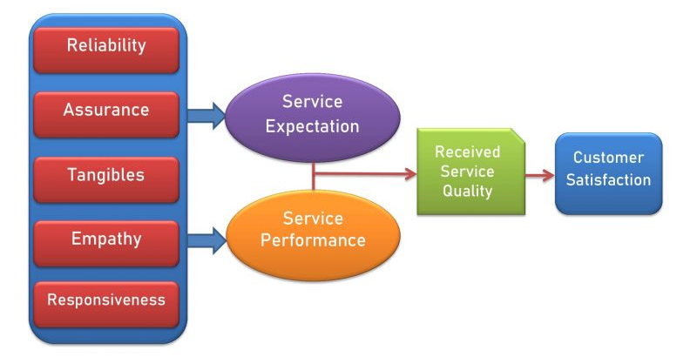
Figure 2.1: Service Quality Framework
(Source: Viljakainen, 2024)
To structure a given internal analysis, strength and weakness of the coordination, the strength and weakness of the operation, and risk of exposure of the service exposed to the risks of the risks are measured with the help of the SWOT framework (Appendix 2). SWOT assists in analysing the diagnostics of the communication flow, the control of handover, and the traceability of the requests in the hotel (Guestreservations.com, 2026). The pressure exerted by the external coordination on the hotel is considered based on the PESTLE framework (Appendix 1) that captures the variables of regulatory, labour, technology and demand that will affect the complexity of working in a hotel (ONS, 2021).
The effectiveness of coordination is correlated with the performance indicators of the hospitality (service quality dimensions), effectiveness of reliability, and responsiveness variations, which are related to them. This combination model has combined the hospitality service system, SWOT, PESTLE, and service quality theory into one model of operations analysis (Nahian, 2025).

2.6 Literature Gaps
Hospitality literature comprises more mannerisms of gauging service results than coordination mechanisms. The organisation of the work of the hotel that is in boutiques is not researched as deeply as the chain operations (Ko and Tsai, 2025). This has overindulgence on technology opposed to process governance analysis. Empirical mapping of coordination failures does not exist. It entails a qualitative synthesis founded on cases (Shand et al., 2022).

2.7 Chapter Summary
The argument that the reliability of the service is the result of the coordination is supported by the literature. However, the amount of the mechanism analysis is lacking in the cases of hospitality. A pre-existing rationale of coordination-based case study exists. The next chapter determines secondary qualitative methodology of the case and the thematic analysis design with others.

CHAPTER 3: METHODS

3.1 Chapter Introduction
This chapter describes and supports the methodological design applied to explore the issue of cross-departmental service coordination and delivery of the guest experience in the chosen hotel placement case of Wivenhoe House Hotel, Colchester, UK. The research approach that is implemented is a qualitative case study design that relies purely on the secondary data and uses thematic analysis as the analysis tool. The use of methods is in accordance with the research objective, which is concerned with process relations and coordination mechanisms but not numerical measurement. The choice of the methodology is according to the research design principles in business and hospitality research literature (Saunders et al., 2012).

3.2 Research Approach
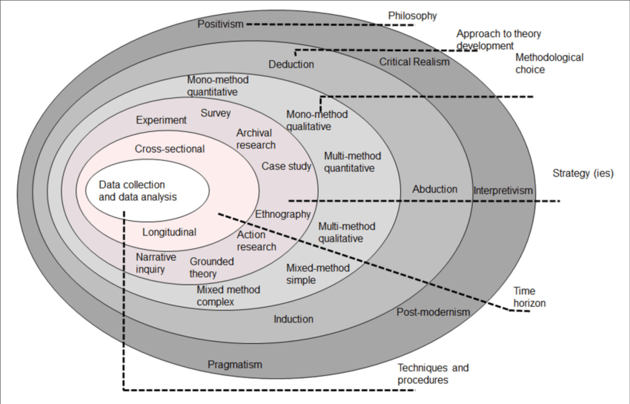
Figure 3.1: Research Onion
(Source: Saunders et al., 2012)
A qualitative research paradigm coupled with an inductive approach is used since the investigation is focused on the coordination process, communication patterns, and service delivery patterns. These are situational and interpretative variables. There is no point that they can be reduced into numerical indicators without losing operational meaning. Qualitative research is a kind of research that suits when it is necessary to use explanations and interpret patterns, not the concept of statistical tests (Marshall, 2015).
The literature on research methodology indicates that qualitative methods are appropriate in studies of organisational behaviour, service systems, and processes interactions that have meaning and structure of importance over the frequency of counts (Saharan et al., 2024). If cross-department coordination entails workflow logic, assignment of responsibilities and patterns of communication, qualitative interpretation offers better fit to analytical levels in comparison to quantitative modelling (Silverman, 2011).

3.3 Research Philosophy and Design
This project is guided by the interpretivism research philosophy. Based on the interactions between people and the shared institutional practice, it presupposes that organisational processes and service experiences are socially-constructed instead of fixed measurable objects (Saunders et al., 2012). The idea of coordination effectiveness is construed based on documented practice and analytical study opposed to it being a technical variable.
The research design is a case study as the study deals with a confined real-life working environment. The case study approach is suggested in cases when the study focuses on the study of modern organisational processes in the environment of their natural flow and when the contextual factors play a key role (Veal, 2006). Due to the sensitivity of service systems and management practices to operational detail, hospitality operations research involves case designs to analyse them. The case design facilitates incorporation of various secondary sources of qualitative data and this enhances the depth of the analysis by source triangulation (Silverman, 2011).

3.4 Data Collection
The research is based on the secondary qualitative data. Secondary sources will consist of peer-reviewed literature on the management in the hospitality and service sector, industry reports, analyses of the hotel sector, and written professional research on coordination and communication systems. Secondary research should be used when the goal is analytical synthesis, but not a behavioural measure (Saharan et al., 2024).
Hospitality and tourism methodology recognise secondary qualitative evidence as legitimate in the case-based operational analysis where there can be constraints on accessing the direct access (Veal, 2006). The sources on industry, i.e. UK hotel market and tourism data is provided to contextualise the operational pressures and coordination requirements (ONS, 2021; Mintel, 2024; Statista, 2025). Relevance was followed by credibility and recency, which agrees with the principle of academic research (Saunders et al., 2012).

3.5 Data Analysis
The analysis using thematic analysis is utilised in the study. Thematic analysis determines common patterns, concepts, and relationship of mechanisms in qualitative texts. Its agreement in qualitative organisational research is due to its efficiency to extract patterns in a systematic way but without losing its contextual meaning (Silverman, 2011).
The coding served a staged logic in which the familiarization with the sources, initial coding of concepts, and clustering specific categories regarding coordination and theme building and theory-link interpretation followed. It is a staged technique that a qualitative research design should employ to enhance the analytical transparency and consistency (Saharan et al., 2024).
Thematic analysis is suitable for cross-source synthesis, since it allows the comparison of coordination mechanisms, communication failures, and integration practices of various studies in the hospitality field (Ning and Kwak, 2022).

3.6 Ethical Considerations
Only published and publicly-available sources are used in the research. None of the personal data, secret hotel records, and personal communication is provided. This eliminates risk among participants and consent. Research ethics demand that the sources should be properly represented, cited, and cannot be misunderstood (Saharan et al., 2024). Each interpretation has its basis on referred literature.

3.7 Chapter Summary
The interpretivist philosophy and inductive approach with thematic analysis as secondary data and tools were justified by this chapter. Selection of the method is in line with research focus and the standards of hospitality research. The design will facilitate intense and situation-specific analysis of cross-department coordination and guest experience systems.

CHAPTER 4: FINDINGS AND DISCUSSION

4.1 Findings
Themes | Research Objectives | Research Questions | Codes
Theme 1: Coordination Structure Determines Service Reliability | RO1 | RQ1 | “Interdepartmental handover,” “task ownership clarity,” “workflow dependency,” “service breakdown at transfer point,” “process alignment,” “role responsibility mapping,” “front office–housekeeping linkage,” “F&B–reception coordination,” “standard operating pathway,” “handover verification gap”
Theme 2: Communication Quality and Information Traceability Drive Coordination Outcomes | RO2 | RQ2 | “Message confirmation practice,” “shared system record,” “request traceability,” “CRM update discipline,” “communication accuracy over volume,” “cross-department log use,” “information duplication risk,” “missing request record,” “verification loop,” “structured communication protocol”
Theme 3: Demand Pressure and Event Operations Expose Coordination Weak Points | RO3 | RQ3 | “Peak demand stress,” “event booking complexity,” “special request escalation,” “time-compressed coordination,” “group booking workflow strain,” “multi-unit dependency under pressure,” “staff overload signal,” “last-minute change impact,” “event preparation briefing gap,” “high occupancy coordination risk”

4.1.1 Theme 1: Coordination Structure Determines Service Reliability
This theme is the fact that coordination structure puts significant influence on the reliability of the guest experience than does individual service effort (Wijendra Gedara, 2025). Secondary qualitative data has indicated the problem of service failures on the inter-department to handover point rather than the lengthy interaction with the guests. The literature on service management supports that most cases of failing to meet the expectations are most often process and not attitude failures (Ford and Solnet, 2022). This is aligned with the operational model that is present in the scenario of the boutique hotels like Wivenhoe House Hotel whereby personalised delivery entails multiple departments responding to a single guest request (Kommu et al., 2024).
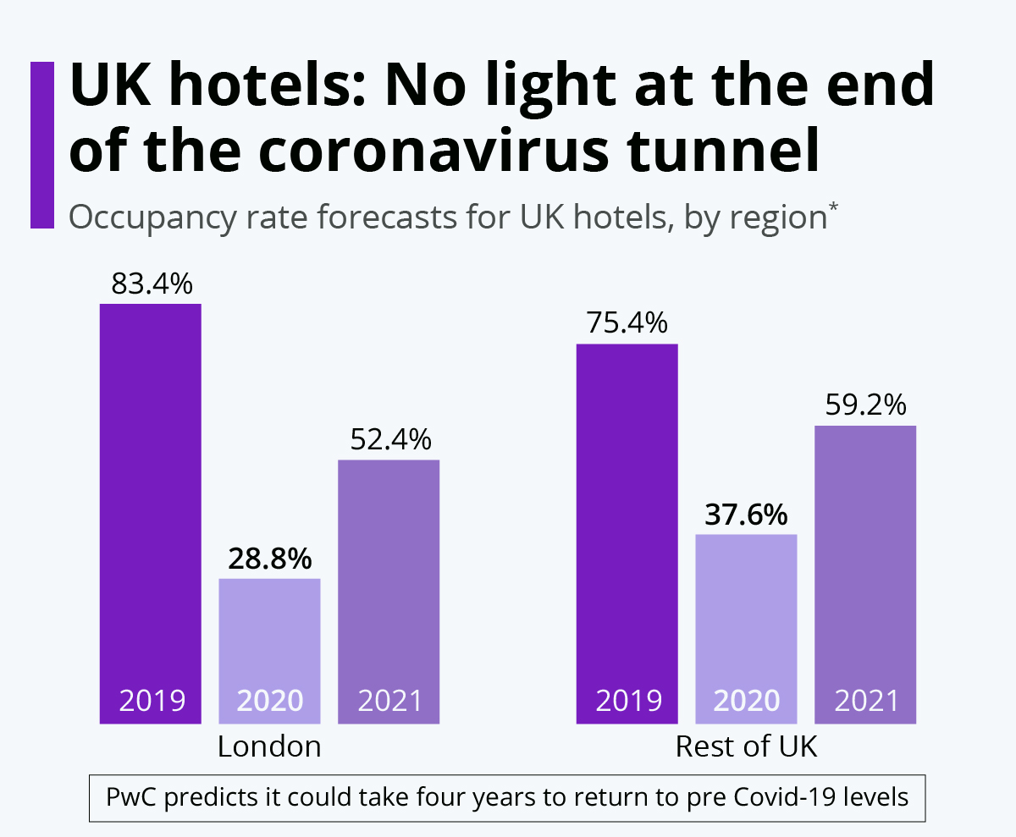
Figure 4.1: UK Hotels Landscape during the COVID-19 Period
(Source: Statista, 2025)
The statistics of the industry and sector show that the UK hotels have been operating in a demand environment, under which the presence of a review would increase punishments against an inconsistent operation (Mintel, 2024). Accuracy of coordination will be a performance variable in such a situation (Statista, 2025). These sources analysing the process of cross-departmental communication state that there are three standard points of risk, like the lack of completeness of the information transfer, the lack of delimiting the divided duties, and the inability of the operational units to suit about time (Rokhkin, 2025). These potential risks may be overlaid on the hotel workflow, i.e., the reception-to-housekeeping orders, booking-restaurant coordination, and preparation of events games (Buhaieva, 2025).
As the given descriptions of the operational cases of the upscale hotel and event-active hotel reveal, high-end bookings create the coordination chains between the front office and the housekeeping and food service departments (Font et al., 2023). Each of all relationships gives the possibility of errors. The findings convey the truth that whereby the coordination is based not on the worklog systems but the levels of verbal relay, like the informal ones, variance is increased. This is correlated with the study of digital transformation that discovered that the increase in traceability of processes reduces the loss of coordination only in cases of constant use throughout the departments (Suri, 2022).
Similar research on tourism operations argues that when the demand variability is in place, cross-units process visibility with a non-dispersed level of service organisations is resilient (Roach et al., 2023). This assists in the explanation that the coordination system is a reliability controlling system. The outcome answers RQ1 by clarifying that as literature discusses cross departmental coordination as a structure service reliability driver and not a support activity (Ghina and Hatammimi, 2025).

4.1.2 Theme 2: Communication Quality and Information Traceability Drive Coordination Outcomes
This theme shows that the quality of communication and traceability of information are predictive concerning the quality of coordination. Communication research attracts a distinction between frequency of message and clarity of message. It has been seen that small ownership and confirmation underlying cannot forestall coordination breakdown in an environment where the degree of communication is elevated (Buhaieva, 2025). These assertions have been corroborated by the literature about coordination within the hotel industry as it indicates that lack of alignment between expectations among various departments will cause further delays and errors associated with duplication of services offered (Panambarage, 2025).
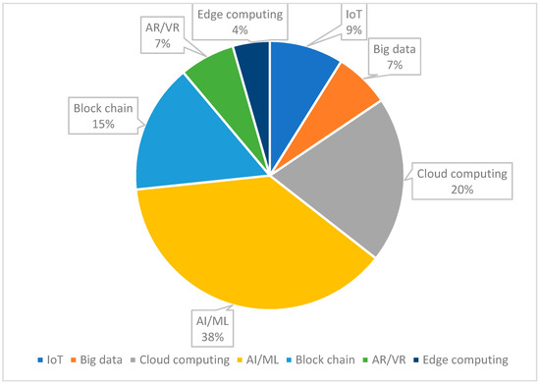
Figure 4.2: Hospitality Feedback System 4.0 with Digitization
(Source: Mintel, 2024)
Research on customer relationship management reveals that such coordination provided by integrated data systems can be effective in a situation where the departments provide records that are shared and updated (Lin and Chen, 2025). This finding is necessary as most digitalisation efforts in the hospitality sector assume that the adoption of systems will cause improved coordination. This assumption has been proved to be misguided by experience. Digital platforms increase the coordination capacity without influencing the coordination behaviour (Hyun et al., 2023).
According to the available literature on the interaction models based on AI-assisted customer interaction, it becomes evident that efficiency gains are achieved in the process of route optimization and response time, but the effect aids accountability is insignificant when compared to cross-department (Islam, 2026). This is a considerable distinction. Organisation does not mean efficiency (Liu, 2024). Wrong handover by responsiveness that is fast leads to service failure. The study of communication competence in hospitality proves that the linguistic clarity and confirmation practice can influence the accuracy of operations (Shaheen, 2025).
As the research on event and booking management claims, the compression of communication is most likely to be inaccurate in the situations when the time pressure is eminent (Parmelee et al., 2025). The reports of the UK hotel market reflect the existence of the expanding segments of the event-focused demand, therefore, introducing a load cycle to the coordination (Bhatti and Mamadjanova, 2025). It makes it possible to conclude that the quality of communication systems and verification systems is what promotes the results of coordination, rather than their quantity (Shuvalova, 2025).
Other indications of process mining and cross-organisational workflow research include that traceable workflows can be used to minimise ambiguity in the speed of coordination and can improve the speed of error detection (Rott et al., 2024). This is in line with the codeines on success of coordination wherein visible request tracking is significant compared with the informal relay. This theme offers a response to the RQ2, which implies that communication clarity and traceability constitute the primary coordination processes that respond to the reliability of guest experience (Finch et al., 2023).

4.1.3 Theme 3: Demand Pressure and Event Operations Expose Coordination Weak Points
This theme shows that the lack of coordination is on the top level about the pressure of demands and in the cases when the working processes are event-concentrated (Pham et al., 2025). Hospitality events as a branch of management research have demonstrated that the non-linear and direct dependency relationships between coordination and density of bookings increase as dependency chains become complex (Brochado et al., 2022). The linking and therefore risk dimensions exist in any additional service element across the departments (Xie et al., 2022).
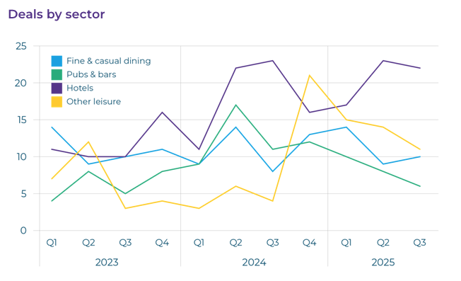
Figure 4.3: UK Hospitality Scenario - Economic Pressures, Labour Decline, and Strategic Opportunities
(Source: Statista, 2025)
The UK tourism statistics supports the fact of the stable development of the hotel business and the rise in occupancy because of the events (ONS, 2021). Based on the market reports, most luxury hotels compete in the market on the eventual and special occasion segments (Mintel, 2024). This kind of market structure strains the coordination. The outcome of the operational efficiency and agility studies based on the findings of the investigation suggest that the different organisations that do not apply the load balancing rule of cross-unit function disintegrate at the peak time (Hyun et al., 2023).
Resilience of service literature indicates that service process discipline can predict the performance stability during a volatile situation, even with high staffing volume (Roach et al., 2023). This conflicts with the overall belief of the general manager that the coordination risk will be resolved by incorporation of new people in the management. As evidence suggests, the absence of rules on coordination increases the amount of message noise, given the growth in the number of players (Kröger and Marx, 2025).
Zero-complaint and continuous value systems provide that prevention of service errors must be factored into process design despite recovery gestures (Mahajan et al., 2025). This is true to hotel operations that serve as load bearing during events and lack a time constraint if recovery is concerned.
The scholarly work can be seen as the strategic leadership and middle management, in the hospitality sector has shown that quality of coordination often depends on the quality of operational supervisors to bring about discipline in the cross-department implementation of plans (Tindoy, 2025). It means that the coordination risk is a partial governance risk. This theme is a response to RQ3, in which the coordination stress tests put forward suggest the finding that structural weaknesses are found to be peak-demand and event operations.

Three sets of results confirmative of the results are obtained. First, the organisation of coordination plays a key role in the service reliability rather than individualism. Second, the success of coordination by the communication clarity and traceability is better compared to technology presence (He et al., 2025). Third, the weaknesses in coordination are not noticed until the conditions reach to demand pressure and the operation of the events reveals such weaknesses in coordination. The findings coincide with the research study goal and will provide the analytical basis of the discussion section.

4.2 Discussion

4.2.1 Discussion on Theme 1, RQ1, and RO1
The first finding proves the fact that the coordination structure is one of the key determinants of reliability of services. This observation aligns with the service systems theory, in which the hospitality delivery is perceived as an interaction of workflow and not a sequence of unidirectional interactions (Ford and Solnet, 2022). Reliability in this case is not a behavioural characteristic. It is a process property. Where reception guarantees, housekeeping preparations, and food and beverage delivery are not tied structurally, dependability is accidental, and not recurrent (Tran et al., 2025).
This discussion goes in line with the findings of the systems thinking, which are that the key outputs of the given service are an outcome of a pattern of interaction but not the average unit performance (Jaaron et al., 2023). Special occasion event organisation and cross-departmental requests like special occasion rooms operation will require numerous steps in the placement scenario. The risk of dependency is induced by one step. The system is not represented in the form of the coordination rules but it relies on the memory, and the informal relay. The design is not stable in nature.
Market data supports an interpretation of that. The UK hotels have a strong demand that is review-based (ONS, 2021). In case of a review transparency, inconsistency is penalised more than moderate performance. This makes the competitive advantage lie on reliability systems compared to peak service gestures. A competitor to the success of such a hotel as Wivenhoe House Hotel where there are boutique hotels is personalised delivery. This causes them to be more reliant on coordination since customisation is a variation in workflow (Statista, 2025).
These strengths in the internal analysis of SWOT have been mentioned as flexibility and personalised service culture in the appendix. Risk of variation can be embedded in flexibility that lacks anchoring of the processes. Integration discipline has been suggested in organisational agility studies to uphold the ability to evolve lest agility is improvisation (Hyun et al., 2023). Therefore, the coordination structure must be balanced between discretion and control (Kröger and Marx, 2025).
The current body of literature regarding operational governance indicates that service organisations must be resilient and it is achieved through clearly defined cross-unit responsibility (Roach et al., 2023). This contributes towards argument, which is, coordination needs to be designed as a system that is managed. Not as an informal practice. This finding in turn maintains the format of RO1 and RQ1 by indicating that cross-department coordination is rather legitimately conceived within the hospitality theory as a structural meaning of service reliability (Brochado et al., 2022).

4.2.2 Discussion on Theme 2, RQ2, and RO2
Key implications are that the quality and traceability of communication have a stronger influence on the coordination outcomes than the availability of technologies. This observation challenges the technology-solution bias of the current discourse of hospitality. The remedy to the digital systems is presented as a magic elixir of coordination. That is non-involvement of simplification. The level of coordination is improved with the use of digital tools. They are not a guarantee of the coordination behaviour (Suri, 2022).
The analysis of CRM reveals that a combined data platform can be employed to improve service alignment in the scenario where the data consistency of record utilisation is high and interdepartmental record visibility occurs (Lin and Chen, 2025). This is a behavioural and procedural and not a technical condition (Wang et al., 2025). The models of service with the help of AI prove not only optimality in route optimization, but also automation in the responsiveness and multiple insignificant effects on the accountability transparency (Islam, 2026). Placing the rapid path routing with no responsibility confirmation causes coordination gaps (Jung and Srinivasa, 2025).
The studies on business communication support this interpretation. Lack of messages is rarely an issue that leads to communicating failure. It comes about through the vagueness in conveying the message and non-ownership (Buhaieva, 2025). A request sent in the hotel operations are not owned requests. The messages are transferred to liable functions by traceability. As it is said in the study of process mining, workflow visibility reduces the occurrence of coordination errors by making responsibility path visibility available (Rott et al., 2024).
In the PESTLE external analysis in the appendix, it has been identified that technological and legal aspects of data management and the workflow systems have increased. Regulatory and data governing concerns increase documentation requirements. That puts a strain on the coordination work. Without traceable systems, compliance tasks will be competing with service tasks and they will become overloaded. This is a reason why integrated coordination design is preferable to tool layering (Carpentiere and Ardito, 2025).
Another limitation is the event communication research. In case of time pressure, the level of communication is reduced and confirmation is skipped (Parmelee et al., 2025). That is why; the spheres of coordination failure are focused on peak booking and event management. The exposure to the place has shown this trend in the risk of event booking confirmation. The rate of communications becomes poor and the messages are not received or forwarded effectively unless the protocols on confirmation are implemented (Shuvalova, 2025).
The study of the communication competence within the hospitality field shows that the clarity of the language used and confirmation practice that can be used to ascertain the accuracy of the operations (Shaheen, 2025). This imparts the element of human capability to the coordination systems. Technology will not solve issues of vague framing of instructions (Bhatti and Mamadjanova, 2025).
This implication is direct. The rules of communication design are needed to accomplish coordination improvement. The channels of communication are not the only ones. This is favourable to RO2 and addresses RQ2 by concluding that the most common coordination mechanisms that affect reliability of experience by the guests include clarity, confirmation, and traceability (Wunker et al., 2024).

4.2.3 Discussion on Theme 3, RQ3, and RO3
This observation is that demands are stress tests and even heavy pressure tests. The observation matches the contingency-based models of management that provide the argument that variability is a phenomenon and that demands variable, rather than stable, measures of process performance (Sirithongsook and Kongchan, 2025). These co-ordination mechanisms that are considered to perform well under normal load will not under normal load when the timeline is compressed.
The numbers of the UK hotel industry support the presence of the long- and short-term trends in demand (ONS, 2021). Events and special occasions are highly relied upon as a revenue mix in the hotel industry and the luxury and boutique hotels (Mintel, 2024). Such a business model increases the dependency level between departments. There are some application layers in every event, which are booking, room preparation, preparation, food service, and communication with the guests. Dependency chains lengthen. Error exposure increases (Ishraq, 2024).
This is since the studies on operational efficiency show that a complexity increase is non-linear, when workflow branches (Barros, 2025). Introduction of tasks brings points of interaction. All the probability points of failure. In terms of lean and the process quality model, the errors and wastes are collected at the handovers (Sutejo et al., 2025). The result of this principle is that coordination risk can be concentrated due to it.
Zero-complaint models are the notion used to support the fact of recovery as more of a burden than prevention in time-starved service settings (Mahajan et al., 2025). The event services failure is quite noticeable and difficult to recover as there are no experience windows. The event situation conditions make recovery gestures of not much significance compared to coordination prevention controls (Chidinma et al., 2023).
The analysis of the strategic leadership of the hotel industry shows that middle managers play a crucial role by helping to transfer the coordination policy into the operational discipline (Tindoy, 2025). The governance strength determines the consistency of enforcement of the coordination rules. This gives performance at coordination to the supervisory control structure and not to the motivation of the front line (Rana et al., 2025).
The orientation of organisational culture studies enables customer focus is directionally right, whilst weak in a mechanical sense (Wijanarko et al., 2020). Culture statements do not outline the pathways of coordination. Systems and governance do. Coordination reliability ought to be structured opposed to being fostered (Cheah and Zhi, 2025).
One weakness is that which should be brought up. These outputs are acquired in the form of the secondary qualitative synthesis as compared to the performance measures within the company. They are not utilising quantified failure rates, but mechanism trends. Among the methods of qualitative analysis of cases, it is possible to use analytical generalisation by aligning patterns of theory compared with statistical inference (Silverman, 2011). Both studies have been consistent due to similarity of literature on service management, literature on communication and literature on operations which adds to the validity.
The context of the placement hotel has a meaning that is operational. The coordination structure should be implemented in the period of peak demand and not just in regular operation. Stress testing process coordination would generate the control of greater reliability (Prasasti et al., 2025).
This satisfies RO3 and RQ3 and demonstrates that the weaknesses of coordination are not foams scattered randomly. It is discovered when there is demand pressure and event operations.

CHAPTER 5: CONCLUSIONS AND RECOMMENDATIONS

5.1 Conclusions
This research has mentioned the effect of cross-department coordination of services to guests on commitment to the delivery of guest experience through Wivenhoe House Hotel as the context of the placement-based research contexts. This depicts that coordination structure should test whether it is more probable than individual service behaviour to play a key role in service reliability. The findings support this aspect of argument. Process congruency leads to consistency in the guest experience as the reception, housekeeping, food and beverage (F&B), and the booking department processes do. Nor does it emerge from lonely front line playing.
The first conclusion is that coordination should be treated as an operational control system. The service management theory identifies hospitality delivery as an inter-dependent service system delivery. These findings confirmed that the reliability failures were in the interdepartmental interrelationships at the handover stage rather than at the stage of interrelationship with the guest. This lays management stress on training process architecture. In circumstances in which communication is dependent on a casual network of messages, variability of results is experienced. Reliability increases in instances where there is the co-ordination of the traceable working procedures that are organised. It is an operation with not a cultural difference.
The latter is inferred to be of quality communication and traceability of the tasks are more decisive than the quantity of communication. Communication and service operations articles have shown that growing ambiguity and no ownership led to a higher number of failures compared to no message. Technology platforms do not guarantee the performance of the coordination but they increase the ability of the coordination. Digital booking and CRM systems come in handy to coordinate the departments only under the conditions when the shared records are updated and reviewed by the departments. Therefore, the enhancement of coordination is promoted by the field of rule construction and checking power, but not by the system adoption.
The key implication is that the demand pressure presents the weakness of coordination more than the daily routine operations do. The statistics related to the UK hotel market verify that demand has been defined by the high and occasion-related demand. Peak and high season periods lead to tight schedules and multi-departments that are chain-dependent. Such conditions cause informal coordination to fall apart faster. Predictive stability in performance about staffing volume is process discipline that predicts the performance. The noise and threat of mistakes to the messages are augmented by inclusion of people without the addition of structure of coordinating the messages.
The conclusion is regarding the model of the 'boutique hotel'. The format of the arrangements of the personalised services and the boutique in the format of the customised requests to the guests makes the coordination more complicated. In the public hotel profiles, experience differentiation and event activity are presented as the competitors of Wivenhoe house Hotel. Due to customisation, affiliations to other departments increase. New touchpoints introduce the risk of coordination. The personalised service strategies should have their coordination controls strengthened rather than watered down.
The conclusion is theoretical. The patterns are clarified by using the combination of the service systems theory, the organisational agility, and process reliability framework models together. Culture-based explanations are not adequate. The customer focus culture promotes intent without laying out the working paths. To achieve coordination reliability, process design, accountability mapping, and verification rules should be created. One cannot do it without motivation.
The aim of research is fulfilled. Coordination of cross-department services has been proved to be one of the basic factors that lead to dependability of the guest experiences. The theoretical-related thematic results have been employed in responding to research questions. The background of the placement is in line with the trend of most literature. Co-ordination is not in support functions. It is just a performance system.

5.2 Research Implications and Contributions
The contribution of the study is on the operations, managerial, and academic levels. It re-develops the guest experience management at operational level as a coordination design issue. Most of the hotel improvement activities revolve around the manner of service and training. The findings can show that the benefits of process integration are greater than the reliability benefits of behavioural coaching (Ford and Solnet, 2022). This has a direct impact on the high-end and event-oriented hotels.
The study at the level of a manager connects the performance of managing efforts to the control and governance by the middle-level management. The works of leadership prove that operational supervisors apply the coordination policies to their daily punishments (Riaz et al., 2024). This implies that the quality of coordination must be measured and verified similarly to the cost and revenue (Larsen and Broderick, 2022). It cannot just be implicit.
The meaning of quality of hospitality services on the academic level is coordination-oriented meaning provided through the paper. Many hospitality researchers measure the outcomes of the satisfaction (Rossini, 2025). The list of studies examining cross-department driving forces of such outcomes is even smaller. The combination of thematic with service systems, SWOT, and PESTLE shows the alignment analysis model that is applicable to the placement-based research (Silverman, 2011).

5.3 Research Limitations
This study only relies on thematic synthesis and secondary qualitative information. It is not based on the key operation indicators, inner performance record of the work, and the face-to-face aspect with the workers. That decreases the precision of measure. Failure rates are the mechanism patterns are not quantified in the results.
The case is centred on the situational context of one of the boutique hotels. Generalisation must be analytical and not statistical. These results can be generalised to other luxurious and bespoke and event-based formulations of hotels. They should not be blindly extended to all the hotel categories.
Another limitation is that of dependence on sources. The industry reports and studies are published from the boundaries of the interpretation. The irregularities of the undocumented practises can be internal. However, qualitative case methodology does not denounce theory-pattern correspondence as a legitimate ground of explanation as far as the sources utilised in it are authentic and coherent.

5.4 Future Scope of Research
Primary mixed-method designs should be applied further to undertake the test between the coordination mechanisms. Quantitative validation of the areas of threshold coordination failures would be possible through the available records of workflow logs and service incidents. It would be possible to map the actual intra-departmental routing activities by process mining, with the help of the process mining, which would be possible only through the process mining (Rott et al., 2024).
Comparison of these two outlets of the luxury hotel and the chain hotel would be useful in comprehending how the coordination risk differs, based on the size of the organisation. Even after the comparison of hotels with events-heavy and holiday-heavy would increase the knowledge of contingency (Barlatier et al., 2023).
The analysis of the technology-specific studies should undergo the further development such that it does not stop at the measurement of the adoption but it continues to the research on the change of the coordination behaviour after the system adoption (Maqousi et al., 2025). This would close the digital capabilities and reality digital gaps identified (Jung and Srinivasa, 2025).

5.5 Recommendations
Cross-department workflow practices must be formalised to strengthen the effort of coordination at Wivenhoe House Hotel. Each guest request that involves multiple departments will have a task owner who shall be named and a point of confirmation. Communication research indicates that the ownership transparency reduces the loss of handover (Buhaieva, 2025).
Call-hitched request logging regulation should exist in reception, housekeeping, and food and beverage units. These coordination records would be single and would be in the CRM and booking system rather than parallel notes (Haigh, 2022). Large-scale and timely data transfer will only improve the processes of data-driven coordination provided there is a homogenous sharing and exchange of records (Lin and Chen, 2025).
Peak demand and event periods should be put on pre-determined event scripts. In the context of the event management study, it is observed that time compression correlates with the increase in risk of making mistakes (Parmelee et al., 2025). With assistance of standardised cross department checklists of event booking and special occasions and large group stays, variability would be reduced though all the flexibility would not be done away with (Wang et al., 2025).
Middle managers should hold short cross-department briefings in forms of short conferences in the weeks before extensive events (Shuvalova, 2025). Research studies on leadership and resilience prove that the under-pressure execution stability is promoted with the help of supervisory alignment (Roach et al., 2023). These brief shorting should be in relation to dependencies rather than large scale motivation (Tindoy, 2025).
The communication training should be centred on the confirmation techniques opposed to politeness and tone. Research into the language proficiency of the hospitality industry links the comprehensible and repeat back lingo with the accuracy of operation (Mackay et al., 2025). The employees should confirm other significant demands on a structured wording (Bhatti and Mamadjanova, 2025).
The use of the digital tools should be rated by how they have improved traceability and not by the features. Technology adoption must not precede process redesign but the latter (Suri, 2022). The following metrics of such coordination as frequency of receiving cross-department requests that were completed and frequency of handover error should be added (RODAS et al., 2025).
Finally, there were supposed to be internal SWOT audit and external PESTLE scanning cycles. The tendencies in the development of the market and the demand of events precondition the growing pressure of coordination (Mintel, 2024). The coordination ability ought to be addressed as a strategic operational resource and not as an informal practice (ONS, 2021).
These are applicable strategies, process-based strategies, and compatible with the placement hotel operating model. They are directed to the coordination organisation, the clarity of the communication, and the demand regulation of the stress. These help to achieve a measurable enhancement of the reliability of guest experience (REDA and DABLANC, 2025).

REFERENCE LIST
Ardan, M. and Febriyanto, K., (2025). Optimising hospital management through integrated epidemiological data: A study in Samarinda. JKKI: Jurnal Kedokteran dan Kesehatan Indonesia, pp.226-241.
Barlatier, P.J., Josserand, E., Hohberger, J. and Mention, A.L., (2023). Configurations of social media‐enabled strategies for open innovation, firm performance, and their barriers to adoption. Journal of Product Innovation Management, 40(1), pp.30-57.
Barros, G.C., (2025). Improving Operational Efficiency in the Food Industry.
Bhatti, M.A. and Mamadjanova, T., (2025). From Calling to Performance: The Role of Linguistic and Communicative Competence in Employee Success. Eurasian Journal of Applied Linguistics, 11(2), pp.147-162.
Biasin, M., DELLE FOGLIE, A., Iorio, C. and Baldoni, B., (2024). BCTs to deliver public services (Smart Cities and Blockchain). Report on Smart Cities & BCT: Potential Impacts, Literature Review, Case Studies and Policy Recommendations.
Britainsfinest.co.uk, (2026), Wivenhoe House, Colchester, [Online], Available at: https://www.britainsfinest.co.uk/hotels/wivenhoe-house [Accessed on 5th February 2026]
Brochado, A., Dionísio, P., Leal, M.D.C., Bouchet, A. and Conceição, H., (2022). Organizing sports events: the promoters’ perspective. Journal of business & industrial marketing, 37(6), pp.1281-1298.
Buhaieva, M., (2025). Business Communication in Professional and Public Activities.
Carpentiere, C.D. and Ardito, L., (2025). The smart tourism model canvas: aligning urban innovation and sustainability in smart city destinations. Journal of Knowledge Management, pp.1-20.
Cheah, S.L.Y. and Zhi, J.N.J. eds., (2025). Corporate Entrepreneurship and Sustainability: A Case Study Collection. Taylor & Francis.
Chidinma, N.T., Akpa, V.O., Al Remeithi, F. and Mukira, A.R., (2023). Cost Reduction Strategies. AJPO Journals USA LLC.
Dakić, M., (2023). Technology use cases. In Mobile App Development for Businesses: Create a Product Roadmap and Digitize Your Operations (pp. 295-376). Berkeley, CA: Apress.
Finch, A., Gaetano, I. and Rutter, J., (2023). How can events help build connected, happy and thriving communities?.
Finch, A., Gaetano, I. and Rutter, J., (2023). How can events help build connected, happy and thriving communities?.
Font, X., Torres-Delgado, A., Crabolu, G., Palomo Martinez, J., Kantenbacher, J. and Miller, G., (2023). The impact of sustainable tourism indicators on destination competitiveness: The European Tourism Indicator System. Journal of Sustainable Tourism, 31(7), pp.1608-1630.
Ford, R.C. and Solnet, D., (2022). How contemporary scholarship addresses service management practices. In The Palgrave Handbook of Service Management (pp. 223-245). Cham: Springer International Publishing.
Ghina, A. and Hatammimi, J., (2025). Service Innovation in Resort Management: The Case of a Tourism Firm in Indonesia. Jurnal Manajemen Teknologi, 24(2), pp.79-106.
Guestreservations.com, (2026), Wivenhoe House Hotel, [Online], Available at: https://www.guestreservations.com/wivenhoe-house-hotel/booking [Accessed on 5th February 2026]
Haigh, C., (2022). The Dynamic Fire Chief: Principles for Organizational Management. Fire Engineering Books.
Han, X. and Zhang, J., (2022). Business model innovation paths of manufacturing oriented towards green development in digital economy. International Journal of Environmental Research and Public Health, 19(24), p.16454.
He, S.Y., Sun, K.K., Chidambaram, B., Ho, C. and Lo, K., (2025). Emerging mobilities and sustainable transport policy directions in Hong Kong. In Handbook on Transport in Asia (pp. 224-248). Edward Elgar Publishing.
Hyun, Y., Park, J., Kamioka, T. and Chang, Y., (2023). Organizational agility enabled by big data analytics: information systems capabilities view. Journal of Enterprise Information Management, 36(4), pp.1032-1055.
Ishraq, M.D., (2024). Exploring possibilities in the stock market: a strategic recommendation for BRAC EPL Investment Limited in the investment banking sector.
Islam, M.T., (2026). AI-Enabled Customer-Interaction Models For Improving Service Efficiency In US Hospitality And Retail Operations. American Journal of Interdisciplinary Studies, 7(01), pp.94-140.
Jaaron, A.A., Pham, D.T. and Cogonon, M.E., (2023). Systems thinking to facilitate “double loop” learning in tourism industry: A COVID-19 response strategy. In Knowledge management, organisational learning and sustainability in tourism (pp. 138-156). Routledge.
Jung, C. and Srinivasa, B., (2025). THE DIRECTION OF AI INNOVATION IN THE UK.
Ko, C.F. and Tsai, C.F., (2025). Tourism and Hospitality Internships in Higher Education: A Conceptual Framework to Implementation. Pakistan Journal of Life & Social Sciences, 23(1).
Kommu, R.V., Singh, S., Syal, A. and Chitre, C., (2024). The moderating role of basic need satisfaction in the relationship between personality dimensions and citizenship behavior. Tourism and Hospitality Research, p.14673584251415072.
Kröger, J. and Marx, S., (2025). Strategic Agility in Marketing. Springer Fachmedien Wiesbaden.
Larsen, D. and Broderick, T., (2022). Lead Without Blame: Building Resilient Learning Teams. Berrett-Koehler Publishers.
Lin, J.Y. and Chen, C.C., (2025). Driving Innovation Through Customer Relationship Management—A Data-Driven Approach. Sustainability, 17(8), p.3663.
Liu, M., (2024). Adopting Effective Strategies Of Agile Project Management In Hotel Rebranding Projects.
Liu, R., Long, J. and Liu, L., (2023). Seeking the resilience of service firms: a strategic learning process based on digital platform capability. Journal of Services Marketing, 37(3), pp.371-391.
Mackay, S.C., Ellison, E., Thompson, M., Preece, P. and Harreveld, B., (2025). ‘They need to know that it’s theirs’: considerations for policy and practice when developing a public art trail in remote communities. International Journal of Cultural Policy, 31(6), pp.835-851.
Mahajan, G., Price, B. and Davidow, M., (2025). Zero Complaints: The Path to Continuous Value Creation. CRC Press.
Maqousi, A., al-Qerem, A., Basu, K. and Alateef, S., (2025). Comprehensive Framework for Smart City Assessment Indicators, Methods, and Practical Applications. In Revolutionizing Urban Development and Governance With Emerging Technologies (pp. 549-578). IGI Global Scientific Publishing.
Marshall, C. (2015), Designing Qualitative Research, 6th Ed, Sage, London.
Mintel, (2024), UK Hotels Market Report 2024, [Online], Available at: https://store.mintel.com/report/uk-hotels-market-report [Accessed on 5th February 2026]
Nahian, S.M., (2025). Cultural considerations in customer relations: managing Eastern European clients in a startup.
Ning, Y. and Kwak, Y.H., (2022). How do consulting firms with different project experience configure dynamic capabilities?. Journal of Management in Engineering, 38(4), p.04022029.
ONS, (2021), Tourism industry, [Online], Available at: https://www.ons.gov.uk/businessindustryandtrade/tourismindustry [Accessed on 5th February 2026]
Panambarage, B., (2025). Mapping key performance indicators and business intelligence implementation in the Finnish hospitality industry: In collaboration with Vitec Hotellinx Ltd.
Parmelee, S.D., Greer, C.F. and Brown, T.K., (2025). Strategic Communication in Event Planning for Corporations, Nonprofits, and Individuals. John Wiley & Sons.
Patrick Nicovich, M.P.A., LNHA, C.J. and McSweeney-Feld, M.H., (2023). explain the ways in which administrators play a key role in operations, including managing. Dimensions of Long-Term Care Management: An Introduction, p.291.
Pham, T.L., Dau, T.K.T. and Nguyen, P.B.A., (2025). The Structural Model of Software Adoption and Organizational Performance: Innovation Acceptance Perspective. Journal of the Knowledge Economy, pp.1-36.
Prasasti, G., Hadisukarno, T. and Rahjasa, P.S.L., (2025). Exploring the Role of Accommodation Contracting in Travel Agent Service Delivery. TRJ Tourism Research Journal, 9(2), pp.192-203.
Rana, M.E., Shanmugam, K. and Seziyan, R., (2025, April). Bridging the Knowledge Gap: Encouraging AI-Based ERP ImplementaHaigh, C., (2022). The Dynamic Fire Chief: Principles for Organizational Management. Fire Engineering Books.tion in Malaysian SMEs for Enhanced Business Growth. In 2025 International Conference on Metaverse and Current Trends in Computing (ICMCTC) (pp. 1-9). IEEE.
REDA, A.K. and DABLANC, L., (2025). State of the Practice on E-Commerce Last Mile Logistics Solutions and Measures.
Riaz, M., Jie, W., Sherani, Ali, S. and Chang, S., (2024). Assessing the role of organizational strategic factors in stimulating green innovation performance: moderating effects of green absorptive capacity. Business Process Management Journal, 30(4), pp.1013-1043.
Roach, C.M., Lewis-Cameron, A. and Brown-Williams, T., (2023). Organizational resilience in public sector organizations: Destination management organizations. Journal of Health and Human Services Administration, 46(1), pp.26-49.
RODAS, M., CAMPO, L. and BIRCH, E., (2025). Surveillance or Safety?.
Rokhkin, V., (2025). Improving Cross-Department Communication Process.
Rossini, L., (2025). Analysis of the Socio-Economic Impact of Small and Medium-sized Sports Events: the Case Study of the National University Championships 2022 in Cassino, Italy.
Rott, J., Böhm, M. and Krcmar, H., (2024). Laying the ground for future cross-organizational process mining research and application: a literature review. Business Process Management Journal, 30(8), pp.144-206.
Saharan, V.A., Kulhari, H., Jadhav, H., Pooja, D., Banerjee, S. and Singh, A., (2024). Introduction to research methodology. In Principles of research methodology and ethics in pharmaceutical sciences (pp. 1-46). CRC Press.
Saunders, M., Lewis, P. and Thornhill, A. (2012) Research Methods for Business Students, FT/Prentice Hall: Harlow
Shaheen, K., (2025). Enhancing English communication skills in the hotel industry through artificial intelligence: A strategic perspective.
Shand, W., Jarvis, S., Tyrrell, B. and Hickson, J., (2022). Place-Based Adult Skills and Training.
Shuvalova, Y., (2025). The role of strategic planning in hotel event management.
Silverman, D. (2011), Qualitative Research Methods, 2nd Ed, Sage: London
Sirithongsook, A. and Kongchan, P., (2025). STRATEGIC MANAGEMENT ACCOUNTING IN THAI UPSCALE HOTELS: A CONTINGENCY-BASED MODEL OF ADOPTION AND IMPLEMENTATION. Veredas do Direito, 22(4), pp.e223555-e223555.
Statista, (2025), Hotels - United Kingdom, [Online], Available at: https://www.statista.com/outlook/mmo/travel-tourism/hotels/united-kingdom [Accessed on 5th February 2026]
Suri, V.K., (2022). Functional automation and digital transformation. Dorrance Publishing.
Sutejo, B., Fais, M.A. and Kunhadi, D., (2025). Lean Six Sigma Integration with VALSAT and FMEA Methods for Waste Identification in PT. X. Jurnal IPTEK, 29(2), pp.137-144.
Tindoy, E., (2025). Strategic Leadership in the Hospitality Industry: Middle Managers in Selected Hotels in the United Arab Emirates.
Tran, D.T.M., Thai, V.V., Duc, T.T.H. and Pham, C.M., (2025). The nexus between organisational culture and differentiation-based competitive advantage in garment firms in Vietnam: does supply chain collaboration matter?. The International Journal of Logistics Management, pp.1-24.
Veal, A J (2006), Research Methods for Leisure and Tourism, 3rd Ed, Financial Times/ Prentice Hall
Viljakainen, K., (2024). Challenges of converting outsourced product to inhouse manufacturing: a case study for corporate’s manufacturing unit.
Wang, J., Wu, Z. and Wang, T., (2025). Data Quality Improvement Supports Digital Transformation in Industry 5.0. Sustainability, 17(24), p.11183.
Wang, Z. and Zhang, J., (2025). From Bits to Boardrooms: A Cutting-Edge Multi-Agent LLM Framework for Business Excellence. arXiv preprint arXiv:2508.15447.
Wijanarko, A., Sajili, M. and Poetri, K., (2020). Building Tourism Competitiveness through a Customer-Focused Culture: Evidence from Manggarai Barat, Indonesia. Jurnal Sains Pemasaran Indonesia (Indonesian Journal of Marketing Science), 25(3), pp.72-87.
Wijendra Gedara, A., (2025). The Role of Cloud-Based Platforms in IT infrastructure-An Engineering System Design Study.
Wivenhoehouse.co.uk, (2026), What’s On, [Online], Available at: https://www.wivenhoehouse.co.uk/whats-on/ [Accessed on 5th February 2026]
Wunker, S., Law, J.L. and Nair, H., (2024). The Innovative Leader: Step-by-step Lessons from Top Innovators for You and Your Organization. Morgan James Publishing.
Xie, Z., Chen, R.R., Wei, W., Yang, X. and Huang, Q., (2022). Corporate new venture development at Dahan Tricom: the case of a new B2B e-commerce business. Emerald Emerging Markets Case Studies, 12(4), pp.1-23.

Appendices

Appendix 1: PESTLE Analysis
Factors | Coordination Impact at Wivenhoe House Hotel
Political | UK hospitality compliance and safety regulation increases documentation and cross-department reporting needs (ONS, 2021).
Economic | Demand fluctuation and cost pressure require tighter inter-department resource coordination (Mintel, 2024).
Social | Rising guest expectation for personalised service increases coordination complexity across units (Ford and Solnet, 2022).
Technological | Digital booking and CRM systems improve visibility but require disciplined cross-team usage (Suri, 2022).
Legal | Data handling and guest record rules require accurate inter-department information transfer (Statista, 2025).
Environmental | Event-led and seasonal demand patterns create coordination load spikes (Hyun et al., 2023).
(Source: Self-made)

Appendix 2: SWOT Analysis
Strengths | Multi-department workflow exposure and personalised service model support flexible coordination (Ford and Solnet, 2022).
Weaknesses | Coordination depends on staff communication discipline rather than fully standardised process controls (Buhaieva, 2025).
Opportunities | CRM and workflow digitisation can strengthen request traceability across departments (Lin and Chen, 2025).
Threats | Peak event demand increases handover error and communication overload risk (Shuvalova, 2025).
(Source: Self-made)

