Apple company

Words: 1795

At the beginning of Apple Company

Apple is a multinational company headquartered in California. The location is Cupertino, California. Our company specializes in bespoke electronics design and development for our clients.
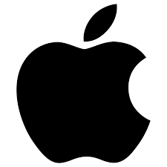
Apple Inc. was founded in 1976 by Steve Jobs, Steve Wozniak, and Ronald Wayne. The company, among other things, creates and sells customer electronics, computer software, and internet services.
Their first creation and sale were the Wozniak Apple I, a personal computer. Then, in 1977, Apple Inc. introduced the Apple II, their second personal computer.
After a few years, Wozniak and Jobs started hiring employees and developing a product line. The year is 1985. Steve Wozniak was leaving Apple, taking with him his best employee. Steve Jobs was working on his own business, NeXT, at the same time.

In 1980, the company was listed on the stock market. Each of their original shares was sold for $22.00. The stock was trading at $128.23 at the time of writing.
Later in the 1990s, the company started to falter, and it began to lose market share to competitors like Microsoft and Intel. As a result, apple's board of directors is considering buying NeXT and bringing Steve Jobs back to the company, according to CEO Gil Amelio.
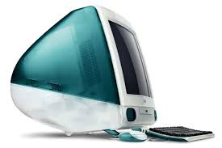
As a result, Apple Computers Inc. has been given a fresh lease of life. Our company launched the iMac in 1998, which gave the critical opportunity, and Apple opened an Apple Store retail network in 1999.
Apple turned its focus to consumer products in 2007, delivering the first iPhone. The company's original name was Apple Computer, Inc. Still, the word "computer" was omitted in 2007 since the company's emphasis had shifted to the broader electronic industry rather than just personal computers.

Although Steve Jobs passed away from cancer in 2011, our company has continued functioning and expanding its product range.

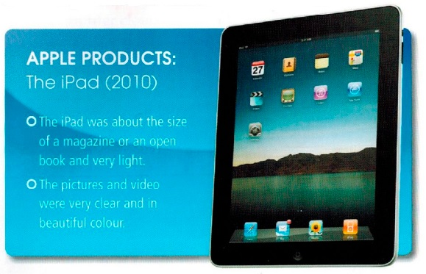
Apple's revenue is estimated to hit $274.5 billion in 2020.

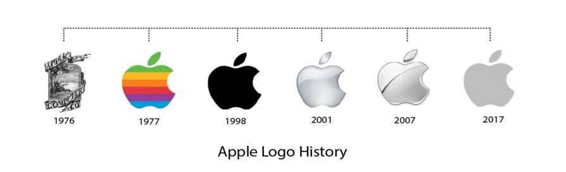
Our company is one of the biggest in the United States' information technology industry. Apple is a member of the Big Tech group, which comprises companies like Amazon, Google, Facebook, and Microsoft in information technology.
The two major mobile phone makers, Samsung and Huawei, are deadlocked for third place.

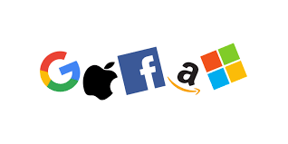
.

BEST PRODUCTS OF APPLE
Apple is a technology business that develops, manufactures, and sells consumer electronics, software, and various online services.
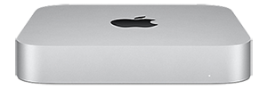
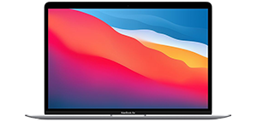
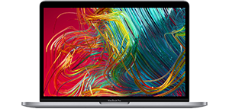
Some of Apple's product portfolios are as follows:
Mac Mini
iMac Book Air
iMac Book Pro

Personal computers are Macintosh computers. Desktop computers such as the iMac and iMac Pro are available in various designs and sizes. The Mac mini is a small desktop computer with a cheap price tag. The MacBook Pro and MacBook Air are two instances of portable personal computers. Those are two professional notebooks you're looking at. Apple's operating system, Mac OS, is a one-of-a-kind creation.
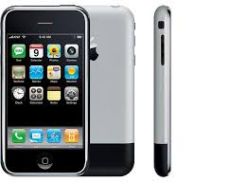
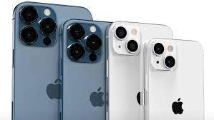
iPhones are the second most important thing. In 2007, the first iPhone was introduced. Those are touchscreen phones in the manner of smartphones. Customers may download a range of applications via the iOS operating system and a specialized app store. This has enormous ramifications for smartphone technology.
Last models ssiPhone
First iPone

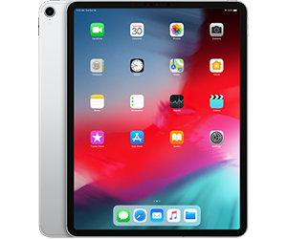
A few accessories are included, such as an iPod and an iPad. The iPod is a portable media player that can be carried about with you at all times. This gadget is used for music listening. Customers may locate their favourite music and performances in a separate iTunes shop. The iPad is a portable multi-media tablet computer that you can take with you everywhere you go. iOS is the name of the operating system. In 2010, the iPad was launched for the first time.
iPad Pro
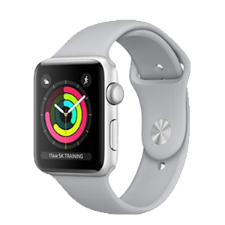
In 2014, Apple was slated to debut the first Apple Watch. This is a smartwatch that monitors the user's fitness and health. It runs on Apple's watchOS operating system and is similar to its other devices.

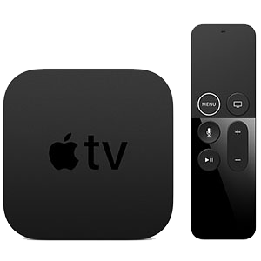
Apple Watch Series 3
Apple TV is a service that the company offers. This digital media player receives music, movies, video games, and audio files from other Apple devices through a tiny network adaptor. These devices run the tvOS operating system.
Apple TV 4K

Apple owns the operating systems macOS, iOS, watchOS, and tvOS, all compatible with its products. Other Apple products and services include iMovie, iWork, iLife, and iCloud. They all have distinct personalities and characteristics. We are a market leader in producing technical information goods and services because our products are one-of-a-kind.

The following divisions make up the Apple Corporation:

Braeburn Capital is a firm that deals with Apple's assets. In 2015, the firm was founded to enhance Apple's asset management.

Dr Dre established Beats Electronics, a high-end audio equipment company, often known as Beats by Dr Dre. Dr Dre created the firm, but it became an Apple subsidiary in 2014. The firm makes headphones and speakers.

Claris is a corporation that creates computer software. The company is working on a variety of Apple-related projects.

Anobit is developing a flash memory controller. In 2012, the business became an Apple subsidiary and began making flash memory components.

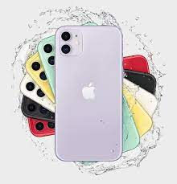

Beddit is a sleep-tracking gadget and software startup that helps users keep track of their sleep. It became an Apple subsidiary in 2017. This business is working on an Apple Watch sleep monitoring app.

What is your favorite Apple Product that you use the most? I bet its iPhone.
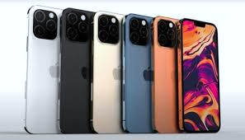


Did you know the price of our products?
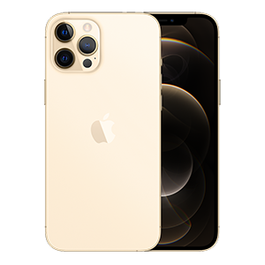
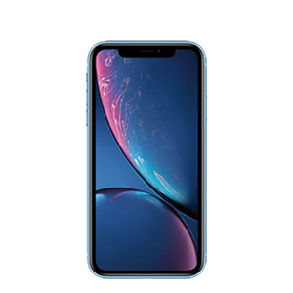
Apple is known for creating high-quality goods at a premium price.
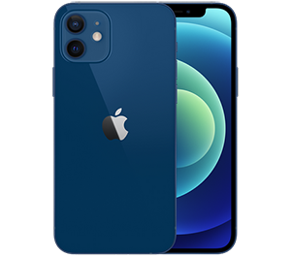
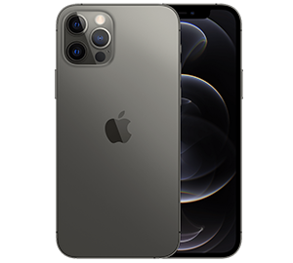
The iPhone 12 is available in 64GB and 256GB models, ranging from $799 to $979. The iPhone 12 Pro supports 5G networks and costs $1,099 for a 256-gigabyte capacity and $1,299 for a 512-gigabyte capacity. The iPhone 12 Pro Max costs $1,099 and may be upgraded to $1,399.
Two more cheap iPhones are the iPhone XR, which starts at $749.99, and the iPhone 11, which starts at $599.99.

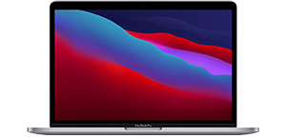
A MacBook Air's price ranges from $999 to $1,999, depending on the device's specs and features, including hard drive and RAM size, colour, and release year. The gadgets that will be introduced in 2020 will be the most costly. An iMac might cost anything from $1,299 and $2,300.
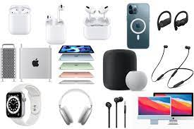
Apple TV is reasonably priced, ranging between $179 and $200. At the time, the iPod was priced between $199 and $399.
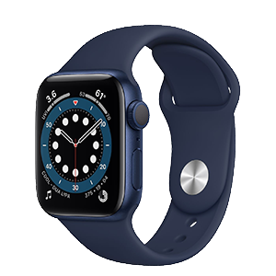
Apple Watch Series 5 prices range from $399 to $529, depending on loop size, colour, and other features. The Apple Watch Series 4 range from $499 to $529. Series 3 has dropped pricing ranging from $199 to $500 depending on GPS availability and other variables.
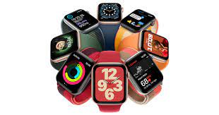
The Apple Watch Series 6 costs $399 and $749, depending on loop size, loop material, GPS, and cellular connection.

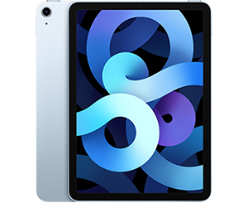
As of its debut date, the iPad's price ranges from $329 to $879, depending on features like memory capacity, screen size, and other factors.

The company's pricing strategy is inextricably linked to developing new items. When something is brand new, the price is more excellent. Furthermore, for more distinctive things and have a greater parametric than others, the corporation charges a premium.

Our pricing philosophy prioritizes providing low-cost, high-quality products to the general population, as well as higher-quality products to professionals and consumers who use their phones and gadgets for business.

Did you know where you can find Apple products?
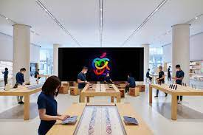
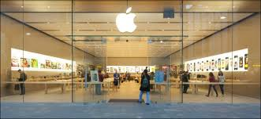
Apple items may be found in stores all around the world.
Apple's retail presence is expanding in key cities throughout the globe.
Apple launched its first shops in 2001, with two primary sites. The shops were then given a fresh look and feel, illustrating Apple's promise.
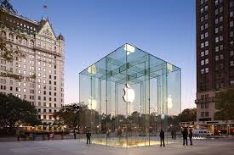
Apple outlets are often found in shopping malls.
Apple shops offer iPhones, iPods, Mac computers, Apple Watches, and various accessories, among other things. In addition, the design and construction of the firm's stores have won architectural honours for the use of glass stairwells and cubbies in retail establishments, in particular.
Customers interested in technical knowledge, equipment and services are attracted to Apple Stores. In addition, because of their strategic location inside retail malls and shopping complexes, Apple Stores are widely accessible to the general public.

The majority of Apple Stores are located in the United States. There are 271 Apple Stores in the United States. In addition, stores may be found in the United Kingdom, Italy, Germany, Spain, France, Sweden, the Netherlands, and other European countries. Other nations with additional locations include Japan, Canada, Australia, China, etc.
Online shops are another opportunity for us to market our items. Previously, Apple's items could be purchased online. However, the online shop was withdrawn from Apple's official website in 2015, leaving just the retail experience.
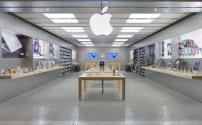
Third-party retail will be Apple's future distribution channel. Apple has made it possible for other businesses and shops to sell their goods all over the globe. In addition, the corporation can now send its items worldwide thanks to this network. This network is critical to the company's success. Apple items are sent to customers in numerous nations and continents using this manner.

The third aspect of retail is assisting with launching and promoting new Apple goods. This keeps clients informed about Apple Company news and developments.
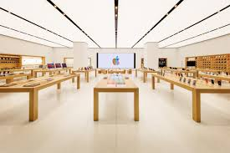

Our advertising model
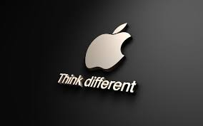
The advertising strategy of the Apple corporation is crucial. Personal selling and partnerships are among how the firm promotes itself. In addition, a series of informative seminars on new goods and improvements are being held by the firm. These presentations allow Apple to keep its consumers up to date on new Apple goods and the company's innovation.

To advertise its newest goods, Apple is airing a television commercial. Third-party firms create certain TV advertising with a financial interest in increasing product sales because they benefit from it.
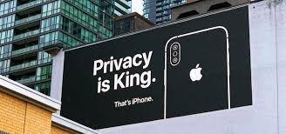
Celebrities are another method for Apple to promote itself in society. The corporation pays celebrities to promote its goods in public or advertising on television.
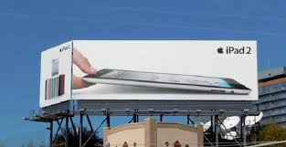
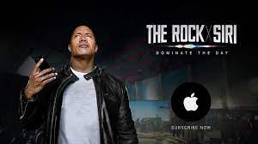
The corporation has a unique marketing technique for promoting new items. The corporation is launching a broader public relations effort, to begin with, connecting better to customers. Apple is showcasing its things before making them available to the general public. The items may now find the items in shops, television, and social media.

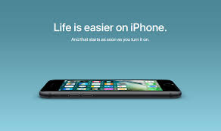
In addition, the goods are now available for purchase at Apple Stores, third-party retailers, and online. At this moment, Apple is boosting up its marketing efforts. Following the first introduction, the corporation continues to promote these items, although less aggressive. Customers often provide reviews and demonstrate the advantages and benefits of new products over older ones. In addition, the corporation is still promoting the new goods via internet media.

Apple has a particularly aggressive marketing approach since it advertises new products before they are released and then makes them available in shops. Customers may put pre-orders for things that will not be available for purchase until later. It is a distinguishing attribute for Apple company.

REFERENCES
- Apple, (2020). Annual Report 2020. Available online on: https://s2.q4cdn.com/470004039/files/doc_financials/2020/ar/_10-K-2020-(As-Filed).pdf
- Capilla, A. (2011). Bringing the best personal computing experiences to all. International Journal of Competitive Intelligence. (4).
- Crukshanks, J. (2006). The Apple Way. New York: McGaw Hill.
- Heracleous, L, Papachroni, A. (2016). Strategic Leadership and Innovation at Apple Inc.
- Isaacson, W. (2011). Steve Jobs. New York: Simons & Schuster.
- Kao, R. (2018). Disruptive Leadership: Apple and the Technology of Caring Deeply--Nine Keys to Organizational Excellence and Global Impact. Taylor & Francis, ISBN 9781351399357.
- Kotler, Ph., Armstrong, G. (2016). Principles of Marketing, 16th Edition, Pearson.
- Kubilay, I. (2015). The Founding of Apple and the Reasons behind Its Success. Procedia - Social and Behavioral Sciences.
- Lashinsky, A. (2012). Inside Apple: How America's Most Admired--and Secretive--Company Really Works. Hachette UK, ISBN: 9781455512171.
- Schlender, Br, Tetzeli, R. (2016). Becoming Steve Jobs: The Evolution of a Reckless Upstart into a Visionary Leader. Crown Business; Reprint edition. ISBN 9780385347426.
- Tozzi, J. (2007). The greatest entrepreneurs of all time. Business Week.
- Yoffie, D., Slind, M. (2008). Apple Inc. Harvard Business School.

