

Student name: Magie Oligo
Student ID: 2436384
Module name: Introduction to Public Health
Module code: LCHS4008
Lecturer name: Dr. Patronella Ganza

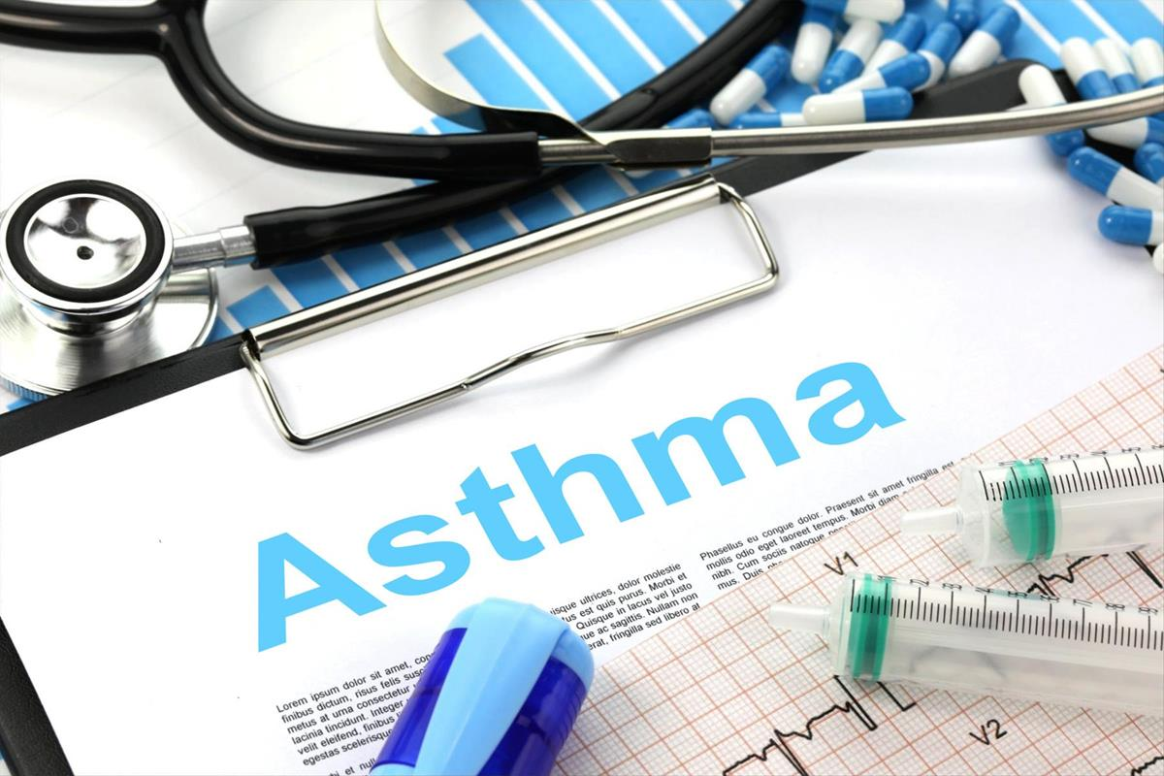
This Photo by Unknown Author is licensed under CC BY-SA

Introduction
Asthma is a long-term condition that affects the tubes in your lungs- the airways that air move in and out when you breathe. If you have asthma, these airways can become irritated and swollen, and they can also make extra mucus. This makes the space inside the airway smaller.
Another problem in asthma is that the muscles around the airways can suddenly tighten. This is called bronchospasm. When this happens, the airways become even narrower, making harder to breathe. Because of these two issues-inflammation (swelling and mucus) and tightening of the muscles your chest can feel tight, you may cough more, and you might hear a wheezing sound when you breathe. The cough may feel dry and irritating.
Worldwide, asthma affects an enormous number of people. In 2019, the World Health Organization estimated that around 262 million people were living with asthma and the condition caused about 455,000 deaths (World Health Organization,2023). It is a major global condition that impacts families, health system, and communities across the continent.
In the UK, asthma is also common. Recent figures show that around 3.9 million people in England had a recorded diagnosis of asthma in 2023/2024 (House of Commons Library,2025).
Across the whole UK, it is estimated that 5.4 million people are currently receiving treatment for asthma, including both adults and children (Asthma UK,2024).

Consequences for Individuals and the Community
- Frequent illness and disruption to daily life, people with asthma often need repeated GP or nurse appointments, use inhalers, or adjust their activities to avoid triggers (dust, pollution, smoke). In the UK, asthma leads to over six million primary-care consultations every year. This means many people are juggling school, work family, and medical care which can be stressful and tiring.
- Risks of severe attacks, hospitalization or even death, asthma can suddenly worsen. In the UK, asthma causes thousands of emergency admissions and several deaths annually. For individuals this means missing work or school and worry for themselves or loved ones. For families it can be emotionally and financially disruptive.
- Reduced quality of life, living with asthma means limiting physical activity, avoiding certain environments (e.g. smoky or polluted air) this can affect mental wellbeing (stress, anxiety) and social life. (Nunes et al., 2017)
- Economic impact on individuals and society, asthma can lead to lost work or school days reduced productivity, or even long-term disability in serious cases according to Asthma + Lung UK. (2025).
On a community level, which means more families under stress, more needing care, and more disruption (work absence, caregiving, etc.).

Consequences for the National Health Service
Asthma is not just a “personal illness,” it is a public health burden.
- Heavy demand on healthcare services, asthma accounts for 2-3% of all primary care consultations. It also leads to tens of thousands of hospital admissions annually these admissions especially emergency ones, requiring bed occupancy, medication, sometimes intensive care.
- Cost to the health service and society, studies estimates that asthma costs the UK’ public health service at least £1.1 billion per year according to Sciencedaily.com (2016). That includes costs for consultations, prescriptions, hospital stays, and disability allowances.
- Inequalities and unfair burden on disadvantaged communities, asthma has worse outcomes in poorer areas, where people may live in cramped or damp housing, face air pollution, or have less access to routine care. This means asthma contributes to wider health inequalities across the country, making it not only a medical issue but also a social justice issue.

How Asthma is Controlled

Asthma cannot always be “cured,” but with the right plan and care, most people can manage it well and live a normal life. Controlling asthma involves a mix of medicines, good habits, and working closely with health professionals.
- Using Inhalers Correctly and Regularly, many people with asthma use a preventer inhaler every day. This type of inhaler reduces inflammation in the airways so that they are less likely to react, even if you do not feel any symptoms. Asthma + Lung UK (2025).
- Then there is the reliever inhaler, used when asthma symptoms flare up (like wheezing, breathlessness, or chest tightness). This inhaler acts fast to open the airways and make breathing easier. (NHS, 2025).
- For some people, doctors now prescribe a combination inhaler (with both a preventer and a reliever built in). This can make treatment simpler and effective, especially if symptoms are frequent.
Using the inhaler correctly the right dose, correct technique, and at the right times matters a lot. Skipping the preventer inhaler reduces its effectiveness. Doctors or nurses often help people create personal asthma action plan. This is like a “road map” for managing asthma. It lists which medicines to take daily, what to do if symptoms get worse and when to get urgent help. Also, regular reviews by GP or asthma nurse help they check how well the treatment works, review inhaler techniques, and make changes if needed (for example, changing medications, dosage, or managing triggers). (NHS, 2025). Lifestyle and Self- Care Helps, staying active like exercise can strengthen the lungs. Keeping a healthy weight, avoid smoking, reducing exposure to known triggers (dusts, pets, smoke) as much as possible. Having vaccinations (e.g. flu) is something many people experience throughout their lives.

Factors Influencing the Health and Wellbeing of People Affected
Asthma affects millions of people in the UK shaping their daily lives of those around them.
- Physical Factors
In the UK, around 5.4 million people receive treatment for asthma, including 1.1 million children (NHS, 2023). Some people manage with inhalers, while others experience frequent attacks. A school child may avoid outdoor play during pollen season in the spring, fearing coughing fits or breathlessness. Adults may struggle with night-time symptoms that leaves them exhausted for work or family responsibilities.
- Emotional and Psychological Factors
Anxiety is common. Many people with asthma in the UK report worrying about attacks, especially when alone or away from home. Teenagers may feel embarrassed using inhalers in front of colleague, affecting confidence and social interactions this creates a cycle of physical and emotional strain (British Lung Foundation, 2022).
- Social Factors
Supportive families and schools make an enormous difference. A parent might need to monitor their child’s inhaler use at school or adjust the home environment to reduce triggers like dust or smoke. Adults may negotiate workplace adjustments to avoid exposure to chemicals or allergens. Lack of understanding from colleagues can lead to social and emotional strain (NHS, 2023).
- Economic Factors
The cost of treatment in the UK is covered by the National Health Service, but indirect costs-like time off work or hospital visits can still strain families. Parents of children with severe asthma may reduce working hours to manage care, affecting household income and wellbeing (British Lung Foundation, 2022).

Impact on People Around Them

- Family and Caregivers: Parents and partners often share the emotional burden of managing asthma. Night-time monitoring of emergency planning is common, particularly for children with severe asthma.
- Schools and Workplaces: Teachers, classmates, and employers must be aware of triggers and emergency plan. Which may require adjustments to routine activities.

- Work colleagues too may be impacted. They might avoid using aerosol sprays in shared spaces, assist during severe asthma episodes, or take an additional task if the individual needs time off to manage their condition. This can create a team wide awareness of the condition but may also lead to increased workload or concern during flare ups (Public Health England, 2020)

Conclusion

In the UK, asthma is a condition that extends beyond the individual. It influences daily routines, emotional wellbeing, social life, and family dynamics. For many lives involves careful planning around triggers, medications, potential emergencies. Supportive families, schools, and workplaces, alongside effective medical care, are essential to maintain health and wellbeing. For many people in the UK, living with asthma means learning how to manage unpredictable symptoms while still trying to lead a full and active life. When individuals receive timely support- such as personalised action plans, regular reviews, and clear guidance they often feel more empowered and less anxious about their condition (NICE, 2021).
Asthma also places a significant pressure on the wider health system, particularly during winter when respiratory illnesses rise (NHS, 2023). However, with good management such as correct inhaler use, understanding triggers, and consistent follow ups care most people can experience meaningful improvements in their wellbeing (Asthma + Lung UK, 2022). Asthma is more than a medical diagnosis, it is a lived experience that requires combine support and a person-centred approach to ensure people feel safe, informed and understood in their everyday lives.

Reference
Asthma + Lung UK (2022) Asthma facts and statistics. Available at https://www.asthmaandlung.org.uk (Accessed 01/12/2025)
Sockrider, M. and Fussner, L. (2020) ‘What Is Asthma?’ American Thoracic Society. 202 p.25-26 Available at https://www.atsjournals.org/doi/pdf/10.1164/rccm.2029P25 (Accessed 29 November 2025)
NHS (2025) Asthma Available at https://www.nhsuk/conditions/asthma/ (Accessed 30 November 2025)
NICE (2021) Asthma: diagnosis, monitoring and chronic asthma management (NG80). National Institute for Health and Care Excellence. Available at https://www.nice.org.uk ( Accessed 01/12/2025)
NHS (20230) Available at https://www.nhs.uk (Accessed 01 December 2025)
WHO (2023) Asthma Available at Global burden of 369 diseases and injuries in 204 countries and territories, 1990–2019: a systematic analysis for the Global Burden of Disease Study 2019. Lancet. 2020;396(10258):1204-22

