14/12/2023
Coexistent Perspectives Essay

Taking the design works of Milton Glaser and Stefan Sagmeister as an example, this paper analyzes the commonalities in their designs and illustrates the importance of following the basic principles of signage design as designers. And further explore the application prospects of visual guidance design in emerging technologies.

Word Count: 4165


LucaBresolin/RobinHowie,designers,FieldworkFacility,design firm,Related Argent, client(www.commarts.com)

Introduction：

In recent years, visual signage design has permeated every aspect of our daily lives, becoming an important component of information transmission and user experience. The content of this article is to deeply explore the representative works of two outstanding signage designers, Milton Glaser and Stefan Sagmeister, analyze the commonalities in their design works, and thus raise the importance of following the basic principles of signage design as designers. Meanwhile, the article will take the works of these two designers as examples to deeply consider the application prospects of visual signage design in emerging technologies.
Firstly, the design works of Milton Glaser and Stefan Sagmeister both have their own uniqueness and style. Milton Glaser combines minimalist design with color combinations and expressive graphic elements, such as "I" ❤ The "NY" logo conveys a profound emotional culture towards the city. On the other hand, Stefan Sagmeister has created many creative and thoughtful works with his unique artistic insights, such as the cover design of books and music albums. This unique design language is the core of guiding design, making the design works unique and more charming.
What is more, by analyzing the works of these two designers, we can see the emotional expression in a work, which is also crucial in guiding design. Glaser and Sagmeister are both adept at using emotional expression and thinking to create resonance between the audience and the work during interaction. This emotional connection not only makes the design more vivid, but also enhances the depth and memory of information transmission.
The importance of design style and graphic innovation in signage design cannot be ignored. Glaser's use of color contrasts strongly with Sagmeister's bold colors in design, highlighting the designer's creativity in expressing information. And this bold and innovative graphics not only enhance the artistic quality of the design work, but also arouse great interest from viewers.
As a designer, following the basic principles of signage design is a crucial step. These basic principles are not only related to whether the work can clearly convey information, improve user experience, maintain product consistency and brand image, etc., but also to the emotional expression and innovation of the design. Adhering to these basic principles not only enables design to play a practical role in information transmission, but also makes the work more outstanding.
In today's society, the rise of various emerging technologies will bring more development opportunities and challenges to visual signage design. The digital era provides more convenient conditions for designers to innovate in their artistic creations. Designers can use various technologies to create and enrich the experience of guiding design. This will deepen the interaction between users and their works, making signage design more promising for application.
In summary, signage design is a field that integrates information science and art, requiring designers to always adhere to basic principles and grasp emotional expression and creativity in their creations. By gaining a deeper understanding of the works of outstanding designers, we can gain a deeper understanding of the fundamental principles of signage design and provide useful guidance for its future development. Designers should constantly improve and reflect on their design path, and on the basis of meeting the needs of the public, they can also stand out in emerging technologies and contribute to the future application prospects of signage design.
Keywords: signage design, personality, originality, emotion and thinking, basic principles, emerging technologies.

Following the basic principles of signage design is of great significance to designers.

Firstly, the primary task of guiding design that can be felt in our lives is to convey information. The basic guiding design principles help ensure that information is transmitted in a clear, concise and clear manner, while enabling users to quickly understand the purpose and content of the design. Secondly, it can improve the user experience, making it easier for users to use and understand the design. Taking the signage design of the subway system as an example, the consistency and identification of the established brand image are crucial for accurately conveying information. The consistent and brand image design of subway signs not only makes it easier for users to identify the brand, but also deepens their memory of the brand.
The adherence to fundamental principles in signage design is not merely a procedural necessity; rather, it constitutes a pivotal determinant of a design's efficacy and impact. Beyond its functional role, an application of these principles serves to captivate user attention and facilitate the effective conveyance of design information or objectives. The visual allure of designs, when aligned with these principles, not only heightens user engagement but also enhances the communicative potential inherent in the visual medium.
Moreover, a conscientious consideration of basic principles empowers designers to fashion aesthetically pleasing works of heightened quality, imbuing designs with an increased allure and artistic merit. Exemplifying this, the guidance system crafted by Michael Bierut and Pentagram for the Metropolitan Museum of Art in New York stands as a testament to the transformative potential of principled design. Characterized by elegant typography, employment of metallic materials, and clear, distinctive logos, this system not only communicates the museum's refined image but underscores the role of aesthetic considerations in augmenting the overall impact of design.
Furthermore, the tenets of basic principles extend their influence into the adaptability of design across diverse media and platforms. The sustainability of a design, contingent upon its ability to seamlessly acclimate to varying digital and media environments, emerges as a critical facet. Principles serve as a guiding compass in this regard, ensuring the endurance and adaptability of the design to different contexts.
In diverse professional domains such as marketing promotion and user interface design, the adherence to signage design principles emerges as a linchpin for enhancing design effectiveness. Whether in the conceptualization of marketing campaigns or the crafting of user interfaces, a steadfast commitment to these principles facilitates the realization of design objectives and optimizes the efficacy of design solutions.
In summation, the observance of basic principles in signage design transcends mere procedural necessity, evolving into a cornerstone that underpins the creation of influential and successful design works. These principles, constituting the bedrock of the design field, furnish a roadmap guiding designers towards heightened success in the creative process. Simultaneously, these principles serve as a guarantor of effective communication with the audience, ensuring the seamless conveyance of information and fostering resonance within diverse contexts. The multifaceted impact of these principles resonates throughout the design process, affirming their indispensable role in shaping the trajectory of impactful and resonant design.

Milton Glaser

Taking Milton Glaser's design works as an example, the graphic expression of his works is both innovative and unique.
The "I" designed for tourism promotion in New York State ❤ The NY logo design is one of his most famous symbols and is widely used in cultural products and promotion in New York City. Firstly, it uses simple and easy to read letters to design the "I" ❤ The message "NY" is conveyed to the audience in a minimalist form. For example, the heart-shaped icon intuitively conveys the concept of "love", making the logo more friendly and infectious; the use of color schemes (red and black) It is concise and eye-catching, and also enhances the recognizability of the logo. Therefore, Glaser successfully conveyed the strong emotions he wanted to express through his simple design elements, making this logo visually easy to recognize and remember. This is also the success of this concise and highly expressive work. Heller, S.,&Fili, L. (2011) In addition, I ❤ The NY logo has strong universality, successfully capturing people's love for New York and their sense of identification with this emotion.Therefore, this makes it a very widely attractive logo.
Glaser's signage design works are characterized by innovative and unique graphics, and he is adept at using simple shapes and colors to express complex concepts. Glaser, M. (2001). On the one hand, his design can evoke strong emotional resonance in the audience when watching works, so emphasizing emotional expression is also crucial. Fisher, M. (2009). On the other hand, Glaser's works are not just artistic expressions, but he also contributes to cultural identity and social values by designing logos and other cultural products. "This study provides data to help understand the importance of brands in today's world, as well as how they influence consumers and help companies or cities escape crises, just like it did in New York."dos Santos, A. C. O., & de Sousa, G. C. B. (2023). Branding communication and the consolidation of the “I ♥NY” brand: Branding communication and the consolidation of the “I ♥NY”brand. Comunicologia - RevistaDeComunicaçãoDaUniversidadeCatólicaDeBrasília,15(2). https://doi.org/10.31501/clogia.v15i2.13012
In conclusion, Milton Glaser's signage design works have found a balance between simplicity and expressiveness, which has left a profound impact on the history of design.”as a founder of New York magazine, - the Blueprint for dozens of city magazines worldwide, Pushpin Studios - the blueprint for hundreds of design studios worldwide and countless political and social campaigns go well beyond the city of New York and the field of graphic design. He is valuable to society”Heller, S. (2004). "Voice: Stefan Sagmeister."Published on November 2004. [Online] Available at: https://hellerbooks.com/pdfs/voice_stefan_sagmeister (Accessed: [Access Date]).Filed in Voice: Journal of Design in Off the cuff.This is Sagmeister's evaluation of him.


Owner NY Department of Economic Development,Produced by New York State,Department of Commerce / Milton Glaser (designer),Country United States,Introduced July 15, 1977,Registered as a trademark in 73758742,Website www.iloveny.com（Fig 1）

Designer Stefan Sagmeister with a highly unique and experimental signage design style.

Stefan Sagmeister embodies his rich personal insights and concepts in the covers of his own designed books.
For example, Sagmeister's exhibition "The Happy Show" at the Museum of Modern Art in New York showcases a sense of design, artistry, and psychology, among others. Through user interaction and graphic transformation design, it deeply demonstrates the psychological effects of individual happiness. Expressing the author's thoughts on the theme of happiness to the audience. Sagmeister is adept at using handicrafts and experimental design elements, breaking conventions and using unique visual elements to convey the emotional and spiritual essence of book content. In addition, for the design of text and graphics, he combined the two to create innovative visual effects that deeply attracted the attention of viewers. And the success of Sagmeister's book cover design lies in its captivating design, which can often stimulate readers' interest and deepen their understanding of the book content. Moreover, personalization and originality are crucial aspects of the work.”When we started out in 1993 we had a style = fart sign hanging in the studio (it is no more) – we very consciously avoided any stylistic traps. In the meantime I have learned that good (and if necessary even trendy) style (and wonderful form) play an important role in delivering content to the viewer. ”Heller, S. (2004). "Voice: Stefan Sagmeister." Published on November 2004. [Online] Available at: https://hellerbooks.com/pdfs/voice_stefan_sagmeister (Accessed: [Access Date]).This not only fully expresses the unique interpretation of art in some of the works, but also highlights personal unique thinking and creative inspiration.
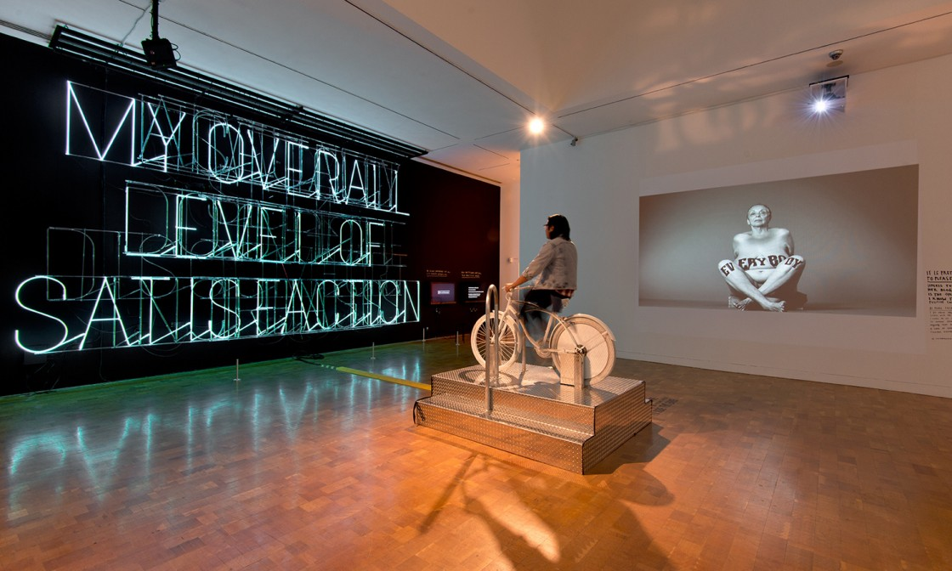
Installation view of Stefan Sagmeister: The Happy Show,March 20 -June 7,2013 at MOCA Pacif ic Design Center, courtesy of The Museum of Contemporary Art,Los Angeles,Photo by Brian Forrest(www.moca.org)(Fig 2)

On the one hand, being adept at using abstract graphic and symbolic elements is an important factor in conveying emotions and atmosphere. For example, many music albums designed by Sagmeister often use experimental layouts on their covers, showcasing stunning visual effects while breaking some traditional design rules. On the other hand, the use of color is often an indispensable element in his designs, used to express and convey emotions and energy through music.In addition, the music album cover designed by Sagmeister can achieve visual and auditory unity according to the music style, and match the music style. Therefore, this also highlights his unique thinking on music and art, making the album cover not only a decorative function of the outer packaging, but also an extension of the artistic nature of the work itself.
In summary, the reason why Stefan Sagmeister's signage design works create such a unique experimental and innovative visual experience is mainly due to the following points - experimental and creative, personalized, and unique understanding. Emotional expression. Finally, as a designer and author, his works not only attract the audience through appearance, but also often evoke profound thoughts and resonance with the works by expressing emotions.To produce content that lends itself well to be spoken in that language. There is a certain content that is best spoke in a certain language (say love is easier declared in the language of a pop song than in architecture – the Taj Mahal notwithstanding). Stefan Sagmeister's signage design works have attracted much attention in the design field, attributed to his outstanding innovative spirit and continuous pursuit of experimentation. This attitude of pursuing uniqueness has made his works occupy a prominent position in the field of signage design.

Although there are some differences in design styles between Milton Glaser and Stefan Sagmeister, there are also certain commonalities in certain aspects.

Milton Glaser emerges as a designer of considerable societal value, his contributions akin to a cultural resonation comparable to that found in the musical compositions of Lou Reed. Notably, his creative ingenuity and penchant for experimentation have transcended traditional design paradigms, manifesting in the utilization of distinctive and innovative patterns and color elements within his works. A meticulous examination of Glaser's designs reveals a deliberate departure from conventional norms, with a unique amalgamation of typography, color, and form that coalesces to engender visually compelling and personality-infused graphic representations (Bonanos, C. 2018).
At the core of Glaser's design philosophy lies a commitment to innovation and experimentation, fostering a symbiotic relationship between art and philosophy. His creative oeuvre serves as a conduit for contemplation on cultural nuances and human emotions, facilitated through the adept integration of graphic elements. The intersection of artistic expression and philosophical inquiry within his works imparts a distinctive intellectual depth, contributing to the broader discourse surrounding culture and human experience.
Furthermore, Glaser's sensitivity to art and culture, coupled with an unwavering passion for craftsmanship in comparison to his contemporaries, imparts an additional layer of refinement and individuality to his creations. This nuanced approach not only elevates the quality of his works but also underscores his commitment to the intricacies of design processes. The fusion of artistic sensitivity and technical prowess becomes evident, positioning Glaser's creations as not mere visual artifacts but as manifestations of a profound engagement with cultural and artistic paradigms.
In essence, Milton Glaser's status as a designer of societal significance is underscored by his adeptness in breaking conventional design boundaries, infusing his creations with innovative elements, and fostering a synthesis of art and philosophy. This intellectual and artistic depth, coupled with his nuanced approach to craftsmanship, culminates in works that transcend mere visual aesthetics, resonating as thoughtful reflections on culture and the human experience.Simultaneously, Stefan Sagmeister enjoys challenging some novel design styles and layouts. On the one hand, emphasizing individuality and originality, although his works also value individuality, they convey emotions and create design styles through experimental and color graphic applications. On the other hand, regarding the understanding of art and culture, Milton Glaser's design emphasizes emotional expression, conveying emotions through concise graphics to create emotional resonance for the audience, while Stefan Sagmeiste's works mainly express emotions through color and shape.
To sum up, the design oeuvres of Milton Glaser and Stefan Sagmeister converge in their notable emphasis on creativity, experimentation, and individuality, coupled with a profound attentiveness to the realms of art, culture, and emotions. These shared thematic underpinnings denote a collective commitment to pushing the boundaries of conventional design paradigms and infusing their creations with distinctive and innovative elements. Both designers have wielded a considerable impact on the field of design, contributing to its evolution through the cultivation of a unique design language that resonates with cultural, emotional, and artistic depth.
The resonance between Glaser and Sagmeister manifests in their shared ethos of creative exploration, where conventional design norms are transcended, allowing for the infusion of avant-garde patterns, color elements, and typographic innovations. This departure from tradition underscores their shared commitment to experimentation and a continual quest for novel and impactful design expressions.
Moreover, the profound attention to art, culture, and emotions evident in their works signifies a shared inclination towards design as a medium for cultural commentary and emotional resonance. The intellectual depth imbued in their creations establishes a dialogue with broader cultural and humanistic contexts, transcending the mere aesthetic realm and contributing to the rich tapestry of design as an intellectual and expressive discipline.
To sum up, the legacy of both Glaser and Sagmeister lies in their shared pursuit of design as a dynamic and individualistic form of expression. Through their distinctive design language and shared thematic foci, they have not only influenced the trajectory of design but have also left an indelible mark on the discipline, emphasizing the enduring power of creativity, experimentation, and a profound engagement with the cultural and emotional dimensions of the human experience.

The profound impact of guiding design on enterprises.

Guide design not only reflects the internal philosophy, culture, and philosophy of a company, but also represents the external image of the company and whether its design is personalized. On the premise of satisfying people's basic visual experience, it showcases more culture and corporate spirit in the visual space, while applying modern science and technology and integrating humanized and dynamic design. The guidance system has evolved from its initial role as a guide to becoming more personalized, artistic, and humanized, playing an increasingly important role in people's lives. (Miller et al., 2014).
The design of guidance systems directly affects the public's impression and objective evaluation of enterprises. Excellent visual system design plays a very important role in establishing corporate culture, image, and the overall image of the city. Nowadays, the design of navigation systems plays a crucial role in providing information channels in people's lives. Navigation systems facilitate people's lives and provide more convenient spatial information. With the increasingly complex architectural environment nowadays, people's demand for the quality of guidance will also become higher.(Passini, R. (1981).) In addition, the outdoor guidance system also serves as a warning and reminder, providing manual assistance in managing the outdoor environment through another form. Under the premise that the visual system plays a fundamental role, injecting emotions and cultural connotations into design can bring better feelings and interactive experiences to people. With the gradual improvement of navigation systems and the continuous development of science and technology, future navigation systems will be more widely used.(Hartmann, D., & Yee, M. 2014).

The possibility of the application and development prospects of visual guidance design in emerging technologies.

For example, smart city information guidance is a visual guidance design that combines emerging technologies, which can provide more humanized and intelligent urban information services. This design utilizes technologies such as artificial intelligence (AI), wearable devices, and (AR) technology to better meet user needs. For example, wearable device design integrates navigation services with wearable devices such as smartwatches or glasses, allowing users to obtain real-time navigation and information through these devices.（Fig 3）By utilizing sensors and data analysis, the guidance system provides users with real-time information about the urban environment, such as weather, air quality, traffic conditions, etc., helping users make decisions conveniently and quickly without having to take out their phones. And the design takes into account sustainability factors, such as solar energy, LED lighting, and various recyclable materials, all of which are closely related to environmental protection.

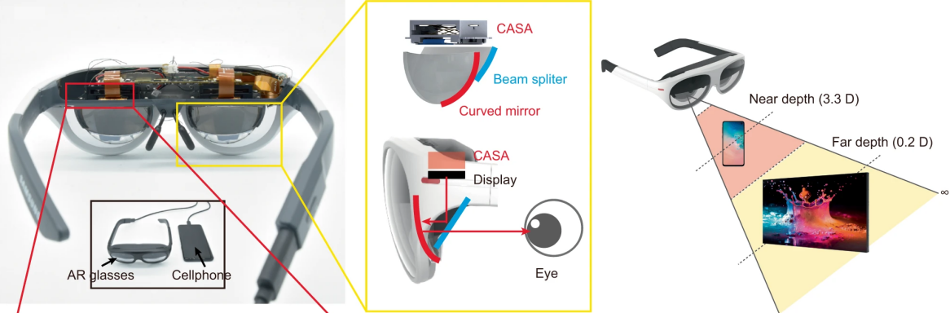
Image source: Samsung https://www.arinchina.com/14350.html （Fig 3）

Firstly, these designs provide more user-friendly and convenient navigation services, which can better meet the needs of different users and greatly improve the user experience. (Heath, T.,&Luff, P. 1991) is expected to become a part of future urban development and improve the overall service performance of urban information.Secondly, these wearable devices and interactive designs greatly enhance user engagement, making this service more closely related to users' daily lives. Furthermore, the application of data analysis enables urban managers to have a more comprehensive and accurate understanding of the city's operational status, thereby making more effective decisions. Finally, paying attention to the sustainability of urban signage design can help cities establish and achieve sustainable development goals, thereby improving the quality of the urban environment.
This example demonstrates the prospects of visual signage design that integrates multiple elements in the development of emerging technologies. Through wearable devices, AR, AI, and other technologies, designers can create more experiential and intelligent signage works, making urban information services more in line with the future development direction.

Drawing inspiration from the design works of Milton Glaser and Stefan Sagmeister for the application prospects of signage design.

Firstly, both Glaser and Sagmeister's works are highly creative and design driven, fully emphasizing the uniqueness of signage design. Creativity and design sense are crucial in leading the trend of design development in the application prospects. Designers can stand out among numerous information signs by guiding the unique visual symbols and graphics in the design.
What is more, both designers focus on emotional expression and establish emotional connections with signage design through user willingness in application prospects. Design works convey profound emotions and insights, which can provide users with a better experience and resonate with them.
Sagmeister often explores new technologies and fields, and is known for its experimental design. In the application prospects of signage design, designers can actively explore emerging technologies and integrate this feature, such as augmented interactive reality, virtual reality, and other technologies, to enrich the more extreme experience that signage design can bring. (Adamson, G., & Mitchell, R. 2016 ).
Many of Glaser's works convey thoughts on human emotions and values through design, and reflect his concern for cultural and social issues. In terms of application prospects, designers pay more attention to cultural, social issues, and sustainability, making design more profound in social connotations.
In conclusion, a shared characteristic discerned in the creative undertakings of both Milton Glaser and Stefan Sagmeister resides in their recurrent engagement across diverse media platforms, such as graphic design, advertising, and music album covers, among others. The potentialities inherent in their collective body of work suggest a trend towards a more expansive and integrative paradigm in signage design. This evolution is underscored by the integration of diverse media elements and methodologies, thereby heralding a trajectory aligned with the contemporaneous zeitgeist of design convergence.
Examining this convergence in light of contemporary design theories, such as the User Experience (UX) framework posited by Hassenzahl, Diefenbach, and Göritz (2010), underscores the increasing significance of a holistic and multisensory approach in design endeavors. According to this theoretical perspective, the synthesis of various media elements is not only stylistically progressive but also instrumental in cultivating a more innovative and comprehensive user experience within the domain of signage design.
Moreover, the prospects for future applications suggest a shift towards a transdisciplinary design ethos, wherein designers adeptly navigate and amalgamate diverse media modalities to enhance the overall impact and resonance of signage projects. This multifaceted approach is poised to contribute to the creation of environments that transcend traditional boundaries and engender a heightened experiential engagement for users.
In essence, the shared penchant of Glaser and Sagmeister for diverse media domains foreshadows an emergent paradigm in signage design—one characterized by a nuanced interplay of various media forms. This paradigm not only aligns with contemporary design theories but also promises to redefine the landscape of user experience in signage design, paving the way for more dynamic, engaging, and innovative applications in the future.In summation, an examination of the design oeuvres of Milton Glaser and Stefan Sagmeister elucidates the prospective trajectories and potentials within the realm of guidance design with respect to innovation. For future applications to wield greater influence in guidance design, an accentuation on the amalgamation of creativity, emotional expression, technological integration, social consciousness, and various other pertinent factors will be imperative.
To sum up, the design legacies of Milton Glaser and Stefan Sagmeister not only offer abundant inspiration to the domain of signage design but also underscore the discerning responsiveness of design endeavors to concurrent societal, cultural, and technological developments. As we project into the future, amid the relentless advancement of nascent technologies, designers will find themselves presented with an augmented array of opportunities to craft visually arresting and conceptually profound signage design masterpieces. This evolutionary trajectory portends an exciting prospect for the field, where the synthesis of artistic ingenuity and technological prowess is poised to propel guidance design to unprecedented heights of aesthetic and functional prowess.

Bibliography
Books
Adamson, G., & Mitchell, R. (2016). "The Experimental Turn in Design Research: Alternative Methodologies, Speculative Analysis, and Creative Practice." Design Issues, 32(4), 3-10.

Borja de Mozota, B. (2003). "Design Management: Using Design to Build Brand Value and Corporate Innovation." Allworth Press.

Bonanos, C. (2018). Milton Glaser: Graphic Design. Phaidon Press.

Bell, P. A., & Dyment, J. E. (2006). "Grounds for Change: Student Involvement in a University Campus Sustainable Transportation Initiative." Environmental Education Research, 12(4), 407-419.

Curedale, R. (2013). "Design Thinking: Process and Methods Manual." Design Community College Inc.

Fisher, M. (2009). Capitalist Realism: Is There No Alternative?. Zero Books.

Glaser, M. (2001). Art Is Work. Overlook Press.

Heller, S., & Fili, L. (2011). Design Culture: An Anthology of Writing from the AIGA Journal of Graphic Design. Allworth Press.

Heath, T., & Luff, P. (1991). "Collaborative activity and technological design: Task coordination in London Underground control rooms." Computer Supported Cooperative Work (CSCW), 6(1), 1-27.

Passini, R. (1981). "Wayfinding in Architecture." Environmental Psychology and Nonverbal Behavior, 5(1-2), 249-265.

Hassenzahl, M., Diefenbach, S., & Göritz, A. (2010). "Needs, affect, and interactive products—Facets of user experience." Interacting with Computers, 22(5), 353-362.

Norman, D. A. (2004). "Emotional Design: Why We Love (or Hate) Everyday Things." Basic Books.

Sanders, E. B. N., & Stappers, P. J. (2008). "Co-creation and the new landscapes of design." CoDesign, 4(1), 5-18.

Websites

Alkhatib, S., & Deifalla, A. (2022). Reliability-based assessment and optimization for the two-way shear design of lightweight reinforced concrete slabs using the ACI and EC2. Case Studies in Construction Materials, 17, e01209-. https://doi.org/10.1016/j.cscm.2022.e01209

De Chernatony, L., & Dall’Olmo Riley, F. (1998). Modelling the components of the brand. European Journal of Marketing, 32(11/12), 1074–1090. https://doi.org/10.1108/03090569810243721

Heller, S. (2004). "Voice: Stefan Sagmeister." Published on November 2004. [Online] Available at: https://hellerbooks.com/pdfs/voice_stefan_sagmeister(Accessed: [Access Date]).

Johansson, P., & Schultzberg, M. (2022). Rerandomization: A complement or substitute for stratification in randomized experiments? Journal of Statistical Planning and Inference, 218, 43–58. https://doi.org/10.1016/j.jspi.2021.09.002

Pransky, J. (2015). The Pransky interview: Dr Martin Buehler, Executive R & D Imagineer at Walt Disney Imagineering and renowned expert in advanced robotics. Industrial Robot, 42(6), 497–501. https://doi.org/10.1108/IR-08-2015-0153

Tarnovskaya, V., & Biedenbach, G. (2018). Corporate rebranding failure and brand meanings in the digital environment. Marketing Intelligence & Planning, 36(4), 455–469. https://doi.org/10.1108/MIP-09-2017-0192

