The first 1000 days

What are the first 1000 days?
The first 1000 days of a child’s life refers to the time of conception, through pregnancy and until their 2nd birthday. “the period from pregnancy to age 3 is the most critical, when the brain grows faster than at any other time; 80% of a baby’s brain is formed by this age.” (World Health Organization, 2018). This is widely recognised by health, education, and child development professionals as a critical time in a child’s development. What happens during this period can have a lasting impact throughout childhood and can shape a child’s lifelong health, learning, and wellbeing. “The first years of life are a critical opportunity for building healthy, resilient and academically competent children, young people and adults.“ (Burton, 2015, quoted in Brodie 2018, p.1).
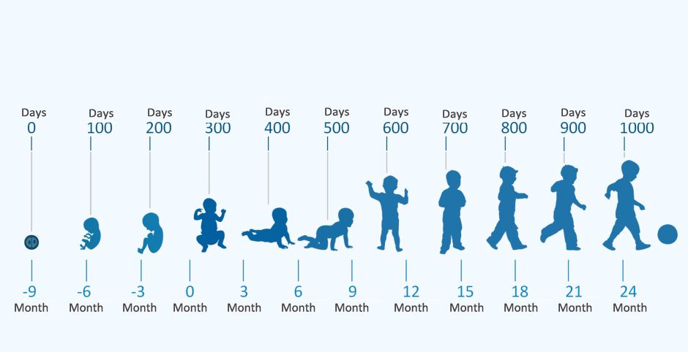 Google image (IDSMed, 2024)

During the first 1,000 days, a child’s brain develops at a rapid rate with millions of brain connections forming every second, particularly those linked to language, emotional, and cognitive skills. Positive early experiences, such as sensitive caregiving, play, and good communication, help strengthen these connections. However if, a child and mother are exposed to continued stress, neglect, or trauma during this important time the brain development may be affected which will possibly have an impact on learning and development at a later stage in their life. Early childhood, particularly from conception to the age of two, is a period when children are highly influenced by their surroundings. During this stage, infants depend entirely on their caregivers, and the quality of early attachment relationships plays a significant role in shaping later development (HM Government, 2021).
In the Public Health Wales document “The first 1000 days: a golden opportunity to build a fairer future” it states that “for the best start in life all babies need love, nurturing care and attention from the most important people in their lives. Good nutrition, playing, talking and responding to babies builds their brains and bodies”. (Public Health Wales, n.d.)
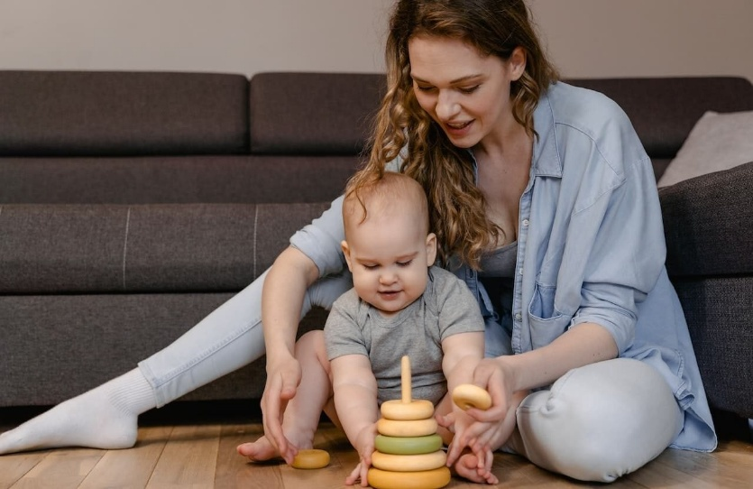
Within this first 1,000 days a child’s emotional and social development are significant as they will build strong, secure bonds with parents and caregivers helping children develop a sense of safety and trust. These early relationships play an important role in developing self-confidence, resilience and helping children to manage and understanding their emotions and feelings. Children who experience consistent, nurturing care are more likely to form healthy relationships and build emotional resilience throughout their development.
Physical growth and overall health are also considerably formed during the first 1,000 days. By ensuring, good nutrition during pregnancy and the first two years of life supports healthy growth, brain development, and helps to build a strong immune function. If a mother and child have an insufficient level of nutrition or healthcare during this time, you may find them facing lasting health problems, including developmental delays and a greater possibility to illness.
Also, during this time, language and communication skills are being established. Therefore, talking, singing, reading, and responding to a child’s cues help build early language skills. These early experiences play and important role to later literacy, learning, and educational success.
I have included a small video from UNICEF which supports this and confirms how important the first 1000 days are in a child's development.
https://youtu.be/NymebwpbL4c (UNICEF, nd)
What is exceptional caregiving?
When you see the words exceptional care, many people will only think of looking after the physical needs of a child. However, there is so much more to it. Exceptional care will encompass everything that a child needs, to have the best start to their life, child-centred support that meets the individual needs of every child. It goes beyond meeting basic needs and focuses on supporting children’s wellbeing, safety, learning, and development and inclusive support that helps them grow physically, emotionally, socially, and cognitively. Exceptional caregivers place the child at the centre of practice, ensuring that every decision made reflects the child’s best interests.
A key feature of exceptional caregiving is the ability to form secure, positive relationships with children. Warm, responsive, and consistent relationships help children feel safe and emotionally secure. When children trust the adults caring for them, they are more confident to explore, communicate, and engage in learning. Emotional support is especially important in early years settings, as it helps children feel secure and builds the foundations for positive social and emotional development.
“Experience shows that if children are happy, active and have enough room to practice various movements they feel like practicing, and if they are provided with toys they are interested in, they do not need assistance from an adult to learn to change their situation and position: They can turn around, crawl, climb, sit up, stand up and walk.” (Pikler Lóczy USA, 2016).

One main aspect of exceptional care is the creation of enabling environments for the children to develop in. These will be environments fully planned to enrich all children’s learning development and their independence. These environments will be welcoming, safe and stimulating and will allow children to explore different activities, gain independence in their abilities, and build their confidence. The activities need to be accessible to all the children and inclusive for all abilities to participate. With a well thought out enabling environment all children will feel safe to push the boundaries of their abilities and they will feel valued.
“Children thrive in inclusive environments, both indoors and outdoors, and where there are open-ended opportunities to play, explore and investigate. Adults who are attuned to children’s interests, responses and nonverbal cues can support positive dispositions to learning as well as increasing knowledge and skills. From birth, children need quality interactions and time with an adult who can support them in their exploration”. (Welsh Government, 2023)
The importance of enabling environments is strongly supported by Bronfenbrenner’s Ecological Systems Theory. Bronfenbrenner (1979) emphasised that a child’s development is influenced by multiple interconnected systems, including family, school, community, and wider society. Exceptional care acknowledges these influences by working in partnership with families and external agencies to provide consistent and holistic support. When environments are responsive and inclusive across these systems, children are more likely to experience stability and positive developmental outcomes.
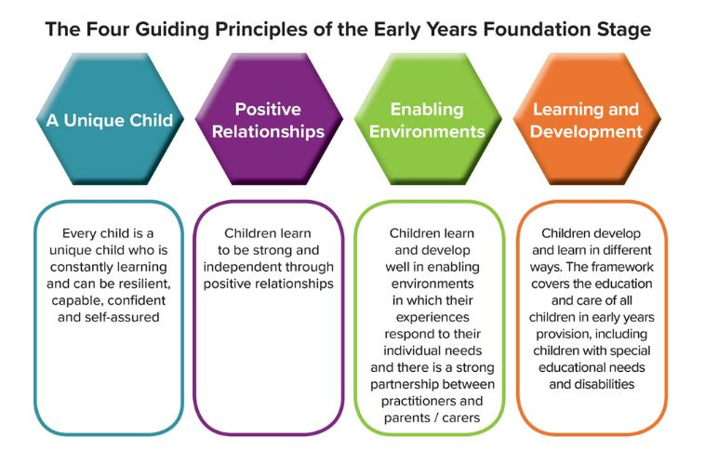
Birth to 5 matters (2021)
Inclusive practice is a key feature of exceptional care. This involves recognising and valuing diversity, including differences in ability, culture, language, background, and family circumstances. Inclusive environments ensure that all children feel welcomed, respected, and supported to participate fully. By adapting provision and practice, caregivers remove barriers to learning and promote equality, enabling every child to reach their potential.
Exceptional care is important because it promotes positive outcomes across all areas of development. Children who experience inclusive, emotionally supportive environments are more likely to develop strong social skills, emotional regulation, and a positive attitude towards learning. It also supports safeguarding, as attentive and responsive caregivers are better placed to recognise concerns and respond appropriately.

Why is effective partnership and support important?
It is essential that during the first 1000 days of a child’s life, good support and partnerships are built between families and the early years practitioners involved with them. Early years practitioners play a central role in supporting children and families during this crucial stage by providing high-quality care and identifying and responding to factors that may impact development.
Effective partnership working is central to supporting children and families in the first 1,000 days. Practitioners work closely with parents and carers, recognising them as the child’s main caregivers and respecting their knowledge of their child is essential. Having open and respectful conversations help to establish trust and allows practitioners to share information about children’s development, daily routines, and wellbeing. This will support consistency between home and the early years setting, which is important for young children who rely on predictable routines to feel secure.
One of the key responsibilities of an early years practitioner is to support children’s physical, emotional, social, and cognitive development through nurturing, responsive care. Consistent, nurturing interactions help children form secure attachments, which are essential for healthy emotional development. This can be supported by recognising children’s cues, meeting basic needs, and providing a safe, stimulating environment that encourages exploration and learning. Building secure relationships early in their development help children feel safe and confident, supporting brain development and resilience.
Collaboration with other professionals and external agencies, such as health visitors, midwives, speech and language therapists, and family support services is important when supporting children and families. By working as part of a multi-agency team, early years practitioners help ensure families receive complete support tailored to their needs. This is especially important in identifying concerns early and putting appropriate support in place before difficulties become more significant.
Maternal factors can strongly influence a child’s development during the first 1,000 days. A mother’s mental health, such as postnatal depression or anxiety, may affect bonding, which can impact a child’s emotional and social development. Early years practitioners are often in a strong position to notice changes in a parents or carers behaviour or signs that they may be finding things difficult. It is not the role of a practitioners make judgements; however, they have a responsibility to listen sensitively, offer reassurance, and signpost families to appropriate support services, including health visitors, general practitioners, or mental health services.
Other maternal factors that may affect development include physical health, stress, social isolation, poverty, domestic abuse, or lack of access to support networks. These factors can reduce a parent’s ability to meet their child’s needs consistently. Practitioners can support families by creating a welcoming, non-judgemental, and inclusive environment where parents feel comfortable to share concerns. Directing them to local services such as families first, who are available to work flexibly with the family and offer the support that best fit them and to direct them on the services available, including early parenting advice, offering advice on forming healthy relationships and directing them to parenting programmes. Practitioners can point them to practical resources such as food banks should there be a financial concern, and setting family support workers can also help, as they can be available as the first port of call and the trusted adult for the parents/carers to turn to and help relieve the pressure and improve results for everyone. I have included a link to the Newport Council document, which can also be shared with parents and provides a wide range of helpful information.
SPACE-Wellbeing.pdf
Identifying developmental delays or additional needs at an early stage is an important aspect of the role. Through regular observation and ongoing assessment, practitioners can identify potential concerns related to communication, physical development, or social interaction. When concerns are identified, practitioners can work collaboratively with families and relevant professionals to access early intervention services. Support provided during the first 1,000 days is especially effective as young children’s brains are highly responsive to early experiences.
Safeguarding is also a fundamental responsibility during this period. Infants and very young children are particularly vulnerable, so practitioners must remain alert to signs of neglect, abuse, or unmet needs. Following the necessary safeguarding policies and procedures, keeping accurate records, and sharing concerns appropriately are essential to protecting children’s wellbeing. By working closely with families, practitioners will ensure children are kept safe and in a nurturing environment.
https://vimeo.com/872530966/46c8b0e55f?fl=pl&fe=sh

What challenges may you encounter?
Practitioners will often face a range of challenges that could affect their ability to provide a high standard of care. These challenges are varied and will include staffing, resources, family circumstances, training, and wider community and social factors.
Staffing remains a persistent challenge within early years settings, with many settings frequently experiencing staff shortages, high turnover, and difficulties in recruiting qualified practitioners. High staff turnover not only disrupts consistency of care but can also hinder the development of trusting relationships between children and practitioners, which are important for secure attachment and effective learning. Low staff morale may affect these issues, as practitioners face challenging workloads, relatively low pay, and limited opportunities for career progression. Together, these pressures may contribute to increased stress and burnout, further intensifying challenges in recruiting and retaining qualified staff.
When staffing levels are insufficient, the opportunity for practitioners to provide individual attention to the children may be significantly affected.
This can make it harder to develop secure, supportive relationships, carefully track children’s progress, and reflect on practice, all of which are essential for improving teaching and care. Limited staffing can also reduce opportunities to provide tailored activities and support for children with additional or complex needs, which may affect inclusion and overall learning outcomes. Early years settings might struggle to maintain proper supervision ratios, manage administrative tasks efficiently, or offer enrichment experiences, such as outdoor play or specialist-led sessions, all of which contribute to a high-quality early childhood experience.

Training within early years is also a challenge, ensuring practitioners have access to appropriate training and ongoing professional development. Early years practitioners should frequently update their knowledge and skills across different areas, including child development, safeguarding, inclusive practice, and current policies and legislation. This will enhances practitioners’ confidence and competence, allowing them to identify children’s individual needs, support those with additional needs and take appropriate action in response to safeguarding issues. Despite its importance, professional development is often overlooked by day-to-day challenges such as time pressures, staff shortages, and funding issues.
Online training can be an alternative, however, it often has limited practical, hands-on experience, which is essential for early years practitioners. Without professional development, practitioners may feel less confident in identifying developmental delays, or managing children’s behaviour, potentially affecting the overall quality of care and learning provided.
Activities that provide meaningful learning opportunities
Early childhood education in a child’s life, plays a important part in their development, providing the building blocks for cognitive, social, emotional, and physical development. Meaningful learning opportunities in early years settings should actively engage children, encourage exploration, and support the growth of essential skills such as problem-solving, creativity, and self-regulation. The EYFS framework highlights the importance of encouraging children to explore, experiment, and develop problem-solving skills through sensory and practical experiences (Department for Education, 2021).
There are lots of activities you could have children engage with to allow them to have meaningful play including; sensory play, mark making, role pay, physical activity and outdoor learning. Each of these activities will allow the children to develop their fine and gross motor skills, their language skills, their social skills and creativity. “One of the most important things we can allow young children to do is play. Through play children will be learning. Play is crucial for developing pre-writing skills and preparing children for school readiness.” (The Curiosity Approach, 2024)
Sensory Play
Sensory play includes activities that engage children’s senses holistically therefore touch, sight, sound, smell, and taste are being developed together. These experiences help children to experiment, solve problems and make predictions, while supporting early scientific thinking and decision making skills. In addition, sensory play can help develop fine and gross motor skills, attention, and emotional regulation.
One popular way to incorporate sensory play is by using sensory trays. These can be filled with resources such as rice, sand, water, or pasta, together with tools like scoops, funnels, or small toys. Children are encouraged to explore textures, pour, scoop, and handle objects in creative ways. For example, a tray of coloured rice will allow children to sort items by colour, practise counting, and describe textures, at the same time supporting numeracy understanding and language development. This can be adapted to include additional items, such as scented materials, herbs, or objects that make noise, which improves sensory engagement and keeps children focused and curious.
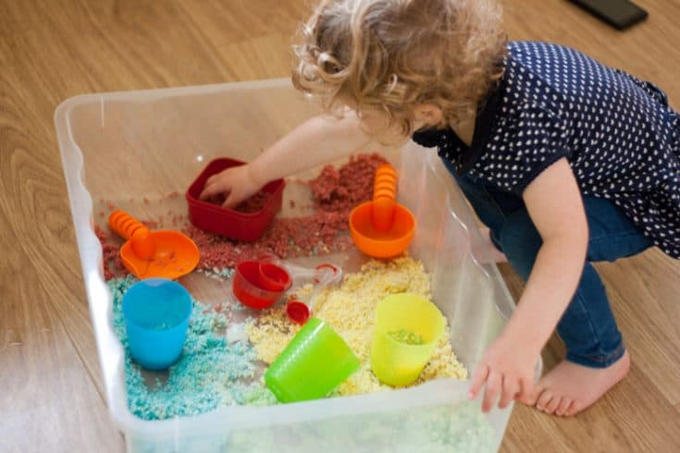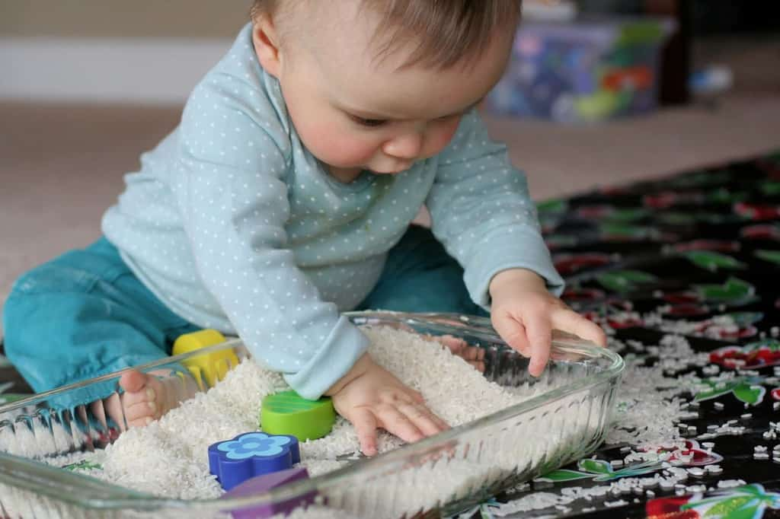

Loose Parts
Loose parts play involves giving children with a variety of exploratory materials that is moveable, combined, redesigned, and manipulated in a number of ways. These materials might include natural resources such as sticks, pine cones, shells, and leaves, or recycled everyday objects like boxes, fabric, bottle caps, and containers. The core concept of loose parts is that children can explore and investigate freely, encouraging creativity, problem-solving, and independent thinking.
Experimenting and exploring with loose parts will allow children to investigates ideas such as balance, weight, shape, and size, supporting early numeracy. For example, children might stack blocks to build a tower, make ramps to see how objects roll, or create pictures using recycled materials.
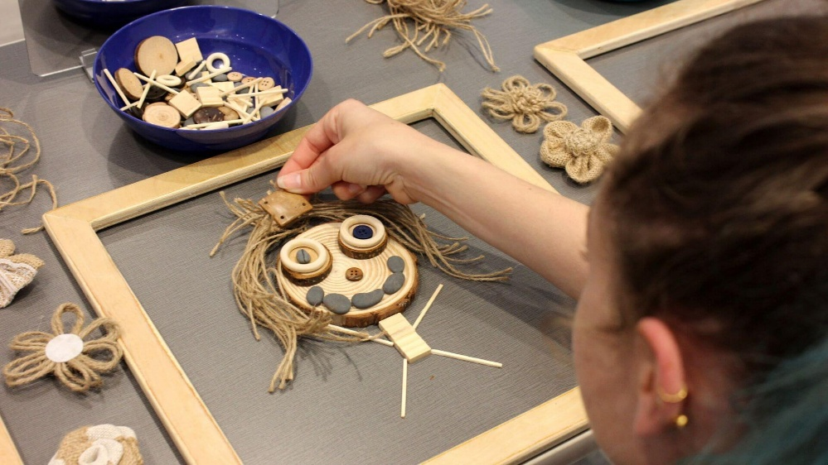

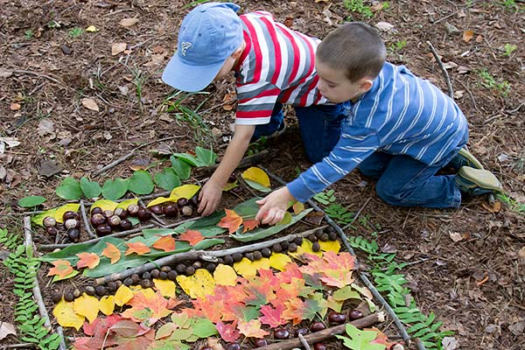

Through these experiences, children develop fine and gross motor skills, and hand-eye coordination. Loose parts can encourage social development, as children will engage in different roles, share resources, and work together to achieve shared goals. Practitioners can support learning by providing a wide range of materials, observing children’s interactions, asking open-ended questions, and building on the children’s ideas where appropriate. By encouraging investigation, experimentation, and creative thinking, loose parts play offers high-quality and meaningful learning opportunities across a range of areas of development.
Looking at international approaches is often a good place to start as they offer children a different level of learning experience. As an example, The Reggio Emilia approach is highly recognised for the way it views young children, supports early learning, and underpins best practice in caregiving. At the heart of the Reggio Emilia philosophy is the belief that children are competent, capable, and active participants in their own development. They believe the approach is guided by children’s interests, ideas, and experiences, with learning developing through exploration, collaboration, and inquiry rather than follow a set curriculum.
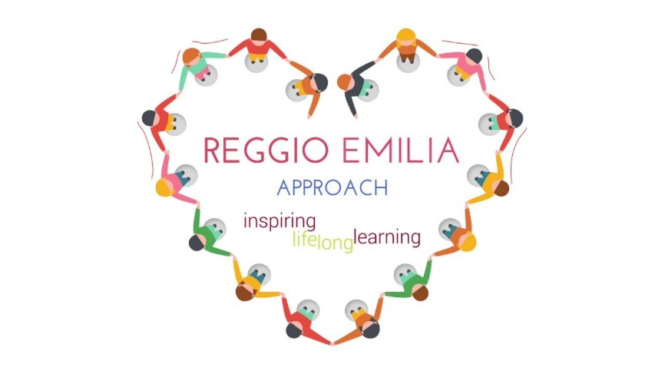
Reggio also believe the learning environment is very important and is often described as the “third teacher.” They design the classrooms to be inspiring and welcoming, that will encourage creativity and exploration. Natural light, flexible spaces, and resources such as loose parts and natural materials, help children investigate and express their ideas in different ways.
https://youtu.be/7n2hCebmT4c - Reggio Emilia
In conclusion, early years practitioners play an important role during the first 1,000 days of life. During this time, practitioners provide consistent, nurturing care that supporting children, helping them to feel safe, valued, and confident. These early relationships are important for developing future learning, behaviour, and resilience.
By working closely with families, practitioners can offer guidance, reassurance, and practical support. Open and honest communication will help to build trust, maintain consistency across home and early years, and identify concerns at an early stage.
Working effectively with multiple agencies helps families obtain the necessary support during challenges, such as health, social care, or specialist services.
Understanding the family as a whole, further helps practitioners provide sensitive and appropriate support. By recognising potential risks early, practitioners can help prevent issues from becoming more serious encourage positive development.
Overall, by offering early support, guidance, and appropriate intervention when needed, early years practitioners help build a solid base for children’s lifelong wellbeing, learning, and development. Their role is essential in giving every child the best possible start in life and the chance to thrive.

References
Early Years Coalition (2021) Birth to 5 Matters: non-statutory guidance for the Early Years Foundation Stage. Available at: https://birthto5matters.org.uk/wp-content/uploads/2021/03/Birthto5Matters-download.pdf (Accessed: 28 January 2026).
Brodie, K. (2018). The Holistic Care and Development of Children from Birth to Three: An Essential Guide for Students and Practitioners (1st ed.). Routledge. https://doi.org/10.4324/9781315453774 (Accessed: 28 January 2026).
Bronfenbrenner, U. (1996) The ecology of human development : experiments by nature and design. Cambridge, MA: Harvard University Press. https://librarysearch.uwtsd.ac.uk/permalink/44WHELF_UWTSD/1pbrh66/alma99100656736402421 ProQuest Ebook Central - Reader (Accessed: 28 January 2026).
Harvard University. (2024). ‘Serve & Return Interaction Shapes Brain Circuitry’. Serve and Return Interaction Shapes Brain Circuitry(Accessed: 28 January2026)
HM Government (2021) The best start for life: A vision for the 1,001 critical days. London: HM Government. Available at: https://assets.publishing.service.gov.uk/media/605c5e61d3bf7f2f0d94183a/The_best_start_for_life_a_vision_for_the_1_001_critical_days.pdf (Accessed: 28 January 2026).
Pikler Lóczy USA, 2016. In honor of Independence Day in USA, we offer you the wise words of Dr. Emmi Pikler on infants’ independent movement or play. [online] Available at: https://pikler.org/2016/07/26/in-honor-of-independence-day-in-usa-we-offer-you-the-wise-words-of-dr-emmi-pikler-on-infants-independent-movement-or-play [Accessed 28 January 2026].
Public Health Wales (n.d.) The first 1000 days: a golden opportunity to build a fairer future [Infographic]. Available at: https://phw.nhs.wales/topics/the-first-1000-days-programme/resources/the-first-1000-days-a-golden-opportunity-to-build-a-fairer-future-infographic (Accessed: 28 January 2026)
The Curiosity Approach. (2024). ‘BEFORE A CHLD WRITES THEIR NAME’. https://www.thecuriosityapproach.com/blog/before-a-child-writes-their-name [Accessed: 28 January 2026].
Welsh Government (2023) Early Childhood Play, Learning and Care: Developmental Pathways 0 to 3. Available at: https://hwb.gov.wales/api/storage/56774946-48aa-4fab-adda-f27508d8dc8f/early-childhood-play-learning-and-care-developmental-pathways-0-to-3.pdf (Accessed: 28 January 2026).
World Health Organization (2018) Nurturing care for early childhood development: a framework for helping children survive and thrive to transform health and human potential. Geneva: WHO. Available at: https://iris.who.int/server/api/core/bitstreams/781de51d-4cef-482e-bb3b-c2b3becf3c9f/content (Accessed: 28 January 2026)
UNICEF (n.d) Nutrition in the first 1,000 days of a child’s life Available at: https://youtu.be/NymebwpbL4c (Accessed: 28 January 2026)

