I acknowledge the use of AI Tool on 08/11/25 to help with ideas on Infographics and the models of Maslow’s Hierarchy of Needs. I confirm that I have not presented any AI generated text as my own work. I confirm I have copies of my drafts, notes, and other resources I used before, and after the use of AI tools which I may be asked to provide in evidence.

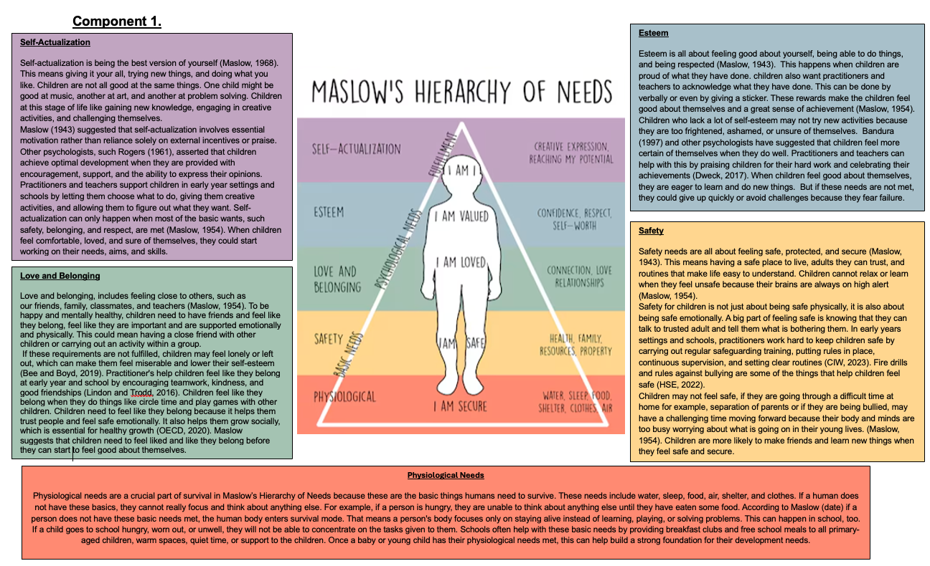

Component 2.
Concepts of holistic child development with links to Maslow’s model.
When taking care of children, you assist their body, brain, feelings, and relationships form. You do not only teach them knowledge. It is like thinking of a child as a tree that needs care, soil, water, and sunlight allowing them to thieve and grow. Researchers argue that to help children grow up healthy, practitioners and teachers need to help them with their bodies, thoughts, feelings, social skills, and creativity all at once (UNICEF, 2023). Maslow's hierarchy of needs is a useful tool for practitioners, teachers and parents since it shows that children need love and safety before they can feel good about themselves and perform creative things.
Holistic development is when families and educational settings take care of all aspects of a child, including their body through nutrition and physical activity, their brain through learning and language, their emotions by making them feel safe and understood, their social lives through friends and family, and sometimes their spiritual or creative areas through art, play, and values. Recent research shows that programs that include health, responsive caregiving, early learning, and nutrition are better than those focused just on letters or numbers (WHO, 2023). Practitioners and teachers need to support the complete child because they cannot focus and learn if these needs are not met.
Attachment is how a child feels safe and close to the person who takes care of them. It helps children learn about the world and trust other people (Bowlby, 1969). A parent or carer who meets a baby's or young child’s needs gives them a safe place to explore and attempt new things (Bretherton, 1992). This safety influence how the child thinks about themselves, so children who are securely attached typically develop better friendships and deal with stress better.
Numerous traditional theories of child development contribute to the understanding of the whole-child idea. According to (Piaget, J.1964) learning should align with children's cognitive development and that children's thinking changes in phases. (Vygotsky, 1978) suggests that by putting emphasis on social learning, children learn best when they receive support and have talks with friends and adults. According to (Bronfenbrenner, U.1979), a child's growth is affected by the family, school, surroundings, and society, all of which are systems. Because they show that development depends on several connected parts rather than a single skill, these ideas support holistic practice.
Maslow’s pyramid model starts with the basic needs like safety and food and moves up to higher levels of needs like love and belonging, esteem and self-actualization. If children are hungry or afraid it will make it harder for children to make friends and learn. Practitioners, teachers and parents can only help children reach higher goals like creativity or direction once, their basic needs are met. (Maslow 1943) described motivation as a group of needs that meet and support each other. The focus of current early childhood frameworks (UNICEF, 2023 WHO, 2023) is on health and responsive parenting.
Holistic thinking leads to real actions. These include having healthy food and regular checkups, safe and warm schools, learning through play which also can improve social and emotional skills, and family support. This policy, the United Kingdom Early Years Foundation Stage, takes a comprehensive approach. According to the Early Years Foundation Stage, practitioners and teachers must meet the health and social needs of children as well as their learning goals. Cognitive, emotional and social outcomes are better with combined approaches which involve parenting support, stimulation, and nutrition rather than single focus programs. Most modern programs and evidence support (Maslow's, 1943) idea of putting basic needs first.
A major factor is inequality. Children that come from low incomes families are more likely to not have their basic needs met, which can lead them to fall behind. To close the gaps, studies suggest that practitioners and teachers need to support from more than one area, such as health, education, and social protection (Tomlinson 2021, UNICEF, 2023). This fits with (Maslow's, 1943) idea that a large proportion of children will never grow up if society does not help them meet their basic needs. For practitioners and teachers to be able to teach in a holistic way, they also need to be trained and given appropriate tools. According to the (WHO, 2023) tests should check more than just reading and writing. They should also check social and mental skills.
Not only is playing fun, but it also helps with language, maths, physical fitness, and making new friends. (Vygotsky, 1978) and more recent studies show that play helps guided learning, in which adults help to improve a child's skills. When children are close to their parents, they feel safe to explore and learn. This fits with both (Maslow's, 1943) ideas about needing to belong and feel good about yourself. Programs that encourage responsive parenting and enjoyable ways to learn help children do better in many areas.
To conclude, when parents, practitioner and teachers help a child grow holistically, they help their body, mind, emotions, and relationships all at the same time. It is easy to see why basic health and safety should come before innovation and higher learning with Maslow's hierarchy. Modern studies and rules around the world support this idea by showing that the most effective programs are those that blend early learning, health support, and responsive caregiving. Children need to learn, play, and make friends, and parents, practitioners and teachers need to build services that help them do those things. A child is like a tree and needs many things to grow strong.

Component 3.
Reflection 1.
My experience from working in early years settings have given me endless opportunities to reflect on a variety of areas of Marlow’s Hierarchy of Needs. I first witnessed child A who was a two and half year-old crying hysterical and clinging to his mum on hand over to the flying start setting. Child A was clearly distressed, trying their best to climb over mum’s shoulders to avoid being handed over to us as practitioners. This made me feel sad and upset to see child A so hysterical and crying. Child A was clearly having attachment issues about leaving Mum. Mum was adamant that chid A was to attend the session and was encouraging staff to take them, by lifting child A from the Mum. I started to feel worried that child A would associate our setting with a negative experience and would struggle coming to the setting on the future sessions.
Child A mum then went on to disclose that child A was still being breast fed as and when wanted, despite being on solid food. This was the causing the separation issues and transition to the setting unsettling. My initial thoughts were that the mum must be mad. I could not understand why anyone would want to continue feeding a child of that age from the breast. One of the reasons I struggled with was because I was thinking that children of that age have teeth and that was it suitable for a child of that age. I did start to look at the child and think that they do not know any difference and that the action of the child A was linked to Marlow’s Hierarchy of Needs for food.
I felt a strong need to comfort the child and reassure them. When I look back, my views have changed in a way of being able to see that the child’s separation from mum meant that breast milk would not be available, which in turn was causing the upset. I could then understand that the mum was trying her best to wean child A and encourage them try cow’s milk or water and have a morning snack with all the other children. I feel like the team all worked well together to reassure child A and the mum.
By speaking to the mum and working together I did go on to read up on the. Weaning process and how to deal with attachment issues. I now feel better informed on how to deal with children who may be in similar situations
Reflection 2.
My second reflection is of child B. Child b was handed over to dad, who was biologically mum but was transitioned recently to dad. Child B would run up to dad for a cuddle and was greeted with a hand stretched out, saying to give him personal space. Child B stopped and looked around at the other children being greeted with open arm, smiles and being asked how their day has been. Child B put their head down and so sad. As a mum myself, this really hurt to watch, and I could not help but feel for child B. The dad continued to look down at his phone, ignoring the child as they left the setting.
The lack of love and belonging and inclusion as in Maslow’s Hierarchy of Needs was evident in how child B was presenting with their behaviours and needs at school. Having an understanding and knowledge of what challenges dad was facing, somewhat could allow me to see why the maternal instinct was not there.
Over the coming days and weeks. We monitored child B behavioural issue as these were quickly becoming challenging and more frequent. We liaised and arranged meetings with dad to offer support for the child and himself and to put strategies in place to help the situation. I thought by having more of an insight of what child B was seeing and having to adapt to, I could best offer my support to the child. My views on the child’s behaviours significantly changed, as I could see that child’s B was seeking love, attention, sense of belonging and inclusion as in Maslow’s Hierarchy of Needs.
When reflecting and looking back this will allow me to have an open mind to why a child may be displaying challenging behaviours and what factors could be contributing towards them. I would feel more confident in future to speak to the parent/carer of the child if needed this can help to identify areas where help and support may be needed for child and parent.
Reflection 3.
My third reflection is of child C. This child was given a task to complete along with the other children in the class. Child C instantly put their head down and huffed and puffed, saying that they could not do it. Child C stated they were no good at things like this. The task had been explained and was something which had been done previously. At that moment I thought how can the child know that they could not do it if they have not even tried. My initial thinking was they just did not want to do the work. When I asked child C why they thought that they would not be good at doing the task. The reply was, because their friends always told them that they are not good at doing anything. The self-doubt and lack of self-esteem really took over and was impacting the child’s ability to move forward and overcome these challenges.
Child C was reassured and offered support and guidance in small groups to help gain confidence. This along with lots of positive praise and rewards helped to build the child’s self-esteem and confidence. Child C was reminded that it is ok to make mistakes and that this helps us learn. Child C was identified as someone who would benefit from relationship-based play to help build their confidence. I think that once this was identified and strategies were put in place, we could better support the needs of the child and work towards the next level. All these interventions supported child C with their progression in Maslow’s Hierarchy of Needs.
This has given me a better understanding towards children who lack confidence and self-esteem, because you do not always know what has caused them to feel like that. I would give the same reassurance, praise and support to other children in the same situation and will be able to refer to groups and support if needed.

References.
Bandura, A. (1997) Self-Efficacy: The Exercise of Control. New York: W.H. Freeman. (Accessed: 16 November 2025).
Bowlby, J. (1969) Attachment and Loss. Volume 1: Attachment. London: The Hogarth Press and Institute of Psycho-Analysis. (Accessed: 21 November 2025).
Bretherton, I. (1992) ‘The origins of attachment theory: John Bowlby and Mary Ainsworth’, Developmental Psychology, 28(5), pp. 759–775. (Accessed: 23 November 2025).
Bronfenbrenner, U. (1979) The Ecology of Human Development: Experiments by Nature and Design. Cambridge, MA: Harvard University Press. (Accessed: 22 November 2025).
Care Inspectorate Wales (CIW) (2023) Guidance for Providers. Cardiff: CIW. (Accessed: 08 November 2025).
Dweck, C. (2017) Mindset: Changing the Way You Think to Fulfil Your Potential. London: Robinson. (Accessed: 23November 2025).
Health and Safety Executive (HSE) (2022) School Safety Guidance. London: HSE. (Accessed: 08 November 2025).
Image of Maslow’s Hierarchy of Needs Triangle (2025) Available at: https://www.etsy.com/uk/listing/1301755905/maslows-hierarchy-of-needs-poster?gpla=1&gao=1&utm_source=connexity&utm_medium=cpc&utm_campaign=shopping_uk_google&utm_content=EAIaIQobChMI0ujUp4yJkQMVvplQBh0fZTsnEAQYCCABEgIB_vD_BwE&gad_source=1&gad_campaignid=2 (Accessed: 08 November 2025).
Lindon, J. and Trodd, L. (2016) Reflective Practice and Early Years Professionalism. 3rd edn. London: Hodder Education. (Accessed: 14 November 2025).
Maslow, A.H. (1943) ‘A Theory of Human Motivation’, Psychological Review, 50(4), pp. 370–396. (Accessed: 14 November 2025).
Maslow, A.H. (1954) Motivation and Personality. New York: Harper & Row. (Accessed: 23 November 2025).
Maslow, A.H. (1968) Toward a Psychology of Being. 2nd edn. New York: Van Nostrand Reinhold. (Accessed: 20 November 2025).
Piaget, J. (1964) The Psychology of the Child. (Translated edition). (Accessed: 20 November 2025).
Rogers, C.R. (1961) On Becoming a Person. Boston: Houghton Mifflin. (Accessed: 20 November 2025).
Tomlinson, M. (2021) ‘Optimising child and adolescent health and development’, BMJ. (Accessed: 23 November 2025).
UNICEF (2023) Early Childhood Development (web page). Available at: https://www.unicef.org/early-childhood-development (Accessed: 24 November 2025).
UNICEF (2023) Reaching children with a holistic approach (report PDF). Available at: https://www.unicef.org (Accessed: 24 November 2025).
Vygotsky, L.S. (1978) Mind in Society: The Development of Higher Psychological Processes. M. Cole (ed.). Cambridge, MA: Harvard University Press. (Accessed: 22 November 2025).
WHO (2023) ‘Global Scales for Early Development (GSED)’. Available at: https://www.who.int/teams/mental-health-and-substance-use/data-research/global-scale-for-early-development (Accessed: 24 November 2025).
WHO (2023) ‘WHO rolls out new holistic way to measure early childhood development’. Available at: https://www.who.int/news/item/27-02-2023-who-rolls-out-new-holistic-way-to-measure-early-childhood-development (Accessed: 24 November 2025).

