Student Name: Chaudhry Badar Munir Mehar
Student Number: 2334056
Module code: LCM4001_LON
Module title: Academic skills

Report title: Reflective Report

Date:19/08/2024

Lecturer Name: Tim Hopkins
Title Page
Content
1 Introduction

2 Reflections
21 Reflective writing
2.2 Note taking
2.3 Finding Information

3 Conclusion
4 References
5 Appendices

1
Academic writing skills has been supportive for me in reading,
writing and understanding the context. It has also made me
reflect on my whole terms learning. I will be explaining about
a reflective report that I have experienced at university for this term.
In this report, I will be writing about my three experiences.
I will discuss reflection writing, note taking and academic writing.
I will be using a reflective model to help me (Gibbs, 1988).
I will also show examples of my class work.

2 Reflections on my learning Experiences
2.1 Reflection
Description
Week 6 was about reflective writing. (See Appendix 2) I have studied reflective
writing through my own experience in understanding and
reflecting back on my academic skills. I can describe the
experience of what has happened, the feeling and how I can
assess my learning. I will then look into and explore the
situation in why this has happened and the reason of the course.
The next step will be to conclude the present actions which are
required for further corrections. I can apply new ideas to different
situations now. I have felt that learning new words through pronouncing
has made me improve on my vocabulary skills and it also has improved my
communication and writing skills. I will practice these skills at my work place
to support and improve my oral communication skills with colleagues and friends.
I will also correct my friends whose English communication skills need to progress.
This class was sometimes interesting and at other times more confusing. It was
confusing for me because I did not understand the vocabulary and the meaning
of the word and had to ask my colleague on how the word is pronounced and what
is the meaning of the word. This experience was useful because I have gained the
skills of my reflective writing skills, I can look back at my own work and progress
from where I need to continue. I haven’t been in study for many years so I
sometimes find the classes difficult to follow. It was useful because it will help
my future studies – it helps me see my progress but also where I need to improve.
I realize that reflection is a useful process that needs practice.
I will use reflection in my future classes, as I look back on what I have achieved and what
needs more work.

2.2 Note-taking
Description
In week 2 I looked at different note taking formats. As shown on appendix 2.
The one I had understood carefully was the spider gram technique.
This spider gram format requires more listening and writing the key
words to the main subject as also stating down the title subject
in the center and connecting the key words around the title
sentence page. This technique is a map mapping diagram for me
and my memory is connecting to the words and increasing my
vocabulary words. I was happy and excited to gain a new method of
note taking technique ideas that will support me in my future academic
skills. I can teach my family and friends this method of note taking if they
struggle in any way of taking or remembering information. This note taking skill
has created knowledge and improved my mind map thinking method skills.
This has made my knowledge increase in improving my thinking method for setting
up the mind mapping spider gram method. I think this was a useful skill for me
in remembering and acknowledging the topic as it improves my listening skills.
I will use this note taking skill in my coming term academic skill lessons. Practicing
my note taking skills, will support my compression skills and will develop my
understanding, knowledge of key academic skills.

2.3 Finding Information
In week 3 I have looked at some different ways in researching good
quality information like official links, government official links,
Library based books give original quality information as shown on Appendix 3. There are
Reference lists, index and chapters. I found it interesting and cheerful to acknowledge
this original and good source of information because I thought that the online
information was correct sort of public information. The online source has too much of
its information list and I was not sure which information to follow and accept in truthful.
I found the words were difficult to pronounce and understand the meaning of the word
definition as English is not my first language and I do struggle with word pronounction.
I do refer back to my finding information list as it supports me to find useful information
in my daily life skill.

3
Conclusion
My final summary will look back at my experience overall in this
term as I have improved on my academic writing and reading
skills and understanding in how to structure paragraphs.
I know that taking out time to study will develop my comprehension
and communication skills for the workplace. This skill will also improve and
develop my good understanding communication skills with my colleagues
and friends. I think that researching theorical and logical with experience helps
me to correct my mistakes. I have learnt the structure in paragraphs, In how
to write out the introduction paragraph which will relate to the title sentence.
The center paragraphs come with the main ideas. These paragraphs have to
provide evidence things like proof and analysis to support the main points in the
paragraphs. In the final conclusion paragraph will state my actions. What will I
do next and what action will be taken in the future. I felt that having the educational
skills as an Individual for myself has given me the confidence in studying more open
minded person in my career.

Reference List: Gibbs reference (2023).

Gibbs reference: Available at https://www.ed.ac.uk/reflection/reflectors-toolkit/
reflecting-on-experience/toolkit/reflecting-on-experience/gibbs-reflective-cycle.

Cullen, Z (2024) ‘Is pay Transparency Good?’ Journal of Economic Perspectives.
38.(1) pp 153-180 https//www.aeaweb.org/full_issue.php?doi=10.1257/jep.38.1
Psge=155 (Accessed 25.02.2024).

Appendices
Appendix 2
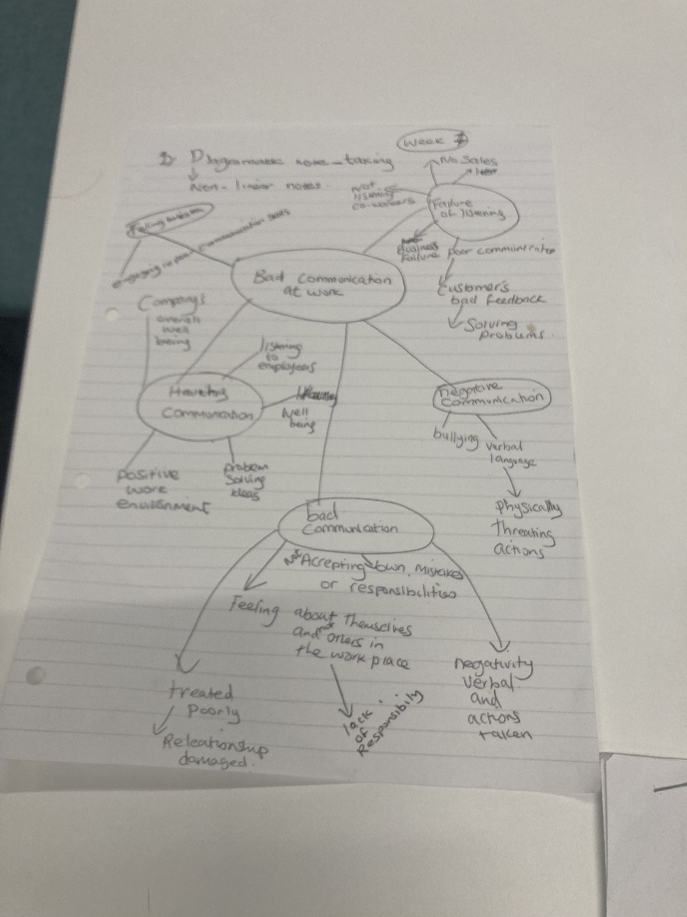
Appendix 2

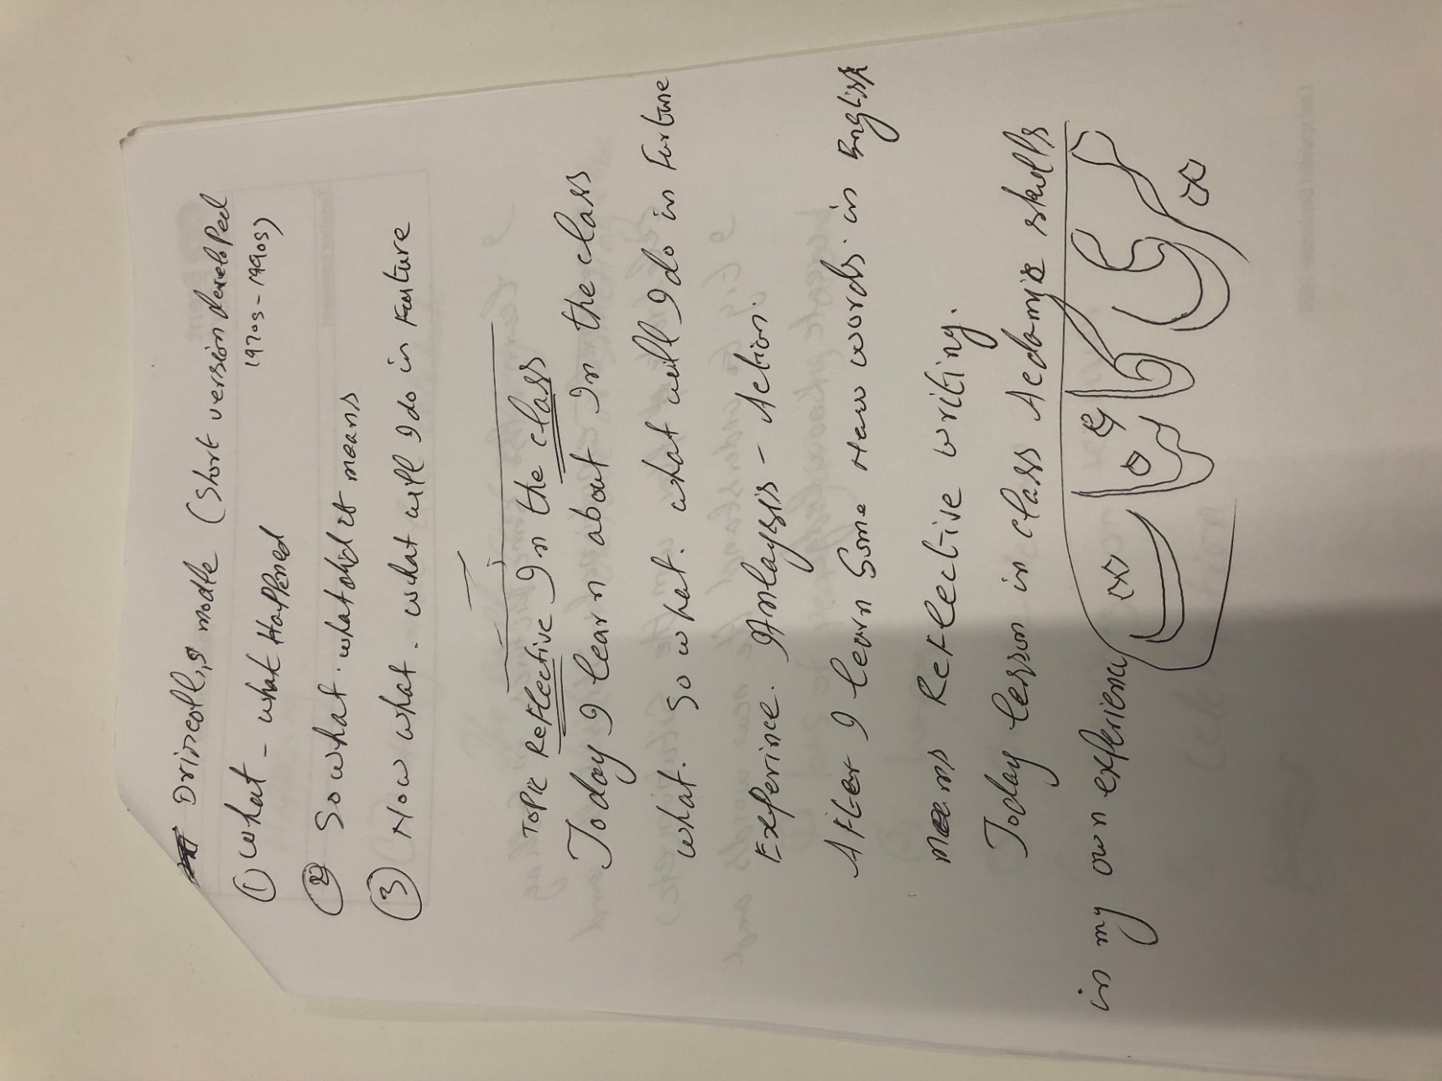
Reflective writing
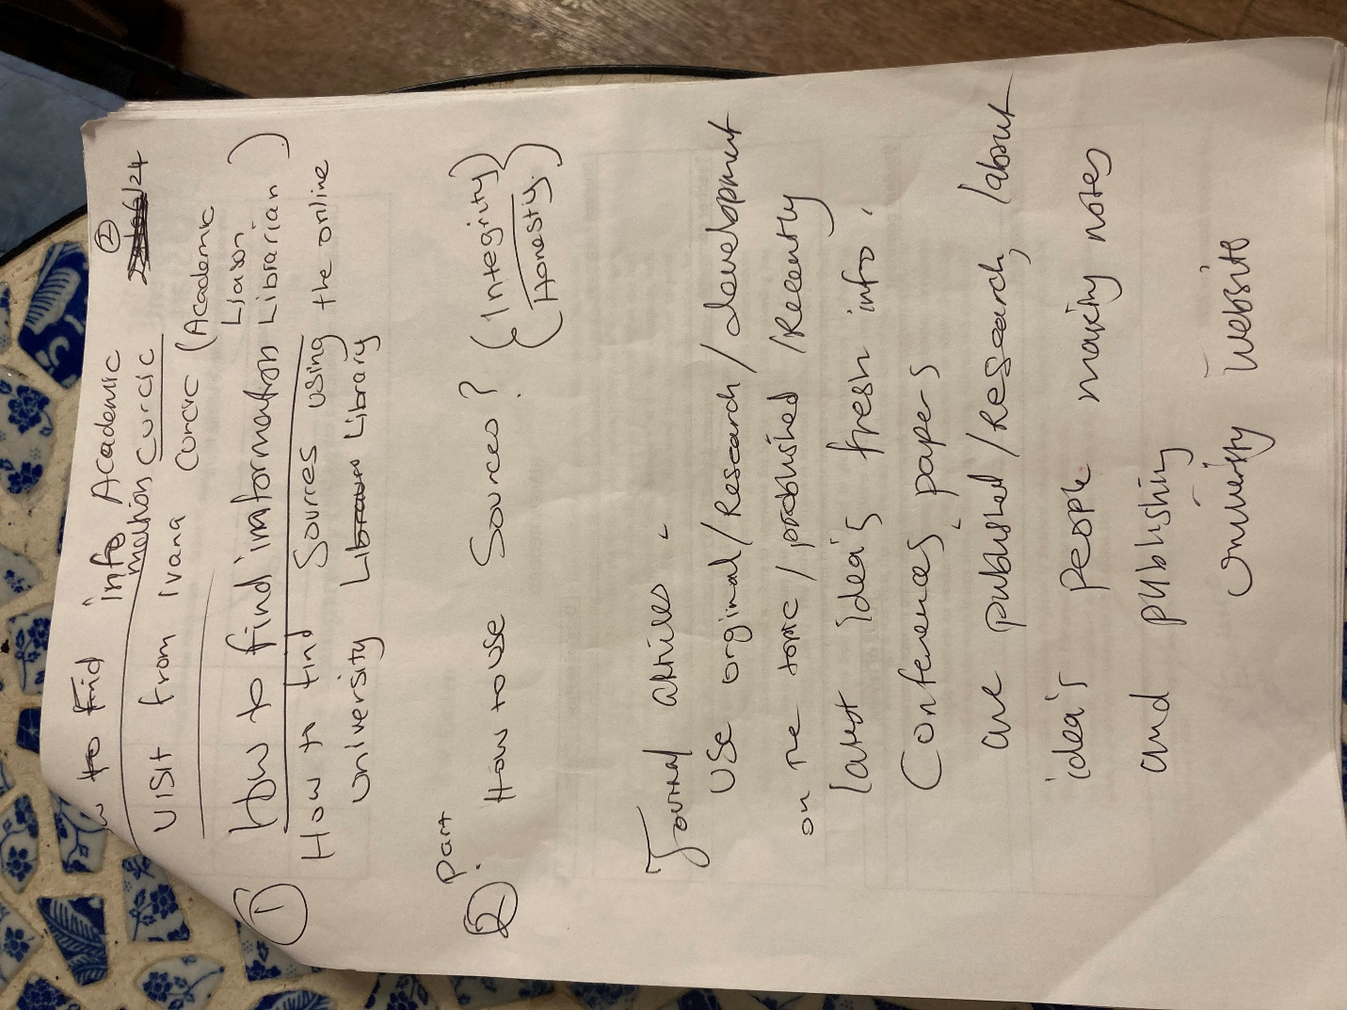

Finding information

