

Student name: Carmen Mosneagu
Student Id: 1714895
Module Title: Effective Team Working & Communication
Lecturer: Sylvia Hoffmann
Date:30/08/2018

OUR LIFE EXPERIENCE AT THE WORKPLACE

Introduction
Many skills are required to work effectively and efficiently in an organization and communication is one of the vital skills among them. Workplace communication is defined as the process of exchanging different information and ideas in an organization. The forms of workplace communication are verbal, non-verbal and written communication. Workplace communication is essential for an organization’s ability to operate effectively and become productive. Effective workgroup and lateral communication result in improvement of individual as well as organization’s overall performance. Good communication also helps in improving employee engagement in terms of enhancement of relationships with co-workers and managers. The report will highlight on workplace communication and its significance. It will also include theories and models of communication. The report will also focus on analysing how workplace communication is helping in improving performance of employees.
Workplace Communication and its significance at the workplace
Workplace Communication
Workplace communication is highly important to different companies as it allows them to operate smoothly. Employees can experience a significant increase in productivity, commitment and morale if they are given opportunities to communicate up and down in organizational communication chain (Keyton et al., 2013). An effective communication is dependent on the professional and interpersonal relationships, which are developed through attentive listening, appropriate body language and active participation.
Significance
Team building: Building an effective team is all about the way in which team members collaborate and communicate with each other. It is essential to have one to one interaction to build a team. By using appropriate platforms of effective communication, members can exchange their thoughts and ideas (Wrench, 2013).
Innovation: When employees are encouraged to communicate their ideas openly, they can come up with creative ideas. Innovation relies upon open communication. Organizations encouraging open communication are more likely to be innovative.
Growth: Growth and development of an organization is dependent on strong and appropriate line of communication. A company will able to implement new tools and techniques in workplace by an effective communication medium, which ultimately results in growth of that company.
Strong management: When managers of an organization are good communicator, they can manage and handle their team properly. Conflict management, delegation of tasks, relationship building, and motivation become much easier, when managers are strong communicators (Cardon, 2014).
Customer service: An organization can provide better and improved customer service through an effective communication. Conversation with a customer creates a positive impact on them and they rate that organization based on the way in which employees deliver service and resolve their issues.
Employee job satisfaction: Employees feel empowered, when they are provided with opportunities to have upward communication. In this type of communication, employees provide their feedback related to workplace issues. When top managers and supervisors listen to their issue and respond to them actively, employees feel special and valued. This ultimately leads to significant increase in employee satisfaction (Zhang and Venkatesh, 2013).
Employee Turnover Rate: Flow of communication is important to employees in the workplace. They feel secure about their position if they receive updated and truthful information from management. They get the power to share concerns and thoughts within organizations. Therefore, excellent communication helps in retaining employees (Rajhans, 2012).
Models of communication
The Shannon- Weaver mathematical Model, 1949
This model is designed by American mathematician Shannon in order to build up effective communication between the sender and receiver (Al-Fedaghi, 2012). The model is concerned with various concepts such as source, transmitter, channel, noise, receiver, message, encode, decode and information destination.

Figure 1: Shannon- Weaver mathematical Model
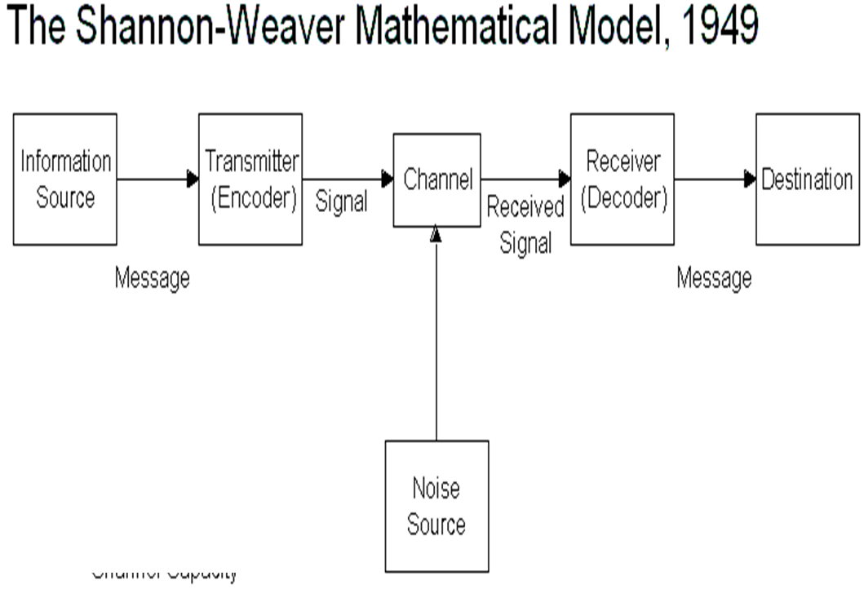 (Source: Al-Fedaghi, 2012)
Sender: Sender is the source of information and he or she develops the messages, chooses the right channel for the communication process and send the message for further activities.
Encoder: Encoder is the transmitter, who plays an important role in converting messages into signals. It can be directly referred to as machine.
Channel: It is the medium, which is used to send the messages.
Decoder: It is referred to as machine that converts signals into messages. Decoder can be the receiver who can translate the messages directly from signals.
Receiver: Receiver is the destination, where final message must reach. When the receiver gets the messages, he or she provides feedback as per the message.
Noise: Noise is referred to as physical disturbances prevent a successful communication process. It does not let the messages pass to the receiver. Noise can be environment, people and other factors.
The model explains that the sender encodes a message and sends that message to the receiver directly or through various channels. Sender converts that message into understandable codes to a machine. The particular message is sent through a suitable medium. The receiver performs the next step in the communication process. He or she decodes that message before interpreting it. The communication channel may have noise for which the receiver may not have the capacity to decode that message. The entire communication process may be hampered due to presence of noise in background (Al-Fedaghi, 2012).
This model can be used in the workplace both in upward and downward direction. In case of upward communication, employees of an organization are senders. They send the message through emails, telephones and direct communication mode. Top managers and supervisors are the receivers. They understand and interpret messages given by employees. They provide their opinions according to the messages. In case of downward communication in the workplace, management gives some order and covey some policies and procedures that an organization is going to implement. Managers may directly communicate with employees or use some channels such as telephone, emails and notices. When the particular message reaches at the employees, they try to give their viewpoint according to the messages.
Rhetorical Theory of communication
Aristotle originally develops this theory as means of challenging different assumptions on what constitutes an effective communication. According to this theory, a communicator provides the thoughts to intended message and stimulates the receiver in a specific manner to achieve desirable result. The theory states that rhetorical communication is the simplest mode to win over the audiences (McCroskey, 2015).
Motivational speakers use rhetorical communication. This theory can be understood by analysing three appeals. These appeals are responsible for the success of communication process. These three appeals are called as the means of persuasion. The three appeals of Aristotle are as follows.
Ethos: It is concerned with ethical appeal, which refers to the credibility and trustworthiness of the speaker or writer.
Pathos: It is concerned with emotional appeal. This component deals with persuading by tempting to the receiver’s emotion.
Logos: It is concerned with logical appeal. It deals with the process of persuading by use of logic and reasoning.
According to rhetorical theory of communication, three things need to be considered before conveying any message. The sender must conceive his or her data before communicating with others. The person must determine the intention after conceiving the data (McCroskey, 2015). The sender must determine the meaning that hoped to stimulate in mind of the receiver. Processes involved rhetorical communications are as follows.
Encoding process: This is the first stage of communication process, where the speaker should convert his or her ideas and thoughts into a manner that the receiver can easily understand. The concepts and words are chosen carefully according to the conceived ideas.
Transmission: This stage is all about choosing a particular channel. The primary channel of the communication process may be oral or written. The channel can be visual like radios and television.
Decoding process: It is the final stage of communication process, where the receiver receives the message and perceives things. There are four elements involved in perceiving such as hearing, interpretation, evaluation and response.
According to the theory, some other elements also determine the success and failure. Noise is the major element that hinders the communication process (McCroskey, 2015). It refers to as the interference to the message provided by the sender. The receiver may perceive the intended message in a different way due to presence of background noise. Feedback channel also helps the sender to adapt as per the receiver’s feedback. This will ultimately help in increasing the chances of success of communication process.

This theory can be implemented in an organization to the suitable appeal of a communication process. Employee and managers need to conceive a particular idea before sending a message to others. They should identify how the receiver will perceive the message that they are conveying. This theory can give a base for winning the audiences during communication process.
How workplace communication and performance of employers can be improved
Communication is the key to the success of an organization. Good communication can bring everyone together towards organizational goal and breakdown obstacles. Effective communication helps in establishing clear expectations for managers and employees. It will convey how the performance will be improved. Loyalty and trust are keys to employee relationship and can be boosted by communication. Therefore, it is essential to improve workplace communication. It can be improved in the following manner.
Develop a communication-friendly Space: Managers encourage employees to express their thoughts and ideas by developing a communication friendly workplace. The employees must be shared with organizational goal. In addition to this, employees should be inspired to communicate with co-workers and build positive relationship among them (Hynes, 2012).
Keep communication constant: Managers should encourage employees to share their views and opinions on a regular basis. It is essential to understand what employees are feeling about the workplace and accordingly managers can do to contribute best to their team.
Collect feedback from employees: Communication should not be only one way in an organization. Employee must be asked to offer feedback and involve in a business decision. They must be inspired to convey the performance of top managers.
Prioritizing Face to face communication: It is important to use face-to-face mode of communication as this has significant value in terms of authenticity and sincerity. If priority will be given to face-to-face communication instead of using telephone and emails then it can be more resonate and effective (Kobayashi, 2018).
Avoid over-communication: It is essential to avoid over communication in the workplace. Employee should get minimum number of emails and messages as required. Employee should not be disturbed without any important work.
Provide a platform for Anonymous Feedback: Organizations should consider the concept of anonymity in workplace communication. Sometimes employees hesitate to make complaint. If they are encouraged to share feedback through anonymous platform, then they can provide suitable feedback on what they are feeling and what additional changes can be taken place (Kobayashi, 2018).
Personalize the communication: In order to build real connection and common ground in conversations, organizations should try to personalize the mediums of communications. Visual mediums can help employees to understand what the managers are trying to convey.
Emphasize on team building: Team building activities and games are good to encourage and improve communication in an organization. Team members can share unexpected things with each other and a bond is created. They start working in a collaborative approach for which individual and overall performance will be enhanced (Hynes, 2012).

Conclusion
The above report has highlighted the concept of workplace communication and its significance in terms of team building, innovation, strong management, growth, customer service, employee satisfaction and employee turnover rate. An organization operates smoothly through an effective workplace communication. This can be only possible through active participation, attentive listening practice and suitable body language. The Shannon- Weaver mathematical Model is the suitable model to understand the process of communication properly. This model has clearly explained each aspect of communication process. Rhetorical Theory of communication has provided some assumptions on the parameters that constitute an effective communication. This theory has also stated the three appeals that are required to persuade audiences involved in communication process. Workplace communication can be improved by developing a communication friendly space, collecting feedback from employees, emphasizing on team building and avoiding over communication.

Reference List
Al-Fedaghi, S., 2012. A conceptual foundation for the Shannon-Weaver model of communication. International Journal of Soft Computing, 7(1), pp.12-19.
Al-Fedaghi, S., 2012. Codeless communication and the Shannon-Weaver model. In International Conference on Software and Computer Applications. Singapore: IACSIT Press,(str. 38-44).
Cardon, P.W., 2014. Business Communication: Developing Leaders for a Networked World (3e). McGraw-Hill.
Hynes, G.E., 2012. Improving employees’ interpersonal communication competencies: A qualitative study. Business Communication Quarterly, 75(4), pp.466-475.
Keyton, J., Caputo, J.M., Ford, E.A., Fu, R., Leibowitz, S.A., Liu, T., Polasik, S.S., Ghosh, P. and Wu, C., 2013. Investigating verbal workplace communication behaviors. The Journal of Business Communication (1973), 50(2), pp.152-169.
Kobayashi, I., 2018. 20 Keys to workplace improvement. Routledge.
McCroskey, J.C., 2015. An introduction to rhetorical communication. Routledge.
Rajhans, K., 2012. Effective organizational communication: A key to employee motivation and performance. Interscience Management Review, 2(2), pp.81-85.
Wrench, J.S. ed., 2013. Workplace Communication for the 21st Century: Tools and Strategies that Impact the Bottom Line [2 volumes]: Tools and Strategies That Impact the Bottom Line (Vol. 1). ABC-CLIO.
Zhang, X. and Venkatesh, V., 2013. Explaining employee job performance: The role of online and offline workplace communication networks. Mis Quarterly, 37(3), pp.695-722.

