

Assignment

Software Development
Section 2

Lecturer: Dr Paul Jenkins
Student: Martin Zhulyov
Student ID: 1912950
Contents
Part 1: Arrays 1
1.1 Definition of Arrays 1
1.1 Declaring Arrays 1
1.2 Initializing Arrays 1
1.3 Assigning values to an array 2
1.4 Accessing the elements of an array 2
1.6Loops through an array 2
1.6.1 For loop 2
1.6.2 Foreach Loop 3
1.7 Importance of the arrays 3
Part 2: Inheritance 4
2.1 Definition of Inheritance 4
2.2 Types of inheritance 5
2.2.1 Single inheritance 5
2.2.2 Multilevel inheritance 6
2.2.3 Hierarchical inheritance 8
2.2.4 Multiple inheritance 9
2.2.5 Important facts about inheritance in C sharp 9
2.2.6 Access modifiers 10
2.2.7 Advantages of inheritance 10
Part 3: Testing 11
Bibliography 12

Part 1: Arrays

1.1 Definition of Arrays
A sequential collection of the same type of data, stored at the contagious memory locations is called Array. A more accurate explanation is that it stores variables of the same type in one place in memory.
Sometimes there is more than one element of the same data type. For example, if there are ten numbers, a creation of ten variables (number1, number2, …, number10) will be necessary without using arrays. But using the arrays, one array of size 10 could be created and all the numbers can be stored in it. Each variable is accessed by an index.
The first index is always zero and it corresponds to the first element of the array. The last index depends on the size of the array. (tutorialspoint.com, n.d.)

Declaring Arrays
The rule of declaring an array in C Sharp has the following syntax:
datatype[] arrayName;
Where,
- “datatype” specifies the type of the declared element;
- “[]” determines the rank of the array, where rank means the size of the array in the memory;
- arrayName indicates the name of the array. (tutorialspoint.com, n.d.)
For an example:
Int[] numbers = { 1, 2, 3, 4, 5 }; - in this example the declared variable numbers stores an array of integers.

or
double[] prices = { 22.75, 17.99, 19.99 };

Initializing Arrays
Declaring an array does not necessarily mean the array to be initialized in the memory. It needs to be initialized by assigning a value.
An array is a reference type, so a new keyword is used to create an instance of the array.
datatype[] arrayName = new datatype[size]; where size specifies the length of the array. (tutorialspoint.com, n.d.)

Creating and initializing an array looks as follows:
Double[] salary = new double[5] { 1540.50, 2720.25, 3000, 1250.75 }

Assigning values to an array
Values to individual array elements can be assigned by using the index number.
For example, if the number 33 needs to be stored at the 3rd location of the array, it will be visualized in the following way:
double[] numbers = new double[10];
numbers[2] = 33;
The index is 2 because the default starting location of the array is always 0. The number will be stored in index 2 in the array and will be displayed at position number 3 in the output. (tutorialspoint.com, n.d.)

Accessing the elements of an array
The way to access the elements of an array is by referring to their index number. The following statement access the value of the third element in array drinks:
string[] drinks = {“Cola”, “Fanta”, “Sprite”, “Schweppes”};
Console.WriteLine(drinks[2]);
// The output will be Sprite. (W3Schools, n.d.)

1.6Loops through an array

For loop
Using the for loop can be one of the ways for looping through the elements of the array. The Length property is implemented to show the number of the loop cycles. The following example shows how all the elements in the drinks array can be displayed:
string[] drinks = {“Cola”, “Fanta”, “Sprite”, “Schweppes”};
for (int i = 0; i < drinks.Length; i++)
{
Console.Writeline(drinks[i]);
}

The output will be:
Cola
Fanta
Sprite
Schweppes. (W3Schools, n.d.)

1.6.2 Foreach Loop
The same output of the elements in the array drinks will be displayed by using the for-each loop:
string[] drinks = {“Cola”, “Fanta”, “Sprite”, “Schweppes”};
foreach (string i in drinks)
{
Console.Writeline(i);
}
The output is the same as when using the for loop. The difference is that the foreach loop doesn’t require the Length property to be used, which makes it easier to be written. (W3Schools, n.d.)

Importance of the arrays
The below declarations are an example of how arrays are helpful. They are helping the user by decreasing the time for building the code, making the code block shorter, and increasing the user's productivity. Here are some examples of how arrays are important in programming:
- Memory saving – in programming an array can be declared dynamically, which gives the programmer more flexibility. Manually allocations can be done at runtime memory during runtime;
- Cache friendly – the closer positions of the values in an array makes them easily accessible from CPU to the cache. This means that looping through an array is faster than any other iteration;
- Predictable timings – The system knows the specific address where an array starts and its location in the memory. This way of accessing makes an array not only fast but also predictable;
- Easier debugging – since arrays have well-defined indexes and the system already knows their addresses, there is no ambiguity when playing with the indexes. These are optimal for usage. In loops, programmers can use indexes to loop over an array;
- Advantages over variables – homogenous collection of data are stored in an array. This is helpful when there is a need to be stored multiple values beneath the same variable. This could be done for any purpose and the result is that the usage and the utilization of the arrays is highly efficient;
- Advantages over data structures – the sequential manner of the data storage are making it efficient to be tracked by using just its index values. This process is not easy when it is done by non-sequential data structures;
- Reusability of code – multiple values can be stored in an array and once they are declared, they can be used unlimited times in the code. This increases the readability of the code and helps for its improvement. (EDUCBA, n.d.)

Part 2: Inheritance

2.1 Definition of Inheritance
Object-oriented programming has 4 basic concepts and inheritance is one of them. It is the concept of deriving features of one class into another class. It can derive attributes and functions of a class and by that way it ensures reusability. If there is a scenario where a class, that have part or parts of its code block which need to be used in another similar class, there is no need for rewriting this part of the code again. The new class can become a sub-class (or child class) of the main class and it can inherit arguments and methods from the parent class.
Some terminologies need to be taken into consideration when implementing inheritance:
- Super-class – the class which features are inherited by other class. Also can be called a base class or parent class;
- Sub-class – the class that is derived from the parent class. Subclasses can inherit all the necessary attributes of their parent class, and also they can have some attributes of their own. It is also called derived or child class.
Inheritance can be done by using the ":" operator after each class name, depending on the type of the inheritance:
Class SubClass : SuperClass
{
// attributes and functions
} (Kirti_Mangal, 2019)

For example:
public class A
{
public void GetInformation()
{
// Method implementation
}
}
public class B : A
{
// class implementation
}
public class Program
{
public static void Main(string[] args)
{
B b = new B();
b.GetInformation();
}
}

}

2.2 Types of inheritance

2.2.1 Single inheritance
The single inheritance is the most simple type of inheritance, where the child class can inherit the features of the parent class and use its attributes and functions. (Kirti_Mangal, 2019)
Figure 1 shows the basic concept of the single inheritance.
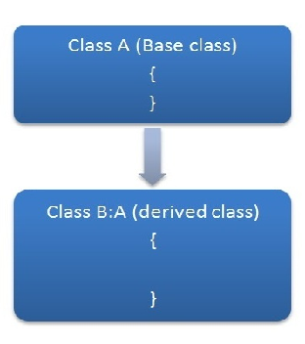Figure 1: Single inheritance. Source: www.c-sharpcorner.com
A simple example of a single inheritance could be:
using System;

namespace Inheritance
{
public class Animal
{
public void whatamI()
{
Console.WriteLine("I am an animal");
}
}
public class Cat: Animal
{
public void iamCat()
{
Console.WriteLine("The type of animal i am is Cat");
}
}
public class Program
{
public static void Main(string[] args)
{
Cat kitty = new Cat();
kitty.whatamI();
kitty.iamCat();
Console.WriteLine("MEOW!");
}
}
}
The output is:
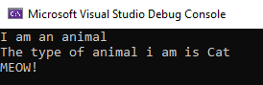
It can be seen how the derived class Cat inherits method from its parent class Animal.

2.2.2 Multilevel inheritance
In the multilevel inheritance one derived class inherits functions and attributes of a parent class, and also this child class becomes parent class for other class down the chain. (Kirti_Mangal, 2019)
The figure shows how child class B becomes the parent class for its derived class C. 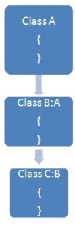
Figure 2: Multilevel inheritance. Source: www.c-sharpcorner.com

A suitable example of multilevel inheritance could be:
The output is: 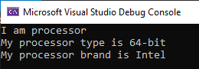
In the above code example, class Brand is inherited by its derived class Type. And Processor is derived class for class Type. This means that Brand is the superclass and the Processor and Type are the derived classes.

2.2.3 Hierarchical inheritance
In the hierarchical inheritance, one class becomes the parent class of more than one other class. This type of inheritance comes in use when a parent class has attributes or methods that can be used in more than one child class. (Kirti_Mangal, 2019)
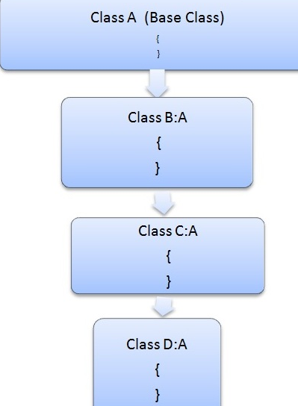Figure 3: Hierarchical inheritance. Source: www.c-sharpcorner.com

The syntax is as follows:
public class A
{
// Implementation
}
public class B : A
{
// Implementation
}
public class C : A
{
// Implementation
}
public class D : A
{
// Implementation
}
}

2.2.4 Multiple inheritance
In multiple inheritance, one derived class can inherit methods, functions, and attributes of more than one parent class. This type of inheritance is not supported by c sharp, but it can be implemented by using interfaces. (Kirti_Mangal, 2019)
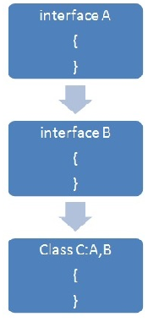Figure 4: Multiple inheritance. Source: www.c-sharpcorner.com
The syntax is as follows:
public interface A
{
// Implementation
}
public interface B
{
// Implementation
}
public class C : A, B
{
// Implementation
}
}

2.2.5 Important facts about inheritance in C sharp
- Private member inheritance – A child class does not inherit the private members of its parent class. However, if the parent class has properties (get and set methods) for accessing the private fields, then the child class can inherit them;
- Inheriting constructors – By default constructors are not members of its class, so during inheritance constructors are not inherited, just members and methods of a class can be inherited. But if a class inherited a class, then a constructor of the parent class can be invoked from its child class;
- Default superclass – In C sharp every class, except object class, has one superclass (single inheritance). If there is no superclass explicitly defined for a class, it is by default inherited from the object class. This means that every class is implicitly a subclass of object class;
- Superclass can only be one – There is no limit to how many subclasses a superclass can have. But every subclass can have only one superclass. This is a consequence of the fact that C sharp has no integrated support of multiple inheritance with classes. The multiple inheritance can be done only by using interfaces. (Kirti_Mangal, 2019)

2.2.6 Access modifiers
When speaking about inheritance, access modifiers are concepts that have to be taken into consideration. They are used to control the visibility of class members. By using them, we can achieve encapsulation, which ensures that critical data will remain hidden from the users at places where this is compulsory. This can be done by declaring a field or fields as private. C sharp has the following access modifiers:
- public – The code can be accessed from all other classes;
- private – The code can be accessed only within the same class;
- protected – The code is accessible within the same class, or from a class that is inherited from that class;
- internal – The code is only accessible within its assembly, but not from another assembly. (W3Schools, n.d.)

2.2.7 Advantages of inheritance
The following results are part of the results that can be achieved when using inheritance:
- Code redundancy.
- Code readability.
- Code reusability.
- The code becomes easy to manage.
- It divides large codes into smaller pieces. (EDUCBA, n.d.)

Part 3: Testing
Testing is a vital part of the Software Development process. It ensures whether the software application meets the requirements or not. The following three testing models will be taken into consideration and compared to each other:
- Waterfall model – It is invented in 1970 by Winston Royce. This model covers multiple stages, flowing progressively downwards:
- Requirement, gathering, and analysis;
- System design;
- Implementation;
- System testing, deployment, and maintenance.
This model is useful when the requirements are clear and the resources are available. It is simple and easy to understand, easy to manage and suitable for small projects. The test is performed at the end of the development cycle
- V model – It is an extension of the waterfall model. The approach of the execution is V-shaped. It is performed into three phases:
- Verification;
- Coding;
- Validation.
It is more beneficial and cost-effective than the waterfall model. The testing is performed in each development phase. Also suitable for small projects.
- Spiral model – this model incorporates iterative and systematic approach. Its four phases are:
- Planning;
- Risk analysis;
- Engineering;
- Evaluation.
This model Can be used when the requirements are not clear. Expensive. Unlike the previous two, this model is suitable for large projects. (Software Testing Help, n.d.)

Bibliography
EDUCBA, n.d. EDUCBA.com. [Online]
Available at: www.educba.com/advantages-of-array/
[Accessed 02 September 2020].
EDUCBA, n.d. EDUCBA.com. [Online]
Available at: https://www.educba.com/inheritance-in-csharp/
[Accessed 17 July 2020].
Kirti_Mangal, 2019. C# Inheritance. p. 1.
Software Testing Help, n.d. SoftwareTestingHelp.com. [Online]
Available at: https://www.softwaretestinghelp.com/software-development-testing-methodologies/
[Accessed 07 July 2020].
tutorialspoint.com, n.d. tutorialspoint. [Online]
Available at: https://www.tutorialspoint.com/csharp/csharp_arrays.htm
[Accessed 02 September 2020].
W3Schools, n.d. W3schools.com. [Online]
Available at: https://www.w3schools.com/cs/cs_arrays.asp
[Accessed 19 July 2020].
W3Schools, n.d. W3Schools.com. [Online]
Available at: https://www.w3schools.com/cs/cs_access_modifiers.asp
[Accessed 02 September 2020].

