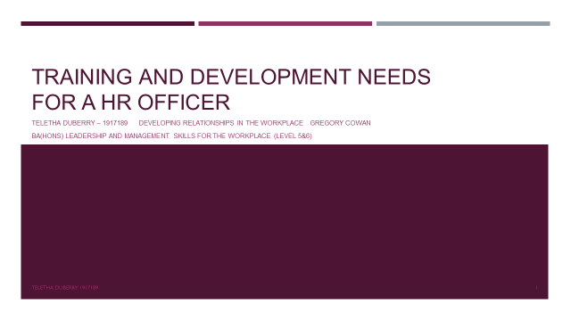

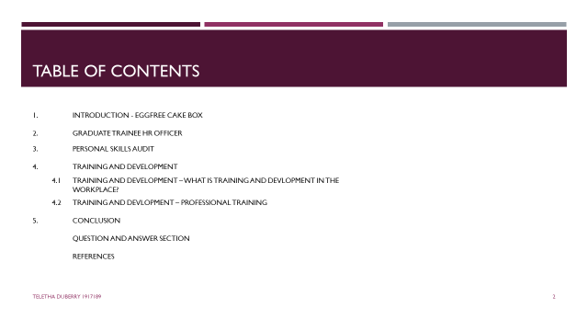

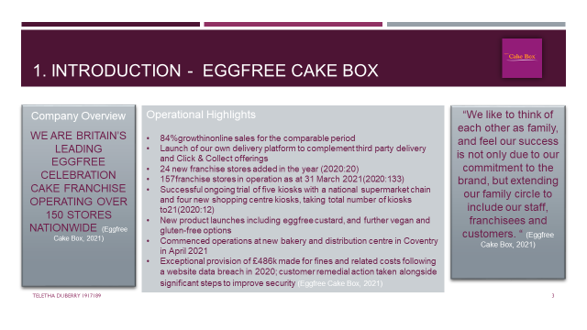
Eggfree Cake Box is Britain’s leading fresh cream and eggfree cake brand. Founded in 2008, they have managed to remain consistent with their celebratory cakes, serving customers with a unique recipe also catering to vegan and gluten free dietary requirements. They are currently operating from 3 distribution centres who provide for over 150 franchises as well as 21+ kiosks across shopping centres and supermarkets in the UK.
Ran like a family orientated business, Cake Box appreciates the hard work of their staff and believes that the organisations success is a result of their commitment and teamwork. This became very evident throughout the Pandemic, as staff within the head office, distribution centres and franchises worked extremely hard to ensure that their mission remained sustainable. This included implementation of new safety measures across head office, franchises and most importantly distribution centres.

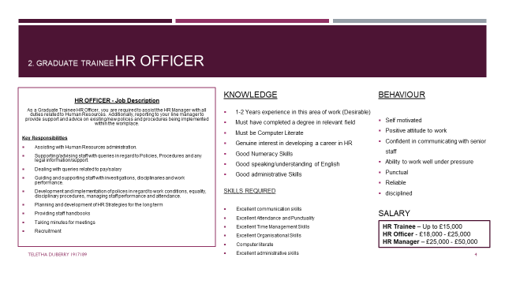
Here at Cake Box, my role as a Trainee HR Officer is to assist the HR Manager and report to my Line Manager. In the HR department our daily tasks consist of administration, where we manage payroll, employee records etc. it is important that we have knowledge on existing and new policies and procedures relevant to the workplace, as it is our role to provide staff and employees with support, advice and guidance.
Quite often general information on policies and procedures, as well as legal information and support is requested by employees, which is also provided in the staff handbooks that we in HR prepare and provide. Additionally, staff and employees can rely on HR to give them advice/support with things like workplace investigations, disciplinaries and grievances. In nature of these issues it is important to revise the workplaces polices in regards to values, beliefs, attitudes and behaviours, so we can better manage staff performance including work conditions, wages/salaries and other circumstances.
As an HR Officer, It’s important for me to develop planning strategies to accommodate staff and employees over a long period, by ensuring that the organisation is looking at staff training and development from the initial recruitment stage.

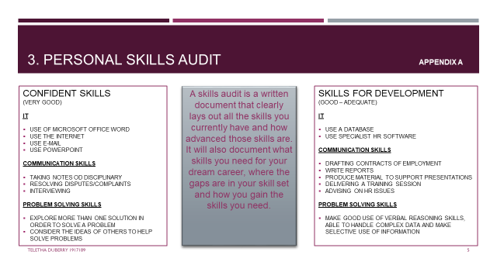
As a Graduate Trainee HR Officer I believe I am well suited to the role however, it is in my due diligence to further develop my skills, so that I can eventually progress to a more senior position and a higher salary. To identify what support and training I require, I completed a Personal Skills Audit where I rated my skills from Very good – Little or no experience, in regard to various functional areas in the workplace.
According to (Jobwise UK, 2017) a Personal Skills Audit requires you to give thought to your skills and make a list. After completing the list, you can now decide the level of each skill and anything that may be significant should be added to your CV immediately as well as any other recruitment profiles.
A full skills audit is recommended annually, and keeping an update of your development and additional skills.
After analysing my skills audit, I see that the areas I am adequate in is using a database and using specialist HR software. This is an area that I will need further training and development in, as this is my first time being introduced to this software. On the contrary my basic IT skills and knowledge of Microsoft Office programs are excellent. I am a great listener which enables me to take notes/minutes at meetings as well as dealing with disputes and complaints. As a fast learner, I am in no doubt that with the right training I will be able to develop my existing skills as well as new skills due to my passion in the HR sector.

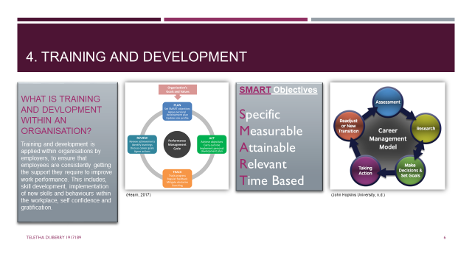
Training and development is applied within organisations by employers, to ensure that employees are consistently getting the support they require to improve work performance. This includes, skill development, implementation of new skills and behaviours within the workplace, self confidence and gratification.

One way to approach this process is by creating a Performance Management Cycle. Strategically structured as a four step process that motivates employees to develop in their required areas, this approach in training and development aligns employee objectives with organisational ojectives . This cycle allows flexibility and can be used consistently until employers and employees are satisfied with the progress being made.

Plan – Employees are expected to set SMART objectives, create a PDP with employer and review employee job role.
Act – Employees are expected to achieve the SMART objectives whilst fulfilling the agreed job role and intergrating the PDP.
Track – Whilst in the ‘Act’ progress should be getting tracked and reviewed, additional guidance and training support should be implemented if required and some feedback from employers to employees is expected to ensure that employees are on track.
Review and Reward – At this final stage, employers and employees will review the process and agree on what goals have been achieved, any knowledge gained, career goals and final actions required to move forward.

A second way to approach training and development is by using a career management model. This five step process is a more personal analysis for employees.
Assessment of personal chararcter – skills, hobbies/interests, strengths and weaknesses
Researching desired career/job opportunities
Make Decisions after clear assessment and set goals that are obtainable
Taking Action entails what is needed to make these goals obtainable, this can consist of applying to study the relevant course to get the required qualification. Additionally, creating or amending your CV for job applications etc.
Readjust or New Transition – Review the process to see if the goals set were obtained to progress in your career, if not you may need to re-evaluate and re-adjust and start the process again.

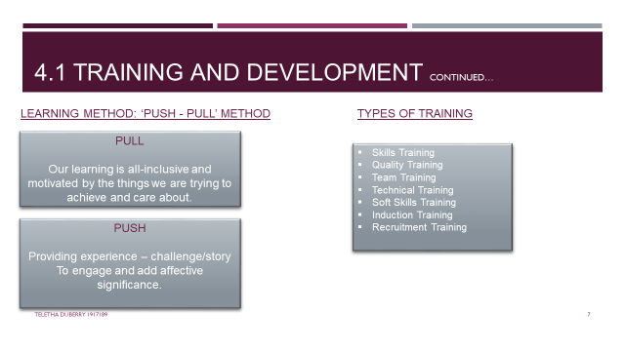

According to (Shackleton-Jones, 2019) Push-Pull method reflects a more realistic approach to learning. This method suggests that as an individual we do not encode knowledge in our memory, but instead emotional patterns are encoded via our experiences and later used to reconstruct new experiences.
From a learning perspective, it is important that we are not a blank canvas, the things we react to are somewhat nature and primarily nurture.
In this case, it will be effective for Cake Box to create a training and development course that consists of shadowing the HR Manager whilst on a 6 month probationary period. This will include the Personal Skills Audit being revised and Personal Development Plan being created to assist with goals and targets over the next 6 months. Within these 6 months, various types of training will be given to assist the trainee’s development, such as skills training, quality training, team training, IT/Technical training, soft skills training, induction training and recruitment training. At the end of the 6 months, the trainee will be reviewed and considered for a more senior position based on their work performance and more importantly their knowledge, skills and behaviour (KSB). Alternatively in the event that the trainee does not meet all targets, the probation period could be extended to allow some more time to focus on areas of weakness. Additional training and development can assist this also…
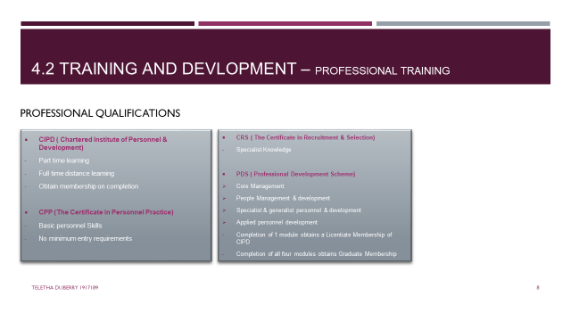

Training and Development in HR is essential within an organisation and contributes to overall organisational performance, especially when working towards financial targets. As technology is evolving, employees are quicker becoming reliant on IT systems and using less skill to fulfil their job roles. However, manpower still plays a major part in efficiency, and will continue to separate a company’s effectiveness in customer service and work performance, from others.
Organisations will find that creating opportunities in training and development internally, will be cost effective and allow employees who are already familiar with the organisational culture, to progress comfortably.
Although most HR Trainee Officers are expected to have a degree in HR, it is also encouraged that they work towards a professional qualification.
The Chartered Institute of Personnel & Development (CIPD), The Certificate in Personnel Practice (CPP), The Certificate in Recruitment & Selection (CRS) and Professional Development Scheme (PDS) are four professional qualifications organisations should be encouraging and supporting their employees to work towards in HR.

As well as training and development in the workplace, it would be beneficial for Cake Box to encourage and support me as a HR Trainee Officer, in becoming more efficient in my job role, so that I can progress further in my career. The process of obtaining professional qualifications will help me to build my confidence, gain further knowledge and apply new skills and jargon to my current job role. In addition, becoming a CIPD member will open new opportunities for me including a higher salary and professional credibility. I will have the option of studying Part time or Full time via distance learning, which will still allow me to receive training and development in the workplace, with maximum efforts being applied to my personal and career development, I am positive that I will progress to a Senior HR Officer and be an asset to my team.

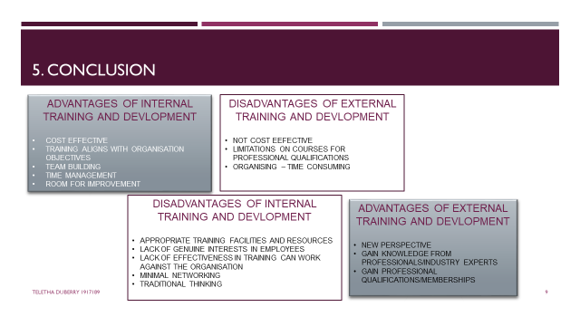

To Conclude, we have identified the importance for training and development in HR and how this contributes to a major part of an organisation.
The option of Internal or External training is available for the HR Manager to apply within the department, and this will be subject to training budgets, facilities, resources etc. both have their advantages and disadvantages and are just as beneficial, depending on the nature of the business,aims and objectives. I would recommend that HR explore various ways in which training and devlopment methods can be applied, to make it more interesting and motivating for employees, as this will assist in the success of the organisation.
As Cake Box operates in the food industry, my job as a HR Trainee Officer is based in the Head Office where we mainly focus on technical operations rather than customer facing. Therefore, internal training will allow for building of work relationships in my department, organised and structured daily training activities and intergration of Cake Box’s organisational culture. Additionally this will be beneficial, as there are available facilities and resources onsite to assist me in my development, which will save on costs and in the process it will also highlight any areas that may need improving within the HR department. This can lead to an improved training and development programme for future employees.
As suggested earlier, I can shadow the HR Manager over a 6 months probationary period, which will be up for review once completed, where I will receive feedback on my development based on targets being met. This will determine my progression on to becoming a Senior HR Officer.

References

Eggfree Cake box, 2021. Annual Report 2021. [Online]
Available at: https://investors.eggfreecake.co.uk/wp-content/uploads/2021/08/Annual-Report-FY21-Final-1.pdf
[Accessed 24 November 2021].

Hearn, S., 2017. Clear Review. [Online]
Available at: https://www.clearreview.com/stages-of-performance-management-cycle/
[Accessed 29 November 2021].

Jobwise UK, 2017. Personal Skills Audit. [Online]
Available at: https://www.jobwise.co.uk/personal-skills-audit/
[Accessed 28 November 2021].

John Hopkins University, n.d. Career Managment Model. [Online]
[Accessed 29 November 2021].

Shackleton-Jones, N., 2019. How should a corporate learning organization be organized?. In: How people learn : designing effective training to improve employee performance. s.l.:Kogan Page, p. 286.

