Marcell Szloboda
Student ID: 1909475
University of Wales Trinity Saint David
Professional Career Development
Lecturer: Hossein Shokri

Table of content:
1. Introduction
2. Goals
3. Personal action plan
4. Skills
5. Reference list

1. Introduction: -studies and employment
My name is Marcell Szloboda. I will present my previous studies and work experiences, moreover I will introduce my goals and plans for my future.
I came from South Hungary. I have graduated in II. Ferenc Rákóczi Secondary Grammar School from an IT class in 2016. I handed my application to an economical university called Faculty of Economics, University of Szeged (Hungary), however, I did not reach the minimum marks which came from my last 2 years. Eventually, I had an opportunity in my high school; they offered a course where I had chance to learn more about logistics and transportation. It was a very complex course, and I learnt about law, transportation management, marketing channels, communication strategies, space utilization and a lot of mathematical calculations. In the beginning I did not realise how many opportunities are front of me. I took this 2-year period very seriously and greatly enjoyed learning about Logistics management; I could imagine myself in this sector in the future.
During this period, I was working in Tesco Ltd. Kiskunhalas as a cashier, picker, and general customer service. I could manage my time between lessons and work, which payed off. I was simultaneously a good student and a good worker. My role was to greet customers and direct them to the correct instore section, to mediate customer complaints and to increase store loyalty. I always had a great relationship with my colleagues even from other departments. It was a good experience, because I had insight into working in a big warehouse. I could understand what I was studying on a deeper level due to my first-hand experience, and I think this further spurred my interest. I always went to work with large curiosity, I always learnt new things and it was good for my employer, because I was multifunctional and motivated. Basically, it was my first official job and at that time it was honoured, because it was rare to find a job at that age. I always provided the highest customer satisfaction with my performance, personality and efficacy.
In 2018 summer, I successfully became a Logistic and Transportation officer. I was an entrant in logistic sector, which meant I had to start look for a job, because I did not want to continue my studies. Firstly, I tried in my hometown with many logistic companies without any success. I found some interesting jobs around Hungary, so I went for interviews. It was disappointing that I never got any response from them.
In September, I decided to move to London and further increase my experience and enjoy living in a different culture. I found a job agency, where I could immediately start to work. They distribute people all over London in hotels, bars, restaurants, supermarkets. In the beginning I was in different hotel almost every day. After a few weeks, a hotel in Green Park called Holiday Inn gave me a regular rota, where I was a breakfast waiter and bar back, however I had a fixed contract and this job wasn't enough to support myself, so I continued to apply for more jobs. In a short time, I got another job for the afternoon; it was in Earl’s Court Ibis Hotel, where I helped with banqueting. I had lot of working hours and after a while it was too mentally and physically exhausting, so I decided to find one job which payed enough to support myself but wouldn’t take all of my time. At that moment, I lived in North London in the 3rd zone, and there was a restaurant called Five Guys. I performed excellently on my trial shift, so they gave me a contract. They proposed me with a full-time contract, but I never had the full timer’s hours. I decided to remain there, because I found it a very interesting job, but only for part time. We had a “crew” and went to events to build screens, stages or help in some warehouses such as Wimbledon, British Got Talent, in BBC and many film studios. These 2 jobs matched very well, I was very flexible with my hours.
After 8 months I decided to relocate and at the same time I changed my job. This is the job that I am still currently doing; I am a maintenance assistant in a 5- star hotel in Green Park, Flemings Mayfair Hotel. My friend offered me this job, however I did not have any experience in this sector, so I had to learn a lot with patience. After one year I am very confident even if I need to work alone. I have learnt many practical solutions, furthermore I learnt how to how to deal with complains, how to be more confident with guests in order to deliver a 5- star quality.
I have lived in London for almost for 2 years. I dare say I learnt a lot about life, met with many different people, made new friendships, tried different jobs. Originally my plan was to come to London, work here and use the money I earn to allow me to travel. As the time passed by, I realised I can do something more, so I applied for the university and I started to learn another language.
2. Goals: -short/ long term goals
Goal is an idea of the future or desired result that a person or a group of people envision, plan and commit to achieve (Locke, Edwin A.; Latham, Gary P. (1990). In my future it is still one of my goal to travel, discover new places, but I have to balance it with my personal development. My dream position is called procurement manager or even a logistic manager. I am always open to new experiences and I think this is the best time for me, because I am still 23 years old with lots of opportunity and willingness to learn.
My future goals according to my career are to learn languages, work in a high position in a logistic company and I would like to run some businesses, for example holiday apartments such as AirBNB and open a beach club. For short-term goals, I would classify my studies and get my foot in the door of a Logistics company where I can learn new skills.
Short term: My destination is shift manager or logistic manager. First of all I need to get into the logistic business, which means I can start to work in a warehouse. In the warehouse I can easily reach a shift manager position within few months regarding my qualifications. From this position I will receive more and more responsibilities, but if I prove that I am reliable and precise I can reach a higher or specified position, probably within 1-5 years.
Long term: Start a small business as a holiday apartment to rent, expand it over time. Later open a beach club and collaborate with the apartments. Continuous development, improving the business for the better service.
3. Personal action plan:
Here I will explain which skills and knowledge I need to learn in order to achieve my goals. Creating an action plan based on awareness, values, reflection, goal-setting and planning for personal development within the context of a career, education, relationship or for self-improvement (Chinoperekweyi, Justine 2017).
As I mentioned in my short term goal I would like to reach a position such as Logistics Shift Manager. Key responsibilities of the Shift Manager role include:
- An ability to cover all elements of the Shift Manager role
- A good working knowledge of operational and administrative procedures at depot level
- An ability to work within set KPIs, including Transport, Health and Safety and ISO
- Execute a team to have outstanding customer service
- Attending at DQA (Daily Quality Assessment) meetings to review product quality
I need to learn the basic responsibilities for the role of manager:
- Daily operation: activities that an undertaking and its workers perform each day to make a benefit and improve the intrinsic interest of the undertaking as a concern
- Set goals: plans for the short, mid, long term. It is necessary to have, because it can be focused on to achieve a target.
- Liaising: Although a manager usually manages a group of workers, they must interact actively with their superiors to relay the information they need to the respective parties.
- Administration: managers complete the organisational work and communicate with other programmes.
- Delegate: effective managers trust their staff and delegate tasks according to the needs of the department.
- Motivation: very important to motivate employees and create an environment where people are satisfied and strive.
- Enforcing policy: managers implement company policies to create an atmosphere that contributes for their acts by workers.
- Training: managers need to train their employees if new system or technology are introduced
4. Skills:
As a manager I have to learn conceptual leadership strategy, communication, stress management, coaching and collaboration skills.
Conceptual leadership skills: A leader must proactively think ahead, have vision, perspective on the company. At the same time, the planning and management of operational processes and the elimination of unexpected situations are also among the management tasks.
Here are some specific leadership skills that belongs into this group.
- Strategic approach: allows the company based on information surrounding socio-economic environment, set up a good lead in the overall picture. And then develop the company's strategy based on this.
- Planning: the leader must to calculate in advance the most important trends, events, processes.
- Decision making: The method of making choices in the decision-making process, gathering evidence and the analysis of possible resolutions. A decision-making method step by step will help to determine more conscientiously and thoughtfully by arranging key facts and identifying alternatives.
- Problem solving: This helps to find an appropriate solution and discovers the source of the problem
- Time management: It is the way how you organise your time, what priority you set up between different activities.
Communication: Team leader has to know how to motivate and lead his/ her team, need to recognise with empathy when someone needs help. A good leader must set a personal example to the employees for example, when the leader joins to the work.
Furthermore empathy, willingness to compromise, ability to motivate others still belongs to communication. A vision based on empathy also helps to make compromises. A willingness to compromise is essential for managing conflict and creating a collaborative workplace culture. The leader has to find the balance between the two poles.
Stress management: It is important to recognise, first and foremost, the main reasons for an individual managing their stress to establish a successful stress management programme and to evaluate intervention strategies that efficiently address these reasons.
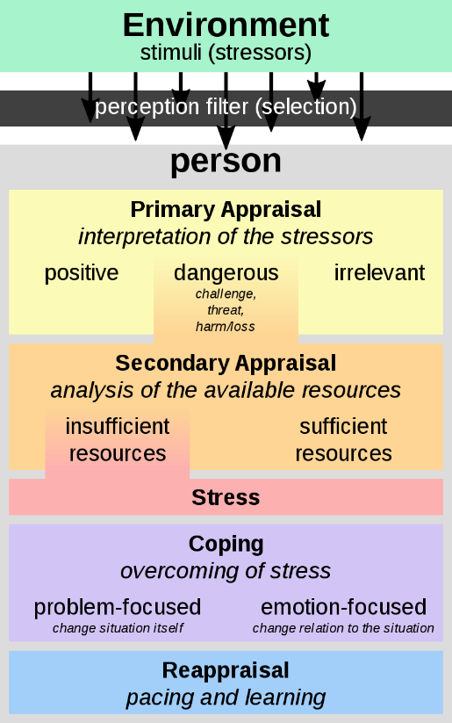
I used Richard Lazarus Transactional model to describe their work. One way of improving our relationship with stress is to understand some of the processes which underpin it, and how they influence the ways we try and cope. One way of understanding this is through the transactional model of stress and coping (Lazarus, R.S. and Folkman, 1984). It is focusing on individual interactions and their external environment. The approach says that stress will not be stressful if the client doesn't see the stressors as a challenge but rather as supportive or even challenging. It suggests that the anger control and anger management of people can be learned.

Coaching: it is a form of development in which an experienced person, called a coach, supports a learner or client in achieving a specific personal or professional goal by providing training and guidance (Passmore, Jonathan, ed. 2016). The meaning of this skill is to transport people where they are to where they wonder to be. It provides advice, motivation, support and feedback to improve people effectiveness.
Collaboration: the process of two or more people or organizations working together to complete a task or achieve a goal (Marinez-Moyano, 2006). It requires an appreciation of several viewpoints and the negotiation of interests from those in the community as a trustworthy team member.

5. Reference list:
Chinoperekweyi, Justine (2017). Exceptionality Without Relapse. Notion Press.
Lazarus, R.S. & Folkman.(1984). Stress, appraisal, and coping. Michigan. Springer Press.
Locke, Edwin A.; Latham, Gary P. (1990). A theory of goal setting & task performance.
Marinez-Moyano (2006) Exploring the Dynamics of Collaboration in Interorganizational Settings, Ch. 4, p. 83, in Schuman. Creating a Culture of Collaboration.
Passmore, Jonathan, ed. (2016) . Excellence in Coaching: The Industry Guide (3rd ed.). London.

