Contents

Briefing Paper Pages 1-2

Reflective Log Pages 3-4

Personal Development Plan Pages 5-7

Reference List Pages 8-9
Reflection is learning through everyday experiences (Johns, et al. 2013) and underpins the work of early years practitioners (Reed and Canning, 2010). Requiring one to think deeply and to question their personal and professional values and pedagogical practices (Moyles, 2010). Tarrant (2013) suggests that the person engaging in reflective practice should be the one who acquires the most from the experience and although (Lindon and Trodd, 2016) agree that practitioners will undoubtedly improve their own practice by engaging in reflective practice, they will consequently also improve outcomes for both the children and families in their care.

Action plan
Conclusion
Analysis
Evaluation
Feelings
Description

Reflections on Early Years Practice

Reflective practice enables practitioners to accept uncertainty, recognise when they don’t understand what is going on and consciously seek to find out (Bolton, 2014). Therefore, for those just setting out on their professional development, reflection is a crucial phase (Tarrant, 2013). However, with effective reflection needing practitioners to have an open-mind, take responsibility and not become complacent (Lindon and Trodd, 2016), it is also an opportunity for experienced professionals to reflect on their values and beliefs (Tarrant, 2013). Therefore, reflective practice needs to be an ongoing, continual process, rather than a temporary exercise (Brock, 2015).
Additionally, Dewey (1933, cited in Brock, 2015) believes that practitioners do not learn from experience alone but from reflecting on such experience, and the process of reflection can be developed through engaging in reading and research and developing knowledge and skills from such practical and personal experiences (Brock, 2015). Moreover, Brock (2015) further recognises that although it is important for practitioners to think and reflect effectively, it is vital that they purposely act on that refection.

Reflective practice can provide strategies to frame appropriate and searching questions (Bolton, 2014), and Johns, et al. (2013) suggest that there are several various models such as those by Gibbs (1988) and Kolb (1984), which all aim to support effective reflection, by encouraging practitioners to widely and deeply explore an experience. Which according to Lindon and Trodd (2016) can enable practitioners to consider questions such as:
- What were the children doing?
- How and what were they learning?
- Was it beneficial?
- What was your role?
- What did you learn?
- What will your next action be?

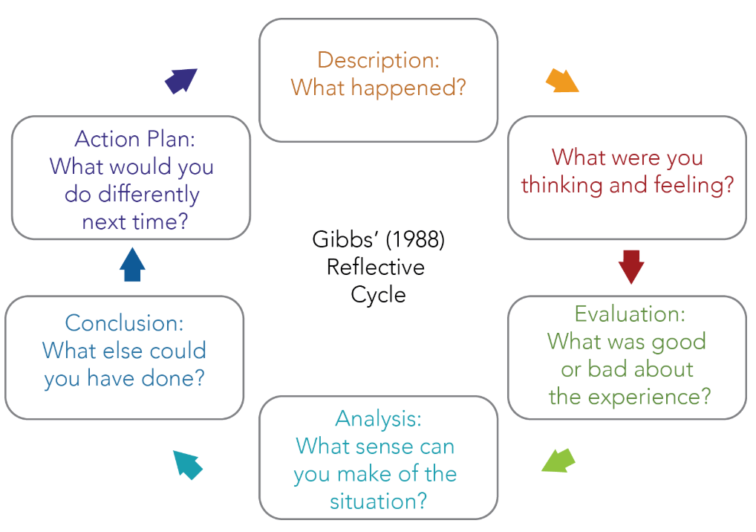

Source: University of Kansas (No Date).
Such questions allow practitioners to ﬁnd meaning in an experience and learn through it. Potentially responding in a more effective way when faced with a similar situation (Reed and Canning, 2010). Furthermore, Bolton (2014) explains that practitioners can use such models to reflect alone or additionally, with a colleague/supervisor for support, which, Lindon and Trodd (2016) suggest can provoke and extend reflection by sharing ideas and working together to evaluate activities, clarify a concept and solve problems, for example (Wild and Street, 2013).

Additionally, observations are also crucial to reflective practice and can enable practitioners to investigate, understand and develop children’s learning (Wild and Street, 2013). Hence the beliefs of Bubb and Earley (2010) that professional discussion and observation are the most effective forms of development for professional growth and change. Practitioners should also be willing to receive constructive criticism and learn from more knowledgeable and experienced others, for the benefit of their development and the children in their care (Lindon and Trodd, 2016).

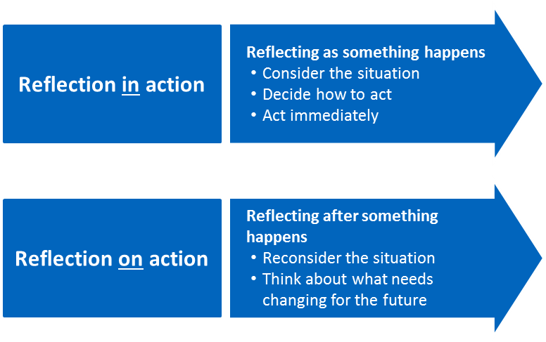
Reed and Canning (2010) consider reflection as a learning journey and Schön (1983 cited in Lindon and Trodd, 2016) recognised two main strands of reflective practice. One being the process of reflecting in-action, which according to Moyles (2010) is the instantaneous, intuitive response to children and the moment-to-moment, day-to-day thinking in the setting. This type of reflective practice can enable practitioners to consider if, when and how to support and intervene in children’s play for example (Wild and Street, 2013). The second being the process of on-action which typically happens after the experience, activity or event, and considers thinking and talking about what has happened, what went well, what could be done differently and why (Lindon and Trodd, 2016).

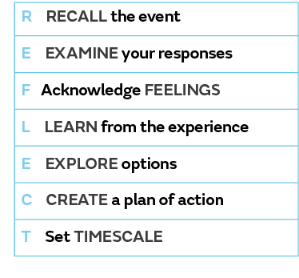
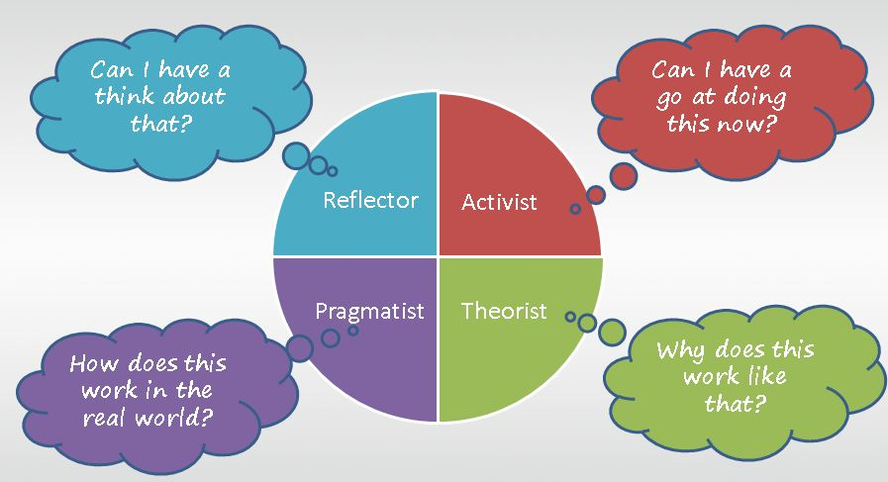

Source: Dental Protection (2018).
The ability to critically reflect will support practitioners to reconsider practice that is uncritical and standardised and to develop a more informed, imaginative and value-driven approach (Moyles, 2010). Accordingly, the implementation of the new curriculum in Wales (Donaldson, 2015) will require all practitioners to think about new or different ways to what and how they teach and consequently, the need to develop new skills and approaches (Welsh Government, 2019). Therefore, it is essential for all practitioners to be reflective in their practice (Hallet, 2013), to support children to become confident, ethical individuals in an ever-evolving world (Welsh Government, 2019).

Tarrant (2013) suggests that reflective practice enables practitioners to move from novice to expert by becoming more aware, in control and recognising one’s strengths and need for further development. Additionally, Hallet (2013) explains that knowledgeably confident, articulate and reflective practitioners, play a crucial role in establishing the ethos of their settings by continuously improving practice, promoting professionalism and evaluating government policy initiatives (Miller and Hevey, 2012). Consequently, supporting a long-term positive impact on children’s learning and achievements, by providing quality education and care (Nutbrown, 2012).

Source: DPG Community (2014).
Regardless of which models and strategies are used, the overall aim, according to Bolton (2014) is to use such strategies to question one’s attitudes, values, assumptions, prejudices, theories and habitual actions and as a result, McGregor and Cartwright (2011) suggest that becoming a reflective practitioner requires a wholehearted immersive approach to teaching, continuously developing ideas, techniques and materials that will interest, motivate and engage all children.

Source: Campus to Career (No Date).
It is important to recognise that one’s social environment, educational experiences, and basic cognitive structure will influence a preferred learning style (McLoed, 2017). Consequently, how one reflects and teaches is very much in regard to one’s personal and professional identity (Tarrant, 2013).

Source: Cambridge International (No Date).
McGregor and Cartwright (2011) suggest that documenting practice is also an important characteristic of self-reflection and the use of journals, diaries and reflective logs can further encourage practitioners to critically reflect and analyse one’s practice and provision, using questions such as, what, why, who, how, when and where (Hallet, 2013). This can help to clarify and document one’s thoughts, develop self-awareness (Brock, 2015), explore issues and dilemmas and consider one’s emotional and intellectual responses to challenges faced (Hallet, 2013).

Reflective Log
Brief description of the activity
The activity was to sit on the floor with a group of eight children to work on a thinking and talking floorbook, using a designated A3 scrap book, coloured pens and pencils.
Aim/Objective of the activity
The aim of the activity was to enable the children to take control of the thinking and contribute to the planning of the class theme which was ‘growing things’. Following a class discussion of the theme, the activity enabled the children to propose ideas of what they would like to be doing during the term, what they would like to find out and where they would like to go for example. Documenting their ideas in the floorbook by words, sentences and pictures.
Your role
My role in the activity was to encourage and motivate the children to participate, support their ideas and ask questions which would allow the children to share and develop their thoughts and ideas appropriately. I also needed to ensure that all the children had opportunities to participate, value the ideas of each child and offer support when needed.
I was also able to carry out observations during the activity and used post it notes to take notes, which were added to the floorbook, to support the class teacher for assessment and planning purposes.
Positive aspects – why?
Overall the children appeared to enjoy filling in the floorbook and were especially enthusiastic about offering their own ideas of what they wish to do, see and be taught for the new theme.
The children can gain self-esteem and feel valued when adults listen to and accept their ideas and opinions and allow them to share their ideas and interests in a way that is important and individual to them and their learning style and cultural experiences.
The activities that the class teacher and I were able to plan for the theme were child-led and by putting up a copy of the completed floorbook page on display, the children had great satisfaction and pride from seeing their ideas come to life.
Challenging aspects – why?
Allowing the children with enough time to think was sometimes challenging as the time I had to complete the task was limited. Furthermore, maintaining their concentration was also occasionally challenging due some children having to wait their turn to draw/write in the floorbook.
Due to the activity being carried out on the floor, many children wanted to lay on their stomachs to write and therefore, space for all to fit comfortably around the A3 scrapbook was limited, this also contributed to the occasional loss of concentration with the task.
What knowledge was demonstrated?
I was able to recognise the importance of children’s contribution to their learning and my role in supporting them to achieve that.
I was able to recognise when children needed more support to write down their responses without taking over and doing it for them. Supporting them enough to enable them to write independently or draw what they wanted to write instead, valued their contribution.
What skills were demonstrated?
At several points during the activity, I was able to motivate all the children in the group to contribute, and accepting their ideas allowed them to feel valued, which in turn will raise their self-esteem.
I was able to ask questions that were not too complicated. I also asked open-ended questions such as, how do you think we could….? Or what would you like to….? Helping the children to develop their ideas and to think about whether their ideas were realistic and possible, without making them feel self-conscious.
Which values were demonstrated?
During the activity, I continuously found opportunities to give positive facial expressions, eye-contact and praise all the children regardless of their level of input. This was done with the aim of ensuring that each child felt that their idea or contribution was valuable and appreciated, which consequently can help to raise their self-esteem.
I was also able to recognise when a child was uncomfortable answering, not pushing the children who were reluctant to contribute, but encouraging them. Offering them time to think when possible and supporting them with initial ideas, without drawing attention to them or making them feel pressured to answer.
What could have been improved on or done differently? Why?
As this was the first time I had carried out this activity with the children, I felt that I had needed more understanding of the best way to use the floorbook and the benefits they offer. I have since taken out a book on ‘Thinking and Talking Floorbooks’ from the library and researched on the internet also. This has enabled me to have a better understanding of its purpose and my role in supporting the children to get the most out of it next time.
I became aware that although the children were grouped according to literacy and numeracy ability. When it came to oral contribution, the grouping differed greatly. For example, some children that have some difficulty with writing and reading, offered fantastic in-depth ideas and knowledge to the activity. Therefore, for future floor book activities, I would mix the groups which will also allow the children to work alongside children they may not often get to work with.
Should a child be reluctant to verbally participate, it may be beneficial to have some visual aids associated with the topic/theme which may give them ideas to offer or to simply point at a picture.
On reflection, I also felt that completing the floor book with a smaller group could allow for a more focussed discussion, maintain better concentration and encourage the less confident children to participate. Furthermore, providing them with more space to write and draw.
The diversity of a thinking and talking floorbook means it can be adapted and used with children of all ages with careful thought and furthermore, be used both indoors and outdoors.
The floorbook we used had a plain black cover and I felt that if the children were to decorate and design the cover, it would further enable them to take ownership of the book and have pride in it.

Personal Development Plan
Area for further development | Why? | How? | Who/Where? | When?
- Knowledge  I wish to complete the level 2 essential skills in both communication and application of number. | Having left school with few GCSE’s due to difficult circumstances at that time, I have been restricted in the employment opportunities I could apply for. I will need to gain these qualifications for potential future employment reasons and to enable me to potentially apply for a future postgraduate course should I wish to. | Further to the initial assessment, which I recently completed, I am able to sign up to attend several classes and also study independently in preparation for the necessary level 2 test. | I will need to contact the relevant persons at Agored Cymru, who run the courses and tests in an adult learning centre in Swansea, to check on when the tests are scheduled for and whether it is possible for me to complete them in the desired time frame. | I would have liked to have completed these tests before July 2019, however the classes clashed with my university lectures. I may need to wait until July 2020 or later if a course on another day can’t be found.
- Knowledge  Finish the Early Childhood education and care degree to a good standard. | Having always wanted to study for a degree but always believed that I was not academically capable, I put off applying for many years. Since completing the first year and have achieved marks that I never dreamed I could, I now have the desire to continue to do well for my own confidence and self-worth and also to gain greater knowledge in supporting the children I work with. | By continuously learning from mistakes and feedback and to research and read relevant resources as much as possible. Challenging myself to continuously improve. | Continue to use the available resources at UWTSD library and ask lecturers for support and guidance when needed. | I hope to complete the degree in the expected time frame which is by July 2020.
- Skills  Although I have previously completed several conversational Welsh language courses, I wish to develop my ability to speak Welsh further and with more confidence. | Most employers in Wales seek Welsh speaking employees and therefore, speaking welsh to a good level can aid employment prospects. Additionally, with the Welsh Government (2018) aim of having a million Welsh speakers by 2050, developing my Welsh language further will enable me to support the Welsh language development of the children I work with. | I believe that my lack of confidence in speaking Welsh to fluent Welsh speakers is an additional factor which hinders my progress and is something I need to overcome, as the best way to learn is by doing. Therefore, by speaking Welsh with more able others will enable me to improve. A higher-level course would also be beneficial. | I will need to ask a more confident welsh speaker such as a colleague at work or my welsh speaking children at home, to allow me to speak welsh regularly to them. The aim will be that they can support my confidence and development by correcting my mistakes and modelling the language. | This is something that needs to be a continuous process in order to achieve success of speaking Welsh at a higher standard.  The higher-level course is something I would like to complete when my current studies end.
- Skills  Further develop my understanding and awareness of the effects of adverse childhood experiences (ACE’s) in order to apply that knowledge further. | I have always been passionate about child protection and the well-being of children. I have recently attended ACE training and believe it is something that all persons working with children should be aware of. Recognising that any child in our care could be suffering yet we may be fully unaware, makes it even more important to understand. | I always make it my aim to treat all children with compassion and care but now that I have a better understanding of what ACE’s are, and the impact they can have on children throughout their lives. I plan to research it further and gain an even greater understanding of how to help children to know their worth and value. | Research and continue to read literature both new and already aware of.  Look online and/or ask my manager if there are any further training opportunities and if so, apply for the course. | Revisit the literature I was given as a continuous reminder.  Further training could be completed over the next few years.  Support for the children in my care will be ongoing.
- Values  Learn to accept that not everything needs to be perfect and done my way. | Being a perfectionist means I often put too much pressure on myself or expect others to do things a certain way. This can prevent me from allowing others to help me in a task, and also causes me to be much slower at getting tasks done. | Over the years I have already begun to understand the importance of and appreciate the benefits of allowing children to do things their way. I plan on gradually allowing others to help me get things done, be more spontaneous and recognise that perfection is rarely achievable or necessary. | Working alongside others who have made me aware of seeing everyone as individuals and how we all have our unique ways, has already helped.  Studying an early years  degree is also helping me to understanding the benefits of child-led play. | This is something I need to reflect on continuously and will be ongoing.  Continuing to give myself deadlines to complete tasks will also be beneficial.

- Values  Recognise my own worth. | Not believing in myself or my capabilities has held me back significantly. I love to see others happy and like to praise and boost the self-esteem of others but find it difficult to do so to myself. I am aware that being negative and self-conscious around children could contradict what I say to them and often children do as you do and not as you say. Therefore, I would like to develop my own self-confidence. | Make a list of all the things I have achieved or done well and overcome. Write down positive things people say about me and read it regularly.  Continue to challenge myself professionally and personally. | This can be done anywhere and during work or at home. Learning to positively accept constructive criticism also.  I am fortunate to have a great support network who continue to tell me my worth and wish that I would see it in myself. | This again is something I need to reflect on continuously and will be ongoing with the support of others.
- Other  Learn basic words in languages appropriate to the children in my care with English as an additional language. | Following the research and reading I undertook when completing the human development handbook. I became conscious of the difficulties some children face during transitions especially those who do not speak the language of the school. Therefore, being able to offer basic, common words to the children will help them to feel valued and welcome and ease transition. | Using foreign language dictionaries, google translate and visual aids.  Asking the parents for pronunciations if possible, will also help them to feel valued and welcomed also. | Visual aids and pictures can be used in the setting with the child/children. Can ask older children in the setting who speak the same language to help with pronunciations also. Reading material and appropriate websites to help with basic words can be used at home. | The need will be dependent on whether there are children with EAL in the setting which has increased significantly over the years, particularly children with Polish as their first language. Therefore, the need will potentially be ongoing, and progression will enable me to learn more basic words.

References:
Bleach, J. (2014) Developing professionalism through reflective practice and ongoing professional development. European Early Childhood Education Research Journal. Vol. 22, No. 2, 185–197, http://dx.doi.org/10.1080/1350293X.2014.883719 (Accessed: 25th May 2019).
Bolton, G. (2014) Reflective Practice. (4th Ed.). London: Sage.
Brock, A. (2014) The Early Years Reflective Practitioner Handbook. London: Routledge.
Bubb, S. and Earley, P. (2010) Helping Staff Develop in Schools. London: Sage.
Cambridge International (No Date) Getting Started with Reflective Practice. Available at: https://www.cambridge-community.org.uk/professional-development/gswrp/index.html (Accessed: 5th June 2019)
Cambridge International (No Date) Reflective On-Action Image. Available at: https://www.cambridge-community.org.uk/professional-development/gswrp/index.html (Accessed: 12th June 2019)
Campus to Career (No Date). When, How, Why Image. Available at: https://campus-to-career.com/2012/08/07/leadership-lessons-the-5-ws/ (Accessed: 13th June 2019).
Cottrell, S. (2015) Skills for Success, Personal Development and Employability. (3rd Ed) London: Macmillan Publishers Limited.
Dental Protection (2018). Seven steps Image. Available at: https://www.dentalprotection.org/ireland/publications-resources/articles/article/reflection-and-risk-management (Accessed: 13th June 2019).
Donaldson, G. (2015) Successful Futures. Available at: https://gov.wales/sites/default/files/publications/2018-03/succesful-futures-a-summary-of-professor-graham-donaldsons-report.pdf (Accessed: 11th June 2019).
DPG Community (2014). Learning styles Image. Available at: https://community.dpgplc.co.uk/blog/honey-and-mumford-learning-styles-a-simple-picture (Accessed: 13th June 2019).
Finlay, L. (2008) Reflecting on ‘Reflective practice’ Available at: https://www.open.ac.uk/opencetl/sites/www.open.ac.uk.opencetl/files/files/ecms/web-content/Finlay-(2008)-Reflecting-on-reflective-practice-PBPL-paper-52.pdf (Accessed: 4th June 2019).
Hallett, E. (2013) The Reflective Early Years Practitioner. London: Sage.
Hargreaves, J. and Page, L. (2013) Reflective practice Massachusetts: Polity Press
Hawkins, S. and Park Rogers, M. (2016) ‘Tools for Reflection: Video-Based Reflection Within a Preservice Community of Practice’, Journal of Science Teacher Education, 27(4), pp. 415–437. doi: 10.1007/s10972-016-9468-1. (Accessed: 7th June 2019).
Johns, C. et al. (2013) Becoming a reflective practitioner. (4th ed). West Sussex: John Wiley & Sons
Lindon, J. and Trodd, L. (2016) Reflective practice and early years professionalism. (3rd Ed) London: Hodder Education.
Maellaro, R. (2013) ‘The Learning Journal Bridge: From Classroom Concepts to Leadership Practices’, Journal of Leadership Education, 12(1), pp. 234–244. doi: 10.12806/V12/I1/234. (Accessed: 4th June 2019).
McGregor, D. and Cartwright, L. (2011) Developing Reflective Practice. Berkshire: Open University Press.
McLeod, S. (2017) Kolb's Learning Styles and Experiential Learning Cycle. Available at: https://www.simplypsychology.org/learning-kolb.html (Accessed: 7th June 2019).
Miller, L. and Hevey, D. (2012) Policy Issues in the early years. London: Sage Publications.
Moyles, J. (2010) Thinking About Play: Developing a Reflective Approach. Milton Keynes: Open University Press.
Nehyba, J., Švábenský, V. and Ukrop, M. (2018) Reflective Diary for Professional Development of Novice Teachers. Available at: DOI: 10.1145/3287324.3287448 (Accessed: 10th June 2019).
Nutbrown, C. (2012) Foundations for Quality. The independent review of early education and childcare qualifications. Available at: https://assets.publishing.service.gov.uk/government/uploads/system/uploads/attachment_data/file/175463/Nutbrown-Review.pdf (Accessed: 25th May 2019).
Reed, M. & Canning, N. (Eds) (2011) Reflective Practice in the Early Years (2nd Ed) London: Sage.
Tarrant, P. (2013) Reflective practice and professional development. London: SAGE Publications Ltd
The University of Kansas (No Date) Gibbs’ Reflective Cycle Image. Available at: https://csl.ku.edu/reflection-models#gibbs (Accessed: 12th June 2019).
UNCRC (no date) A summary of The UN Convention on the Rights of the Child. Available at: https://downloads.unicef.org.uk/wp-content/uploads/2010/05/UNCRC_summary-1.pdf?_ga=2.106078982.462546560.1560302992-765864174.1558015181 (Accessed: 10th June 2019).
Venninen, T., Leinonen, M., Ojala, M. and Lipponen, L. (2012) ‘Creating conditions for reflective practice in Early Childhood Education.’ International Journal of Child Care and Education Policy, 6:1, pp.1-15. https://ijccep.springeropen.com/articles/10.1007/2288-6729-6-1-1
Warden, C. (2006) Talking and Thinking Floorbooks. Perthshire: Mindstretchers
Watson, S. (2017) Why Should Children Lead their Learning? Available at: https://treeof.com/blog/2017/10/25/why-should-children-lead-their-learning-by-mindstretchers/#.XQQK2NNKi1v (Accessed: 9th June 2019).
Welsh Government (2018) Cymraeg 2050, A Million Welsh Speakers. Available at: https://gov.wales/sites/default/files/publications/2018-12/cymraeg-2050-welsh-language-strategy.pdf (Accessed: 14th June 2019).
Welsh Government (2019) Education is changing. Available at: https://gov.wales/education-changing (Accessed: 11th June 2019).
Welsh Government (2019) Preparing for the new curriculum. Available at: https://gov.wales/preparing-new-curriculum (Accessed: 11th June 2019).
Wild, M and Street, A. (2013) Themes and debates in early childhood. London: Sage.

