MODULE NAME : DATA HANDLING AND BUSINESS INTELLIGENCE
COMPONENT 2 - ESSAY
MODULE CODE : LCBB5000
STUDENT NAME : CRINA MIHUT
STUDENT ID: 2218982
LECTURER NAME : DR XAVIER MATIENI

Table of Contents
Part 1 3
Reference List 9
Part 2 10
Reference List 17

Part 1
As a data analyst the first and foremost task is using Microsoft Excel as a component for pre-processing. Then pre-processing can allow next steps like analysing the data, visualising the data and involving, assessing all capabilities, limitations and suitability for specific datasets. These are also phase of doing analytical tasks at hand, an analyst always has to adopt a systematic approach to evaluate the Excel’s effectiveness in each of the following areas:
- Pre-processing of data
This is all about evaluating Excel's ability for efficiently cleaning, transforming and preparing the datasets for the final analysis. The following tasks have been considered for the current context of sales datasets:
Data Import: The data has been provided already ready-to-use categories, no extra importing level is necessary to increase the capability of datasets (generally importing is done of datasets as CSV, Excel Files, and databases). This is a simple Excel file where no significant performance issue has been conducted. Generally, Excel files when used after importing from the system software no significant performance issue occurs. In a production firm to retail firm all users prefer importing data as large Excel files through which it can be easy to process the data and perform later steps without significant issues.
Data cleaning: Data cleaning is an important step where Excel’s tools are used to remove duplicates. For example: in the current datasets cleaning has helped to identify and remove the same date, same product code two times sold from the retail stores. Such duplication gives wrong answers, that is why data cleaning is an important tool. It corrects the errors and every data analyst does not skip this step of correcting the entire datasets before final calculation and transformation. It is also a type of standardised data format.
Data transformation: This is the third major step after correcting the whole datasets, it is all about determining Excel's features and functions such as pivot tables, formulas, and columns. This is sufficient in transforming the raw data into a structured format suitable for analysis. This has not been necessary here as the current given datasets are already transformed.
- Data analysis
Excel’s functionality for performing the statistics, calculations and deriving important insights are important to make the ultimate decisions. A data analyst mainly is liable to focus on this task, by utilising the functionality properly and then performing important statistics to analyse the data. The statistics can be descriptive, advanced analysis and data modelling. Descriptive statistics is important for average and mean value understanding. A retail store sells thousands of products and always those products have a minimum average value category. In terms of statistical data analysis using Excel functions these methods are sums, Average count etc. This is also a type of visualisation technique important for calculating central tendency, standard deviation and mean etc. In business language, a business data analyst can seek to understand how much products are expensive and how much products are purchased by certain customer groups on an average as well, who are the deviated customer groups and purchase rare items. These are some of the important insights a business data analyst can ever get by data handling and Excel functioning. In case of advanced analytics, Excel’s features are also analysed and some popular methods are Power query. PivoT tables, ToolPAK etc. Advanced Analytics performing is possible on Excel as enough tools add on can be utilised by a data analyst and then advanced analytical results like regression, correlation, hypothesis testing can be performed. These are the utility of Excel’s different add on features and popularly used to measure relationships, degree of relationship changes between two significant variables etc. Not only a business analyst but also a business researcher can deeply determine the important relationships among the variables like sales data, retail’s productivity, location impact, type of products preferred by targeted customers’ groups etc. these are some of the popular variables analysed by business research analysts. This impacts on overall decision-making of a retail business.
Data modelling is an evaluation process used by a data analyst to build predictive models, forecasting, and also scenario analysis using certain tools like goal seek, what-if Analysis, and also Solver. This is also an important part of determining Excel’s capabilities to understand the effectiveness of business running processes. Then the next part comes to data visualisation. It is an important function of a business data analyst or for a data analyst to determine the actual result, tendency, trends of the data etc. Therefore, in this given dataset many visualisations have contributed a lot to determine the actual tendency, trend, and forecasting of what is possibly the next hit selling items in the retail store. Visualisations mainly are Excel’s other capability to communicate with the data result, or can be said to be an accurate communication process for bringing the insights effectively. The main visualisation formats are the following:
- Chart Types: This is an evaluation process of Excel, and a variety of chart types are commonly used as line charts, pie charts, column charts etc. these all-chart types can be also customised with various Excel tools for representing the various types of data. Here, also to determine what are the sales trends over months, most profitable segments, purchase intentions etc. have been analysed. Only demerit of chart types visualisations is difficulty to work with thousands of product categories.
- Dashboards: This is an Excel’s feature for example: Pivot Charts, Slicers and sparklines to allow for creation of interactive dashboards to summarise and visualise key trends and metrics. Data analysts often use this tool for interactive insights visualisation, this is also an important way of making important decisions.
- Data Visualisation Best Practices: It is an important feature of Excel for assessing the data visualisation, how much this can adhere to the best practices such as labelling axes. Appropriate colour knowledge also is necessary to carry out interactive data visualisations on the dashboards, and on the charts, diagrams etc. Here, also these have been followed to make the result more interactive and useful to understand what business exactly is going on in the retail store.

Sales trends over the months
Month | Total Sales
January | 18363.87
February | 18153.38
March | 0
April | 12943.44
May | 35775.42
June | 21639.04
July | 15275.59
August | 31341.59
September | 11369.58
October | 0
November | 360018.00
December | 0

Now, coming to the evaluation process where a data analyst plays a crucial role, this evaluation process mainly adheres to the rules and reliability, validity of the result. For example: if a product has been found to be sold frequently, then it is checking through certain sales records, determining the product aspects and how sellers planned for marketing the product. If such actions have been predetermined to effectuate the retail store’s selling process, that means the result is valid. If not, then a data analyst also has to use the data visualisation and analysed results to understand what factors have driven to make the marketing and sales plan for the product less effective. This is how a business owner or retail manager can evaluate the ultimate findings and interactive dashboards in presence of the data analyst; just to make important critical decisions for the retail inventory optimization, maintaining a product standard, creating more sales value, generating profits etc. The evaluation process helps to perform a suitable task and assess whether the features of Excel also can align with the business model, business performance and regularly work with every data. This is a specific requirement through which business analysts also can meet business objectives and suggest to the manager, teams to optimise their business inventories, make best possible decisions based on predictive analytics, keeping a close eye on the most valued assets of the Organisation, products that satisfy customers most. Also, this showcases a performance standard of the retail store. The Excel data sets have been used here based on its features and functionalities. It has enabled best data handling and minimised the complexity for a data analyst. A data analyst is supposed to work with large datasets and use the best functional features of Excel, after transforming the data into Excel sheets. It is also responsive to data handling tools and functions for removing any manipulation. The ease of use also has mattered here, and it always matters to a business data analyst because an entire business model and performance standard today rely on the decision-making process. Everyday data of a retail store over thousands of products are connected to business growth and sustainability, because data are connected to inventory and marketing, sales growth etc. The more performance will be understood, can be evaluated based on a certain strategy; the more it will impact on the inventory, operational areas of a retail brand. Today, every top retailer is becoming digital analytics friendly and relying more on business data analytics processes. They want to assure that they have the best valued assets through better inventory, operational management, and strength in selling the best trendy products to every customer segment.
Most frequently purchased products
Paper Craft little Birdie is the most sold product of the brand. The data handling with Excel’s functionalities have provided the ease of use, and in future data analyst’s personal level of proficiency also would not impact the business decision making; the reason is adopting right business data analytics tools, utilising right add Ons on Microsoft Excel. The chances of misleading data, false manipulation are also less through working with advanced data analytics and more. But the integration with Excel must be a right task, otherwise the potential result and effectiveness will be harmed through the advanced analytical processes.
How many products does the customer purchase in each transaction?
Total number of transactions = 65536
Total Quantity of sold products = 553873
Therefore, customers purchase in each transaction = 553873 / 65536 = 8.45
Most profitable customer segments
Location | Total Sales
Australia | 49.52
Austria | 7937.83
Belgiam | 2134.57
Channel Island | 158.12
Cyprus | 1289.82
Czech Republic | 23.52
Denmark | 239.8
EIRE | 7263.28
Finland | 395.55
France | 7893.22
Germany | 7369.25
Greece | 232.65
Iceland | 3965.52
Italy | 2151.27
Japan | 474.8
Malta | 143.68
Netherland | 1216.1
Norway | 2123.96
Portugal | 1402.01
Spain | 2032.56
Sweden | 90.42
Switzerland | 749.85
United Kingdom | 475276.8
USA | 265.69

Based on findings, what strategy could you recommend to the business to gain more profit?
Evaluating Excel's compatibility with the latest analytical tools will be an important step for creating a competitive edge. Also, data analysts have to stay updated with the new features and tools applications for creating validated insights from large datasets, only this will be the next generation business growth strategy by relying on advanced analytics and relying on interactive dashboards like data visualisation. Currently, based on the evaluation criteria above Excel’s effectiveness have been determined and how the retail store has performed. This business has still right on track but needs to improve the marketing and sales strategy, as one category of product has sold most; other category of products and those inventory management seek attention. The business data analyst again has to play a crucial role for future data handling and using various visualisation tools; the more interactive data visualisation and trends analysis will be performed; more compelling sales strategy can be owned by the retailer.

Reference List
Duque, J., Godinho, A., and Vasconcelos, J. (2022). Knowledge data extraction for business intelligence A design science research approach. Procedia Computer Science, 204, 131-139.
Boulila, W., Al-Kmali, M., Farid, M., and Mugahed, H. (2023). A business intelligence-based solution to support academic affairs: case of Taibah University. Wireless Networks, 1-8.
Shubho, O. Q., Tumpa, Z. N., Dipto, W. I. R., and Alam, M. R. (2022). Real-time data visualization using business intelligence techniques in small and medium enterprises for making a faster decision on sales data. Decision Intelligence Analytics and the Implementation of Strategic Business Management, 189-198.
Islam, M. (2020). Data analysis: types, process, methods, techniques and tools. International Journal on Data Science and Technology, 6(1), 10-15.
Sousa, R., Miranda, R., Moreira, A., Alves, C., Lori, N., and Machado, J. (2021). Software tools for conducting real-time information processing and visualization in industry: An up-to-date review. Applied Sciences, 11(11), 4800.
Mirwansyah, D., and Sari, D. W. (2021, April). Implementation of Business Intelligence in Data and Information for Student Admission Process in Mulia University. In Journal of Physics: Conference Series (Vol. 1807, No. 1, p. 012015). IOP Publishing.
Hamad, A. A., Abdulridha, M. M., Kadhim, N. M., Pushparaj, S., Meenakshi, R., and Ibrahim, A. M. (2022). Learning methods of business intelligence and group related diagnostics on patient management by using artificial dynamic system. Journal of Nanomaterials, 2022, 1-8.
Wark, J. D. (2022). Power Up: Combining Behavior Monitoring Software with Business Intelligence Tools to Enhance Proactive Animal Welfare Reporting. Animals, 12(13), 1606.
Cainas, J. M., Tietz, W. M., and Miller-Nobles, T. (2021). Kat insurance: data analytics cases for introductory accounting using excel, power bi, and/or tableau. Journal of Emerging Technologies in Accounting, 18(1), 77-85.
Nurdin, A. A., Salmi, G. N., Sentosa, K., Wijayanti, A. R., and Prasetya, A. (2023). Utilization of Business Intelligence in Sales Information Systems. Journal of Information System Exploration and Research, 1(1), 39-48.

Part 2
1. How many students are male and female?
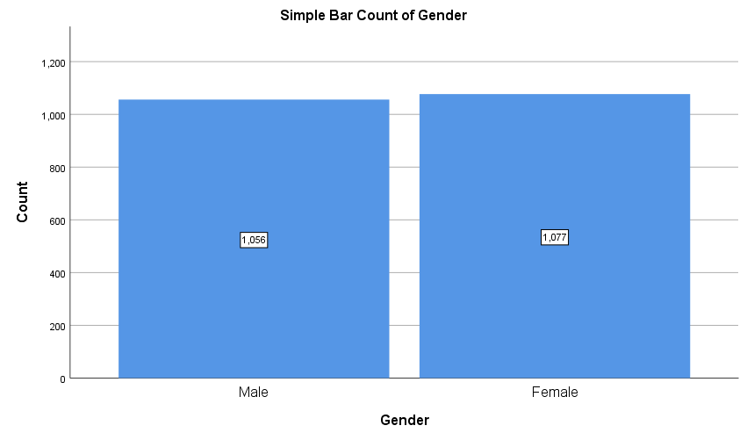
The genders of students are divided under the variable of gender. In SPSS, there are multiple options to produce a graphical representation of the total number of males and females. Here, the percentage of males is slightly higher than females. The identification could have been done in Excel as well but it could have consumed more time because of the sorting of data using internal Excel functions.
2. How many student qualifies and does not qualify for reduced/free lunch?
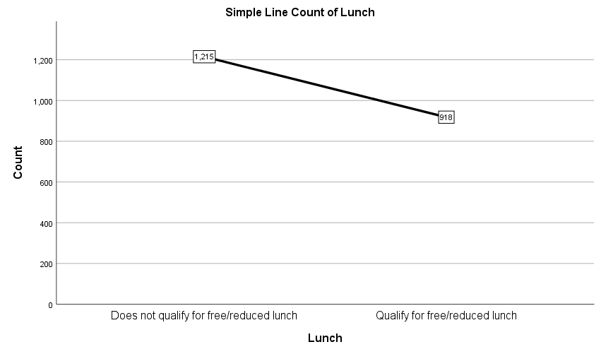

It is found that the number of students who qualify for reduced or free lunch is lower than the number of students who do not qualify for reduced or free lunch. There is not a huge difference between these two numbers but the number is significant for sure.
3. What are the mean and median of students who qualifies and does not qualify for reduced/free lunch?
Students who doesn’t qualify for reduced/free lunch
Mean | 21.44774
Median | 21

Student who qualifies for reduced/free lunch
Mean | 24.5817
Median | 25

In both cases, it is found that the mean and median are close to each other and it means the data set has a symmetrical distribution.
4. A specific example of Clustering
Number of clusters: 2
Initial Cluster Centers
 | Cluster
 | 1 | 2
Zscore(Gender) | -1.00966 | .98997
Zscore(Lunch) | 1.15018 | -.86902
Zscore(Pretest) | -2.35609 | 2.80497
Zscore(Posttest) | -2.29518 | 2.35206

Iteration Historyª
Iteration | Change in Cluster Centers
Iteration | 1 | 2
1 | 2.416 | 2.666
2 | .158 | .138
3 | .091 | .078
4 | .036 | .030
5 | .018 | .015
6 | .009 | .007
7 | .012 | .010
8 | .009 | .007
9 | .002 | .002
10 | .002 | .002
a. Iterations stopped because the maximum number of iterations was performed. Iterations failed to converge. The maximum absolute coordinate change for any center is .002. The current iteration is 10. The minimum distance between initial centers is 7.504.

Final Cluster Centers
 | Cluster
 | 1 | 2
Zscore(Gender) | -.03995 | .03288
Zscore(Lunch) | .94050 | -.77410
Zscore(Pretest) | -.81735 | .67274
Zscore(Posttest) | -.79154 | .65150

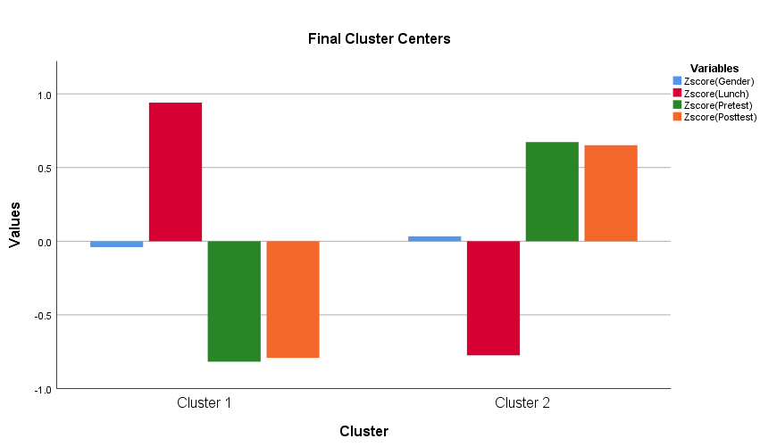

ANOVA
 | Cluster |  | Error |  | F | Sig.
 | Mean Square | df | Mean Square | df | F | Sig.
Zscore(Gender) | 2.802 | 1 | .999 | 2131 | 2.805 | .094
Zscore(Lunch) | 1552.918 | 1 | .272 | 2131 | 5714.678 | .000
Zscore(Pretest) | 1172.849 | 1 | .450 | 2131 | 2605.785 | .000
Zscore(Posttest) | 1099.950 | 1 | .484 | 2131 | 2271.201 | .000

Number of Cases in each Cluster
Cluster | 1 | 963.000
Cluster | 2 | 1170.000
Valid |  | 2133.000
Missing |  | .000

Steps
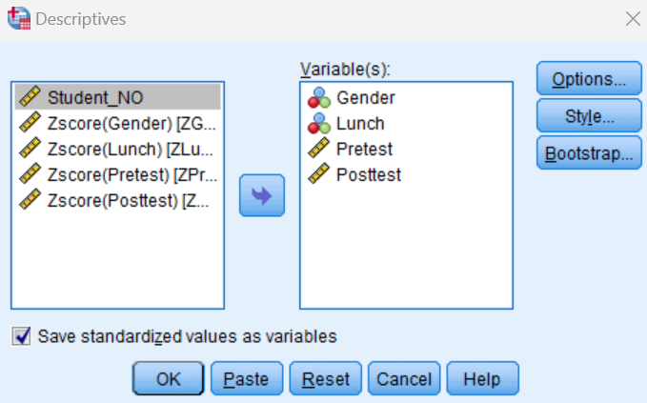
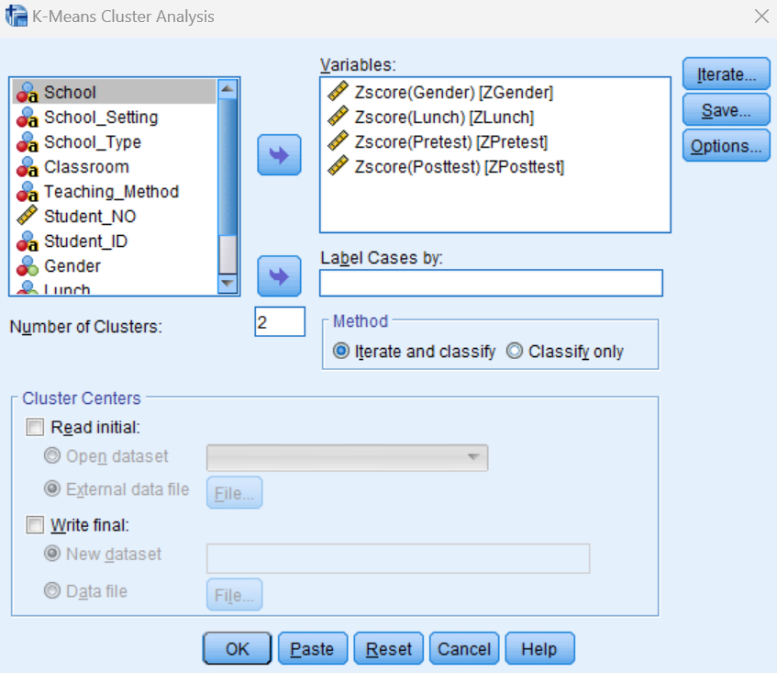
One of the supervised learning algorithms is K-means clustering. The major purpose of it is to divide multiple objects into clusters according to the similarities and dissimilarities of them. It is quite easy to implement and understand. When multiple objects or variables are used in K-means clustering within a certain context then it allows to identify the variable with the maximum significance. Here, 3 clusters are used for different variables and it is found that the variable of gender has the significance of .094. The remaining variables have a significance of zero and it means the contribution of gender or the importance of gender is higher than the remaining three.
Some methods of determining and text-mining
Data mining methods
- Classification is an important process of determining as it is used for assigning specific labels to different dataset according to the features of those. The aim of it is to develop models that can accurately identify or predict new objects according to the labels and features. It is used these days for making decisions by the government regarding the economy (Rybchak and Basystiuk, 2017).
- Clustering is used for finding out the groups of objects that may be similar to each other but there are no similarities among them and objects in other groups. In this process, different data sets are divided into groups and classes according to data similarity. In reality, clustering can be used for grouping customers based on their shopping behaviour.
- Regression is a statistical technique within data mining for identifying the relationship between dependent variables and independent variables. Modern-day businesses use it for forecasting related to finance sales, promotions etc (Jo, 2019).
Text mining method
- Sentiment analysis is known as opinion mining; it is a natural language processing technique to find out the type of data in terms of positivity, negativity or neutrality. The areas like customer support management and social media monitoring are highly based on sentiment analysis applications (Gaikwad et al. 2014).
- Topic modelling is another popular method of text mining. It is primarily used for analysing the clusters of topics within a series of texts. The classification, summarisation or categorisation of documents is done by topic modelling (Zong et al. 2021).
- Within texts, there are different named entities and Named Entity Recognition (NER) is used for detecting and categorizing those. It classifies those within predefined categories suggesting names, locations, financial values etc.
5. Advantages and disadvantage of using SPSS and Excel
SPSS | Advantages | Disadvantages
SPSS | The availability of statistical tools in SPSS is far better than most other packages (Abbott, 2016) | It allows long names of variables and these may not be compatible with other statistical packages
SPSS | It is a GUI based program | It is expensive under certain context and the purchased licence is not also user friendly according to many complaints
SPSS | It provides the opportunity of data analysis, data visualisation and modelling. | There are complexities within the graphing and charting features because of too many functionalities. It is much tougher than Excel (Bala, 2016).
SPSS | It Alauddin tooth multiple variables and the user can modify and test different variables accordingly | The features associated with the editing of output files are difficult.
SPSS | It allows to run complex statistical analysis without getting delayed | It is less flexible than other options.
 | Advantages | Disadvantages
Excel | It is good for beginners with the most popular statistical test available. The interpretation of results is also possible with ‘stats coach’ (Cleff, 2019). | The primary purpose of Excel is to save and analyse numerical data and it is not a complete statistical package.
Excel | The possibility of converting numerical data into graphical representation is multiple and the process is simple as well. | The tool pack of data analysis is unavailable by default and a user has to install it (Stehlik-Barry and Babinec, 2017).
Excel | It can be used as an interactive data summarization tool for condensing large data sets into a separate and concise table. | There is a requirement of numerical figures within the cells for Excel to analyse the data properly.
Excel | There are multiple worksheet options and a user can perform multiple statistical analysis easily. | Manual data entry is time consuming; do certain options are available for faster fill up but those are not enough

Reference List
Abbott, M. L. (2016). Using statistics in the social and health sciences with SPSS and excel. John Wiley and Sons.
Bala, J. (2016). Contribution of SPSS in Social Sciences Research. International Journal of Advanced Research in Computer Science, 7(6).
Cleff, T. (2019). Applied statistics and multivariate data analysis for business and economics: A modern approach using SPSS, Stata, and Excel. Springer.
Gaikwad, S. V., Chaugule, A., and Patil, P. (2014). Text mining methods and techniques. International Journal of Computer Applications, 85(17).
Jo, T. (2019). Text mining. Studies in Big Data, 45.
Rybchak, Z., and Basystiuk, O. (2017). Analysis of methods and means of text mining. ECONTECHMOD: An International Quarterly Journal on Economics of Technology and Modelling Processes, 6(2), 73-78.
Stehlik-Barry, K., and Babinec, A. J. (2017). Data analysis with IBM SPSS statistics. Packt Publishing Ltd.
Zong, C., Xia, R., and Zhang, J. (2021). Text data mining (Vol. 711, p. 712). Singapore: Springer.

