
Module: Strategic Management
Module code: LCMB7003
Assignment Title: Strategic Management Practices of Tesla Inc.
Student Name: Gurumukh Singh Pavitar Singh
Student ID: 2434321
Word Count: 5119
Submission Date:28 April 2026

Table of contents
SECTION 1 2
1. Organisational Context and Overview 2
1.1 Company Background: Tesla 2
1.2 Mission, Vision and Strategic Intent 3
1.3 Business Model 4
1.4 Industry Context 4
2. External and Internal Environment Analysis 5
2.1 External Environment 5
2.2 Internal Environment 10
3. CSR and Sustainability Objectives 12
3.1 Tesla CSR strategy 12
3.2 Alignment between sustainability mission and corporate strategy 13
4. Comprehensive & Holistic View – Balanced Scorecard 13
4.1 Financial Perspective 13
4.2 Customer Perspective 16
4.3 Internal Business Processes Perspective 16
4.4 Learning and Growth Perspective 16
5. Strategic Choices and Implementation 17
5.1 Business-Level Strategic Choices 17
5.2 Corporate-Level Strategic Choices 18
5.3 Change Management and Strategy Implementation 18
6. Strategic Evaluation and Recommendations 19
6.1 SWOT Analysis 19
6.2 Ansoff Matrix Evaluation 20
6.3 Strategic Recommendations 21
SECTION 2 – Reflective Account 21
2.1 Gibbs reflective cycle 21
Reference List 26

SECTION 1

1. Organisational Context and Overview

1.1 Company Background: Tesla
The American automobile multinational company Tesla Inc. was founded in 2003 by Martin Eberhard and Marc Tarpenning with its official headquarters in Texas, United States (Tesla, 2026). Historically, the company was named after Serbian-American physicist Nikola Tesla. Apart from being a car manufacturing company, its initial foundation was also established as a technology company with a major focus on batteries, computer software, and its proprietary motor. In 2004, with $6.5 million in initial funding, Elon Musk reshaped the company's image and joined the Tesla Board of Directors as chairman (Forbes, 2022). Since then, the company has specialised in designing, developing, manufacturing and selling electric vehicles, including energy generation and storage solutions. The notable Tesla brands include Model S, Model 3, Model X, and Model Y, showcasing a broader operation that spans the Asia Pacific and Europe (GlobalData, 2024).
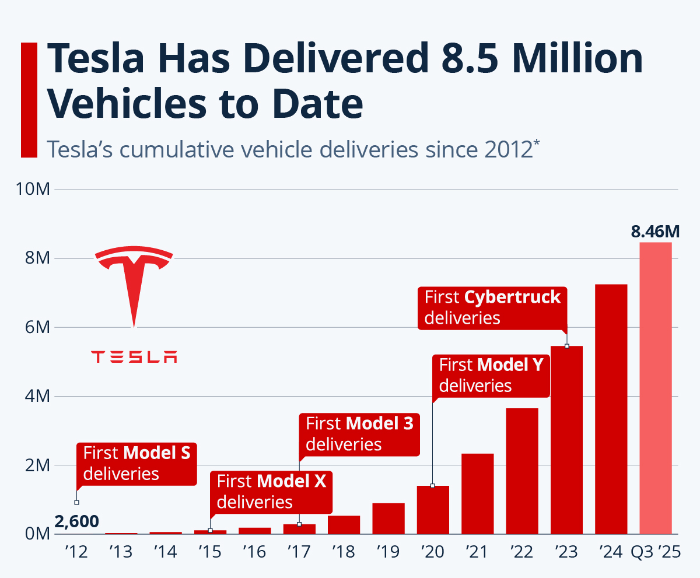
Figure 1: Tesla's growth in vehicle delivery
(Source: Richter, 2025)
The above statistical representation highlights the feasibility of Tesla in terms of delivering 8.4 million vehicles (Richter, 2025). However, the company's financial performance is determined to be below expectations as its revenue during quarter four fell to $17.7 billion (approximately 11%) (Dan, 2026). Moreover, the venture is showcasing improvement by transforming Fremont factory lines to produce Optimus humanoid robots, eventually targeting the growth of delivery up to 1 million units per year (Dan, 2026).

1.2 Mission, Vision and Strategic Intent
The mission of Tesla is to “accelerate the world’s transition to sustainable energy”, and the vision is to “create the most compelling car company of the 21st century by driving the world’s transition to electric vehicles” (Pereira, 2023). In support of the vision and mission statement, the strategy of the company is inclined towards transitioning into electrification with the rapid expansion of business towards becoming a leading automobile manufacturing venture (Pereira, 2023).

1.3 Business Model
Tesla operates through a Direct-to-Consumer (DTC) sales business model in terms of transforming and improving strategies with new processes and ideas. The DTC business model is leveraged by the company to reduce costs in comparison to traditional dealership models (Asuncion et al., 2023). Tesla prioritises customer experience by controlling prices and through brand communication.

1.4 Industry Context
Tesla operates within an evolving automotive industry with a growing demand for electric vehicles (EVs) and advanced safety systems. In 2025, the industry showed growth of $4357.69 billion, and is projected to reach $8508.56 billion by 2025 at a growth rate of 6.92% (Palwe, 2026). The industry is dominated by key players, such as Toyota Motor Corporation (JP), Volkswagen Group (DE), General Motors Company (US), Ford Motor Company, BYD Auto and so on. In terms of EV sellers, Tesla is overtaken by BYD in 2025 with the delivery of approximately 2.26 million battery electric vehicles (Pereira, 2023).
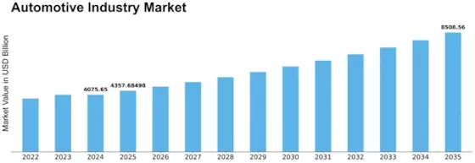
Figure 2: Global automotive industry growth
(Source: Palwe, 2026)

2. External and Internal Environment Analysis

2.1 External Environment
PESTEL Analysis
Factors | Description | Threats/Opportunities for Tesla
Political | - The political stability index of the USA as of 2024 is -0.10, meaning the presence of destabilisation, political violence or unconstitutional challenges (Global Economy, 2024)  - Rising geopolitical tension in the Middle East poses an uncertainty over US trade policy (Li, 2026)  - EV demand is revived despite rising fuel prices ($2.96 a ​gallon) and subsidy cuts (Reuters, 2026) | The political environment of the USA is highlighted as a threat to be threats for Tesla, which can disrupt the supply chain, hindering Tesla's operations. However, the rise in EV demand can be leveraged by Tesla to strengthen brand visibility
Economic | - The Gross Domestic Product (GDP) of the US is $32.38 trillion as of 2026 and has increased by 4.9% (Worldometer, 2026)  - The annual inflation rate has witnessed a sharp increase by 3.3% in 2026 (Trading Economics, 2026)  - The automotive supply chain in the US faces complexities due to economic volatility, electrification initiatives, and regulatory pressures (Moody, 2025) | Economic volatility, electrification pressure, and regulation fluctuation demonstrates interest threat to the venture, delaying its production and concern of cost overruns. However, GDP can support income in terms of premium EVs
Social | - As per the 2025 survey report, 44% Americal consumers consider environmental impact to be extremely important (Nordigården et al., 2025)  - Americans showcase environmentally friendly consumer behaviour and prefer buying products or services from green brands (Watty, 2025)  - 57% supports transition with a desire to shift from gas and diesel-powered vehicles to EVs, pertaining to sustainability efforts (Katsadouros and Herrington, 2024) | In this case, Tesla determines threats as the failure to meet growing environmental expectations of customers can give rise to greenwashing accusation, threatening brand identity
Technological | - Advancement in battery innovation is on the path to becoming a leader in battery tech (Whittle, 2025)  - Investment of $3 billion in the project for advancing the production of batteries and battery materials  - Solidified its position in AI, attracting investment of $2.7 trillion in tech and AI and $90 billion in energy (US..gov, 2026) | This implies an opportunity for Tesla as innovation leadership can strengthen Tesla's effort towards the adoption of robotics
Environmental | - Targeting the reduction of 50–52% greenhouse gas (GHG) pollution by 2030 (Ding et al., 2024)  - The 1970 Clean Air Act under the Environmental Protection Agency aims to address air pollution problems and toxic air emissions (EPA, 2019) | Aggressive and stringent environmental protection targets forces automaker to witness compliance costs, affecting their manufacturing and supply chains
Legal | - The National Highway Traffic Safety Administration (NHTSA) is responsible for detecting motor vehicles and enforcing fuel economy standards (USA.Gov, 2026)  - New rules for self-driving cars and for eroding safety oversight | This infers threats, as EV battery safety rules increase compliance costs and the rising risk of liability or litigation
Table 1: Tesla Pestle Analysis
(Source: Self-Developed)
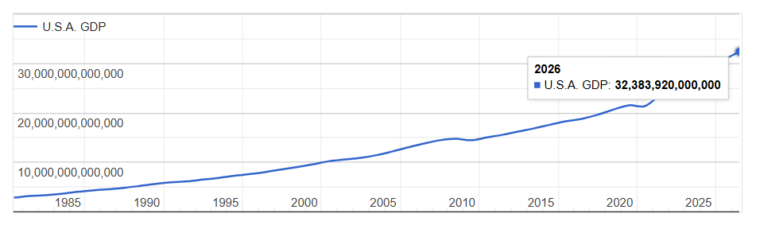
Figure 3: USA GDP growth
(Source: Worldometer, 2026)
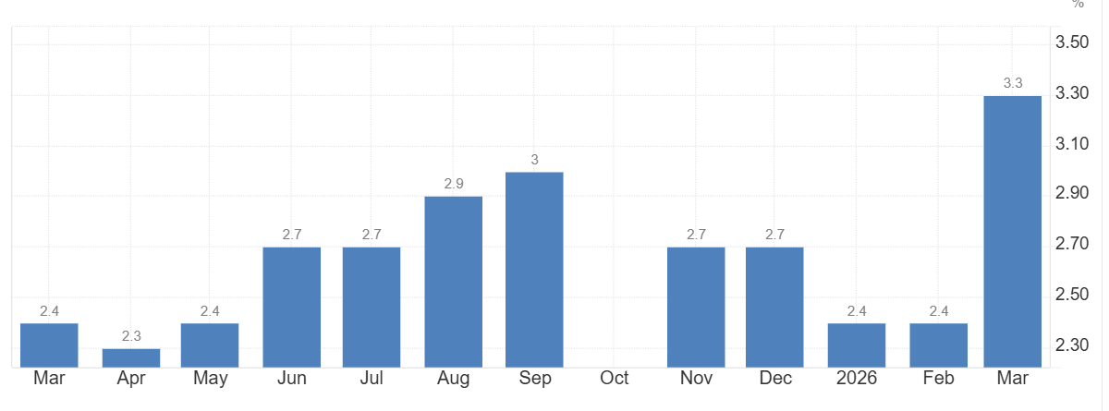
Figure 4: USA inflation rate increase
(Source: Trading Economics, 2026)
Porter’s Five Forces
Threat of new entrants | The entry of new automotive firms has a moderate level of impact on Tesla. New ventures require higher investment pertaining to the establishment of gigafactories, battery plants, and charging networks, eventually failing to compete with powerful brands, such as Tesla (Yang and Fulton, 2023). This means new firms are unlikely to match Tesla's scale, and the company effortlessly innovates and is inclined towards a fully autonomous future in terms of maintaining its leading position (Tesla, 2025).
Supplier power | Tesla determines a moderate to high level of impact in terms of supplier bargaining power. Reason being the production of battery materials for EVs is confined to a few countries, such as China (PBS News, 2025). Including the shortage of auto-grade chips, as suppliers, such as Nvidia, leverage on Taiwan Semiconductor Manufacturing Company (TSMC) for AI chips (Dany Kitishian, 2025).
Buyer power | Tesla demonstrates a moderate level of impact from bargaining buying power. Reason being consumers gain an opportunity to choose from other EV brands. Besides, subsidy cuts can make buyers more price-conscious (Reuters, 2026).
Threat of substitutes | Tesla witnessed a low to moderate impact as 50% of global customers show a willingness to buy an ICE (Internal Combustion Engine) (Sankaran, 2025). For rage conscious buyer Plug-in hybrid electric vehicles (PHEVs) tend to be an interim substitute (Akuffo and Smith, 2023).
Competitive rivalry | Tesla demonstrates a higher impact from competitive rivalry from Lucid Group Inc, Rivian Automotive, General Motors Co, and Ford Motor Co (Hudson, 2026). However, in terms of EVs, the Tesla Model Y is dominating the market, posing a competitive threat to rivals, such as BYD (EV Boosters, 2025)
Table 2: Tesla industry competitiveness
(Source: Self-Developed)
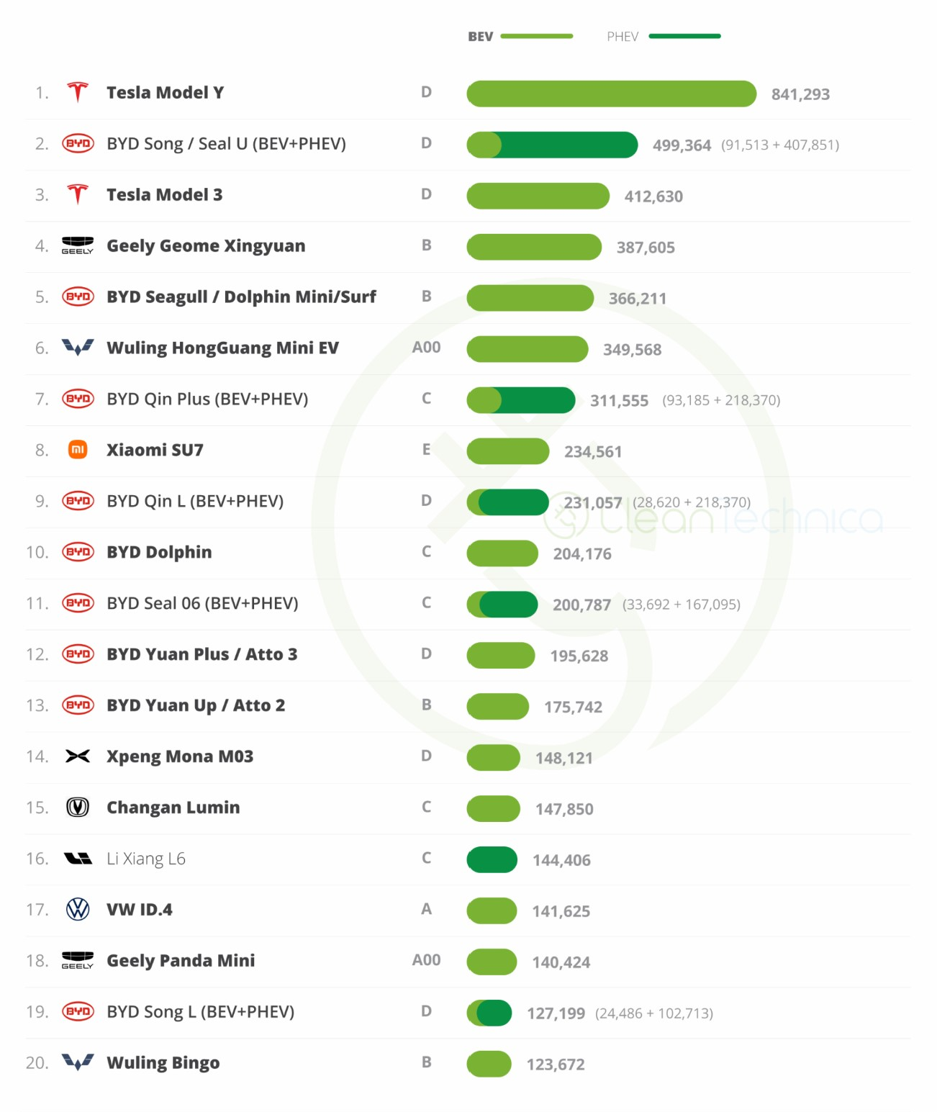
Figure 5: Tesla EVs' competitiveness
(EV Boosters, 2025)
Critical Success Factors
Tesla is able to create differentiation from rivals as its focus on Self-Driving Fuels a Software Flywheel, supporting it to dominate within the EV market (DIM News, 2025). However, the new self-driving rules can create uncertainty for the automobile firm as it fails to align with the deployment of global regulation on Automated Driving Systems (ADS) in terms of supervising the development and delivery of autonomous vehicles (UNECE, 2026). The Gigafactory output is supporting Tesla to optimise manufacturing capacity and expand its operations. Besides, the company is also focusing on cost reduction and operational efficiency, with the recognition of $94.83 billion in revenue and operating activities of $14.75 billion in 2025. However, the rapidly evolving trade and fiscal regulation, including automotive and energy market uncertainty, has hindered its overall growth by $2.86 billion in 2025 in comparison to the previous record (Tesla, 2025) .

2.2 Internal Environment
Resource Analysis
Tesla Gigafactory is one of the prime and significant resources as it supports the optimisation of integrated manufacturing facilities. Recently, the company has announced expansion with the formation of a new collaboration with Samsung in terms of manufacturing advanced semiconductors and to increase AI training capacity at Cortex 2 at Gigafactory Texas (Tesla, 2025). Besides, the proprietary battery technology supports the vertical integration of the company, packed with 6,831 cells designed to directly impact vehicle cost and charging speed (Kelty, 2025).
Capabilities & Core Competencies
The operational capabilities and competencies of Tesla are driven by the approach of vertical integration. This influences the major aspects of production, including the assessment of raw materials to final assembly (Emmer, 2024). This allows Tesla to manage quality and rapidly innovate, as the company has been able to showcase differentiation in terms of redesigning software in the support of alternative chips (Emmer, 2024).
VRIO Analysis
Resources/Capabilities | Value | Rarity | Imitability | Organisation | Competitive Advantage
Brand reputation | Yes | Yes | No | Yes | Sustained competitive advantage
Battery expertise | Yes | Yes | No | Yes | Sustained competitive advantage
Global manufacturing footprint | Yes | No | Yes | Yes | Competitive parity
Table 3: VRIO analysis
(Source: Self-Developed)
Tesla has a sustained competitive advantage in terms of brand reputation, as its EV association is unmatched, supporting its strategic direction and leadership (Wade, 2024). Additionally, Tesla captures a sustained competitive advantage in terms of battery expertise as it is linked with vertical integrated approach to AI training. This supports its raw material generation, including cell design, large-scale production and others (Thomas, 2025). However, the company highlights competitive parity in response to global manufacturing footprint, as its competitors also have multi-region factories.
Sources of Competitive Advantage
Cost leadership through scale: Internal strengths offer Tesla an opportunity to dominate the market position in terms of cost leadership. The company is known for focusing on the development of its own technologies, production processes, and entire factories, which has allowed it to seek cost reduction, thereby improving its product development process (Fox, 2023).
Differentiation via technology: The proprietary technology of Tesla cannot be easily replicated by competitors. This is supporting Tesla to focus towards proprietary EV charging network by enhancing its focus to generate additional revenue of $3 billion by 2030 and $5.4 billion by 2032 (Brulte, 2026). Besides, Tesla has shown progress with a shift towards the North American Charging Specification (NACS). Through this, the company is fulfilling its promise towards electric vehicle owners to boost accessibility with the expansion of more than 3,500 Superchargers (Merritt, 2023).

3. CSR and Sustainability Objectives

3.1 Tesla CSR strategy
Tesla ensures to focus on environmental, social, and corporate governance (ESG) in supporting acceleration towards sustainable energy. The company has emphasised the adoption of a fully integrated ecosystem in terms of addressing the concerns of energy generation, energy storage, transportation and manufacturing. The utilisation of Tesla products has enabled consumers to avoid the release of nearly 32 million metric tons of carbon dioxide equivalents (CO2e) in 2024 (Tesla, 2024). The venture further showcases a commitment to creating an inspiring and safer environment where employees can thrive. The presence of a policy that supports the promotion of a fair and respected work environment has enabled Tesla to witness an increase in employee response concerning safety improvements of 731,500 by 2024 and a decrease in work-related injury by 2.28% (Tesla, 2024).
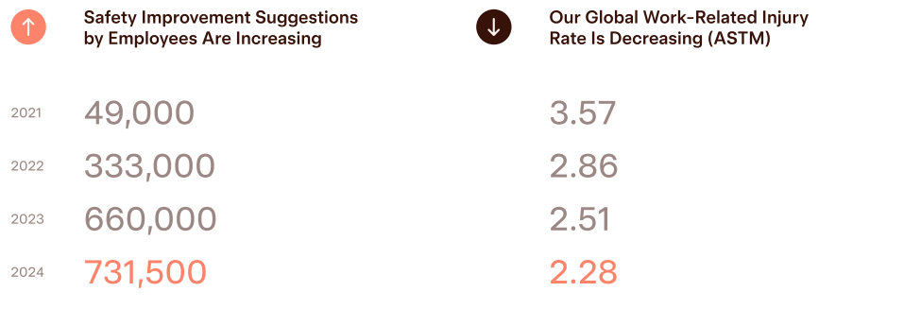
Figure 6: Tesla workplace improvements
(Source: Tesla, 2024)
Besides, Tesla secures a high standard by aligning with the regulatory requirements of the EU, including being a responsible member of the Initiative for Responsible Mining Assurance (IRMA), Responsible Minerals Initiative (RMI) and Fair Cobalt Alliance (FCA), with the practice of robust audit processes (Tesla, 2021). In addition, the venture has also addressed risk concerning child labour and unsafe mining in the Democratic Republic of Congo (DRC). It has fulfilled its commitment towards the development of new cobalt-free battery technology and has also showcased its collective efforts to end child labour and support in the DRC (Posner, 2020).

3.2 Alignment between sustainability mission and corporate strategy
Tesla's sustainability mission and corporate strategy showcase a strong alignment in terms of fulfilling the promise towards the acceleration of the world’s transition to sustainable energy. In this instance, the automotive venture has claimed to avoid 20 million metric tons of CO2e (Tesla, 2023). The progress of the company in reducing emissions is being supported by the plan concerning net-zero emissions. In this aspect, the company is fulfilling its corporate goal to deploy net-zero ambitions in the full product lifecycle process and additionally transitioning its operational electricity load to 100% renewables with the continued use of Supercharger electricity (Tesla, 2023).

4. Comprehensive & Holistic View – Balanced Scorecard
The concept of Balanced Scorecard (BSC) was first coined by Kaplan and Norton in 1992, when they defined it as a structured methodology used for the management of strategy and vision within an organisation (Tawse and Tabesh, 2023). By measuring performance through four perspectives that include Financial Performance, Customer Demand, Internal Business Processes, and Learning & Growth. The difference between this method and other traditional methods adopted by accountants lies in the recognition of intangible assets alongside tangible ones, as important factors driving the competitive edge of organisations.

4.1 Financial Perspective
Financial performance refers to the amount of value that Tesla brings to the shareholders. Tesla's financial goals are to continue to achieve stable revenue growth and increase its operating margins as it becomes larger. The sales for Tesla in Q4 2025 stood at $17.7 billion, representing an estimated decline of 11% from the last quarter, which was at 19.8% (Kolodny, 2026). This is because of stiff competition in the market and the reduced average selling price of cars, attributed to reductions in prices.

Perspective | Objective | KPI | Target | Initiative
Financial | Drive profitable scaling and fiscal discipline. | • Annual Revenue Delta  • Operating Profitability  • Unit Production Cost | • +15% Revenue (YoY)  • 10%+ Operating Margin  • -30% Battery Cell Cost. | • Speed up car production at all major factories.  • Find cheaper ways to make the batteries.
Customer | Strengthen brand loyalty and expand market share. | • Net Promoter Score (NPS)  • Global EV Market Share  • Retention Rate | • Maintain NPS above 80  • 25% Global Market Share  • Top-tier Brand Loyalty | • Make the "Self-Driving" software easier to subscribe to.  • Build more charging stations in more places.  • Start a rewards program for loyal owners.
Internal Process | Optimise manufacturing efficiency and R&D pipeline. | • Assembly Line Uptime  • Quality Yield (Defect %)  • Software Update Cadence | • Zero Unscheduled Stops  • <1% Factory Defect Rate  • Monthly OTA Updates | • Fix the factory flow so work never has to stop.  • Design our own computer chips instead of buying them.  • Use AI cameras to spot mistakes on the assembly line.
Learning & Growth | Build AI talent and an innovation culture. | • R&D Intensity Ratio  • Talent Stability (Attrition)  • IP/Patent Velocity | • R&D at 8% of Revenue  • Sub-10% Staff Turnover  • 500+ New Patents Annually | • Build "Dojo" (a giant computer) to train smarter AI.  • Hire the best tech experts from around the world.  • Create an "AI School" to teach staff new skills.
Table: Balanced Scorecard for Tesla

4.2 Customer Perspective
Understanding the perspective of a customer offers useful insight on how Tesla produces value for its customers and the company’s position within the marketplace. Tesla continues to have a very high Net Promoter Score (NPS) in comparison to other OEMs (Original Equipment Manufacturers), which suggests a strong identity of brand loyalty from its customers (Braidy et al., 2025). The key target for the Company’s market share expansion is from its core EV (Electric Vehicle) product lines while protecting the premium identity of the Tesla brand from low-price competitors such as BYD (Qin, 2023).

4.3 Internal Business Processes Perspective
These elements are the key internal processes that Tesla must excel at in order to give value to its stakeholders. One such internal business process is production efficiency; therefore, for it to ramp up production of the Model Y and Cybertruck, it must overcome manufacturing bottlenecks at its Gigafactories throughout the world (Chari and Ferreira, 2025). Tesla's approach to manufacturing can be found in its "idiot index" (reducing the number of parts involved in the manufacturing process); this is similar to the principles of Lean Manufacturing, where continuous improvement is a focus.

4.4 Learning and Growth Perspective
Tesla's ability to learn and grow is the basis for all three of the perspectives previously discussed through asking what Tesla needs to learn/develop to reach its goal. For example, with the development of its Dojo supercomputer, Tesla is focused on creating an exclusive capability to produce AI systems (Govindarajan and Venkatraman, 2024). As the competition for talent is high, talent acquisition/retention continues to be critical for the company. In addition, the fully developed culture of innovation can be seen in Tesla's quick innovation cycle and the cannibalisation of its existing products. For instance, the Model S will be replaced with the Model 3 uses this dynamic capability.

5. Strategic Choices and Implementation

5.1 Business-Level Strategic Choices
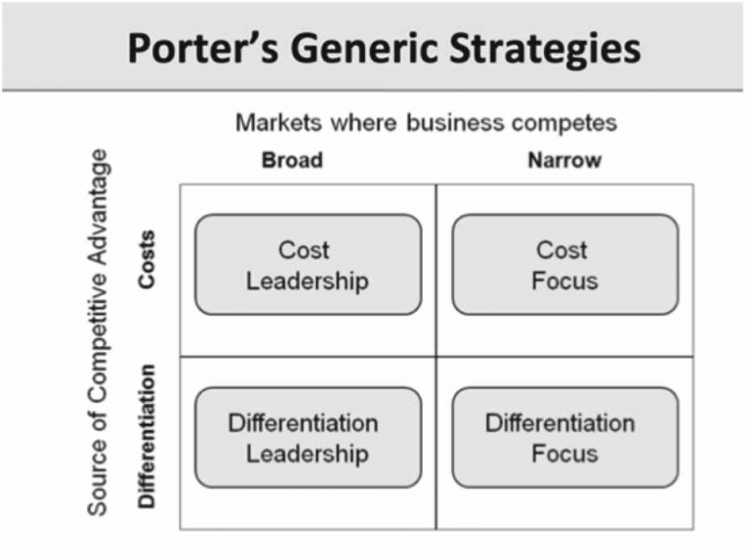
Figure 7: Porter's Generic Strategies
Source: (Subrahmanyam, 2019)
The distinction between Porter (1980) and the generic strategy used by Tesla in relation to their differentiated business strategy is the way in which the company has used its business strategy (or generic strategy) to position itself (Acar, 2024). In the case of Tesla, its value proposition has been based on the use of technology to create a unique product instead of price or any other measure of cost. Tesla's focus on differentiation has created a premium perception of the Tesla brand, especially among owners of the Model S and Model-X vehicles, who paid more for their vehicles because of their high-performance characteristics than they would for an internal combustion engine vehicle. With the introduction of the Model-3 and Model-Y vehicles (Liu et al., 2025),
Tesla began transitioning from a differentiation-only strategy to implementing both a cost-leadership and differentiation strategy as a means of expanding its market share to compete against competitors like BYD and traditional OEMs (Yan, 2022). To grow its market share, Tesla has utilised price discounts of over 20 per cent on purchases made in 2023 and 2024. Although these strategies are designed to help Tesla expand its market share and out-compete its competition, they also carry a high level of risk due to the potential negative impact on Tesla's brand equity that continuous discounting may have.

5.2 Corporate-Level Strategic Choices
Tesla's corporate-level diversification strategy through energy storage systems (Megapacks & Powerwalls) and solar power (Solar Roofs) falls into a related diversification strategy type (Xu, 2025). Moreover, Tesla's energy division is one of the company's fastest-growing business areas; for instance, the Megapacks are expected to generate over 10 GWh of energy per year by 2024 (GlobalData, 2024). Internationally, since entering India (as one of Tesla's newest countries) and Southeast Asia, the company's headquarters has focused on finding high-growth opportunities in both of these regions as it relates to developing a new vehicle lineup to meet the needs of a cost-sensitive customer base.

5.3 Change Management and Strategy Implementation
The rapid implementation of strategic changes at Tesla is a reflection of Elon Musk's distinctive approach to leadership. While this style enables rapid changes in the organisation with shorter product development cycles and faster to build Gigafactories (three built in record times), there have been some challenges associated with implementing strategic changes at Tesla (Banker, 2023). Some of these challenges include frequent restructuring, significant turnover of executives, and the abrupt decision to discontinue the much-publicised $25,000 Tesla vehicle in early 2024.

6. Strategic Evaluation and Recommendations

6.1 SWOT Analysis
Strengths
Tesla's unique position allows it to benefit from global Gigafactory platforms, vertically integrated, and utilize its unique 4680 battery cells through its extensive Supercharger network of over 60,000 locations, which gives Tesla an advantage in being perceived as a technology leader (Ank et al., 2023). Combining its AI and full self-driving (FSD) program, direct-to-consumer sales, and full range of its own energy products (Megapack/Powerwall), gives Tesla excellent brand equity as a disruptor in the technology space.
Weaknesses
Tesla has certain weaknesses related to key-person risk (Elon Musk) as well as the apparent reduction in revenues during Q4 2025 (Zhu and Zhou, 2025). Supply chain concerns for batteries, employee strike risk, and the low number of car models compared to traditional OEMs are additional challenges for Tesla that impact the inflated valuation of the company's stock.
Opportunities
Expanding into the Indian and Southeast Asian markets offers the potential for growth. Creating a subscription model for FSD will also be an opportunity. Developing autonomous ride-hailing services and increasing the adoption of the Optimus robot present additional possibilities, as well as the growth of the energy storage and battery recycling industries.
Threats
BYD's rapidly expanding footprint (with 2.26 million BEV sales in 2025) and low-cost competitors out of China are significant threats to Tesla and require management to maintain high performance (Yankevich and Yankevich, 2022). Changes in incentive programs, regulations around autonomous vehicles, and additional competition from traditional OEMs are additional threats for Tesla.

6.2 Ansoff Matrix Evaluation
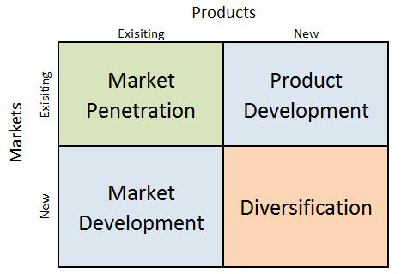
Figure 8: Ansoff Matrix
Source: (Dudovskiy, 2023)
The current strategy of Tesla is viewed as a multidimensional growth strategy with Ansoff’s (1957) matrix (Dudovskiy, 2023). With respect to Out Market Development, Tesla continues to expand further into existing markets (US, China, and Europe) in conjunction with Model Y, the best-selling passenger vehicle globally in 2023. With reference to the Product Development dimension, Tesla is now developing a Cybertruck, Semi-Truck, and Optimus Robot to address the needs of current and new customers with respect to energy solutions (Ezugwu et al., 2025). Further, it is stated that Diversification is evident through the Energy Solutions provided by Tesla, such as Megapacks and the Autobidder platform, to address a completely different customer group than their Automotive products.
Evaluating Tesla from a BCG Matrix (Boston Consulting Group) viewpoint offers insight on how Tesla’s corporate strategy is progressing (Mogaji, 2025). The Star of the company is its automotive segment, especially Model Y, as it currently has a leading market position and the electric vehicle segment is continuing to grow rapidly.
The Energy Solutions offered by Tesla fall into the Question Mark category as they continue to grow rapidly, but have low market share when compared to traditional utility companies. Insurance services will likely become the Cash Cows for Tesla due to the rapid growth of its fleet of automobiles.

6.3 Strategic Recommendations
Currently, there are four strategies recommended to allow Tesla to grow sustainably through the current market analysis:
Create a Model Under $30,000: To create a vehicle in this price range to limit the losses Tesla is experiencing from the 4.27 million vehicles manufactured by BYD (a budget-oriented competitor) in 2024, Tesla must build an entry-level model to serve this market (Sriram, 2026). This reflects Ansoff's market penetration strategy because there exists a competitor (BYD Seagull) with an entry-level model already.
Develop an Alternative Supply Chain: Tesla should develop a supply chain network outside of China (Australia, Canada, and Chile) to reduce their geopolitical risk from China's dominance of battery materials (George, 2024).
Create a Good Governance Structure: Moving away from a company that is solely dependent on Elon Musk's management style through the creation of an effective board structure with a practical succession plan will help reduce 'key-person dependency.'
Create Closed Loop Battery Recycling Infrastructure: A closed-loop battery recycling infrastructure will help Tesla to comply with strict regulations, such as the EU's Battery Regulation of 2025.

SECTION 2 – Reflective Account

2.1 Gibbs reflective cycle
The framework of Gibbs' Reflective Cycle, as per Praveena et al. (2025), is an important approach to deeply explore experience and observations, with the focus on areas to further improve skills and competencies. The cycle encompasses six cire dimension, including description, feelings, evaluation, analysis, conclusion, and action plan. In the context of exploring by learning experience pertaining to the approach that I adopted in researching, analysing and preparing a strategic management report of Tesla, I will consider the phases of Gibbs' Reflective Cycle.
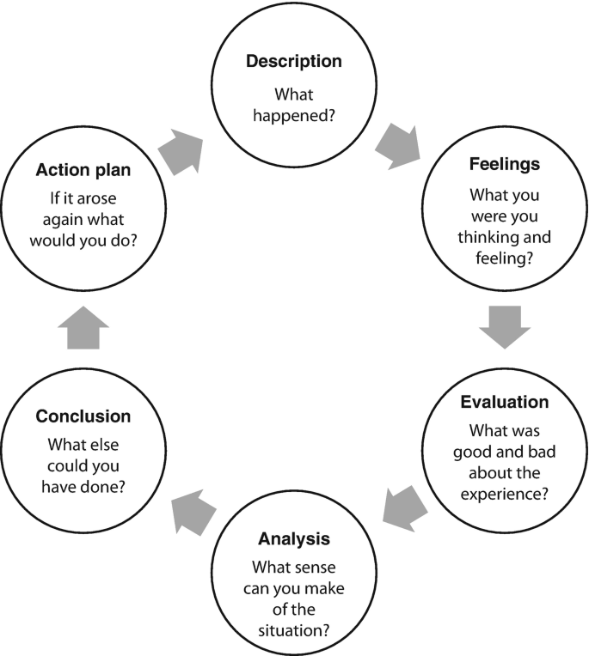
Figure 10: Gibbs' Reflective Cycle
(Source: Newton and Young, 2021)
Description
In the process of developing a strategic report concerning Tesla, I emphasised the identification of credible sources for the collection of data and multiple strategic frameworks. I massively leveraged the approach to effectively access secondary data and adopted a viable research process with the concentration of steps, such as researching, data collection, analysis and evaluation. The adoption of this structure has enabled me to ensure the accuracy and validity of the report, in addition to the generation of actionable outcomes. Moreover, I ensured to set a simple workflow and research process, which has allowed me to develop a comprehensive report on Tesla. Besides, the research that I ensured in terms of utilising appropriate frameworks and models has supported me in the clarification of facts and provide explanation as required.
Feelings: Application of strategic frameworks
The research for my dissertation began with an equal mixture of intellectual curiosity and concern. The company I researched was particularly intriguing to me because of its contradictory nature: it is a luxury company with aspirations for the mass market; it is a leader in sustainability, but has a CEO involved in politics. However, the wide range of issues that I researched created a challenge in terms of how to combine or use all of the different frameworks. One of the frameworks I was particularly enthusiastic about using was the VRIO model. When I completed an analysis of Tesla’s charging stations using the VRIO model and discovered that the rarity and imitability of charging stations do not just come from the amount of capital spent but also from the data ecosystem created by the charging stations, I found it to be an exciting intellectual challenge (Astawa, 2022).
Conversely, when I examined the CSR issues regarding Tesla, I felt uncomfortable using a critical approach toward determining whether the information I found was consistent with conflicting information in the body of literature on CSR. When I examined the ethical implications relating to the extraction of cobalt or relationships with labor from the Fremont facility, I had to rely on my own ability to pick and choose between contradicting constructs.
Evaluation: Critical evaluation development
Critical evaluation with the consideration of both Tesla's strengths and limitations has been a major turning point for me in the process of developing the report. As in the beginning, I mostly concentrated on the strength of the company, understanding things from a critical perspective has been pretty challenging for me. In this aspect, I emphasised learning to ask tough questions and consider challenging issues in support of my report argument. The focus that I ensured towards the development of a critically evaluated report has allowed me to gain insights from a complex automotive industrial perspective, due to which I was able to offer Tesla recommendations as a part of enhancing its strategic growth. In general, I also learned to identify my personal bias, as I found myself focusing on the information that supports Tesla's competencies. Overall, the compression of critical evaluation as a part of my analysis has supported me in collecting evidence-based information in supporting the actual analysis of the strategic report.
Analysis
In the initial phase, I witnessed challenges of identifying selective sources for information generation. This often led me to make use of inauthentic information, making me worried about weakening the point of the report. Additionally, I also struggled dealing with a lot of questions as I faced uncertainty in identifying sources for information and using a framework that supports overall analysis. This made me prepared to face challenges in terms of collecting evidence-based data, where in one instance I found myself mostly relying on self-assumption. Apart from this, time management has also been a major challenge. In this instance, I took a long time to gather information and connect ideas, which has forced me to rewrite several points. Also, learning bias has been another complexity, which has impacted my expectations that I was willing to accomplish with the development of a meaningful report. I also determined that this specific challenge was threatening my overall academic performance, with the fear of impacting my upcoming professional competencies.
Conclusion
The overall learning, researching, analysing and preparing of the report has been overwhelming. Despite the challenges I encountered in several aspects, I motivated myself to prepare a report that offers an in-depth analysis of Tesla. I also realised the importance of shifting my mindset towards the pursuit of critical exploration. I also learned from my weaknesses and tried to undertake different approaches to handle my emotions. Besides, I also learned ideas to use a relevant framework in support of the context and answer strategic questions by accessing credible and reliable information. Moreover, the overall research and analysis that I conducted in the development of the report has shaped my skills and knowledge to learn from my own mistakes and seek improvements, by ensuring self-awareness, resilience, critical thinking and others. The learning that I have gained in this process is pertinent to supporting both my personal and professional growth.
Action Plan
Improvement Areas | Action | Strategies | Time-Frame
Selectivity skills | Gain a comprehensive understanding of the discussion and initiate consistent and evidence-based decisions | I will focus on relevant and authentic information and ensure the combination of cognitive, analytical and strategic thinking | 5 months
Critical thinking skills | I will proactively question my assumptions and compare and analyse evidence from diverse sources, including I will also emphasise on minimise my cognitive bias | I will eliminate the use of information that can lead to bias, practice on solving why and how questions, and engage on problem based learning either online or among peers | 6 months
Analytical skills | I will solve complex problems and focus on data-driven decisions | Enrol in online analytical courses and practice self-reflection | 5 months
Table : Improvement action plan
(Source: Self-developed)

Reference List
Akuffo , R. and Smith, A. (2023). Why are car buyers preferring Hybrids over EVs? [online] Available at: https://finance.yahoo.com/video/why-car-buyers-preferring-hybrids-173235219.html?guccounter=1&guce_referrer=aHR0cHM6Ly93d3cuZ29vZ2xlLmNvbS8&guce_referrer_sig=AQAAAL3kRi8PBHJ8jFcpLup_Ie6ZzlBh-bYkM0_zKoS31aPx7LYgmf-CCyKtksFeSiqCHvLonj62qwOgXCoBpVw1SDxJglO0c3Z-2KRcQ1cGSoCjbDpSdYhk6ovJw-ibp_bveLvDf2HbMBBrPT7YghYR11Eqh-qujr7V-BXwugag-Juy.
Asuncion, J., Murphy, M., Prutow, N., Siantar, M., Tyre-Vigil, J. and Awwad, M. (2023). Benefits and Effects of Tesla’s Direct-to-Customer Sales Model. [online] Available at: https://ieomsociety.org/proceedings/2023lisbon/471.pdf.
Brulte , G. (2026). The Autonomy Leaderboard. [online] The Road to Autonomy. Available at: https://www.roadtoautonomy.com/tesla-proprietary-charging-network/ [Accessed 18 Apr. 2026].
Dan (2026). Tesla (TSLA) Stock in 2026: The Most Polarizing Bet in Markets Just Got Bigger. [online] Phemex.com. Available at: https://phemex.com/academy/tesla-tsla-stock-2026.
Dany Kitishian (2025). TSMC AI Fabricating Dominance: Chip Manufacturing Leadership in AI Era - Klover.ai. [online] Klover.ai - Klover.ai. Available at: https://www.klover.ai/tsmc-ai-fabricating-dominance-chip-manufacturing-leadership-ai-era/.
DIM News (2025). Tesla’s FSD: The Software Flywheel Dominating the EV Market. [online] Datainsightsmarket.com. Available at: https://www.datainsightsmarket.com/news/article/teslas-fsd-the-software-flywheel-dominating-the-ev-market-20827.
Ding, C., Ke, J., Levine, M. and Zhou, N. (2024). Potential of artificial intelligence in reducing energy and carbon emissions of commercial buildings at scale. Nature Communications, [online] 15(1), p.5916. doi:https://doi.org/10.1038/s41467-024-50088-4.
Emmer, M. (2024). Why vertical integration is the path to strategic advantage. Forbes. [online] 29 Jan. Available at: https://www.forbes.com/councils/forbesbusinesscouncil/2024/01/29/why-vertical-integration-is-the-path-to-strategic-advantage/.
EPA (2019). Clean Air Act Overview. [online] United States Environmental Protection Agency. Available at: https://www.epa.gov/clean-air-act-overview.
EV Boosters (2025). 8 of the world’s top 10 best-selling EVs are Chinese, + 29% overall growth in the first 10 months of 2025. [online] EVBoosters. Available at: https://evboosters.com/ev-charging-news/8-of-the-worlds-top-10-best-selling-evs-are-chinese-29-overall-growth-in-the-first-10-months-of-2025/.
Forbes (2022). Tesla: A history of innovation (and headaches). [online] Forbes. Available at: https://www.forbes.com/sites/qai/2022/09/29/tesla-a-history-of-innovation-and-headaches/.
Fox, E. (2023). Legacy OEMs Must Act as Tesla Leverages Cost Leadership. [online] Tesla Mag EN. Available at: https://www.tesla-mag.com/en/legacy-oems-must-act-as-tesla-leverages-cost-leadership/.
Global Economy (2024). USA Political stability - data, chart. [online] Available at: https://www.theglobaleconomy.com/USA/wb_political_stability/.
GlobalData (2024). Tesla Inc: Overview. [online] www.globaldata.com. Available at: https://www.globaldata.com/company-profile/tesla-inc/.
Hudson (2026). Tesla’s Top Competitors and Peers in 2026. [online] Hudson-labs.com. Available at: https://hudson-labs.com/research/tesla-competitors-tsla.
Katsadouros, E. and Herrington, J. (2024). What automotive can teach us about brand sustainability. [online] Kantar.com. Available at: https://www.kantar.com/inspiration/sustainability/what-automotive-can-teach-us-about-brand-sustainability.
Kelty, K. (2025). The battery technology behind the wheel. [online] Available at: https://asia.stanford.edu/wp-content/uploads/ee402s-04022009-tesla.pdf.
Li, R. (2026). Tensions lift prices, reshape farm trade. [online] Chinadaily.com.cn. Available at: https://global.chinadaily.com.cn/a/202604/17/WS69e1a0bba310d6866eb4402b.html [Accessed 18 Apr. 2026].
Merritt, S. (2023). EV Charging: Tesla’s NACS connector sets a new standard. [online] EVBoosters. Available at: https://evboosters.com/ev-charging-news/ev-charging-teslas-nacs-connector-sets-a-new-standard/ [Accessed 18 Apr. 2026].
Moody (2025). Supply chain insights. [online] Available at: https://www.moodys.com/web/en/us/site-assets/ma-kyc-ebook-supply-chain-insights-navigating-disruption-in-automotive.pdf.
Newton, J.M.W. and Young, M.D. (2021). Reflective Practice in Education. Clinical Education for the Health Professions, [online] pp.1–22. doi:https://doi.org/10.1007/978-981-13-6106-7_32-1.
Nordigården, D., Feber, D., Grünewald, F. and Pley, M. (2025). Do US consumers care about sustainable packaging in 2025? [online] McKinsey & Company. Available at: https://www.mckinsey.com/industries/packaging-and-paper/our-insights/do-us-consumers-care-about-sustainable-packaging-in-2025.
Palwe, S. (2026). Automotive Industry Trends: 2026 Automotive Market. [online] Marketresearchfuture.com. Available at: https://www.marketresearchfuture.com/reports/automotive-industry-7683.
PBS News (2025). World’s supply of clean energy minerals is concentrated in fewer countries, report says. [online] PBS News. Available at: https://www.pbs.org/newshour/world/worlds-supply-of-clean-energy-minerals-is-concentrated-in-fewer-countries-report-says.
Pereira, D. (2023). Tesla Mission and Vision Statement. [online] Business Model Analyst. Available at: https://businessmodelanalyst.com/tesla-mission-and-vision-statement/?srsltid=AfmBOooGiVRNW1kNgusk2M0Y_6rlA8S-HFE00MeCGUfLJ681CT-lLsaa [Accessed 18 Apr. 2026].
Posner, M. (2020). How Tesla Should Combat Child Labor In The Democratic Republic Of The Congo. [online] Forbes. Available at: https://www.forbes.com/sites/michaelposner/2020/10/07/how-tesla-should-combat-child-labor-in-the-democratic-republic-of-the-congo/.
Praveena, K.S., Juslin F, Patil, C.M. and Bhargavi K (2025). Using Gibb’s Reflective Model Approach for Enhancing Project-Based Learning Among Students Through Reflective Assessment. Journal of Engineering Education Transformations, [online] 38(2), pp.148–155. Available at: https://journaleet.in/index.php/jeet/article/view/2071.
Reuters (2026). Rising US fuel prices revive EV demand despite subsidy cuts. [online] ETAuto.com. Available at: https://auto.economictimes.indiatimes.com/news/industry/rising-us-fuel-prices-revive-ev-demand-despite-subsidy-cuts/130304306 [Accessed 18 Apr. 2026].
Richter, F. (2025). Infographic: Tesla Has Delivered 8.5 Million Vehicles to Date. [online] Statista Daily Data. Available at: https://www.statista.com/chart/35416/vehicles-delivered-by-tesla-since-2012/.
Sankaran, A. (2025). Global consumers driven back to ICE vehicles as EV enthusiasm cools: EY research. [online] Ey.com. Available at: https://www.ey.com/en_gl/newsroom/2025/12/global-consumers-driven-back-to-ice-vehicles-as-ev-enthusiasm-cools-ey-research.
Tesla (2023). Impact Report 2023. [online] Tesla. Tesla. Available at: https://www.tesla.com/ns_videos/2023-tesla-impact-report-highlights.pdf.
Tesla (2024). Tesla Impact Report. [online] Available at: https://www.tesla.com/ns_videos/2024-tesla-impact-report-highlights.pdf.
Tesla (2025). Full Self-Driving (Supervised) | Tesla. [online] Tesla. Available at: https://www.tesla.com/fsd.
Tesla (2025). TESLA, INC. ANNUAL REPORT ON FORM 10-K FOR THE YEAR ENDED DECEMBER 31, 2025. [online] Available at: https://ir.tesla.com/_flysystem/s3/sec/000162828026003952/tsla-20251231-gen.pdf.
Tesla (2026). Electric cars, solar panels & clean energy storage. [online] Tesla.com. Available at: https://www.tesla.com/.
Tesla (2021). Tesla 2021 Impact Report. [online] Available at: https://www.tesla.com/ns_videos/2021-tesla-impact-report.pdf.
Thomas, M. (2025). Tesla Battery Technology . [online] Acte.in. Available at: https://www.acte.in/tesla-battery-technology-explained.
Trading Economics (2026). United States Inflation Rate. [online] Trading Economics website. Available at: https://tradingeconomics.com/united-states/inflation-cpi.
UNECE (2026). UN announces a global regulation to facilitate safe introduction of self-driving vehicles on public roads worldwide. [online] Available at: https://unece.org/sustainable-development/press/un-announces-global-regulation-facilitate-safe-introduction-self.
US..gov (2026). Lead the World in AI. [online] The White House. Available at: https://www.whitehouse.gov/priorities/tech-innovation/.
USA.Gov (2026). National Highway Traffic Safety Administration | USAGov. [online] www.usa.gov. Available at: https://www.usa.gov/agencies/national-highway-traffic-safety-administration.
Wade, M.R. (2024). Tesla’s crossroads - I by IMD - Strategy - Michael Wade. [online] IMD business school for management and leadership courses. Available at: https://www.imd.org/ibyimd/innovation/teslas-crossroads-can-elon-musks-stock-market-darling-retain-an-edge-over-rivals/.
Watty , F. (2025). Environmentally friendly consumer behavior U.S. 2025| Statista. [online] Statista. Available at: https://www.statista.com/statistics/1557917/environmentally-friendly-consumer-behavior-us/?srsltid=AfmBOorXuz-Nivr-XzIUsqtosRp9wZZvXm70GN4iMV7nlPTglXhOu6hg [Accessed 18 Apr. 2026].
Whittle, C. (2025). Driving American battery innovation forward. [online] MIT News | Massachusetts Institute of Technology. Available at: https://news.mit.edu/2025/driving-american-battery-innovation-forward-1201 [Accessed 18 Apr. 2026].
Worldometer (2026). United States GDP - Worldometer. [online] www.worldometers.info. Available at: https://www.worldometers.info/gdp/us-gdp/.
Yang, H. and Fulton, L. (2023). Investigating Investment Plans for Expanding Battery and Electric Vehicle Production in Europe. World Electric Vehicle Journal, [online] 14(12), p.347. doi:https://doi.org/10.3390/wevj14120347.
Tawse, A. and Tabesh, P., 2023. Thirty years with the balanced scorecard: What we have learned. Business Horizons, 66(1), pp.123-132.https://www.sciencedirect.com/science/article/pii/S0007681322000258
Kolodny, L. (2026). Tesla tops estimates for quarter, but wraps up first annual revenue drop on record. [online] CNBC. Available at: https://www.cnbc.com/2026/01/28/tesla-tsla-2025-q4-earnings.html [Accessed 18 Apr. 2026].
Braidy, A., Pokharel, S. and ElMekkawy, T.Y., 2025. Research perspectives on innovation in the automotive sector. Sustainability, 17(7), p.2795.https://www.mdpi.com/2071-1050/17/7/2795
Qin, K., 2023, February. Analysis of Tesla's Innovation Strategy. In Proceedings of the 2022 2nd International Conference on Financial Management and Economic Transition (FMET 2022) (Vol. 227, p. 228). Springer Nature.https://books.google.com/books?hl=en&lr=&id=l_ChEAAAQBAJ&oi=fnd&pg=PA228&dq=The+key+target+for+the+Company%E2%80%99s+market+share+expansion+is+from+its+core+EV+(Electric+Vehicle)+product+lines+while+protecting+the+premium+identity+of+the+Tesla+brand+from+low-price+competitors+such+as+BYD.&ots=WbQD36oT03&sig=YnllzgbD_Pb51iFfwm1-e1U7M5s
Chari, M. and Ferreira, V.F.M., 2025. Strategy as What a Business Should Do Over Time to Succeed: A Case Study of Tesla, Inc. American Business Review, 28(1), p.15.https://digitalcommons.newhaven.edu/americanbusinessreview/vol28/iss1/15/
Ezugwu, E.O., Bhattacharya, I., Ayomide, A.I., Antony Dhason, M.V., Soyoye, B.D. and Banik, T., 2025. Powertrain in battery electric vehicles (BEVs): Comprehensive review of current technologies and future trends among automakers. World Electric Vehicle Journal, 16(10), p.573.https://www.mdpi.com/2032-6653/16/10/573
Isaacson, W. (2025). Elon Musk. [online] Grahammann.net. Available at: https://grahammann.net/book-notes/elon-musk-walter-isaacson [Accessed 18 Apr. 2026].
Govindarajan, V. and Venkatraman, V., 2024. Fusion strategy: How real-time data and AI will power the industrial future. Harvard Business Press.https://books.google.com/books?hl=en&lr=&id=diTIEAAAQBAJ&oi=fnd&pg=PT10&dq=For+example,+with+the+development+of+its+Dojo+supercomputer,+Tesla+is+focused+on+creating+an+exclusive+capability+to+produce+AI+systems&ots=TsnbKwpowZ&sig=pHoLiuaemzEyoKqXY0eUDzflBbA
Subrahmanyam, S., 2019. Carrefour's competitive strategy-cost leadership and differentiation: A case study. Pacific Business Review International, 11(8). https://www.researchgate.net/profile/Sarah-Azad-Fouad-Arif/publication/333118406_Carrefour's_Competitive_Strategy-_Cost_Leadership_and_Differentiation_A_Case_Study/links/5cdc7435299bf14d959c419a/Carrefours-Competitive-Strategy-Cost-Leadership-and-Differentiation-A-Case-Study.pdf
Acar, S., 2024. A review of Porter’s generic strategies: Strategy examples in international firms. International Social Sciences Studies Journal, 10(11), pp.1902-1918.https://sssjournal.com/files/sssjournal/e5935340-8b65-4cf6-a1c1-cf266026257d.pdf
Liu, C., Boothman, S.G. and Graham, J.D., 2025. The rise and recent decline of Tesla’s share of the US electric vehicle market. World Electric Vehicle Journal, 16(2), p.90.https://www.mdpi.com/2032-6653/16/2/90
Yan, J., 2022. BYD and Tesla’s competitive advantages and future development prospects. BCP business & management, 18, pp.442-450.https://pdfs.semanticscholar.org/8bf8/8e60a3dbab92368b2278081d201445ce31f5.pdf
Xu, J., 2025, September. Research on the Collaborative Development of ESG Performance and Innovation Capability in the Manufacturing Industry. In 2025 3rd International Academic Conference on Management Innovation and Economic Development (MIED 2025) (pp. 583-595). Atlantis Press.https://www.atlantis-press.com/proceedings/mied-25/126016325
Banker, S. (2023). Elon Musk Ensures That Product Development Is Not Siloed. [online] Forbes. Available at: https://www.forbes.com/sites/stevebanker/2023/10/18/elon-musk-ensures-that-product-development-is-not-siloed/ [Accessed 18 Apr. 2026].
Ank, M., Sommer, A., Abo Gamra, K., Schöberl, J., Leeb, M., Schachtl, J., Streidel, N., Stock, S., Schreiber, M., Bilfinger, P. and Allgäuer, C., 2023. Lithium-ion cells in automotive applications: Tesla 4680 cylindrical cell teardown and characterization. Journal of The Electrochemical Society, 170(12), p.120536.https://iopscience.iop.org/article/10.1149/1945-7111/ad14d0/meta
Zhu, J. and Zhou, Z., 2025. The Impact of a Series of Pension Fund Divestments and the Elon Musk-Donald Trump Conflict on Tesla's Stock Price in 2025: An Event Study Approach. Advances in Economics, Management and Political Sciences, 246, pp.62-70.https://aemps.ewapub.com/article/view/30520
Yankevich, N. and Yankevich, S., 2022. Electromobility Market: Perspectives and Risks. Global Economics Science, pp.162-186.https://ojs.wiserpub.com/index.php/GES/article/view/1337
Dudovskiy, J. (2023). Marriott Ansoff Matrix. [online] Research-Methodology. Available at: https://research-methodology.net/marriott-ansoff-matrix/ [Accessed 17 Mar. 2026].
Mogaji, E., 2025. New Product Development. In Strategic Marketing Management: Principles and Practice (pp. 245-279). Cham: Springer Nature Switzerland.https://link.springer.com/chapter/10.1007/978-3-031-99367-1_9
Sriram, A. (2026). Tesla loses EV crown to China’s BYD as competition, tax credit expiry hit demand. Reuters. [online] 2 Jan. Available at: https://www.reuters.com/business/autos-transportation/teslas-quarterly-deliveries-fall-more-than-expected-lower-ev-demand-2026-01-02/ [Accessed 18 Apr. 2026].
George, A.S., 2024. Strategic battery autarky: Reducing foreign dependence in the electric vehicle supply chain. Partners Universal International Research Journal, 3(1), pp.168-182.http://www.puirj.com/index.php/research/article/view/177
Astawa, I.P.M., 2022, March. VRIO model as a framework for developing tourism competitiveness. In International Conference on Applied Science and Technology on Social Science 2021 (iCAST-SS 2021) (pp. 173-178). Atlantis Press.https://www.atlantis-press.com/proceedings/icast-ss-21/125971060

