
Professional Career Development

Student Name: | SOBIA DIN
Student Number: | 1707873
Module No: | BMSK4005
Module Title: | Professional Career Development

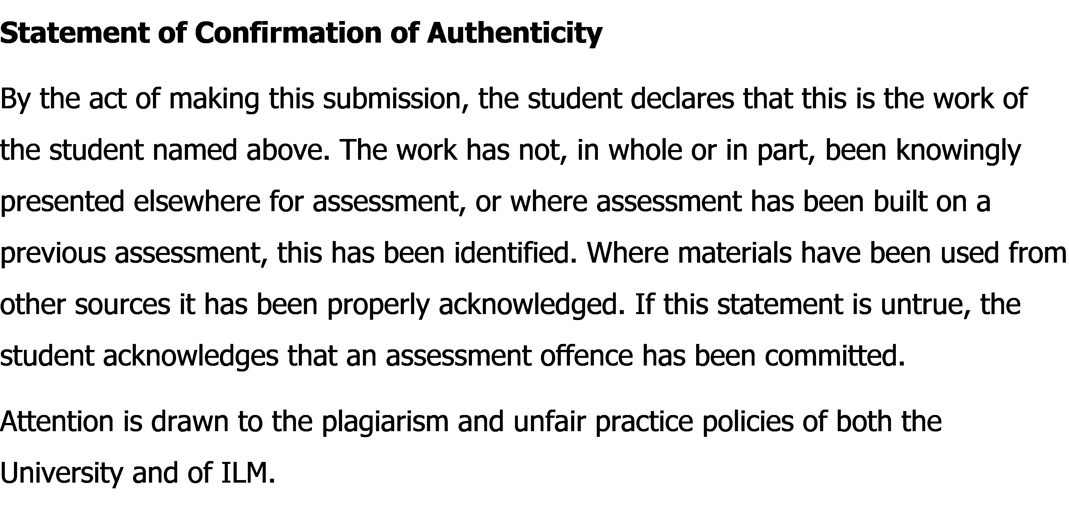

Table of Contents

Introduction………………………………………………………………………………………………………1
Part 1- getting to know myself
- Self-evaluation review……………………………………………………………….3-5
- Johari window…………………………………………………………………………..6-7
- Research and learning style……………………………………………………..7-10
- SWOT analysis………………………………………………………………………11-12
Part 2: Explore possibilities
- Review of the employment of the world…………………………………13-15
- Review of own potential………………………………………………………..15-17
Part 3: Making choice
- SMART objectives………………………………………………………………………18
Part 4: Making it happen
- Personal development plan……………………………………………………18-19
- Assessment of the effectiveness of PDP………………………………………20
Conclusion …………………………………………………………………………........................................20
Reference …………………………………………………………………………...................................21-22
Appendix…………………………………………………………………………............................................23

Introduction
Professional career development is the way of building your career from the early stage in life. The process involves some of the stages including self-assessment, research, career plan, identification the points to fulfill those plans and also developing the own skills and knowledge to gain the career goals and objectives. Professional career development helps a person to identify own interest, knowledge and develop those skills to become successful in the workplace. This report is the portfolio of the stages how I have planned to develop my career and how I can achieve my own goals. I have divided the report into four categories. Getting to myself, exploring my possibilities, making choices and making it happen are the stages of the whole report. In the first stage, I will include the level of awareness, skills and knowledge I should have to achieve my goals. Basically I will include my current position and I will also do SWOT analysis of myself to know my strengths, weaknesses, opportunities and threats. I will also include self-evaluation review in the first part. In the second part of the report, I will include the my understanding on review of the employment of the world, review of own potential and my effectiveness of personal contribution in my employability. In the third part of my report, I will show my short term and long-term goal in different time period by using SMART objectives. In the forth part of the report, I will include my personal development plan. I will also the assessment of the personal development plan for the job that suitable for me. I will also provide some of the useful references and in the appendix; I will add some of the necessary evidence to make my report more valuable. (anon, n.d)

Part 1: Getting to know myself

Self-Evaluation Review:

Personal Values and Principles: Personal value and principles are what a person believes to be important. This helps a person to understand what is right and wrong. Personal principles of an individual refer to the core beliefs and values that dictate or largely influence that individual’s conducts, actions, attitude and behavior (Alba, 2013). I have some values and principles in life. Some of them are given below:
- Honesty: I am a very honest person and I prefer honestly in every step of my life. I never did anything that indicates that I am dishonest person.
- Trustworthy: I always keep everyone’s trust. If I promise to do any work timely, I will do the work timely.
- Determination: I always determine towards work. No matter what I have to face because of my determination, I will do the work anyway. At the I love to take challenges and like to take risk because I think no risk no gain. That is why I take the challenges to achieve my goals.
- Fairness and justice: Another important values of my mine are fairness and justice. I always keep myself fair to anything. And I don’t injustice to people.
- Respect: This is the most important value that I have. I always respect everyone no matter what the age is. Because I belief you will be respected by the people if you respect others.
- Responsible: I am a very responsible person. I had this value from my childhood as I had to take my family responsibility so early, which made a responsible person. I take every work with responsibility and finish it in a proper way.

(anon, 2018)

Self Motivation Quiz:
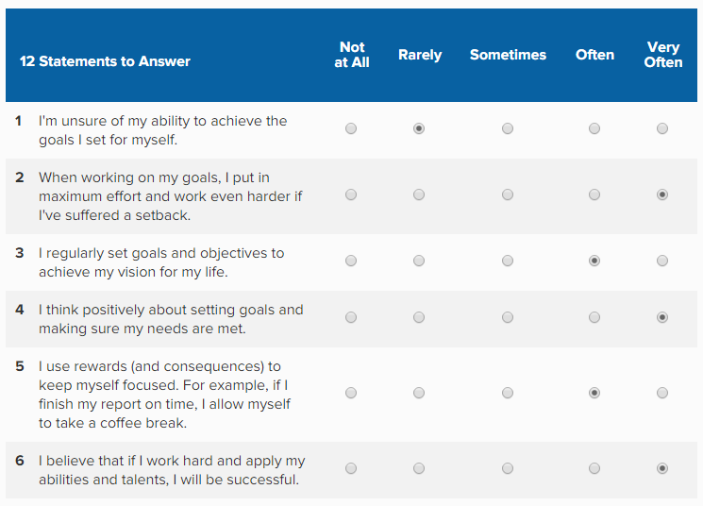

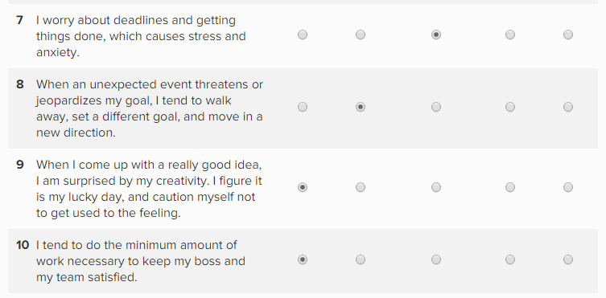

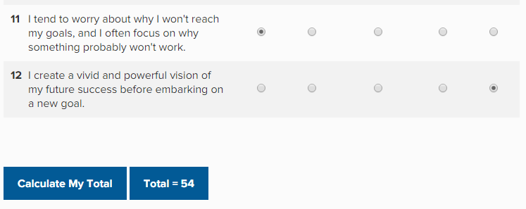

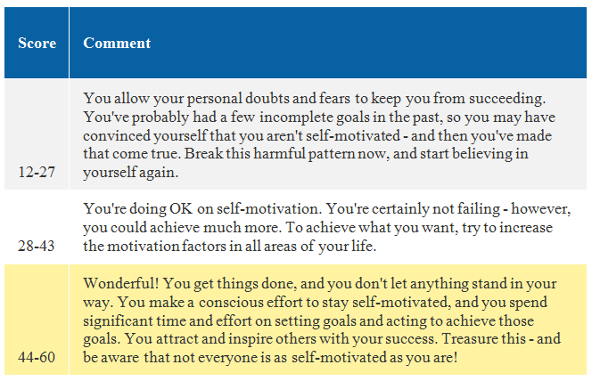

In the above, I have shown my self-motivation quiz score, which is 54. It is an indication that I am good at achieving my goals and I spend significant time and effort on setting goals and acting to achieve those goals. I have used these tools to motivate myself and to inspire myself and this also indicates that I have motivated enough to achieve my goals.
(anon, n.d)

Johari Window Model:

For some people, it is very difficult to comfort with others or with others behavior. Johari window model helps a person to communicate with others in a better way. Is has four quarters. And I have used this technique so that I can reflect myself.

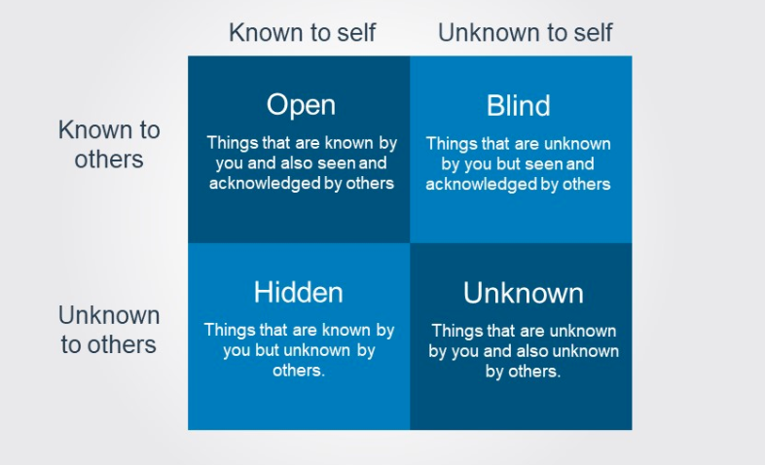

Open Area: This is the area where people know about me and I know about myself too. I am honest and I am very responsible person at my workplace. When I was a retail assistant, my manager knows that I am very honest person therefore he used to handle cash counter on behalf of him. I also know that I can take responsibility from the childhood. That is why; I took the responsibility to design individual floral centerpiece and stage decoration arrangements for a wedding at the Decorium as I was the freelance florist of “Just UK events’’
Hidden: this is the area where people don’t know things about me but I know the things only. People don’t know that I am an introvert and shy person because I manage to do things with my skills. When I was freelance as “just UK events” they didn’t know my leadership skills. But I have gain leadership skills from my childhood, as I was the leader of the school basketball team.
Blind: This is the area where people know about my skills but I don’t about myself. When I was freelancer at Just UK events, I had t work with lots of people and sometimes in a team. Sometimes we had to solve so many customers problem. But among the entire employee, I was the only employee who can handle customer very nicely. I didn’t know that I had customer service skills, which was known to everyone at my workplace.
Unknown: This is the stage where I don’t know things about me as well others. For example: Before coming to private freelance, I never think that I had the skills of Multi tasking. When I was just an employee at just UK events, I had to do the work that I was assigned by the manager. But now I had to handle my own customer, meet the deadline, reaching customer through electric media and so on. (Joseph Luften, n.d)

Research and Learning Styles

Learning is necessary for every leaner. Different author has different definition on learning style. As per Davis (2010), learning is a procedure through which that enhances abilities of people that are basic for accomplishing development. In any case, Evans (2012) has expressed that, when an individual encounters new perspectives and gets associated with various types of communications and accordingly that person's execution and execution potential continue changing and this procedure is called learning.
The importance of understanding leaning style:
- Leaning style makes the leaning easier and makes it more effective to the reader.
- It also increases the versatility. It helps people to learn from a wide variety of different experiences.
- Improve learning skills and processes.
- It also increases the awareness of how to learn.
- It also improves solving skills.
The Honey and Mumford's Learning Style:

The Honey and Mumford's (1992) Learning Style recognizes and orders a person's learning style. There are four styles: an activist, reflector, scholar and logical thinker, with an aggregate of eighty inquiries in the test (Honey and Mumford, 1992). Activists are those individuals who learn by doing. Activists need to get their hands messy, to make a plunge with the two feet first. Have a receptive way to deal with getting the hang of, including themselves completely and without inclination in new encounters. On the other hand, theorist get a kick out of the opportunity to understand the theory behind the exercises. They require models, thoughts and certainties with a particular true objective to partake in the learning system. Like to separate and incorporate, drawing new information into a systematic and reliable 'speculation'. Their decision of learning exercises incorporates models, insights, stories, cites, foundation data, applying ideas hypothetically and so on. Pragmatist likes to apply new learning’s to genuine practice to check whether they work. Preferences research facilities, fieldwork, and perceptions. Reflector people learn by watching and mulling over what happened. They may decline hopping in and like to watch from the sidelines. They need to stay back and see experiences from different interchange perspectives, gathering data and utilizing the chance to progress in the direction of an appropriate conclusion. (rumson, n.d)
The VAK learning Style:
The Visual-Auditory-Kinesthetic (VAK) learning styles model provides a simple way to explain and understand learning styles. The VAK learning Style is divided into three categories to determine a person’s dominate or preferred learning style. And those are:
- Visual learners: Visual learners are more prefer seeing and thinking things through visual aids like PowerPoint slides, pictures, handouts.
- Auditory learners: Auditory learners prefer learning by listening via tapes, discussions and lectures.
- Kinesthetic learners: Kinesthetic learners prefer learning by experience. They also like to do experiment of their own. (anon, n.d)

My Own Learning Style: I have given the Honey and Mumford learning style quiz to understand my own leaning style. And the questions are given below:
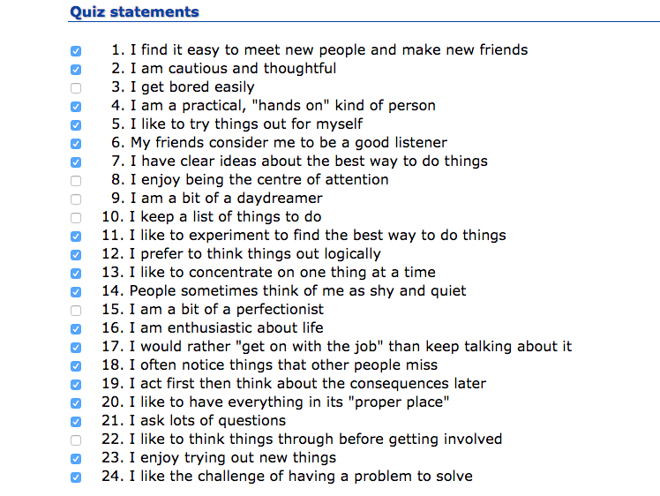
There were 24 questions in the questionnaire but I have ticked those which suits me and with my style.

The results has shown below in the pic chart:
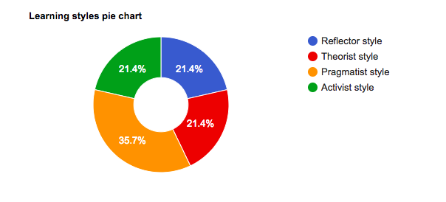
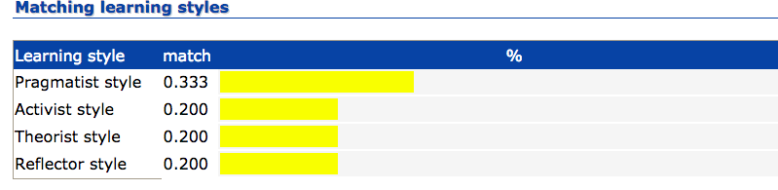

From the result, I can conclude that I am pragmatist learner and I like put my leaning into reality. And I also like to experiment new things and also get attracted by the new ideas. As I have the characteristics of activist, theorist and reflector style equally, I can use those to learn more. According to my result, I am very practical and I took always-practical decision and also solve my problem in the same way.

SWOT analysis:
Strengths: There are some internal factors that I use in my employability. Some of them are given below:
- Some positive traits: I have some positive traits that follow very strictly. I have already mentioned those above in this report that I am very honest, trustworthy, fair and very determine towards my work. I believe in justice to everyone and commitment. I can take the responsibility of the work.
- My knowledge, experiences and skills: I have been studying in the floral field for many years. I have also gathered enough experiences in the same field. I have learned so many skills including managing skills, problem solving skills, leadership skills, designing skills, promotional skills and communication skills. These are the internal factors of mine.
- Network: I have created a strong network through floral business. And I have also created a strong bonding with them. I can use those network in future to take any kind of help from them as well.
- Commitment and deadline: In my business, commitment and meeting the deadline in very important. I took order from the customer and I have to give them the delivery timely. As they order flower for an occasion, if I miss any deadline that will ruin the occasion which also ruin my business reputation.
Weaknesses: Some of the negative internal factor, which I need to improve to become successful in my life. Those are given below:
- Lack of knowledge in other sector: Job sectors are becoming competitive day by day. To gain advantage in employability, every candidate should have knowledge in different sector. But I have only qualification in floral designing. I think I should develop my knowledge on other sector too.
- Lack of goals: I had no goals in life. I wasn’t getting the proper job to gain knowledge in my field. Now I am very determine towards my work and entered into the profession, which I always wanted.
- Lack of Multi-tasking: I had to always work under my manager. I had to work on those particular assigned job daily. That is why; I didn’t get the chance to do multitasking. But now I am working on multitasking skills to gain more employability.
- Weak in technology: Technology has brought revolutionary changes in the workplace. I didn’t get the chance to use those new technologies in the workplace. It has become a weakness of mine.
Opportunities: I have good opportunities in some of the external factor, which I should start working on. Some of them are given below:
- Technological knowledge: every organization is using latest technology in the workplace. So If I gain knowledge on using those technologies, there is a great opportunity for me in future.
- Advancement and increase demand in floral business: I have been studying in the floral field from the beginning of my life. And the demand and the advancement in the floral business are increasing very rapidly. There is also a chance of increasing the demand more. If it happens in future, there will be much opportunity for me.
- More specific job roles: There are still many organizations that are not giving clear job roles in the recruitment process. If they make it more specific, I can also set my goals on those specific job roles.
Threats: Some external factor has become threats for me anyway. I have no control over them and I have to face them anyway. Some of the threats are given below:
- Competition with college graduate: Students who are graduated from some of the reputed college have more idea about any sector than us. I have to compete with them to gain my employability.
- Competition with superior skills and experienced people: There are many people are doing good in the floral business and they have superior skills than me as they are more experienced in this field. I have to compete with them to gain my employability.
Part 2: Explore possibilities
Understanding and expectations of the world of employment: I have gain minimum level of knowledge on understanding and expectation of the world of employment so that I can gain some advantage on my employability and work on the employer expectation. From my point of view, there are basically two parts. One is what employer wants from the employee and what employee wants from the employer or from the organization. I have discussed both of the side below:
What are the characteristics employers looking for?
- Have clear goals in life: Employer are looking for those employee who have clear goals in life. Because they think if a person doesn’t know what he/she wants, how will he/she understand the organization’s need. Therefore a candidate should have clear goals in life.
- Know owns strengths: Employers are looking for those people who have clear idea about their strengths. Because if a candidate know his strengths, he can proof it in the recruitment process and he/she can use those strengths to become successful in the professional life. An employee or a candidate should know what are his/her strengths.
- Think different: Employer wants to hire those people who think differently. Because employer thinks that they can bring changes in the organization. A candidate or an employee should think differently to bring chances or take advantage in employability.
- Proactive: Employer wants to hire proactive person because they don’t have to spend much time on those people. Proactive people don’t wait for the command for the superior whenever they see work they just do it.
- Employability skills: Candidate who has good employability skills always gets a preference. Employers are also looking for those people, as they are already experienced.
- Like to learn new things: There are some people who don’t like to learn new things. They always want to stay in the boundary. In the professional life they face lots of problem. Because employer always prefer people who like to learn new things. A good candidate should always have interest to learn new things.

What recruiters do?
Recruiters are the assets for any organization because their activities are directly or indirectly related to the organizational growth. Recruiters are the people who understand the necessity of the organization. They know what kind of people organization is looking for and who can increase the growth of the organization. Some of the activities of a recruiters are given below:
- Understand organization’s need: Recruiters are the people who set clear job roles in the job description, as they know the need of the organization very clearly. They also hire people who are suitable on those particular job roles. They spend lots of time in the recruitment process so that they can hire the best people for the organization.
- Choose the best candidate for the organization: Recruiters plan for the recruitment process so that they can hire the best employee. They do research to reach the candidates and they give the recruitment ad on the media. Basically they have to go through lots of process to choose the best candidate for the organization.
- Manage interview process: After giving the ads in different pages and medias, they arrange the interview process. They also invite the best interviews from different organization sometimes.
- Follow-up with candidates: Lastly, they make a conclusion in the recruitment process by giving follow up to the candidates.

Purpose of job description: Basically job description is the way of letting the candidates know about the tasks, duties and responsibilities that they are going to perform in the organization. The main purpose of job description is hiring the right people for the right position. Well-written job description allows a candidate or an employee to understand the expectations of the roles.
Purpose of person specification: It a description of the skills, knowledge, experiences and qualification that a candidate must have to perform the specific job duties. Recruiters design their questionnaire according to the person speciation. Recruiters mention the skills, knowledge, qualification and experience in the job description so that the person who has those can apply for the right position. And the main purpose of doing that is to hire the right person.

Own potential in the suitable job roles:
I have gathered many experiences by doing job in different organization. Based on my experiences, knowledge and skills I think I have the potentiality for the following jobs:
Manager of an organization: According to my experiences, knowledge and skills, I think I can be manager of an organization. I have the experience of handling cash, control stock and management. I have also experiences in dealing with customer refunds and complaints. I can manage people and handle customer care service very nicely. On the other hand, I have leadership skills and with the help of these skills I have started my business. Now I have to handle my own customers. I have to take order from them and have to promote the brand at the electric media. I have to give salary to my employee. Sometimes I also motivate them towards and give them bonus if necessary. I have communication skills to deal with any situation. These are the potential skills I have which made me think that I can be a good manager.
Director of an organization: I have also the potentiality to become a director of an organization because I have good leadership skills. I have worked in different organization in UK, after getting all the experiences I have started my business in online. I have my own employee and customers now. And because of my previous experiences including customer management, communication skills and good leadership skills, I am handling my employee and customers very nicely. And I think I can use those to become a director of any organization.
I also think also ready for the above job. And here in my CV attached below:
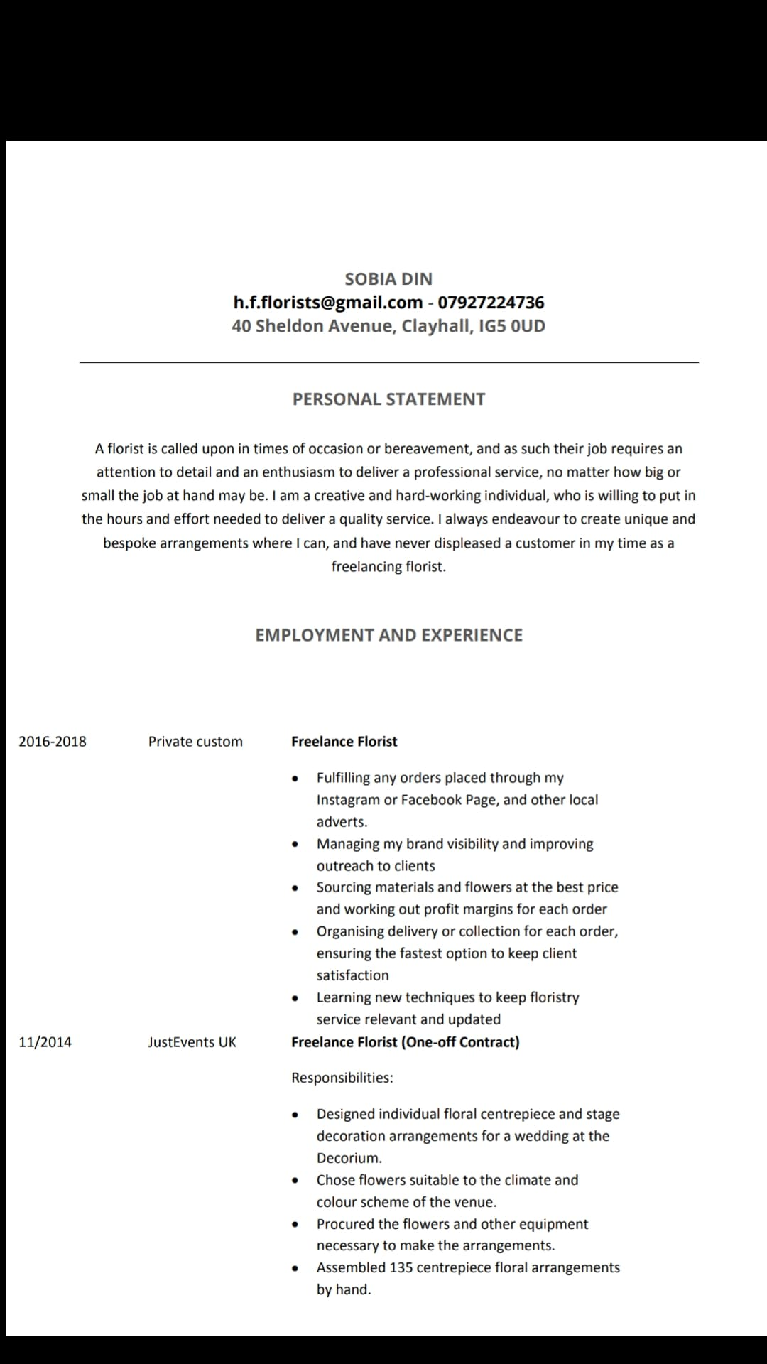

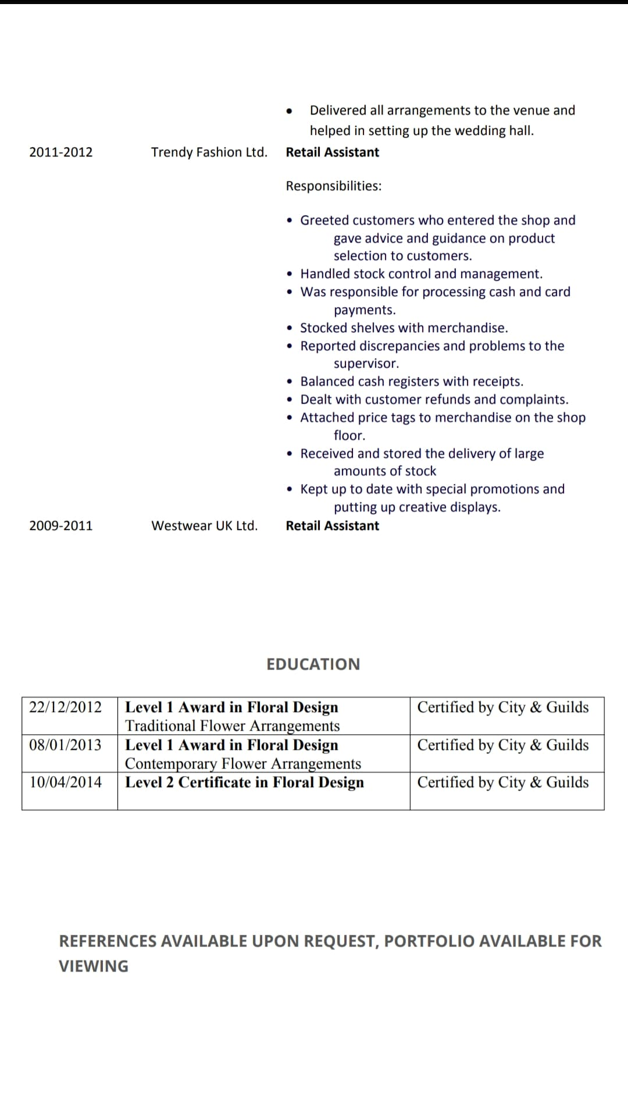

Part 3: Making choice
My short, middle and long-term goals: I have three goals in my life. And I will discuss my goals below by using SMART objectives.
- Specific: My goals are very specific. My short-term goal is to complete my study with a good grade. My middle term goal is to be manager of an organization. And my long-term goal is to be director of any organization.

- Measurable: My goals are also measurable. I want to achieve my short-term goal at the end of year 2019. And I want to be a manager in 2021, which is my middle term goal. And want to be director at the end of year 2025.

- Attainable: Completing my degree, becoming a manager and a director are attainable. As I have my own business, I know how to handle a business. If I become a director, I will be able to handle the whole organization because of my experience using leadership skills, communication skills and managing skills and customer handling skills.

- Realistic: According to the Honey and Mumford quiz result, I am very practical in life. Therefore I don’t dream of anything that I cannot achieve.

- Time bound: I have measured the maximum time to achieve my goals. I hope I can achieve my all goals at the end of 2025.

Part 4: Making it happen
Personal Development Plan: At the point when a man determines a few goals for his/her own vocation change and afterward sets out procedures for accomplishing those destinations and settle on the achievement criteria that will mean the best possible accomplishment of those targets then this entire procedure is called as personal and professional development plan. (Ferguson, 2012).
Action plan:

Start date | Completion date | Skill, experience, | How will this be gained? | Provider (e.g. workplace
 |  | Knowledge to be gained | (e.g. on the job experience, | Educator, university,
 |  |  | (e.g. on the job experience, | Coach/mentor etc.
 |  |  | Formal/informal | Coach/mentor etc.
 |  |  | Seminars/courses,
 |  |  | Coaching/mentoring etc.
30-09-2018 | 30-12-2025 | -Leadership Skills | -By continuing my floral business. | -At my own workplace
01-09-2018 | 30-12-2019 | -Communication skills | -By attending the classes and dealing with my own customer | -University and workplace
30-09-2018 | 30-12-2019 | -Problem solving skills | -By attending different seminar | -Mentor
01-09-2018 | 29-12-2025 | -Customer service skills | -By dealing with customer at my workplace. | -Myself
01-09-2018 | 30-12-2019 | -Technological skills | -By attending different seminar and university classes | -University of Wales
01-09-2018 | 30-12-2019 | -Teamwork | -By making group for the course project. | -University of Wales

Importance of personal development plan:
A personal development plan gives a person a framework about where he/she should focus and what is the strengths and weakness of a person. It helps a person to perform in a better way in specific job role. PDP helps a person to reflect in the time. It also shows the opportunity in life and what can I person can do about it.
PDP also shows the framework of time where a person can where he/she can go in next five years or ten years. It also helps a person to work according to that way so that he/she can achieve those long-term goals in life. But a personal deployment plan should be formulated based on SMART objective. If the plan is not specific, measurable, attainable, realistic and time bound, then there Is no point of having it (Ferguson, 2012).
PDP also helps a person by showing the skills and it helps the employee to become confident and efficient on those skills. As I want to be manager and a director of an organization in future, this PDP will help me to achieve those objectives in life. it will show me what resources I have to collect to fulfill each goals.

Conclusion
Every person should have proper professional career plan. By doing this report, I have gather lots of knowledge on that particular topic and it will help me to increase my employability in future. I have completed my life exercise; I have found my strengths and weakness. I also did SMART objectives to set my short term and long-term goals. I have also created a personal development plan to achieve those objectives. Basically, I should say this report will help me to learn lots of thing which will help me to become successful and career oriented in future.

References:
- Alba, G. D. and Sandberg, A. (2013) Unveiling Professional Development: A Critical Review of Stage Models. Review of Educational Research, 76/3, 383-418. (TCP/ SAM).

- Brown, S. and Lent, R. (2004). Career Development and Counseling: Putting Theory and Research to Work. Wiley.

- Cowan, J. and J. Westwood (2014) Collaborative and Reflective Professional Development. Active Learning in Higher Education, 7/1, 63-71.

- Davis, R. and M. Priston (2010) An Evaluation of the Impact of Continuing Professional Development on Personal and Professional Lives. Journal of In-Service Education, 28/2, 231-254.

- Evans, L. (2012). Professionalism, Professionalism and the Development of Education Professionals. British Journal of Educational Studies, 56/1, 20–38.

- Unit 13 Personal and Professional Development. 2018. Unit 13 Personal and Professional Development. [ONLINE] Available at: https://www.locusassignments.com/courses/mont-rose-college-unit-13-personal-and-professional-development/ [Accessed 28 August 2018].

- James Clear. 2018. Core Values List: Over 50 Common Personal Values. [ONLINE] Available at: https://jamesclear.com/core-values [Accessed 28 August 2018].

- Self-Motivation Quiz - Goal Setting Tools from MindTools.com. 2018. Self-Motivation Quiz - Goal Setting Tools from MindTools.com. [ONLINE] Available at:https://www.mindtools.com/pages/article/newLDR_57.htm [Accessed 28 August 2018].

- ToolsHero. 2018. Johari Window Model, a powerful Communication Skills model | ToolsHero. [ONLINE] Available at: https://www.toolshero.com/communication-skills/johari-window-model/ [Accessed 28 August 2018].

- ELN Resources. 2018. Honey and Mumford four Learning Styles. [ONLINE] Available at: http://resources.eln.io/honey-and-mumford-learning-styles/ [Accessed 28 August 2018].

- Visual-Auditory-Kinesthetic (VAK) learning styles model. 2018. Visual-Auditory-Kinesthetic (VAK) learning styles model. [ONLINE] Available at:http://thepeakperformancecenter.com/educationallearning/learning/preferences/learning-styles/vak/ [Accessed 28 August 2018].

